JOINT PROGRAMME ON GENDER
Leveraging the full potential of Gender Equality and Women's
Empowerment to Achieve Rwanda's Transformation

MID-TERM REVIEW
January 2019 – June 2021

ANNEXES FOR FINAL REPORT

By
NATIONAL GENDER MACHINERY (NGM)
(MIGEPROF, GMO, NWC, FFRP)

MINISTRY OF FINANCE AND ECONOMIC PLANNING (MINECOFIN)

ONE UN
(UN Women, UNDP, UNFPA, UNHCR, UNICEF, IOM, OHCHR)

December, 2022

LIST OF ANNEXES
Annex 1: Evaluation matrix
Annex 2: Coherence and incoherence between outcomes and their outputs and indicators
Annex 3: Discrepancies in the naming of outputs
Annex 4: Link between JP, UNDAP II, and NST1
Annex 5: Participants in the mid-term review
Annex 6: Questions for direct beneficiaries of joint programme
Annex 7: Questions for implementing partners (gvt’ cso, and private sector institutions
Annex 8: Questions for donors
Annex 9: UN staff survey
Annex 10: UN agencies interventions
Annex 11: Terms of references
Annex 12: JP resized budget per outcome

ANNEXES

Annex 1: Evaluation matrix

Eval criteria (UNDP, 2021, p.2) | ToR | Questions based on ToR | Questions of interview guides | Indicators | Method of data collection | Data sources | Assumptions
RELEVANCE: Is the Intervention doing the right things? The extent to which the intervention objectives and design respond to global and national needs, policies and priorities and those of beneficiaries and partner institutions, and continue to do so as circumstances change. | - Assess relevance of the programme strategies and design in the evolving context of the challenging environment including in the context of Covid-19 realities (how COVID-19 pandemic has affected the program and how the JP adapted to this situation);  - Assess to what extent the program design considered and incorporated lessons learnt from the previous joint program and see if there are any changes that need to be made to ensure its continued relevance and possibly make it more relevant? | - How useful, realistic, and harmonised are the design, theory of change, underlying assumptions, and defined outcomes, outputs, indicators, and targets?  - To what extent is the intervention aligned with relevant national, regional, and international priorities (agreements/conventions, structures, politics, strategies, inclusion and LNOB, partnership/ collaboration and synergy) on gender equality and women's empowerment and is linked with previous recommendations  - To what extent is the intervention relevant to the beneficiaries' needs in the current context (cultural, technological, development) of Rwanda | - Q3 (DB): Was the support you received the one you needed in your business? Explain; Q11(IP). Is the programme adequately responding to the needs of the beneficiaries? Explain (Max. six lines)  - Q9(DB): What did you like the most in the assistance you received from this institution? Q10(DB): What did you dislike the most in the course of the project which has supported you?  - Q4(DB): Were you satisfied with the support? Explain  - Q5(DB): What would have been the kind of support that would respond better to your needs for your business?  - Q2(Do). How long has your institution been in partnership with UN and Rwandan Government for the Joint Programme on Gender in Rwanda?  - Q5(Do). How do you perceive UN‘s and government’s roles in the implementation of the Joint programme on gender? What could it do more or less of? (Max. Ten lines)  - 2.1 (UN) Has the programme design taken into account the recommendations from the previous evaluations? Explain  - Q8(DB): How do you appreciate or depreciate the process and criteria that the institutions used to select the beneficiaries [or to serve them]? Were all the categories of people having the same chance to be supported by the project? Explain  - Q9(IP). How do you observe the implementation of the principle of Leaving No One Behind (inclusion of people from all vulnerable categories) within the Joint programme? (Max. six lines)  - How are the theory of change and the Joint programme framework articulated and linked (Document analysis) | - The level to which the theory of change and the Joint programme framework are coherent and logically articulated  - The level to which Joint programme on gender is in line with national, regional, and international priorities, and existing practices in GEWE  - The level to which the Joint Programme responds to the beneficiaries' needs in GEWE | - Individual interview with direct beneficiaries, implementing partners, UN agencies and donors;  - Consultation of existing narrative reports of the programme, and  - Use of existing of published and non-published documents on programme design, monitoring and evaluation  - Meeting with stakeholders | - Direct beneficiaries;  - IP;  - Donors  - UN & NGM reports  - JP documents | - Relevant documents and reports of Joint programme are availed  Internet and other repositories (libraries, offices…) are accessible  Potential informants are in accord with the MTR, are willing to participate, and create time for this purpose

Eval criteria (UNDP, 2021, p.2) | ToR | Questions based on ToR | Questions of interview guides | Indicators | Method of data collection | Data sources | Assumptions
EFFECTIVENESS: Is the intervention achieving its objectives? The extent to which the intervention achieved, or is expected to achieve, its objectives, and its results, including any differential results across groups. | - Assess progress made toward the achievement of the expected results and performance of the joint programme after 3 years of implementation (its appropriateness, design, results Framework and possible risks to sustainability in promoting gender equality and women empowerment).  - To assess the extent to which the support provided by the Joint Program have benefited and utilized by direct beneficiaries? (Indashyikirwa beneficiaries, support provided to women in cross border trade, socioeconomic reintegration of teen mothers, legal assistance to GBV victims, women in business, among others)  - Assess effectiveness of the programme in achieving the specific results of the programme. | - What has been the progress made towards achievement of the expected outputs and outcomes?  - What are the internal and external factors that contributed to the achievement or non-achievement of intended results?  - To what extent have the living conditions of beneficiaries been improved because of Joint Programme? | - Q2(DB): What are/were the kinds of support they (JP) provided to you (be specific, showing the provided materials and services, quantities and qualities)?  o Materi al supports  o Services provided  - Q2a(IP). Were all the activities planned in your project for this mid-time carried out? Explain (Max. six lines); 2.3 Were the activities planned for this mid-time carried out? Explain (Max. six lines)  - Q2b(IP). What are the main achievements of the project so far? (Max. six lines); 2.4 What are the main achievements (describe, give numbers, and estimate the level of achievements in %)? (Max. Ten lines)  - Q4(DB). How are you satisfied with the JP’s main achievements to date? (Max. Ten lines)  - 2.2 (UN)Is the programme on track when looking at the targets for the indicators? _____ Yes ____ No  - Q3.(Do) What is the main objective(s) of the partnership? (Max. Six lines)  - Q3a(IP): Has the project achieved what was intended to be achieved in this mid-time? Explain (Max. six lines)  - Q3b(IP). Is the programme having other results or impact beyond what was initially planned? Explain (Max. six lines). Q3. Is the programme having other results or impact beyond what was initially planned? _____ Yes _____ No. Explain (Max. Six lines)  - Q5(IP). What are the main factors behind the success of the programme (maximum 3 factors) (See examples below, provide maximum 3 factors)  • Good/enough human resources/staff  • Enough financial resources  • Good planning/focus/goal and indicators  • Good strategy/approach  • Good management/ coordination/ leadership/communication  • Good stakeholders/beneficiaries  • Rewards/sanctions for beneficiaries  • Etc.  • Please specify (Max. six lines):  - Q8(IP). Can you please tell me two main strengths contributing to the successful implementation of the Joint Programme? (e.g., the organisation's technical capacity, the leadership, financial capacity etc.) (Max. six lines)  - Q6(DB): Were your living conditions improved because of this support? Explain  - Q4(IP). What impact on the beneficiaries have you observed (e.g., increased number of women eager to compete for local election, increased awareness of women’s rights, increase % of services provided for SGBV, etc.)? (Max. six lines) | - The number/quantity, quality, and process of the programme's activemennts in reference to the defined targets for the outputs, and outcomes  - The number of factors that have significantly contributed to the success of JP  - The extent to which the former life conditions of the beneficiaries have positively changed because of Joint Programme on gender | - Individual interview with direct beneficiaries, inplementing partners, UN agencies and donors;  - Consultation of existing narrative reports of the programme,  - Meeting with stakeholders | - Direct beneficiaries  - UN  - UN & NGM reports  - IP,  - Donors | - Relevant documents and reports of Joint programme are availed  Potential informants are willing to participate, create time for this purpose, and are able to report and appraise the results of the programme

Eval criteria (UNDP, 2021, p.2) | ToR | Questions based on ToR | Questions of interview guides | Indicators | Method of data collection | Data sources | Assumptions
EFFICIENCY: How well are resources being used? The extent to which the intervention delivers, or is likely to deliver, results in an economic and timely way. | • Assess the program implementation and management arrangements, including coordination among different stakeholders, the monitoring and evaluation system in place, etc… | - To what extent does the management structure of the intervention support efficiency for programme implementation?  - Have programme funds and activities been delivered in a timely manner? If not, what were the bottlenecks encountered? | - Q10 (UN) Were the resources allocated to the implementation of the Joint Programme (human and financial) sufficient as regard the planned activities? _____ Yes ____ No. Explain (Max. Six lines)  - Q12(IP). What can you say about the management, coordination, and follow up of the project? (Max. ten lines)  - Q8(Do). How do you appreciate your partnership with One UN and the resources mobilization strategies used for Joint Programme? (Max. Ten lines) | - The extent to which the management structure of the programme supports efficiency for programme implementation?  - The amount of money availed and the respect of the implementation calendar and the financial deposit | - Individual interview with direct beneficiaries, implementing partners, UN agencies and donors;  - Consultation of financial and narrative reports of the programme  - Meeting with stakeholders | IP, UN, UN report, NGM reports  Donors  UN | - Relevant financial and narrative documents and reports of Joint programme are availed  Potential informants are willing to participate, and are able to comment and appraise the management of the resources of the programme

Eval criteria (UNDP, 2021, p.2) | ToR | Questions based on ToR | Questions of interview guides | Indicators | Method of data collection | Data sources | Assumptions
SUSTAINABILITY: Will the benefits last? The extent to which the net benefits of the intervention continue or are likely to continue. | Propose potential sustainability plan of the programme; | - What is the likelihood that the benefits from the project will be maintained for a reasonably long period of time after the project phase out? | - Q7(DB): How do you think this support you received will continue to impact your life after the period of the project?  - Q9(Do). What do you think on the sustainability of this Joint programme, given the approach of UN and partners? (Max. Ten lines)  - Q11(UN). Do you find this Joint Programme relevant and sustainable in the context of Rwanda? ____ Yes _____ No. Explain (Max. Six lines)  - Q15(UN). How could the Joint programme’s partners further leverage its sustainability (Max. Ten lines) | - The likeliness of the programme's benefits to remain longer after it has timed out? | - Individual interview with direct implementing partners, UN agencies and donors;  Meetings with stakeholders | - Direct beneficiaries,  - Reports (UN, NGM).  - Donors  - UN | - Potential informants are willing to participate, and are able to comment and appraise the sustainability of the programme's results

Eval criteria (UNDP, 2021, p.2) | ToR | Questions based on ToR | Questions of interview guides | Indicators | Method of data collection | Data sources | Assumptions
Lessons learned & Best practices | Document lessons learnt from the program interventions that will inform future program undertakings; Document best practices out of the joint program interventions | What lessons learnt from JP interventions and/or best practices that will inform future program undertakings | Q10(IP). Please list any lessons learnt and/or best practices from the implementation of the Joint programme, which may be useful for your institution or other institutions in the future? (Max. Ten lines) | The number of lessons learned and/or best practice from JP which can infor future programming | Interview with Direct beneficiaries, IP, UN, Desk review | IP, UN, UN & NGM reports | Potential informants are willing to participate, and are able sort out a lesson learned from the implementation of the programme; The reports of the programme are availed

Eval criteria (UNDP, 2021, p.2) | ToR | Questions based on ToR | Questions of interview guides | Indicators | Method of data collection | Data sources | Assumptions
Challenges and gender issues | Identify key challenges of the programme and provide recommendations for addressing them | What are the key challenges or threats identified during the implementation of JP progamme? | 2.6 9(UN)What were the challenges in reaching the expected achievements and how were they addressed? (Max. Ten lines)  Q7. (Do) What do you foresee as the key challenges or threats which may hinder advancing GEWE in Rwanda in the coming years and how can they be overcome? (Max. Ten lines)  Q9. (UN) Can you please tell me two main bottlenecks, if any, having an impact on the Joint Programme implementation and mitigation strategies? (Max. six lines)  Q8. (IP) Can you please tell me two main threats which could potentially hinder implementation of the programme and any mitigation strategies? (Max. six lines)  Q7(IP). What are the main factors, if any, behind the bottlenecks faced by the programme [See examples below], (provide maximum 3 factors)  • Challenge in human resources/staff  • Insufficient financial resources  • Challenge in planning/focus/goal and indicators  • Challenge in strategy/approach  • Challenge in management/coordination/ leadership/communication/ collaboration  • Challenge among stakeholders/beneficiaries  • Reward/sanctions for beneficiaries  - Q6. (Do) What do you foresee as the key gender issues and opportunities for Gender Equality and Women’s Empowerment in Rwanda in the coming years? (Max. Ten lines) | The number of challenges observed during the implementation of JP on gender | Interview with Direct beneficiaries, IP, UN, Desk review | UN  Donors  UN  IP; UN  IP, UN | Potential informants are willing to participate, and are able to sort out a lessons learned from the implementation of the programme; The reports of the programme are availed

Eval criteria (UNDP, 2021, p.2) | ToR | Questions based on ToR | Questions of interview guides | Indicators | Method of data collection | Data sources | Assumptions
Recommendations | Recommend adjustments, if any, to the joint programme strategies and directions for the remaining programme implementation period; | What can be recommended to be adjusted in order to ensure a relevant, effective, efficient, impactful programme able to produce sustainable results; | Q11(DB): What advice can you give so that the project that supported you is efficient in sustainably supporting people from your contextual background?  Q13(IP). How should the programme be improved in order to better respond to the real needs of the beneficiaries and to have a sustainable solution? | The number of relevant recommendations for successful implementation during the remaining time of JP on gender. | Interview with Direct beneficiaries, IP, UN, Desk review | Donors, UN  Direct beneficiaries  IP, UN & NGM annual reports | Potential informants are willing to participate, and are able to analysise the past shortcomings and foresee the strategy for more success; The reports of the programme are availed
Legend: DB: Direct Beneficiaries; IP: Implementing Partners; Do: Donors, UN: United Nations

Annex 2: Coherence and incoherence between outcomes and their outputs and indicators
JP FRAMEWORK | COHERENCE
Outcome 1: By 2024, people in Rwanda benefit from enhanced gender equality, justice, human rights, peace, and security. (UNSDCF 2018-2024 Outcome 5)
JP Output 1.1: Women’s capacity to compete for leadership positions and to lead decision-making processes at local and national levels strengthened | 1.1 Correlated
Indicator 1: No of Women candidates with skills & capacities to participate in electoral process | 1.1 Correlated
Indicator 2: No of Women & girls reached out through mentorship program in leadership & entrepreneurship | 1.1 Correlated
JP Output 1.2: National and local level Government institutions’ capacities to execute gender-responsive development strategies, sector strategies, district development plans and budgets increased | 1.2 Correlated
Indicator 1: Gender budget tracking tool for use by state institutions developed. | 1.2 Correlated
Indicator 2: No of Gov. inst. with 2 staff who have skills to systematize gender budget planning & execution tracking & reporting. | 1.2 Correlated
JP Output 1.3: Community awareness of gender equality and civic understanding of women’s right to equal participation in decision making increased | 1.3 Correlated
Indicators: (1) Proportion of media houses with gender mainstreaming editorial policies in place | 1.3 Correlated
Outcome 2: By 2024, people in Rwanda participate more actively in democratic and development processes and benefit from transparent and accountable public and private sector institutions that develop evidence-based policies and deliver quality services. (UNSDCF 2018-2024 Outcome 6)
JP Output 2.1: Accountability mechanisms on gender equality and women’s empowerment in government agencies, CSOs, FBOs, I/NGOs and political parties are monitored and strengthened | 2.1 Not directly correlated
Indicator 1: Level of citizen satisfaction with SV delivery in local administration | 2.1 Not directly correlated
Indicator 2: %age citizens satisfaction with the performance of LG councils | 2.1 Not directly correlated
Outcome 3: By 2024, people in Rwanda benefit from more inclusive, competitive, and sustainable economic growth that generates decent work and promotes quality livelihoods for all. (UNSDCF 2018-2024 Outcome 1)
JP Output 3.1: Women have enhanced skills and access to finance and markets to leverage business opportunities | 3.1 Correlated
Indicator 1. #. of target population with entrepreneurship skills. (Disaggregated by sex, rural/urban, age range). | 3.1 Correlated
Indicator 2. No. of people reached through new financial products ( e.g. new products, UN Supported Women's Investment Funds). (Disaggregated by sex, age and rural/urban). | 3.1 Correlated
JP Output 3.2: Women’s capacity and opportunities to access remunerated off-farm employment increased | 3.2 Correlated
Indicator 1. Number of youth led organizations and networks participating in national policy dialogue, advocacy and programming, including in humanitarian settings. | 3.2 Correlated
JP Output 3.3: Corporate sector actors demonstrate increased understanding of and commitment to implement gender equality and women’s empowerment practices | 3.3 Correlated
Indicator: No of target population with entrepreneurship skills | 3.3 Correlated
Outcome 4: By 2024 people in Rwanda, particularly the most vulnerable have increased resilience to both natural and man-made shocks and enjoy a life free from all forms of violence and discrimination. (UNSDCF 2018-2024)
JP Output 4.1: Increased awareness among target communities on Sexual and Gender Based Violence prevention, reporting, response, and service availability for victims | 4.1 Correlated
Indicator: # of individuals that have improved knowledge and awareness on SGBV prevention and response (by target group). | 4.1 Correlated
JP Output 4.2: Strengthened capacity of relevant institutions/GBV service providers to handle/respond to S/GBV cases including capacity to harmonize and preserve forensic evidence | 4.2 Correlated
Indicator: # of service providers with the capacity to respond to cases of SGBV, child abuse, exploitation and neglect. | 4.2 Correlated

Annex 3: Discrepancies in the naming of outputs
Original JP | UN report 2021 | NGM report 2022 | Addendum | PPT NGM 2021
JP Output 1.2: National and local level Government institutions’ capacities to execute gender-responsive development strategies, sector strategies, district development plans and budgets increased | JP Output 1.2: National and local level Government institutions’ capacities to execute gender-responsive development strategies, sector strategies, district development plans and budgets increased | JP Output 1.2: National and local level Government institutions’ capacities to execute gender-respoonsive development strategies, sector strategies, district development plans and budgets increased | Output 1.2 Local and national level Government institutions' capacities to coordinate and execute gender-responsive dev`t frameworks and budgets are strengthened | Output 1.2: Local & national level Government institutions' capacities to coordinate & execute gender-responsive dev`t frameworks & budgets are strengthened.
JP Output 1.3: Community awareness of gender equality and civic understanding of women’s right to equal participation in decision making increased | JP Output 1.3: Community awareness of gender equality and civic understanding of women’s right to equal participation in decision making increased | JP Output 1.3: Community awareness of gender equality and civic understanding of women’s right to equal participation in decision making increased | Output 1.3 Community awareness of gender equality and civic understanding of women’s right to equal participation in decision making increased. | [Output 1.3 missing]
JP Output 2.1: Accountability mechanisms on gender equality and women’s empowerment in government agencies, CSOs, FBOs, I/NGOs and political parties are monitored and strengthened | JP Output 2.1: Accountability mechanisms on gender equality and women’s empowerment in government agencies, CSOs, FBOs, I/NGOs and political parties are monitored and strengthened | JP Output 2.1: Accountability mechanisms on gender equality and women’s empowerment in government agencies, CSOs, FBOs, I/NGOs and political parties are monitored and strengthened | Output 2.1 Accountability and oversight mechanisms on gender equality and women’s empowerment in public and private institutions and the implementation of national and international gender equality and women's empowerment frameworks are monitored and strengthened | Output 2.1 Public & private institutions’ accountability & oversight mechanisms on GEWE are strengthened
JP Output 3.1: Women have enhanced skills and access to finance and markets to leverage business opportunities | JP Output 3.1: Women have enhanced skills and access to finance and markets to leverage business opportunities | JP Output 3.1: Women have enhanced entrepreneurial skills and increased access to finance and markets to leverage business opportunities | Output 3.1 Women have enhanced entrepreneurial skills and increased access to finance and markets to leverage business opportunities | Output 3.1 Women have enhanced entrepreneurial skills & increased access to finance & markets to leverage business opportunities
JP Output 3.2: Women’s capacity and opportunities to access remunerated off-farm employment increased | JP Output 3.2: Women’s capacity and opportunities to access remunerated off-farm employment increased | Output 3.2: [Missing] | Output 3.2 Women and men have equal capacity and opportunities to access existing and newly created off-farm employment | JP Output 3.2: Women and men have equal capacity and opportunities to access existing and newly created off-farm employment
Output 3.3: Corporate sector actors demonstrate increased understanding of and commitment to implement gender equality and women’s empowerment practices | Output 3.3: [Missing] | Output 3.3: [Missing] | Output 3.3 Corporate sector actors demonstrate increased understanding of and commitment to implement gender equality and women’s empowerment practices | Output 3.3: [Missing]
Output 4.1: Increased awareness among target communities on available /S/GBV services (e. at the IOSC), how to prevent and/or timely report and how to respond to incidents of S/GBV | JP Output 4.1: Increased awareness among target communities on Sexual and Gender Based Violence prevention, reporting, response, and service availability for victims | JP Output 4.1: Increased awareness among target communities on Sexual and Gender Based Violence prevention, reporting, response and service availability for victims | Output 4.1 Increased awareness among target communities on Sexual and Gender Based Violence prevention, reporting, response and service availability for victims. | Output 4.1 Increased awareness among target communities on SGBV prevention, reporting, response & service availability for victims.

Annex 4: Link between JP, UNDAP II, and NST1
JOINT PROGRAMME |  | UNDAP |  | NST1
OUTCOMES | OUTPUTS | OUTCOMES | OUTPUTS | PILLARS | PRIORITY AREAS
Outcome 1 | - Output 1.1: Women’s capacity to compete for leadership positions and to lead decision making processes at local and national level strengthened  - Output 1.2: Local and national level Government institutions’ capacities to coordinate and execute gender-responsive development frameworks and budgets are strengthened  - Output 1.3: Community awareness of gender equality and civic understanding of  - women’s rights to equal participation in decision making increased | Outcome 5: “By 2024, people in Rwanda benefit from enhanced gender equality, justice, human rights, peace and security” | Output 5.1: National gender machinery, state and non-state institutions have the requisite technical and financial capacity to advance gender equality, women's economic empowerment, political participation and decision making at national and local levels. | Transformational Governance Pillar | - Priority area 1: Reinforce Rwandan culture and values as a foundation for peace and unity  - Priority area 5: Strengthen Capacity, Service delivery and Accountability of public Institutions  - Priority area 6: Increase citizens’ participation, engagement and partnerships in Development
Outcome 2 | - Output 2.1: Accountability and oversight mechanisms on gender equality and women’s empowerment in public institutions strengthened | Outcome 6: “By 2024, people in Rwanda participate more actively in democratic and development processes and benefit from transparent and accountable public and private sector institutions that develop evidence-based policies and deliver quality services” | Output 6.4: Public and private institutions in all sectors, particularly at the local level, are technically able to plan, budget, implement and report on service delivery for increased transparency and accountability. | Transformational Governance Pillar | - Priority area 5: Strengthen Capacity, Service delivery and Accountability of public Institutions
Outcome 3 | - Output 3.1: Women have enhanced entrepreneurial skills increased access to finance and markets to leverage business opportunities  - Output 3.2: Women and men have equal capacity and opportunity to access existing and newly created off farm employment  - Output 3.3: Corporate sector actors demonstrated increased understanding of and commitment to implement gender equality and women’s empowerment practices | Outcome 1: “By 2024 people in Rwanda benefit from more inclusive, competitive and sustainable economic growth that generates decent work and promotes quality livelihoods for all” | - Output 1.4: Private and public institutions have the requisite technical and financial capacity to create decent employment, foster skills development, empower and promote entrepreneurship and financial inclusion for all, especially women and youth. | Economic Transformation Pillar | - Priority area 1: Create 1,500,000 (over 214,000 annually) decent and productive jobs for economic development.  - Priority area 3: Establish Rwanda as a Globally Competitive Knowledge-based Economy  - Priority area 5: Increase domestic savings and position Rwanda as a hub for financial services to promote investments
Outcome 4 | - Output 4.1: Increased awareness among target communities on sexual and gender-based violence prevention, reporting, response, and service availability for victims  - Output 4.2: Capacity of relevant institutions and Sexual and Gender Based Violence service providers to handle/respond to Sexual and Gender Based Violence cases, including capacity to harmonize and preserve forensic | Outcome 4: “By 2024 people in Rwanda, particularly the most vulnerable have increased resilience to both natural and man-made shocks and enjoy a life free from all forms of violence and discrimination.” | Output 4.2: Violence Prevention and response: Service providers and communities have strengthened capacities and knowledge to prevent and respond to SGBV, violence against children, child abuse, exploitation and neglect. | Transformational Governance Pillar  Social transformation Pillar | - Priority area 1 (governance): Reinforce Rwandan culture and values as a foundation for peace and unity  - Priority area 5 (Governance): Strengthen Capacity, Service delivery and Accountability of public Institutions  - Priority Area 5 (social): Moving Towards a Modern Rwandan household

OTHER NST1 PRIORITY AREAS (NOT SHOWN IN THE ABOVE TABLE):

Economic Transformation Pillar
Priority area 2: Accelerate Sustainable Urbanization from 18.4% (2016/17) to 35% by 2024
Priority area 4: Promote industrialization and attain a structural shift in the export base to High-value goods and services with the aim of growing exports by 17% annually
Priority area 6: Modernize and increase productivity of Agriculture and livestock
Priority 7: Sustainable Management of Natural Resources and Environment to Transition Rwanda towards a green economy

Social Transformation Pillar
Priority Area 1: Promoting resilience and enhancing graduation from poverty and extreme poverty
Priority Area 2: Eradicating Malnutrition
Priority Area 3: Enhancing demographic dividend through ensuring access to quality health for all
Priority Area 4: Enhancing the demographic dividend through improved access to quality education

Transformational Governance Pillar
Priority area 2: Ensure Safety and Security of citizens and property
Priority area 3: Strengthen diplomatic and international cooperation to accelerate Rwanda and Africa’s development
Priority area 4: Strengthen Justice, Law and Order

UNDAP II OUTCOMES ALIGNED WITH NST1:
Economic Transformation
- Outcome 1: By 2024 people in Rwanda benefit from more inclusive competitive and sustainable economic growth that generates decent work and promotes quality livelihoods for all.
- Outcome 2: By 2024 Rwandan Institutions and communities are more equitably productively and sustainably managing natural resources and addressing climate change and natural disasters.

Social Transformation
- Outcome 3: By 2024 people in Rwanda particularly the most vulnerable enjoy increased and equitable access to quality education, health, nutrition and WASH services.
- Outcome 4: By 2024 people in Rwanda particularly the most vulnerable have increased resilience to both natural and man-made shocks and enjoy a life free from all forms of violence and discrimination.

Transformational Governance
- Outcome 5: By 2024 people in Rwanda benefit from enhanced gender equality, justice, human rights, peace and security.
- Outcome 6: By 2024 people in Rwanda participate more actively in democratic and development processes and benefit from transparent and accountable public and private sector institutions that develop evidence based policies and deliver quality services.

Annex 5: Participants in the mid-term review
Participants per JP intervention/institution and operation basis
NAME | JP COMPONENT | PLACE
Direct beneficiaries
- Mahoro Izere | Indashyikirwa | Ngarama/North
- Hamisa Uwimana | Crossborder | Rubavu/North West
- Jeanne d’Arc Kampororo | Election | South (Nyanza)
- Kankindi Francine | Crossborder | Mururu/South West
- Adele Nyirasinayobye | Crossoborder | Rusizi/South West
- Francoise NYIRAHABIMANA | Crossborder | Byahi/North West
Implementing Partners
- Theogene | IOSC | Gakoma/Gisagara/South
- Lea | IOSC | Kinihira/East
- Eric | IOSC | Mibirizi/West
- Jeanne | IOSC | Muhima/Kigali
- Claudine | IOSC | Kibagabaga/Kigali
- Ernest Bucyayungura | Pro-Femmes | Kigali
- Jonathan Munyanziza | RWAMREC | Kigali
National Gender Machinery
- Alfred | MIGEPROF | Kigali
- Jn Baptiste Hitimana | MIGEPROF | Kigali
- Christiane Umuhire | MUGEPROF | Kigali
- Camarade Samuel | MUGEPROF | Kigali
- Angelique Kagaga | MUGEPROF | Kigali
- Emmanuel Ntagozera | MUGEPROF | Kigali
- Shakila Bishumba | NWC | Kigali
- Rebecca Asiimwe | GMO | Kigali
- Speciose Nyiraneza | FFRP | Kigali
United Nations
- Denise Umwari | UNW | Kigali
- Emma Carine Uwantege | UNW | Kigali
- Redempter Batete | UNICEF | Kigali
- Leon MUWONI | UNICEF | Kigali
- Takashi Ujikawa | IOM | Kigali
- Noel Dukuzumuremyi | UNHCR | Kigali
Donors
- Aimée Delphine Umurungi | Swiss Dvpt Cooperation | Kigali
- Louis Busingye | SIDA/Swedish Embassy | Kigali

Summary participants per JP intervention/institution
INSTITUTIONS | NUMBER OF INFORMANTS
UN
UN Women | 2
UNICEF | 2
UNHCR | 1
IOM | 1
DONORS
Embassy of Sweden | 1
Swiss Cooperation | 1
NATIONAL GENDER MACHINERY
MIGEPROF | 6
NWC | 1
FFRP | 1
GMO | 1
IMPLEMENTING PARTNERS
IOSC/Hospitals | 6
Profemmes | 1
RWAMREC | 1
DIRECT BENECIFIARIES
Crossborder business women | 4
Indashyikirwa (agents of change) | 1
Women mobilisation for election | 1
 | 30

Mapping of participants





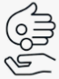

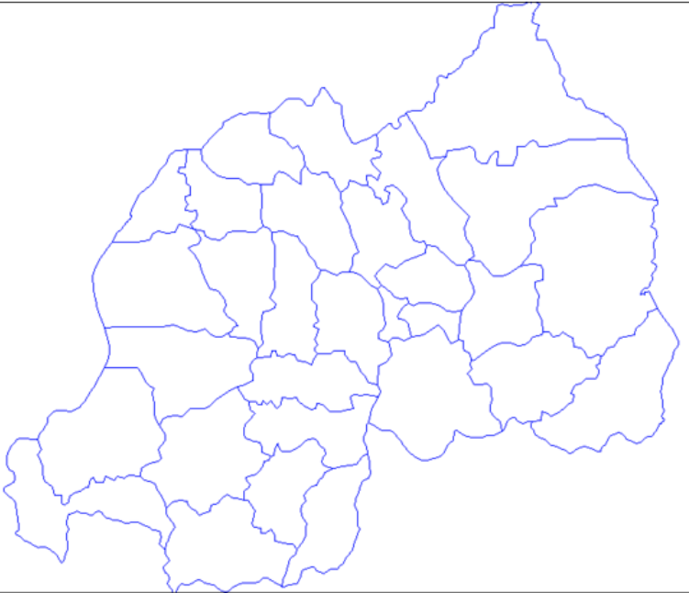
Nyarugenge
Nyanza
Gisagara
Gasabo
Rulindo
Rubavu
Kicukiro
Rusizi
Gatsibo (Ngarama)

LEGEND
SIGN | MEANING
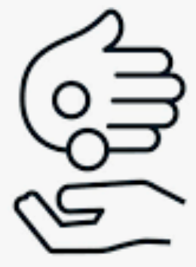 | Direct beneficiaries
 | Implementing Partners
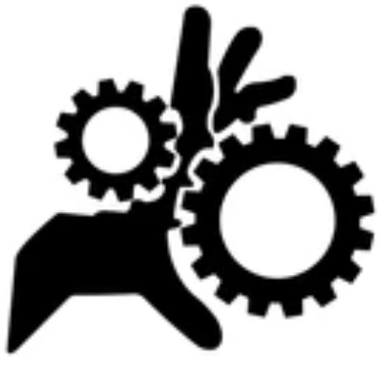 | National Gender Machinery
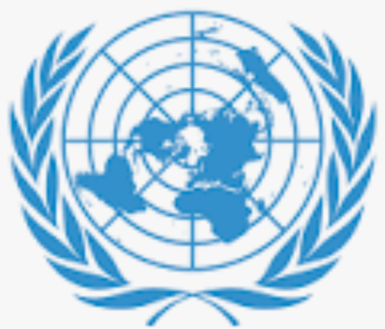 | United Nations
 | Donors

Annex 6: Questions for direct beneficiaries of joint programme

MID-TERM REVIEW FOR THE JOINT PROGRAMME ON GENDER
“Leveraging the full potential of Gender Equality and Women's Empowerment to achieve Rwanda's transformation”

QUESTIONS FOR DIRECT BENEFICIARIES OF JOINT PROGRAMME
Q1. Identification of the respondent
- Sex
- Age
- Marital status
- Type of your business/services
- Institution in partnership with Joint Programme, which supported you
- How long have you been in relationship of support with this institution?
- Which Programmes/project of that institution is supporting you?
Q2: What are/were the kinds of support they provided to you (be specific, showing the provided materials and services, quantities and qualities)?
  - Material supports
  - Services provided
Q3: Was the support you received the one you needed in your business? Explain
Q4: Were you satisfied with the support? Explain
Q5: What would have been the kind of support that would respond better to your needs for your business?
Q6: Were your living conditions improved because of this support? Explain
Q7: How do you think this support you received will continue to impact your life after the period of the project?
Q8: How do you appreciate or depreciate the process and criteria that the institutions used to select the beneficiaries [or to serve them]? Were all the categories of people having the same chance to be supported by the project? Explain
Q9: What did you like the most in the assistance you received from this institution?
Q10: What did you dislike the most in the course of the project which has supported you?
Q11: What advice can you give so that the project that supported you is efficient in sustainably supporting people from your contextual background?

Annex 7: Questions for implementing partners (gvt’ cso, and private sector institutions
MID-TERM REVIEW FOR THE JOINT PROGRAMME ON GENDER
“Leveraging the full potential of Gender Equality and Women's Empowerment to achieve Rwanda's transformation”

QUESTIONS FOR IMPLEMENTING PARTNERS (GVT’ CSO, AND PRIVATE SECTOR INSTITUTIONS)
Q1. Identification of the respondent
- Name:
- Institution:
- Position:
- UN agency in partnership with your institution on the Joint Programme
- How long has your institution/ organization been in partnership with Joint programme 2019-2023?
- The type of project implemented by your institution
- What are/were the main objectives of the project implemented by your institution?
Q2a. Were all the activities planned in your project for this mid-time carried out? Explain (Max. six lines)
Q2b. What are the main achievements of the project so far? (Max. six lines)
Q3a: Has the project achieved what was intended to be achieved in this mid-time? Explain (Max. six lines)
Q3b. Is the programme having other results or impact beyond what was initially planned? Explain (Max. six lines).
Q4. What impact on the beneficiaries have you observed (e.g., increased number of women eager to compete for local election, increased awareness of women’s rights, increase % of services provided for SGBV, etc.)? (Max. six lines)
Q5. What are the main factors behind the success of the programme (See examples below, provide maximum 3 factors)
- Good/enough human resources/staff
- Enough financial resources
- Good planning/focus/goal and indicators
- Good strategy/approach
- Good management/coordination/leadership/communication
- Good stakeholders/beneficiaries
- Rewards/sanctions for beneficiaries
- Etc.
- Please specify (Max. six lines):
Q6. Are there any challenges and if so, how have they been addressed? If COVID-19 is mentioned as a challenge, please explain how it affected the implementation and what the mitigation strategies were. (Max. six lines)
Q7. What are the main factors, if any, behind the bottlenecks faced by the programme (See examples below, provide maximum 3 factors)
- Challenge in human resources/staff
- Insufficient financial resources
- Challenge in planning/focus/goal and indicators
- Challenge in strategy/approach
- Challenge in management/coordination/ leadership/communication/ collaboration
- Challenge among stakeholders/beneficiaries
- Reward/sanctions for beneficiaries
Q8. Can you please tell me two main threats which could potentially hinder implementation of the programme and any mitigation strategies? (Max. six lines)
Q9. How do you observe the implementation of the principle of Leaving No One Behind (inclusion of people from all vulnerable categories) within the Joint programme? (Max. six lines)
Q10. Please list any lessons learnt and/or best practices from the implementation of the Joint programme, which may be useful for your institution or other institutions in the future? (Max. Ten lines)
Q11. Is the programme adequately responding to the needs of the beneficiaries? Explain (Max. six lines)
Q12. What can you say about the management, coordination, and follow up of the project? (Max. ten lines)
Q13. How should the programme be improved in order to better respond to the real needs of the beneficiaries and to have a sustainable solution?

Annex 8: Questions for donors

MID-TERM REVIEW FOR THE JOINT PROGRAMME ON GENDER
“Leveraging the full potential of Gender Equality and Women's Empowerment to achieve Rwanda's transformation”

QUESTIONS FOR DONORS
Q1. Identification of respondent
- Name:
- Institution/ organization:
- Position:
- Programmes with UN Women:
Q2. How long has your institution been in partnership with UN and Rwandan Government for the Joint Programme on Gender in Rwanda?
Q3. What is the main objective(s) of the partnership? (Max. Six lines)
Q4. How are you satisfied with the JP’s main achievements to date? (Max. Ten lines)
Q5. How do you perceive UN‘s and government’s roles in the implementation of the Joint programme on gender? What could it do more or less of? (Max. Ten lines)
Q6. What do you foresee as the key gender issues and opportunities for Gender Equality and Women’s Empowerment in Rwanda in the coming years? (Max. Ten lines)
Q7. What do you foresee as the key challenges or threats which may hinder advancing Gender Equality and Women’s Empowerment in Rwanda in the coming years and how can they be overcome? (Max. Ten lines)
Q8. How do you appreciate your partnership with One UN and the resources mobilization strategies used for Joint Programme? (Max. Ten lines)
Q9. What do you think on the sustainability of this Joint programme, given the approach of UN and partners? (Max. Ten lines)

Annex 9: UN staff survey
MID-TERM REVIEW FOR THE JOINT PROGRAMME ON GENDER
“Leveraging the full potential of Gender Equality and Women's Empowerment to achieve Rwanda's transformation”

UN STAFF SURVEY
Q1. Identification of the respondent
- Name:
- UN Agency:
- Position:
- Components of the Joint Programme to which your agency is contributing (See attached document):

Q2. Achievements
Please refer to the attached document “UN agencies interventions” and provide the following information on each output assigned to your agency:
2.1 Has the programme design taken into account the recommendations from the previous evaluations? Explain
2.2 Is the programme on track when looking at the targets for the indicators? Yes No

2.3 Were the activities planned for this mid-time carried out? Explain (Max. six lines)
2.4 What are the main achievements (describe, give numbers, and estimate the level of achievements in %)? (Max. Ten lines)
2.5 Has the Joint Programme achieved what was intended to be achieved in this mid-time? Explain (Max. six lines)
2.6 What were the challenges in reaching the expected achievements and how were they addressed? (Max. Ten lines)
[Please answer the above three question for each output assigned to your agency)
Q3. Is the programme having other results or impact beyond what was initially planned?
Yes No. Explain (Max. Six lines)

Q4. What impact on the beneficiaries have you observed (e.g., increased number of women eager to compete for local election, increased awareness of women’s rights, increase % of services provided for SGBV, etc.)? (Max. Six lines)
Q5. What are the main factors behind the success of the programme (maximum 3 factors)?
- Good/enough human resources/staff
- Enough financial resources
- Good planning/focus/goal and indicators
- Good strategy/approach
- Good management/coordination/leadership/communication
- Good stakeholders/beneficiaries
- Rewards/sanctions for beneficiaries
- Others (please specify) (Max. six lines):
Q6. What are the main factors, if any, behind the bottlenecks faced by the programme (maximum 3 factors)
- Challenge in human resources/staff
- Insufficient financial resources
- Challenge in planning/focus/goal and indicators
- Challenge in strategy/approach
- Challenge in management/coordination/ leadership/communication/ collaboration
- Challenge among stakeholders/beneficiaries
- Reward/sanctions for beneficiaries
- Others (please specify) (Max. six lines):
Q7. How is the principle of Leaving No One Behind (inclusion of people from all vulnerable categories) included in your programme? (Max. Six lines)
Q10 Were the resources allocated to the implementation of the Joint Programme (human and financial) sufficient as regard the planned activities? Yes No. Explain (Max. Six lines)

Q8. Can you please tell me two main strengths contributing to the successful implementation of the Joint Programme? (e.g., the organisation's technical capacity, the leadership, financial capacity etc.) (Max. six lines)
Q9. Can you please tell me two main bottlenecks, if any, having an impact on the Joint Programme implementation and mitigation strategies? (Max. six lines)
Q10. Can you please tell me two main threats, if any, which are/were likely to hinder implementation of the programme and any mitigation strategies to be put in place? (Max. six lines)
Q11. Do you find this Joint Programme relevant and sustainable in the context of Rwanda?
Yes No. Explain (Max. Six lines)

Q12. What are the key gender issues and opportunities relating to Gender Equality and Women’s Empowerment that you foresee as important in the coming years? (Max. Ten lines)
Q13. Are there any lessons learnt or best practices from the implementation of Joint programmes, for future implementation? Explain (Max. Ten lines)
Q14. What can you say about the management, coordination, and follow up of the project? (Max. ten lines)
Q15. How could the Joint programme’s partners further leverage its sustainability (Max. Ten lines)

Annex 10: UN agencies interventions
UN AGENCIES INTERVENTIONS
IOM
 | RESULTS (Revised) | Indicator, baseline, target, verification means (original document)
UNDAP Outcome 4 | Output 4.1
By 2024 people in Rwanda, particularly the most vulnerable have increased resilience to both natural and man-made shocks and enjoy a life free from all forms of violence and discrimination. | Increased awareness among target communities on Sexual and Gender Based Violence prevention, reporting, response and service availability for victims. | 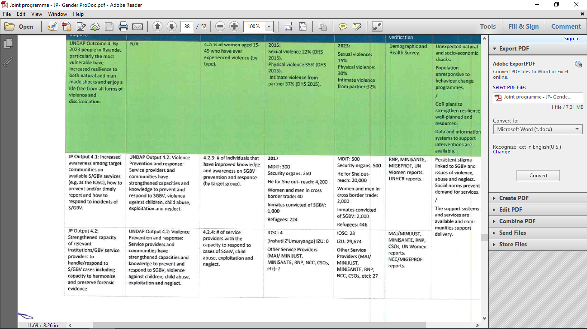
 | Output 4.2
 | Violence service providers to handle/respond to Sexual and Gender Based Violence cases, including capacity to harmonize and preserve forensic evidence

UN WOMEN
 | RESULTS | Indicator, baseline, target, verification means (original document)
UNDAP Outcome 5 | Output 1.1
By 2024, people in Rwanda benefit from enhanced gender equality, justice, human rights, peace and security. | Women’s capacity to compete for leadership positions and to lead decision making processes at local and national level strengthened | 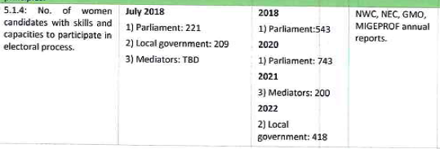
 | Output 1.2
 | Local and national level Government institutions' capacities to coordinate and execute gender-responsive development frameworks and budgets are strengthened | 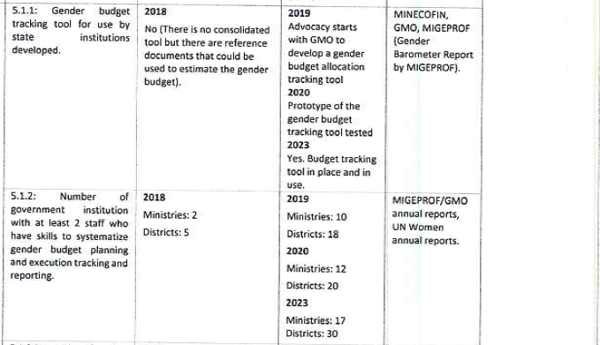
 | Output 1.3
 | Community awareness of gender equality and civic understanding of women’s right to equal participation in decision making increased. | 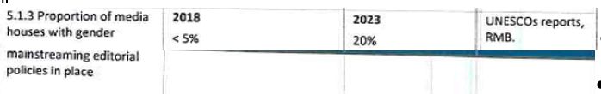
UNDAP Outcome 6 | Output 2.1
By 2024, people in Rwanda participate more actively in democratic and development processes and benefit from transparent and accountable public and private sector institutions that develop evidencebased policies and deliver quality services. | Accountability and oversight mechanisms on gender equality and women’s empowerment in public and private institutions and the implementation of national and international gender equality and women's empowerment frameworks are monitored and strengthened | 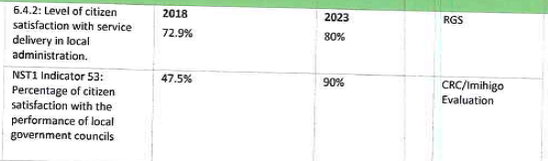
UNDAP Outcome 1 | Output 3.1
By 2024 people in Rwanda benefit from more inclusive, competitive and sustainable economic growth that generates decent work and promotes quality livelihoods for all. | Women have enhanced entrepreneurial skills and increased access to finance and markets to leverage business opportunities | 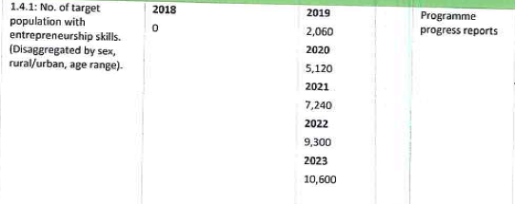  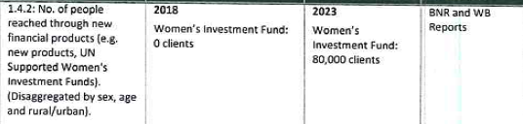
 | Output 3.2
 | Women and men have equal capacity and opportunities to access existing and newly created off-farm employment | 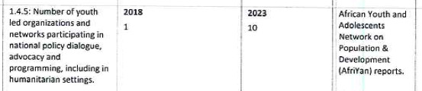
 | Output 3.3
 | Corporate sector actors demonstrate increased understanding of and  commitment to implement gender equality and women’s empowerment practices | 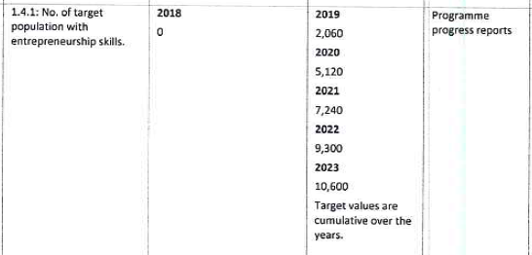
UNDAP Outcome 4 | Output 4.1
By 2024 people in Rwanda, particularly the most vulnerable have increased resilience to both natural and man-made shocks and enjoy a life free from all forms of violence and discrimination. | Increased awareness among target communities on Sexual and Gender Based Violence prevention, reporting, response and service availability for victims.
 | Output 4.2
Capacity of relevant institutions and Sexual and Gender Based
Violence service providers to handle/respond to Sexual and Gender Based Violence cases, including capacity to harmonize and preserve forensic evidence

UNDP
 | RESULTS | Indicator, baseline, target, verification means (original document)
UNDAP Outcome 5 | Output 1.3
By 2024, people in Rwanda benefit from enhanced gender equality, justice, human rights, peace and security. | Community awareness of gender equality and civic understanding of women’s right to equal participation in decision making increased.
UNDAP Outcome 6 | Output 2.1
By 2024, people in Rwanda participate more actively in democratic and development processes and benefit from transparent and accountable public and private sector institutions that develop evidencebased policies and deliver quality services. | Accountability and oversight mechanisms on gender equality and women’s empowerment in public and private institutions and the implementation of national and international gender equality and women's empowerment frameworks are monitored and strengthened
UNDAP Outcome 1 | Output 3.1
By 2024 people in Rwanda benefit from more inclusive, competitive and sustainable economic growth that generates decent work and promotes quality livelihoods for all. | Women have enhanced entrepreneurial skills and increased access to finance and markets to leverage business opportunities
UNDAP Outcome 4 | Output 4.2
By 2024 people in Rwanda, particularly the most vulnerable have increased resilience to both natural and man-made shocks and enjoy a life free from all forms of violence and discrimination. | Capacity of relevant institutions and Sexual and Gender Based

UNFPA
 | RESULTS | Indicator, baseline, target, verification means (original document)
UNDAP Outcome 4 | Output 4.1
By 2024 people in Rwanda, particularly the most vulnerable have increased resilience to both natural and man-made shocks and enjoy a life free from all forms of violence and discrimination. | Increased awareness among target communities on Sexual and Gender Based Violence prevention, reporting, response and service availability for victims.
 | Output 4.2
 | Violence service providers to handle/respond to Sexual and Gender Based Violence cases, including capacity to harmonize and preserve forensic evidence

UNHCR
 | RESULTS | Indicator, baseline, target, verification means (original document)
UNDAP Outcome 5 | Output 1.1
By 2024, people in Rwanda benefit from enhanced gender equality, justice, human rights, peace and security. | Women’s capacity to compete for leadership positions and to lead decision making processes at local and national level strengthened
 | Output 1.3
 | Community awareness of gender equality and civic understanding of women’s right to equal participation in decision making increased.
UNDAP Outcome 1 | Output 3.1
By 2024 people in Rwanda benefit from more inclusive, competitive and sustainable economic growth that generates decent work and promotes quality livelihoods for all. | Women have enhanced entrepreneurial skills and increased access to finance and markets to leverage business opportunities
UNDAP Outcome 4 | Output 4.1
By 2024 people in Rwanda, particularly the most vulnerable have increased resilience to both natural and man-made shocks and enjoy a life free from all forms of violence and discrimination. | Increased awareness among target communities on Sexual and Gender Based Violence prevention, reporting, response and service availability for victims.
 | Output 4.2
 | Capacity of relevant institutions and Sexual and Gender Based
 | Violence service providers to handle/respond to Sexual and Gender Based Violence cases, including capacity to harmonize and preserve forensic evidence

UNUCEF
 | RESULTS | Indicator, baseline, target, verification means (original document)
UNDAP Outcome 4 | Output 4.1
By 2024 people in Rwanda, particularly the most vulnerable have increased resilience to both natural and man-made shocks and enjoy a life free from all forms of violence and discrimination. | Increased awareness among target communities on Sexual and Gender Based Violence prevention, reporting, response and service availability for victims.

Annex 11: Terms of references

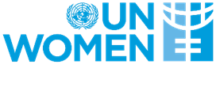

Terms of Reference for the recruitment of Local consultant to conduct the Mid-Term Review for the Joint Programme on Gender, entitled “Leveraging the full potential of Gender Equality and Women's Empowerment to achieve Rwanda's transformation”
1. BACKGROUND AND CONTEXT
Rwanda has adopted its new National Strategy for Transformation (NST1) to guide its national transformation programme over seven years (2017 - 2024) and accelerate the implementation and achievement of the Sustainable Development Goals (SDGs). Aligned to this strategy, the United Nations Development Assistance Plan 2018 - 2023 (UNDAP II) provides a guiding framework for support to the GoR’s transformational agenda, including to furthering gender equality and women’s empowerment (GEWE). In this framework, the Joint Programme on gender entitled “Leveraging the Full Potential of Gender Equality and Women's Empowerment to Achieve Rwanda's Transformation” (2019-2023) was developed by the One UN together with the GoR, to advance Gender
Equality and Women’s Empowerment (GEWE) under the National Strategy for Transformation (NST1) and through the UNDAP II pillars of Economic Transformation, Social Transformation and Transformational Governance.
The overall goal of this Joint programme is to ensure that "Women and girls, especially the most vulnerable, participate in, contribute to and benefit from the political, economic and social transformation in Rwanda" through leveraging the comparative advantages of the participating UN agencies – UN Women (Lead), UNDP, UNFPA, UNHCR, UNICEF, IOM and OHCHR – and its implementing partners, namely Government Institutions under the leadership of the Ministry of Gender and Family Promotion (MIGEPROF), CSOs, and the Private Sector.
This joint programme is funded by the Embassy of Sweden through the SIDA and the Swiss Agency for Development and Cooperation as well as the Royal Netherlands Government through the Netherlands Embassy to Rwanda although financial gaps still exist which lead to the resizing of the programme.
The programme interventions are structured around the following three main priority areas:
- Enhancing women’s leadership and participation in governance institutions at local and national level;
- Strengthening women’s economic empowerment and access to economic opportunities
- Ending Violence against women and girls.
The Joint Program “leveraging the full potential of gender equality and women's empowerment to achieve Rwanda's transformation (2019-2023)” has been under implementation since 2019 by the National Gender Machinery (NGM) institutions namely MIGEPROF, GMO, NWC, FFRP and other participating UN Agencies namely UN Women, UNDP, UNFPA, UNHCR
, UNICEF, IOM, OHCHR as well as other implementing partners from government and CSOs to ensure that the programme builds synergies and makes tangible contributions to the promotion of gender equality, empowerment of women and the fight against gender based violence.
It is within this background that the Ministry of Gender and family promotion in collaboration with UN Women as lead institutions of this joint programme would like to hire the service of a consultant to conduct its mid-term review to take stock of the achievements, lessons learnt, challenges which will inform future programming for the remaining programme implementation period.
- PURPOSE OF THE CONSULTANCY
The purpose of this consultancy is to evaluate the program achievements registered over the last 3 years of implementing the Joint program on “leveraging the full potential of gender equality and women's empowerment to achieve Rwanda's transformation” in Rwanda that has run from January 2019 and will close in June 2023, with probability of extension to 2024.
- OBJECTIVES OF THE CONSULTANCY
The overall objective of the consultancy is to take stock of the results (outcome level) achieved during the last 3 years of the program period whilst borrowing lessons from the same experience to inform future program undertakings. The MTR will also guide the way forward given the numerous challenges the Joint program faced including resource mobilization gaps and Covid-19 pandemic. The evaluation will assess the relevance, effectiveness, and sustainability of the programme within the country context of the implementation of the One Plan and UN Women Annual Work Plan
More specifically, the objectives of the MTR will be to:
  - Assess progress made toward the achievement of the expected results and performance of the joint programme after 3years of implementation.
  - Assess relevance of the programme strategies and design in the evolving context of the challenging environment including in the context of Covid-19 realities;
  - Assess effectiveness of the programme in achieving the specific results of the programme.
  - Document best practices out of the joint program interventions
  - Document lessons learnt from the program interventions that will inform future program undertakings.
  - Recommend adjustments, if any, to the joint programme strategies and directions for the remaining programme implementation period;
  - Identify key challenges of the programme and provide recommendations for addressing them
  - Propose potential sustainability plan of the programme;

- SCOPE OF WORK
  - Carry out a comprehensive situational analysis of the existing gender equality and women empowerment initiatives and document issues constraining effective attainment of the joint programme planned results.
  - Evaluate the program achievements for the last 3 years versus the planned targets and document causes for discrepancies and guide the way forward given the challenges encountered.
  - Review existing literature and carry out key informant interviews and group discussions to draw lessons learnt and some human-interest stories resulting from the programme implementation
  - Organize a national dissemination workshop during which the findings will be presented to the stakeholders of the joint programme

- DELIVERABLES
- An inception report indicating the consultant’s understanding of the assignment, the proposed methodology, timeframe and budget. The methodology should also include the evaluation questions, identified stakeholders for interviews and discussions. The inception report should be presented to key stakeholders for the validation.
- A draft report indicating preliminary findings on the joint program mid-term review
- A power-point presentation for use during the national validation and dissemination workshops and the consultant availability to facilitate those workshops.
- Final report on the mid-term review highlighting key achievements and lessons learnt from the joint program for “leveraging the full potential of gender equality and women's empowerment to achieve Rwanda's transformation as well as key challenges and recommendations
- DURATION AND ADMINISTRATION OF THE CONSULTANCY
The consultancy will be carried out for a period of 30 days from the time of the contract signature by both parties. The consultant will work closely and regularly with the entire National Gender Machinery including the Ministry of Gender and Family Promotion, National
Women’s Council, GMO, FFRP as well as the One UN. The contract will be signed between the consultant and UN Women and the consultant will be jointly supervised by the Ministry of Gender and Family Promotion and UN Women.

- COMPETENCES
  - The consultancy should be carried out by an individual consultant.
  - The consultant should have at least 7 years of progressive work experience in undertaking program evaluations, surveys and other related studies
  - Proven knowledge of undertaking studies related to gender and women empowerment is a key requirement.
  - The consultant should provide proof of undertaking similar work by submitting at least 3 certificates of good completion for previous similar consultancies in the same subject line

- QUALIFICATION AND EXPERIENCE
The consultant should have the following qualifications:
  - Master’s degree in a field relevant to the assignment, such as Gender studies, Gender Economics, development studies, Public Policy, Social Development, Social Sciences, Project/programme management, evaluation or related fields.
  - Have at least 7 years of experience in programme evaluation in a development context and proven accomplishment in undertaking evaluations, including leading evaluations of multi-stakeholder programmes for multilateral organizations.
  - Experience in evaluating gender equality and human rights – related programmes/projects.
  - Proven experience in qualitative and quantitative evaluation methods.
  - Proven experience in multi-stakeholder engagement and strong interpersonal and leadership skills.
  - Have proven knowledge of national, regional and international gender commitments, policies and conventions.
  - Knowledge in results-based programming.
  - Proficiency in written and spoken English and knowledge of Kinyarwanda is required; French would be an advantage.

Annex 12: JP resized budget per outPUTS
 | RESULTS | UN Agency | BUDGET 2021-2023
 | RESULTS | UN Agency | Available | TBM | Total
UNDAP Outcome 5  By 2023, people in Rwanda benefit from enhanced gender equality, justice, human rights, peace and security. | Output 1.1  Women’s capacity to compete for leadership positions and to lead decision making processes at local and national level strengthened | UN Women | $148,060 | $356,940 | $505,000
 |  | UNHCR | $200,000 | $100,000 | $300,000
 | Total Output 1.1 |  | $348,060 | $456,940 | $805,000
 | Output 1.2  Local and national level Government institutions' capacities to coordinate and execute gender-responsive development frameworks and budgets are strengthened | UN Women | $115,849 | $594,151 | $710,000
 | Total Output 1.2 |  | $115,849 | $594,151 | $710,000
 | Output 1.3  Community awareness of gender equality and civic understanding of women’s right to equal participation in decision making increased. | UN Women | $115,849 | $309,151 | $425,000
 |  | UNDP | $89,132 | $610,868 | $700,000
 |  | UNHCR | $30,000 | $32,000 | $62,000
 | Total Output 1.3 |  | $234,981 | $952,019 | $1,187,000
UNDAP Outcome 6  By 2023, people in Rwanda participate more actively in democratic and development processes and benefit from transparent and accountable public and private sector institutions that develop evidence-based policies and deliver quality services. | Output 2.1  Accountability and oversight mechanisms on gender equality and women’s empowerment in public and private institutions and the implementation of national and international gender equality and women's empowerment frameworks are monitored and strengthened | UN Women | $111,045 | $463,955 | $575,000
 |  | UNDP | $275,000 | $165,000 | $440,000
 | Total Output 2.1 |  | $386,045 | $628,955 | $1,015,000
UNDAP Outcome 1  By 2023 people in Rwanda benefit from more inclusive, competitive and sustainable economic growth that generates decent work and | Output 3.1  Women have enhanced entrepreneurial skills and increased access to finance and markets to leverage business opportunities | UN Women | $115,849 | $184,151 | $300,000
 |  | UNDP | $50,000 | $0 | $50,000
 |  | UNHCR | $500,000 | $1,000,000 | $1,500,000
 | RESULTS | UN Agency | BUDGET 2021-2023
 | RESULTS | UN Agency | Available | TBM | Total
promotes quality livelihoods for all. | Total Output 3.1 |  | $665,849 | $1,184,151 | $1,850,000
promotes quality livelihoods for all. | Output 3.2  Women and men have equal capacity and opportunities to access existing and newly created off-farm employment | UN Women | $115,849 | $164,151 | $280,000
promotes quality livelihoods for all. | Total Output 3.2 |  | $115,849 | $164,151 | $280,000
promotes quality livelihoods for all. | Output 3.3  Corporate sector actors demonstrate increased understanding of and  commitment to implement gender equality and women’s empowerment practices | UN Women | $74,030 | $55,970 | $130,000
promotes quality livelihoods for all. | Total Output 3.3 |  | $74,030 | $55,970 | $130,000
UNDAP Outcome 4  By 2023 people in Rwanda, particularly the most vulnerable have increased resilience to both natural and man-made shocks and enjoy a life free from all forms of violence and discrimination. | Output 4.1  Increased awareness among target communities on Sexual and Gender Based Violence prevention, reporting, response and service availability for survivors. | UN Women | $671,170 | $0 | $671,170
 |  | UNICEF | $750,000 | $685,185 | $1,435,185
 |  | UNFPA | $1,180,000 | $0 | $1,180,000
 |  | UNHCR | $230,000 | $237,000 | $467,000
 |  | IOM | $24,412 | $0 | $24,412
 | Total Output 4.1 |  | $2,855,582 | $922,185 | $3,777,767
 | Output 4.2  Capacity of relevant institutions and Sexual and Gender Based  Violence service providers to handle/respond to Sexual and Gender Based Violence cases, including capacity to harmonize and preserve forensic evidence | UN Women | $743,845 | $316,155 | $1,060,000
 |  | UNDP | $70,000 | $143,000 | $213,000
 |  | UNFPA | $142,000 |  | $142,000
 |  | UNHCR | $185,000 | $597,960 | $782,960
 |  | IOM | $32,588 | $0 | $32,588
 | Total Output 4.2 |  | $1,173,433 | $1,057,115 | $2,230,548
Direct Project Management Costs | Technical Support | Managing Agency | $213,254 | $736,926 | $950,180
 | Monitoring and evaluation (data collection and external evaluation) | Managing Agency | $100,000 | $100,000 | $200,000
 | Audit | Managing Agency | $30,000 | $70,000 | $100,000
 | Operational office costs (rent, security, equipment, communication) | Managing Agency | $10,000 | $40,000 | $50,000
 | Communication, documentation and public relation | Managing Agency | $10,000 | $85,000 | $95,000
 | Results-based management capacity strengthening for implementing partner and Joint Programme Staff | Managing Agency | $20,000 | $30,000 | $50,000
 | Contingency | Managing Agency | $10,000 | $23,000 | $33,000
 | Sub-Total Direct Project Management Cost |  | $393,254 | $1,084,926 | $1,478,180
 | Grand Total | UN Women | $2,604,798 | $3,181,551 | $5,606,350
 |  | UNDP | $484,132 | $918,868 | $1,403,000
 |  | UNICEF | $750,000 | $685185 | $1,435,185
 |  | UNFPA | $1,322,000 | $0 | $1,322,000
 |  | UNHCR | $1,145,000 | $1,966,960 | $3,111,960
 |  | IOM | $57,000 | $0 | $1,00,000
 | Grand Total |  | $6,362,930 | $7,100,565 | $13,463,495
 | Monitoring and Evaluation (data collection and external evaluations) | Managing Agency | $100,000 | $100,000 | $200,000
 | Audit | Managing Agency | $30,000 | $70,000 | $100,000

How can the citizen's satisfaction prove that the mechanism is monitored? The satisfaction of the citizen may be based on other thing (e.g. service delivery] rather than the monitoring. How is the satisfaction of the citizen linked with the monitoring? Even without the monitoring, the citizen (beneficiaries) can be satisfied or not. Who is nonitoring and who is satisfied? These re different people.

