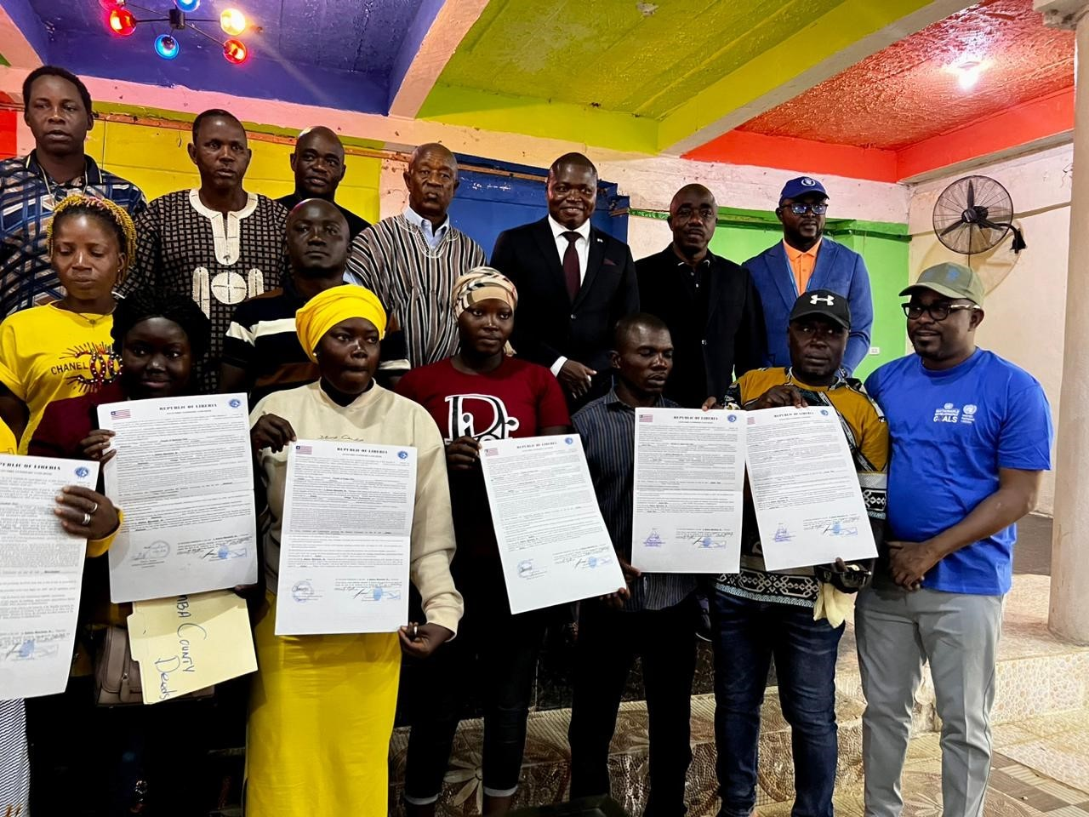

EXECUTIVE SUMMARY
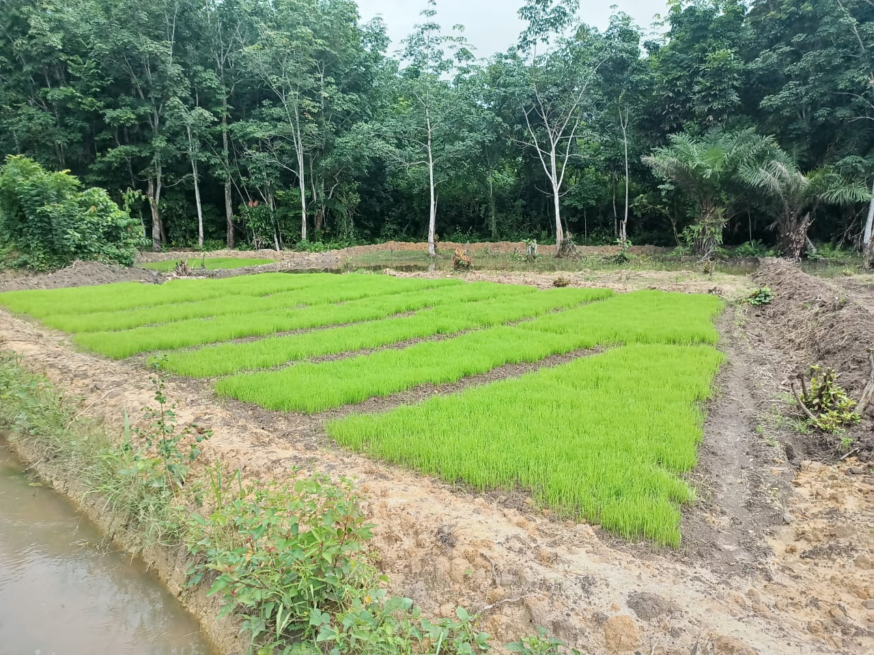
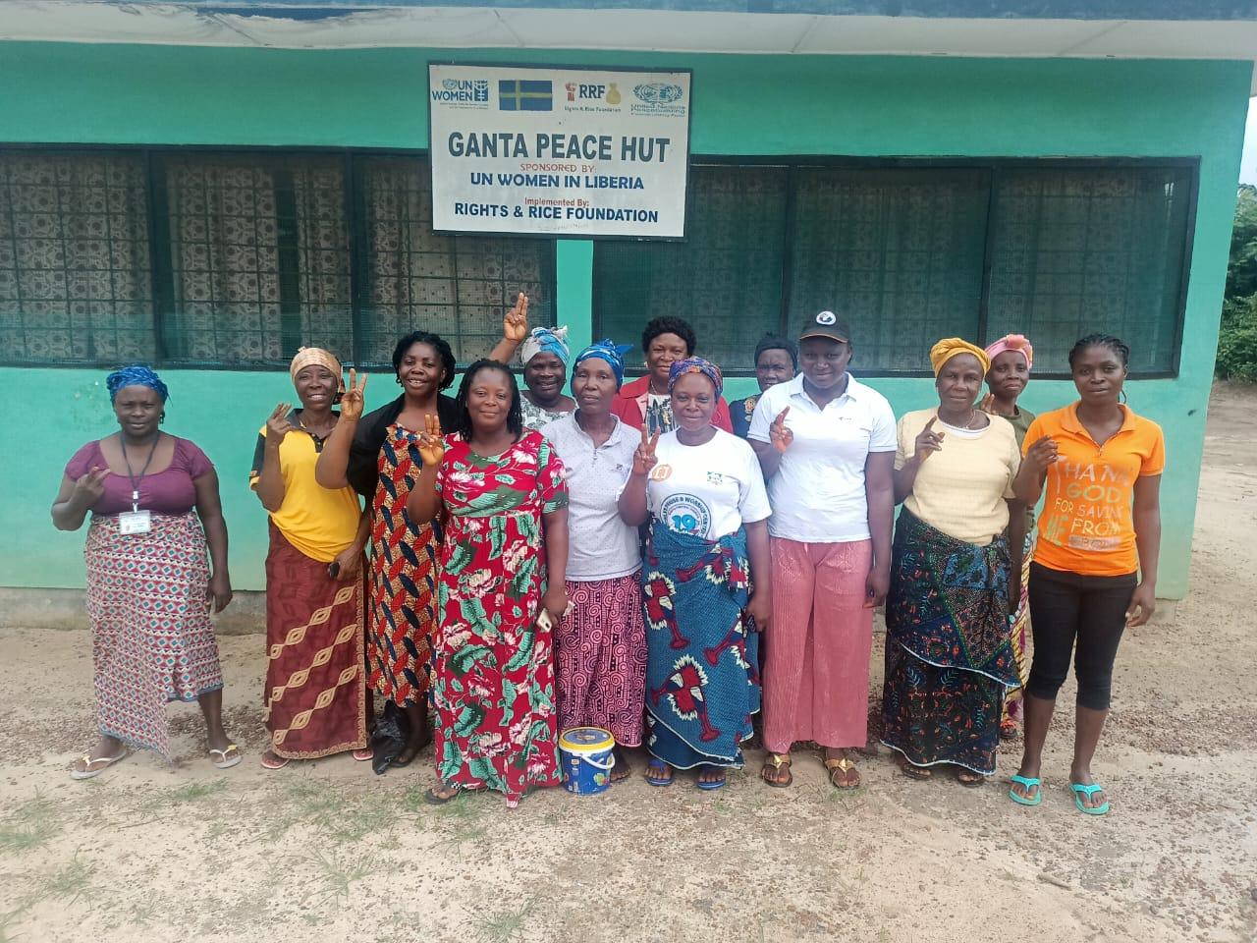
FINAL EVALUATION OF THE PROJECT “SUSTAINING PEACE AND RECONCILIATION THROUGH STRENGTHENING LAND GOVERNANCE AND DISPUTE RESOLUTION MECHANISMS IN LIBERIA”

PROFESSOR ONWUEMELE ANDREW (INTERNATIONAL CONSULTANT)
CAROLINE BOWAH (NATIONAL CONSULTANT)

JULY 2023

EXECUTIVE SUMMARY
Background and introduction
This report is the product of the final evaluation of the project “Sustaining Peace and Reconciliation through Strengthening Land Governance and Dispute Resolution Mechanisms in Liberia” (2020–2023). This project was implemented by the United Nations Entity for Gender Equality and the Empowerment of Women (UN Women), the United Nations Development Programme (UNDP) and the World Food Programme (WFP) from 2020 to 2023 with funding from the United Nations Peacebuilding Fund (PBF). Its broad goal was to support the implementation of the Land Rights Act (LRA) and the Local Government Act (LGA) in Liberia. The initiation of the project was informed by the understanding that the root causes of the Liberian civil war remain unresolved. Furthermore, evidence from recent assessments show that land disputes, lawlessness, corruption, boundary disputes and concession-related tensions continue to be the main triggers of conflicts in Liberia. To address some of the land-related problems, the Government of Liberia passed the LRA in 2018. The Sustaining Peace and Reconciliation project was established to support the implementation of the LRA through strengthening the effectiveness, transparency and inclusiveness of land administrative structures at the national and county levels and of concession-awarding processes, as well as strengthening the existing semi-formal and informal land dispute resolution mechanisms in Liberia’s counties. The overall objective of the final evaluation was to assess the extent to which the Sustaining Peace and Reconciliation project has achieved its objectives.

Methodology
The evaluation applied the Organisation for Economic Co-operation and Development’s Development Assistance Committee evaluation criteria: relevance, effectiveness, efficiency, impact, coherence and sustainability. The evaluation also took into consideration gender equality and human rights as separate, stand-alone criteria. These criteria were used as the main analytical framework in line with the UN Women evaluation policy. The evaluation used a mixed-methods approach involving document review, interviews, and focus group and survey techniques to collect qualitative and quantitative data. Participants included representatives of the project recipients, including members of multi-stakeholder platforms (MSPs), Peace Huts, and community land development and management committees (CLDMCs); staff of the Liberian Land Authority (LLA), the National Centre for Coordination of Response Mechanisms (NCCRM), the National Bureau of Concessions (NBC) and the Environmental Protection Agency (EPA); community beneficiaries in the counties; and the project team made up of UN Women, UNDP and WFP staff. Survey participants were purposively selected based on the accessibility of the counties. Quantitative data were analysed using descriptive statistics, and thematic coding was used to analyse qualitative data. Findings from qualitative and quantitative data analysis were thus triangulated by source before concluding. The intended audience of the evaluation includes UN Women, UNDP and WFP in Liberia, and PBF and the United Nations Country Team (UNCT) more broadly.

Findings
Relevance
Findings from this evaluation show that the project results addressed the major peacebuilding needs of the target groups and counties in Liberia. Peacebuilding is a top development priority need in Liberia. Evidence from assessments has revealed that the issues identified as the root causes of Liberia’s 14-year civil war remain unaddressed, and it also reveals that land disputes, boundary disputes and concession-related tensions continue to be the main triggers of violence. In addition, the capacity of government institutions to implement the newly enacted laws and policies is still low because of a lack of continuous training and facilities to function optimally at the county level. The Sustaining Peace project was initiated to address these peacebuilding needs. The outcomes of the project, including strengthening the effectiveness, transparency and inclusiveness of land administrative structures at the national and county levels, and strengthening existing semi-formal and informal land dispute resolution mechanisms by building the capacity of the relevant platforms to participate in the decision-making processes of the land dispute mechanisms, were all relevant to the targeted beneficiaries. The Sustaining Peace and Reconciliation project was found to be in complete alignment with Liberia’s national plans on gender right promotion, with the Pro-Poor Agenda for Prosperity and Development (PAPD) and the United Nations Sustainable Development Cooperation Framework (UNSDCF), and with specific government priorities on land governance and land conflict. The Sustaining Peace and Reconciliation project was founded on the basis of national plans, policies and strategies, with the various outputs of the project falling under the pillars and priority areas of several national plans, policies and strategies..

Effectiveness
The evaluation found that the project was effective and had made significant progress towards the achievement of the expected outputs and outcomes. The project was effective in increasing awareness of the LRA among customary governance authorities and communities in targeted counties, and in improving understanding of women’s and youth rights to land. The project was also effective in building the capacities of county land offices and county land boards in targeted counties and putting procedures and systems in place for formalizing customary land in a way that reflects the rights and needs of all community members. Evidence from interviews and document reviews confirmed that the project’s theory of change proved realistic and was implemented to a large extent. The evaluation found that several innovative practices were mainstreamed in both the design and implementation of the project, including the recognition of the important roles of government partners such as the NBC, EPA and PBO in its design and implementation; the adoption of the implementation modality by the project team; and how the project built on the results of and lessons learned from past United Nations projects. In addition to this, the issuance of statutory land-titled deeds and maps to eight customary communities in Nimba, Sinoe, Maryland and Grand Cape Mount Counties under the project was considered innovative. Evidence from the quantitative survey and Interviews conducted among the beneficiaries in the counties revealed that about 85 percent males, 89 percent of female beneficiaries are satisfied with the results achieved by the project.

Efficiency
The review of project documents and interviews with the project team confirmed that available resources were allocated strategically to achieve the project outcomes. The project lasted 36 months, with a planned budget of US$3,996,522.48. Of these funds, US$3,409,033.68 was budgeted for project implementation activities, which represents 85.33 percent of the total budget, while US$587,488.80 was budgeted for staff personnel, which represents 14.7 percent of the total budget of the project. As at June 2023, 100 per cent of all allocated budgets for the project activities had been spent, which represents a good absorption rate for the project. Evidence from the budget analysis also revealed that UN Women received the highest budget allocation of all project team members, of US$2,087,727.83, which represents 52.2 per cent of the total budget, followed by UNDP, with a total budget allocation of US$1,043,557.73, representing 26.1 per cent of the total budget, then WFP, which received US$865,236.92, representing 21.7 per cent of the total budget. A review of the activities implemented by output shows that UN Women, through its partners, implemented 22 activities across the two outcomes of the project, while UNDP and WFP implemented 19 and 16 activities, respectively. The number of outputs and the types of activities implemented informed the allocation of resources. Evidence from interviews confirmed that the budget allocated for the entire duration of the project was adequate, and several measures were put in place to limit fraud while ensuring that the project’s inputs were efficiently utilized. Some of the measures included:
- The direct coordination of events in the field by the LLA and local community leaders
- The use of local facilitators for most of the capacity-building activities and of volunteers (members of MSP and CLDMCs), which reduced transaction costs for project implementation activities
- The competitive procurement of all goods and services to ensure value for money
- The use of local implementing partners for project implementation
- The regular monitoring of implementation activities by United Nations agencies.

Impact
The evaluation found that the project effected the target group and larger society in several ways. The project made significant progress in addressing the social, environmental and economic challenges arising from government land concessionary activities in targeted communities. In partnership with the EPA, the project provided environmental safeguarding training to strengthen community early warning monitoring and water pollution detection capabilities. In terms of the local economy, the communities affected by concessionary activities witnessed tangible improvements in their livelihoods through the adoption of alternative livelihood opportunities introduced by the project. This intervention brought about positive changes and economic empowerment for the affected communities. The project’s evaluation revealed numerous indirect positive effects on the target groups in the counties. Particularly noteworthy were the successful boundary harmonization efforts and the erection of cornerstones to clearly demarcate boundaries between communities. As a result of this harmonization, the project’s intervention communities received legally probated and registered titled land deeds, replacing the outdated tribal certificates, which further secured their land rights. Furthermore, the project had a significant impact on communities’ perceptions of women’s right to land ownership. As a result of the project, women are now able to inherit land, and their participation in land discussions, decision-making processes, dispute resolution, leadership, community development and peacebuilding activities has substantially increased. At the national level, the project played a crucial role in contributing to the formulation of gender policies for the NBC. In addition, the project contributed to the production of a communication strategy, which was validated by relevant stakeholders. However, owing to certain constraints, the communication strategy could not be implemented. The media and communication component are expected to yield beneficial impacts when eventually implemented.

Sustainability
The project targeted key national institutions, such as the NRCCM, NBC, PBO and LLA, and, at the local level, the county land authorities. The project strengthened the capacities of these institutions as a key strategy for ensuring that the benefits of the project were sustainable. The project promoted national ownership through wide consultation with national institutions, aligning the project objectives with the national priorities of the government and adapting existing alternative conflict resolution mechanisms, such as MSPs and Peace Huts, for use by the project. This approach of promoting the participation of the project duty bearers and rights holders enhanced the likelihood of the benefits of the project being sustained. Furthermore, the project focused on building the capacities of different stakeholders, including duty bearers and rights holders. Building the capacities of government institutions and beneficiaries was utilized as a strategy for building ownership and ensuring the sustainability of the project results. The evaluation found that the intervention design included appropriate sustainability and exit strategies. Some of the sustainability strategies of the project included the adoption of existing alternative dispute resolution mechanisms in the counties, such as the MSPs, CLDMCs and Peace Huts, into the project design. This adoption will ensure that the MSP, CLDMC and Peace Hut will continue to run with the goal of the project beyond the project lifetime. In addition, the use of local facilitators such as the NBC and LLA for the various capacity-building activities, as well as the local implementing partners, will ensure that knowledge gained by both the facilitators and trainees remains at the national and intervention community levels.

Coherence
The project created synergies with several other programmes being implemented at the country level by United Nations agencies, international non-governmental organizations and the Government of Liberia. Evidence shows that the project created synergies with the Just Energy Transition project, implemented by the Sustainable Development Institute, and the Land Governance Support Activity (LGSA), funded by the United States Agency for International Development. The project also created synergies with other land governance initiatives being implemented by other institutions, such as the projects “Securing Land Rights for Women and Rural Communities in South-Eastern Liberia”, implemented by ActionAid Liberia, ForumCiv, Development Education Network-Liberia and JSGB, and “Capacity Development in Land Administration”, funded by the Swedish International Development and Cooperation Agency. However, it is essential to actively coordinate project implementation with the implementation of other programmes in the country, rather than leaving it to chance, as is currently the case with project implementation. Evaluative evidence reveals that the project complemented, and worked in harmony and coordination with, other interventions in this area. The project was implemented in collaboration with development partners that have widely supported the development of the land sector. This was achieved through the formation of the Land Donor Working Group, which brings together all the partners involved in land projects in Liberia. Within this group, a matrix was developed to identify each partner’s specific project and its location. This high level of coordination has proven invaluable in preventing duplication of effort among the various stakeholders working in the land sector in Liberia.

Gender equality and human rights
The evaluative evidence confirmed that gender equality and human rights considerations were integrated into the project’s design and implementation. All objectives, strategies, approaches and activities highlighted in the project focused on addressing the root causes of gender inequalities with respect to land. The project was designed to target women and young in specific counties, to strengthen their capacity and skills and enable them to participate in the decision-making processes of land dispute mechanisms. The project also targeted men and other members of the communities in the counties to address the underlying sociocultural challenges in the intervention areas and change the dominant traditional cultural perception that the right place for women is in the home, and the narrative that land-related matters and peacebuilding is a masculine domain. Further key evidence of gender consideration is the development of a gender policy for the NBC and a gender-responsive performance-monitoring matrix to support concession contract renegotiations between the government and concessionaries. However, there is a need to involve more women-led organizations as implementing partners. Evaluative evidence confirmed that the project budget was gender-responsive to a large extent. Evidence shows that 80 per cent of the budget contributed to gender equality and women’s empowerment (GEWE). For instance, about US$3,200,000 was budgeted for activities promoting GEWE. Evaluative evidence shows that there was no discrimination of any kind, as all stakeholders were involved in the implementation of the project.

Lessons learned
Lesson 1. The design of the Sustaining Peace and Reconciliation project, based on experience and lessons learned from previous interventions, contributed to its effectiveness.
The design of the Sustaining Peace and Reconciliation project was based on the lessons learned from several interventions in the same context, including the Liberia Land Administration Project, funded by the World Bank (2018–2022); the Voluntary Global Guidelines on Responsible Governance of Tenure of Land, Fisheries and Forest in the Context of National Food Security; and the LGSA (2016–2020). By mainstreaming successful practices from previous projects into the Sustaining Peace and Reconciliation project, while also being mindful of potential pitfalls, the project’s overall achievements were significantly enhanced. As a result, the project recorded substantial successes, thanks to the incorporation of proven effective methods and the avoidance of previous shortcomings.

Lesson 2. Working with local people and organizations to implement project activities and implementing partners in supporting project implementation activities is critical to promoting ownership and sustainability of project benefits.
The Sustaining Peace project utilized local people and organizations as well as local implementing partners in the implementation of project activities. The project worked with local implementing partners such as the Rice and Rights Foundation and Volunteers for Sustainable Development in Africa to implement project activities in the targeted communities. Not only did this inclusive strategy foster local ownership of the initiatives, but it also ensured the sustainability of project benefits within the intervention communities.

Lesson 3. Capacity-building activities for project beneficiaries are necessary for both promoting ownership and ensuring the sustainability of project benefits.
The Sustaining Peace project implemented capacity-building activities for both government bodies and community mechanisms, specifically the LLA, NCCRM, MSP, CLDMCs and members of the community in the intervention counties. The capacity-building activities were unique to the different categories of project beneficiaries. The capacity-building activities for county land offices, county land boards and CLDMCs focused on putting in place procedures and systems for the formalization of customary land in a way that reflects the rights and needs of all community members. For communities, capacity-building focused on building the skills needed to participate in formal and informal land dispute mechanisms, while, for the NBC, it focused on strategies for effectively preventing potential conflict triggers from arising among concessionaires. The approach of the project ensured that the knowledge gained remained with the beneficiaries after the end of the programme.

Lesson 4. Engaging relevant government institutions and community leaders in the intervention communities is important for successful project implementation.
The Sustaining Peace project, from the beginning, engaged relevant government institutions such as the LLA, NCCRM and NBC, as well as community leaders, as key stakeholders. This approach provided entry points into government institutions and intervention communities, which, in the long run, promoted government buy-in and ownership of the project. Similarly, working with various community leaders in the targeted counties not only provided easy access to local community mechanisms for community members but also contributed to achieving the project objectives, as evident in the inclusion of women and youth in the community leadership structures in some of the targeted communities.

Lesson 5. The duration of an intervention focusing on addressing the underlying causes of gender inequality is an important factor that contributes to achieving project objectives and the sustainability of benefits.
Addressing the deep-rooted, underlying causes of gender inequality and people’s deeply held views requires a considerable amount of time. The Sustaining Peace project was a 36-month project with one key objective, namely, to change communities’ perceptions of women’s and youth rights to land. While the project was successful in meeting this objective, the sustainability of the results will remain in doubt unless sustained awareness-raising activities and long-term interventions to address the root causes of gender inequality are implemented in the intervention counties.

Lesson 6. The timing of the project’s implementation after the enactment of the LRA and LGA ensured alignment with the project and government priorities and played a significant role in the acceptance of the project by the government and local communities.
The Sustaining Peace project was strategically designed and implemented to coincide with government efforts to implement the LRA and LGA. This alignment enabled the project to provide valuable support for government initiatives, which significantly contributed to securing government buy-in and acceptance of the project at both the national and county levels. Moreover, the project’s timing was crucial, as it coincided with a period of heightened conflict in the intervention communities. This context served to underscore the project’s relevance and importance, leading to strong acceptance and support from the local communities in the counties. Overall, the project’s alignment with government priorities and its timely response to the prevailing conflict challenges were instrumental in garnering support from stakeholders at all levels and creating an environment conducive to successful implementation.

Lesson 7. The joint nature of the project allowed the three UN agencies involved to bring into the project their comparative advantage, which increased the effectiveness of the project’s overall design and implementation.
The Sustaining Peace project was implemented jointly by three UN agencies: UN Women, UNDP and WFP. While it was not directly implemented on the ground by these UN partners, the project’s outcomes and outputs were tied to the specific mandates of the UN partners and therefore made use of their specialist knowledge, skills and experience . While UN Women project activities focused on the advancement and full realization of women’s rights and opportunities with respect to land, UNDP supported the institutionalization of land governance structures through the implementation of boundary harmonization in the intervention communities. WFP, in line with its mandate under the project, delivered rounds of food assistance and livelihood opportunities as a pathway to peace, stability and prosperity for the intervention communities.

Lesson 8. Linking the livelihood component of the project with the Home Grown School Feeding Programme and training on the use of forest residues and agricultural waste for economic production boosted the livelihood opportunities and potential of the targeted beneficiaries.
The lesson learned from the project’s linking of the livelihood component with the Home Grown School Feeding Programme, which provided a source of markets for the sale of agricultural produce, was considered important. In addition, training on the use of forest residues and agricultural waste (including rice and coconut husks, dried palm branches and sugar cane straws) for economic production increased the livelihood opportunities for targeted beneficiaries and therefore should be replicated in future interventions.

Recommendations
The evaluation has identified 11 recommendations that are critical for ensuring that UN agencies can make a valuable contribution to peacebuilding in Liberia. They have been listed in order of importance, as perceived by the evaluation team. The recommendations are based on the evaluation framework and the analysis that informed findings and conclusions. However, they will be validated by the project team during the review of this draft evaluation report.

Recommendations actions, who is responsible and timeframe.

Specific recommendations | Responsibility | Priority
- Consider expanding the customary boundary harmonization to more communities, accompanied by the issuance of land title deeds. This is critical to sustaining peace in the intervention communities (Findings 6 and 9) | UN Women, UNDP, WFP | Immediate
- Consider improving the livelihood component of the intervention by focusing on distribution of farm inputs rather than food distribution, and also provide start-up capital for the Village Savings and Loan Association (Finding 19) | UN Women, UNDP, WFP | Immediate
- Consider sustaining the awareness-raising activities on women’s land rights and their participation in decision-making at the community level, since gender inequality this is a deep-rooted traditional norm in the intervention communities (Findings 6 and 19) | UN Women, UNDP , WFP | Immediate
- Consider including a monitoring and evaluation (M&E) unit in the overall management structure of the project. While the evaluation rated the management structure of the project “good”, it is good practice to locate the M&E unit within the organizational structure of any project, as it is an important component of the project team (Finding 14) | UN Women, UNDP, WFP | Immediate
- Consider whether the implementing partners have an adequate number of staff for project implementation and also consider including women-led organizations as implementing partners. Women-led organizations can play a pivotal role in advocating for women’s land rights and promoting gender equality within the community (Findings 9 and 12) | UN Women, UNDP, WFP | Immediate
- Consider developing a coordinating mechanism for all development partners working in the same intervention communities, to ensure that project complementarity occurs as planned (Finding 27) | UN Women, UNDP, WFP | Immediate
- Consider continuing capacity-building activities for government institutions, to strengthen their knowledge, skills and ability to address issues related to women’s and youth land rights effectively (Findings 18 and 20) | UN Women, UNDP, WFP | Immediate
- Consider implementing another phase of the project to cover more counties and communities (particularly heightened land conflict areas), to extend the benefits of the project to other communities (Finding 19) | UN Women, UNDP, WFP | Immediate
- Consider testing and implementing the communication strategy developed by the project, which will help to consolidate the benefits of the project in the intervention communities (Finding 30) | UN Women, UNDP, WFP | Immediate
- Consider linking Peace Huts, MSPs and CLDMCs with public bodies, such as the courts and security institutions, to foster collaboration between local dispute resolution mechanisms and public bodies operating in the same location. This integration can create a more comprehensive and efficient system for resolving land-related disputes and conflicts within the community (Finding 18) | UN Women, UNDP, WFP | Immediate
- Consider replicating the lessons learned and good practice identified by the evaluation in other contexts.

