Final Evaluation of POWER Programme On Women’s Empowerment
in SRMNCAH Rights in Humanitarian Settings in the Horn of Africa Region
(December 2019 – June 2022)
final Evaluation Report | June 2023

Acronyms
ADA | Austrian Development Agency
ARRA | Administration for Refugee and Returnee Affairs
AU | African Union
AWAC | Alliance of Women Advocating for Change
AWP | Annual Workplan
CDO | Community Development Officer
CEDAW | Convention on the Elimination of All Forms of Discrimination Against Women
CO | Country Office
CSO | Civil Society Organization
EM | Evaluation Manager
EQ | Evaluation Question
ESARO | East and Southern African region
EVAW | Ending Violence Against Women
FAWE-U | Forum for African Women Educationalists in Uganda
FGD | Focus-Group Discussion
FGM | Female Genital Mutilation
GBV | Gender Based Violence
GERAAS | Global Evaluation Report Assessment and Analysis
GEWE | Gender Equality and Women Empowerment
GRB | Gender Responsive Budgeting
HEW | Health Extension Worker
HIV/AIDS | Human Immunodeficiency Virus/Acquired immunodeficiency syndrome
HoA | Horn of Africa
HQ | Headquarters
HSRRIP | Health Sector Refugee Response Integrated Plan
IASC | Inter-Agency Standing Committee
ICPD | International Conference on Population and Development
ICWEA | International Community of Women Living with HIV in Eastern Africa
IGAD | Intergovernmental Authority on Development
IMC | International Medial Corps
IP | Implementing Partner
LEAP | Leadership, Access, Empowerment and Protection
M&E | Monitoring and Evaluation
MAG | Male Action Network
MHPSS | Mental Health and Psychosocial Support
MISP | Minimum Initial Service Package
MoES | Ministry Of Earth Sciences
MoGLSD | Ministry of Gender, Labour and Social Development
MoH | Ministry of Health
OCHA | United Nations Office for the Coordination of Humanitarian Affairs
OECD-DAC | Organisation for Economic Co-operation and Development- Development Assistance Committee
OPM | Office of the Prime Minister
PLHIV | People Living with HIV
POWER | Programme On Women’s Empowerment in Sexual, Reproductive, Maternal, New-born, Child and Adolescent Health (SRMNCAH) rights
PRO-SEVU | Second Chance Education Programme
QA | Quality Assurance
RO | Regional Office
SASA! | Start, Awareness, Support and Action
SDG | Sustainable Development Goals
SGBV | Sexual and Gender-Based Violence
SIGI | Social Institutions and Gender Index
SN | Strategic Notes
SN/AWP | Strategic Notes and Annual Workplan
SP | Strategic Plan
SRH | Sexual and Reproductive Health
SRHR | Sexual Reproductive Health Rights
SRMNCAH | Sexual, Reproductive, Maternal, New-born, Child and Adolescent Health
STI | Sexually Transmitted Infection
TL | Team Leader
TOC | Theory of Change
TOR | Terms of Reference
TPO | Transcultural Psychological Organisation
UFE | Utilization-Focused Evaluations
UMG | Universalia Management Group
UN | United Nations
UN Women | UN Entity for Gender Equality and the Empowerment of Women
UNAIDS | Joint United Nations Programme on HIV/AIDS
UNCRPD | United Nations Convention on the Rights of Persons with Disabilities
UNCT | UN Country Team
UNDAF | United Nations Development Assistance Framework
UNEG | United Nations Evaluation Group
UNFPA | United Nations Population Fund
UNGEI | United Nations Girls’ Education Initiative
UNHCR | United Nations High Commissioner for Refugees
UNHQ | United Nations Head Quarters
UNICEF | United Nations Children’s Fund
UNYPA | Uganda Network of Young People Living with HIV/AIDS
USD | United States Dollar
USSD | Unstructured Supplementary Service Data
VAWG | Violence Against Women and Girls
VSLA | Village Savings and Loan Association
WASH | Water, Sanitation and Hygiene
WHO | World Health Organization
WLO | Women Led Organizations
WRO | Women’s Rights Organizations

Contents
1. Introduction 1
1.1 Background 1
2. Object of the Evaluation 4
2.1 Programme Overview 4
2.1.1 Programme Logic and Theory of Change 4
2.1.2 Programme Resources and Timeline 6
2.1.3 Programme Management 7
2.2 POWER in Ethiopia, Uganda and at Regional Level 7
3. Evaluation Objectives, Scope and Methodology 17
3.1 Evaluation Objectives 17
3.1.1 Evaluation Scope and Use 17
3.2 Evaluation Design & Approach 18
3.2.1 Evaluation Matrix 19
3.3 Data Collection Methods 20
3.4 Data Analysis 23
3.5 Limitations 25
4. Evaluation Findings 26
4.1 Relevance 26
4.2 Effectiveness 31
4.3 Factors that Affected Performance 43
4.4 Sustainability 48
5. Conclusions 50
6. Recommendations 53

Figures
Figure 1.1 Social Ecological Model 2
Figure 1.2 Sexual and Reproductive Health Rights and the SDGs 3
Figure 2.1 Refugee Population in the Gambella Region 11
Figure 2.2 Refugee Statistics for Uganda 12

Tables
Table 2.1 Outputs and Outcomes 5
Table 2.2 Budget Breakdown (By Office, Year, Outcome Area) 6
Table 2.3 Relevant Policies, Strategies, Action Plans on SRMNCAH in Ethiopia 10
Table 2.4 Relevant National Policies, Strategies, Action Plans on SRMNCAH 12
Table 2.5 Target Beneficiaries in Ethiopia & Uganda 14
Table 2.6 Implementing Partners 15
Table 3.1 POWER Evaluation Questions (EQs) and sub-questions 19
Table 3.2 Stakeholders Consulted 21
Table 3.3 Focus Group Discussions in Ethiopia 23
Table 3.4 Focus Group Discussions in Uganda 23
Table 4.1 POWER Results Framework 32
Table 4.2 Planned vs. Actual Beneficiaries in Regional Level Activities 46

Appendices
Appendix I Terms of Reference 55
Appendix II Evaluation Matrix 67
Appendix III Logic Model for Power 71
Appendix IV Data Collection Tools 73
Appendix V Stakeholder Mapping 83
Appendix VI List of Interviewees 85
Appendix VII Evaluation Team and Timeline 88
Appendix VIII Mapping POWER Results 92
Appendix IX Results Assessment Form – ADA 107
Appendix X Ethical Considerations 110
Appendix XI Bibliography 112

Acknowledgements
The Evaluation Team would like to thank all those informed the evaluation of POWER – Programme On Women’s Empowerment in SRMNCAH rights in humanitarian settings in the Horn of Africa Region. The evaluation team is thankful to all the different stakeholders who took the time to meet with the evaluation team, and share their perspectives and insights with us. The team is also grateful for UN Women’s support in coordinating with stakeholders at the national, regional and HQ level. The evaluation team would like to express its gratitude in particular to Nazneen Damji, Alembirhan Berhe, Sunita Caminha, Jackline Kiambi, Emmanuel Achar, Elizabeth Mushabe, Eshetu Bonga, and Addisalem Befekadu from UN Women.
Evaluation Team
Ms. Katrina Rojas – Team Leader (TL)
Ms. Meaghan Carly Shevell – International Evaluator
Ms. Laura Nyirinkindi – National Consultant (Uganda)
Ms. Wubet Girma – National Consultant (Ethiopia)

Executive Summary
Overview of the Intervention:
UN Women’s Program On Women’s Empowerment in Sexual, Reproductive, Maternal, Newborn, Child and Adolescent Health (SRMNCAH) rights in humanitarian settings in the Horn of Africa Region (POWER) focused on improving equal access to quality SRMNCAH services in refugee and host community settings in Ethiopia and Uganda, as well as at the regional level in the Horn of Africa through related advocacy and training activities. POWER was funded by the Government of Austria through the Austrian Development Agency (ADA) with a total budget of USD 1,639,086.86 (EURO 1,421,070) with a programme duration of two and a half years, from December 19, 2019 until June 30 2022 to include a no-cost extension due to the COVID-19 pandemic and related delays. POWER aimed to contribute to the following three Outcome Areas:
- Establishing rights-based national and local SRMNCAH frameworks;
- Improved promotion of equal gender norms, attitudes and practices on women’s rights to SRMNCAH in the humanitarian settings;
- Empowered women and girls exercise their SRMNCAH rights and seek services in humanitarian settings.
The programme adopted a localized approach in the design and implementation of activities and methodology applied in Ethiopia and Uganda respectively. POWER aimed to bolster existing local networks by working together with implementation partners that support SRMNCAH, engaging various key stakeholders such as government (at national and sub-national levels), community and religious leaders, women’s rights organizations, and other grassroots community groups. As such, the specific methodological approach adopted in each context was shaped by the partners and their programme experience.
In Ethiopia, POWER interventions were concentrated in the Gambella Region, implemented in three refugee camps (Jewi, Nguenyyiel, Kule), and three hosting weredas or administrative districts (Itang, Lare, Gambella district). POWER’s methodological approach in Ethiopia was rooted in a networking methodology utilized at the grassroots level in the community, specifically the ‘one-to-five women networks’ who were trained and supervised by a Health Extension Worker (HEW) and Community Health Workers (CHW) on health issues. Moreover, “Women to Women Support Groups” were created in refugee camps and replicated to the host community. POWER also engaged community leaders and religious leaders at the grassroots level through “Male support group” as “Agents of Change” organized, where they educated peer male groups mostly about family planning and woman’s right to access to medical care. Youth Transformational Leaders and Refugee Task Forces also enabled POWER implementation in sharing and disseminating knowledge to their peer groups. The International Medical Corps (IMC) was the key Implementing Partner of the POWER programme in Ethiopia.
In Uganda, POWER was implemented in the West Nile region, in four camps in the following districts: Bidi Bidi camp in Yumbe district, Rhino camp in Arua district (which later was consigned under the newly formed district Terego, carved out of Arua), Maaji-123 and the Agojo refugee settlement. POWER’s methodological approach in Uganda is guided by the SASA! (Start, Awareness, Support and Action) model for social change adapted to the humanitarian context. SASA! was used by POWER partners to mobilize and women, men, boys, and girls to recognize the importance of gender balance, minimize harmful gender norms and practices, and reduce violence and discrimination against women and girls that hinder access and utilization of SRMNCAH services. Through this approach the POWER programme implemented women-only safe spaces for refugees and host communities (POWER clubs) to discuss SRMNCAH issues and gender-related barriers, and act as referral pathways for SRMNCAH services and women’s economic empowerment activities. In Uganda, POWER was implemented by a consortium of Implementing Partners including ICWEA as the Lead, UNYPA, AWAC, with support from FAWE-U.
At the regional level, activities were mainly concentrated around the policy components of POWER, in ensuring an enabling environment with policies in place that support SRMNCAH rights. This included the following regional activities:
- Regional research activities
- SIGI Regional Policy Dialogue
- Gender-Responsive Budgeting (GRB) training and course
- Advocacy training
Evaluation Purpose, Objectives and Intended Audience
This report presents the results of the Final Evaluation of POWER (December 2019-June 2022). The objective of the evaluation was to assess implementation progress and achievement against the outcomes detailed in the Programme’s log frame. Additionally, the evaluation documents challenges, delays, good practices, and lessons to contribute to learning and improved programme implementation. Moreover, the evaluation generates evidence to be used by UN Women and other stakeholders to inform strategic decisions.
The primary intended internal users of the evaluation are UN Women staff in the Ethiopia and Uganda country offices and at field implementation locations, in the ESARO regional office, and at headquarters. The main external users of the evaluation are the national and local institutions engaged with as part of programme implementation, including national line ministries and institutions, human rights organizations including women’s organizations, the Austrian Development Agency, the UN Country Teams (UNCT) in both Ethiopia and Uganda, and other UN agencies including H6 partners and UNHCR. Intended uses of the evaluation are to inform UN Women learning and planning of future programming, and to support other partners’ learning and advocacy around SRMNCAH issues.

Evaluation Methodology
The evaluation adopted a utilization-focused, participatory and gender-responsive approach, ensuring a gender-balanced sample wherever possible (with some limitations), the collection of sex-disaggregated data, and the application of a gender lens throughout all phases of the evaluation. Evaluation criteria and related evaluation questions were framed by the Evaluation Matrix, which was developed based on the Terms of Reference, the programme’s theory of change, and a review of programme documents, and validated by key stakeholders. The framework for the evaluation included OECD-DAC criteria of relevance, efficiency, effectiveness, and sustainability.
The evaluation team used the following methods of data collection, with an emphasis on qualitative approaches: i) Desk review of available documentation; ii) stakeholder interviews; iii) focus group discussions; iv) and site visits, with a purposeful sampling of key stakeholders for comprehensiveness and inclusion; and v) analysis of budget data (i.e. workplans). A sampling strategy was developed in consultation with UN Women (ESARO, COs, and IPs) and validated in the Inception Phase; stakeholders were selected based on their knowledge of the programme, the context of SRMNCAH in the area, and involvement in the provision of SRMNCAH services in site visit locations. A total of 48 people (25 female, 23 male) were consulted as part of the KIIs conducted, with a total of 25 in Uganda, 13 in Ethiopia and ten at the regional level. A total of ten FGDs were conducted with a total of 127 participants (106 female, 21 male), with five focus groups in Ethiopia and five in Uganda.
A total of five in-person visits to implementation sites were conducted: Two in the Gambella region of Ethiopia, consisting of one refugee camp (Jewi Camp) and one host community (Gambella town); and three in the West Nile region of Uganda in Terego (refugees and host community), Yumbe (Bidi Bidi refugee camp and host community), and Adjumani (Akojo refugee camp). Field visits to refugee camps and host communities in Uganda and Ethiopia mainly comprised of Focus Group Discussions (FGDs) with direct and indirect beneficiaries, key informant interviews with primary and secondary duty bearers, as well as general observations of SRMNCAH service-delivery in camps/host communities where possible.
Key Findings
POWER was relevant, timely, and aligned with national and community needs, particularly at the country-level in Ethiopia and Uganda. It filled a critical gap by focusing on demand -barriers to SRMNCAH services in refugee contexts, addressing needs across the reproductive health cycle. Programme coverage was informed by the evidence base and in consultation with national-level leaders, district leadership, and community decision-makers. This was enhanced by POWER’s intersectional approach in addressing the specific SRMNCAH needs of women and girls in both refugee and host communities. POWER’s comprehensive approach provided a continuous cycle of interventions across the reproductive health cycle, addressing gender-related barriers for the health of newborns, children, adolescents and mothers. POWER was distinctive in its application of a rights-based approach to the provision of health services (i.e. SRHR as a human right). Moreover, POWER was relevant in strengthening the intersection of gender and health, bringing a much-needed gender lens to health dimensions in advocating for further integration of SRHR at sub-national, national and regional levels.
Evidence generation and stakeholder consultations, often conducted at the regional level, enhanced the relevance of the POWER programme in each context. Systematic reviews of the evidence-base and stock-taking of existing frameworks and best practices conducted in initial phases of POWER were helpful in shedding light on the needs in countries to improve the relevance of programmes in country. These informed programme design to address gaps and identified barriers to SRMNCAH.
In Ethiopia and Uganda there were varying degrees of coherence with existing UN Women initiatives and ongoing UN Women country office strategies. At the regional level, POWER did not clearly link to UN Women’s regional strategy (i.e. Strategic Note). POWER has achieved different degrees of coherence at the country-level. In Uganda, the programme built-upon past experience and partners, through previous UN Women SWaSHE and PRO-SEVU projects, bringing in trusted implementing partners (i.e. ICWEA, FAWE-U, UNYPA, and AWAC) from those projects. In Ethiopia, POWER built on its trusted Implementing Partner the IMC, but lacked links with UN Women’s previous/ongoing work and the Country Strategic Note (2017-2021). At regional level, POWER was not linked with the two relevant UN Women ESARO Strategic Notes (covering the periods 2018-2021 and 2022-2025), and did not clearly link to other UN Women global programmes or EVAW initiatives (e.g. Spotlight, LEAP).
UN Women redesigned some POWER activities (especially regional activities) in adapting to the COVID-19 pandemic, which limited the relevance of the approach, and the reach and content of the activities. UN Women adjusted the original design of POWER activities in response to the COVID-19 pandemic related restrictions and constraints. While a no-cost extension was approved to account for COVID-19 related delays, the overall results framework was not modified to reflect adjustments to the activities. As a result, the programme implemented was not fully aligned with the planned results and activities in the programme document.
There is greater evidence of progress towards achieving results for Outcome 1 (rights-based SRMNCAH frameworks) and related outputs. Most output targets under Outcome 2 (equal gender norms) have been met, with evidence suggesting some progress has been made against output targets under Outcome 3 (women’s empowerment). Assessment of equal gender norms and women’s empowerment at the outcome level is limited by the lack of baseline data, with targets dependent on DHS surveys that have not been conducted. Reliance on baseline data that is not available for the monitoring and evaluation of progress does not allow for measurement of social norms and behavioural change.
POWER has contributed to increased awareness of SRHR and bolstered the capacities of rights holders and duty-bearers for policy development. There is consistent progress evidenced across both country contexts in integrating rights-based SRMNCAH priorities into humanitarian response plans and improving the accountability of duty-bearers in tracking SRMNCAH commitments. This has created an enabling environment that paves the way for rights-based policy frameworks that promote and protect SRMNCAH in humanitarian settings.
While gender norm change remains the broader objective, some behavior changes among different stakeholder groups could be noted, with more support for women and girls’ SRHR from local leaders, men and boys, and community influencers and less community resistance to SRMNCAH rights. In both Ethiopia and Uganda, there was a noted increase in access to SRH services, with the perception of improvement in service utilization retention for refugee and host communities.
POWER was successful in empowering women and girls to exercise their SRMCAH rights as well-informed service users and in becoming rights advocates and champions of change. This was accomplished through increasing their access to information on available SRMNCAH services, addressing gender-related barriers to SRMNCAH services in their communities, providing support to women to hold duty-bearers accountable, increasing women’s economic empowerment through savings clubs and start-up capital, and building their capacities as advocates and leaders.
POWER helped to connect actors on SRMNCAH in an integrated network at the local level, building on existing community structures and local approaches. POWER’s localized approach helped to build on existing community solutions and community structures. However, fewer links and synergies were developed with global and regional initiatives.
Regional activities enhanced knowledge or capabilities of individual participants. They provided some added some value in cross-connecting partners and facilitating learning across the Horn of Africa, despite challenges with exclusively virtual approaches.
The evaluation identified the following success factors in enhancing POWER’s effectiveness: Effective partnerships; UN Women’s expertise in bringing in the gender dimension to the demand-side of SRHR; and efforts to build on existing structures and local linkages that strengthen local buy-in. However, POWER’s performance was challenged by delays in start-up due to COVID-19 and limited internal human resources, and other challenges with coordinating and collaborating with some actors.
The sustainability of POWER results in Uganda and Ethiopia has been enabled by using existing community structures and working with well-established partners. These approaches contributed to improved ownership of the programme at sub-national level with potential to maintain the momentum of progress.
Conclusions
POWER was highly relevant and responsive to the needs and priorities of women and girls in humanitarian settings. It was effective in contributing to different types of results especially at sub-national and national levels. The project filled important gaps identified in SRMNCAH services for women and girls in humanitarian settings, both in refugee and host community contexts. This was achieved by engaging local leadership, community structures, and institutions at the local and national level, fostering a stronger ecosystem of SRMNCAH champions and expanded strategic and targeted networks for collective action.
POWER’s success was largely due to its effective linkages at the local level to further embed discrete programme activities. There were noted efforts to leverage on existing partnerships, particularly partnerships established through previous UN Women projects. However, there was less synergy with other UN agencies and UN Women global programmes, lacking clear alignment with UN Women’s Strategic Note.
Through the POWER project, UN Women added value to health initiatives in humanitarian settings by using a rights-based approach to improve SRMNCAH for refugees and host communities and emphasizing the demand for such services. Evaluation findings also pointed to the value of UN Women in bringing in the gender dimension into the humanitarian space, where gender-related issues are often deprioritized as part of humanitarian response.
Outcome Two on social norm change proved to be more an ambition than an achievable outcome, not only due to a shortened timeframe, but to a need for more conceptual clarity and the availability of appropriate monitoring tools to assess behavior change, let alone norm change.
Lessons Learned
Inspired by the success factors and challenges impacting POWER’s performance, the evaluation also revealed a number of valuable lessons that can apply to different contexts and the sector more broadly, with relevance for other programming in the areas of SRMNCAH and gender equality in humanitarian settings. The following set of mutually-reinforcing approaches are proposed:
- Grounding in the Social Ecological Model: The design and implementation of POWER was unique in each context, tailored to the specific barriers to demanding SRMNCAH information and services identified, and the local systems and structures mapped across social ecological systems.
- Combining Supply & Demand-Side: POWER was successful in working with the right partners, particularly at the local level, and affirmed that UN Women is well positioned to bring in the demand-side focus in improving SRMNCAH. However, there is the potential for stronger synergies with former H4+/H6 partners, and linkages with other relevant programmes (e.g. Spotlight, LEAP).
- Integrating SRMNCAH in Emergencies: POWER successfully integrated rights-based SRMNCAH priorities into humanitarian response plans, national action plans and sub-national strategies. This is critical in ensuring SRHR do not slip through the cracks, and become deprioritized in emergency contexts.
- Bolstering an ecosystem of gender equality champions for SRMNCAH, especially at the local level: A key contributing success factor was POWER’s localized approach, which built on community structures and local institutions. This effectively contributed to greater local buy-in that allows for greater sustainability.
- Investing in research to inform programme design & monitoring to improve and implementation: POWER achieved greater success in building on documentation to inform its design, but was limited by its approach to measurement of social norm change, lacking available baseline information, warranting greater investment in monitoring frameworks and approaches.
Recommendations
The evaluation raised the following recommendations, that target both the design as well as strategic considerations:
- For programming design, the evaluation recommends that UN Women should consider a longer period of implementation and a greater level of investment for the next phase of the programme. Several stakeholders noted that the programme was overly ambitious for achieving social norm and behavioural change, cut shorted by internal and external delays.
- In a next phase of the programme, UN Women should seek greater integration between country and regional dimensions of programming, including leveraging existing partnerships with UN Agencies. Future programming should consider clearer linkages with UN Women’s Strategic Note, with greater integration with existing related programmes, and a more coordinated/joint programming modality that leverages the strengths of other UN partners for providing SRMNCAH services in humanitarian settings.
- To design robust interventions that transform social norms, UN Women needs more focused investment on monitoring and evaluating this work. This includes further development of pathways of change and measurement that considers the availability of baseline data to assess changes with the onset of the programme.
- For strategic considerations, UN Women should continue to focus on empowering women and girls to demand SRMNCAH services as part of a rights-based approach, in collaboration with partners that work on the supply of SRMNCAH services. The evaluation confirmed that UN Women’s emphasis on demand generation filled important gaps in the SRMNCAH rights for women and girls in humanitarian settings, both for refugee and host populations.
- Finally, UN Women should continue to invest in areas that were identified as success factors for the POWER programme. This includes continuing to engage local leadership, building capacities of GEWE champions by engaging women advocates, men and youth, and embedding SRMNCAH in local frameworks, structures and institutions. Economic empowerment activities provided another promising strategy for its effects on agency, shifts in social norms, and ability to enhance access to quality SRMNCAH services.

Introduction
The Universalia Evaluation Team is pleased to present the Final Evaluation Report to UN Women for the Final Evaluation of POWER - Programme On Women’s Empowerment in Sexual, Reproductive, Maternal, New-born, Child and Adolescent Health (SRMNCAH) rights in humanitarian settings in the Horn of Africa Region. With funding support from the Austrian Development Agency (ADA), POWER focused on improving equal access to quality sexual and reproductive health (SRH) services for women and youth in refugee and host community settings in Ethiopia and Uganda, and related advocacy and training at the regional level.
The Final Evaluation Report responds to the revised Inception Note, which was validated by evaluation reference group members. The Final Evaluation Report is informed by a review of available documentation (internal and external) and the perspectives of a diverse range of stakeholders who participated in interviews and focus group discussions (see Evaluation Methodology section for further details). The Report is also informed by feedback received from the Evaluation Reference Group as part of the Preliminary Findings Presentation delivered in December 2022.
This report presents the results of an assessment of programmatic progress, challenges, gaps, results achieved, and lessons learned, with recommendations for further engagement and improvement of similar programmes in the Horn of Africa or other similar contexts. The primary intended internal users of the evaluation are UN Women staff in the Ethiopia and Uganda country offices and at field implementation locations, in the ESARO regional office, and at headquarters. The main external users of the evaluation are the national and local institutions engaged with as part of programme implementation, including national line ministries and institutions, human rights organizations including women’s organizations, the Austrian Development Agency, the UN Country Teams (UNCT) in both Ethiopia and Uganda, and other UN agencies including H6 partners and UNHCR. Intended uses of the evaluation are to inform UN Women learning and planning of future programming, and to support other partners’ learning and advocacy around SRMNCAH issues.

Background
Every day, over 800 women die from preventable causes related to pregnancy and childbirth, with nearly two-thirds of maternal deaths occurring in sub-Saharan Africa. Sexual Reproductive Maternal Newborn Child and Adolescent Health (SRMNCAH) is particularly thwarted in humanitarian and conflict settings, with sixty percent of preventable maternal deaths, 53% of under five deaths, and 45% of neonatal deaths occurring in these contexts. Studies on maternal deaths in refugee camps in the Horn of Africa have identified the need for greater attention to family planning, contraception, and adolescent sexual and reproductive health services, capacity gaps and delays in receiving care as contributing factors; this is further compounded by significant obstacles in reporting, reviewing and following-up on maternal deaths.
A defining challenge of the 21st century has proven to be the global refugee crises, with over 5.5 million people facing long-term displacement in the East and Horn of Africa, a majority of which are women, children and adolescents. Experiences of displacement raise several health challenges for mobile populations, including in refugee and temporary camps. Moreover, women and girls in conflict or humanitarian settings are at an increased risk of gender-based violence, sexually transmitted infections, unintended pregnancies, lack of information, economic exclusion, maternal death, and illness in conflict or humanitarian settings. Pre-existing barriers to women and girls’ sexual reproductive health and rights (SRHR) are further exacerbated in humanitarian contexts, undermining women and girls’ access to their basic rights. During crises and amidst the context of scarce resources for health systems and competing conflict-related and health priorities (e.g. malaria, COVID, Ebola), research has shown that women’s health services remain a low priority in most developing country health programs and continue to face cutbacks in donor funding in this area.
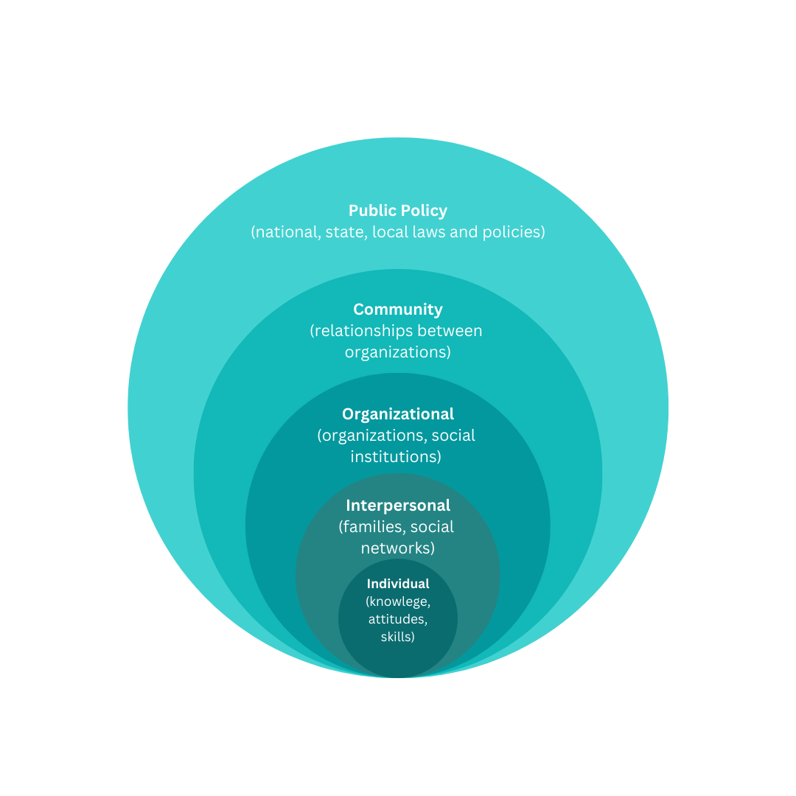
These challenges are underpinned by unequal gender norms, attitudes and practices that limit women and girls’ access to sexual, maternal, and reproductive health services and family planning. Moreover, cultural norms and practices and lack of education (which is often linked with unequal gender norms) hinder women and girls’ access to SRH services, with adverse implications for their health and well-being. Gender barriers to SRMNCAH information and services in humanitarian settings are present at multiple levels within women and girls’ socioecological environments, including at the individual, interpersonal, community, organizational, and policy/enabling environment levels according to the social ecological model (see Figure 1.1).
Figure 1.1 Social Ecological Model
To improve SRMNCAH in humanitarian settings in the Horn of Africa region, there is the need for strong advocates who advocate for improved access to services with strategic and targeted responses that address underlying gender barriers within surrounding social, cultural, institutional, legal and economic structures that obstruct women and girls from having equal access to SRMNCAH services. Thus, creating the conducive environment for access is the responsibility of duty bearers to demonstrate gender-responsive behaviors and attitudes, as much as it is the right of women and girls to access them. The socio-ecological model confers importance to change at all levels of society.
*Source: Adapted from Bronfenbrenner’s (1979) socio-ecological model
Ultimately, this context undermines the realization of women’s reproductive rights and access to quality health services that are enshrined in the Convention on the Elimination of all forms of Discrimination Against Women (CEDAW), the Sustainable Development Goals (SDGs), the Beijing Platform for Action, and the Programme of Action of International Conference on Population and Development (ICPD). It also compromises the achievement of SDG Goal 5 on Gender Equality, in particular Target 5.6 on sexual and reproductive health and reproductive rights (and Targets 5.1, 5.2, 5.3, 5.4, 5.5 more broadly), as well as Goal 3 on health (Target 3.7). Regional instruments in place to further bolster SRMNCAH rights in the Horn of Africa include the African Union Sexual and Reproductive Health and Rights Continental Policy Framework (2005), operationalized through the Maputo Plan of Action. The Addis Ababa Declaration on Population and Development beyond 2014 is also important in this regard.
Figure 1.2 Sexual and Reproductive Health Rights and the SDGs
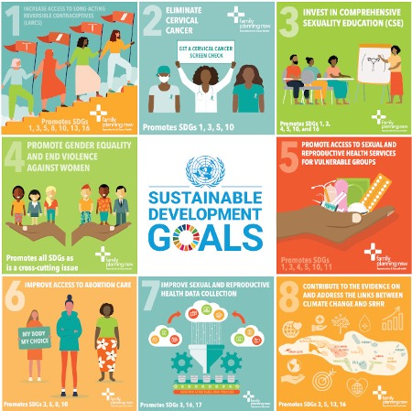
Source: Family Planning NSW Sexual and Reproductive Health and Rights and the Sustainable Development Goals Report (May, 2021)

Object of the Evaluation

Programme Overview
UN Women’s Program on Women’s Empowerment in Sexual, Reproductive, Maternal, Newborn, Child and Adolescent Health rights in humanitarian settings in the Horn of Africa Region (POWER) aimed to contribute to UN Women’s global programming on Health and HIV’s overall goal to ensure that every woman, child, and adolescent girl everywhere realizes her rights to quality SRMNCAH services, particularly in humanitarian settings. POWER emerged from the results and lessons of the H4+ Joint Programme 2011-2016, with the 2017 evaluation report emphasizing UN Women’s comparative advantage in the SRMNCAH space and its value-add in the partnership in bringing the gender dimension into the health area by driving demand-focused interventions. The POWER project drew on the experience of H4+/H6 partnerships (i.e. UNFPA, UNICEF, WHO, UNAIDS, UN Women and the World Bank group) and UN Women’s global programming and policy work in HIV/AIDS over the past decade. POWER extended the approach to humanitarian settings in the Horn of Africa.
POWER’s focus was on improving equal access to quality SRMNCAH services in refugee and host community settings in Ethiopia and Uganda, as well as at the regional level through related advocacy and training activities. POWER was designed to bring together various key stakeholders such as government, community and religious leaders, women’s rights organizations, and other grassroots community groups. The project adopted a localized approach in the design and implementation of activities and methodology applied in Ethiopia and Uganda respectively. POWER aimed to bolster existing local networks by working together with implementation partners that support SRMNCAH. As such, the specific methodological approach adopted in each context was shaped by the partners and their programme experience. Further details on how POWER was designed and implemented in each of these geographic contexts are provided in Section 2.1.2 below.

Programme Logic and Theory of Change
The programme’s theory of change is summarized as follows:
- If relevant governmental institutions and humanitarian actors have established rights based SRMNCAH frameworks for humanitarian settings.
- If Women affected by humanitarian crises have the right to SRMNCAH and if targeted communities in affected locations can promote equal gender norms, attitudes and practices on women’s rights to SRMNCAH in humanitarian settings.
- If women and girls are empowered to exercise their SRMNCAH rights and seek services in humanitarian settings.
- Then, Every woman, every child, every adolescent girl, everywhere demands her rights to quality SRMNCAH services in selected humanitarian settings in the Horn of Africa Region.
According to the full log frame (See Appendix III ), POWER aims to contribute to three outcomes and related supporting outputs and activities, with slight variations between the two countries and at the regional level. A summary of outcomes and outputs are provided in the table below.
Table 2.1 Outputs and Outcomes
Outcome | Outcome explanation | Output(s)
Established rights-based national and local SRMNCAH Frameworks in humanitarian settings | - Policy-level focus: bolstering SRMNCAH commitments and policies by raising awareness and building capacities of rights-holders and duty-bearers  - Strengthen and support duty bearers with sufficient evidence and improved rights-based national and local SRMNCAH frameworks and promote gender equality to ensure they are applied to the relevant humanitarian contexts.  - Addressing structural issues by working together with national and local authorities.  - This includes policy dialogue at the regional level | - Gender barrier analysis of women’s access to quality SRMNCAH services in conducted in humanitarian setting  - Right-based SRMNCAH priorities integrated into humanitarian response plans  - Improved accountability of duty bearers to deliver on SRMNCAH commitments in humanitarian settings
Improved promotion of equal gender norms, attitudes and practices on women’s rights to SRMNCAH in the humanitarian settings | - Target unequal social norms and attitudes that hinder the realization of SRH rights  - Extend the reach and accessibility of life-saving health services  - Engage religious and traditional leaders to transform unequal social norms that undermine gender equality | - Increased engagement with women, men and boys, including community/religious leaders & local health care workers to identify community solutions to promote equal gender norms and practices on women’s rights to SRMNCAH even in humanitarian settings.  - Proven approaches to address unequal gender norms in humanitarian settings are taken to scale  - Evidence-base created and fed back to communities on the impact of community solutions
Empowered women and girls to exercise their SRMNCAH rights and seek services in humanitarian settings | - Strengthen the capabilities of women and girls as key agents of change with women leaders as gender equality champions  - Support women, girls and communities in making informed choices as they seek quality SRMNCAH services  - Increase awareness and knowledge of SRMNCAH rights and capacities to advocate for those rights. | - SRMNCAH rights and services championed by women leaders  - Improved engagement by women organizations in humanitarian responses to ensure SRMNCAH rights and services  - Increased awareness and knowledge amongst individual women of their SRMNCAH rights and available services in health care facilities even in emergencies
According to POWER’s pathway narrative which details the pathway for change, the following four elements are critical in addressing social norms change: (1) Integrated SRHR and SGBV/HIV prevention and management services; (2) financial stress management and resilience building; (3) increased access to learning and skilling opportunities; and (4) male spousal engagements.
The programme is also guided by UN Women’s theory of change developed for a flagship programme and policy work on Demanding Rights to Reproductive, Maternal, Newborn, Child, and Adolescent Health Services that was tailored for the POWER programmes to highlight the nuances of the humanitarian contexts. The theory of change pursues the following mutually-reinforcing outcomes:
- Rights-based National and Local RMNCAH frameworks are established;
- Civil registration of women and girls’ identity, births, deaths, marriages, and other vital events is increased;
- Equal gender norms, attitudes and practices on women’s rights to RMNCAH are promoted;
- Women are empowered to exercise their RMNCAH rights and seek services.

Programme Resources and Timeline
POWER was funded by the Government of Austria through the Austrian Development Agency (ADA) with a total budget of USD 1,639,086.86 (EURO 1,421,070). The duration of the programme was two and a half years, from December 19, 2019 until June 30 2022. According to a draft workplan with data available for 2020 and 2021, the programme invested just under €500,000 in each country, and approximately €200,000 for regional level activities. By outcome area, the total budget allocated for Outcome 1 was €215,145, €330,210 for Outcome 2, and €244,260 for Outcome 3. In addition, the total of other costs for 2020 was €378,088 and €253,368 for 2021, which included costs for human resources (€279,389 total), equipment (€14,220 total), logistics and operational costs (€8,640 total), visibility and publications (€41,000 total), project committee meetings (€18,000 total), monitoring and evaluation (€81,000 total), contingency (€60,018.21), and administrative costs (€129,188 total). A breakdown of the budget, by office, outcome area and year is provided in Table 2.2 below.
Table 2.2 Budget Breakdown (By Office, Year, Outcome Area)
 | ETHIOPIA |  | UGANDA |  | ESARO (REGIONAL) |  | HQ
 | 2020 | 2021 | 2020 | 2021 | 2020 | 2021 | 2020 | 2021
Outcome 1 | € 53,145.00 | 0 | € 103,500.00 | 0 | € 58,500.00 | 0 | 0 | 0
Outcome 2 | € 150,210.00 | 0 | € 162,000.00 | 0 | € 18,000.00 | 0 | 0 | 0
Outcome 3 | € 148,860.00 | 0 | € 77,400.00 | 0 | € 18,000.00 | 0 | 0 | 0
Other Costs | € 114,764.40 | € 29,484.00 | € 106,524.00 | € 29,484.00 | € 59,398.20 | € 41,398.20 | € 97,401.09 | € 153,001.76
TOTAL | € 466,979.40 | € 29,484.00 | € 449,424.00 | € 29,484.00 | € 153,898.20 | € 41,398.20 | € 97,401.09 | € 153,001.76
POWER further aimed to contribute to the overall achievement of the UN Women Strategic Plan (SP) 2018-2021, particularly its contribution to Indicator 5 of the SP Outcome 2: Women lead, participate in and benefit equally from governance systems, and Indicator 6 of the SP Outcome 5: Women and girls contribute to and have greater influence in building sustainable peace and resilience, and benefit equally from the prevention of natural disasters and conflicts and from humanitarian action. POWER was also intended to align with both Uganda and Ethiopia’s national priorities within the United Nations Development Assistance Framework (UNDAF) for 2016-2020 respectively, and with the UN Women 2020 Strategic Notes and Annual Workplans (SN/AWP) in both countries as well as in the East and Southern African region (ESARO).
POWER was guided by UN Women’s Programming Guide on Promoting Gender Equality in Sexual, Reproductive, Maternal, Newborn, Child and Adolescent Health in its application of a gender lens to the social-ecological model of health-related behaviours to humanitarian settings. In doing so, POWER worked predominately at the individual and community levels, as well as policy level to address gender inequality and power imbalances to bolster an enabling environment for improved SRMNCAH and equal access to services.

Programme Management
POWER was managed by the respective UN Women Country Offices (CO) in Ethiopia and Uganda, with the ESARO Regional Office Policy Specialist for Ending Violence against Women managing regional activities and providing technical and coordination support to COs and general oversight from UN Women Headquarters. POWER was further supported by the UN Women Project Teams in regional and country offices, with UN Women Senior Policy Advisor on Health and HIV and Programme Specialist on Health providing strategic guidance. Implementation at the country and regional levels was managed by project managers in both Ethiopia and Uganda country offices, a Programme Assistant in the regional office, and Programme Officers based in field implementation locations in the Gambella region of Ethiopia and the West Nile region of Uganda.

POWER in Ethiopia, Uganda and at Regional Level
In line with the above programme logic, POWER included two complementary streams of activities: (1) At the national level in the contexts of Ethiopia and Uganda, and (2) at the Regional level in the Horn of Africa. Specifically, POWER was implemented in refugee and host communities in Ethiopia and Uganda and included broader interventions at the regional level in the Horn of Africa (HoA) to coordinate country-level initiatives and regional advocacy and knowledge-sharing, which included policy dialogues and training activities. Ethiopia and Uganda were selected given the high number of refugees both countries receive as a result of recent crises in the HoA region, and the increased vulnerability of these populations in accessing quality SRMNCAH services. It is important to note that across all three contexts, the implementation of POWER was significantly impacted by the COVID-19 pandemic, resulting in delays and shaping the (re)design of some activities to adapt to restrictions on in-person gatherings. Given the impact of COVID-19 on the implementation of the programme, a no-cost extension for the programme was approved.
POWER was also supported at the global level with technical assistance and guidance by UN Women HQ, who facilitated the documentation and dissemination of programme learnings and undertook the management of evaluation and reporting. For example, this included the preparation of case studies, checklists and other tools, and managing the dissemination of evaluation and learning products.

POWER at the Regional Level:
At the regional level, activities were mainly concentrated around the policy components of POWER, in ensuring an enabling environment with policies in place that support SRMNCAH rights, whereas at the country-level the focus was more on removing gender-related demand-side barriers to accessing SRH services and improving their quality and reach. This primarily included the following key regional activities: (1) research/documenting pieces, (2) Social Institutions and Gender Index (SIGI) dialogue, (3) Gender Responsive Budgeting (GRB) training and course, and (4) advocacy training.
1. Regional Research Activities: Initial research was conducted at the onset of POWER to determine the evidence base on SRMNCAH in the Horn of Africa (e.g. through situation analysis, country analyses), mapping existing regional and national legislative frameworks and instruments, as well as mapping of SRMNCAH programmes in humanitarian settings to reveal gender-related issues that need to be addressed; analyses of frameworks also aimed to highlight opportunities to influence and create linkages . Regional research activities also aimed to identify gaps, persisting barriers, promising practices and community solutions for SRH demand creation and service delivery in humanitarian settings in the HoA region. The objective of these efforts was to facilitate cross-country learning and exchange, and establish a reference point to inform country programme development and the specific design of POWER interventions.
2. Regional Policy Dialogue: In response to a recommendation by the ADA to adopt the Social Institutions and Gender Index (SIGI) data to address gender-related barriers to sexual, reproductive, maternal, newborn, child, and adolescent health in humanitarian settings, a series of four virtual regional policy dialogues were conducted in 2021. The Regional Policy Dialogue convened a total of 110 participants (including various government ministries, civil society organizations, regional development partners and institutions working on SRMNCAH and H6 partners, ADA, OECD, IGAD, AU) across the four sessions, with approximately 40 representatives per session across seven countries in the HoA (Djibouti, Ethiopia, Kenya, Somalia, South Sudan, Sudan, and Uganda) with regional organizations from South Africa, Tanzania, and Zimbabwe. The Regional Policy Dialogue was organized by ESARO in partnership with the Organization for Economic Cooperation and Development (OECD), with the overall aim to determine how SIGI data can be utilized to address barriers to SRMNCAH in HoA region and to track progress on gender equality through improved monitoring of SRMNCAH commitments in humanitarian settings. The SIGI measures discrimination against women in social institutions and underlying drivers of gender inequality across 180 countries, with the aim for data generated to inform transformative policy changes. The Regional Policy Dialogue aimed to support relevant institutions and actors to establish rights-based national and local SRMNCAH Frameworks in humanitarian settings, with POWER’s specific focus on improving the monitoring on the delivery of SRMNCAH commitments by duty-bearers, exploring relevant indicators and measures to track the implementation of commitments to address gender-related barriers to SRMNCAH services in humanitarian settings.
3. Gender-Responsive Budgeting (GRB): Regional activities focused on Gender Responsive Budgeting initially included both an in-person training and an online course component. The focus on GRB as part of POWER is part of UN Women’s broader work in financing for gender equality in order to strengthen the implementation of policy commitments to gender equality and women’s rights through improved budgeting processes. Due to COVID-19, the GRB training was conducted virtually, organized by UN Women ESARO and conducted from September 20th-23rd 2021. The virtual training engaged government ministries, civil society and development partners to support the integration of rights-based SRMNCAH priorities into humanitarian response plans through an improved understanding of the relationship between GRB, gender equality, human rights, human development, and good governance. The training emphasized the importance of financing interventions that address gender-related barriers to SRMNCAH services, and aimed to ensure that gender equality commitments receive adequate allocations and dedicated attention in plans and budgets.. The training highlighted Uganda’s notable success in integrating gender-related goals into budgets, policies, programs and processes, emphasizing the importance of effective leadership by the Ministry of Finance for enduring effects. The GRB training was complemented by facilitating participant access to UN Women Training Centre’s GRB course available online and subsidized through UN Women as well as a follow-up session examining how information gained through the training was adapted and implemented at the country level.
4. Advocacy Training: Two advocacy training sessions on SRMNCAH rights and services were conducted in November 2021 (November 16th to 18th) and then in January 2022 (January 25th to 27th). In light of COVID-19, the trainings were adjusted to a virtual platform, bringing together women and men from relevant government ministries, regional economic communities and civil society advocates on SRMNCAH rights issues. The objective of these trainings was to increase the awareness and knowledge of individual advocates, building capacities to enhance advocacy strategies.
The first cohort included a total of 21 participants (19 female, 2 male) from Djibouti, Ethiopia, Kenya, South Sudan, and Uganda over the course of three days (3 hours each day, 9 hours in total). The second cohort in January 2022 included a total of 23 female participants, and included sister agencies such as UNICEF, various governmental institutions, youth organizations, organizations of persons with disabilities (OPDs), women’s rights organizations (WROs), and NGOs. The second training was similarly conducted virtually over three days. Both trainings included a pre-training assessment to validate the training content and approach, as well as follow-up engagement with participants following the training and supporting the development and recording of advocacy messages from their learnings for participants who expressed interest.

POWER in Ethiopia
As the current third highest refugee hosting country in Africa, Ethiopia has 874,239 refugees from over 25 different countries, with the majority originating from South Sudan, Somalia, and Eritrea. Ethiopia experienced a spike in displacement due to conflict and drought, with large numbers of displaced citizens as a result of conflicts erupting around the country, further aggravated by ongoing ethnic-related tensions. The recent conflict in northern Ethiopia has created millions of Internally Displaced Persons (IPDs) and refugees, with IDPs expected to return. Ethiopia previously held one of the highest maternal mortality rates globally, with 676 maternal deaths for every 100,000 live births in 2011. More recent data is beginning to show some improvement, with the mortality rate considerably declining to 401 maternal deaths for every 100,000 live births in 2017. The goal of the reproductive health programme is to reduce the maternal mortality ratio to 199 maternal deaths per 100,000 live births and the neonatal mortality rate to 10 deaths per 1,000 live births by 2020.
SRMNCAH rights, including those of refugees, in Ethiopia are reinforced by a number of policy frameworks, which are summarized in Table 2.3 below. However, the context of conflict has deprioritized SRH commitments, and stretched thin the already inadequate existing health services, further destabilizing women’s access to SRH services.
Table 2.3 Relevant Policies, Strategies, Action Plans on SRMNCAH in Ethiopia
country | Policy, Strategy or Action Plan
Ethiopia | - The Health Sector Transformation Plan (2016-2020), with a goal to end preventable maternal and child deaths by 2030;  - The Health Sector Transformation Plan II (2020/21-2024/25), National Adolescent and youth Health Strategy (2021-2025) and Reproductive Health Strategy (2021-2025)  - The Ethiopian National Reproductive Health Strategy (2016-2020) which contains 12 strategic objectives to include improving maternal and newborn health, family planning, youth reproductive health, among others;  - Article 25 of the Ethiopian Refugee Proclamation 1110/2019 that guarantees every recognized refugee and asylum seeker access to available health services;  - The Comprehensive Refugee Response framework for Ethiopia that emphasizes the need to expand reproductive health services;  - Ethiopian Country Refugee Response Plan;  - Ethiopia’s National Refugee Strategy for Prevention and Response to Sexual and Gender-based Violence (2017-2019) that aims to protect women and girls from harmful practices and engage men and boys.
In Ethiopia, POWER interventions were concentrated in the Gambella Region, which is host to seven camps for refugees from South Sudan, predominantly from the Nuer ethnic group, and from Eritrea, Somalia and Sudan. In the Gambella region, there is a reported total of 360,462 individuals and 71,888 households affected, 87% of which are women and children (See Figure 2.1 for a breakdown of the refugee population and key trends in the Gambella region). POWER was implemented in three refugee camps (Jewi, Nguenyyiel, Kule) which host South Sudanese refugees, and three hosting weredas or administrative districts (Itang, Lare, Gambella district) who are primarily Nuer.
Figure 2.1 Refugee Population in the Gambella Region
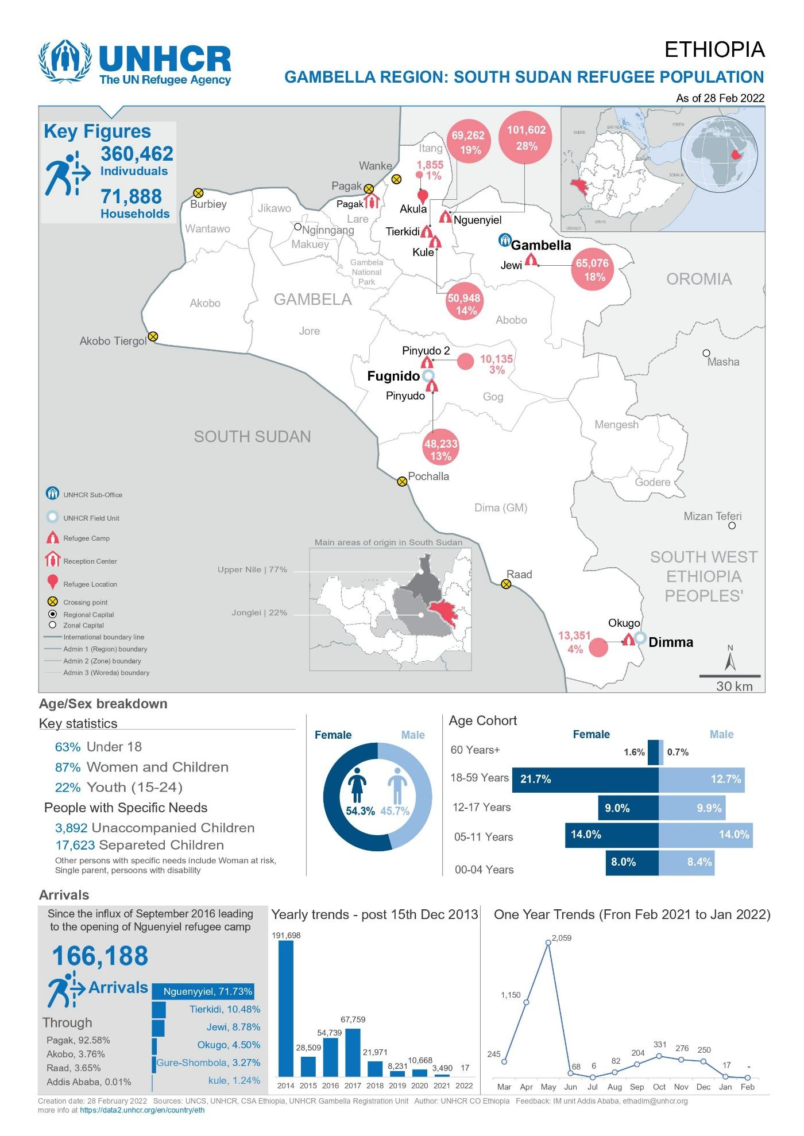
Source: UNHCR Gambella Region: South Sudan Refugee Population (as of 28 Feb 2022)
POWER’s methodological approach in Ethiopia was rooted in a networking methodology utilized at the grassroots level in the community. As part of this approach, ‘one-to-five women networks’ were trained and supervised by a Health Extension Worker (HEW) and Community Health Workers (CHW) on health issues. HEWs and CHWs are trained community health workers responsible for community outreach activities, identifying women and girls in need to increase the utilization of services, and monitoring progress. The COVID-19 pandemic and subsequent declared state of emergency throughout the country, affected the free movement of people with prohibitions on gatherings (i.e. more than 10 people) for any reason, with one-on-one meetings with the necessary protective gear allowed. The one-to-five support groups in camps and host community were mostly organized in close proximity from one another in order to facilitate immediate reach-out and support. On the other hand, there were occasional security and stability issues in Gambella Town, which hindered women from going to health centers as they did not feel safe due to conflicts erupting both internally and externally. In addition, some opted to stay home to reduce the risk of COVID-19 contamination while accessing health services.
In addition, community leaders, both men and women, as well as religious leaders have a trusted role in conveying messages to their respective members. Moreover, “Women to Women Support Groups” were created in refugee camps and replicated to host community in providing support as the first “go-to” person/group. As part of the Grassroot level community group, “Male support group” as “Agents of Change” were also organized, where they educated peer male groups mostly about family planning and woman’s right to access to medical care. Through POWER, the Youth Transformational Leaders and Refugee Task Forces enabled implementation in sharing and disseminating knowledge to their peer groups and also protecting one another from early marriage influences and exposures.

POWER in Uganda
Uganda is the largest refugee-hosting country in Africa, and hosts the third highest number of refugees in the world, with 1,525,197 refugees reported as of August 31, 2022. Most of the refugees (81%) are women and children with the highest percentage in the reproductive range of 18-59 years (see Figure 2.2 for a breakdown of refugee population in Uganda). This reproductive-age cohort has been growing significantly. Refugees in Uganda are mainly fleeing from South Sudan, the Democratic Republic of the Congo and Burundi.
Figure 2.2 Refugee Statistics for Uganda
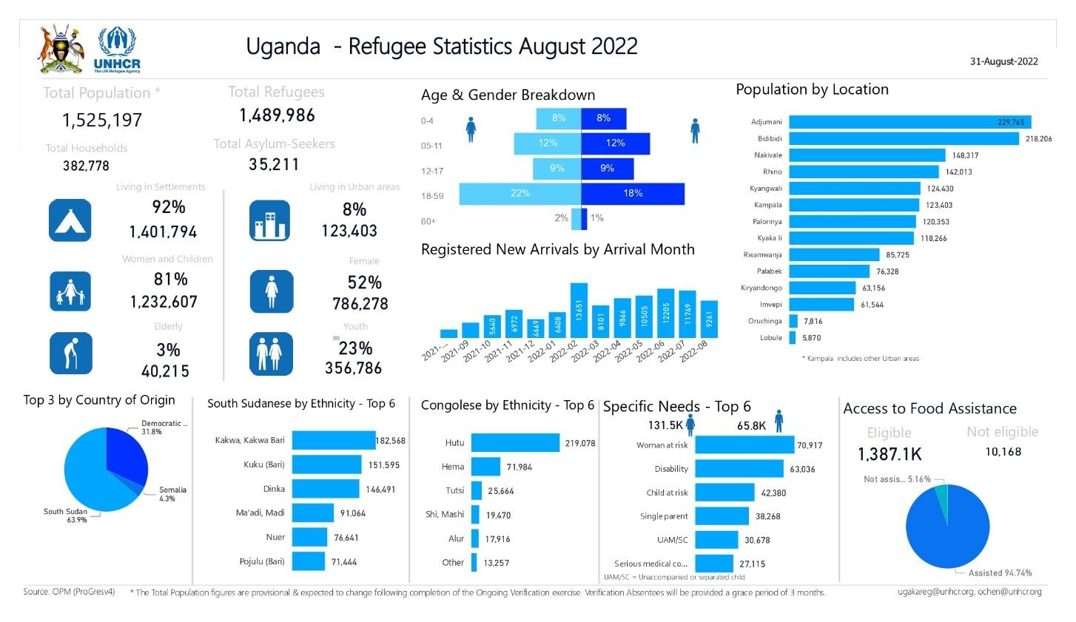
Source: UNHCR Uganda: Refugee Statistics (August 2022)
Various policy frameworks guide the delivery of SRH services, and frame responses to the needs of refugee and host populations in Uganda (these are summarized in Table 2.4). Considering the decentralized health system in Uganda, these frameworks are of particular importance at the district level.
Table 2.4 Relevant National Policies, Strategies, Action Plans on SRMNCAH
country | Policy, Strategy or Action Plan
Uganda | - The Refugee and Host Population Empowerment (ReHope) Framework and the Uganda Refugee Policy and the Comprehensive Refugee Response Framework;  - The Ministry of Health Strategic Plan (2020/21 - 2024/25) which is an overarching sector Plan that includes provisions on increasing access to sexual and reproductive health services;  - The National Policy Guidelines and Service Standards for Sexual Reproductive Health and Rights (2006) to promote quality integrated sexual and reproductive health services and contribute to reduction of maternal morbidity and mortality.  - The Health Sector Response Plan, which provides an overarching framework for supporting district local governments and implementing partners in the development of district-specific Integrated Refugee Response plans as part of the established decentralised health system;  - The recently established Health Sector Refugee Response Integrated Plan (HSRRIP) (2019-2024), aiming to strengthen health system resilience and integrated services for both refugee and host community populations through a coordination mechanism at the national, district and sub-district level.  - All the above being guided by the Ministry of Health Strategic Plan 2020/21 - 2024/25 with specific frameworks and guidelines developed by the MoH to improve the demand for quality SRMNCAH services:  - Mainstreaming Gender and Human Rights in the Health Sector (2018);  - Policy Guidelines on Prevention and Response to Sexual Harassment (2018);  - The Health Sector GBV/VAC Action Plan;  - The Training Manual for Health Workers on Clinical Management of Sexual Violence and Violence against Children and the Client Charter;  - The Male Involvement in SRHR/HIV/GBV Strategy and Training Manual;  - The guideline launched to support male engagement in the health sector.
Uganda continues to face a number of challenges that undermine the realization of national and district-level response plans, including food insecurity, epidemics such as COVID-19, Ebola and Cholera, poor psychological well-being, unmet needs for family planning, pregnancy-related morbidity and mortality, lack of access to specialised services and referral hospitals, inadequate health services with significant disparities, and an inequitable sectoral resource base (e.g. underfunding, shortage of health workers, drugs and other major medical supplies). These conditions are expected to worsen with the ongoing famine vulnerabilities in the Great Lakes Region.
Within Uganda, the West Nile region comprises the largest refugee hosting region (host to approximately 820,000 refugees from South Sudan), where socioeconomic and development indicators are most concerning. In response, POWER was implemented in the West Nile region, with a presence in four camps in various districts: Bidi Bidi camp in Yumbe district, Rhino camp in Arua district (which later was consigned under the newly formed district Terego, carved out of Arua), Maaji-123 and Nyumazi in Adjumani. Following guidance from the Office of the Prime Minister (OPM) Adjumani Desk, the Nyumazi location was later changed to the Agojo refugee settlement. More than 300,000 people, 66% percent of which are women, live in the Adjumani district, and includes a semi-permanent settlement community nearby.
In Uganda, the SASA! (Start, Awareness, Support and Action) community mobilization approach has been adapted to the humanitarian context. SASA! is recognized as a leading model for social change by countering power imbalances between men and women, boys and girls with more equitable platforms for engagement and decision-making. Building on the proven effectiveness of the SASA! methodology implemented by UGANET (an implementing partner of the Spotlight initiative), SASA! was used by POWER partners to mobilize women and men using the four phased approach to mentor women, men, boys, and girls to recognize the positive impacts of gender balance in a relationship, to minimize harmful gender norms and practices and reduce violence and discrimination against women and girls that hinder access and utilization of SRMNCAH services. The POWER programme designed and implemented a group care model with women-only safe spaces for refugees and host communities, where women and girls became members of a ‘POWER clubhouse’ with a pre-determined ‘minimum package’. These clubs included sharing personal experiences and raising issues (e.g. gender-related barriers) related to SRMNCAH quality, access, and utilization. Using this SASA! Approach, the POWER clubhouse promoted peer learning, mentorship and social integration.
The POWER clubs also served as referral pathways, not limited to only SRMNCAH services but inclusive of other health care services as needed, and vehicles for economic empowerment activities. For example, the POWER clubs doubled as the Village Savings and Loan Association (VSLA), which was self-initiated by the POWER members through shared savings from their group enterprise and self-sustained individual small-scale businesses. Through the programme, 14 POWER clubs were started in Adjumani, Terego and Yumbe districts in 2020, with an additional 12 clubs established in 2021, each with 20 women and girls of different vulnerabilities, totalling to 520 memberships.

POWER Target beneficiaries
According to the updated POWER Proposal document (November 2019), the targeted reach of POWER was a total of 980,990 direct (women, girls, and their families) and indirect beneficiaries. For a breakdown of target beneficiaries by country, region, and beneficiary type, see Table 2.5 below.
Table 2.5 Target Beneficiaries in Ethiopia & Uganda
Beneficiary | Direct Beneficiaries | Indirect Beneficiaries | Total
Ethiopia
Gambella Region (Total) | 13,600 | 366,719 | 380,319
Uganda
West Nile Region (Total) | 12,000 | 588,671 | 600,671
Total | 25,600 | 955,390 | 980,990
*Source: Updated Proposal Document (November 2019)

Key Partners & Stakeholders Involved
UN Women worked with different implementation partners (IP) in Ethiopia and Uganda, who were responsible for delivering POWER activities in each country context.
In Ethiopia, POWER was implemented by the International Medial Corps (IMC), an organization that provides aid to address crises related to refugees, armed conflict, and drought. IMC offers critical care and prevention services in difficult and at times dangerous conditions. It has an established program that creates access for SRH, HIV/AIDS, and GBV care, and women-friendly centers for refugees and IDPs in Gambella and Dollo Ado and provides training to health professionals on identifying and responding to GBV, STIs and FGM.
In Uganda, POWER was implemented by a consortium of three different Civil Society Organization (CSO) partners and the Forum for African Women Educationalists in Uganda (FAWE-U). The consortium included: International Community of Women Living with HIV in Eastern Africa (ICWEA) as the lead of the consortium, Uganda Network of Young People Living with HIV/AIDS (UNYPA), and the Alliance of Women Advocating for Change (AWAC) working in various respective areas focusing on different SRMNCAH issues for women and girls particularly in the areas of GBV and HIV/AIDS response, prevention and management, and capacity strengthening for SRH service-delivery in refugee camps and host communities. As the lead consortium partner, ICWEA had a key role in the design of POWER, its roll out in driving up awareness raising on SRHR and SRMNCAH services. AWAC and Reach-a-Hand Uganda kick-started POWER implementation, with primary responsibility in mobilizing and sensitizing the target population (women and girls 15-49 years, active reproductive age brackets). Once this group was mobilized, FAWE-U then formed the POWER clubs as they exist today, as well as introduced and implemented the economic empowerment component of POWER clubs (livelihoods and soft skills, encouraging second chance education) using their trained Community Volunteer Facilitators (CVFs). UNYPA’s peer educators mobilized and sensitised the unique demographic of young adolescents/youth affected by HIV/AIDS, with AWAC mobilizing survivors and women and girls involved in commercial sex work. In this way, POWER built on the existing mandates of each of these partners with the women’s groups/clubs and savings programs.
Further details on the implementing partners involved in POWER are outlined in Table 2.6 below.
Table 2.6 Implementing Partners
implementing partner | Main Activities Offered | Comments
Ethiopia
IMC | Healthcare, Mental Health and Psychosocial Support (MHPSS), GBV prevention and treatment, SRH, HIV/AIDS, nutrition, WASH assistance;  Women-friendly centers  Training to service providers to respond to GBV, Sexually Transmitted Infections (STIs) and Female Genital Mutilation (FGM)
Uganda
FAWE-U | Women and girls’ socioeconomic empowerment | Previous involvement with UNW through the PRO-SEVU project on the promotion of second chance education for the most vulnerable and marginalized women and girls.  Critical role in the design of POWER (clubs) and its roll out and implementation. In particular, FAWE led on the POWER clubs design and the economic empowerment aspect of POWER.
ICWEA  (IP Consortium Lead) | Consortium lead: oversaw programme development and implementation  Services for women living with HIV and sex workers, including prevention, care and treatment;  Trainings;  Sensitization: Community/Male engagement;  Advocacy: Worked with Village Health Teams to promote HIV testing and health seeking behaviour | Worked with UNW previously under SWaSHE project that built and strengthened women’s movement building as advocates and drivers of change, extending this work with POWER to expand reach to the POWER districts (using experiences and lessons from the Karamjoa sub regions)
UNYPA | Capacity-Building, and mentorship for young people on SRH, GBV, sex workers and HIV related challenges;  Advocacy campaigns;  Linked sex workers and women living with HIV to FAWE’s economic clubs  Women and girls support groups;  Training for women leaders;  Sensitization: Male/community engagement and district leadership;  Capacity-strengthening for service delivery in camps and host communities. | Worked previously with UNW under SWaSHE project strengthening women’s movement building as advocates for quality SRMNCAH services;  Through POWER they are continuing to implement the programmes they have within the Uganda Network of Young People Living with HIV/AIDS (UNYPA)
AWAC | Mobilize, capacitate and advocate for services and livelihoods for women/girl refugees involved in commercial sex work (commercial sex work survivors) and women and young persons living with HIV/AIDS;  Training and empowering women leaders using SASA model;  Creation of pathways for linkages and referrals for HIV services, family planning and GBV between affected populations and service providers | POWER built on their existing mandate with the clubs and savings program
In addition to the above IPs, POWER collaborated with a range of traditional and non-traditional humanitarian actors (e.g. the International Rescue Committee) including other UN Agencies (e.g. UNFPA, UNHCR), humanitarian clusters, taskforces, and working groups (e.g. Reproductive Health Cluster in Ethiopia, and Protection and Sexual Exploitation and Abuse Working Group in Uganda). The programme also engaged national and local governments, including through relevant district and local government structures (e.g. Regional Health Bureaus, Refugee Agencies, such as ARRA in Ethiopia, and refugee hosting district and local level governments), the Office of the Prime Minister and relevant Ministries (e.g. Ministry of Health, Ministry of Women, Children and Youth Affairs in Ethiopia, and the Ministry of Gender, Labour and Social Developments in Uganda) in order to support the alignment of programme implementation with national and local humanitarian strategies and response plans.

Evaluation Objectives, Scope and Methodology
As part of funding support received from the Austrian Development Agency (ADA), UN Women is required to conduct a final evaluation of POWER by independent external evaluators. The evaluation will serve the dual purposes of accountability and learning to document results achieved, challenges, good practices and lessons learned during programme implementation.

Evaluation Objectives
According to the Terms of Reference (See Appendix I), the objective of the final evaluation is to assess implementation progress and achievement against the outcomes detailed in the Programme’s log frame. Additionally, the evaluation documents challenges, delays, good practices, and lessons learned to contribute to learning and improved programme implementation. Specifically, the evaluation objectives were to:
- Assess implementation progress and achievement of the programme against the outcomes set and stipulated in the programme document, including identification of success factors and constraints;
- Take stock of and document lessons learned, promising practices, gaps, success and challenges to inform future work towards SRMNCAH- rights and advancing and addressing gender equality in sexual and reproductive health programmes;
- Develop specific recommendations for further improvement and potential programmatic interventions in the area of integrating gender equality and women’s rights into SRMNCAH programmes in Humanitarian settings;
- Produce a document focused on learning drawn from the evaluation that will be used by UN Women and other stakeholders to popularize the learning for advocacy and improved programming.
Moreover, the evaluation generates evidence to be used by UN Women and other stakeholders to inform strategic decisions, for example to:
- Inform and contribute to evidenced-based policy dialogues with policy-makers and other stakeholders to advance gender equality in SRMNCAH services in humanitarian settings;
- Provide evidence to advocate for the inclusion of gender-responsive SRMNCAH services and actions in humanitarian settings in national policies and strategic agendas;
- Inform UN Women, partners/stakeholders of best practices in engaging communities to address gender-related barriers to SRMNCAH services and supporting women leaders and the empowerment of women.

Evaluation Scope and Use
The evaluation will cover the period of December 2019 – 30 June 2022. Its geographic scope will encompass programme activities in Ethiopia and Uganda, as well as activities at the regional level. The evaluation will assess programmatic progress, challenges and results achieved, with a focus on progress at the output level and how these contribute to outcome-level progress.
The primary intended internal users of the evaluation are UN Women staff in the Ethiopia and Uganda country offices and at field implementation locations, in the ESARO regional office, and at headquarters. The main external users will be the national and local institutions engaged with as part of programme implementation, including national line ministries and institutions, women’s rights and human rights organizations, the Austrian Development Agency, the UN Country Teams (UNCT) in both Ethiopia and Uganda, and other UN agencies (e.g. H6 partners). Intended uses of the evaluation are to inform UN Women learning and planning of future programming, and to support other partners’ learning and advocacy on addressing gender equality within SRMNCAH programming.

Evaluation Design & Approach
The evaluation adopted a utilization-focused, participatory and gender-responsive approach to address the objectives outlined in Section 2.2. The details of the evaluation team, including roles and responsibilities, and evaluation timeline and deliverables are outlined in Appendix VII .
Utilization-focused: The evaluation adopted a utilization-focused approach, developed by Patton (2008), with the aim of ensuring that evaluation products are relevant and of practical use to those individuals and organizations who they are meant for. The evaluation approach was shaped by the intended uses of evaluation findings and recommendations by its intended internal and external users to the extent possible. Participatory approaches were used primarily with users from UN Women and with the evaluation reference group given the limited timeline.
Ethically sound, gender-responsive and inclusive: All members of the evaluation team were in compliance with the UN Women Evaluation Policy and to the norms and standards outlined in the UNEG guidance on Integrating Human Rights and Gender Equality Perspectives in Evaluations and the UNEG Ethical Guidelines for Evaluation. The evaluation ensured that all members of the team respected and adhered to the principles required by the UNEG guidance on Integrating Human Rights and Gender Equality in Evaluation (2011). Specifically, the evaluation ensured a gender-balanced sample wherever possible, the collection of sex-disaggregated data, and the application of a gender lens throughout all phases of the evaluation (see Section 3.3 for more details on methodology, as well as related limitations in Section 3.5). The evaluation team was cognizant of power relations with other stakeholders, including the team’s own positioning, at all times during the evaluation process. Careful consideration was given to providing opportunities for all voices to be heard as part of the evaluation, including marginalized groups of women and girls with an intersectional lens (e.g. women and girls living with HIV/AIDS). The evaluation guaranteed the confidentiality of information and ensured informed consent. All evaluation questions were formulated to capture the human rights and gender equality dimensions of the issue.
The sensitive nature of the subject evaluated encompassing topics such as gender-based violence and harmful practices, with sexual and reproductive health rights considered contentious in some contexts, required the application of ethical guidelines for collecting data. These are outlined in further detail in Appendix X.
Results-Focused and Theory-Based
The evaluation gathered evidence on the extent to which the program has achieved or has made progress towards the achievement of originally envisioned program results. In focusing on results, the evaluation identified constraints and opportunities that emerged during the implementation process.
To this end, the evaluation drew upon the program’s overarching theory of change (see Section 1.2.2) and the program’s results framework as complementary tools describing both the ‘how’ and the ‘what’ of originally envisioned program results. The analysis of program contributions focused on analyzing not only whether any changes have been observed, but also why observed changes have (or have not) occurred and, when possible, the roles played by the intervention or other internal and external factors or any unintended and unplanned results (positive and/or negative).

Evaluation Matrix
The evaluation (evaluation criteria and related evaluation questions) was framed by the Evaluation Matrix, presented in Appendix II, which was developed based on the assignment Terms of Reference, the programme’s theory of change, and a review of programme documents. This Evaluation Matrix was validated by key stakeholders as part of the Inception Phase. The matrix elaborates on specific types of analysis and performance criteria, as well as on the main sources of information for each (sub)question.
The evaluation questions are grouped into three overarching questions (EQs) as shown in Table 3.1 below. The framework for the evaluation included OECD-DAC criteria of relevance, efficiency, effectiveness, and sustainability. Each of the overarching evaluation questions addressed one or more of the evaluation criteria of relevance, effectiveness, efficiency, and sustainability.
Table 3.1 POWER Evaluation Questions (EQs) and sub-questions
EQ1 – How relevant has the programme been in relation to regional, national and local needs, priorities and commitments, and in relation to its envisaged objectives? |  | Criteria: RELEVANCE
1.1 | To what extent were the objectives of the programme aligned with existing needs, commitments and priorities of stakeholders at global, regional, and national levels?
1.2 | How appropriate were the overall programme design, approach, and strategies in view of achieving expected results and available resources?
EQ2 – To what extent did the programme reach the planned results and what was UN Women’s contribution to these results? |  | Criteria: EFFECTIVENESS, EFFICIENCY
2.1 | To what extent did the programme contribute to the establishment of rights-based national and local SRMNCAH frameworks in humanitarian settings?
2.2 | To what extent did the programme contribute to the promotion of equal gender norms, attitudes and practices on women’s and girls’ rights to SRMNCAH in the humanitarian settings?
2.3 | To what extent did the programme contribute to empowering women and girls to exercise their SRMNCAH rights and seek services in humanitarian settings?
2.4 | What internal factors supported or posed challenges to the achievement or results?
2.5 | What external factors supported or posed challenges to the achievement or results?
EQ3 - How likely are the benefits and achievements of the programme to be sustained after the programme has ended? |  | Criteria: SUSTAINABILITY
3.1 | To what extent has programme implementation supported continuation of some or all of the programme activities by national humanitarian partners or by the local governments?

Data Collection Methods
The evaluation team used the following methods of data collection, with an emphasis on qualitative approaches: i) Desk review of available documentation; ii) stakeholder interviews; iii) focus group discussions; iv) and site visits, with a purposeful sampling of key stakeholders for comprehensiveness and inclusion; and v) analysis of budget data (i.e. workplans). Data collection was conducted in three parallel streams by three evaluation consultants to expedite the timeframe: During the data collection period, one national consultant conducted data collection at the country-level in Ethiopia (beginning in the capital followed by travel in-country to implementation sites), a second national consultant conducted data collection at the country-level in Uganda (beginning in the capital followed by travel in-country to implementation sites), and international consultants conducted data collection remotely at the regional level. To further assist with timely sharing of interview notes within the team, the evaluation team utilized note-takers and interpreters for focus group discussions in the field. To ensure consistency and integration of evaluation findings across all three streams, all evaluation team members were provided regular and clear guidance, including preparatory and debriefing calls as well as structured and user-friendly tools and guidelines for collecting, capturing and reporting information.
Key Documents Reviewed
* Monitoring reports tracking progress on SRMNCAH
* UN Women Annual Reports and results management system
* Gender Risk analyses and assessments
* National government’s humanitarian response plans
* Relevant national policies and strategies
* Advocacy, training and community outreach reporting
* Call to Action videos
Document Review
The evaluation team conducted a systematic review of relevant country level, regional, and overall programme-related documents as shown in textbox. This included key documents listed in the evaluation TOR, additional documents provided by UN Women or identified by other stakeholders, and sources found through our own research. A full list of documents consulted is available in Appendix XI.
Key Informant Interviews
The evaluation team conducted semi-structured interviews with key stakeholders within and outside of UN Women. All interviews were guided by interview protocols available in Appendix IV, which were designed to respond to evaluation questions and sub-questions identified in the Evaluation Matrix and adapted to each stakeholder group.
A sampling strategy was developed in consultation with UN Women (ESARO, COs, and IPs) and validated in the Inception Report; key informants were informed by the stakeholder map developed during the Inception Phase (see Appendix V). Stakeholders were classified according to level of involvement and selected based on their knowledge of the programme, the context of SRMNCAH in the area, and involvement in the provision of SRMNCAH services in site visit locations. In sampling participants of regional activities, the evaluation team purposefully selected a gender-balanced group with stakeholders from different country contexts and all activity types (e.g. SIGI dialogue, GRB, advocacy training) and from organizations working with different marginalized groups (e.g. persons with disabilities, persons living with HIV/AIDS). At the country-level, the evaluation team identified the need to include the perspectives of men and established gender-balanced sample where feasible and appropriate.
The evaluation reached out to those identified in the agreed sample, however, not all of the stakeholders responded to the interview request. Specifically, there was a low response rate from those who participated in regional-level activities, with donors and H4/H6 partners not available for interview. The evaluation team made efforts to provide other forms of participation in the evaluation, such as sharing questions by email to include written responses. Finally, following further clarification on the role and involvement of regional actors (e.g. AU, IGAD), these stakeholders initially listed in the stakeholder map were not selected for interview. A list of key informant interviewees reached and included in the evaluation is provided in Appendix VI.
Remote interviews were conducted virtually through a web-based platform (e.g. Microsoft Teams or Zoom), or alternatively by phone, depending on the preference of individual interviewees. Interviews were approximately one hour in duration, and conducted in the language of preference of the participant (e.g. local language, and using an interpreter in refugee camps). A total of 48 people (25 female, 23 male) were consulted as part of the KIIs conducted, with a total of 25 in Uganda, 13 in Ethiopia and 10 at the regional level. Table 3.2 below provides a detailed breakdown of the different stakeholders consulted as part of the interviews conducted in each context.
Table 3.2 Stakeholders Consulted
STAKEHOLDER TYPE | REGIONAL |  |  | ETHIOPIA |  |  | UGANDA |  |  | TOTAL
STAKEHOLDER TYPE | Total | Gender |  | Total | Gender |  | Total | Gender
STAKEHOLDER TYPE | Total | Female | Male | Total | Female | Male | Total | Female | Male
RO/ HQ | 6 | 6 |  |  |  |  |  |  |  | 6
Country Office |  |  |  | 4 | 2 | 2 | 2 | 1 | 1 | 3
Implementing Partners |  |  |  | 3 | 1 | 2 | 9 | 7 | 2 | 12
UN Agencies |  |  |  | 1 |  | 1 |  |  |  | 1
Government | 2 | 2 |  | 5 | 1 | 4 | 14 | 4 | 10 | 21
NGOs/CSOs and WROs | 2 | 1 | 1 |  |  |  |  |  |  | 2
TOTAL | 10 | 9 | 1 | 13 | 4 | 9 | 25 | 12 | 13 | 48
Field Visits and Focus Group Discussions
Data collection during field visits mainly comprised of Focus Group Discussions (FGDs) with direct and indirect beneficiaries as well as general observations of SRMNCAH service-delivery in camps/host communities where possible, in addition to additional semi-structured interviews with key stakeholders such as related implementation partners and relevant grassroots groups or organizations in the area.
The evaluation’s approach to FGDs entailed a three-step process:
- First, the evaluation worked closely with UN Women staff at HQ and in the respective country and regional office(s) to identify and establish initial contact with envisaged informants and obtain relevant documents and other sources of information on programme implementation in the respective countries, as well as on the respective national and regional contexts around SRMNCAH.
- Second, on-site data collection was carried out by two national consultants. The two national consultants conducted a total of five in-person visits to implementation sites: two in the Gambella region of Ethiopia, consisting of one refugee camp (Jewi Camp) and one host community (Gambella town); and three in the West Nile region of Uganda in Terego (refugees and host community), Yumbe (Bidi Bidi refugee camp and host community), and Adjumani (Akojo refugee camp).
- Site visits included key informant interviews (KII) with primary and secondary duty bearers (e.g. implementing partners, service-providers, camp staff) and FGDs which focused on the end/target population (rights holders) who were participants of the programme.
Given time constraints for the evaluation, in selecting site visit locations, key sampling criteria included proximity in order to minimize travel time and maximize engagement with stakeholders. Site visits in each country were expected to take up to five working days, with a sixth day to account for travel time to, from, and within sites. In Gambella, as the site visit period was postponed due to administrative delays obtaining security clearance, time in-capital was used to conduct remote video calls where possible to minimize time in Gambella to reduce security risks. Site visit selection was balanced with data analysis on other sites, where information was available (e.g. through call-to-action videos).
The primary criteria for selecting FGD participants was based on participation in POWER programme activities. Where possible, the evaluation separated FGDs by gender and other relevant groupings based on their role and involvement in POWER. A general focus group facilitation guide is available in Appendix IV, which includes how they were conducted as well as a guiding list of questions.
A total of ten FGDs were conducted with a total of 127 participants (106 female, 21 male), with five focus groups in Ethiopia (See Table 3.3) and five in Uganda (See Table 3.4). In Ethiopia, three focus groups were conducted in Jewi camp with 30 participants in total -- one with Youth Transformational Leaders (4 female, 6 male), Women-to-Women support group (12 female), and the Refugee Task Force (1 female, 7 male) -- and two FGDs in Gambella Town with a total of 14 participants that included one host community mother-to-mother support group (5 female) and one host community youth transformational leaders (3 female, 6 male). The evaluation team’s target was 8 men from the Men Agents of Change group for a FGD in Gambella town, however, only one man showed up. The reasons for this are not clear but suggest insufficient motivation on the part of the members (see Section 3.5 on associated limitations). According to stakeholder analysis in Uganda, which was carried out with support of UN Women, there did not appear to be an established Male Engagement in Uganda as there is in Ethiopia, and instead the evaluation sought the perspectives of men on women and girls’ SRMNCAH through KIIs with local leadership (predominately male). In Uganda, two FGDs were conducted in Terego (one in the refugee camp and one with host community) with a total of 24 women/girls, two in Yumbe – one in Bidi Bidi refugee camp with 19 women/girls and one with the host community with 21 participants (18 female, 2 male) – and one FGD was conducted in Akojo in Adjumani with a total of 20 women and girls.

Table 3.3 Focus Group Discussions in Ethiopia
ETHIOPIA
LOCATION | TOTAL | GENDER
LOCATION | TOTAL | FEMALE | MALE
Jewi Camp
Women-to-Women Support Group | 12 | 12 | 0
Youth Transformational Leaders | 10 | 4 | 6
Refugee Task Force | 8 | 1 | 7
Gambella Town
Host Community: Mother-to-Mother Support Group | 5 | 5 | 0
Host Community: Youth Transformational Leaders | 9 | 3 | 6
Total Participants | 44 | 25 | 19
Total # FGDs | 5
Table 3.4 Focus Group Discussions in Uganda
UGANDA
LOCATION | TOTAL | GENDER
LOCATION | TOTAL | FEMALE | MALE
Adjumani District
Agojo Refugee settlement | 20 | 20 | 0
Terego District
1 Rhino Refugee Camps  1 host community | 24 | 24 | 0
Yumbe District
Bidi Bidi Refugee Camp | 19 | 19 | 0
Host community | 20 | 18 | 2
Total Participants | 83 | 81 | 2
Total # FGDs | 5

Data Analysis
To maximize the quality of data and mitigate the risks and constraints inherent in each individual data collection tool, the evaluation team used several processes to check and clean the data. These included: (i) during interviews, the evaluator took detailed notes and reviewed written interview notes immediately after the conversation to identify areas requiring clarification or follow up; (ii) document/desk study data was excerpted directly from the sources as much as possible to ensure accuracy; (iii) data aggregation was guided by clear questions and discussed as a team.
At the end of the data collection phase and again during data analysis, the evaluation team gathered for joint data analysis sessions to discuss and cross-reference the results of each line of inquiry, identify patterns and outliers, and draft emerging summary findings in response to the evaluation questions and sub-questions. This joint data analysis session included both international and national consultants. The evaluation team shared interview notes in a timely manner, uploading to a secure shared platform (MS Teams) to enable real-time collaboration and sharing.
Data management was essential to ensure confidentiality of data, and consistency and quality of the data analysis conducted within the evaluation team over the duration of this evaluation. Data collected was safely stored, on the shared MS Teams platform in the case of interview notes, and on our own in-house secure server in the case of sensitive data. This ensured both easy and secured access for the assessment teams as well as confidentiality for individual respondents. Within three months of the approved final evaluation report, the evaluation will remove all files from the shared MS Teams platform.
To analyse data, the evaluation team employed several analytical techniques, including descriptive analysis, content analysis, quantitative analysis, and comparative analysis.
- Descriptive analysis was used as a first step, before moving on to more interpretative approaches, to describe relevant internal and external contexts at regional, country and local levels, and map the nature and scope of program activities during the evaluation period.
- Content analysis constituted the core of the qualitative analysis. This is where the evaluation team focused its efforts to answer the evaluation questions. As part of its content analysis the team developed a simple word- based framework for data chunking and analysing all interview data and data emerging from document review, KIIs and FGDs. This framework was closely aligned with the evaluation matrix to ensure consistency. Emerging issues and trends constituted the raw material for crafting preliminary observations that were subsequently refined to feed into the draft and final evaluation reports. A gender lens was applied throughout content analysis.
- Quantitative analysis was used to interpret financial data on the amounts invested in different program locations and outcome areas. Quantitative analysis was also employed where possible to identify trends emerging from stakeholder consultation data.
- Comparative analysis was used to study and contrast findings emerging from different countries, programming sites or beneficiary groups as well as views expressed by different stakeholder (sub-) groups.
Triangulation was used to ensure the reliability of information and to increase the quality, integrity and credibility of the evaluation findings and conclusions. The evaluation team made efforts – to the greatest extent possible – to base individual findings on several lines of inquiry and different data sources. The evaluation report indicates cases where triangulation has not been possible.
Data analysis and reporting was further enriched by feedback provided by stakeholders from the reference group(s) during the presentation of preliminary findings.

Limitations
The evaluation was constrained by a few gaps in information or questions raised that could not be validated. Overall, the accelerated timeline for inception and data collection phase reduced time available for data collection preparation and planning. The speed of the design phase of the evaluation had important implications for what was accomplished during limited time in the field. It was not possible, for example, to adopt course corrections once the teams were on site. For example a focus group was scheduled to be held with the male engagement group in Ethiopia, but only one participant attended. The limited time allowed for data collection in Gambella, and security concerns, did not enable the team to extend the time in the field for the FGD to be rescheduled or for other potential participants to be invited. As a result of this design flaw, the evaluation does not include the perspectives of this key stakeholder group. This gap has limited the evaluation’s assessment of male engagement in POWER’s pathways of change. However, the low attendance rate of the male engagement group scheduled in Ethiopia, and the lack of a structured ‘male engagement’ group in Uganda may signal the lack of an intentional strategy to engage men and boys in a targeted way. The evaluation team determined, given time constraints, that the priority groups targeted for FGDs were the direct beneficiaries, most of whom were women, given the types of beneficiary groups created by the project. In the absence of the male only FGD in Ethiopia, interviews with local leaders (who were primarily male) provided some insights into male engagement and support of SRMNCAH.
At the strategic level, the evaluation does not include the donor’s perspectives of POWER, as they were not available for interview. The evaluation also does not include the perspectives of H6 partners despite efforts made by the evaluation team to identify and schedule these interviews. At the regional level, there was a low response rate for interview requests among participants in regional training activities. Additionally, fieldwork conducted in-country was limited by operational factors, such as those related to insecurity, administrative delays in achieving require clearance and delays in scheduling stakeholder consultations.
The assessment of progress achieved against POWER’s results framework was limited by the lack of baseline data to ascertain differences before and after the programme. DHS surveys were unavailable to track several indicators. Due to the lack of DHS data, POWER did not have baseline measures to help assess POWER’s contributions to increasing the proportion of women and girls with basic knowledge about SRHR and the uptake of SRMNCAH services.
Outcome area 2 on gender norms represents a broader challenge faced by similar projects and programmes that seek to achieve the same. Measuring social norm change in itself is difficult, is not well understood, and is lacking in well-conceived monitoring and evaluation tools. Pathways of change for social norm change are also not well articulated and yet can serve as a basis for developing the appropriate tools. Such limitations can be seen in the design of the POWER project and its monitoring framework as well, which in turn created limitations for its evaluability.
These limitations combined have implications for the comprehensiveness of evaluation findings. The limitations stated constrained the ability to triangulate findings from a variety of data sources. In order to mitigate these effects, the evaluation team also drew on case studies and other POWER knowledge products in order to corroborate findings from the field work. Accounting for these caveats, the evaluation presents results that give valuable insights on programme performance that can be taken into consideration.

Evaluation Findings

Relevance
The evaluation examined the criterion of relevance by assessing the extent to which the programme was relevant to regional, national, and local needs, priorities, and commitments. It also considered the programme’s relevance in terms of appropriateness of design, approach, and strategies in relation to its envisaged objectives.

POWER was relevant, timely, and aligned with national and community needs, particularly at the country-level in Ethiopia and Uganda. It filled a critical gap by focusing on demand -barriers to SRMNCAH services in refugee contexts, addressing needs across the reproductive health cycle.
Overall, it is evident from the perspectives of direct beneficiaries and other key partners in the field that POWER was highly relevant to local needs in both country contexts in Ethiopia and Uganda. Programme coverage was informed by the evidence base and in consultation with national-level leaders, district leadership, and community decision-makers.
This was enhanced by POWER’s intersectional approach in addressing the specific SRMNCAH needs of women and girls in both refugee and host communities. POWER’s comprehensive approach provided a continuous cycle of interventions across the reproductive health cycle, addressing gender-related barriers for the health of newborns, children, adolescents and mothers.
The programme was successful in integrating gender equality, health and refugees into relevant local and national frameworks. The programme uniquely met a niche area in integrating refugees into the decentralized (Uganda) and centralized (Ethiopia) health systems, and in district and national plans. In Uganda, stakeholders noted that the integration of POWER activities and results in district plans and budgets was facilitated by the participatory programme design that allowed for deeper involvement of district leaders and finding entry points to advocate for gender budgeting and to SRMNCAH services. Uganda has been particularly successful in this area, with evidence that POWER was able to change policies (see Finding 6 under Effectiveness) and be part of budget-making procedures that influence SRMNCAH.
In Ethiopia, the programme managed to engage the Ministry of Health (MoH) in integrating SRH services in humanitarian settings, thus raising the profile of SRMNCAH issues for refugees and host communities on the health agenda. In Uganda, POWER contributed to reducing gaps in implementing SRMNCAH policy and programme frameworks by bringing in district-level partners in service delivery level. There is evidence that POWER was aligned with district and parish priorities related to SGBV, People Living with HIV (PLHIV), and refugees in Uganda, allowing for a complementary programme. In collaboration with UNFPA, Uganda now has in place the Minimum Initial Service Package (MISP) for SRH in humanitarian emergencies, which provide a series of lifesaving activities required to respond to the SRH needs of affected populations within the first three months of crisis. This involved engagement of the Ministry of Health for Uganda’s MISP Readiness Assessment (MRA).
POWER was distinctive in its application of a rights-based approach to the provision of health services (i.e. SRHR as a human right). Moreover, POWER was relevant in strengthening the intersection of gender and health, bringing a much-needed gender lens to health dimensions in advocating for further integration of SRHR at sub-national, national and regional levels. This was also evident in developing POWER as part of the H6 partnership to address the SDGs. In this partnership, UN Women’s role has been to support greater integration of gender dimensions into health systems. The importance of POWER’s work in humanitarian settings is also reinforced by the Inter-Agency Humanitarian Evaluation on Gender Equality and the Empowerment of Women and Girls, which emphasizes the need to integrate gender more strongly in all aspects of the humanitarian response. This is further amplified by the Inter-Agency Standing Committee (IASC) for Gender in Humanitarian Action that emphasizes the integration of gender equality in a rights-based approach to humanitarian action.
Stakeholders confirmed that UN Women was well positioned to advance this gender focus in the health system, further bolstering the interrelatedness between gender equality and SRHR issues. In Ethiopia, for example, POWER created opportunities for SRHR advocacy, ushering in space to advance the agenda of SRMNCAH together with the Ministry of Gender and the Ministry of Health. Discussions at POWER clubs (e.g. spousal discussion series) and participatory table talks (for example on using the ‘Twogere Toolkit’) in Uganda further supported an enabling environments for SRHR advocacy, with young women and girls claiming agency for their bodies and their SRH rights and becoming SRHR advocates and champions.

Evidence generation and stakeholder consultations, often conducted at the regional level, enhanced the relevance of the POWER programme in each context.
Systematic reviews of the evidence-base and stock-taking of existing frameworks and best practices conducted in initial phases of POWER were helpful in shedding light on the needs in countries to improve the relevance of programmes in country. This provided the opportunity to build on existing research on district and national priorities and commitments and evidence on the most pressing needs in the community. In this way, the programme aptly addressed important gaps and identified barriers to SRH services (i.e. barriers to the demand of SRH services), particularly for the most vulnerable groups in society and underserved populations. For example, previous research identified the absence of health services, particularly SRH services, for refugees in Ethiopia, which then became a focus of POWER; now, IMC (IP of POWER in Ethiopia) represents the only organisation providing SRHR services in the Gambella refugee camp and host community. While IMC was providing services in this area prior to POWER, POWER added the critical rights-based approach. Assessments in Uganda identified demand barriers obstructing women and girls’ access to SRMNCAH services (e.g. underlying deeply-rooted cultural norms/practices, institutional and legal gaps), and factors contributing to the underutilization of SRMNCAH services. This informed the focus of POWER in addressing demand-site barriers to improve access, quality and reach of SRMNCAH services.
POWER contributed to gender analyses of demand-side barriers to SRMNCAH services with the various regional research, mapping and analytical reports produced. For example, the Regional Reference Report on Sexual, Reproductive, Maternal, New-born, Child and Adolescent Health in the Horn of Africa maps out programmes, existing legislative, policy and other frameworks on SRMNCAH and country analyses related to SRMNCAH strategies in humanitarian settings. It highlighted existing gaps in policy and programming that excluded women as rights holders and the insufficient investments in data collection, monitoring and barriers to women and girls on SRMNCAH rights. In Ethiopia, three publications include gender risk analyses of women’s access to SRMNCAH services: a) 2021 Policy brief on Gender Barrier Analysis on Available Legal and Policy Frameworks for SRMNCAH Rights and Service Access; b) 2022 Report on Documenting SRMNCAH Gender-Responsive Policies and Strategies; c) 2021 Framework on the Role of Gender Barriers and Gender Inequality on Sexual Reproductive, Maternal, Neonatal, Child and Adolescent Health (SRMNCAH) Service Utilization in Host and Refugee communities in Gambella.
One of the early regional activities was a review (desk review and online interviews) of existing literature on addressing SRMNCAH issues in humanitarian contexts to consolidate existing knowledge on SRMNCAH frameworks, barriers, and community solutions. This community solutions review then served as a key reference document for the programme, feeding directly into the work being done at the country-level in Ethiopia and Uganda. Regional research also helped to provide a better understanding of norms that shape women and girls’ SRHR, in order to target relevant demand-side barriers to services.
At the regional level, POWER was relevant in light of the similar challenges faced across the HoA region, with regional activities exposing the needs and gaps in other countries in the region. However, in comparison with the programmatic focus on Ethiopia and Uganda, POWER was not designed to respond to challenges and opportunities in other countries that were included in the regional activities.
Additionally, POWER was informed by mapping international, regional and national policy frameworks and commitments related to SRHR, assessing how governments are faring in upholding these commitments, and identifying relevant entry points. This was further complemented by a partner analysis that informed the selection of POWER implementing partners in Ethiopia and Uganda.
Overall, POWER was designed with COs using proposal writing workshops, with UN Women stakeholders emphasizing that COs were driving the design of the programme to improve its relevance to national priorities. Stakeholders also shared that the priority setting for the design of the programme was driven by donor interests and requests, such as donor interest in the area of SRHR/SRMNCAH, a focus on the humanitarian context in the Horn of Africa, the focus on refugee and host communities in Ethiopia and Uganda, the incorporation of the SIGI index, among others. However, this could not be further triangulated as the evaluation was not able to include donor perspectives.
In the case of the design of activities for Youth Transformational Leadership, it was emphasized that this lacked the necessary consultation to tailor to the needs of participants, particularly its relevance within the refugee context. It was noted that the content of the Youth Transformational Leaderships workshop in Ethiopia was not based on a prior needs assessment and as a result was considered less relevant, and lacking a purposeful selection process for attendees. This was confirmed by beneficiaries, who raised that this training was not tailored to reflect and address their actual needs, both in refugee and host community contexts. While in Uganda transformation leadership activities did not similarly target youth, trainings and mentorships offered to POWER club members were considered particularly relevant in being transformative with 19 of the 49 newly elected refugee women council leaders originating from the POWER transformational leadership mentorship classes. These transformational leadership classes enhanced knowledge, skills and what constitutes an effective leader, and ae now stronger advocates for SRMNCAH.
While stakeholders recognize that POWER brought in key partners during the design process at the country-level there was less intentional engagement of key regional organizations such as AU and IGAD. For example, these actors were not factored into the design as part of its inception, nor did it budget for their involvement. As such, although these organizations were named in project documents, they were not as connected to the programme during its implementation.

In Ethiopia and Uganda there were varying degrees of coherence with existing UN Women initiatives and ongoing UN Women country office strategies. At the regional level, POWER did not clearly link to UN Women’s regional strategy (i.e. Strategic Note).
POWER has achieved different degrees of coherence at the country-level. In Uganda, the programme built-upon past experience and partners, through previous UN Women SWaSHE and PRO-SEVU projects which had a focus on strengthening women’s movements as advocates to improve access to SRH services and the second chance education for the most vulnerable and marginalized groups of women and girls. POWER brought in trusted implementing partners (i.e. ICWEA, FAWE-U, UNYPA, and AWAC) from those projects, combining them into a consortium of partners to implement POWER across their relevant mandate areas in humanitarian settings of the West Nile refugee hosting districts, in turn extending the reach and quality of the work of those IPs. In examining the latest UN Women Uganda Country Office Strategic Note (2022-2025), health, including SRH and HIV (LNoB) are considered as part of their analysis of the situation, but does not fit clearly within a designated area of programming. There is an element of empowering women and girls in demanding quality services more broadly under Programme Area 5, and mentions under UN system coordination that UN Women Uganda will continue to advocate for the prioritization and mainstreaming of GEWE in Inter-Agency coordination mechanisms, processes and decisions on a number of different issues, including HIV/health. Through building on previous UN Women projects in related areas, POWER offered a complementary strategy for UN Women’s existing work in HIV/AIDS and Ending Violence Against Women (EVAW).
In Ethiopia, there were fewer links with UN Women’s previous/ongoing work and the Country Strategic Note (2017-2021), which had less emphasis on sexual and reproductive health outside of sexual exploitation and abuse and a greater focus on EVAW, women’s economic empowerment and women in leadership. However, POWER did manage to build on existing SRMNCAH initiatives through its Implementing Partner (IMC); POWER complemented SRH initiatives that were being implemented by IMC through other funding (i.e. UNHCR funding), extending its reach and service provision. Stakeholders reported that UN Women enabled the expansion of SRH services to a broader target population.
At regional level, the two relevant UN Women ESARO Strategic Notes (covering the periods 2018-2021 and 2022-2025) did not appear to prioritize SRHR or related POWER programming objectives. Instead, POWER was managed within the EVAW section (with ESARO EVAW Specialist and Programme Assistant overseeing POWER at the regional level), but did not clearly link to other EVAW initiatives, such as Spotlight and Leadership, Access, Empowerment and Protection (LEAP). POWER’s humanitarian angle with its focus in refugee and host community settings also introduced an added layer of complexity, as the project was not implemented by the humanitarian unit. This highlights the potential for a subsequent programme to be more strategically integrated with other UN Women regional programming. During the implementation of POWER, there were some misperceptions among UN Women staff about the emphasis of POWER and its link to service delivery, which in their view would fall outside of the priorities of UN Women.

UN Women redesigned some POWER activities (especially regional activities) in adapting to the COVID-19 pandemic, which limited the relevance of the approach, and the reach and content of the activities.
UN Women adjusted the original design of POWER activities in response to the COVID-19 pandemic related restrictions and constraints. In 2020, in the very early stages of implementation, nearly all POWER activities were delayed as a result of COVID-19, particularly those that included physical contact or in-person gatherings. While a no-cost extension was approved to account for COVID-19 related delays, the overall results framework was not modified to reflect adjustments to the activities. As a result, the programme implemented was not fully aligned with the planned results and activities in the programme document. COVID-19 and related challenges are discussed further in Finding 10, where it is explored as a significant external factor affecting POWER’s overall performance.
COVID-19 related limitations affected the implementation of all CO programming including POWER, requiring ‘reprogramming’ to adapt to government measures and restrictions, including re-strategizing the delivery of planned activities that involved physical gatherings (e.g. information sessions, support groups). In Ethiopia, the lockdown and restrictions limited the number of participants in each group gathering, delayed group discussions, and demanded project implementation to use alternative mechanisms. For example, some training modalities and information dissemination sessions that involved gatherings needed to be modified for example to mini-media, loud speakers announcements. Virtual meetings were proposed with added procedures to procure laptops and necessary materials which further created delays in delivering messages on time. In addition, all government offices were closed thus administrative and procedural matters were on hold for two weeks.
COVID-19 also impacted the relevance of regional-level activities, which consequently had to be completely redesigned to switch to virtual platforms. Virtual settings demanded significant changes to the structure and content from the initial design of full day/multi-day in-person workshops and convening of actors. Changes in the design of regional activities to accommodate virtual spaces was reported as a barrier in attracting the target number of participants and limited the possibilities for participant engagement. For example, the virtual GRB regional training was reduced to a total of three days, three hours per day, and the target number of participants was reduced from 80 to 30. Similarly, UN Women reduced the targets for the regional-level advocacy training for women advocates and women leaders to two 30 person cohorts.
The limitations of virtual engagement are well documented and had clear implications on the relevance of virtual POWER activities. Stakeholders noted the fatigue with the plethora of virtual meetings less meaningful engagement through a virtual approach despite UN Women’s efforts to adapt and adopt different methods, such as panels, music, and theatre.

Effectiveness
The evaluation assessed effectiveness by analyzing POWER’s achievement of outputs and contributions to outcomes, according to the programme’s log frame (See Appendix III ). This included the extent to which the programme contributed to:
- The establishment of rights-based national and local SRMNCAH frameworks in humanitarian settings (Outcome 1);
- The promotion of equal gender norms, attitudes, and practices on women and girls’ rights to SRMNCAH in the humanitarian settings (Outcome 2);
- The empowerment of women and girls to realize their SRMNCAH rights and seek SRH services in humanitarian settings (Outcome 3).

There is greater evidence of progress towards achieving results for Outcome 1 (rights-based SRMNCAH frameworks) and related outputs. Most output targets under Outcome 2 (equal gender norms) have been met, with evidence suggesting some progress has been made against output targets under Outcome 3 (women’s empowerment).
In mapping available data against the POWER results framework (see Table 4.1 below), the evaluation team determined that there is strongest evidence of progress in meeting intended targets for Outcome 1 (rights-based SRMNCAH framework) and its related outputs. The status of progress and supporting evidence for each Outcome area and its related outputs are further detailed in Appendix VIII. Additionally, results are also mapped according to the ADA template in Appendix IX.
However, it is important to note data limitations in assessing Outcome 2 (equal gender norms) and Outcome 3 (women’s empowerment), with no baseline data and some indicators/targets not available. Specifically, DHS surveys were unavailable to track several indicators. Assessment of equal gender norms and women’s empowerment at the outcome level is thus limited by the lack of baseline data, with targets dependent on DHS surveys that have not been conducted. Reliance on baseline data that is not available for the monitoring and evaluation of progress does not allow for measurement of social norms and behavioural change. At the same time, as further noted in Internal Factors, POWER was not designed with progress markers that were specific enough to be able to track its contributions along the pathways of change.
Interviews and focus group discussions explained that POWER was limited in scope in achieving broader long-term change. Moreover, stakeholders consistently expressed that POWER’s contribution to more long-term change was undermined by its shortened implementation timeline. The COVID-19 pandemic introduced unexpected delays, impacting the timing of POWER implementation. This pressed UN Women and POWER IPs to implement activities in a shorter period of time than planned, which had unintended consequences on POWER’s results.

Table 4.1 POWER Results Framework
LEGEND
 | Target(s) fully met
 | target(s) partially met/some progress
 | target(s) not met/no progress
 | target(s) could not be measured/no data available
 | OUTCOME 1
Results statements | Established rights-based national and local SRMNCAH Frameworks in humanitarian settings  - Policy-level focus: bolstering SRMNCAH commitments and policies by raising awareness and building capacities of rights-holders and duty-bearers.  - Strengthen and support duty bearers with sufficient evidence and improved rights-based national and local SRMNCAH frameworks and promote gender equality to ensure they are applied to the relevant humanitarian contexts.  - Addressing structural issues by working together with national and local authorities.  - This includes policy dialogue at the regional level
Indicators & Targets | - Number of rights-based SRMNCAH frameworks developed and approved in humanitarian contexts  TARGET: At least 2 per country and at the regional level  - Number of humanitarian plans incorporating recommendations from newly established SRMNCAH frameworks.  TARGET: At least 1 National plan per country
Indicator status
 | Output 1.1 |  | Output 1.2 |  |  | Output 1.3
Results statements | Gender barrier analysis of women’s access to quality SRMNCAH services in conducted in humanitarian setting |  | Right-based SRMNCAH priorities integrated into humanitarian response plans |  |  | Improved accountability of duty bearers to track SRMNCAH commitments in humanitarian settings
Indicators & Targets | Gender risk analyses of women’s access to SRMNCAH services conducted in each of the countries  TARGET: To be completed in each country in year 1 |  | Number of action plans that integrate SRMNCAH priorities in humanitarian settings  TARGET: At least one per country |  |  | Number and type of institutions strengthened to track implementation of commitments to address gender barriers to SRMNCAH  TARGET: At least 2 per country
Indicator status
 | Outcome 2
Results statements | Improved promotion of equal gender norms, attitudes and practices on women’s rights to SRMNCAH in the humanitarian settings  - Target unequal social norms and attitudes that hinder the realization of SRH rights  - Extend the reach and accessibility of life-saving health services  - Engage religious and traditional leaders to transform unequal social norms that undermine gender equality
Indicators & Targets | - Proportion of women (ages 15-49) who make their own sexual and reproductive decisions, by age, location, income quintile, education, marital status and disability.  TARGET: Annually 20% increase – (to be determined at baseline)  - Number of communities that promote equal gender norms, attitudes and practices on women’s rights to SRMNACH in humanitarian settings  TARGET: To be decided at inception phase
Indicator status
 | Output 2.1 |  |  | Output 2.2 |  | Output 2.3
Results statements | Increased engagement with women, men and boys, including community/religious leaders & local health care workers to identify community solutions to promote equal gender norms and practices on women’s rights to SRMNCAH even in humanitarian settings. |  |  | Proven approaches to address unequal gender norms in humanitarian settings are taken to scale |  | Evidence-base created and fed back to communities on the impact of community solutions
Indicators & Targets | - Number of community mobilization/outreach events conducted on the advantages of SRMNCAH services  TARGET: At least 4 events per year  b. Number of men, women, boys, girls, community/religious leaders (m/f), health workers (m/f) engaged  TARGET: At least 50% of targeted population |  |  | Number and type of proven approaches to address gender norms implemented/up-scaled in humanitarian setting  TARGET: at least 2 proven approaches per context |  | Effective M&E systems and tools created to ascertain change and feedback to communities in humanitarian settings e.g., surveys, key informant interviews, focus group discussions  TARGET: Tools established by Y1 and reported by end of Y2
Indicator status
 | Outcome 3
Results statements | Empowered women and girls to exercise their SRMNCAH rights and seek services in humanitarian settings  - Strengthen the capabilities of women and girls as key agents of change with women leaders as gender equality champions  - Support women, girls and communities in making informed choices as they seek quality SRMNCAH services  - Increase awareness and knowledge of SRMNCAH rights and capacities to advocate for those rights.
Indicators & Targets | - Proportion of women and girls with basic knowledge about sexual and reproductive health e.g. ways to prevent pregnancy  TARGET: At least 40% increase in knowledge  - % increase in the uptake of SRMNCAH services.  TARGET: At least 30%
Indicator status
 | Output 3.1 | Output 3.2 |  |  |  | Output 3.3
Results statements | SRMNCAH rights and services championed by women leaders | Improved engagement by women organizations in humanitarian responses to ensure SRMNCAH rights and services |  |  |  | Increased awareness and knowledge amongst individual women of their SRMNCAH rights and available services in health care facilities even in emergencies
Indicators & Targets | Number of women leaders reached through SRMNCAH capacity development initiatives (transformative leadership training)  TARGET: 100 leaders | - Number of women groups and networks supported  TARGET: Not available  - Number of women’s rights events on SRMNCAH organized at national and local levels  TARGET: At least 4 events per year, per community |  |  |  | - Number of outreach initiatives conducted to promote better health-seeking behaviour  TARGET: At least 4 events per year in targeted areas  - Number of women accessing SRMNCAH services  TARGET: At least 25% increase
Indicator status

A review of available reporting data (Annual Narrative Reports submitted to the donor for 2020, 2021, and 2022), triangulated by the perspectives of stakeholders consulted as part of the evaluation and those documented in the call-to-action videos and stories, was used to assess the degree to which POWER targets were met. Overall, most results are evidenced at the country-level, where the bulk of investments were made and where the programme was able to have more of an extended reach.

Outcome 1: Rights-Based SRMNCAH Frameworks

POWER has contributed to increased awareness of SRHR and bolstered the capacities of rights holders and duty-bearers for policy development. This has created an enabling environment that paves the way for rights-based policy frameworks that promote and protect SRMNCAH in humanitarian settings.
“UN Women gave us power to say what we have learnt” – Member of POWER Women’s groups in Ethiopia
There is consistent progress evidenced across both country contexts in contributing to the development of humanitarian plans or national plans incorporating recommendations from newly established SRMNCAH frameworks. Interviews confirmed that POWER activities on awareness-raising have contributed to an enabling environment for policy development. This is a notable area of success for POWER in both Ethiopia and Uganda, where there is now increased awareness at the national level that has led to the establishment of rights-based SRMNCAH frameworks and policy development that protect and promote SRHR, and the integration of SRMNCAH and rights into existing frameworks. There has been considerable investment with substantial results in the area of mobilization and community messaging at the country-level, with shifts in commitments in line ministries and stronger political engagements.
POWER was notably successful in integrating rights-based SRMNCAH priorities into humanitarian response plans and improving the accountability of duty-bearers in tracking SRMNCAH commitments. In Ethiopia, POWER drew on the collaboration around the development of the Multi-Sectoral Response Plan (The Role of Gender Barriers and Gender Inequality on Sexual Reproductive, Maternal, Neonatal, and Adolescent Health (SRMNCAH) Service Utilization in Host and Refugee Communities in Gambella), to bring together partners and government through a jointly developed action plan and shared responsibilities to support implementation. A response plan on “Preventing and Responding to Child Marriage in Gambella Region and Refugee Camps Gambella, Region” was developed, approved by the regional government, and disseminated in the region in November 2021. In addition, POWER supported integration of SRMNCAH priorities in COVID-19 socio-economic response plans (COVID-19 economic response plan). Of note in Uganda, the Minimum Initial Service Package (MISP) was also developed to provide SRH within the first three month of a humanitarian crisis. Stakeholders affirmed that there has been an improved integration of SRHR and GBV at national and sub-national levels, particularly at the district level. For example, this resulted in national action plans including SRMNCAH priorities in humanitarian settings in Uganda, and new policy commitments to address women’s and girls’ SRMNCAH needs in humanitarian contexts, as reflected in Uganda’s United Nations Sustainable Development Cooperation Framework 2021–2025.
Institutions have also been strengthened to better track implementation of commitments to address gender barriers to SRMNCAH at the national and sub-national levels in both country contexts. In Ethiopia, this has included the national level (i.e. the Ministry of Health and the National Network of Positive Women Ethiopia) and in Gambella region including the Health Bureau, Wereda health offices, Women and Child Affairs Office, Education Office, RRS, Finance, Economic and Development Bureau. In Uganda, there has been improved tracking of SRMNCAH commitments for key duty-bearers (e.g., MoH, MoES, MoGLSD, Health Bureau, RRS, and the Ministry of Finance, Planning and Economic Development). Additionally, a number of CSOs contribute to monitoring implementation of SRMNCAH commitments at the sub-national level, such as ICWEA who work with women and girls living with HIV/AIDS, FAWE-U Educationalists who focus on women and girls attaining quality education and skills for improved livelihoods, UNYPA who work with young people living with HIV/AIDS, AWAC who work with Female Sex Workers, and Reach A Hand Uganda for Young People in promoting the improvement of SRHR. Other actors have also included International Rescue Commission and Medical Teams International, with UNHCR as a health partner based at health facilities for refugees and host communities.
There was also evidence of increased awareness and capacities for SRMNCAH policy development at the regional level; POWER’s regional activities included duty-bearers from the Horn of Africa in a policy dialogue on the SIGI, with participants came from Djibouti, Ethiopia, Kenya, Somalia, South Sudan, Sudan, and Uganda. POWER also provided training on GRB for government, statisticians, civil society organizations and United Nations staff working in humanitarian roles and contexts in Djibouti, Ethiopia, Kenya, Somalia, Sudan, South Sudan and Uganda. The capacity building session provided participants with information on the processes and steps of gender analysis and GRB to ensure gender-specific barriers to SRMNCAH are included in budget allocations for SRMNCAH Although participants were able to practice skills following the training, UN Women recognized the need to provide additional support, with only some continuing on with follow-up training on approaches used in different gender budgeting initiatives.
As noted in Finding 2 , at regional level, POWER contributed to gender analyses of demand-side barriers to SRMNCAH services with the various regional research, mapping and analytical reports produced. For example, the Regional Reference Report on Sexual, Reproductive, Maternal, New-born, Child and Adolescent Health in the Horn of Africa maps out programmes, existing legislative, policy and other frameworks on SRMNCAH and country analyses related to SRMNCAH strategies in humanitarian settings. It highlighted existing gaps in policy and programming that excluded women as rights holders and the insufficient investments in data collection, monitoring and barriers to women and girls on SRMNCAH rights.

Outcome 2: Equal Gender Norms

Despite the short implementation timeline, POWER made progress in promoting equal gender norms and practices on SRMNCAH, garnering more support for women and girls’ SRHR from local leaders, men and boys, and community influencers, overall reducing community resistance to SRMNCAH rights. This contributed to extending the reach and accessibility of critical SRH services.
In the absence of baseline and results data, the evaluation relied on stakeholder consultations to fill this gap through their shared perceptions of observed changes in gender norms and underlying structural barriers in their communities that hinder access to quality SRH services. In both Ethiopia and Uganda, there was a noted increase in access to SRH services, with the perception of improvement in service utilization retention for refugee and host communities. For example, this has included a noted increase in HIV testing, and greater access to family planning and GBV care and treatment. Service-users (i.e. women and girls rightsholders) reported improvements in the quality of available SRH services in both refugee camps and host communities. For example, health facilities offer more complete services that now contain the necessary infrastructure and materials to deliver, with an increase in gender and youth friendly spaces that respond to the needs of women and girls. A number of stakeholders specifically underscored the increase in number of referrals for SRH services through the POWER referral pathways (e.g. clubs and village health teams and CSOs).
While gender norm change remains the broader objective, some behavior changes among different stakeholder groups could be noted. Interviews and focus groups highlighted that participants in women’s spaces and support groups have experienced some breakthroughs in men accepting their presence and role in community-level decision making platforms. Women are also gaining voice within women-only spaces through the POWER clubs. Women participants shared that their male spouses are increasingly in support of their partner’s SRMNCAH, and male local leaders interviewed have begun to speak out on women’s issues to support their access to SRMNCAH services. While the uptake of family planning showed some improvement, it remains challenging, owing to its complex ties to other harmful cultural norms surrounding the practice of polygamy.
“Now our men are changing a bit. Allowing us to use family planning. But it is a struggle.“ – Women’s Group in Ethiopia
POWER also contributed to increased engagement with women, men and boys, including community/religious leaders and local health care workers to identify community solutions promoting equal gender norms and practices on women’s realization of their SRMNCAH rights in humanitarian settings, such as through community mobilization and outreach events on the advantages of SRMNCAH services (e.g. radio shows, community campaigns, community information awareness sessions, community dialogues). According to stakeholders consulted, POWER began to mobilize male counterparts to speak out on women’s issues, leveraging on Men @ Work for Gender Equality Campaign efforts in Ethiopia (e.g. male action network (MAG) groups established). However, the evaluation was not able to validate this further with male engagement groups given the limitations outlined above. Overall, stakeholders felt that these various outreach and community mobilization efforts have contributed to increase awareness of women and girls’ SRMNCAH rights and women’s rights issues, among key local leaders, change-makers and community influencers.
“I am building the capacity of faith actors to be able to change the perception and attitude towards SRMNCAH in order to allow adolescent girls and young women make autonomous decisions about their bodies, free from coercion, violence and discrimination in humanitarian settings” – Kenya Muslim Youth Development Organization, UN Women POWER Call to Action Video
Through the various stock-taking activities (see Finding 2), POWER has also contributed to scaling up documented and proven approaches to address unequal gender norms in humanitarian settings. Similarly, it has also made progress in tracking SRMNCAH data on gender norms through M&E systems and tools. For example, the inclusion of gender equality indicators in the Health Management Information System of Ethiopia and health facility-related data collection mechanisms, the use of a SRMNCAH gender dashboard in Uganda.
At the regional level, SIGI dialogues provided training on using SIGI data sets available to track progress in gender equality and towards shifting gender norms, and how SIGI can be adapted and applied in humanitarian contexts in the Horn of Africa. As part of the SIGI dialogues, country teams presented their proposed action plans and commitments to measure women’s realization of SRMNCAH rights in their country, including specific planning on how to adapt SIGI in select humanitarian contexts. However, there is limited data available with less evidence of follow-up on regional activities such as SIGI to assess the extent to which these plans and commitments have been implemented to date.

Outcome 3: Women’s Empowerment

POWER has contributed to empowering women and girls to exercise SRMNCAH rights and champion women leaders and capacities to advocate for SRMNCAH rights in some targeted programme settings.
POWER was successful in empowering women and girls to exercise their SRMCAH rights as well-informed service users and in becoming rights advocates and champions of change. This was accomplished through increasing their access to information on available SRMNCAH services, addressing gender-related barriers to SRMNCAH services in their communities, providing support to women to hold duty-bearers accountable, and building their capacities as advocates and leaders. Empowering women to claim their rights contributed to the creation of important referral pathways, resulting in an increase in women and girls’ access to critical SRH services.
“UN Women came to support us and gave us power.“ – Woman Leader in Jewi Camp
POWER activities contributed to greater knowledge of their SRHR and information to make informed choices on SRMNCAH health, which contributed to improved uptake and utilization of SRH services. FFocus group discussions and interviews confirmed that the increased awareness and knowledge of SRMNCAH rights enhanced capacities for women to advocate for those rights as gender equality champions and agents of change. In Uganda, this has contributed to refugee women participating in public office and vying for leadership in Refugee Welfare Councils. One such Council Vice President reported participating in the quarterly Refugee Engagement Forum to lobby for women refugee rights, hold duty-bearers accountable, and to inform the implementation of the Comprehensive Refugee Response Framework. In Ethiopia, it was noted that POWER had influenced development of the Gender Policy, GBV Prevention and Response Policy, and other manuals and strategies.
“my husband now supports me with 7000 every week 5000 for saving and the 2000 is for the transport since my home is a bit distant from where we hold our weekly meetings. Being in a group has been very beneficial because when one has faced a problem, and the member approaches the group, as a group we are able to hold each other up and provide counselling and some financial support to the member. I have been able to use the money received from this saving group to start an individual business and I am renting a piece of land from the host community where I have planted sorghum” (Uganda POWER Club Member, female)
In Uganda, focus group participants indicated that women from host communities and refugee camps who were not selected as beneficiaries also joined the POWER club meetings and went on to form their own clubs with similar goals. Through this group care model, hundreds of women are now equipped with knowledge of and skills in SRMNCAH services and their rights to receive such services. Sessions resulted in increased knowledge and awareness of services available to women and adolescent girls and motivated young women to seek SRMNCAH services of their choice. Moreover, Reach-a-Hand Uganda utilized SAUTI-Plus, a mobile application, to sensitize, mobilize and refer people to available service points where they can access and utilize any SRMNCAH services to choose from. SAUTI-Plus is an unstructured supplementary service data (USSD) code that can be accessed by anyone who can access a phone with dial-in functionalities. The code provides information on SRMNCAH and rights, raises demand for SRMNCAH care and services, and supports referrals. A total of 2400 new subscribers were reached by the 2nd quarter of 2022, with 920 referrals made to different family planning service points.
In addition, through ICWEA, POWER has strengthened the capacity of more than 30 local women’s clubs, networks and organizations in Uganda. As a result of POWER, nearly half of Action Research survey respondents confirmed that there was increased access to SRMNCAH information in the community in Gambella refugee camps. However, FGD participants and key informants pointed out that at this stage they may have only some information about SRMNCAH, not the kind that is helpful for behavioural change and improved SRMNCAH service utilization. In addition, women residing in remote villages have limited information about and awareness of SRMNCAH and services compared with those who are close to areas where service providers are located.
Although economic empowerment was not as prominent in POWER’s design, interviews and focus group discussions with stakeholders in the field identified this as a roaring success of the programme, referred to in Uganda as ‘health and wealth’ success story. Stakeholders reported that women were increasingly more financially independent as a result to POWER (e.g. savings clubs, start-up capital, business training), and this was considered a critical ingredient in beginning to disrupt and transform underlying gender norms, attitudes and stereotypes that confine women as financial dependents. Linking back to SRH, women reported being able to use money and savings generated through POWER to access critical health care to supplement weaknesses in government health facilities (e.g. available medicine and health services). In Ethiopia, stakeholders explained that business training and start-up capital enabled the economic empowerment of women and adolescent girls with an increase in women’s entrepreneurship.
“Because of the money I have been saving, I am able to pay fees for my girls to attend better schools than the government schools, and they will be educated, not like me” – Yumbe FGD participant
“I used to be a sex worker when I had just arrived, because I had to survive. I got mental challenges and my husband had left me, I had to feed my children. Joining the power savings club made me meet fellow women going through many problems like me and they advised me well. I became stronger, although I still have mental problems. I can now afford to get good treatment from clinics in Arua town… Also I have a big shop now in Agoja and my business is doing very well.” – POWER club member in Agoja Camp

POWER was successful in increasing the number of women leaders championing SRMNCAH rights and services through transformative capacity development initiatives. For example, POWER reached over 200 women leaders in Ethiopia, including adolescent groups and women’s rights advocates trained at the sub-national level in the Gambella region by IMC in 2021, with young women at national level having benefited from the transformative leadership training programme.
POWER transformative leadership training (training of trainers, ToTs) delivered in Uganda benefited over a thousand adolescent girls and young women from the three districts covered by the programme, including the refugee settlements of Maaji 1,2,3 in Adjumani, Rhino camp in Terego and Bidi-Bidi camps in Yumbe. Among those trained were several young female district officials and members of village health teams. A training-of-trainers programme was established in Uganda with the long-term goal of strengthening young women leaders use of transformative leadership principles and practices to promote knowledge of SRMNCAH rights and services within their communities. By mid-2022, nearly a thousand additional young women and adolescent girls had been trained using this approach, helping to scale up and sustain this important work. Women’s organizations have become more engaged in guaranteeing SRHR and providing SRH services.
Through the women’s groups and networks in Ethiopia, POWER trained advocates for women and representatives from women’s rights organizations (WRO) and CSOs in advocacy and leadership skills through two rounds of capacity-building focused training. Stakeholders consulted explained that POWER clubs (e.g. mothers-to-mothers support clubs in Ethiopia and POWER clubs in Uganda) created safe-spaces to identify gender barriers and create local solutions together. POWER clubs in Uganda used group care as a peer-learning mechanism to provide a platform focused on addressing individual needs to overcome gender-related barriers faced by women and girl refugees within their households and communities.
POWER outreach initiatives helped to promote better health-seeking behaviour. In Ethiopia, outreach initiatives focused on women’s empowerment and gender equality to increase access to SRMNCAH services. In Uganda, outreach was aimed at improving women and girls’ understanding of their SRMNCAH rights to increase service utilization and build resilience to various socio-economic shocks.

POWER helped to connect actors on SRMNCAH in an integrated network at the local level, building on existing community structures and local approaches. Fewer links and synergies were developed with global and regional initiatives.
Evidence highlights that the programme’s effectiveness in large part hinged on linkages established at district and community levels. POWER’s localized approach helped to build on existing community solutions and community structures, such as through mother-to-mother communication (See also ‘Success Factors’ under Finding 8 ).
POWER emerged to address the lack of a coordinated multisectoral response to SRMNCAH rights issues. There is strong evidence that POWER helped to bridge the siloes, strengthening coordination, monitoring and reporting on SRMNCAH for example the SRMNCAH dashboard and the integration of SRH gender-sensitive indicators in HMIS in Uganda. POWER helped to bring together relevant local leadership, creating linkages and more integrated networks between the Office of the Prime Minister (OPM), different ministries, regional bureaus and social sectors (e.g. education, social protection), government refugee agencies, local councillors, and community development officers (CDOs). POWER’s effectiveness was also improved through successful partnerships at the community level, creating linkages with community health workers, traditional leaders, and trusted implementing partners.
This cross-sectoral collaboration in refugee and host communities united strategically positioned local leadership, supporting the formation of technical working groups to develop frameworks for preventing child marriage and protecting SRMNCAH rights. This enabled POWER’s advocacy efforts and contributed to positive dialogue with policy-makers and practitioners, for example resulting in the region’s first multisectoral response plan to prevent and respond to child marriage in Ethiopia.
In Uganda, there was evidence that elected local government leaders (e.g. local councillors) often stepped in to provide support within their various mandate areas (e.g. health advocacy, economic empowerment) to POWER activities on behalf of community development officers (CDOs). The evaluation also highlighted strong participation of the OPM in Uganda in contributing to the effective and relevant allocation of development partners to deliver SRMNCAH services in formerly excluded areas, enhancing the geographic reach of POWER and increasing access to services for vulnerable groups of women and girls. Effective local linkages were also established through POWER by engaging an embedding district level institutions in Uganda to integrate SRH and GBV in their programmes and responses.
POWER was not as successful in creating these linkages beyond the sub-national and national levels, with a perception that POWER was not as strongly embedded in other UN Women initiatives in broader contexts nor strongly aligned with UN Women’s broader portfolio of work. In some cases, POWER built on previous UN Women partnerships, such as with the organizations involved in the SWaSHE and PRO-SEVU initiatives in Uganda, but there is less evidence of effective of consistent cross-connections between POWER and other related UN Women initiatives such as Spotlight or LEAP. There was some interconnection noted in Uganda at the sub-national level, where there was cross-connection between POWER and LEAP and Spotlight programmes. In this case, it was highlighted as a strength for POWER in leveraging upon the prior presence of Spotlight and LEAP.
While H6 partners did not participate in the evaluation, interviews and documents reviewed suggest that UN Women did not maximize or leverage the H4/H6 partnership with the same energy/intentionality as it did other types of local partnerships and coordination mechanisms (see Finding 9). The evaluation team identified this as missed opportunity to amplify the programme’s results. However, the context of a short implementation timeline, additional COVID-19 limitations, and a tight budget did not leave much room for the time and resources required for nurturing additional partnerships. It is also important to note that the H6 partnership is not an active group at the regional level and regional offices of the H6 partners are in different locations, which also may limit the level of engagement among these organizations.

Regional activities enhanced knowledge or capabilities of individual participants. They provided some added some value in cross-connecting partners and facilitating learning across the Horn of Africa, despite challenges with exclusively virtual approaches.
As noted in other findings, COVID constrained planned regional activities and required a shift to virtual design and approaches. The inherent limitations of on-line approaches affected the level of engagement of participants and the ability to follow-up on how knowledge acquired through the trainings were applied in their contexts. UN Women made noted efforts to maximize effects of discrete activities by reinforcing those at the regional level (through additional training), by involving the same partners where possible, and building on areas where there was pre-existing country office activity.
While participants recognized the relevance and value of training content, there was less evidence on how these had been applied after the training. In the training on GRB, for example, subsequent application of GRB was limited by the number of participants from each country and by where those participants are located in their own ministry and in the budgeting process. Similarly, some of the participants interviewed were only now reaching out to UN Women Country Offices to explore potential for follow-up to the training (e.g., in Kenya).
In addition, the lack of UN Women presence in certain country contexts in the HoA challenged the ability to mobilize key actors to participate in POWER regional training and dialogue. In some cases, by UNFPA, UNICEF and UNHCR were able to identify relevant participants, but UN Women still faced the challenge of providing relevant follow up to facilitate the application of the tools and approaches at country level.

Factors that Affected Performance
This section presents findings on the internal and external factors that affected the operational and programmatic performance of POWER. It also highlights efforts by UN Women and POWER partners to adapt accordingly and make any necessary programming adjustments.

A number of success factors facilitated POWER’s effectiveness. These largely centered on effective partnerships, UN Women’s expertise in bringing in the gender dimension to the demand-side of SRH, and efforts to build on existing structures, local linkages and related buy-in.
Interviews, focus group discussions, direct observations from site visits and a review of supporting documentation highlighted several internal and external factors contributing to POWER’s success in Ethiopia and Uganda respectively. These are summarized in the accompanying textbox and described in further detail below, as well as picked up further and discussed more broadly as part of dedicated findings.
ETHIOPIA  - Institutional capital of UN Women and IP (IMC) in Ethiopia  - Effective partnerships (IP)  - Bringing in the missing demand-side to complement existing supply-side focus by central government  - Building on existing institutional set-up and community structures | UGANDA  - High level of buy-in from local leadership (especially at the district level)  - Advocacy support from male partners and leaders  - Strong leadership at the local level (esp. district and sub-county)  - Flexibility in programme management
In Ethiopia, the institutional capital of UN Women and the IP (IMC), especially in the Gambella region, was a salient factor in the success of the programme. Stakeholders consulted shared the perception of UN Women as a widely respected and trusted institution, known for its technical expertise in gender mainstreaming (especially in SRH services) and its strong relationships with civil society organizations. IMC was also recognized for working in this particular area in SRH/HIV in Gambella. According to POWER documents that highlight best practices, a key strength of IMC was that it also drew on its own primary research on child marriage and teen pregnancy in the Kule refugee camp.
At the same time, the major value-add of UN Women and the uniqueness of POWER was the application of a rights-based approach to integrating SRMNCAH into humanitarian responses by first creating the demand through capacity-building and awareness creation of rights to SRH services for women, girls, boys and men, the community, health providers, and local leadership. This approach created the space for establishing new rights-based SRMNCAH frameworks or enhancing existing frameworks. A significant success of POWER was its contribution to the integration of SRMNCAH into humanitarian health response plans and nation-wide health plans. UN Women’s institutional capabilities to bring in the demand-side filled a gap and complemented the centralized provisions of SRMNCAH services provided by the government (through the MoH).
In Uganda, stakeholders across different groups consistently shared the perception that a central factor contributing to POWER’s success was the strong coordination and organisational role of the Office of the Prime Minister, and the high level of buy-in from the local political leadership, particularly at the district level as well as lower local governments and religious and traditional authorities. This was directly observed as part of the site visits conducted as part of the evaluation, where interactions indicated that government and district partners have been very involved in POWER, consistently and early-on from the onset as part of the design process. For example, local councillors (elected local government leaders) were deeply committed to supporting POWER, helping to get women registered in the POWER clubs and to monitor POWER activities. There is also evidence that local leadership heavily facilitated the training by CDOs and local councillors to beneficiaries to impart knowledge that fostered a better understanding of women and girls’ SRMNCAH rights, gender equality and economic empowerment. High levels of local buy-in also hold important implications for sustainability, as these actors continue to lobby for SRMNCAH (See Finding 13).
Implementing Partners’ (IP) prior knowledge of similar gender-responsive work in Uganda and their participation in previous UN Women programmes (e.g. SWaSHE and PRO-SEVU) seemed to have been an important success factor. UN Women used its comparative advantage in bringing expertise in gender equality and women’s empowerment, and made efforts to build on existing partnerships from other initiatives where possible . For example through Spotlight and LEAP Phase 1 in Uganda, the Refugee Law Project provided support for follow-up on legal aid, Transcultural Psychological Organisation (TPO) Uganda provided mental health and psychosocial support, and IRC provided medical aid and support in health facilities. These previous partners then played a critical role in POWER’s referral pathway, particularly in combatting SGBV.
POWER’s ability to achieve success despite tight timelines and budgets was in large part due to UN Women’s ability to build on pre-existing effective structures and partnerships (see also Finding 9). For example, in Ethiopia, this level of success was due in part to the pre-existing and trusted partner (IMC) in the region, who brought smooth communication channels and networks, strong collaboration with government offices (including ARRA), and a proven modality of implementation, which otherwise would have been difficult to deliver in the given timeframe.
The support of male partners and cultural and religious leaders was another critical success factor. This component of POWER helped to promote ‘positive masculinity’, increase acceptance of positive gender norms/practices and reduce community resistance to POWER results. This is consistent with case study reporting on best practices in engaging with men and boys, for example through the Men @ Work for Gender Equality campaigns. Stakeholders, including religious and elected leaders, reported a lot of resistance and persistence of patriarchal models before the implementation of POWER; women were also resistant to speak up on SRMNCAH issues due to power imbalances. Feedback from focus groups and interviews suggests an increase in men supporting their women partners and male leaders supporting GEWE. In one district visited by the evaluation team in Uganda, beneficiaries reported that POWER had improved buy-in and advocacy from male-dominated religious leaders in their community on SRH issues (e.g. with regards to family planning).
“As community leaders, we took awareness raising training on gender equality and we are aware that women have an equal right. We were given a telephone number to call for example, if we see early marriage, rape, home child birth, family planning need, and GBV.” -- Men Agent of Change in Ethiopia
Finally, other noteworthy success factors identified included flexibility in programme management (among government, UN Women and IPs) in the face of COVID-related challenges, as well as constant and highly visible leadership by UN Women at district level and IP effective engagement with beneficiaries. The positive relationships were evidenced by direct observation during site visits.

The effectiveness and efficiency of the programme was challenged by internal (e.g. limited human resources, lengthy process in start-up) and external (e.g. COVID, conflict/insecurity) factors that affected POWER’s performance.
The evaluation also revealed various limiting factors at the operational and programmatic level. Overall, the short implementation timeline was flagged by most as the biggest limiting factor in achieving POWER results consistently across all contexts. Significant external factors that impacted POWER’s success included the COVID-19 pandemic and related challenges, as well as insecurity particularly in the Ethiopian context. These had implications for the programmatic success of POWER due to the deprioritization of SRMNCAH and restrictions on SRH services. Specific limiting factors in Ethiopia and Uganda are summarized in the textbox below.
ETHIOPIA  - Insecurity and COVID-related programmatic challenges  - Mismatched timeline to inform government yearly strategic planning  - Mismatched timeline for capacity-building workshops and empowerment/business trainings (outside of POWER implementation timeline)  - COVID-related programmatic challenges | UGANDA  - Weaker coordination and programmatic management among IP consortium  - Weak coordination among the IPs resulting in delays  - Health workers not strongly integrated into POWER referral pathway  - COVID-related programmatic challenges

External factors
Across all contexts and across all stakeholder groups, participants consistently reported that the COVID-19 pandemic and related restrictions on in-person group gatherings had the biggest impact on POWER’s approach and ability to reach targets as planned. Interviews highlighted the many challenges of convening people in virtual and physical spaces, particularly at the community level, yet physical gatherings were key to the success of the POWER clubs’ entrepreneurship and referral functions. COVID-19 contributed to excessive absences and understaffing and delayed the hiring or replacement of key staff of the programme (for example in Uganda).
At the country-level, IPs had to shift the design and approach of activities to virtual formats and reorganize workplans from what was budgeted. Moreover, COVID-19 restrictions also meant that in some cases monitoring was conducted remotely. In Ethiopia, COVID-19 restrictions limited travel which limited the potential for the UN Women project officer to be physically present in the field, leaving IMC to play a more prominent role in the project. COVID-19 also had programmatic implications in Uganda, with restrictions in movement limiting the Savings clubs which traditionally met weekly. Beneficiaries also reported a link between the socioeconomic impacts of COVID (e.g. its impact on economic activities, financial distress, and rise in SGBV and adolescent pregnancy) and related effects on women’s savings and gaining financial independence through POWER economic empowerment activities.
Regional activities shifted to virtual modalities, which had implications for attracting the target number of participants (See Table 4.2 below) and also affected the relevance and potential effects of the training sessions due to the virtual format and more limited possibilities for follow-up activities in country.
Table 4.2 Planned vs. Actual Beneficiaries in Regional Level Activities
Beneficiary | initial target | revised target | actual
Regional-Level Activities
GRB Course/Training | 80 participants | 30 participants | 24 participants  3 subsequently completed online GRB course
Advocacy Training | - | 2 cohorts x 30 participants each | Cohort 1: 21 participants  Cohort 2: 23 participants
*Source: Interviews, Advocacy training reporting documents, GRB training reporting documents
UN Women made adaptations to try and overcome limitations of the virtual modality by including different methods such as panels, music, and theatre for example. For several regional activities, the methodology was adapted based on participant feedback to include more plenary discussion and presentations, make greater use of chat box feature, and integrate discussions in smaller breakout groups due to connectivity challenges, as well as follow-up with surveys.
The implementation of POWER was also affected by the persisting conflict and instability, particularly in Ethiopia, as well as more broadly in the Horn of Africa (e.g. Somalia, Kenya, Sudan). Active crises also minimize the possibility for participation in regional level activities, due not only to safety issues but also internet shutdowns that prevent online participation. Crises often result in the deprioritization of sexual and reproductive health and at times halt or even roll back progress made in advancing SRHR, which was further reaffirmed by the perspectives of stakeholders.
Finally, stakeholders in Uganda pointed out that the health facilities were not well-stocked with the necessary SRH resources (e.g. medicines, ambulances). This caused frustration for refugee women and adolescent girls who were increasingly gaining awareness of their SRHR and seeking to realize these rights, but were limited in doing so without the facilities and resources required to respond to these needs. In addition, health services were often very basic and unable to address complex health problems or go beyond basic routine care. In Ethiopia, the conflict contributed to increased levels of unemployed youth in camps and Gambella town who were exposed to substance abuse and consequently at higher risk of sexual and gender-based violence. Ultimately, such an environment affects the safety of young people, which makes adolescent girls and women more reluctant to seek SRH services.

Internal factors
At the operational level, stakeholders reported that resourcing (including staffing) was the most significant internal factor affecting POWER’s performance. Despite having dedicated programme management positions in each country and at regional level, stakeholders reported being stretched in some areas and thus limited in delivering the outputs, particularly in certain locations that were considered under resourced. For example, the budget allocated to staffing at the regional level (€69,296.40) was not proportional to the required level of effort to implement regional activities (including necessary follow up) across the implementation period. Engaging relevant regional actors (e.g. AU and IGAD) would require a very different level of resourcing to support a more coordinated approach.
An analysis of the logframe and how the Monitoring and Evaluation (M&E) of POWER results was set up to track results reveals issues with the use of unavailable DHS as a baseline (see Finding 5). This reflects M&E considerations not adequately built into the design of the programme, contributing to more limited reporting on results. However, there were noted efforts to emphasize qualitative data, such as through the case studies, ‘call-to-action’ videos, and ‘stories of change.’ There are also challenges with the way results statements are framed, lacking precision for example around its usage of ‘men and boys’, ‘local health care working’ (e.g. who else in the health system). There is the need to extend the emphasis on duty-bearers beyond the community-level. As social norm change takes a long time to emerge, the programme would require more nuanced progress markers and a more specific pathway of change. Additionally, Outcome 3 addresses the rightsholders angle, but lacks the complementary focus on duty-bearer responsibilities given the rights-based focus of POWER.
In Uganda, various stakeholder groups (e.g. UN Women, government-OPM, district leadership, beneficiaries) reported that the geographic coverage (i.e. only 14 of 63 parishes were covered by the POWER programme in one district) at the time of the design of POWER was not sufficient. In the case of Ethiopia, stakeholders shared that it was less an issue of staffing limitations and more a matter of other necessary resources that were not availed, such as laptops for IMC, and some compensatory items for beneficiaries (e.g. sanitary items, torch lights for nighttime emergencies) and certificates for trainees.
Stakeholders also shared that POWER was perhaps overly ambitious. The intended results were difficult to achieve within the intended duration of a two year programme, even with the no-cost extension of six months to extend the duration to account for COVID-19 delays. More time and investment would be required to deliver a programme of this nature, given that it involves behavioral change among beneficiaries. In addition to COVID-related delays, implementation timelines were further abridged due to administrative delays. Stakeholders also noted that POWER was slow to start-up, with several stakeholders at the country-level noting that the administrative process during start-up absorbed half of the total programme timeline, leaving little time for the actual implementation of all activities. Consequently, there was the shared perception that this limited the potential to achieve the planned results and annual targets set to achieve in effectively less than a year.
Other limiting factors identified in Ethiopia and Uganda included a mismatch in POWER’s implementation timeline, with some key activities occurring too late in the implementation period to see the outcome, and other activities not timed appropriately to inform or be integrated into key decision-making and planning processes. For example, the government-level SRMNCAH workshop components of POWER did not build on the existing timeline for government yearly planning; POWER ended before governmental planning cycles began in July, and thus represented a missed opportunity to integrate SRMNCAH into action plans for the coming year and support the government with strategic planning. Certain components of POWER, particularly those related to economic empowerment (e.g. business trainings) were carried out at the end of the programme, with no possibility for follow-up. In Uganda, stakeholders repeatedly emphasized the roaring success of POWER savings clubs in enabling women to achieve a higher level of economic empowerment, including leveraging POWER for an additional grant to boost these results towards the end of POWER (disbursed mid-May), with some delays due to bank detail errors resulting in three groups receiving their grants at the end of June. Consequentially, this delayed UN Women and FAWE-U’s prior plan to handover grants in a stakeholder meeting with district, OPM, and UNHCR leadership.
A final internal factor that affected the relevance and effectiveness of regional-level activities, was the extent of UN Women’s national presence through Country Offices across the Horn of Africa region. For example, the lack of UN Women Country Offices in Djibouti and Eritrea limited the mobilization of relevant participants for the regional trainings and the potential for follow-up on advocacy and GRB workshops and SIGI.

Sustainability
In assessing the evaluation criterion of sustainability, the evaluation team examined to what extent programme implementation supported the continuation of some or all of the programme’s results, including the handover of activities to humanitarian partners or local governments.

The sustainability of POWER results in Uganda and Ethiopia has been enabled by using existing community structures and working with well-established partners. These approaches contributed to improved ownership of the programme at sub-national level with potential to maintain the momentum of progress.
As documented above in Finding 6 and Finding 8 , POWER established robust linkages at the local level, with strong buy-in evidenced by institutions at the national and sub-national level. Evaluation evidence highlights that POWER was successful in bringing in government at various levels and across different departments, enabling cross-sectoral linkages that ushered in space for ongoing collaboration.
The programme also effectively engaged opinion leaders and community influencers in creating seeds of change, as well as building the capacities of women’s organizations. In Uganda, POWER’s engagement with relevant local stakeholders built capacities within refugee camps and host communities, and strengthened government health systems to further contribute to the sustainability and ownership of the project. Although the project had ended, these actors continued to lobby for women’s groups to benefit from parish development model funds. POWER helped to leverage additional funding from the local government to avail funds for community groups who were supported under POWER. Stakeholders shared the perception that this approach of building-capacity in key change agents was effective in influencing change through increased ownership and buy-in.
In Ethiopia, POWER’s Implementing Partner IMC had signed an exit document with the government bureaus as part of a handover of activities. However, as noted above (Finding 8 ) the timing of this hand-over process did not allow for POWER to inform the government’s strategic planning by including SRMNCAH into workplans and expected outcomes, thereby limiting the potential sustaining results on SRMNCAH.
Interviewees across all stakeholder groups recognized that POWER achieved remarkable results at the output level for women’s empowerment and creating local linkages, considering the timeline for implementation of effectively less than a year (see Finding 8 ). The limited duration gave few opportunities to identify the means of sustaining the momentum and results that were beginning to manifest by the close of the POWER project. However, there are opportunities to capitalize on community structures and well-established partners that were identified as critical enablers for sustainability and for carrying forward POWER results and approaches. In particular, the evaluation team noted the importance for actors to continue to create demand and help connect women and girls to the appropriate SRMNCAH services.

Conclusions and Lessons Learned
It is important to contextualize these conclusions in the context of POWER’s short timeline, with the implementation timeframe further compressed by delays in start-up and due to COVID-19.
Conclusion 1: | Evaluation Criteria: | Related Findings
POWER was highly relevant and responsive to the needs and priorities of women and girls in humanitarian settings. It was effective in contributing to different types of results especially at sub-national and national levels. The project filled important gaps identified in SRMNCAH services for women and girls in humanitarian settings, both in refugee and host community contexts. | Relevance, Effectiveness | 1, 2, 4, 5, 6, 7, 8, 10, 12
The evaluation highlights POWER’s overall success, with significant results achieved during the short period of implementation. This was particularly the case at the country-level, where the bulk of investments were made. While often noted as overly ambitious in scope, the programme managed to overcome some of the timebound limitations by building on local approaches and through effective local linkages. However, it is important to note the impacts of the COVID-19 pandemic and related restrictions on in-person gatherings which forced the redesign of POWER activities and in some cases affected the relevance, particularly of virtual regional trainings.
POWER was very responsive to needs and priorities identified and informed by the evidence base, filling a former void for SRMNCAH services for women and girls in refugee camps and host communities. POWER contributed to different types of results that are not typically reflected in humanitarian response plans or gender equality work in humanitarian settings. In particular, POWER has managed to achieve significant results in improving women’s agency and bodily autonomy in claiming their SRMNCAH rights, socioeconomic empowerment, and creating space for an enabling environment for policy development and integrating rights based SRMNCAH frameworks. This was achieved by engaging local leadership, community structures, and institutions at the local and national level, and by increasing awareness of SRHR in communities and building a critical mass of male action support groups as advocates for women and girls’ SRHR in humanitarian settings. This has effectively fostered a stronger ecosystem of SRMNCAH champions and expanded strategic and targeted networks for collective action.
Conclusion 2 | Evaluation Criteria: | Related Findings:
POWER’s success was largely due to its effective linkages at the local level to further embed discrete programme activities. There were noted efforts to leverage on existing partnerships, particularly partnerships established through previous UN Women projects. However, there was less synergy with other UN agencies and UN Women global programmes, lacking clear alignment with UN Women’s Strategic Note. | Effectiveness, Efficiency, Sustainability | 3, 9, 10, 11, 12, 13
POWER was designed and implemented with the intention to develop and build on important relationships, institutions and structures at the local level through its localized approach. In large part, POWER was able to achieve reported results in the short timeframe by enhancing existing structures and approaches as a way of getting a ‘head start’ in implementation. These were identified and intentionally integrated into the design of POWER, and informed by the evidence base on best practices, including what worked well in generating demand for improved policy frameworks and services for SRMNCAH, documenting why and how these could be scaled-up. This provided a solid foundation for the design of POWER’s approach, the identification of partners and activities. The evidence base also enabled local buy-in, ownership and sustainability of results.
Evaluation findings emphasize successful linkages at the local level as a critical factor in POWER’s performance. Such linkages were not as intentionally pursued with other partners, especially in the UN system, partly due to time and resource constraints. POWER emerged from previous work under the H4/H6 framework, and while the evaluation was not able to include the perspectives of H6 partners, the perceptions of UN Women stakeholders suggest that there was limited engagement with these actors. This presents a possible missed opportunity to demonstrate its UN system coordination mandate for GEWE and leverage on existing partnerships.
Conclusion 3 | Evaluation Criteria: | Related Findings:
Through the POWER project, UN Women added value to health initiatives in humanitarian settings by using a rights-based approach to improve SRMNCAH for refugees and host communities and emphasizing the demand for such services. | Relevance, Effectiveness | 1, 3, 6, 8, 11
POWER was particularly successful through its complementary approach to supply and demand of SRH services, dovetailing centralized health service provision in-country with its expertise focused on generating the demand for rights-based SRMNCAH services. This approach capitalized on the institutional capital and strategic positioning of UN Women, by increasing awareness and recognition of SRMNCAH rights, supporting advocacy for women’s leadership, extending the reach and quality of SRMNCAH services and strengthening referral pathways through POWER clubs and support groups.
However, the evaluation also revealed that UN Women’s specific role in this relationship between supply and demand-side was not well understood among stakeholders. This was further reinforced by the lack of clear alignment between POWER and UN Women’s Strategic Notes at regional level.
Evaluation findings also pointed to the value of UN Women in bringing in the gender dimension into the humanitarian space, which has been noted as often relegated with the deprioritization of gender-related issues in emergency contexts as part of humanitarian response.
Conclusion 4 | Evaluation Criteria: | Related Findings:
Outcome Two on social norm change proved to be more an ambition than an achievable outcome, not only due to a shortened timeframe, but to a need for more conceptual clarity and the availability of appropriate monitoring tools to assess behavior change, let alone norm change. | Effectiveness, Efficiency | 5, 12
A clearly articulated pathway of change for Outcome 2 was not forthcoming, and the socio-ecological model was also not leveraged to identify the kinds of behavior change expected of different stakeholder groups and at individual and collective levels of analysis beyond the community level. While activities were initiated to engage religious leaders, community leaders, health workers, and men as husbands and caregivers, they were not supported by baseline data on attitudes and behaviors to be targeted. Scale of engagement could also not be measured as basic data were not available on target numbers and the numbers reached by stakeholder group, gender and community. Even then, such data on numbers reached or engaged are not tantamount to evidence on behavior change. And to detect shifts in gender norms, which was otherwise not realistic within the project timeframe, collective behavior change must be measured.
With the limited resources on measuring social norm change available, the interventions for this project under Outcome 2 and in relation to the empowerment Outcome 3 were designed to raise awareness of women and girls’ SRMNCAH rights across an array of community-level stakeholders so that women and girls would be supported in accessing those rights. The extent to which the forms of support are firmly anchored in those communities is more difficult to ascertain, given the absence of monitoring tools.

Lessons Learned
The evaluation revealed a number of valuable lessons that can apply to different contexts and the sector more broadly. Knowledge gained through this particular intervention has relevance and applicability for other programming in the areas of SRMNCAH in humanitarian settings.
Overall, POWER’s success factors and challenges indicate the utility of the following set of complementary approaches. Ultimately, these mutually-reinforcing approaches affirm that no single organization or programme can do it all, and thus combining complementary approaches can offer more comprehensive and continuous solutions.
- Grounding in the Social Ecological Model: Programming can be improved by utilising the social ecological model as programming guidance, using the model as a diagnostic tool to identify barriers and map opportunities to better target programming partners and design. UN Women’s programming for gender equality in SRMNCAH - including the POWER programme - is grounded in the social ecological model. The social ecological model can be a helpful tool for mapping which actors and programmes are available across the different layers, and identifying where there are gaps, to ensure a coordinated and comprehensive response across all levels.
  - The design and implementation of POWER was unique in each context, tailored to the specific barriers to demanding SRMNCAH information and services identified, and the local systems and structures mapped across social ecological systems.
- Combining Supply & Demand-Side: A comprehensive continuum of care for SRMNCAH requires a concerted effort between the between supply-side and demand-side through effective synergies. POWER’s successes and challenges illustrate valuable lessons in working with the right partners who complement UN Women; The evaluation of POWER affirms that UN Women has demonstrated expertise in bringing the demand-side focus in realizing sexual and reproductive health rights in humanitarian contexts, and is well positioned to work with partners working on the supply-side of SRMNCAH services. For example, complementing UN Women’s focus on addressing gender-related barriers that prevent women and girls from seeking SRMNCAH services (e.g. reducing discriminatory norms and legislation, strengthening the accountability of duty bearers), with partners that offer quality SRMNCAH services.
  - POWER was particularly successful at the local level, with some success identifying and leveraging regional and global partners, such as other UN Agencies, with expertise in humanitarian settings (e.g. POWER’s work with UNHCR). However, the evaluation revealed the potential for stronger linkages with former H4/H6 partners. Insights from POWER also highlight opportunities for greater synergy when linking with other actors working on relevant programmes (for example Spotlight, LEAP, and global programmes on HIV/AIDS, child marriage). These lessons emphasize an integrated and cross-sectoral approach as an important strategy to support norm change and addressing gender equality issues.
- Integrating SRMNCAH in Emergencies: In order to ensure SRHR do not slip through the cracks, it is critical to integrate rights-based SRMNCAH frameworks into humanitarian response plans. SRHR and gender equality more broadly is often deprioritized in the context of emergencies, raising the importance of bringing in a gender lens that addresses the unique needs and priorities of the gender dimension in the humanitarian space. POWER successfully integrated rights-based SRMNCAH priorities into humanitarian response plans, national action plans and sub-national strategies, particularly those that brought together key partners and governments through shared responsibilities. For example, this included the Multi-Sectoral Response Plan in Host and Refugee Communities in Gambella, and integrating SRMNCAH priorities in COVID-19 response plans. Insights from POWER also emphasized the significance of strengthening institutions to track SRMNCAH policy commitments to improve the accountability of duty-bearers in addressing gender barriers.
  - This goes in conjunction with the previous approach on combining supply and demand-focused expertise, and the added value of UN Women’s POWER programme in its focus on increasing the demand of SRMNCAH in humanitarian contexts.
- Bolstering an ecosystem of gender equality champions for SRMNCAH, especially at the local level: Where POWER was most successful, the programme was robustly backed by local leadership, including women’s leadership and women’s active political participation (e.g. refugee women participating in public office and vying for leadership in Refugee Welfare Councils, participating in Refugee Engagement Forums to lobby for women refugee rights) and community engagement. A key contributing success factor was POWER’s localized approach, which built on community structures and local institutions. This effectively contributed to greater local buy-in that allows for greater sustainability, and a strengthened network of SRMNCAH champions.
- Investing in research to inform programme design & monitoring to improve implementation: Evidence can be used for two different yet complementary purposes, described below.
  - Utilizing research evidence on gaps and best practices to inform programme design: The evaluation identified the use of an evidenced-based approach, particularly in making use of research evidence to inform programme design as a key success factor in maximizing relevance and effectiveness of POWER programme activities. For example, the programme was informed and enriched by an extensive and timely review of policies in Ethiopia and to some extent in Uganda. This improved targeting to ensure that programming adequately and appropriately meets real needs, according to barriers identified in documenting activities. However, the speed of implementation did not always allow for adjustments to be made along the way in response to emerging evidence.
  - Using monitoring data to improve implementation: Regular results reporting and measurement data can be used to assess progress to encourage reflections on what’s working well and areas for further strengthening to make necessary adjustments in implementation. POWER was limited by its approach to measurement of social norm change, lacking available baseline information. Ultimately, this does not allow for effectively monitoring changes in attitudes and behaviors related to gender norms since the beginning of the intervention. This signals the need for greater investment in monitoring frameworks and embedded measurement approaches, and underscores the importance of developing results frameworks with realistic and reliable data as baselines and indicators that allow for the assessment of progress in areas of social norm change.

Recommendations
As part of the evaluation process, stakeholders were consulted on their recommendations for UN Women and for similar future programmes more broadly. Data analysis coded for any recommendations that emerged from interviews, FGDs, and available documentation, and other recommendations extrapolated from information collected together formed the basis of preliminary areas for recommendation presented at the Preliminary Findings Workshop. During the Workshop, preliminary recommendations were enriched by the feedback of Evaluation Reference Group members to maximize their pertinence and practicality.
The following recommendations are made to UN Women based on the experience of the POWER programme. The recommendations highlight key design and strategic considerations for a subsequent phase of a programme focused on women’s empowerment for SRMNCAH rights.

Design Considerations:
- UN Women should consider a longer period of implementation and a greater level of investment for the next phase of the programme. It is noteworthy that POWER was able to achieve its outputs with a high volume of implementation activity within a very short timeframe. Yet stakeholders noted that the design was too ambitious even before COVID-19 led to a more compressed timeline. Programme duration is a critical factor affecting the potential for social norm and behavioural change that can sustain demand generation. Thus, future initiatives should consider a timeline of that allows for delivering activities and carrying out the necessary follow-up measures.
- In a next phase of the programme, UN Women should seek greater integration between country and regional dimensions of programming, including leveraging existing partnerships with UN Agencies. Due to resource limitations and time constraints, UN Women was not able to consistently link regional training and dialogue to strategic priorities at country level. Regional training activities should be linked to Country Office strategies so that there is appropriate follow up on the interest generated by initiatives such as SIGI and GRB and to ensure application of new knowledge and skills. Greater synergy at the various levels can be further reinforced with more clear linkages with UN Women’s Strategic Note, with greater integration with existing related programmes. Similarly in a subsequent phase of a POWER programme, UN Women should consider a coordinated/joint programming modality that leverages the strengths of other UN partners for providing SRMNCAH services in humanitarian settings.
- To support interventions to transform unequal gender norms, UN Women needs a focused investment on design, monitoring and evaluating this work. The agency should seek to create a more common understanding of the conceptual work required to develop pathways of change and to support its success in results reporting with the commensurate level of monitoring and evaluation methods and instruments. Knowledge sharing with UN sister agencies that are grappling with similar issues and are still in an inchoate stage of developing the guidance would accelerate this work and position UN Women in its coordination role to consolidate the gains and evolve collectively in designing robust interventions in transforming social norms.

Strategic Considerations:
- UN Women should continue to focus on and communicate its work in empowering women to demand SRMNCAH services as part of a rights-based approach. The evaluation confirmed that UN Women’s emphasis on demand generation filled gaps in the SRMNCAH rights for women and girls in humanitarian settings, both for refugee and host populations. This focus is a critical component of reducing discriminatory legislation, norms and service-delivery practices and enhancing access to quality services for women and girls. However, it requires collaboration with key partners and other UN Agencies strategically positioned on the supply-side for a comprehensive and complementary approach.
- UN Women should continue to invest in areas that were identified as success factors for the POWER programme. This includes continuing to engage local leadership and embedding SRMNCAH in local frameworks, structures and institutions. Building the capacities of champions of GEWE and engaging men, children and youth in this regard has also been critical in POWER’s efforts to raise awareness and demand creation for SRMNCAH rights. Awareness raised through POWER needs to be followed up with improved accountability for duty-bearers in order to sustain this momentum and the progress achieved. Economic empowerment activities provided another promising strategy for its effects on agency, shifts in social norms, and ability to enhance access to quality SRMNCAH services. Measurement of progress also requires the availability of baseline data to assess changes with the onset of the programme.

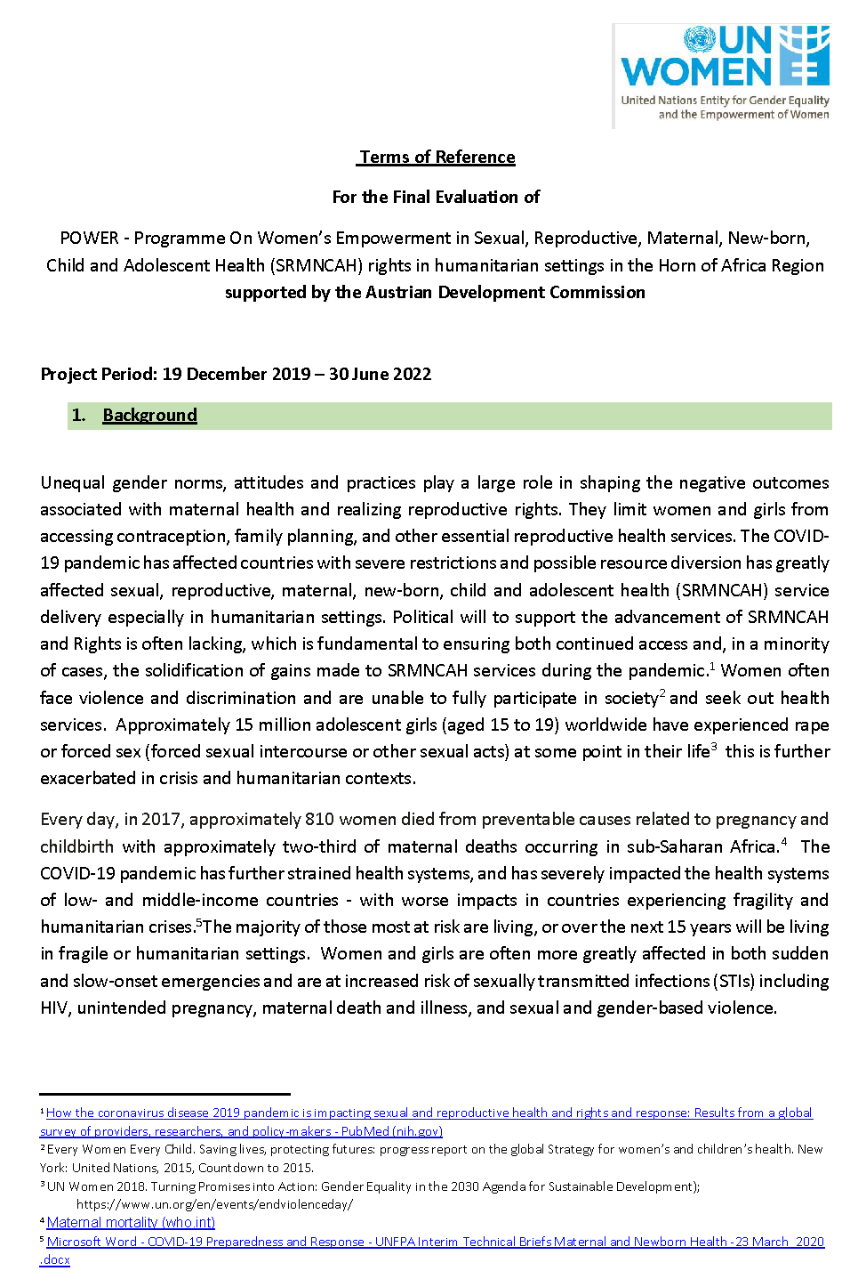
Terms of Reference

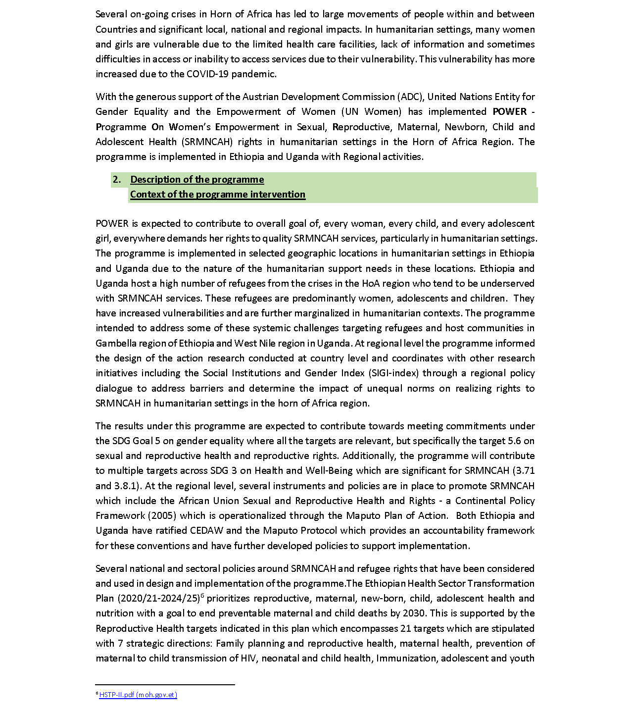

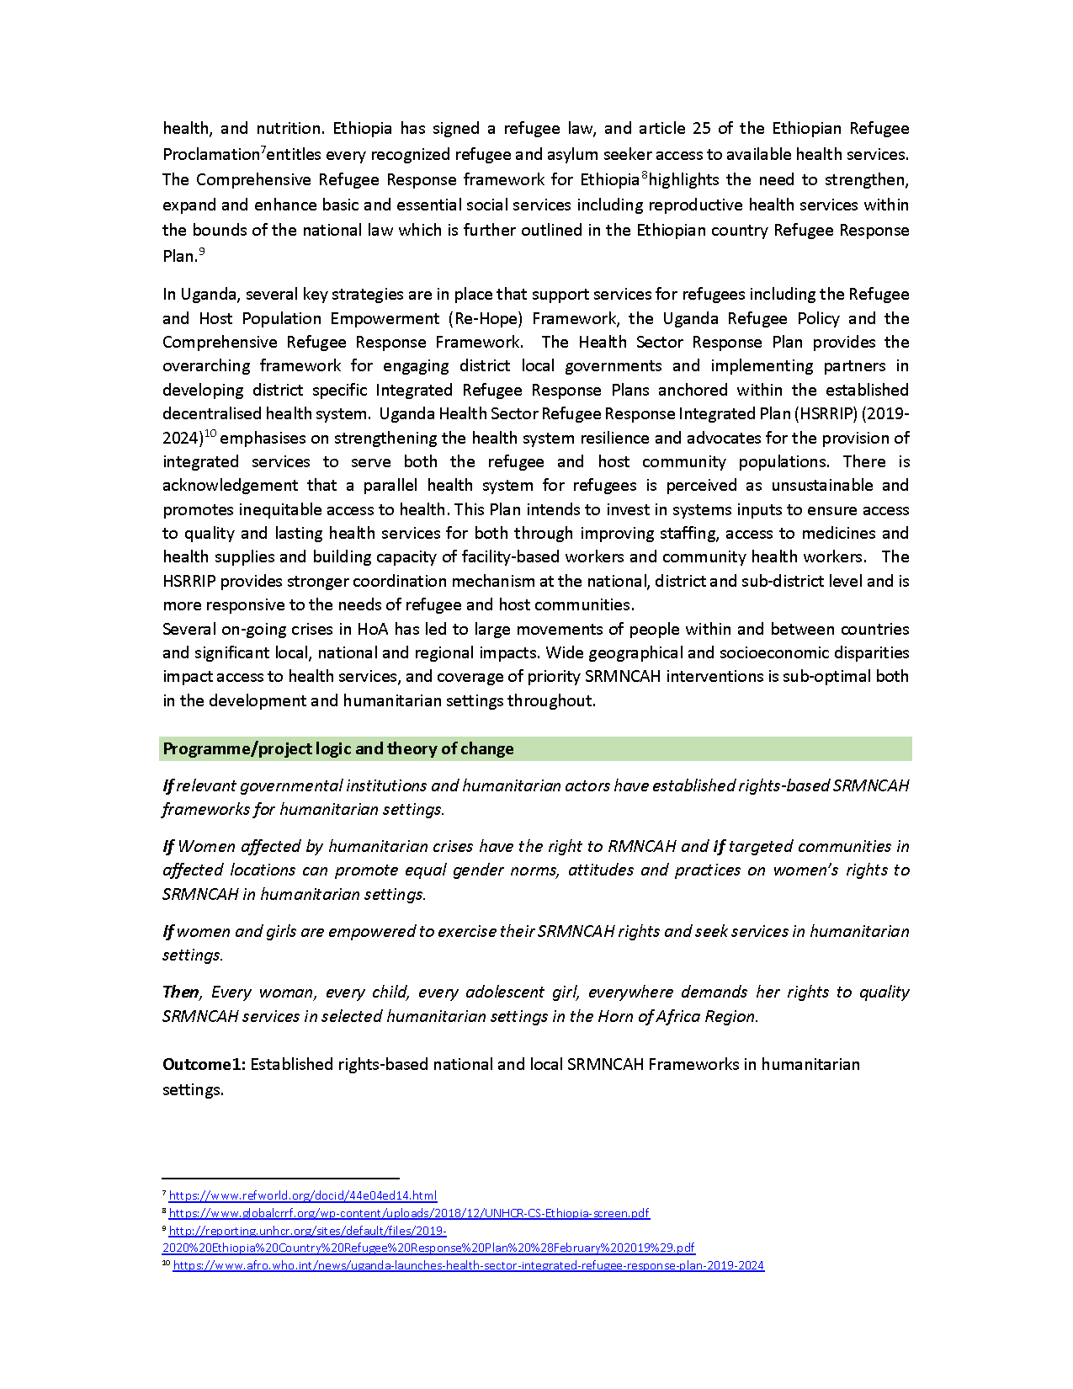

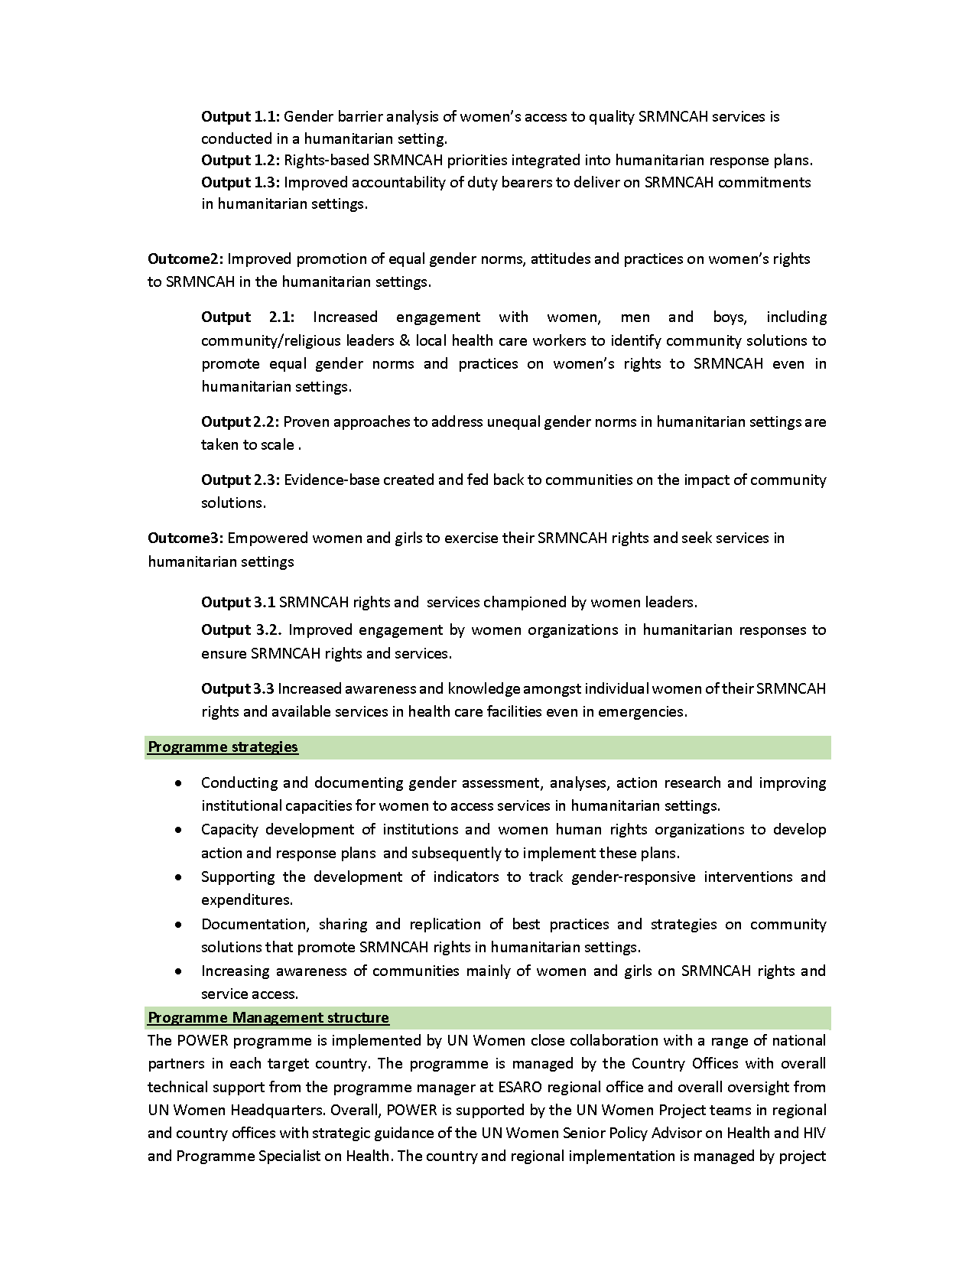

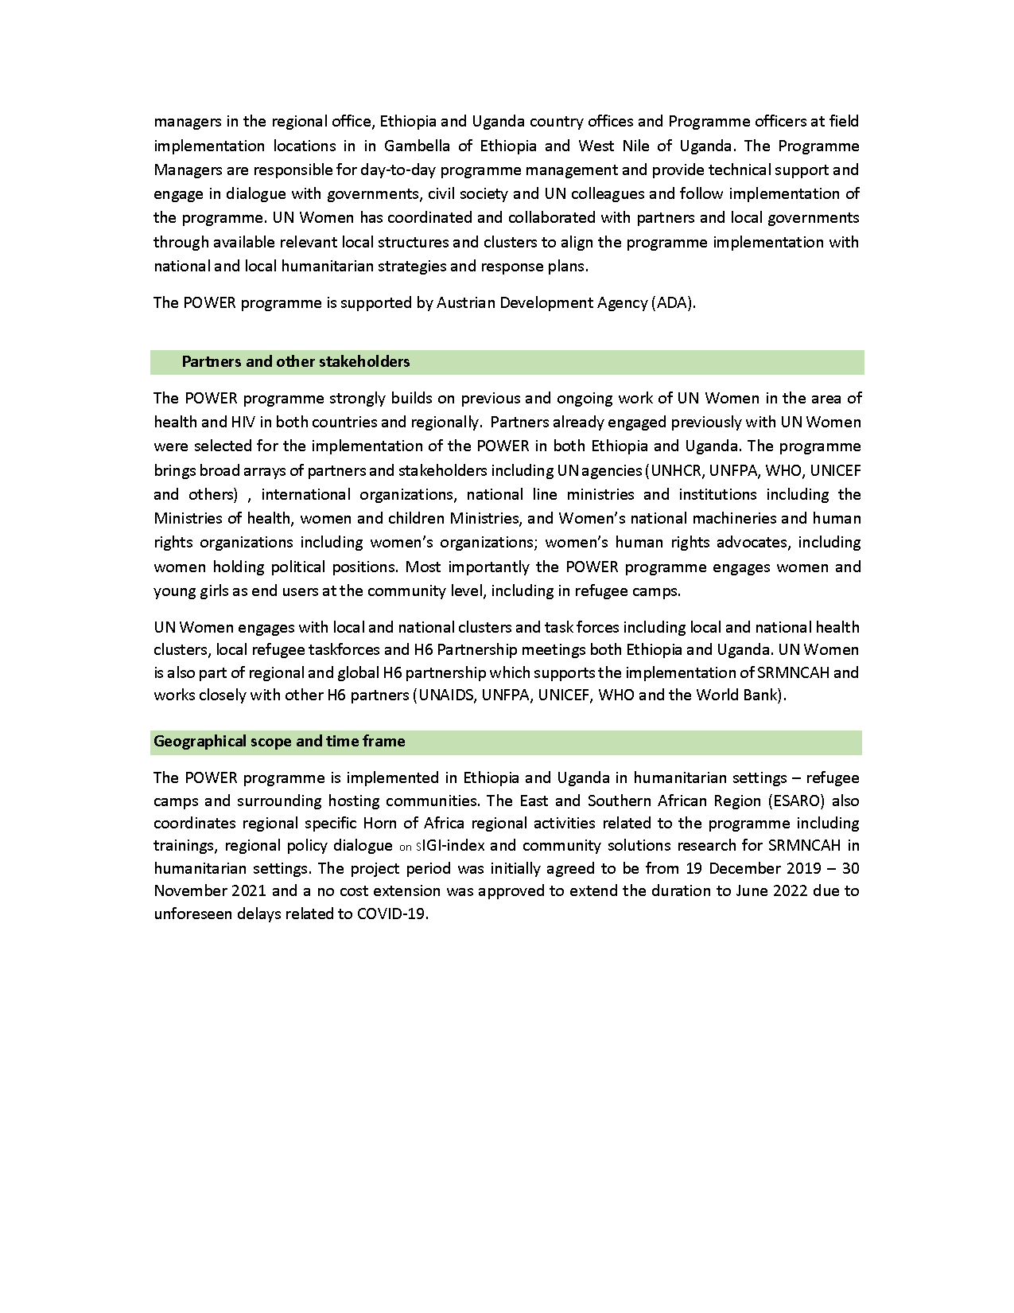

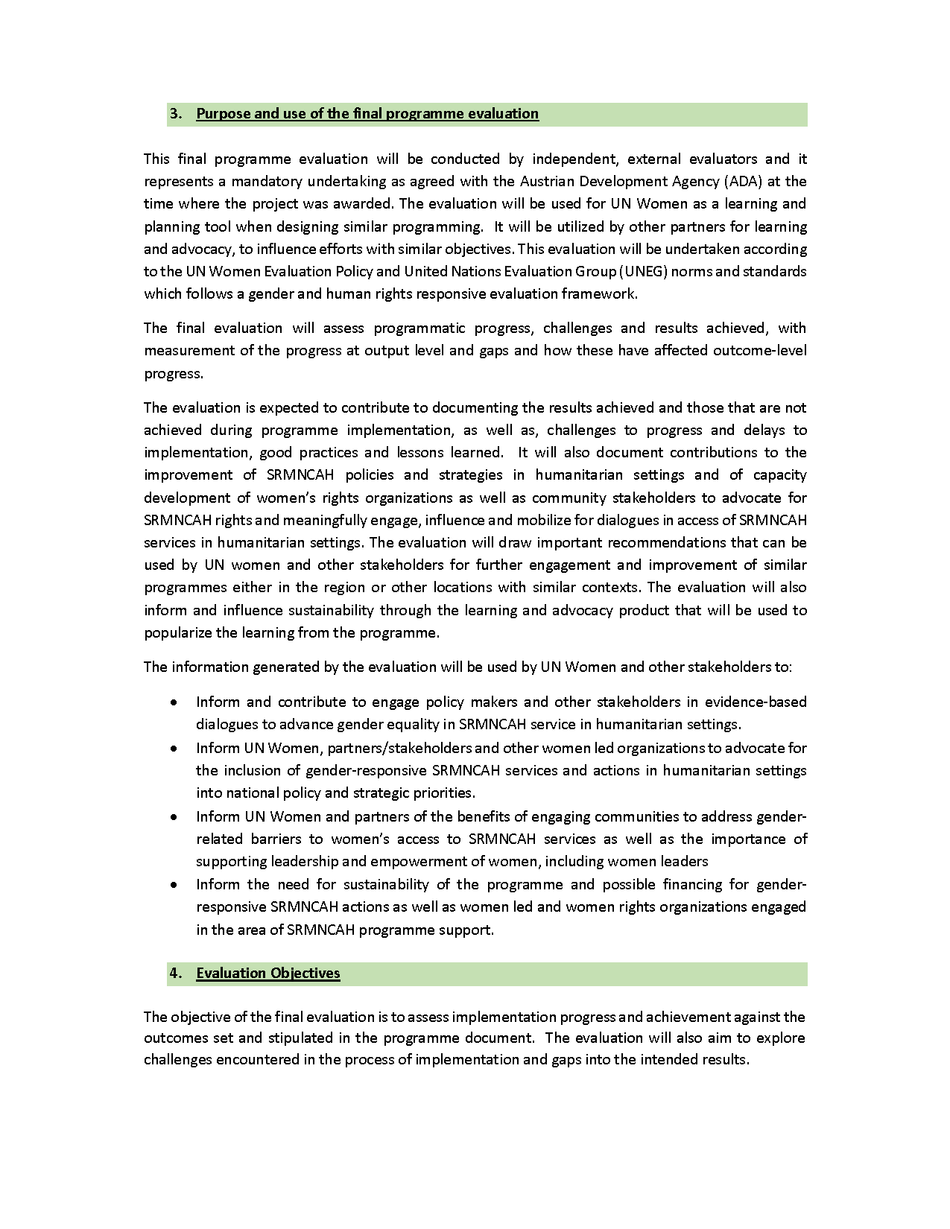

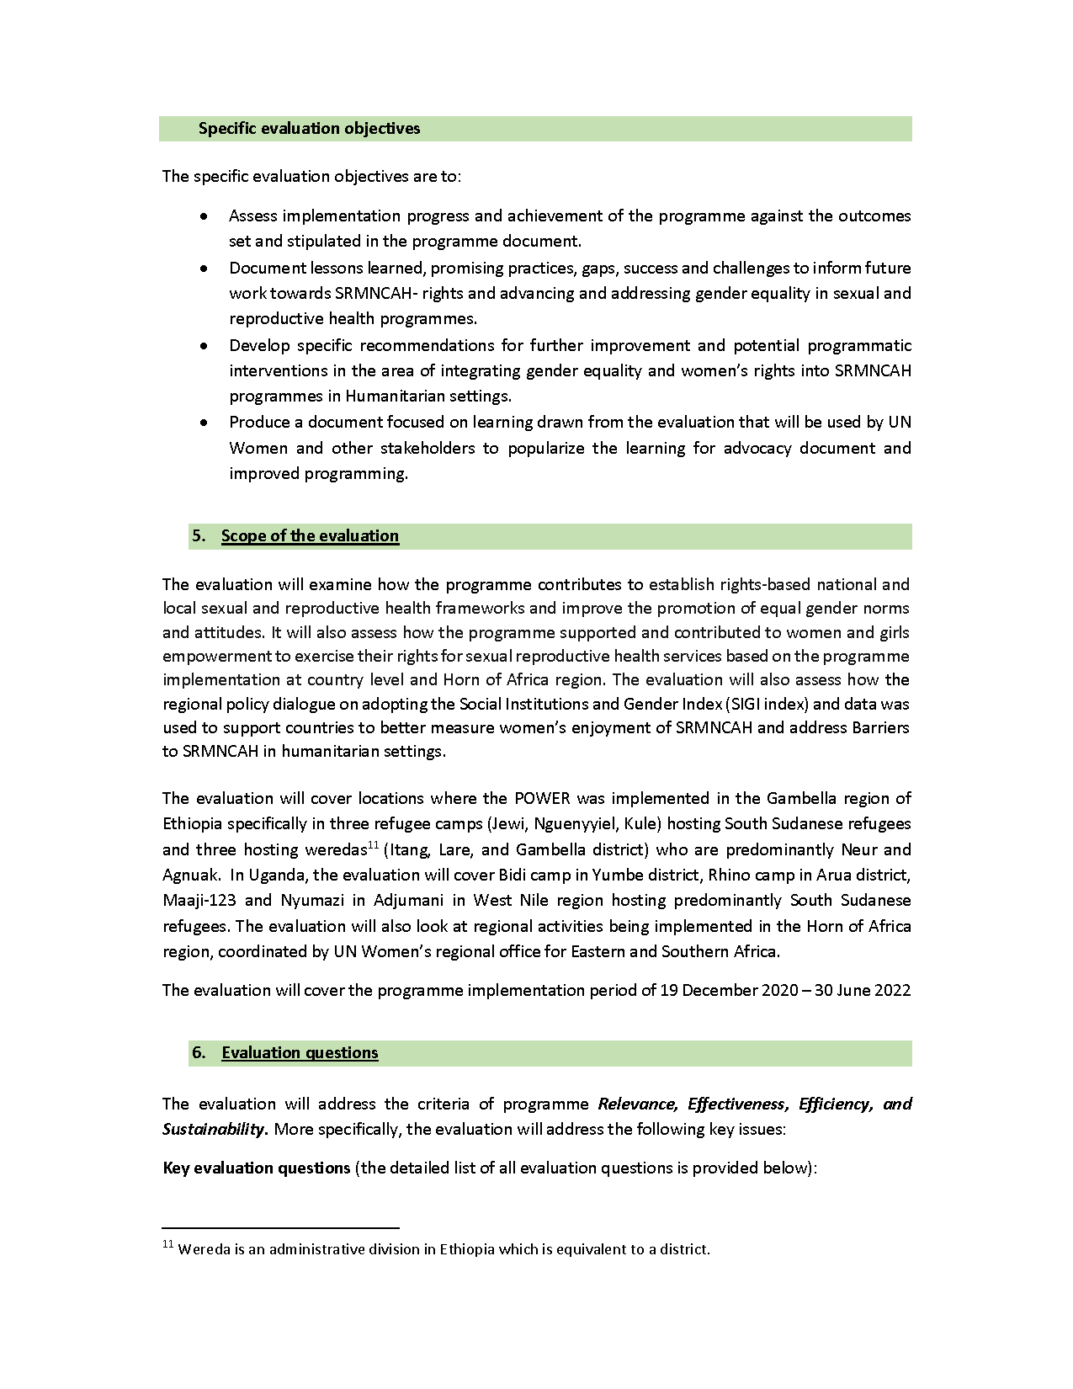

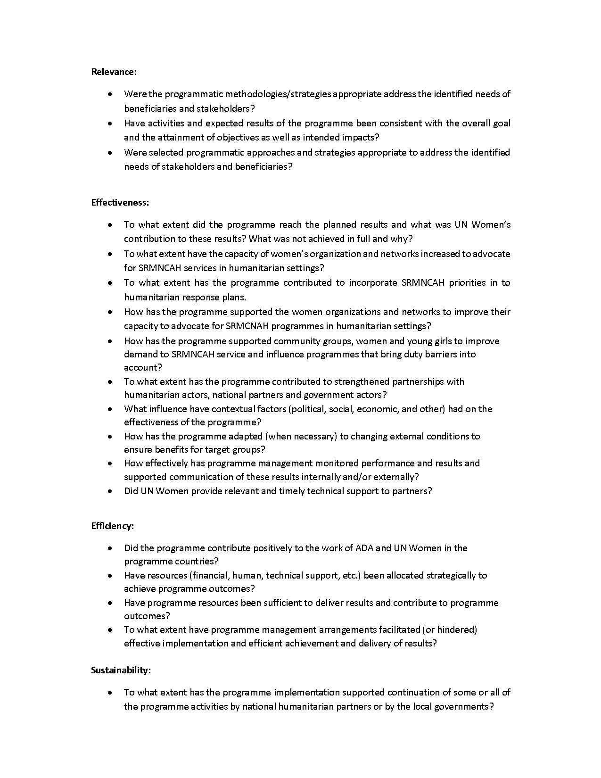

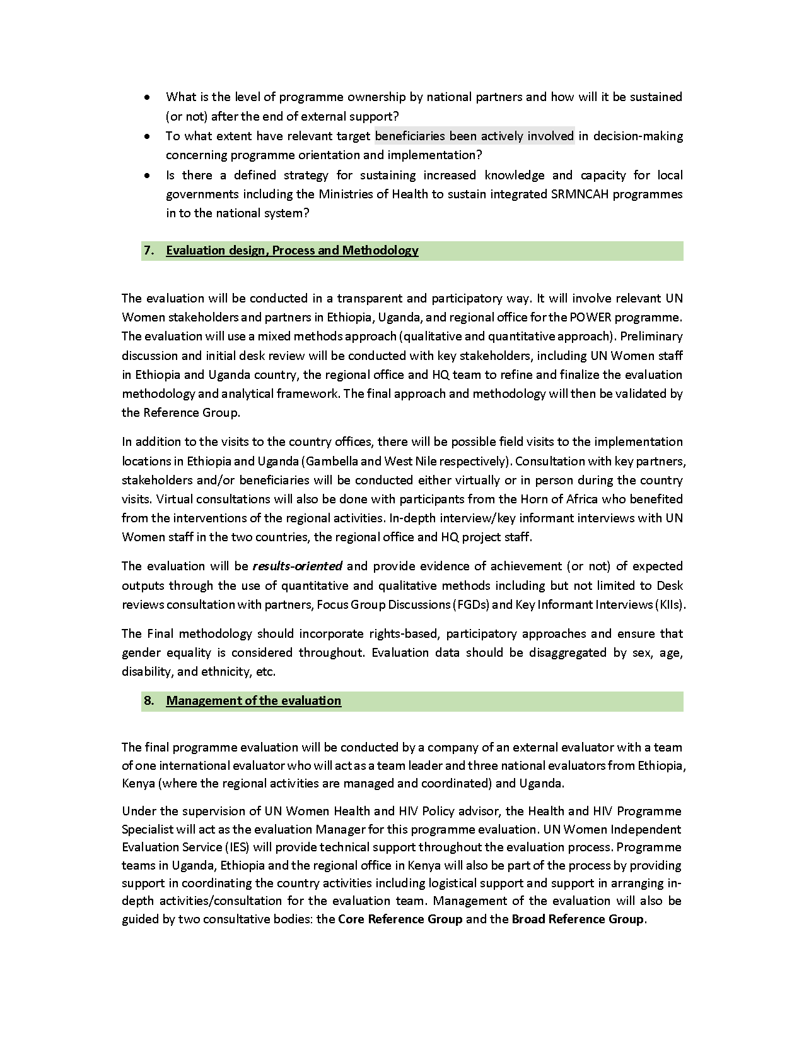

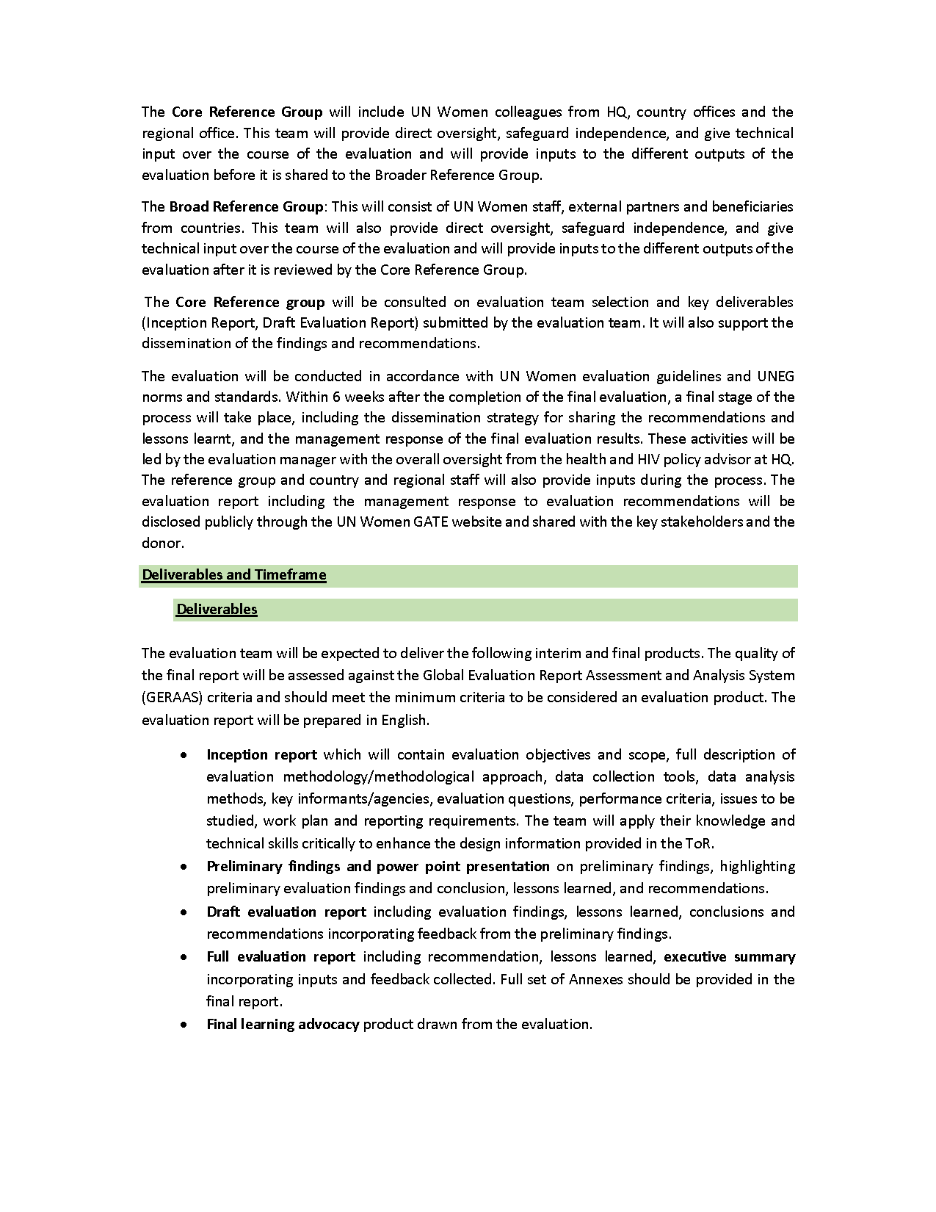

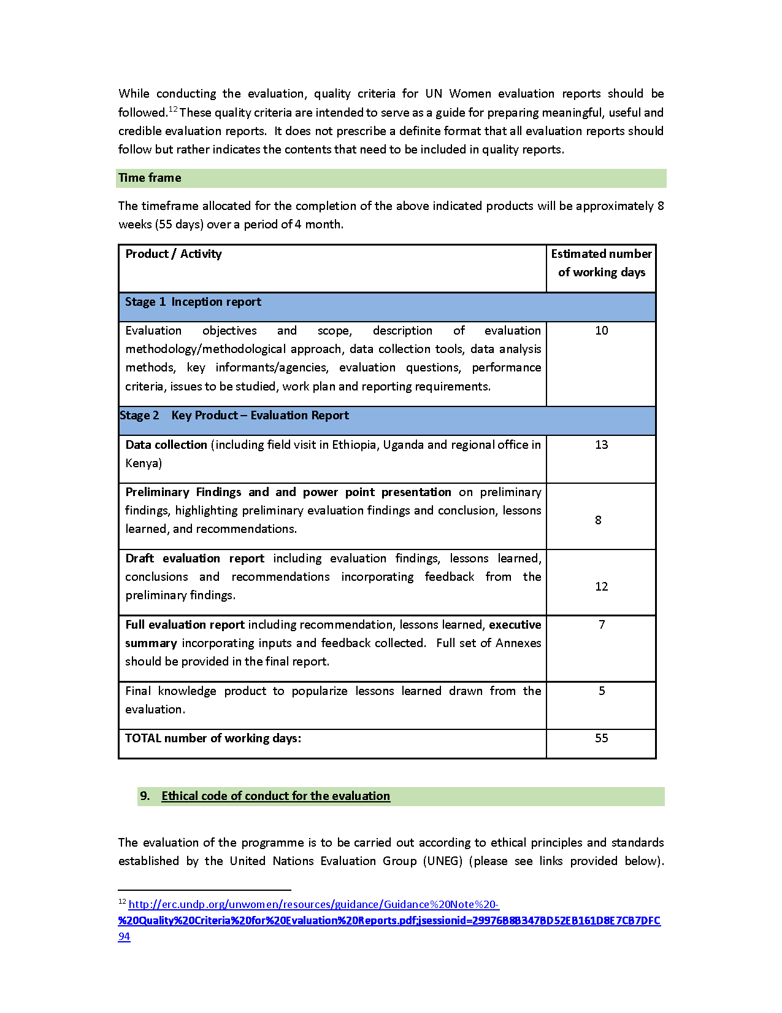

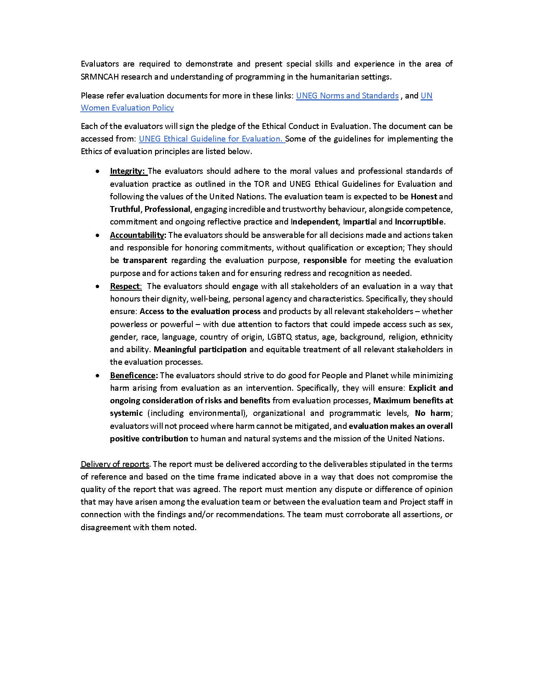

Evaluation Matrix
The Evaluation Matrix is used as a guide for data collection and analysis, and includes evaluation criteria, questions and sub-questions, as well as draft indicators and data sources. Sub-Questions are included to provide additional prompts as we collect and analyze data.

Evaluation questions and sub-questions | Indicators | data sources
EQ 1: How relevant has the programme been in relation to regional, national and local needs, priorities and commitments, and in relation to its envisaged objectives?
Evaluation criteria: Relevance
1.1 To what extent were the objectives of the programme aligned with existing needs, commitments and priorities of development partners at global, regional, and national levels? | - Evidence of alignment of the objectives of the programme with gaps in women and girls’ SRMHNCAH rights in the targeted countries  - Evidence that findings and recommendations of previous assessments or reviews were taken into account to ensure or programme relevance  - Evidence of alignment of the objectives of the programme with programme country government priorities and commitments.  - Evidence of alignment of the objectives of the programme with UN Women and Austrian Development Agency strategies and priorities at global, regional and country levels  - Evidence of the programme building synergies with other similar UN Women interventions and other similar UN system or donor interventions at global, regional, or country levels | - Document and literature review  - Strategic Notes and/or Workplans at the global, regional and country level  - Consultations with UN Women staff at HQ, RO and CO levels  - Consultations with selected programme partners (donor, national government entities, CSOs)  - Consultations with beneficiaries
1.2 How appropriate were the overall programme design, approach, and strategies in view of achieving expected results and available resources? | - Evidence of activities and expected results of the programme having been consistent with the overall goal and the attainment of objectives as well as intended impacts  - Evidence of the validity of the Theory of Change underlying the programme  - Extent to which the programme design was realistic given available resources  - Key stakeholders’ views on strengths and weaknesses of the overall programme design, approach and strategies in relation to addressing the identified needs of stakeholders and beneficiaries  - Evidence of contextualization of strategies and interventions | - Review of programme documents and financial information  - Consultations with UN Women staff at HQ, RO and CO levels  - Consultations with selected programme partners (donor, national government entities, CSOs)  - Consultations with beneficiaries
EQ 2: To what extent did the programme reach the planned results and what was UN Women’s contribution to these results?
Evaluation criteria: Effectiveness and Efficiency
2.1 To what extent did the programme contribute to the establishment of rights-based national and local SRMNCAH frameworks in humanitarian settings? | - Evidence of integration of SRMNCAH priorities into humanitarian response plans  - Changes in the capacity of women’s organizations and networks to advocate for SRMNCAH services in humanitarian settings and hold decision-makers to account  - Stakeholder views on relevant changes and contributions made by the programme under review, and on unplanned (positive or negative) programme effects | - Document and literature review  - Consultations with UN Women staff at HQ, RO and CO levels and at implementation locations  - Consultations with external partners at national (government, advocates, SRMNCAH champions, other UN agencies) and local levels (community members/leaders, women’s organizations, advocates, women and girls in targeted communities
2.2 To what extent did the programme contribute to the promotion of equal gender norms, attitudes and practices on women’s and girls’ rights to SRMNCAH in the humanitarian settings? | - Evidence of increased engagement of women, men and boys, and girls including community/religious leaders & local health care workers to identify community solutions to promote equal gender norms and practices on women’s and girls’ rights to SRMNCAH  - Number of proven approaches to addressing unequal gender norms in humanitarian settings having been taken to scale  - Stakeholder views on (planned and unplanned, positive and negative) effects of the programme  - Evidence of programme contribution to observed changes  - Evidence of other actors’ contributing to observed changes
2.3 To what extent did the programme contribute to empowering women and girls to exercise their SRMNCAH rights and seek services in humanitarian settings? | - Evidence of improved demand for SRMNCAH services (in targeted communities)  - Changes in the capacity of community groups, women leaders, women and young girls to champion SRMNCAH rights and to influence programmes that hold duty bearers to account in this regard  - Changes in the capacity of women’s organizations to engage in humanitarian responses to ensure SRMNCAH rights and services.  - Changes in the awareness and knowledge amongst individual women and girls of their SRMNCAH rights and available services in health care facilities even in emergencies  - Stakeholder views on programme contributions, including on unplanned (positive or negative) programme effects
2.4 What internal factors supported or posed challenges to the achievement or results? | - Evidence of steps taken to adapt the programme to changing external conditions to ensure benefit to target groups  - Processes and mechanisms put in place to ensure effective and efficient performance monitoring and communication of results internally and externally  - Stakeholder view on the quality and timeliness of technical support provided by UN Women  - Evidence of strengthened UN Women partnerships with humanitarian actors, national partners and government actors  - Evidence of programme contributions to the work of UN Women in the programme countries  - Extent to which available programme resources were allocated strategically to achieve results  - Stakeholder views on the extent to which programme management arrangements have, positively or negatively, influenced programme implementation | - Document and literature review  - Consultations with UN Women staff at HQ, RO and CO levels and at implementation locations  - Consultations with external partners at national (government, advocates, SRMNCAH champions, other UN agencies) and local levels (community members/leaders, women’s organizations, advocates, women and girls in targeted communities
2.5 What external factors supported or posed challenges to the achievement or results? | - Types of contextual factors (political, social, economic, other) at global, national and programme levels supporting/hindering effectiveness  - Documented evidence of how contextual factors have supported or hindered programme performance  - Perceptions of key stakeholders on the effects of contextual factors on programme performance
EQ 3: How likely are the benefits and achievements of the programme to be sustained after the programme has ended?
Evaluation criteria: Sustainability
3.1 To what extent has programme implementation supported continuation of some or all of the programme activities by national humanitarian partners or by the local governments? | - Evidence of programme ownership by national partners, e.g. actual or planned resource allocation or integration into relevant plans  - Evidence of targeted beneficiaries having been actively involved in decision-making concerning programme orientation and implementation  - Existence of a defined strategy for sustainability including sustaining increased knowledge and capacity for local governments including the Ministries of Health to sustain integrated SRMNCAH programmes into the national system  - Stakeholder views on degree of national/local ownership of the programme and/or programme elements | - Document review  - Consultations with UN Women staff at HQ, RO and CO levels and at implementation locations  - Consultations with local government representatives and programme beneficiaries

Logic Model for Power
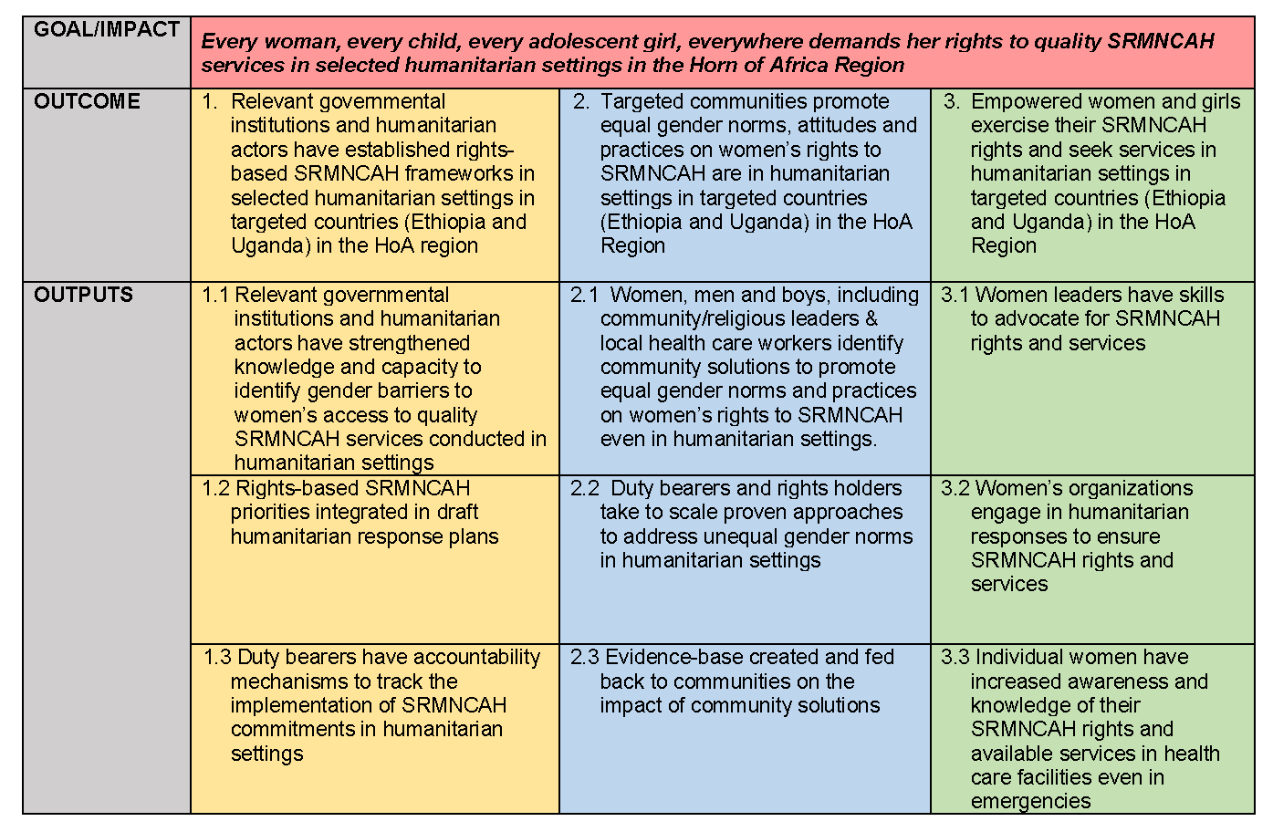
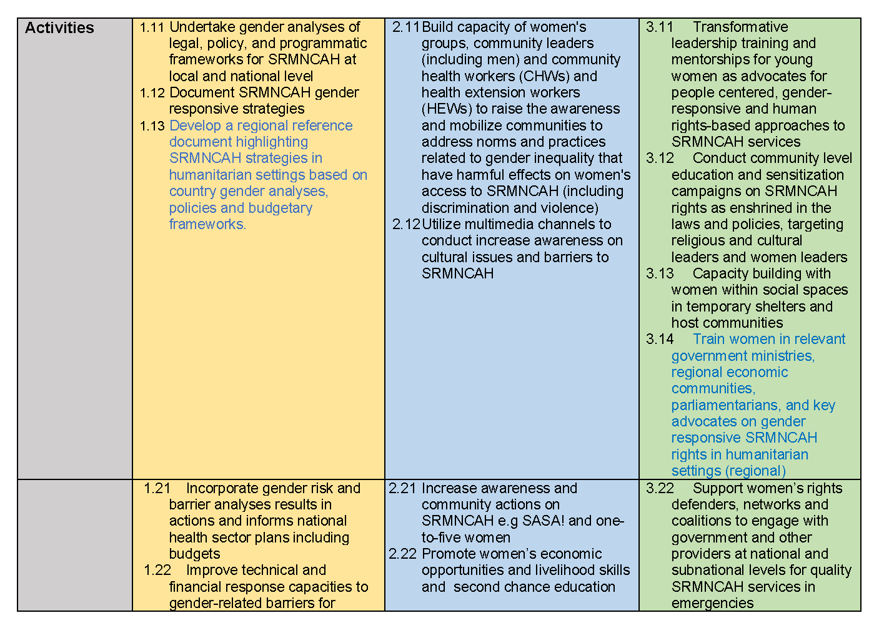
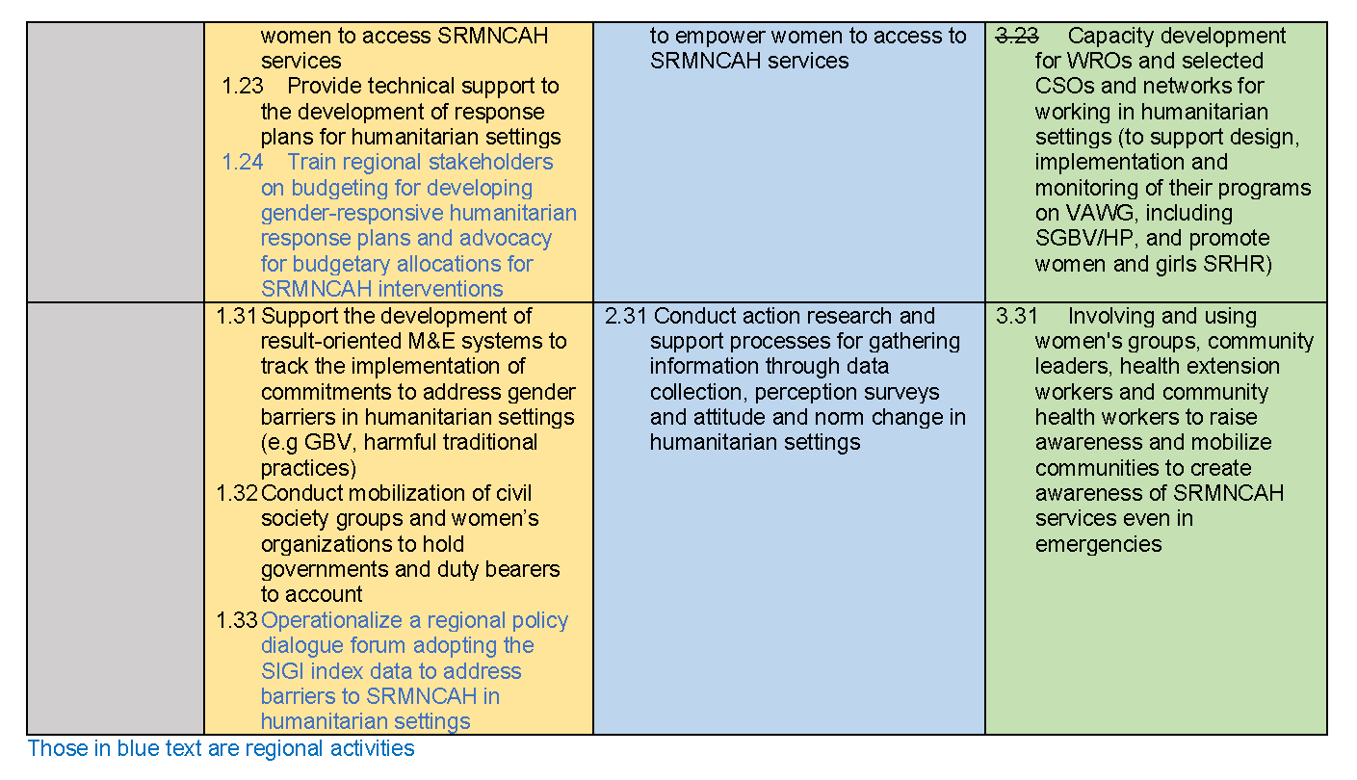

Data Collection Tools
Interview Protocols
Draft Interview Protocols are provided below, which contain a draft list of questions adapted by stakeholder group. Interview Protocols This draft interview guide will be revised once the Inception Note is approved by UN Women.
UN Women Stakeholders
Background
Thank you for agreeing to this interview with Universalia (www.universalia.com). The interview should take 45-60 minutes and will be facilitated by [name of evaluation team member]. The interview will remain entirely confidential and only aggregated data will inform the evaluation report. Participating in interviews is optional, and does not affect their relationship with POWER or UN Women; participants are also free to stop their participation at any point without any consequences.
Summary of Main Points
Interviewer: Please provide the brief, main take-away points from the interview. If you are handwriting and require more space, please use extra sheets of paper.
Responses to Interview Questions
Interviewer: Please provide interviewee(s) responses in bullet points for the questions and sub-questions listed below. If you are handwriting and require more space, please use extra sheets of paper.
  - To what extent was the programme relevant in relation to regional, national, and local needs and priorities?
At the outset, how were existing needs and priorities identified? By whom?
  - Which stakeholders at regional, national or sub-national levels were consulted on the proposed programme approach? What other evidence and considerations informed programme design?
  - What were the main objectives of POWER, and did UN Women have the necessary capacity (financial resources, staff, technical capacity) to meet these objectives?
  - How, and how well, did UN Women adapt the Programme to changes in the context, including the COVID crisis?
- To what extent did the Programme reach its planned results, and what was UN Women’s contribution to these results?
  - What progress was made in terms of establishing or strengthening relevant rights-based national and local SRMNCAH frameworks? How specifically did the programme contribute to observed results?
  - What, if any, changes occurred in terms of the promotion of equal gender norms, attitudes, and practices on women’s rights in the targeted communities? How did the programme contribute to related changes?
  - What changes occurred in terms of women and girls exercising their SRMNCAH rights and seeking services? What were programme contributions in this regard?
  - What, if any, were unplanned (positive or negative) effects of the programme at regional, national, or local levels?
- What internal and external factors either supported or posed challenges to programme implementation and results?
  - What internal factors supported or challenged the achievement of results, with what effects?
  - What external factors contributed to the achievement of results (e.g. political, social, economic)?
- How likely are benefits and achievements of the programme to be sustained after POWER ends?
  - What factors are likely to support continuation of activities and/or consolidating and sustaining gains that have been achieved? (e.g. regional/national/local ownership or leadership; institutionalization of gains in frameworks, policies etc.)
  - What factors or risks pose challenges to the sustainability of gains achieved with programme support?
Government Partners
Background
Thank you for agreeing to this interview with Universalia (www.universalia.com). The interview should take 45-60 minutes and will be facilitated by [name of evaluation team member]. The interview will remain entirely confidential and only aggregated data will inform the evaluation report. Participating in interviews is optional, and does not affect their relationship with POWER or UN Women; participants are also free to stop their participation at any point without any consequences.
Interviewer: Offer all interviewees to provide a summary of what POWER was about and which geographic areas it operated in as some respondents may need a reminder of the particular programme in question.
Summary of Main Points
Interviewer: Please provide the brief, main take-away points from the interview. If you are handwriting and require more space, please use extra sheets of paper.
Responses to Interview Questions
Interviewer: Please provide interviewee(s) responses in bullet points for the questions and sub-questions listed below. If you are handwriting and require more space, please use extra sheets of paper.
- To what extent was the POWER (programme) relevant in relation to existing national and/or local needs and priorities?
  - To what extent were you and/or other government actors consulted and engaged during programme design? Were your views taken into consideration?
  - How relevant were the programme objectives in relation to existing needs and priorities? To what extent were they complementing efforts by other actors/partners?
  - Did UN Women have the necessary capacity (financial resources, staff, technical capacity) to meet its programme objectives?
  - How, and how well, did UN Women adapt the Programme to changes in the context, including the COVID crisis?
- To what extent did the Programme contribute to positive changes in relation to enabling women and girls to demand their rights to quality SRMNCAH services?
  - What progress was made in terms of establishing or strengthening relevant SRMNCAH policies or frameworks? How specifically did the programme contribute to results?
  - To what extent and how did the programme contribute to changes around the promotion of equal gender norms, attitudes, and practices on women’s rights in the targeted communities?
  - What changes occurred in terms of women and girls exercising their SRMNCAH rights and seeking services? What were programme contributions in this regard?
  - What, if any, were unplanned (positive or negative) effects of the programme?
  - What, if any, results that you hoped to see where not, or only partially, achieved?
- What factors either supported or posed challenges to programme implementation and results?
  - What internal factors (characteristics of programme design or management) supported or challenged programme implementation and results? E.g.:
    - Financial resources
    - Geographic scope (number/location of programming sites)
    - Capacity/selection of implementing partner organizations
    - Strengths or weaknesses of overall programme management
  - What external factors contributed to the achievement of results (e.g. political, social, economic)?
- How likely are benefits and achievements of the programme to be sustained after POWER ends?
  - What factors are likely to support continuation of activities and/or consolidating and sustaining gains that have been achieved?
  - What factors or risks pose challenges to the sustainability of gains achieved with programme support?
Implementing Partners
Background
Thank you for agreeing to this interview with Universalia (www.universalia.com). The interview should take 45-60 minutes and will be facilitated by [name of evaluation team member]. The interview will remain entirely confidential and only aggregated data will inform the evaluation report. Participating in interviews is optional, and does not affect their relationship with POWER or UN Women; participants are also free to stop their participation at any point without any consequences.
Summary of Main Points
Interviewer: Please provide the brief, main take-away points from the interview. If you are handwriting and require more space, please use extra sheets of paper.
Responses to Interview Questions
Interviewer: Please provide interviewee(s) responses in bullet points for the questions and sub-questions listed below. If you are handwriting and require more space, please use extra sheets of paper.
- Could you please briefly introduce yourself and your organization?
  - How did your collaboration with UN Women under POWER come about? What was your organization’s role in programme implementation?
  - How long have you been with [name of organization]. What has been your role in implementation of POWER?
  - To what extent were you/was your organization consulted and engaged during programme design? Were your views taken into consideration?
- What have been the main achievements of the programme?
  - What do you consider the main progress or achievements that programme activities contributed to?
    - In terms of (increased) engagement of women, men and boys, community/religious leaders and health workers
    - In terms of solutions/ideas being scaled up
    - In terms of creating/expanding the evidence base of community solutions
    - In terms of changes in the attitudes and/or behaviours of women and girls and groups advocating for their rights (e.g. increase in demand for SRMNCAH services; changes in the work and influence of advocates)
    - Other
  - To what extent and how did you have to adapt your work to respond to contextual changes, including the COVID crisis? What were the effects of these adaptations?
  - What, if any, were unplanned (positive or negative) effects of the programme?
  - What, if any, results that you hoped to see where not, or only partially, achieved?
- What factors either supported or posed challenges to your work?
  - What internal factors within your organization either supported or posed challenges to your work?
    - Numbers of staff; staff experience/skills; staff turnover
    - Networks/partnerships
    - Financial resources
    - Programming strategies (did any strategies turn out to be more or less successful than other? Why?
  - What were strengths or weaknesses of UN Women’s overall programme management? E.g.:
    - to what extent were UN Women requirements for programme planning, monitoring, and reporting clear and appropriate?
    - How frequent, purposeful, and helpful was your communication with UN Women?
    - Was the amount of flexibility that you were allowed to adapt your work to evolving contexts appropriate?
    - Other
  - What external factors contributed to the achievement of results (e.g. political, social, economic)?
- How likely are benefits and achievements of the programme to be sustained after POWER ends?
  - To what extent is your organization planning to/able to continue or build on achievements reached under POWER? What factors determine this?
  - What other factors are likely to support continuation of activities and/or consolidating and sustaining gains? (e.g. ownership or leadership by government or non-government actors/in communities; changes in relevant frameworks, policies etc.)
  - What factors or risks pose challenges to the sustainability of gains achieved with programme support?
UN Women Partners (e.g. other UN Agencies/MDBs/intl. NGOs working on SRMNCAH issues)
Background
Thank you for agreeing to this interview with Universalia (www.universalia.com). The interview should take 45-60 minutes and will be facilitated by [name of evaluation team member]. The interview will remain entirely confidential and only aggregated data will inform the evaluation report. Participating in interviews is optional, and does not affect their relationship with POWER or UN Women; participants are also free to stop their participation at any point without any consequences.
Interviewer: Offer all interviewees to provide a summary of what POWER was about and which geographic areas it operated in as some respondents may need a reminder of the particular programme in question.
Summary of Main Points
Interviewer: Please provide the brief, main take-away points from the interview. If you are handwriting and require more space, please use extra sheets of paper.
Responses to Interview Questions
Interviewer: Please provide interviewee(s) responses in bullet points for the questions and sub-questions listed below. If you are handwriting and require more space, please use extra sheets of paper.
- To what extent was the POWER (programme) relevant in relation to existing national and/or local needs and priorities?
  - How relevant were the programme objectives in relation to existing needs and priorities?
  - To what extent were programme objectives building on and/or complementing efforts by other actors, including (if applicable) those of your own organization? Can you give an example?
- To what extent did the Programme contribute to positive changes in relation to enabling women and girls to demand their rights to quality SRMNCAH services?
  - Since 2019, what progress was made in terms of establishing or strengthening relevant SRMNCAH policies or frameworks? How specifically did POWER contribute to related changes?
  - During the 2019-2022 period, what changes occurred around the promotion of equal gender norms, attitudes, and practices on women’s rights in the targeted communities? What, if any, were related contributions of the POWER initiative?
  - What changes occurred in terms of women and girls exercising their SRMNCAH rights and seeking services? What were programme contributions in this regard?
  - Were there any results that you had hoped to see but that where not, or only partially, achieved? If so, which?
- What factors either supported or posed challenges to programme implementation and results?
  - What internal factors () likely supported or challenged programme implementation and results? E.g.:
    - Characteristics of programme design (e.g. scope, focus, resources)
    - Characteristics of programme management (e.g. partnerships/networking; selection/management of implementing partner organizations; communication)
    - Other
  - What external factors contributed to the achievement of results (e.g. political, social, economic)?
- How likely are benefits and achievements of the programme to be sustained after POWER ends?
  - What factors are likely to support continuation of activities and/or consolidating and sustaining gains that have been achieved?
  - What factors or risks pose challenges to the sustainability of gains achieved with programme support?
Focus Groups Facilitation Guide
Final Evaluation of POWER – Programme On Women’s Empowerment in Sexual, Reproductive, Maternal, New-born, Child and Adolescent Health (SRMNCAH) rights in humanitarian settings in the Horn of Africa Region

FGD FACILITATION GUIDE (GENERIC)

Interviewer(s)
Date:
Location (e.g. camp name):
Name of beneficiary group:
Total number of participants | # of wo-men | # of men | Local govt | Community or religious leader(s) | NGO/  CSO | Respondent age group / Respondent profile | Related to which pro-gramme output
Introduction
Good morning/afternoon everyone. Thank you for being with us today. We appreciate the time you are spending with us. Before we start, I would like to introduce myself/our team.
My/our names are [insert name/names]. We have been hired by UN Women to conduct this study to know more about POWER, a programme on sexual and reproductive health. As part of this, we want to learn more about your experiences in receiving support from UN Women/from [insert name/names of implementing partner], any benefits you’ve had as a result of these activities, any challenges you’ve faced, and also any recommendations you may have for UN Women/[implementing partner] for the future.
To be clear, we are not UN Women/ [implementing partner] staff.
This discussion should take between 1.5 hours and 2 hours.
Confidentiality and consent
Your participation in this group discussion is voluntary, and you can refuse to answer any questions, or choose to leave this discussion at any time. Refusal to participate will not affect your support from UN Women/[implementing partner] now or in the future. This meeting does not have any impact on whether you or your family receives any assistance.
The information you provide is confidential. This means that your names and identity details will be kept secret and not included when presenting the research findings. There will be no way to identify who provided this information.
By participating in this discussion, you will help us understand what has been working well with the program, what the challenges are, and how UN Women/[implementing partner] can make similar programs better in the future.
We value your input, and there are no wrong answers but only different points of view - please share your viewpoint even if it differs from others’ comments.
Can you please confirm that you would still like to go ahead with participating in this FGD?
[To the moderator: If any participant does not want to participate, please thank them for their time and proceed with group participants who have given consent.]
Participants’ introductions
Everyone introduce themselves by mentioning name, displacement details (e.g. where she/he is from—if no security risks are involved in answering—how long she/he has been displaced) and family situation.
Ground rules
- The most important rule is that only one person speaks at a time. There may be a temptation to jump when someone is talking but please wait until they have finished speaking
- In this discussion, there are no right or wrong answers. We want to understand your opinions and preferences, and respect all input
- Occasionally, I may repeat some of the things you say to make sure I understand them correctly. If what I summarize is wrong, please correct me.
- When you have something to say, please do so. There are many of you in the group and it is important that I hear the views of each of you. You don’t need to agree with what other people in the meeting say.
Does this sound good to you? Do you have any questions before we begin?
- Getting a sense of POWER-related services received by participants
- Please raise your hand if you participated in meetings or workshops/trainings with UN Women/[implementing partner]
- Please raise your hand if you received information material (posters, brochures) on gender equality and/or women’s health and rights from UN Women/[implementing partner]
- Please raise your hand if you have been involved in awareness-raising programmes.
- Please raise your hand if you have received house-to-house visits.
- Please raise your hand if you have received education services from UN Women/[implementing partner]
- Please raise your hand if you have received referral services from UN Women/[implementing partner]
- Please raise your hand if you have been supported with in-kind or grants support (e.g. start-up capital to open a business) from UN Women/[implementing partner].x
[Note numbers of participants that raise their hands for each, in particular numbers of men and women, if a group is mixed-gender.]
- Programme relevance and contributions to results
- Think about 2-3 years ago. At the time, what difficulties did women and girls face when trying to access quality SRMNCAH services [such as xxx]?
  - Optional prompts: E.g. challenges related to the availability or quality of SRH services (e.g. delivery, FP, ANC); communities/women and girls being aware of existing services; communities/men/families supporting women and girls in accessing existing services; other issues such as food, shelter, or children’s health and needs being higher priority
- Over the past 2-3 years, what have been the most important changes that have occurred in your community? To what extent did UN Women/Implementing Partner activities contribute to these? Could you give a concrete example?
- How were you consulted on the type of UN Women/[implementing partner] activities available? Do you feel that your inputs have influenced the type of programming provided?
Is there anything that you wished UN Women/[implementing partner] had one more or less of, or had done differently than they did?
- Are there any other organizations active in the community that provide the same or similar assistance? Did UN Women//[implementing partner] work with them on this?
- Likely sustainability of gains
- You mentioned several positive changes that have occurred in your community. What needs to happen for these changes to be maintained?
  - This could relate to, for example, attitudes within the community; the availability of services; new/changing needs; competing priorities)
- Are there any needs in relation to SRH services for women and girls that are not yet met? If yes, which ones are the most important/urgent ones?
- Do you have any suggestions for UN Women/[implementing partner] for future improvements of similar programmes?
Closing
Thank you for sharing your experiences and opinions with us. We really appreciate the time you’ve taken to speak with us.
Before we end the discussion, do you have any questions for us

Stakeholder Mapping
Stakeholder | Key Actors identified
Internal (UN Women) Stakeholders
Regional Office (RO) & HQ | Programme Manager(s)  UN Women Project Teams  UN Women Senior Policy Advisor on Gender Equality, Health and HIV  UN Women Programme Specialist on Health  UN Women ESARO Deputy Regional Director  UN Women ESARO Evaluation Specialist  UN Women HQ Evaluation Specialist  UN Women ESARO Policy Specialist - EVAW
Country Office (CO) Ethiopia | Programme Manager(s)  UN Women Project Teams  UN Women Programme Specialist on EVAWG and HR  UN Women Programme Analyst
Country Office (CO) Uganda | Programme Manager(s)  UN Women Project Teams  UN Women Programme Specialist on LNoB  UN Women Monitoring and Evaluation Specialist for Uganda
External Stakeholders
Donors | Austrian Development Agency (ADA)
Regional Actors | African Union and IGAD
UN Agencies | H6 Partnership focal points: UNFPA, UNAIDS, UNICEF, WHO  UNHCR (who co-chair monthly refugee health coordination meetings in Uganda)  UNOCHA  Joint Program Partners: UNHCR, UNDP and UNFPA on safety and access to justice.  Relevant humanitarian clusters: Health and protection clusters, GBV clusters, Reproductive Health Cluster (Ethiopia), etc.
Government Actors | National, District, Sub-District Level governments, including:  Refugees and Returnees Services (RRS), formerly the ARRA  Regional Health Bureau  Prime Minister Office of Uganda  Ministry of Health (Ethiopia and Uganda)  Ministry of Finance (Ethiopia)  Ministry of Women, Children and Youth Affairs (Ethiopia)  Woreda Health Bureau and Health Posts (Ethiopia)  Ministry of Gender, Labour and Social Developments (Uganda)  Regional Health Bureau (Ethiopia)  Woreda Health Bureau and Health Posts (Ethiopia)  Ethiopian Public Health Emergency Management institute (EPHI)  Ethiopian Human Rights Commission (EHRC)  SGBV, Protection and Gender Reference Group (Uganda)  Protection and Sexual Exploitation and Abuse Working Group (Uganda)  Health and Nutrition Working Group (Uganda)  Public Health Officers and District Health Offices partners in each refugee hosting district (Uganda)
NGOs/CSOs and Local Women’s Rights Organizations (WROs) | Ethiopia:  Rehabilitation and Development Organization (RaDO)  Network of Women Associations (NEWA)  National Network of HIV Positive Women (NNPWE)  Local refugee taskforces  “Agent of changes” and community leaders  Mother to mother support group  One-to-five Women Network  Health Extension Workers (HEW)  Community Health Workers (CHW)
NGOs/CSOs and Local Women’s Rights Organizations (WROs) | Uganda:  Local refugee taskforces
Implementing Partners | Ethiopia:  International Medical Corps (IMC)
Implementing Partners | Uganda:  Forum for African Women Educationalist (FAWE),  International community of Women living with HIV/AIDS in East Africa (ICWEA),  Uganda Network of Young people living with HIV/AIDS (UNYPA),  Alliance of Women Advocating for Change (AWAC)

List of Interviewees
No. | STAKEHOLDER GROUP | ORGANIZATION | ROLE/POSITION | GENDER
REGIONAL/HQ
1 | Government | Ministry of Health |  | Female
2 | Government | Ministry of Gender, Child and Social Welfare |  | Female
3 | NGOs/CSOs and WROs | NEPWU |  | Female
4 | NGOs/CSOs and WROs | Jonglei State Women Association |  | Male
5 | Regional Office (RO) | UN Women ESARO | Policy Specialist - EVAW | Female
6 | RO | UN Women ESARO | UN Women Deputy Regional Director East & Southern Africa | Female
7 | RO | UN Women ESARO | UN Women Project Teams | Female
8 | RO | UN Women ESARO | UN Women ESARO Evaluation Specialist
9 | HQ | UN Women HQ |  | Female
10 | HQ | UN Women HQ |  | Female
ETHIOPIA
11 | CO | UN Women | Deputy Country Representative and Head of Office a.i | Male
12 | CO | UN Women |  | Female
13 | CO | UN Women |  | Male
14 | CO | UN Women |  | Female
15 | Government | Refugee and Returnee Affairs (RRA) | Health and Nutrition Team Leader | Male
16 | Government | Ministry of Health | Women, Children and Youth Directorate | Female
17 | Government | Gambella Regional Health Bureau | MNCH Director | Male
18 | Government | Ministry of Women, Children and Youth Affairs |  | Male
19 | Government | Gambella town WCYA | WE Core processor | Male
20 | Implementing partners | International Medical Corps (IMC) | Health PC | Male
21 | Implementing partners | International Medical Corps (IMC) | SRH Program Manager (Gambella) | Male
22 | Implementing partners | Jawi camp IMC | SRH Program Officer | Female
23 | Un Agencies | UNCHR |  | Male
UGANDA
24 | CO | UN Women |  | Female
25 | CO | UN Women |  | Male
26 | Implementing partners | AWAC |  | Female
27 | Implementing partners | FAWE |  | Female
28 | Implementing partners | FAWE |  | Male
29 | Implementing partners | ICWEA |  | Female
30 | Implementing partners | UNYPA |  | Female
31 | Implementing partners | AWAC/FAWE-U- | AWAC/FAWEU field officer for Terego district | Female
32 | Implementing partners | FAWE-U | FAWE-U field officer for Yumbe district | Male
33 | Implementing partners | FAWE-U | FAWE-U field officer for Adjumani district | Female
34 | Implementing partners | UNYPA | UNYPA field officer for Adjumani district | Female
35 | Government | Terego District-Level Government (DLG) | ADHO-MCH | Female
36 | Government | Terego DLG | DCDO | Male
37 | Government | Terego DLG | Chairperson Social Services | Male
38 | Government | Terego DLG | Senior Midwife | Female
39 | Government | Terego DLG | Councilor | Male
40 | Government | Yumbe DLG | DSFP/EPI-ADHO-MCH | Male
41 | Government | Yumbe DLG | Senior district gender officer | Male
42 | Government | Yumbe DLG | Chairperson Social Services | Male
43 | Government | Yumbe DLG | Senior Midwife | Female
44 | Government | Yumbe DLG | Dist. Deputy Speaker | Male
45 | Government | Yumbe DLG | Councilor | Male
46 | Government | Adjumani | Senior CDO | Male
47 | Government | Adjumani | Dist. Deputy Speaker | Male
48 | Government | Adjumani | Vice chairman RWC Agojo | Female

Evaluation Team and Timeline

Evaluation Team Members’ Roles and Responsibilities
The review team was comprised of Katrina Rojas, Meaghan Shevell, Wubet Girma, and Laura Kyirinkindi, who bring a mix of prior experience and expertise that is relevant to this evaluation. Their role and responsibilities in the evaluation are outlined in the table below.
Team Member | Role | Key responsibilities
Katrina Rojas | Team Leader  Senior Evaluation Consultant | Overall responsibility for all aspects of the Evaluation, including the quality and timely submission of deliverables
Meaghan Shevell | Project Manager  Evaluation Consultant | Main liaison with client, provided support for document review, data collection, analysis, and report writing. Conducted remote data collection with regional stakeholders.
Wubet Girma | National Consultant (Ethiopia) | Contributed to data collection planning and methodology development. Conducted data collection in Ethiopia, and contributed to document review and analysis.
Laura Kyirinkindi | National Consultant (Uganda) | Contributed to data collection planning and methodology development. Conducted data collection in Uganda, and contributed to document review and analysis.

Evaluation Timeline and Deliverables
Reporting to UN Women Evaluation Manager, the evaluation team produced the following deliverables according to the timeline in the table which follows.
- Inception Report: Included evaluation objectives and scope, description of the evaluation methodological approach and methodology, data collection tools, data analysis methods, key stakeholders, evaluation questions and criteria, with work plan and requirements.
- Preliminary Findings Presentation: Preliminary evaluation findings were presented to the reference group for feedback and validation.
- Draft Evaluation Report: Included evaluation findings, lessons learned, conclusions and recommendations. The draft report was informed by feedback received from the preliminary findings presentation.
- Full Evaluation Report and ADA Results Assessment Form (RAF)
- Final knowledge product, which contains high-level key findings and lessons learned

Mapping POWER Results
Notes: The information presented below is solely based on document review. Unless there is a footnote indicating a source document, the information is based on UN Women’s draft Final Narrative Report from 2022 to be submitted the Austrian Development Agency.
Legend
Target(s) fully met
Target(s) partially met/some progress
Target(s) not met/no progress
Target(s) could not be measured or no data available

 | Outcome 1
Results statements | Established rights-based national and local SRMNCAH Frameworks in humanitarian settings  - Policy-level focus: bolstering SRMNCAH commitments and policies by raising awareness and building capacities of rights-holders and duty-bearers.  - Strengthen and support duty bearers with sufficient evidence and improved rights-based national and local SRMNCAH frameworks and promote gender equality to ensure they are applied to the relevant humanitarian contexts.  - Addressing structural issues by working together with national and local authorities.  - This includes policy dialogue at the regional level
Indicators & Targets | - Number of rights-based SRMNCAH frameworks developed and approved in humanitarian contexts  TARGET: At least 2 per country and at the regional level  - Number of humanitarian plans incorporating recommendations from newly established SRMNCAH frameworks.  TARGET: At least 1 National plan per country
Indicator status
Results data | - Ethiopia: One SRMNCAH framework on prevention and responding to child marriage was developed and approved at sub-national level. (Preventing and Responding to Child Marriage in Gambella Region and Refugee Camps in Gambella)  Uganda: No evidence  Regional: No evidence  - Ethiopia: One humanitarian plan developed and approved: Multi-sectoral gender-responsive action plan on SRMNCAH (The Role of Gender Barriers and Gender Inequality on Sexual Reproductive, Maternal, Neonatal, and Adolescent Health (SRMNCAH) Service Utilization in Host and Refugee Communities in Gambella)  Uganda: Two national action plans integrated SRMNCAH priorities in humanitarian settings in Uganda: National Health Preparedness and Emergency Response plan and National Policy for Disaster Preparedness and Management  POWER also led to new policy commitments to address women’s and girls’ SRMNCAH needs in humanitarian contexts, as reflected in Uganda’s United Nations Sustainable Development Cooperation Framework 2021–2025

 | Output 1.1 | Output 1.2 | Output 1.3
Results statements | Gender barrier analysis of women’s access to quality SRMNCAH services in conducted in humanitarian setting | Right-based SRMNCAH priorities integrated into humanitarian response plans | Improved accountability of duty bearers to track SRMNCAH commitments in humanitarian settings
Indicators & Targets | Gender risk analyses of women’s access to SRMNCAH services conducted in each of the countries  TARGET: To be completed in each country in year 1 | Number of action plans that integrate SRMNCAH priorities in humanitarian settings  TARGET: At least one per country | Number and type of institutions strengthened to track implementation of commitments to address gender barriers to SRMNCAH  TARGET: At least 2 per country
Indicator status
Results data | Ethiopia: Three publications: a) 2021 Policy brief on Gender Barrier Analysis on Available Legal and Policy Frameworks for SRMNCAH Rights and Service Access; b) 2022 Report on Documenting SRMNCAH Gender-Responsive Policies and Strategies; c) 2021 Framework on the Role of Gender Barriers and Gender Inequality on Sexual Reproductive, Maternal, Neonatal, Child and Adolescent Health (SRMNCAH) Service Utilization in Host and Refugee communities in Gambella  Uganda: Included as part of regional data below.  At the regional level the Regional Reference Report on Sexual, Reproductive, Maternal, New-born, Child and Adolescent Health in the Horn of Africa which maps out programmes, existing legislative, policy and other frameworks on SRMNCAH and country analyses related to SRMNCAH strategies in humanitarian settings. The Reference Report covers 13 countries, but focuses on the eight countries in the HoA (Djibouti, Eritrea, Ethiopia, Kenya, Somalia, South Sudan, Sudan and Uganda). It highlighted existing gaps in policy and programming in terms of exclusion of women as rights holders and insufficient investments in data collection, monitoring and barriers to women and girls on SRMNCAH rights. | Ethiopia: Drawing on the collaboration around the development of the Multi-Sectoral Response Plan (The Role of Gender Barriers and Gender Inequality on Sexual Reproductive, Maternal, Neonatal, and Adolescent Health (SRMNCAH) Service Utilization in Host and Refugee Communities in Gambella), partners and the government have jointly developed an action plan and shared responsibilities to support implementation. A response plan on “Preventing and Responding to Child Marriage in Gambella Region and Refugee Camps Gambella, Region” was developed, approved by the regional government, and disseminated in the region in November 2021. In addition, POWER supported integration of SRMNCAH priorities in COVID-19 socio-economic response plans (COVID-19 economic response plan)  Uganda: Two national action plans integrated SRMNCAH priorities in humanitarian settings in Uganda: National Health Preparedness and Emergency Response plan and National Policy for Disaster Preparedness and Management.  POWER also led to new policy commitments to address women’s and girls’ SRMNCAH needs in humanitarian contexts, as reflected in Uganda’s United Nations Sustainable Development Cooperation Framework 2021–2025 | Ethiopia: 2 at national level; 7 in Gambella region.  - National level  - MoH  - National Network of Positive Women Ethiopia  - Sub-national level: Gambella  - Health Bureau  - Wereda health offices  - Women and Child Affairs Office  - Education Office  - RRS  - Finance, Economic and Development Bureau  Uganda: 6 national institutions; 4 sub-national institutions, including CSOs.  - National level  - MoH  - MoES  - MoGLSD  - Health Bureau  - RRS  - Ministry of Finance, Planning and Economic Development  - Sub-national level  - International Community of Women living with HIV Eastern Africa (ICWEA)  - Uganda Network of Young People Living with HIV/AIDS (UNYPA)  - Alliance of Women Advocating for Change (AWAC) (works with Commercial Sex Workers)  - Reach A Hand Uganda for Young People (promotion of SRHR)  In addition, at regional level:  - duty bearers from the Horn of Africa (64 government and civil society participants (43 women and 21 men) participated in 4 round policy dialogues on the SIGI. Participating countries: Djibouti, Ethiopia, Kenya, Somalia, South Sudan, Sudan, and Uganda  - POWER’s approach included training on GRB for government, statisticians, civil society organizations and United Nations staff working in humanitarian roles and contexts in Djibouti, Ethiopia, Kenya, Somalia, Sudan, South Sudan and Uganda. The capacity building session provided around 30 country and regional participants from seven countries with information on the processes and steps of gender analysis and GRB to ensure gender-specific barriers to SRMNCAH are included in budget allocations for SRMNCAH. Although participants were able to practise skills independently following the training, UN Women recognized the need to provide additional support. More than a third of participants went on to receive mentoring and follow-up training on the approaches used in different gender budgeting initiatives.

 | Outcome 2
Results statements | Improved promotion of equal gender norms, attitudes and practices on women’s rights to SRMNCAH in the humanitarian settings  - Target unequal social norms and attitudes that hinder the realization of SRH rights  - Extend the reach and accessibility of life-saving health services  - Engage religious and traditional leaders to transform unequal social norms that undermine gender equality
Indicators & Targets | - Proportion of women (ages 15-49) who make their own sexual and reproductive decisions, by age, location, income quintile, education, marital status and disability.  TARGET: Annually 20% increase – (to be determined at baseline)  - Number of communities that promote equal gender norms, attitudes and practices on women’s rights to SRMNACH in humanitarian settings  TARGET: To be decided at inception phase
Indicator status
Results data | - There was no DHS conducted in both countries recently to track this indicator. This will be captured in the next survey.  - There was no DHS conducted in both countries recently to track this indicator. This will be captured in the next survey.

 | Output 2.1 | Output 2.2 | Output 2.3
Results statements | Increased engagement with women, men and boys, including community/religious leaders & local health care workers to identify community solutions to promote equal gender norms and practices on women’s rights to SRMNCAH even in humanitarian settings. | Proven approaches to address unequal gender norms in humanitarian settings are taken to scale | Evidence-base created and fed back to communities on the impact of community solutions
Indicators & Targets | - Number of community mobilization/outreach events conducted on the advantages of SRMNCAH services  TARGET: At least 4 events per year  b. Number of men, women, boys, girls, community/religious leaders (m/f), health workers (m/f) engaged  TARGET: At least 50% of targeted population | Number and type of proven approaches to address gender norms implemented/up-scaled in humanitarian setting  TARGET: at least 2 proven approaches per context | Effective M&E systems and tools created to ascertain change and feedback to communities in humanitarian settings e.g., surveys, key informant interviews, focus group discussions  TARGET: Tools established by Y1 and reported by end of Y2
Indicator status
Results data | a. Ethiopia: 6 radio shows; 9 community campaigns; 12 sessions of community mobilization and outreach events conducted; 10 new male network groups established  Uganda: 6 radio talk shows; community information awareness sessions and community dialogues  Regional level: No regional activity associated with this Output  b. Ethiopia: Between 2020 and 2021, 10 new male network groups of between 15 and 20 members were established in Ethiopia’s Kule camp alongside a further 40 existing male network groups in the Jewi and Nguen-yiel refugee camps, all in the Gambella region. A total of 7,643 men were directly engaged through community dialogue supported by POWER, and a further 7,408 men through home-based awareness sessions.  More than 500 public communication messages were disseminated across the six POWER intervention sites in Ethiopia, reaching more than 220,000 men and women in these areas. Through peer-to-peer outreach, new male networks and discussion spaces were created to support women’s access to SRMNCAH services and more gender-equitable behaviours.  1,135 (1015 women and 120 men) community leaders, mother-to-mother support groups, gender equality advocates, network leaders and traditional birth attendants increased their knowledge on advocacy for SRMNCAH rights at community levels. Through these leaders, 296 community conversation dialogues were conducted in 6 intervention locations (3 in the refugee camps and 3 host communities) reaching 6,402 community members (4,423 women and 1,979 men).  POWER organized 838 community conversations/dialogues, a mass campaign, and house-to-house visits which increased the knowledge and awareness of 1,296 women leaders and 14,685 individual women on their rights and access to services. In addition, a 3-day learning session equipped 49 community workers (42 women, 7 men) with knowledge on women rights issues linking the community to service provision centres.  Uganda: The radio talk shows reached an estimated 1,721,896 (67% men and 33% women), encompassing all of the West Nile region’s refugee and host communities.  Through community information awareness sessions and community dialogues, 532 cultural, religious and women leaders (301 women and 231 men) acquired knowledge and awareness on dispelling myths and addressing cultural barriers restricting women’s and girls’ access to and use of SRMNCAH services and economic opportunities. | Ethiopia: Four approaches: Mother-To-Mother Support Groups, PLHIV Adherence support groups, Male Network Groups and Peer to Peer Educators were strengthened  Uganda: Four approaches: Men@work4GE, POWER clubs, peer educators, table talk  The UN WOMEN ESARO 2022 Research paper on Community Solutions for SRMNCAH in Humanitarian Settings in the Horn of Africa also documented 11 promising practices and evaluated approaches for addressing gender norms. Intervention examples covered Ethiopia, Uganda, Kenya, Sudan, South Sudan, Eritrea, Djibouti, and Somalia | Ethiopia: Used District Health Information System, Version 2, (DHIS2) for tracking of SRMNCAH data; Joint monitoring of field programmed sites and discussions with external secondary program beneficiaries conducted; Routine institutional field monitoring visits conducted; inclusion of gender equality indicators in the Health Management Information System of Ethiopia and health facility-related data collection mechanisms; One action research study on the SRMNCAH POWER programme in the Gambella Region  Uganda: SRMNCAH gender dashboard; Used DHIS2 for tracking of SRMNCAH data; Joint monitoring of field programmed sites and discussions with external secondary program beneficiaries conducted; Routine institutional field monitoring visits conducted  Regional:  - SIGI dialogues (4 online sessions) provided training on the SIGI, data sets available, approaches to data collection, how SIGI can be adapted for application in humanitarian contexts. Country teams presented their proposed plan of action and commitment to measure women’s enjoyment of their SRMNCAH rights in humanitarian settings in their country; including planning to adapt SIGI in select humanitarian contexts.  - UN WOMEN ESARO 2022 Research paper on Community Solutions for Sexual, Reproductive, Maternal, Newborn, Child and Adolescent Health in Humanitarian Settings in the Horn of Africa was commissioned to document promising SRMNCAH community solutions in humanitarian settings in the region. The document aims to facilitate cross-country learning and to inform community interventions, advocacy initiatives and programme development on SRMNCAH in humanitarian settings, as part of POWER and other programmes. Intervention examples covered Ethiopia, Uganda, Kenya, Sudan, South Sudan, Eritrea, Djibouti, and Somalia

 | Outcome 3
Results statements | Empowered women and girls to exercise their SRMNCAH rights and seek services in humanitarian settings  - Strengthen the capabilities of women and girls as key agents of change with women leaders as gender equality champions  - Support women, girls and communities in making informed choices as they seek quality SRMNCAH services  - Increase awareness and knowledge of SRMNCAH rights and capacities to advocate for those rights.
Indicators & Targets | - Proportion of women and girls with basic knowledge about sexual and reproductive health e.g. ways to prevent pregnancy  TARGET: At least 40% increase in knowledge  - % increase in the uptake of SRMNCAH services.  TARGET: At least 30%
Indicator status
Results data | - Ethiopia: The DHS was not conducted during the implementation period of POWER.  Uganda: The DHS was not conducted during the implementation period of POWER.  Regional: No evidence.  According to the 2022 final report to the donor, in Ethiopia and Uganda, around 500 empowered women’s rights advocates increased access to information on available SRMNCAH services, supported efforts to hold duty barriers accountable, and amplified ways to address gender-related barriers to SRMNCAH services in their communities. As a result, nearly 10,566 women and girls in Ethiopia and Uganda were linked with SRMNCAH services including ANC, FP, and institutional deliveries.  - Ethiopia: The DHS was not conducted during the implementation period of POWER. Between the 2016 DHS and the 2019 mini-DHS: The use of modern contraceptives increased from 24% to 41%. The uptake of ANC increased from 62% to 74%. Births attended in a health facility increased from 26% to 48%.  Uganda: The DHS was not conducted during the implementation period of POWER.  Regional: No evidence.

 | Output 3.1 | Output 3.2 | Output 3.3
Results statements | SRMNCAH rights and services championed by women leaders | Improved engagement by women organizations in humanitarian responses to ensure SRMNCAH rights and services | Increased awareness and knowledge amongst individual women of their SRMNCAH rights and available services in health care facilities even in emergencies
Indicators & Targets | Number of women leaders reached through SRMNCAH capacity development initiatives (transformative leadership training)  TARGET: 100 leaders | - Number of women groups and networks supported  TARGET: Not available  - Number of women’s rights events on SRMNCAH organized at national and local levels  TARGET: At least 4 events per year, per community | - Number of outreach initiatives conducted to promote better health-seeking behaviour  TARGET: At least 4 events per year in targeted areas  - Number of women accessing SRMNCAH services  TARGET: At least 25% increase
Indicator status
 | Ethiopia: A total of 218 women leaders reached. 150 women leaders, adolescent groups and women’s rights advocates were trained at the sub-national level in the Gambella region by IMC in 2021.  68 young women at national level benefited from the transformative leadership training programme.  Uganda: Training-of-trainers (ToTs) for 60 adult and young women; additional training of 20 health workers in Village Health Teams.  According to 2022 Case Study Report on POWER, transformative leadership training delivered in Uganda benefited 60 adolescent girls and young women from the three districts covered by the programme, including the refugee settlements of Maaji 1,2,3 in Adjumani, Rhino camp in Terego and Bidi-Bidi camps in Yumbe. Among those trained were several young female district officials and members of village health teams. A training-of-trainers programme was established in Uganda with the long-term goal of strengthening young women leaders use of transformative leadership principles and practices to promote knowledge of SRMNCAH rights and services within their communities. By mid-2022, approximately 950 additional women had been trained using this approach, helping to scale up and sustain this important work.  Regional:  - In 2021, 19 women leaders and 2 male gender equality advocates were reached through the virtual Regional Training for Advocacy on SRMNCAH Rights.  - In 2022, 23 female participants from Djibouti, Ethiopia, Kenya, South Sudan, and Uganda took part in the Regional Advocacy training on gender-responsive SRMNCAH rights for women leaders and advocates. | a. Ethiopia: 16 women groups and networks. POWER trained 92 (41 women and 51 men) women advocates and representatives from WROs and CSOs in advocacy and leadership skills in two rounds of capacity building training.  Uganda: 26 POWER clubs in Uganda. Using group care as a peer-learning mechanism, the clubs provide a platform focused on addressing individual needs to overcome gender-related barriers faced by women and girl refugees within their households and communities. As of June 2022, 950 women and girls had become members of 26 POWER clubs in the West Nile region. Through this group care model, hundreds of women are now equipped with knowledge of and skills in SRMNCAH services and their rights to receive such services.  In addition, through ICWEA, POWER has strengthened the capacity of more than 30 local women’s clubs, networks and organizations.  Regional: There was no regional activity linked with this indicator/output.  b. Ethiopia: 5 organized at national and local level in Ethiopia (International Women’s Day, World Breast Feeding Day, Safe Motherhood Day and International Youth Day). In 2021, POWER organized a month-long advocacy campaign and panel discussions that engaged 200 community members in Gambella Region to raise community awareness and engagement on SRMNCAH services and preventable maternal and infant mortality.  Uganda: 2 women’s rights events on SRMNCAH were organized at national and local level (International Women’s Day and 16 Days of activism against gender-based violence).  Regional: There was no regional activity linked with this indicator/output. | a. Ethiopia: 4 outreach initiatives on access to SRMNCAH services conducted focusing on women’s empowerment and gender equality  Uganda: 3 outreach initiatives conducted to improve health seeking behaviour.  Regional: Through the global coordination of POWER with countries office and the regional office, a microsite dedicated to POWER was developed. The microsite is a multi-media space for sharing different knowledge-based learnings generated through the programme, where others can learn, adapt and build on the POWER approach and results.  b. Ethiopia: 9,202 women and girls seeking SRMNCAH services including antenatal care , family planning, labour and delivery, and treatment of sexually transmitted infections.  Results of the Action Research Ethiopia in Gambella refugee camps: Nearly 73 per cent of women study participants (out of 242) visited a health facility to get ANC for their last pregnancy. The study shows that a significant proportion (70 per cent) of female refugees deliver their children in health facilities. Of the total 237 women who participated in the survey, 51 per cent have had access to health facilities. Based on the multivariable logistic regression analysis result, women’s and men’s participation in SRMNCAH programmes under the POWER was found to have a statistically significant association with FP and ANC service uptake. Among this progress that occurred as a result of POWER, 47 per cent of the respondents confirmed that there is increased access to SRMNCAH information in the community. For instance, 27 per cent of respondents said that women have started to use FP services. However, FGD participants and key informants pointed out that they may have only some information about SRMNCAH, not the kind that is helpful for behavioural change and improved SRMNCAH service utilization. Women residing in remote villages have limited information about and awareness of SRMNCAH and services compared with those who are close to areas where service providers are located  Uganda: 258 women and girls reported utilizing SRMNCAH services of their choice between 2020 and 2021. In addition, a total of 141 table talks sessions were attended by 1,485 young people (1,074 women and 411 men). The sessions resulted in increased knowledge and awareness of services access to women and adolescent girls and motivated 186 young women participants to seek SRMNCAH services of their choice.  POWER designed and launched SAUTI-Plus, an unstructured supplementary service data (USSD) code that can be accessed by anyone who can access a phone with dial-in functionalities. The code provides information on SRMNCAH and rights, raises demand for SRMNCAH care and services, and supports referrals. A total of 2400 new subscribers were reached by the 2nd quarter of 2022, with 920 referrals made to different FP service points.  Regional: There was no regional activity linked with this indicator/output.

Results Assessment Form – ADA
ADA Guidelines for Programme and Project Evaluations (Annex 9): | Results Assessment Form (RAF) template
Attention: This form must be completed for each PP evaluation and submitted together with the evaluation report.

FOR THE EVALUATION MANAGER AND ADA PPM TO FILL IN (Part 1) |  |  |  |  |  |  | FOR THE EVALUATOR/S TO FILL IN (Part 2)
ADA PP Number | ADA Organizational Unit managing the PP | PP Title | CRS Code/s | Country/Region of PP | Evaluation Manager | Project Budget | Evaluation company/ evaluator | Timing of evaluation | Completion date of evaluation (xx/xx/xxxx) | Assessment of results - key aspects | Score (choose only one answer for each aspect assessed) | Justifiy score. Include finding and reference page/s in evaluation report.
 |  |  |  |  |  |  | Universalia | Final |  | 1. The extent to which the planned output/s (as defined in the project document/logframe/Theory of Change) has/have been achieved taking into account the causal link between inputs and outputs. | L
 |  |  |  |  |  |  | Universalia | Final |  | 2. The extent to which the planned outcome/s (as defined in the project document/logframe/Theory of Change) has/have been achieved taking into account the causal link between outputs and outcomes. | NAS
 |  |  |  |  |  |  | Universalia | Final |  | 3. The extent to which the PP contributed to the objectives at impact level (as defined in the project document/logframe/ToC. | NAP
 |  |  |  |  |  |  | Universalia | Final |  | 4. The extent to which the outputs, outcomes and impact achieved contributed to results related to the relevant cross-cutting issues. Please add a justification for each relevant cross-cutting issue.
 |  |  |  |  |  |  | Universalia | Final |  | 5. Have the right approaches - with a view to implementing ADA's overarching principles - been adopted to ensure results achievement?

Achievement of Results - Score
F (Fully achieved) | Expected output/outcome/impact, as stated in the PP document, have been fully achieved
L (Largely achieved) | Expected output/outcome/impact, as stated in the PP document, have been achieved to a large extent
P (Partially achieved) | Expected output/outcome/impact, as stated in the PP document, have been only partially achieved, ie to a small extent
N (Not achieved) | Expected output/outcome/impact, as stated in the PP document, have not been achieved
NAP (not applicable) | No output/outcome or impact level results were stated in the project document, or the assessment of output/outcome and impact has not been part of the TOR of the PP evaluation and thus cannot be assessed in the RAF
NAS (not assessed) | The assessment of output/outcome or impact has been part of the TOR, but it was not possible to make a solid assessment.
The level of achievement (F, L, P, N) stated in the RAF must be documented the evaluation report through solid, triangulated evidence. The RAF must include a reference to relevant key findings and evidence in the evaluation report.
In case of NAP, a reference to the project document and it's goal and objectives or the evaluation`s TOR and which criteria were assessed as part of the evaluation, must be included.
In case of NAS, a thorough justification must be included, with reference to the evaluation report, why a solid assessment was not possible.
Language
PP | Programme/Project
Results achievement | Achievements in terms of effectiveness (output and outcome level) and impact.

Ethical Considerations
The ET members did not have any conflict of interest and operated with independence and impartiality throughout the evaluation. The team ensured compliance with ethical and moral principles, including the application of the UNEG Code of Conduct for Evaluation and Ethical Guidelines for Evaluation.
Given that there were no children or vulnerable groups involved in the evaluation data collection, the evaluation did not go through a formal Institutional Review Board ethics review as part of the design process. However, the evaluation still adhered to the ethical considerations related to safety, confidentiality, and data protection regarding its treatment of participants in the evaluation process.
The team applied ethical standards to the data collection process including the protection of rights and dignity of evaluation informants. This included applying the principles of informed consent, voluntary participation, assurances of anonymity and confidentiality and do no harm principles in all parts of a data collection exercise.

Protocols for Safety, Confidentiality, and Data Protection
In line with informed consent principles and confidentiality, interviewees were informed at the start of the interview regarding the purpose of the evaluation, assurances of voluntary participation, and confidentiality of all responses. The ET applied the principle of “do no harm” – both for the ET and evaluation participants together with the standard ethical requirements of any evaluation data collection process.
Confidentiality: Notes taken by ET have been stored in personal computers with password protection. No compensation for participation in the evaluation process was provided. The ET ensured that informed consent protocols were verbal, to avoid signing of any type of printed forms that might put participants at risk. For all interviews, personal data, including contact details were stripped from the data before it was shared to ensure further confidentiality. All interview notes from the ET are kept electronically on password encrypted computers. Any potential personal identifiers have been removed from the data prior to analysis. Data analysis was carried out only by the ET members to ensure confidentiality. Data compiled in reporting was aggregated so that individual responses cannot be traced to specific locations or individuals. Both quantitative and qualitative information will be maintained on ET computers only until the finalization of the report, at which time it will be deleted to further protect individuals from possible identification.
Gender Norms: The ET ensured that gender roles were respected and provided space for women to share their views in safe and enabling environment.
- Ensuring informed consent of all individuals and organizations invited to contribute to the evaluation (i.e. ensuring that they understand the evaluation purpose, how their responses will be used, and the status of the evaluation team as independent third party);
- Respecting the right of all individuals and groups to choose whether they wish to participate in the evaluation or not, including the right to not answer any question they do not feel comfortable addressing.
- Ensuring anonymity of participants and confidentiality of information shared by stakeholders;
- Conducting data collection that involves stakeholders in way that is responsive to and respectful of cultural, including linguistic, sensitivities;
- Bringing together, in the evaluation team, actors from both the global North and South, including national/local consultants proficient in relevant local languages;
- Ensuring that all project stakeholders, in particular the relative powerless ones have equal opportunities to be represented and heard in the evaluation with due attention to factors that could impede such access such as sex, gender, race, language, country of origin, LGBTQ status, age, religion, ethnicity and ability;
- Ensuring that data collection activities do not cause adverse effects for informants. This is of particular relevance when conducting consultations with beneficiaries given that SRMNCAH issues are often (perceived to be) sensitive and may be linked to traumatic experiences;
- Together with UN Women, developing strategies for sharing relevant evaluation findings with project stakeholders in meaningful ways. This includes ensuring that evaluation reports and other relevant documents produced during the evaluation are available to project stakeholders, and are written in clear and understandable language;
- Basing data analysis and formulation of evaluation findings on a rights-based perspective that keeps the overarching question in mind, to what extent program goals, activities and strategies have been relevant and effective in view of making positive changes in peoples' (especially women's) lives.

Bibliography
The following documents have been identified and will be consulted for the review:
UN Women Key Documents
UN Women. Terms of Reference (TOR) For the Final Evaluation of POWER - Programme On Women’s Empowerment in Sexual, Reproductive, Maternal, New-born, Child and Adolescent Health (SRMNCAH) rights in humanitarian settings in the Horn of Africa Region supported by the Austrian Development Commission
UN Women. Learning from POWER: Programme On Women’s Empowerment In Sexual, Reproductive, Maternal, Newborn, Child And Adolescent Health Rights in Humanitarian Settings in the Horn Of Africa Region (June 2022)
UN Women and International Medical Corps (IMC) with support from ADC. Report on Progress and Challenges to Sexual, Reproductive, Maternal, Newborn, Child and Adolescent Health (SRMNCAH): Findings from the Programme on Women’s Empowerment (POWER) Action Research in Gambella (March 2022)
UN Women. Training Report: Advocacy Training on Gender Responsive SRMNCAH Rights in Humanitarian Settings for Women Leaders & Advocates (January 25-27, 2022)
UN Women POWER Programme. Donor Report: Annual Narrative Report (2021)
UN Women, ADC, IMC. Progress and Challenges to Sexual, Reproductive, Maternal, Newborn, Child and Adolescent Health (SRMNCAH): Findings from the Programme on Women’s Empowerment (POWER) Action Research in Gambella (March 2022)
UN Women, ARRA, IMC. Report on Preventing and Responding to Child Marriage in Gambella Refugee Camps and Gambella Region (2021)
UN Women, East and Southern Africa Regional Office. Research Paper: Community Solutions for Sexual, Reproductive, Maternal, Newborn, Child and Adolescent Health in Humanitarian Settings in the Horn of Africa (December 2021)
UN Women Training Report on Gender-Responsive SRMNCAH Rights in the Humanitarian Settings –Advocacy Training for Women Leaders & Advocates (November 16-18, 2021)
Un Women Training Report on Gender Responsive Budgeting: Engaging Government Ministries, Civil Society and Development Partners (September 20-23, 2021)
UN Women and MAE Consulting PLC. Report on the Role of Gender Barriers and Gender Inequality on Sexual, Reproductive, Maternal, Newborn, Child and Adolescent Health (SRMNCAH) Service Utilization in Host and Refugee Communities in Gambella (July 2021)
UN Women and Social Institutions & Gender Index (SIGI). Report of Proceedings – Regional Policy Dialogue: Adopting the Social Institutions and Gender Index Data to Address Barriers to Sexual, Reproductive, Maternal, Newborn, Child, and Adolescent Health in Humanitarian Settings (July 15, 22, 29 and August 12, 2021)
UN Women Ethiopia. Analysis of Gender Barriers in National Laws and Policies on Sexual, Reproductive, Maternal, New-born, Child and Adolescent Health (SRMNCAH) Rights and Access to SRMNCAH Services in Humanitarian Settings in Ethiopia (Gambella Refugee Camps) (June 2021)
UN Women POWER Programme. First Progress Report to the ADA: Annual Narrative Report for 2020
UN Women POWER Programme. Logic Model, UN Women Proposal (November 2019)
UN Women POWER Programme Proposal (changes Nov. 2019)
UN Women Program on Women’s Empowerment in Sexual, Reproductive, Maternal, Newborn, Child and Adolescent Health (SRMNCAH) rights in humanitarian settings in the Horn of Africa Region (POWER) Programme Proposal (June 6, 2019)
UN Women (Leadership and Governance Section). Programming Guide: Promoting Gender Equality in Sexual Reproductive, Maternal, Newborn, Child and Adolescent Health (June 2019)
Policy Brief: Regional Reference Report on Sexual, Reproductive, Maternal, Newborn, Child and Adolescent Health in the Horn of Africa
Checklist: UN Women Tool for Gender-Responsive Sexual, Reproductive, Maternal, Newborn, Child and Adolescent Health Programming in Humanitarian Settings
UN Women Regional Gender Responsive Budgeting Training on Responding to Gender Specific Barriers to
Sexual, Reproductive, Maternal, New-Born, Child, and Adolescent Health in Humanitarian Settings
UN Women. Leaving No One Behind: From Principle to Action. A Strategic Guidance Note Addressing Extreme Vulnerabilities and Interesting Inequalities in Humanitarian Settings.
POWER COMMUNITY LEARNING HUB (POWER-CLHub) MINIMUM PACKAGE. Promoting Women’s Empowerment in Sexual, Reproductive, Maternal, Newborn, Child and Adolescent Health (SRMNCAH) rights in the horn of Africa
Promoting Women’s Empowerment in Sexual, Reproductive, Maternal, Newborn, Child and Adolescent Health (SRMNCAH) rights - The Pathway
UN Women Uganda Country Office. Teenage Pregnancy Programming Guidance Note Uganda
Un Women. In Brief: Regional Reference Report on Sexual, Reproductive, Maternal, Newborn, Child and Adolescent Health in the Horn of Africa
UN Women. Brief: POWER Program on Women’s Empowerment in Sexual, Reproductive, Maternal, Newborn, Child and Adolescent Health Rights in Humanitarian Settings in the Horn of Africa Region
UN Key Documents
UNHCR Global Compact on Refugees. Overview of Ethiopia. Available at: https://www.globalcrrf.org/wp-content/uploads/2018/12/UNHCR-CS-Ethiopia-screen.pdf
UNHCR, September 2022. Uganda: Refugee Statistics August 2022. https://data.unhcr.org/en/documents/details/95604
UNHCR Gambella Region: South Sudan Refugee Population (as of 28 Feb 2022)
UNHCR. Monthly infographics of Ethiopia, as of 31 August 2018. Available at: https://data2.unhcr.org/en/documents/download/68018
Trends in Maternal Mortality: 1990 to 2015. Geneva, World Health Organization, 2015; WHO Fact Sheet, 2018 - https://www.who.int/news-room/fact-sheets/detail/maternal-mortality
Other Documents
Ethiopia Health Sector Transformation Plan. Available at: https://www.globalfinancingfacility.org/ethiopia-health-sector-transformation-plan-201516-201920
National Legislative Bodies / National Authorities, Ethiopia: Proclamation No. 1110/2019, 27 February 2019, available at: https://www.refworld.org/docid/44e04ed14.html

For example, see “Regional Reference Report on Sexual, Reproductive, Maternal, Newborn, Child and Adolescent Health in the Horn of Africa”
H6 partners include: UNFPA, UNICEF, WHO, UNAIDS, UN Women and the World Bank Group.
H6 partners include: UNFPA, UNICEF, WHO, UNAIDS, UN Women and the World Bank Group.
Trends in Maternal Mortality: 1990 to 2015. Geneva, World Health Organization, 2015; WHO Fact Sheet, 2018 - https://www.who.int/news-room/fact-sheets/detail/maternal-mortality
van Boekholt, T. A., Moturi, E., Hölscher, H., Schulte‐Hillen, C., Tappis, H., & Burton, A. (2022). Review of maternal death audits in refugee camps in UNHCR East and Horn of Africa and Great Lakes Region, 2017–2019. International Journal of Gynecology & Obstetrics. https://obgyn.onlinelibrary.wiley.com/doi/full/10.1002/ijgo.14504
https://www.popcouncil.org/research/baobab-filling-gaps-in-evidence-to-enhance-sexual-and-reproductive-health-a
https://africa.unwomen.org/en/stories/news/2022/06/ensuring-women-and-girls-access-sexual-and-reproductive-health-rights-in-humanitarian-settings-in-ethiopia
Financial sustainability of reproductive health services—Understanding costs: An essential skill in reproductive health programs," FRONTIERS Legacy Themes. Washington, DC: Population Council, 2009.
https://africa.unwomen.org/en/stories/news/2022/06/ensuring-women-and-girls-access-sexual-and-reproductive-health-rights-in-humanitarian-settings-in-ethiopia
According to Bronfenbrenner’s (1979) socio-ecological model, individuals are nested within broader interdependent layers of their social ecology, to account for personal, social, structural, and cultural contexts that shape their experience; Bronfenbrenner U. The ecology of human development. Cambridge, MA: Harvard University Press; 1979.
The H4 partnership (UNFPA, UNICEF, WHO, and the World Bank group) was initially created in 2008 to address MDGs 4 & 5. This later became H4+ with the addition of UNAIDS, and then H6 with the addition of UN Women, and the partnership has since evolved to address the SDGs. For more information, see https://www.unaids.org/sites/default/files/media_asset/h6-partnership-vision_en.pdf
Terms of Reference, p.3.
Source: Draft POWER workplan 2020-2021
Proportion of women aged 15-49 years who make their own informed decisions regarding sexual relations, contraceptive use and reproductive health care
Percentage of humanitarian needs overviews and response plans that demonstrate gender analysis
For example, see “Regional Reference Report on Sexual, Reproductive, Maternal, Newborn, Child and Adolescent Health in the Horn of Africa”
Along with the POWER programme, this included: EU-UN Spotlight Initiative: Africa’s Response to Addressing VAWG, SGBV, HP, SRHR including FGM and Child Marriage (2017); UN in Support of Peace and Security in the Great Lakes Region (2018); Promoting the Leadership, Access, Empowerment and Protection (LEAP) of women and girls in COVID-19 Response (2020).
For example, see the research paper on “Community Solutions for Sexual, Reproductive, Maternal, Newborn, Child and Adolescent Health in Humanitarian Settings in the Horn of Africa” (UN Women ESARO, December 2021).
“Report of Proceedings – Regional Policy Dialogue: Adopting the Social Institutions and Gender Index Data to Address Barriers to Sexual, Reproductive, Maternal, Newborn, Child, and Adolescent Health in Humanitarian Settings”
Ferrant, G., L. Fuiret and E. Zambrano (2020), “The Social Institutions and Gender Index (SIGI) 2019: A revised framework for better advocacy”, OECD Development Centre Working Papers, No. 342, OECD Publishing, Paris, https://doi. org/10.1787/022d5e7b-en.
https://gender-financing.unwomen.org/en
The GRB course is available here: https://portal.trainingcentre.unwomen.org/product/gender-responsive-budgeting/
A virtual follow up session with participants from both cohorts was scheduled for April 2022.
https://reliefweb.int/report/ethiopia/unhcr-ethiopia-quarterly-fact-sheet-april-june-2022#:~:text=Attachments&text=Ethiopia%20is%20the%20third%2Dlargest,as%20of%2030%20June%202022.
https://data.unhcr.org/en/country/eth
Monthly infographics: Ethiopia as of 31 August 2018; https://data2.unhcr.org/en/documents/download/68018
https://www.thelancet.com/journals/lancet/article/PIIS0140-6736(10)60518-1/fulltext
https://www.macrotrends.net/countries/ETH/ethiopia/maternal-mortality-rate; https://www.concernusa.org/story/worst-countries-to-be-a-mother/
Mini Demographic and Health Survey 2019
POWER Updated Proposal Document (November 2019)
https://www.globalfinancingfacility.org/ethiopia-health-sector-transformation-plan-201516-201920
https://www.globalfinancingfacility.org/ethiopia-health-sector-transformation-plan-201516-201920
https://www.refworld.org/docid/44e04ed14.html
https://www.globalcrrf.org/wp-content/uploads/2018/12/UNHCR-CS-Ethiopia-screen.pdf
http://reporting.unhcr.org/sites/default/files/2019-2020%20Ethiopia%20Country%20Refugee%20Response%20Pl
https://data.unhcr.org/en/documents/details/95604
POWER Updated Proposal Document (November 2019)
SASA! Was developed by Raising Voices to address the links between VAW and HIV/AIDS, utilizing the following four strategies: local activism, media and advocacy, communication materials and training. It is defined by its four phases of the Start phase, Awareness phase, Support phase, and finally the Action phase. For more information please see a short video introducing SASA! and a longer video illustrating more of the programme approach.
See also, Power Community Learning Hub (Power-Clhub) Minimum Package, n.d.
These numbers are according to the updated proposal document (November, 2019); however these numbers need to be confirmed as there are some discrepancies when adding up the breakdowns within camps.
While a definition of ‘indirect beneficiaries’ is not provided in the POWER proposal document, it does specify that in Ethiopia this is “apportioned from the host and refugee communities”, and in Uganda a “majority of whom will be women, youth and children. Community/religious leaders, men and boys will also be engaged through specific interventions and through outreach activities.”
https://internationalmedicalcorps.org/country/ethiopia/#tigray
The SWaSHE project focused on strengthening women’s movements to improve access and quality of SRH, HIV prevention and women’s economic empowerment.
For example, who co-chair monthly refugee health coordination meetings in Uganda, and supported the coordination of refugee management and the allocation of settlements by zoning.
See, for example: Mayne, J. “Addressing Cause and Effect in Simple and Complex Settings through Contribution Analysis”. In Evaluating the Complex, R. Schwartz, K. Forss, and M. Marra (Eds.), Transaction Publishers, (2011).
Relevance is defined as “the extent to which the objectives of a development intervention are consistent with beneficiaries’ requirements, country needs, global priorities and partners’ and donor’s policies.” Effectiveness is defined as “the extent to which the development intervention’s objectives were achieved, or are expected to be achieved, taking into account their relative importance.” Sustainability is defined as “the probability of continued long-term benefits. The resilience to risk of the net benefit flows over time.” All definitions from http://www.oecd.org/dac/evaluation/2754804.pdf, as of July 2019.
Young Transformational Leaders are a group of adolescents and man and woman who are expected to positively influence their peer in leadership mechanisms, information sharing and supporting each other when facing challenges.
Women to Women Support Group is comprised of women from all age groups young to elders, religious backgrounds, and economic and refugee status. The Group is organized to provide immediate support to the women nearby in the form of advising on health issues before going to health centers, e.g. care before delivery; information sharing about available services in the camp and reporting abuses.
Refugee Task Forces are a group of men and women from all age group to support the refugee administration in providing information, keeping peace and security in the camp especially at night and during ration distributions.
Our server has been granted secret security status by the Government of Canada. Its access is restricted to a limited number of staff within the firm. The server has a double back-up system so that information can always be retrieved if lost or deleted accidentally. A team of technicians are available 24h to solve any issues.
Cristina Bicchieri, Norms in the Wild. How to Diagnose, Measure, and Change Social Norms. Oxford: Oxford University Press, 2016, 264 pages, ISBN 978-0190622053. See: https://journals.openedition.org/oeconomia/2980
UNFPA and UNICEF jointly developed a Manual on Social Norms and Change for the abandonment of female genital mutilation/cutting (FGM/C). This manual represents an attempt to articulate strategies for social norm change that need to be in place before establishing a measurement system for measuring change at many different levels of society. For an example of tackling the measurement challenge for social norm change, see: https://doi.org/10.1136/bmjopen-2018-023819
For example, see: Parish Development Plan, National and district level Plans to fight SGBV, National Strategies to end child marriage and teenage pregnancies, Uganda Women’s Entrepreneurship Programme, Laws and policies and programmes to end harmful practices, National Laws, policies, strategies to protect and promote the rights of PLHIV, Laws and policies on refugees.
https://www.unfpa.org/sites/default/files/1._IAHE_GEEWG-final_report-2021.pdf
For example, this referred to contraceptives expiring on the shelves at health facilities.
UN Women, Gender Barriers in Ethiopia’s National Laws and Policies on Sexual, Reproductive, Maternal, New-born, Child and Adolescent Health (SRMNCAH) Rights and Access to SRMNCAH Services in Humanitarian Settings, August 2021.
Shiferaw, F. Documenting SRMNCAH Gender-Responsive Policies and Strategies, prepared for UN Women Ethiopia, June 2022.
MAE Consulting, The Role of Gender Barriers and Gender Inequality on Sexual Reproductive, Maternal, Neonatal, Child and Adolescent Health (SRMNCAH) Service Utilization in Host and Refugee communities in Gambella, submitted to International Medical Corps, July 2021.
Based on inputs from Country Offices where UN Women had a presence in the HoA.
Uganda’s 2022-2025 Strategic Note proposes the following programme areas: (1) Inclusive and accountable governance and women’s access to Justice; (2) Increased protection of women’s rights, gender responsive peace and security; (3) Increased productivity, income and access to resources for women and girls; (4) Vulnerable women mitigate and adapt to climate change & Disaster Risk Reduction; (5) Women & girls enjoy quality basic social and protection services (EVAW); and (6) gender equality and women rights fulfilled in a culturally responsive environment.
The Spotlight initiative focuses on eliminating violence against women and girls through large-scale investments in Africa, Asia, the Caribbean, Latin America, and the Pacific. https://www.unwomen.org/en/what-we-do/ending-violence-against-women/spotlight-initiative
LEAP is UN Women’s flagship program that considers women’s leadership, empowerment, access and protection in crisis response. The program seeks to ensure humanitarian responses are gender inclusive, supports protection and economic for women affected by emergencies and provides positive coping mechanisms for these women.
No baseline information is available.
No information available on the target.
No baseline data available.
No baseline data available.
No baseline data available.
UN Women, Annual Narrative Report for 2021 to the Austrian Development Agency.
UN Women, Annual Narrative Report for 2021 to the Austrian Development Agency.
See: National Health Preparedness and Emergency Response Plan, and National Policy for Disaster Preparedness and Management
UN Women, ADC, Learning From Power: Programme On Women’s Empowerment In Sexual, Reproductive, Maternal, Newborn, Child And Adolescent Health Rights In Humanitarian Settings In The Horn Of Africa Region, Case Studies, June 2022.
UN Women, ADC, Learning From Power: Programme On Women’s Empowerment In Sexual, Reproductive, Maternal, Newborn, Child And Adolescent Health Rights In Humanitarian Settings In The Horn Of Africa Region, Case Studies, June 2022.
For example, In Ethiopia 10 new male network groups of between 15 and 20 members were established between 2020 and 2021 in Ethiopia’s Kule camp alongside a further 40 existing male network groups in the Jewi and Nguen-yiel refugee camps, all in the Gambella region. A total of 7,643 men were directly engaged through community dialogue supported by POWER, and a further 7,408 men through home-based awareness sessions. Additionally, Through peer-to-peer outreach, new male networks and discussion spaces were created to support women’s access to SRMNCAH services and more gender-equitable behaviours.
For example, in Ethiopia: Mother-To-Mother Support Groups, Male Network Groups and Peer to Peer Educators were strengthened. In Uganda: Men@work4GE, POWER clubs, peer educators, PLHIV Adherence support groups, and table talk approaches were scaled-up.
Gender dashboard is a site for reporting of gender disaggregated data on HIV and other gender-related data (https://genderdashboard.uac.go.ug)
UN Women, ADC, Learning From Power: Programme On Women’s Empowerment In Sexual, Reproductive, Maternal, Newborn, Child And Adolescent Health Rights In Humanitarian Settings In The Horn Of Africa Region, Case Studies, June 2022.
UN Women, ADC, Learning From Power: Programme On Women’s Empowerment In Sexual, Reproductive, Maternal, Newborn, Child And Adolescent Health Rights In Humanitarian Settings In The Horn Of Africa Region, Case Studies, June 2022.
According to the Reach a Hand website, this is an e-referral system linking young people to health workers.
UN Women, ADC, IMC, Progress and Challenges to Sexual, Reproductive, Maternal, Newborn, Child and Adolescent Health (SRMNCAH): Findings from the Programme on Women’s Empowerment (POWER) Action Research in Gambella, March 2022.
For example, see POWER’s log frame which does not include any outputs for women and girls’ economic empowerment. Given this departure from the logframe, the evaluation considers this a positive unintended consequence of POWER.
Specifically, this included 1,040 girls and young women from the POWER clubs, and 49 newly elected refugee welfare women leaders. Nineteen of these newly elected women’s leaders were members of the POWER clubs.
UN Women, ADC, Learning From Power: Programme On Women’s Empowerment In Sexual, Reproductive, Maternal, Newborn, Child And Adolescent Health Rights In Humanitarian Settings In The Horn Of Africa Region, Case Studies, June 2022.
See also, Power Community Learning Hub (Power-Clhub) Minimum Package, n.d.
Specifically, the “Preventing and Responding to Child Marriage in Gambella Region and Refugee Camps, Gambella Region” plan.
For example, with TPO partners providing mental health and psychosocial support and RLP providing legal aid advice and legal services .
H6 partners were either not identified as key stakeholders or not available to be interviewed during the evaluation.
For example, many regional trainings were adjusted in approach in terms of structure, agenda (including reducing the total time from multi-day full day trainings to blocks of a few hours online over several days), and target groups in order to ensure online engagement.
For example, see: https://africa.unwomen.org/en/stories/from-where-i-stand/2022/06/from-where-i-stand-i-see-positive-change-through-the-power-of-womens-organizations-and-adolescent-peer-groups-in-our-community; https://africa.unwomen.org/en/stories/from-where-i-stand/2022/06/from-where-i-stand-i-advocate-for-women-and-girls-in-my-community-to-know-their-rights
https://africa.unwomen.org/en/stories/news/2022/06/power-club-receives-a-grant-to-recognize-their-dedication-to-womens-empowerment
This sub-question introduces a proposed additional lens that had not been covered by the evaluation questions in the TOR but that might be of relevance to UN Women and/or external partners.
This indicator addresses the question “Have programme resources been sufficient to deliver results and contribute to programme outcomes?” as outlined in the TOR. In our view, this question is primarily relevant in the context of programme design rather than an implementation question.
Based on our experience conducting similar evaluations, we expect that most available data, e.g. progress reports, will be structured according to the three programme outcomes as described in the TOR. The first three sub-questions in this section of the matrix are therefore closely aligned with these outcomes to facilitate best use of available data sources.
e.g. in terms of the engagement of men and boys, community/religious leaders, local health care workers to identify community solutions to promote equal gender norms and practices on women’s rights to SRMNCAH
e.g. programme human and financial resources; UN Women’s and implementing partners’ technical capacity; programming strategies; programme management, monitoring or reporting processes; partnerships; etc.
Any information relevant to describing FGD participants, e.g. (ranges of) ages; type or engagement with/participation in or benefiting from programme activities; community role(s); etc.
UN Women, ADC, Learning From Power: Programme On Women’s Empowerment In Sexual, Reproductive, Maternal, Newborn, Child And Adolescent Health Rights In Humanitarian Settings In The Horn Of Africa Region, Case Studies, June 2022.
UN Women, Gender Barriers in Ethiopia’s National Laws and Policies on Sexual, Reproductive, Maternal, New-born, Child and Adolescent Health (SRMNCAH) Rights and Access to SRMNCAH Services in Humanitarian Settings, August 2021.
Shiferaw, F. Documenting SRMNCAH Gender-Responsive Policies and Strategies, prepared for UN Women Ethiopia, June 2022.
MAE Consulting, The Role of Gender Barriers and Gender Inequality on Sexual Reproductive, Maternal, Neonatal, Child and Adolescent Health (SRMNCAH) Service Utilization in Host and Refugee communities in Gambella, submitted to International Medical Corps, July 2021.
UN Women, Annual Narrative Report for 2021 to the Austrian Development Agency.
UN Women, Annual Narrative Report for 2021 to the Austrian Development Agency.
UN Women, ADC, Learning From Power: Programme On Women’s Empowerment In Sexual, Reproductive, Maternal, Newborn, Child And Adolescent Health Rights In Humanitarian Settings In The Horn Of Africa Region, Case Studies, June 2022.
UN Women, ADC, Learning From Power: Programme On Women’s Empowerment In Sexual, Reproductive, Maternal, Newborn, Child And Adolescent Health Rights In Humanitarian Settings In The Horn Of Africa Region, Case Studies, June 2022.
No baseline information is available.
No information available on the target.
UN Women, Annual Narrative Report for 2021 to the Austrian Development Agency.
UN Women, Annual Narrative Report for 2021 to the Austrian Development Agency.
UN Women, Annual Narrative Report for 2021 to the Austrian Development Agency.
UN Women, ADC, Learning From Power: Programme On Women’s Empowerment In Sexual, Reproductive, Maternal, Newborn, Child And Adolescent Health Rights In Humanitarian Settings In The Horn Of Africa Region, Case Studies, June 2022.
Results from the 2022 Action Report Ethiopia in the Gambella refugee camps also confirm that the number of community members participating in awareness-raising programmes has increased. Out of all the survey participants, more than 70 per cent of women and girls (out of 242) and 60 per cent of men and boys (out of 162) said that they had engaged in community dialogues and discussions on SRMNCAH organized in different ways over the previous three years. Source: UN Women, ADC, IMC, Progress and Challenges to Sexual, Reproductive, Maternal, Newborn, Child and Adolescent Health (SRMNCAH): Findings from the Programme on Women’s Empowerment (POWER) Action Research in Gambella, March 2022.
UN Women, ADC, IMC, Progress and Challenges to Sexual, Reproductive, Maternal, Newborn, Child and Adolescent Health (SRMNCAH): Findings from the Programme on Women’s Empowerment (POWER) Action Research in Gambella, March 2022.
Gender dashboard is a site for reporting of gender disaggregated data on HIV and other gender-related data (https://genderdashboard.uac.go.ug)
UN WOMEN ESARO, ADC, Research paper on Community Solutions for Sexual, Reproductive, Maternal, Newborn, Child and Adolescent Health in Humanitarian Settings in the Horn of Africa, 2022.
No baseline data available.
No baseline data available.
Mini-DHS is a survey conducted to measure the progress made after the preceding DHS pending for the full nation-wide DHS. It provides valuable information on trends in key demographic and health indicators over time. The 2019 Ethiopia Mini Demographic and Health Survey (EMDHS) is a nationwide survey with a nationally representative sample of 9,150 selected households.
No baseline data available.
UN Women, ADC, Learning From Power: Programme On Women’s Empowerment In Sexual, Reproductive, Maternal, Newborn, Child And Adolescent Health Rights In Humanitarian Settings In The Horn Of Africa Region, Case Studies, June 2022.
UN Women, ADC, Training Report Gender-Responsive SRMNCAH Rights In The Humanitarian Settings- Advocacy Training For Women Leaders & Advocates, 16th -18th November 2021.
UN Women, ADC, Training Report Advocacy Training On Gender Responsive SRMNCAH Rights In Humanitarian Settings For Women Leaders & Advocates, 25th -27th January 2022.
See also, Power Community Learning Hub (Power-Clhub) Minimum Package, n.d.
UN Women, ADC, Learning From Power: Programme On Women’s Empowerment In Sexual, Reproductive, Maternal, Newborn, Child And Adolescent Health Rights In Humanitarian Settings In The Horn Of Africa Region, Case Studies, June 2022.
UN Women, Annual Narrative Report for 2021 to the Austrian Development Agency.
Link was not available at the time of writing the report.
UN Women, ADC, IMC, Progress and Challenges to Sexual, Reproductive, Maternal, Newborn, Child and Adolescent Health (SRMNCAH): Findings from the Programme on Women’s Empowerment (POWER) Action Research in Gambella, March 2022.
UN Women, ADC, Learning From Power: Programme On Women’s Empowerment In Sexual, Reproductive, Maternal, Newborn, Child And Adolescent Health Rights In Humanitarian Settings In The Horn Of Africa Region, Case Studies, June 2022.
UN Women, 2019. Programming Guide: Promoting Gender Equality in Sexual, Reproductive and Maternal, Newborn, Child and Adolescent Health. Available at: https://www.unwomen.org/sites/default/files/Headquarters/Attachments/Sections/Library/Publications/2019/Promoting-gender-equality-in-SRMNCAH-Programming-guide-en.pdf

