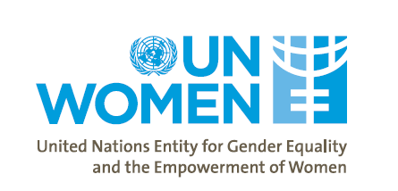

FINAL EVALUATION OF THE FINLAND PROGRAMME DOCUMENT PROJECT

Evaluation Brief
Project information
Project Title: Project Document Finland 2020-2023
Project Number: 13273
Donor Reference: 101
Project Duration: 1 January 2020-31 December 2023
Project Country: Kenya
Geographical Coverage: National and Turkana, Kitui, Kwale and Marsabit Counties
UN Women Strategic Areas: Women in Leadership, Normative Gender Commitments, Elimination of Violence Against Women and Girls, Women, Peace, and Security
Donor Funding: EUR 4,836,764

Purpose of the Evaluation:
This Evaluation Brief presents a summary of the key findings, conclusions, and recommendations from the End of Project Evaluation of the Finland Programme Document Project conducted by two independent consultants between September and December 2023. The Brief also highlights UN Women’s Contribution to Gender Equality and Women Empowerment Successes in Kenya Through Government of Finland Support from 2020-2021. The intended audience and users of the Brief include: UN Women; the Government of Finland; Government of Kenya Partners both at National and County Levels; Implementing Partners; Civil Society Organisations; Media; academic institutions; and the direct beneficiaries of the project.

Project Summary:
With support from the Government of Finland and working with a broad range of State and Non-State partners, the UN Women Kenya Country Office (KCO) implemented a four-year (2020-2023) GEWE project, anchored on the KCO’s Strategic Note thematic focus areas of: (1) Women Political Participation (WPP) and Normative Work; (2) Elimination of Violence Against Women and Girls (EVAWG); and (3) Women Peace and Security (WPS). The three outcomes of the project were: (1) Increased number of women in Kenya as leaders in national and county institutions; (2) Enhanced implementation of the National GBV Policy in the selected 4 counties and at national level; and (3) Enhanced implementation of the women, peace, and security commitments in line with UNSCR 1325 and 2242. The project’s purpose was to advance gender equality and empowerment of women in Kenya through actively contributing to key governmental priorities, which encompassed adherence to the Kenyan Constitution of 2010, Medium-Term Plan III, Vision 2030, and the SDGs.

Project Partners:
National Council of Churches in Kenya (NCCK); Kenya Women Parliamentarian Association (KEWOPA); Movement of Men Against Aids Kenya (MMAAK); Echo Network Africa (ENA); Ministry of Public Service and Gender, State Department for Gender and Affirmative Action (SDfGAA); Ministry of Health(MoH); Kenya School of Government (KSG); Office of the Registrar of Political Parties (ORPP); National Gender and Equality Commission (NGEC); Africa Woman and Child Feature Service (AWCFS); World Vision Kenya; Strathmore University; Ministry of Interior and Coordination of National Government- National Steering Committee on Peacebuilding and Conflict Management (NSC); National Counter Terrorism Centre (NCTC); Human Rights Agenda (HURIA); Saku Accountability Forum (SAF) and Consortium members; Echo Network Africa/African Women Leaders Network (AWLN); Wajir Women for Peace in Wajir County; Horn of Africa Women Empowerment Network Kenya Agency in Mandera County

Evaluation Methodology:
The evaluation was anchored on gender-sensitive evaluation as per UN Women evaluation guidelines and policy. It utilised six main approaches to analysis and interrogation of the project namely; i) Outcome evaluation based on the project’s results framework, ii) UN Evaluation Group (UNEG) evaluation criteria, iii) Interrogation of the Theory of Change, iv) Process evaluation, iv) Context analysis, and vi) UN Gender Responsive evaluation.

- Desk Review: 55 documents
- 26 Key Informant Interviews
- 11 Focus Group
- Quantitative Survey of project beneficiaries: 327 respondents (53.2% female and 46.8% male)
- Outcome Harvesting session involving seven implementing partners.
KEY EVALUATION FINDINGS

Relevance:
The project was designed to effectively deliver on the intended objectives. The Theory of Change and three outcome areas were found to be: highly relevant to the Gender Equality and Women Empowerment Context in Kenya at both national and county levels; in alignment with the WPP, EVAWG and WPS Peace and Security needs and concerns of women and girls in Kenya. It aligned well with the development trajectory and priorities of the Government of Kenya, UN Women, Government of Finland and Implementing Partners. Relevance can be strengthened in future interventions through consideration (by UN Women and Embassy of Finland) for inclusion of the WEE pillar to align it with the SN and the UN Women Global Strategy.

Effectiveness:
The project has largely been effective as it had a good mix of approaches to implementation, identified relevant activities that align with the Theory of Change (ToC) and has returned substantive results that demonstrate effectiveness. The project returned substantive results across all three outcome areas that contributed to: (i) significant increase in women participation in elective politics and substantive improvements in the normative framework; (ii) enhanced implementation of the national GBV policy in the four targeted counties leading to improvements in the referral mechanisms and changes in community perceptions towards violence against women; and (iii) improvement in the overall policy and empowerment of women to participate meaningfully in peace and security discourse in the country.

Efficiency:
The project has largely been efficient as it has returned value for money (considering the results reported when compared to resources expended) through pursuing several strategies and implementing apt mechanisms that assured efficiency. The project implemented several mechanisms to ensure best use of resources to achieve substantive results against available budget. Pursuit of more synergies, addressing delays in disbursements and reconsideration of timing of support can steer future projects towards better utilization of time and resources available.

Coherence:
Coherence was buttressed by the positioning of UN Women as a thought leader and trusted convener of GEWE initiatives in the country, coherence of the project with similar GEWE interventions nationally and at county level, within UN Women and within UN Systems in Kenya; and with international frameworks, instruments and obligations for women’s human rights was strong.

Impact:
Although it is still early to determine the full impact of the project, there are good pointers towards long term impacts. Pointers to long-term impacts include: a 67.8% increase in women participation in elective politics between 2017 and 2022; substantive improvements in the normative framework in the country that is attributed in part to interventions through support of the UNW and Finnish government; gradual improvements in perceptions of communities on value of women leadership; and an engendered normative framework, developed through UN Women support, including that includes review/development of the Political Parties Amendment Act, development of GBV policy (and gender policies at county levels), and development and implementation of KNAP II.

Gender Equality and Human Rights:
The project elaborately integrated gender equality and human rights considerations in its design, implementation and monitoring. It has contributed to development of a gender and women’s human rights sensitive and responsive legal and policy framework; increased awareness on and claiming of women’s human rights; and strengthened capacity of duty bearers to promote gender equality and women’s rights. Whilst it has made commendable efforts to mainstream disability, more needs to be done in terms of providing resources specifically for disability mainstreaming.

Sustainability: The project has established a strong foundation for medium and long-term sustainability through capacity building and an inclusive and participatory ethos that has enhanced ownership of the project by national and sub-national stakeholders. Some likely long term benefits of the project include: an engendered legal and policy framework (GBV policies, the Political Parties Amendment Act and KNAP II on UNSCR 1325); technical capacity for GEWE mainstreaming and reporting acquired by government partners at both national and county levels; and shift in attitudes among targeted communities. More capacity strengthening in resource mobilization and advocacy and lobbying for increased state budget for GEWE is key to strengthening sustainability.

KEY ACTIONS/SUPPORT FROM UN WOMEN & PARTNERS.

- Support towards WPP: Mentorship of women candidates, capacity building, advocacy and lobbying, normative work (towards Political Parties Amendment Act), Material support; and awareness creation and norm changing through male engagement.

- Support towards EVAWG: Capacity building for duty bearers, normative work (national GBV policy and county level gender policies), awareness creation and norm change through male engagement, establishment of coordination structures – support to gender sector working groups.

- Support towards WPS: Capacity building for duty bearers, normative work (support towards development of National Action Plan on UNSCR 1325 (KNAP II) and localisation in four counties), awareness creation and norm change to promote women involvement in WPS, establishment of coordination structures – support to KNAP II Secretariat, WPS Task Force and National Steering Committee.

UN WOMEN’S CONTRIBUTION TO GENDER EQUALITY AND WOMEN EMPOWERMENT SUCCESSES IN KENYA THROUGH GOVERNMENT OF FINLAND SUPPORT FROM 2020-2023

Women Political Participation (WPP)
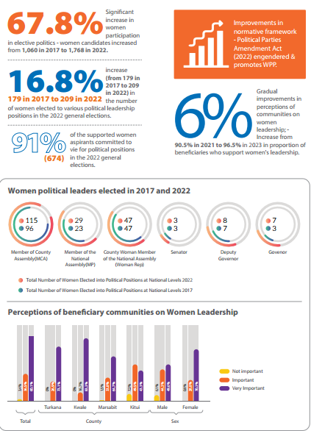

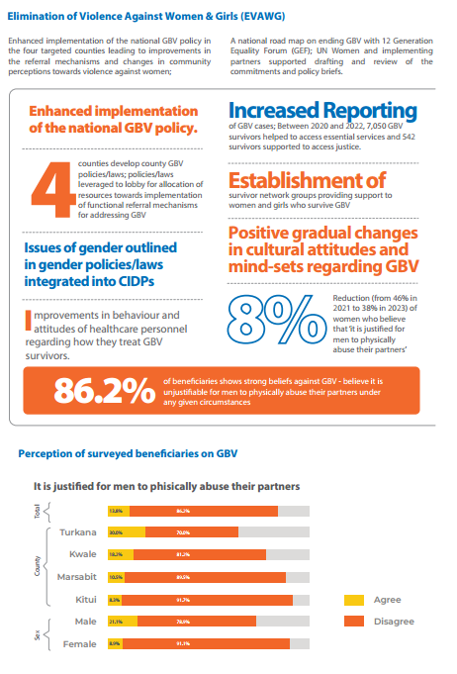
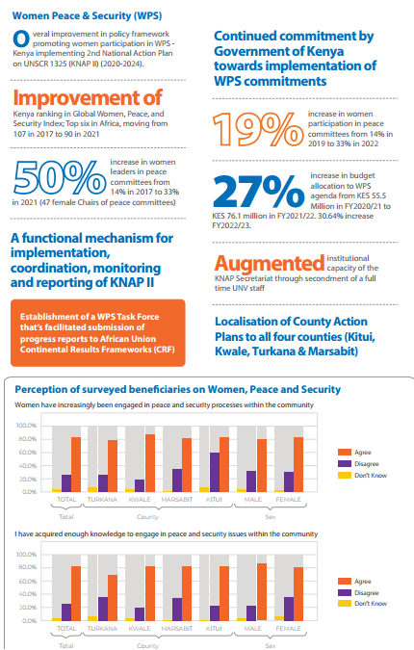

KEY LESSONS LEARNT
- Normative work is critical for creating an enabling legal and policy environment necessary for the implementation of commitments on gender equality and women’s rights.
- Stakeholder Participation at all stages of the project cycle, including design, implementation, monitoring and evaluation is a critical ingredient for fostering ownership-a prerequisite for long-term sustainability. Stakeholders with a well-developed sense of ownership identify with the project and become motivated by the potential impact of the project on their well-being and that of the community they live in.
- Coherence: where coherence is strong within the project, there is better integration of project activities across all the pillars, which increases efficiency and produces holistic benefits for the beneficiaries from all the pillars.
- Interdependence of GEWE thematic areas: given the inextricable linkages between WPP, WPS, EVAWG and WEE, excluding the latter in a GEWE project undermines the effectiveness of the other pillars and limits the capacity of the project to provide a holistic GEWE package to beneficiaries.
- Leaving No One Behind/Social inclusion: effective implementation of this principle requires adequate resources and specific budget lines to support special mechanisms that will enable people with disability or women in marginalised and hard to reach areas to participate in programme activities.
- Empowered women demand their rights: if women are empowered from grassroots up to national level through awareness creation, capacity strengthening and movement building they can effectively advocate for and claim their rights.
- Long-term support: If norm-changing interventions end before the targeted population has reached a level of “normative suasion”, where they genuinely believe in the new norms being promoted and support and encourage each other to adopt the new norms, a reversal of gains made by the intervention is likely to occur as the targeted population will slide back to the old norms.
- Adaptability and Flexibility: where donors are flexible in response to emerging and unforeseen challenges, the implementing UN agency and IPs are better able to respond to the emerging issue. UN Women was able to quickly adapt and respond to the threat of Covid by utilizing the budget availed by the donor to create awareness, procure virtual communication equipment and secure personal protective equipment.
- Male Engagement deployed as a strategy for awareness creation and lobbying and advocacy is effective in tackling deeply rooted socio-cultural norms that limit gender transformation across all three thematic areas:
- A multi-stakeholder approach involving government and non-state actors from civil society not only ensures success through leveraging on different competences and capacities of the stakeholders but also lays the foundation for sustainability, providing assurance for continued impact.
- Strategic engagement and utilisation of media (both legacy and social media) is an effective strategy in awareness creation, norm and attitude changing and dismantling retrogressive and harmful socio-cultural practices that sustain violence against women and limit their participation in politics and in peace and security initiatives.

- Symbiosis across themes: pursuit of more synergies and facilitation of cross-learning among implementing partners is necessary for more shared learning, increased operational efficiency, and harnessing of unique strengths of individual partners across the three thematic areas.

- Lack focal points at county level for UN Women limits interface with communities and decreases the efficiency of reporting and collaboration among implementing partners.

WAY FORWARD
- Consider extending the lifespan of the project: Consider extending the project into Phase 2 and replicate and upscale strategies that have proved to be effective such as male engagement; awareness creation; advocacy and lobbying for implementation of the normative framework; capacity strengthening etc. Future interventions can focus on Marsabit, Kwale and Turkana Counties.
- Expand coverage of the project to include marginalized communities in hard-to-reach locations beyond urban settlements in line with the Leaving No One Behind principle.

- Ensure participation of stakeholders in all the stages of the project cycle by availing a budget for the consultations and ensuring that there is adequate lead time for consultations.

- Persons with disability: Enhance participation of persons with disability in line with the Leave No-one Behind principle by providing specific budget lines to cater for their special needs such as transport, assistive devices and helpers.

- Disbursement of funds: Review existing modalities for funds disbursement to implementing partners to address reported delays to facilitate smooth implementation of activities and attainment of results. Consider multi-year funding modalities for IPs with proven capacity.

- UN Women representation/presence in counties: Consider UN presence or representation in Counties with a higher number of IPs for improved coordination and communication. Alternatively, coordinate IPs at the county level through SDfGAA county focal point or county gender structure.

- Further Capacity straightening of IPs through capacity needs assessment, training and mentoring on programme and financial management, MEL, reporting as some IPs were noted to be having capacity gaps.

- Project Manager: Consider designating a Project Manager to oversee future interventions, working with thematic leads.

- Timing of support for WPP: design support for WPP to cover the whole electoral cycle, including before, during and after elections.

