
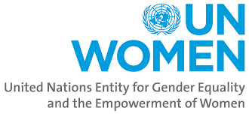

Muktar Abdi Hussein (National Evaluator) March-June 2024
Commissioned by UN Women
End of Program Evaluation: LEAP III Programme on Strengthening protection of women and girls from the disproportionate and adverse gendered impacts of drought and famine in Somalia (1 March 2023 –February 2024)
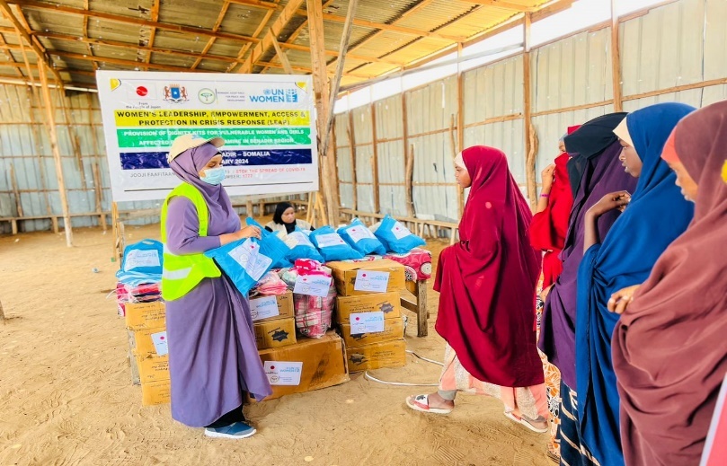
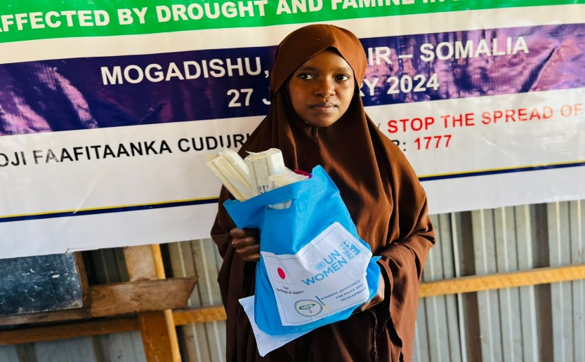
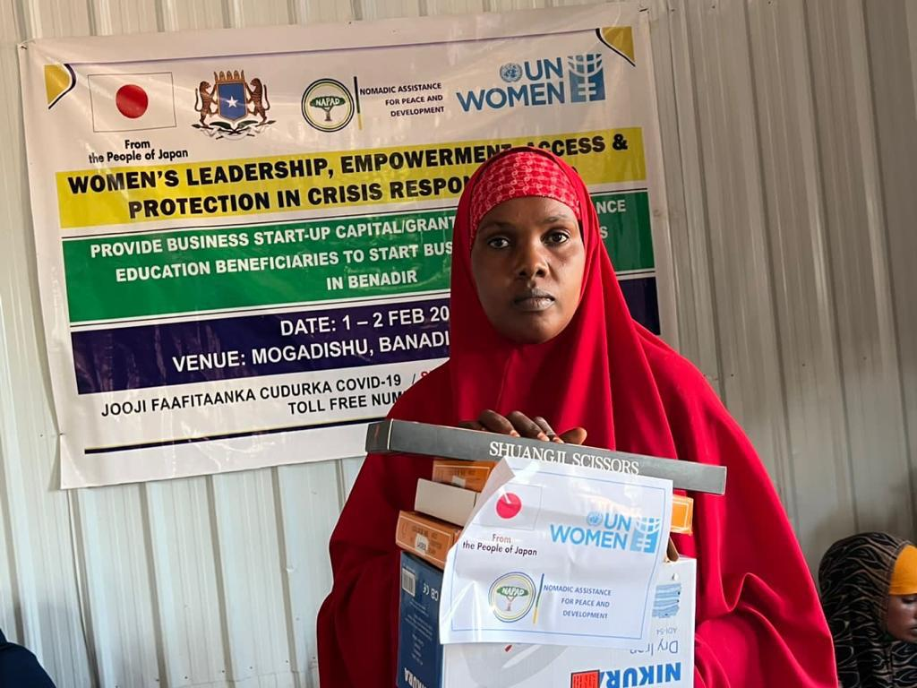
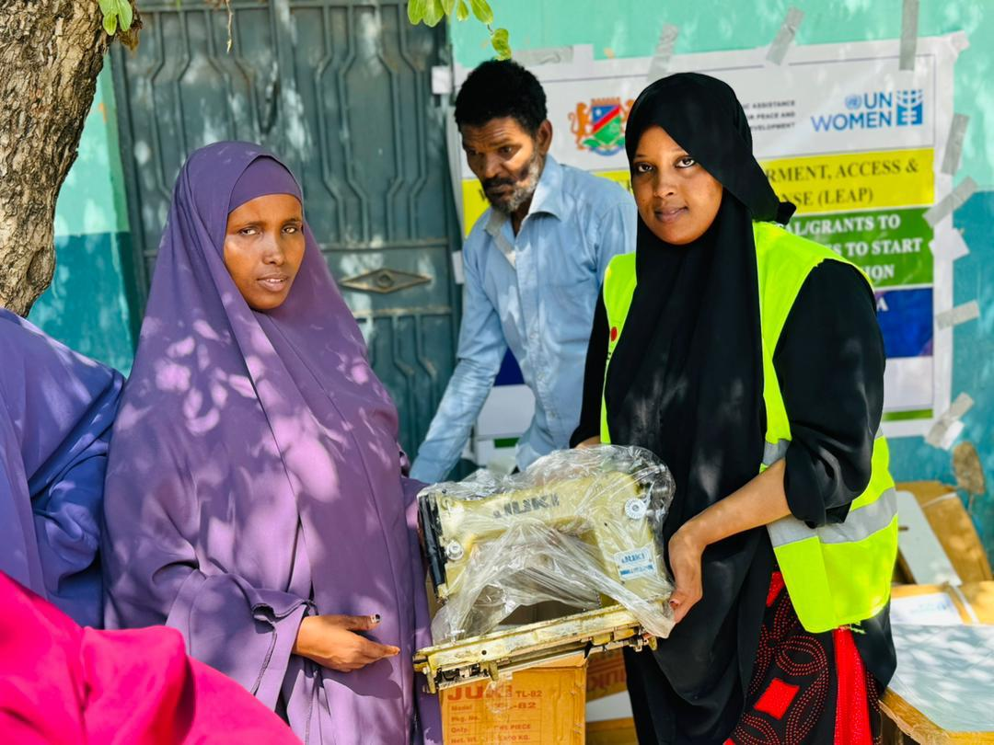
List of Acronyms and Abbreviations 4
Executive Summary 4
1. Background, Project Description and Context 10
1.1. Background and Context 10
1.2. Project Description 14
1.3. Evaluation Purpose, Objectives and Scope 17
1.3.1. Purpose 17
1.3.2. Objective 18
1.3.3. Scope 18
1.4. Evaluation Criteria and Key Questions 19
1.5. Theory of Change 20
2. Evaluation Methodology and Limitations 21
2.1. Evaluation Methodology 21
Contents

2.2. Data Collection and Analysis Methods 22
2.2.1. Data collection tools 23
2.2.2. Data analysis methods 24
2.3. Limitations 25
2.4. Quality Assurance, Ethical Considerations, Gender and Human Rights in the Evaluation Process 26
2.5. Evaluability Assessment 26
3. Findings of the Evaluation 29
3.1. Relevance 29
3.1.1. Relevance of the Timely Implementation of the Project 29
3.1.2. Relevance to the Needs of the target population 30
3.1.3. Relevance of the project to the needs of women 32
3.1.4. Relevance of the Project Design 33
3.2. Coherence 35
3.3. Effectiveness 36
3.3.1. Achievement of Indicators 36
3.3.2. Enabling and Hindering Factors to Results 41
3.3.3. Effectiveness in Partnerships 43
3.4. Efficiency 44
3.4.1. Fund Utilization 44
3.4.2. Financial Management 44
3.4.3. Project Management and M&E process 46
3.5. Sustainability 47
3.5.1. Substantiality of the Results 47
3.5.2. Proposed Measures to Enhance Protection of Women and Girls 51
3.5.3. Gender Equality and Human Rights 53
4. Lessons Learnt and Good Practices 56
5. Conclusions 58
6. Recommendations 60
7. Annexes 64
7.1. Documents Reviewed 64
7.2. Data Collection Instruments (questionnaires and interview guides) 64
7.3. Evaluation Matrix 64
7.4. List of People Interviewed 64
7.5. Evaluation ToR 64
7.6. Evaluator Profile 64

Table of Figures
Figure 1: Reconstructed ToC 21
Figure 2: Number of Trainees Per Skill 30
Figure 3: Women receiving start-up kits. 30
Figure 4: VSLA Training in Kismayo 33
Figure 5: Tailoring Machine not in use. 50
Figure 6: The Henna items not in use. 51

List of Tables
Table 1: Summary of the Project 15
Table 2: Project stakeholders 16
Table 3: Evaluation criteria and Key Questions 19
Table 4: Number of KIIs Conducted 23
Table 5: Number of FGDs Conducted 24
Table 6: Analysis of the Evaluability of LEAP III project 27
Table 8: Achievement of indicators 37
Table 9: Total number of beneficiaries reached. 39
Table 10: Perception of FGD participants on the project 40
Table 11: Perception of respondents on prevention of SGBV and awareness raising. 40
Table 12: Project's expenditure 45

List of Acronyms and Abbreviations

AU | African Union
BECO | Benadir Electrical Company
CEDAW | Convention on the Elimination of All Forms of Discrimination Against Women
CSO | Civil Society Organization
FGDs | Focus Group Discussions
FGM | Female Genital Mutilation
GERAAS | Global Evaluation Reports Assessment and Analysis System
GEWE | Gender Equality and Women's Empowerment
HRP | Somalia Humanitarian response plan
IDP | Internally Displaced Persons
IP | Implementing Partner
KIIs | Key Informant Interviews
LEAP | Women’s Leadership, Empowerment, Access & Protection in Crisis
NAPAD | Nomadic Assistance for Peace and Development
NDP | National Development Plan
ProDoc | Project Document
RRM | Rapid Response Mechanism
SDGs | Sustainable Development Goals
SEA | sexual exploitation and abuse
SGBV | Sexual And Gender-Based Violence
SRH | Sexual And Reproductive Health
ToC | Theory of Change
TVET | Technical And Vocational Education and Training
UN | United Nations
UNDP | United Nations Development Project
UNEG | UN Evaluation Group
UNFPA | United Nations Population Fund
UNSDCF | UN Sustainable Development Cooperation Framework
VSLAs | Village Savings and Loan Associations

Executive Summary
Background - UN Women, the United Nations Entity for Gender Equality and the Empowerment of Women, is committed to eliminating discrimination against women and girls, empowering women, and achieving gender equality. It supports member states in meeting their gender equality goals and building partnerships with civil society and other stakeholders. In 2022, Somalia experienced a severe drought that affected approximately 7.8 million people. The situation remains dire, with 7.1 million individuals facing acute food insecurity and over 214,000 people experiencing emergency levels of hunger. Certain regions, such as Bay and Banadir, are at risk of famine due to high rates of malnutrition and mortality. Climate shocks, such as droughts and floods, further exacerbate the humanitarian crisis in Somalia. Livelihoods dependent on agriculture and livestock are severely affected, leading to internal displacement. Women and children make up the majority of individuals in internally displaced persons (IDP) sites, and women face increased vulnerability during droughts and floods, including the risk of sexual violence.
The COVID-19 pandemic has compounded existing challenges, impacting the livelihoods of women and girls. Limited resources and access to aid have led to tensions between host communities and IDPs. Food scarcity and high prices affect basic social services and reproductive health, while incidences of sexual violence and abuse increase due to displacement and insecurity. The plight of women in Somalia is characterized by challenges and heightened vulnerability due to recurring natural disasters, armed conflict, displacement, and cultural norms that perpetuate gender inequality. The susceptibility to natural disasters disrupts livelihoods, while armed conflict exposes women to sexual and gender-based violence. Displacement leads to overcrowded living conditions and limited access to services. Harmful practices like female genital mutilation and child marriage perpetuate gender inequality. Access to essential services, such as healthcare and education, is limited by infrastructure, resources, and security issues.
Project Description – The 2022-2023 drought in Somalia has affected 7.8 million people and led to the displacement of over 1 million individuals. Women and girls are particularly vulnerable, facing multiple challenges such as sexual violence, loss of livelihoods, food insecurity, and limited access to resources. The humanitarian response plan for food security was underfunded, creating a funding shortfall exacerbated by international focus on the crisis in Ukraine.
To tackle the complex multiple interlinked and complex crises mentioned above, UN Women implemented the LEAP III project (women’s leadership, empowerment, access, and protection) in Somalia. The LEAP III project, aligned with the Government of Japan's commitment to gender equality, aims to empower women and girls affected by the drought through protection and alternative livelihood opportunities. It sought to enhance leadership skills, promote gender-responsive resilience, and directly reach 9,200 beneficiaries. Cultural norms and practices like female genital mutilation pose challenges, requiring engagement with local leaders and organizations. Economic empowerment approaches, such as Village Savings and Loan Associations, have proven effective in building resilience. UN Women partnered with NAPAD, a local CSO, and engaged relevant ministries during project implementation.
Purpose and Scope of the Evaluation - The independent end line evaluation was conducted to comprehensively assess the achievements of the project in relation to the set objectives. The evaluation aimed to identify and document valuable lessons learned, including design issues, best practices, and lessons that could be scaled up or replicated in future projects. Furthermore, it sought to evaluate the Project's contribution to women's economic empowerment, protection, and support for alternative livelihood opportunities to facilitate recovery from the impacts of the drought and famine among crisis-affected women in Mogadishu, Baidoa, Kismayo, and Garowe.
UN Women placed a priority on a gender-responsive approach for this end line project evaluation, actively supporting the achievement of gender equality and women's empowerment. The evaluation specifically focused on UN Women's key areas central to supporting women and girls' empowerment in humanitarian action, including leadership and participation, protection and safety, and economic well-being.
The objectives of the evaluation were described as assess the relevance of the LEAP III intervention in addressing the needs of women and girls, evaluate the effectiveness and efficiency of UN Women's approach in achieving the intended results as defined in the logical framework and Project Theory of Change, analyse the integration of the human rights approach and gender equality principles in LEAP III and humanitarian action Project in the response, Identify and validate lessons learned, promising practices, and innovations supported by the LEAP III Project within the context of the aid effectiveness agenda, assess the added value of the LEAP strategy and related interventions to UN Women's mandate and the overall presence of the UN System in project locations, evaluate the inter-connectedness and sustainability of UN Women's initiatives in increasing leadership, protection, and economic opportunities for refugee women, while identifying possible weaknesses to improve future scale-up Project and provide actionable recommendations regarding the strategy and overall approach to UN Women's Project in humanitarian settings.
The evaluation applied six evaluation criteria established by the UN Evaluation Group (UNEG), including relevance, effectiveness (including normative and coordination mandates of UN Women), efficiency, coherence, and sustainability. These criteria guided the evaluation process to ensure a comprehensive assessment. The evaluation focused on the end of the project, covering all activities implemented from March 2023 to March 2024. It encompassed project beneficiaries in Mogadishu (Benadir region), Baidoa (Southwest State), Kismayo (Jubaland), and Garowe (Puntland) in Somalia.
As part of the evaluation process, the evaluation team conducted a rapid evaluability assessment during the inception phase. This assessment included evaluating the relevance, appropriateness, and coherence of the implicit theory of change, and strengthening or reconstructing it, if necessary, through a stakeholder workshop.
Evaluation Audience and Intended Use - The evaluation will serve as a valuable resource for a wide range of stakeholders involved in the initiative. These stakeholders include relevant staff from target ministries, local government institutions, and government agencies. The evaluation findings and recommendations will provide them with valuable insights to enhance their policies, Projects, and interventions related to the project. Participating civil society organizations (CSOs) will also benefit from the evaluation. It will provide them with evidence-based information on the effectiveness of their contributions and interventions, enabling them to refine their strategies and approaches to better support the target beneficiary communities.
The target beneficiary communities and groups themselves will have a significant stake in the evaluation. Their perspectives and experiences will be captured, and the evaluation will provide them with a platform to voice their opinions and concerns. The findings will contribute to shaping interventions that are more responsive to their needs and aspirations. Members of community leadership structures, such as community elders or representatives, will play a vital role in utilizing the evaluation. The insights gained from the evaluation will enable them to advocate for the necessary changes and improvements within their communities, ensuring that the voices of the affected populations are heard and considered in decision-making processes.
Relevant staff from participating UN agencies will use the evaluation findings to assess the impact of their Projects and identify areas for improvement. The evaluation will contribute to their ongoing efforts to strengthen their response to displacement challenges and enhance collaboration among different agencies. The staff of implementing partners, who are responsible for the implementation of various project activities, will benefit from the evaluation by gaining a better understanding of the project's outcomes and impact. The evaluation will provide them with valuable lessons learned and best practices that can inform their future interventions and Project design.
Sector leads in the participating UN agencies and refugee response coordination will utilize the evaluation to inform their coordination efforts and ensure that the response is effective and aligned with the identified needs and priorities. The evaluation will contribute to their ongoing efforts to harmonize interventions and promote a comprehensive and coordinated approach. UN Agencies technical working groups, comprising technical experts in specific thematic areas related to displacement, will utilize the evaluation findings to enhance their understanding and expertise. The evaluation will inform their ongoing discussions and contribute to the development of evidence-based guidelines and recommendations to address the challenges faced in the field. Development partners, including bilateral and multilateral organizations, will utilize the evaluation findings to assess the impact of their support and investments. The evaluation will provide them with valuable insights into the effectiveness of their contributions and help guide their future funding decisions and priorities.
Evaluation Methodology & Related Limitations: The evaluation employed a comprehensive mixed-methods approach, integrating quantitative and qualitative methods to effectively address the evaluation questions. To achieve this, the evaluators utilized various qualitative data collection methods such as Key Informant Interviews (KIIs) and Focus Group Discussions (FGDs) with key stakeholders. These methods were chosen to enable the triangulation of information from multiple sources, enhancing the validity of the findings. A total of 112 stakeholders were interviewed (96 FGD participants and 16 KIIs).
The evaluators thoroughly reviewed project documents and assessed progress against existing indicators. The primary objective was to evaluate the project's successful accomplishment of outcomes and measure its performance against predetermined targets and benchmarks. This rigorous analysis played a crucial role in gauging the project's effectiveness and overall impact. To gain a deeper understanding, in-depth interviews were conducted with diverse stakeholders, including UN Women staff, partner organization, and other relevant individuals. These interviews followed a structured approach to encourage open and candid dialogue, seeking perspectives from those directly involved and affected. This enabled a detailed exploration of the project's strengths, weaknesses, challenges, and successes. The valuable insights gathered during these interviews significantly influenced the evaluation's final findings and recommendations. During the analysis and report writing phase, significant attention was devoted to synthesizing and interpreting the data collected in the fieldwork. The evaluator examined all available data sources to draw meaningful conclusions and formulate well-grounded recommendations. The evaluation also involved a thorough desk review of various documents. These included the Project Document (ProDoc), project budget and expenditure tracking documents, the Project proposal, the VSLA Assessment Report, and the Project workplan.
As the evaluator prepared to embark on the data collection phase of the project, they proactively identified several potential risks and limitations that could impact the smooth progress of the evaluation process. Safety and security concerns for the evaluation team during field visits, particularly in areas with security challenges or instability. Difficulty in reaching and engaging with the intended beneficiary communities, as they may have migrated or changed locations since the project completion. Potential biases in the selection of focus group participants, requiring careful attention to ensure diverse representation. Lack of knowledge or awareness about the project within the targeted communities, which could affect the quality and depth of data collected. Despite the proactive identification and mitigation planning for these various risks and limitations, the evaluation process would ultimately encounter some unforeseen challenges along the way.
Quality Assurance, Ethical Considerations, Gender, and Human Rights in the Evaluation Process: The evaluation process maintained a strong commitment to ethical standards and guidelines to protect the rights and well-being of the participants. Several strategies were employed to ensure compliance with these ethical principles. During the preparatory phase, participants were actively engaged and consulted. The data collection tools were thoroughly tested on a group of participants who were informed about the testing process and asked to participate voluntarily. Throughout the data collection phase, strict confidentiality of all data collected from the participants was assured. This aspect was explicitly stated in the introductory sections of the data collection tools, and participants were informed that the data would be used exclusively for research purposes.
Participation in the evaluation was based on informed consent. Participants were provided with comprehensive information about the evaluation, its approach, and their role in the assessment. They were given the opportunity to ask questions and make an informed decision about their willingness to participate. The interactions between the interviewers and participants, as well as among the participants themselves, were guided by principles of mutual respect and trust. Safeguards were put in place to ensure confidentiality during the data processing and reporting phases. This involved avoiding precise references to individual participants or attributing specific statements to particular individuals. In the case of Key Informant Interviews (KIIs), personal information that could potentially identify specific individuals was carefully removed during the data processing stage.
EVALUATION FINDINGS
Relevance - The evaluation of the LEAP III project assessed its relevance from four different perspectives. The first perspective examined the project's timeliness. Community members expressed that the project effectively filled the gap left by the limited capacity of the government. It provided crucial support, protection services, and economic opportunities for women and girls. The second perspective focused on the needs of the target population. The project took a comprehensive approach by addressing multiple interconnected issues such as violence, gender inequality, climate change, and economic empowerment. It employed strategies that encompassed legal frameworks, psychosocial support, community engagement, and economic initiatives.
The third perspective considered the specific needs of women. The evaluation highlighted the project's strong commitment to addressing these needs and promoting gender equality and women's empowerment. The project implemented various interventions, including training, counselling services, provision of dignity kits, establishment of safe spaces, and support for economic opportunities. As a result, positive outcomes were observed. The fourth perspective assessed the project's alignment with international commitments, regional priorities, and Somalia's National Development Plan (NDP). The evaluation found that the LEAP III project was well-designed and aligned with these frameworks. It effectively addressed gender inequality, promoted resilience, and ensured the protection and empowerment of women and girls who were affected by drought and famine in Somalia.
Effectiveness - The effectiveness of the LEAP III project was assessed across three dimensions, providing a comprehensive evaluation of its outcomes and impact. In terms of achieving objectives, the project demonstrated significant success in fulfilling its overall goal of supporting women and girls who were adversely affected by drought and famine in Somalia. It effectively addressed the gendered impacts of these crises, focusing on the recovery and empowerment of women and girls. Moreover, the project explicitly targeted and challenged gender-specific structural barriers deeply entrenched in social norms and attitudes. It made remarkable progress in tackling culturally ingrained practices such as female genital mutilation (FGM), child marriage, forced marriage, and the denial of women's rights.
The second dimension examined the enabling and hindering factors affecting the project's results. The project recognized the disproportionate impact of drought and famine on women and girls in Somalia. They are particularly vulnerable to extreme poverty, hunger, exploitation, and abuse in such circumstances. The urgency for comprehensive interventions to address their vulnerability, ensure their safety, well-being, and empowerment was evident. The project identified the surge in sexual and gender-based violence (SGBV) within internally displaced persons (IDP) communities during drought and famine. It highlighted the lack of knowledge, limited public awareness, insufficient capacity building, and scarcity of economic opportunities as factors exacerbating the vulnerability of community members.
The third dimension focused on the effectiveness of partnerships in the project. Key stakeholders, including the government of Somalia at both the Federal and State levels, actively participated in the project's implementation. This active engagement created a sense of ownership and collaboration, ensuring that the project aligned with the government's priorities and objectives. Clear roles and responsibilities were established among all stakeholders, promoting effective coordination and cooperation. This partnership approach facilitated the successful execution of the project, leveraging the expertise, resources, and influence of each stakeholder to maximize the project's impact.
Efficiency – The efficiency of the project's fund utilization was generally positive, with the majority of activities demonstrating effective use of allocated resources. However, the short duration of the Technical and Vocational Education and Training (TVET) Project limited the depth of skill development. The allocation of in-kind grants to TVET graduates was insufficient to fully equip them for market competition. In terms of financial management, most activities utilized the budget effectively, but certain activities exceeded their assigned budgets. The Project as a whole demonstrated financial prudence by utilizing allocated funds for support activities and fully exhausting the budget for Project activities.
Sustainability - The project aimed to establish sustainable structures and mechanisms to ensure long-term benefits. It empowered communities, trained local leaders, and fostered ongoing efforts for gender equality and women's empowerment. The project recognized the importance of local ownership and capacity-building. It also implemented accountability systems, such as community-based monitoring and partnerships with civil society organizations. The project engaged women, youth, and men to challenge harmful social norms and supported women's economic empowerment. Recreational activities provided healing and empowerment for women survivors. The project addressed the needs of women and girls affected by crises and aimed to break the cycle of vulnerability. However, some women faced challenges in fully utilizing their skills due to lack of resources and equipment in certain trades, such as tailoring, henna artistry, and cloth dyeing. The disconnect between the training provided and the availability of the fully required resources appears to be a key factor that prevented the women from fully capitalizing on the skills they had acquired.
Lessons Learned –Conducting community conversations and dialogues promotes mindset shifts towards gender equality and women's empowerment. Awareness-raising campaigns on climate change empower individuals to take action and become agents of change. Providing psychosocial and economic support helps women and girls overcome challenges and build resilience. Strengthening Village Savings and Loan Associations (VSLAs) enhances financial inclusion and economic empowerment. Community engagement, multi-sectoral collaboration, holistic economic empowerment, and comprehensive capacity building are crucial elements for sustainable change and empowerment.
Recommendations – The evaluation report provides several recommendations to maintain the project's momentum and further enhance its impact.
- Continue and expand the project's geographic reach to reach more communities affected by drought and famine.
- Strengthen partnerships with local organizations, government agencies, and community leaders.
- Foster economic opportunities through diversification and support of sustainable livelihoods.
- Integrate climate change action and resilience-building components into future Project.
- Establish community-based support systems to address gender-based violence (SGBV).
- Enhance the capacity of legal and law enforcement sectors to handle SGBV cases effectively.
- Revise the duration and resource allocation of the Technical and Vocational Education and Training (TVET) Project to enhance its effectiveness and support participants' economic empowerment.

Background, Project Description and Context

Background and Context
The United Nations Entity for Gender Equality and the Empowerment of Women (UN Women), grounded in the vision of equality enshrined in the Charter of the United Nations, works for the elimination of discrimination against women and girls; the empowerment of women; and the achievement of equality between women and men as partners and beneficiaries of development, human rights, humanitarian action and peace and security. UN Women provides support to Member States’ efforts and priorities in meeting their gender equality goals and for building effective partnerships with civil society and other relevant actors.
In 2022, Somalia faced a severe drought that had a devastating impact on nearly half of its population, estimated at around 7.8 million people. The current situation is dire, with approximately 7.1 million individuals experiencing acute food insecurity, and over 214,000 people facing emergency levels of hunger and famine-like conditions. By March 2023, eight regions of the country, particularly the Bay and Banadir regions, were at risk of experiencing famine, as they are already grappling with high rates of malnutrition and mortality.
According to UNFPA report in 2023, among those affected in Somalia, approximately 2 million women of reproductive age have been impacted, including more than 380,000 who are pregnant and in urgent need of life-saving sexual and reproductive health (SRH) services and information. The situation presents heightened risks of gender-based violence (GBV) for women and girls. Factors contributing to this include multiple displacements, living in overcrowded and poorly lit shelters and toilets within camps, and the need to undertake long journeys for essential resources such as water, food, and animal feed. In the face of poverty, child marriage has emerged as a harmful coping mechanism for families, exposing young girls to physical and sexual abuse, malnutrition, and an increased likelihood of maternal and neonatal mortality. This rise in child marriages and sexual violence against women and girls has resulted in a greater number of unplanned and high-risk pregnancies. Pregnant women who are displaced or forced to relocate face amplified risks during pregnancy and childbirth, including the danger of postpartum haemorrhaging, which, if not promptly treated in a hospital setting, can be fatal. Enhanced accessibility and availability of health services, including rights-based family planning options, can play a crucial role in providing women and girls with timely treatment, referrals, and opportunities for birth spacing.
The prolonged state of vulnerability, stemming from recurring climate shocks such as droughts, floods, and tropical storms, which are further compounded by ongoing conflict and insecurity devastate crops and livestock, disrupting livelihoods and exacerbating hunger. As a result, internal displacement becomes a common response as individuals are forced to abandon failed farmlands and pastures. The 2020-2023 drought alone led to over 1.6 million displacements by early 2023. Additionally, flash floods in April 2023 caused further displacement.
The impact of climate change is particularly detrimental to Somali’s dependence on livestock agriculture and forestry, presenting a significant concern that drives the country's humanitarian needs. This has a profound effect on women's livelihoods, as data from the United Nations Development Program (UNDP) reveals that the majority (70% to 80%) of individuals residing in internally displaced persons (IDP) sites and settlements are women and children. Women and girls consistently face heightened vulnerability during droughts and floods, as they are burdened with the triple challenge of ensuring their own survival, caring for their families, and avoiding the risk of sexual violence.
Moreover, the COVID-19 pandemic has further exacerbated existing challenges by severely impacting the livelihoods of women and girls. Struggles over limited resources and access to aid persist, often leading to tensions between host communities and IDPs. Host communities themselves are also affected by protracted conflict, drought, cyclical climatic shocks (such as droughts and floods), locust invasions, political instability, socioeconomic vulnerability, and deteriorating livelihoods. These combined shocks continue to fuel the ongoing humanitarian crises in Somalia.
Food scarcity and increasing food prices force poor families to spend all their income on meeting basic food needs leaving little or no possibilities for meeting the basic social services and reproductive health including maternal and newborns health needs of the affected populations. Increasing incidences of sexual violence, intimate partner violence, and abuse is most likely to become worse as more women and girls suffer multiple displacements, loss of livelihoods, food insecurity, sexual abuse and exploitation, poor access to markets and water insecurity has been reported.
Increases in the incidence of GBV are more likely as women and young girls are exposed to GBV risks as they travel long distances to collect water and fuel; use toilets and seek casual jobs for survival. Lack of adequate protection along lonely tracks in IDP camps and host communities predisposes women and young girls to harassment and attacks of sexual nature.
In Somalia, the plight of women is fraught with immense challenges and a heightened vulnerability, particularly within the context of an ongoing humanitarian crisis. Various factors contribute to the increased susceptibility of women in Somalia, including recurring natural disasters, armed conflict, displacement, and cultural norms that perpetuate gender inequality.
The country's susceptibility to natural disasters is a significant concern. Somalia experiences frequent climate shocks such as droughts, floods, and tropical storms. These calamities have a devastating impact on women's livelihoods, particularly those reliant on agriculture and livestock for economic sustenance. The consequences include heightened food insecurity, loss of income, and restricted access to basic necessities, further exacerbating their vulnerability.
Armed conflict and insecurity pose another significant threat to women in Somalia. Prolonged conflicts disproportionately affect them, subjecting them to an increased risk of sexual and gender-based violence (SGBV). Conflict-affected areas become breeding grounds for atrocities such as rape, forced marriages, abductions, and domestic violence against women. Moreover, the absence of functional justice systems compounds the challenges, limiting women's access to justice and accountability for these crimes.
Displacement is a prevalent issue in Somalia, forcing many women and their families to flee their homes due to conflict, natural disasters, or a combination of both. Displaced women face dire circumstances, residing in overcrowded and unsanitary living conditions. They encounter limited access to healthcare, education, and economic opportunities, further intensifying their vulnerability to SGBV.
Cultural norms and gender inequality are deeply ingrained in many Somali communities, perpetuating harmful practices like female genital mutilation (FGM) and child marriage. These practices not only undermine women's rights, health, and overall well-being but also contribute to their heightened vulnerability. Addressing these deeply entrenched norms and promoting gender equality requires active engagement with community leaders, religious figures, and grassroots women's organizations.
The humanitarian crisis in Somalia severely restricts women's access to essential services, including healthcare, education, and protection services. Insufficient infrastructure, lack of resources, and security challenges further impede women's ability to access these crucial services, exacerbating their vulnerability.
To support the affected population in Somalia, UN Women Somalia has been working closely with partner agencies in promoting humanitarian assistance interventions aimed at addressing critical gender gaps in humanitarian response and enhancing resilience and well-being among women and girls in IDP settlements and their host communities.
In response to the situation of women and young girls in the context of displacement, UN Women Somalia implemented the Leadership, Empowerment, Access and Protection Project with an outreach of 9,200 women and girls. The Women’s Leadership, Empowerment, Access & Protection in Crisis (LEAP) Project aims to make gender equality and women’s empowerment central for coordinated, effective humanitarian action and crisis response in Somalia. The country remains on the frontline of climate change, which continues to induce crises resulting in widespread displacement, rapid urbanization, food insecurity, increased poverty and epidemic and pandemic disease outbreak. Critically, climate change is also increasingly understood as a major driver of conflict in Somalia as the struggle for dwindling resources intensifies clan divisions and inter-clan conflict.
The 2022-2023 drought has affected 7.8 million people throughout the country and resulted in the displacement of more than 1,000,000 people. The situation of women and girls is worsened by the persistent droughts in Jubaland, Southwest State, Puntland, Banadir. Increasing incidents of sexual violence, intimate partner violence, and abuse are most likely to become worse as more women and girls suffer multiple displacements, loss of livelihoods, food insecurity, sexual abuse and exploitation, poor access to markets, and water insecurity.
The project came when the 2022 Humanitarian Response Plan for Food Security was underfunded (with only 40% of the plan having secured funding with limited allocation for protection sector). There is a need for development, peace and humanitarian actors (triple nexus) to pool their resources to meet the 60% funding shortfall, which has been exacerbated by the international focus on the crisis in Ukraine, and diversion of funds to assist Ukrainians in crisis.
LEAP III is aligned to the Government of Japan’s commitment to promote Gender Equality and Women’s Empowerment in humanitarian crises. The LEAP III project contributed to the UN Women Somalia Strategic Note, which supports the Women's Leadership, Empowerment, Access & Protection in Crisis Response (LEAP) initiative. This alignment is in line with ongoing drought and famine responses, as well as the Somalia National Development Plan 2020-2024 Pillar 3: Inclusive economic growth and Pillar 4: Improved social and human development. The project also aligns with the priorities outlined in the Somalia Humanitarian Response Plan (HRP) and the drought response and famine prevention plan, which articulate the Rapid Response Mechanism (RRM), protection, and Gender-Based Violence (GBV) priorities. Similarly, the project is contributing to UN Sustainable Development Cooperation Framework 2021-2025 (UNSDCF), which represents the commitment of the Federal Government of Somalia and the United Nations to partner in achieving peace, stability, and prosperity for all Somalis. The four overarching strategic priorities of the UNSDCF are: 1) Inclusive Politics and Reconciliation, 2) Security and Rule of Law, 3) Economic Development, and Social Development.

Project Description
The LEAP III project supported 9,200 drought and famine-affected women, girls, and youth in four federal member states in Somalia to strengthen resilience, livelihood opportunities, and protection interventions. The project adapted gender-responsive strategies that foster the participation and empowerment of vulnerable women and girls, who were identified as having the lowest coping capacity for shocks and the greatest vulnerability to climate disasters, including drought. The project sought to respond to women and girls affected by drought through increased access to protection and support for alternative livelihood opportunities to facilitate recovery from the impacts of the ongoing drought. It was expected to enhance the leadership skills of IDP women and girls, develop their capacities to promote gender-responsive resilience among crisis-affected women and girls in Kismayo, Baidoa, Garowe, and Banadir. The project was expected to directly reach 9,200 beneficiaries (IDP women and girls) and indirectly benefit an additional 10,000 (reached through billboards, community meetings, and awareness-raising activities).
The current LEAP model builds upon the achievements of UN Women's previous work in Somalia, drawing on the experience of LEAP Project. It aims to harness the leadership, empowerment, access, and protection of women and girls by creating spaces for them to come together, mobilize, and engage in income-generating activities. The model also focuses on providing opportunities for livelihood and skills development, effective services, protection mechanisms, and empowerment support. Additionally, LEAP supports the coordination and capacity-building of humanitarian actors to achieve better outcomes for women, girls, boys, and men.
However, certain rigid cultural norms and practices, such as female genital mutilation (FGM), deeply rooted in society, pose challenges to the timely implementation of project activities. To address this, engagement with local leaders, religious leaders, women, women-led organizations, and relevant government entities plays a crucial role in strengthening and promoting measures to prevent and respond to sexual and gender-based violence (SGBV) and other harmful practices that continue to impact women and girls.
In terms of economic empowerment, the implementation of Village Savings and Loan Associations (VSLAs) has proven effective. These approaches have enhanced women's resilience by instilling a culture of saving, which enables them to meet basic family needs during challenging economic times. Through VSLAs, members have been able to save amounts ranging from $2 to $9, while contributing between $0.2 and $1 per month to the Social Fund.
Table 1 below provides a summary of the project:
Table 1: Summary of the Project
Project Title | Strengthening the Leadership, Empowerment, Access and Protection of Women Affected by Drought and Famine in Somalia
Overall Objective | To strengthen the protection and resilience of 9,200 women and girls impacted disproportionately by drought and famine in Somalia.
Outcomes | - Women and girls in the identified priority areas are protected from SGBV in the context of ongoing drought and impending famine in Somalia.  - Women and girls in Somalia in the identified priority areas have increased access to alternative livelihoods that support recovery of the gendered impacts of drought and famine.
Duration | 12 Months (1 March 2023 –February 2024)
Geographical Focus in Somalia | Jubaland, Southwest, Puntland and Banadir. Districts: Kismayo (Jubaland), Baidoa (Southwest), Garowe (Puntland) & Banadir
Target Beneficiaries | Direct: 9,200 refugees, IDP women and girls in Somalia
Total Budget | USD 600,000
Funding Source | Government of Japan Supplementary Budget
Implementing Organization | UN Women Somalia Country Office
Other Partners | Relevant Governments entities, UN Agencies, INGOs, Japan NGOs and companies, CBOs, Academia, Private Sector entities, Women Networks

UN Women partnered with Nomadic Assistance for Peace and Development (NAPAD), a local CSO as an implementing partner for the project. Additionally, relevant ministries at both the Federal and State levels were engaged during the project implementation. See table 1 for more information.
Table 2: Project stakeholders
Partner | Role played in the project
NAPAD | Conducted two-days training for 200 women, youth, and men on relevant legal frameworks governing VAWG and SGBV in crises contexts in
NAPAD | Conducted community conversations/dialogues led by community opinion leaders on QUARTERLY bases for 800 men and youth to advocate for mindset shift towards the protection and promotion of Gender Equality and Women's Empowerment (GEWE)
NAPAD | Conducted two-day training on psychosocial counselling, peer influences, and mentorship Projects for 300 women, girls & youth to facilitate change by addressing the underlying causes and drivers of violence against women and girls at the community level.
NAPAD | Conducted TWO awareness-raising and environmental education campaigns on climate change action for 700 women, girls, youth, men and engage local communities through various innovative approaches to climate change issues including promoting conservation agriculture and the planting of trees to empower them to address climate change
NAPAD | Conducted a Two-day workshop on how to strengthen the referral pathways for 100 duty bearers for promoting, respecting, and fulfilling human rights for survivors
NAPAD | Developed/disseminated referral pathways/messages for right-holder through informal community meetings, radio, and other traditional platforms for 5,000 participants
NAPAD | Procured 500 dignity kits for Sexual and gender-based violence (SGBV) survivors and vulnerable women and girls affected by drought and famine
NAPAD | Provided recreational, educational, psychosocial, and economic opportunities and vocational skill building for three months to 440 women and girls through the one stop/ GBV centres/ safe spaces
NAPAD | Provided business start-up capital/grants to 440 second-chance education beneficiaries to start business enterprises in Kismayo, Baidoa, Garowe and Benadir.
NAPAD | Facilitated linkages of skills training graduates to Financial Institutions (banks etc.) through advocacy and relationship building
NAPAD | Conducted Impact Assessment of 42 VSLA groups established under LEAP 2 and documentation and dissemination of findings to humanitarian stakeholders and actors to inform policy and practice on socio-economic interventions in humanitarian crises
NAPAD | Strengthened the capacity of existing Savings and Loan Associations (VSLAs) through trainings to engage in IGAs, improve their standard of living, diversifying production, earning more income and financial accessibility in Kismayo, Baidoa districts.
NAPAD | Conducted Community engagement and stakeholder consultative meetings for 130 participants at state and community level on inclusion and participation to promote commitment and cooperation towards effective and sustainable implementation of the VSLAs
Ministry of Women and Human Right Development (Federal and State Level) | Monitoring, guiding and oversight role in coordination with UN Women and NAPAD.
UN Women | Implementation  Monitoring  Recruitment of project staff  Evaluation of the project  Financial disbursement and control

Evaluation Purpose, Objectives and Scope

Purpose
The purpose of this evaluation was to assess the progress and impact of our organization's initiatives over the past year. This evaluation was undertaken at this point in time to provide transparency to key stakeholders, including donors, community partners, and the affected population, on how resources were utilized and whether the project made meaningful progress towards the stated goals. Furthermore, it aims to demonstrate accountability for the commitments of the project.
In terms of learning, the evaluation sought to identify areas of strength and weakness in the project and operations, in order to inform future planning and continuous improvement. Additionally, it aimed to understand the contextual factors and implementation challenges that have affected the results, so that the project can adapt approaches accordingly. Ultimately, the insights generated could be used to refine project’s theory of change.
When it comes to decision-making, the evaluation gathered evidence to support data-driven choices about resource allocation, Project expansion, and other strategic priorities. This information would help determine whether the project should continue, modify, or discontinue specific initiatives based on their demonstrated effectiveness and alignment with organization's priorities.
It is a priority for UN Women that this end line project evaluation is gender-responsive and actively supported the achievement of gender equality and women’s empowerment, with emphasis on UN Women key areas central to supporting women and girls’ empowerment in humanitarian action: Leadership and participation, Protection and safety, and Economic well-being.
As per the ToR, the primary intended users of this evaluation are:
- Relevant staff in target ministries/local government/government institutions, and participating CSOs
- Target beneficiary communities/groups
- Members of community leadership structures
- Relevant staff in participating UN-agencies
- Staff of implementing partners
- Sector leads in the participating UN-agencies and refugee response coordination. UN Agencies technical working groups UNACs
- Development partners.

Objective
The objectives of the evaluation are to:
- Assess the relevance of LEAP intervention in addressing the needs of women and girls;
- Assess the effectiveness and efficiency of UN Women’s approach for achievement of results, as defined in the logical framework, including the Project Theory of Change;
- Analyze how the human rights-based approach and gender equality principles were integrated in LEAP and humanitarian action Project in the Somalia’s response;
- Identify and validate lessons learned, promising practices and innovations of work supported by LEAP Project within the context of the aid effectiveness agenda;
- Assess the added value of the LEAP strategy and related intervention to UN Women’s mandate
- Assess the inter-connectedness and sustainability of UN Women’s initiatives on increasing leadership, protection and economic opportunities for refugee women and analyze possible weaknesses to improve next steps for scale-up Project;
- Provide actionable recommendations with respect to the strategy, and overall approach to UN Women’s Project in humanitarian settings.
The evaluation will apply six UN Evaluation Group (UNEG) evaluation criteria (relevance, effectiveness-including normative, and coordination mandates of UN Women- efficiency, coherence, and sustainability).
The primary intended uses of this evaluation are:
- Learning and improved decision-making to support the scale up of LEAP.
- Feedback, participation, and accountability to affected communities
- Capacity development and mobilization of women and girls in IDPs on Covid-19 decision making and recovery.

Scope
The evaluation is an end of project evaluation and covered all project activities implemented from March 2023 to February 2024. The evaluation covered project beneficiaries in Mogadishu (Benadir region), Baidoa (Southwest State) and Kismayo (Jubaland), Garowe (Puntland) in Somalia.
The evaluation team undertook a rapid evaluability assessment in the Inception which included the following:
- An assessment of the relevance, appropriateness, and coherence of the implicit theory of change, strengthening or reconstructing it where necessary through a stakeholder workshop;
- An assessment of the quality of performance indicators in the Project, and the accessibility and adequacy of relevant documents and secondary data;
- A review of the conduciveness of the context for the evaluation;
- Recommendations for improvements/changes in the indicators, as per the prodoc;
- Ensuring familiarity with accountability and management structures for the evaluation.
In terms of thematic scope of the evaluation covered several key areas. By covering these diverse thematic areas, the evaluation provided a comprehensive assessment of the LEAP III project's performance in the target locations. Firstly, the evaluation assessed the relevance of the project, examining factors such as the timeliness of implementation, the alignment of the project to the needs of the target population, the relevance of the project to the specific needs of women, as well as the overall design of the project.
Secondly, the evaluation also looked at the coherence of the project, analyzing how it aligned and complemented other ongoing interventions in the region. Thirdly, a core component of the evaluation was assessing the effectiveness of the project. This involved examining the achievement of the project's indicators, identifying the key enabling and hindering factors that influenced the results, as well as evaluating the effectiveness of the project's partnerships.
Fourthly, the evaluation delved into the efficiency of the project, reviewing aspects such as fund utilization, financial management, and the overall project management and monitoring and evaluation processes. Finally, the evaluation assessed the sustainability of the project's results, including the measures taken to enhance the protection of women and girls, as well as the project's contributions to advancing gender equality and upholding human rights.

Evaluation Criteria and Key Questions
The evaluation applied six UN Evaluation Group (UNEG) evaluation criteria (relevance, effectiveness, coordination, efficiency, coherence, and sustainability). The evaluation sought to answer the following key evaluation questions. For detailed evaluation questions and sub-questions, see annex 7.3.
Table 3: Evaluation criteria and Key Questions
Relevance | - Were the intervention objectives and design (and strategies adopted) appropriate to address the identified needs of beneficiaries and stakeholders and the underlying causes of gender inequality?
Effectiveness and Impact | - To what extent has UN Women achieved planned outputs and contributed to expected outcomes? What difference has the intervention made in the lives of refugee women and girls, men, and institutions (intended and unintended, positive or negative, results)?  - What were the main Project enabling and hindering factors to achieving planned outcomes? What actions need to be taken to overcome any barriers that limit required progress?  - What is UN Women’s comparative advantage compared with other UN entities and key partners in delivering on this project?  - To what extent has gender equality and women’s empowerment been mainstreamed in LEAP geographical scope?
Sustainability | - To what extent did the intervention, as designed and implemented, take longer-term and interconnected problems into account? How did the intervention contribute to the longer term, such as recovery or development?  - What are the measures that have been incorporated to promote sustainability?  - To what extent was capacity of partners developed in order to ensure sustainability of efforts and benefits?
Coherence | - To what extent did the intervention add value while avoiding duplication of efforts?  - To what extent have the intervention activities collaborated to create synergies beyond this project?  - Are the intervention objectives coherent with those of the UN Women Somalia Strategic Note?  - What is UN Women’s comparative advantage compared with other UN entities and key partners in delivering on this Project?
Efficiency | - Is the balance and coherence between Project-operational, coordination and policy-normative work optimal?  - Is the budget allocated for all activities sufficient to cover all the required tasks?  - Were all the activities implemented within the specified timelines?  - Were the human resources sufficient to deliver the project activities?
Capacity of Implementing Partner | - Did the Implementing Partners have the necessary capacity and capabilities to deliver the Project?
Human Rights and Gender Equality | - What contribution did this program make to implement global norms, standards and programming principles for Human rights, development effectiveness, gender equality and the empowerment of women?  - To what extent did the program change the dynamics of power in relationships between different groups (including refugees and host communities)?  - How has attention to/integration of gender equality and human rights concerns advanced the area of work?  - To what extent was gender equality and women’s empowerment advanced as a result of the intervention?  - To what did the project did the project promote the inclusion of marginalized populations (including Persons with Disabilities) in its activities?

Theory of Change
According to the project documents, the project had no Theory of Change (ToC) that could illustrate the change pathways. However, based on the activities and their results, the evaluator proposes the following ToC:
IF the capacity of community members (women, youth, and men) is built to meaningfully participate in efforts to bring about positive shifts in prevailing attitudes and social norms that condone VAWG and SGBV and Strengthen SGBV referral pathways and referral mechanisms to increase access of women and girls affected by drought and famine to SGBV services as well as increase their psychosocial, livelihood and economic opportunities skills, THEN there would be strengthened protection and resilience of women and girls impacted disproportionately by drought and famine in Somalia BECAUSE increased access to services will improve their wellbeing and livelihoods.
Figure 1: Reconstructed ToC

Evaluation Methodology and Limitations

Evaluation Methodology
The evaluation methodology utilized a comprehensive mixed-methods approach, combining both quantitative and qualitative methods, to effectively address the evaluation questions. A primary focus was placed on capturing results through the inclusion and representation of the perspectives of marginalized groups including (including Persons with Disabilities) and women.
The mixed-method approach involved analysing project documents in conjunction with qualitative data collection methods such as Key Informant Interviews (KIIs) and Focus Group Discussions (FGDs) with key stakeholders. This approach was chosen to enable the triangulation of information from multiple sources, thereby enhancing the validity of the findings.
The evaluation was structured according to three key phases, following recommended practices in the field. The first phase was the inception phase, which involved establishing the evaluation framework and setting clear objectives. The second phase was the fieldwork phase, during which data collection through various methods took place. The final phase was the analysis and reporting phase, where the collected data was thoroughly analysed and synthesized to produce comprehensive and meaningful evaluation findings.
In addition to these project-specific documents, relevant international standards and guidelines were also considered for quality assurance The UNEG (United Nations Evaluation Group) Norms and Standards for Evaluation were consulted to ensure that the evaluation followed established best practices and methodologies.
To gain insights from previous evaluations conducted by UN Women, the UN Women Global Evaluation Reports Assessment and Analysis System (GERAAS) was utilized. This system provided a comprehensive collection of evaluation reports that offered valuable lessons learned and good practices.
Lastly, the UN Women Evaluation Handbook: How to manage gender-responsive evaluation was consulted to ensure that the evaluation process effectively incorporated a gender-responsive approach, thus promoting gender equality and women's empowerment throughout the evaluation.

Data Collection and Analysis Methods
The evaluator used document review, Key Informant Interviews and Focus Group Discussions to achieve the objectives of the evaluation. In addition to conducting document review, the evaluator undertook a comprehensive assessment of progress made against existing indicators that had baseline values while those without baseline captured their current progress. The primary objective was to evaluate whether the project had successfully accomplished its intended outcomes and to measure its performance against predetermined targets and baselines.. This rigorous analysis played a crucial role in enabling the team to gauge the project's effectiveness.
To gain a more profound understanding, the evaluator conducted in-depth interviews with a diverse range of stakeholders. These interviews involved engaging with national UN Women staff, partner organizations, government officials and the beneficiaries.. The interviewer adopted a structured approach to encourage open and candid dialogue. By asking probing questions, the evaluator aimed to delve into the intricacies of the project, seeking perspectives from those directly involved and affected.
Through these in-depth interviews, the evaluation team gathered direct and, personal experiences, and expert opinions. This approach allowed them to explore the project's strengths, weaknesses, challenges, and successes in detail, thereby acquiring a nuanced understanding of its implementation and outcomes. The valuable insights shared during these interviews played a pivotal role in shaping the evaluation's final findings and recommendations.
During the analysis and report writing phase, the evaluator devoted significant attention to synthesizing and interpreting the data collected during the fieldwork. This phase involved a meticulous examination of all accessible data sources to draw meaningful conclusions and formulate well-grounded recommendations. The initial step in this process entailed thoroughly reviewing and analysing the vast array of data collected from staff, partner, and stakeholder interviews, as well as any other pertinent sources. The evaluator scrutinized the data, identifying patterns, trends, and key findings. Through this rigorous process, they gained deeper insights into the project's strengths and weaknesses. .

Data collection tools
Desk review:
In conducting the evaluation, a thorough review was undertaken of various documents that provided essential information and context for the project. These documents included the Project Document (ProDoc), which outlined the objectives, activities, and expected outcomes of the project. The Project budget and expenditure tracking documents were examined to gain insights into the financial aspects and resource allocation of the project.
The Project proposal served as a valuable resource in understanding the initial rationale and justification for the project. The VSLA (Village Savings and Loan Association) Assessment Report was reviewed to assess the effectiveness of the VSLA component within the project.
The Project workplan was carefully examined to evaluate the planned activities, timelines, and milestones. This document provided a blueprint for understanding how the project was intended to unfold over time.
By reviewing these various documents, the evaluator was able to gather a comprehensive understanding of the project's background, objectives, implementation strategies, financial aspects, and evaluation requirements. This information served as a foundation for conducting the evaluation and informed the subsequent data collection and analysis processes.
Key Informant Interviews:
The consultant conducted key informant interviews (KIIs) with key stakeholders involved in the LEAP III project across all target locations. These stakeholders included beneficiaries of the project, implementation partners (NAPAD), ministries of women at both the State and Federal Levels, as well as UN Women staff at the Country Office. In cases where it was necessary and feasible, virtual interviews were conducted to accommodate the availability of the informants. Overall, a total of 16 KIIs were conducted as part of the evaluation process.
Table 4: Number of KIIs Conducted
Typology | Number
Workshop Trainees on how to strengthen the referral pathways for 100 duty bearers for promoting, respecting, and fulfilling human rights for survivors | 5 (F=4, M=1)
Dignity Kits beneficiaries and Sexual and gender-based violence (SGBV) survivors and vulnerable women and girls affected by drought and famine | 4 (Female=4)
NAPAD Project Staff | 2 (F=1, M=1)
UN Women Project Staff | 1 (1 Male)
Ministry of Women and Human Rights Development at the Federal Government of Somalia | 1 (1 Female)
Ministry of Women and Human Rights Development at the Federal Member states (Jubaland, Puntland, South State) | 3 (F=2, M=1)
Total | 16 (F=12, M=4)
Focus Group Discussions:
A series of Focus Group Discussions (FGDs) using a structured questionnaire were conducted with the target beneficiaries of the project. These FGDs aimed to assess the achievement of desired outcomes based on key project outputs. Additionally, the discussions sought to gather valuable feedback from participants regarding the project's approach and activities, with the intention of deriving important lessons learned. The composition of each FGD comprised approximately 8 participants, who were purposively selected to ensure a diverse representation in terms of gender, age groups, and level of participation in project activities. In collaboration with UN Women, a total of 12 FGDs were successfully conducted with a total of 96 participants (25% male).
Given the absence of reliable statistical data pertaining to the general and specific population, a representative sampling procedure based on statistical approaches was deemed impractical. Therefore, a purposive sampling method was employed to select participants for the FGDs. This approach aimed to capture a range of perspectives and experiences. To mitigate potential bias resulting from exclusively selecting beneficiaries with positive outcomes, bilateral interviews were included to gather insights from both those who benefitted the most and those who experienced limited or no benefits from the project. UN Women, in collaboration with the implementing partner (IP), played a crucial role in mobilizing participants and ensuring suitable venues for the FGDs were provided.
Table 5: Number of FGDs Conducted
Typology | Number
Trainees on legal frameworks governing VAWG and SGBV in crises contexts | 2
Community opinion leaders and youth | 2
Trainees on psychosocial counselling, peer influences, and mentorship Projects. | 2
Beneficiaries of awareness-raising and environmental education campaigns on climate change action | 1
Recreational, educational, psychosocial, and economic opportunities and vocational skill building Beneficiaries | 2
Savings and Loan Associations (VSLAs) Training recipients | 2
Community engagement and stakeholder consultative meetings participants | 1
Total | 12 FGDs

Data analysis methods
To analyse the data collected for this evaluation, a content analysis approach was employed. This involved a systematic process of recording, transcribing, and coding the data to identify recurring themes and patterns within the opinions and experiences shared during the Key Informant Interviews (KIIs) and Focus Group Discussions (FGDs).
The first step of the data analysis process involved carefully reviewing and taking detailed notes of the transcripts from the interviews and discussions. This allowed the evaluators to gain a comprehensive understanding of the content and context of the data. The contents of the transcripts were categorized based on commonalities and similarities. This categorization process helped in organizing the data and identifying key themes that emerged across the interviews and discussions. The categories were linked together to form a coherent summary of the findings.
Throughout the analysis, the evaluators considered the evaluation questions as a guiding framework. The data was interpreted in view of these objectives to assess whether the intervention achieved its intended results. Additionally, the analysis aimed to document valuable lessons learned, identify best practices, and formulate relevant recommendations. By employing a content analysis approach, the evaluation team was able to extract meaningful insights from the data collected during the KIIs and FGDs. This systematic process facilitated a thorough examination of the information gathered, enabling the evaluators to draw conclusions and develop a comprehensive evaluation report.

Limitations
Prior to embarking on the data collection phase in the field, the evaluator proactively identified several potential risks and limitations that could impede the smooth progress of the evaluation process. These risk factors encompassed various aspects. One of the identified concerns was the safety and security environment. Given the complexity of the project locations, there was an inherent risk associated with ensuring the safety of the evaluation team members during their field visits. This was particularly relevant in areas that had experienced security challenges or were prone to conflicts or instability. In coordination with the local authorities in the target locations, prior to the field visits, the evaluator conducted a comprehensive risk assessment to identify potential security threats, conflict hotspots, and areas of instability in the project locations. This assessment involved gathering information from reliable sources, such as local authorities, security experts, and organizations with a presence in the area.
Another potential challenge revolved around the difficulties in reaching some of the targeted communities. The dynamic nature of these communities meant that there was a possibility that they may have migrated elsewhere, travelled, or even changed their address since the completion of the project. This could have posed obstacles to locating and engaging with the intended beneficiaries for data collection purposes. This limitation was mitigated through getting the whole list of beneficiaries where every beneficiary was likely to be interviewed.
Additionally, a risk of inbuilt bias in the selection of focus group members was acknowledged. It was important to be mindful of potential biases that could arise during the participant selection process for the focus group discussions. Careful attention was required to ensure that a diverse range of participants, representative of the target population, was included to minimize any inherent biases.
Furthermore, a limitation that was recognized was the lack of knowledge within the targeted communities regarding the project. This could have affected the quality and depth of the data collected, as participants might not have had sufficient understanding or awareness of the project's objectives, activities, and expected outcomes. To mitigate this, the evaluator introduced the project so that the beneficiaries associate the activities they participated and the project.
Despite the proactive identification and mitigation of these risks and limitations, the evaluation encountered some unforeseen internal delays. These delays were related to the receipt of certain documents from UN Women, which impacted the timeline for the completion and submission of all the evaluation deliverables. In addition, the presence of political differences between the Federal Government and Puntland State created some challenges and slightly contributed to the lag in adhering to the originally planned timeline. Therefore, the evaluator worked diligently to address and mitigate the identified risks and limitations, adapting their approach as necessary to ensure the integrity and effectiveness of the evaluation process.

Quality Assurance, Ethical Considerations, Gender and Human Rights in the Evaluation Process
The evaluation adhered to a specific set of rules of conduct for the evaluator, which were related to ethical obligations towards the participants throughout the data collection, management, storage, and usage processes. Several strategies were deployed to ensure compliance with these ethical principles:
- During the preparatory phase, participants were actively engaged and consulted. Additionally, the data collection tools were thoroughly tested on a group of participants who were clearly informed about the testing process and asked to participate voluntarily.
- Throughout the data collection phase, participants were assured of the strict confidentiality of all data collected from them. It was explicitly stated in the introductory sections of all data collection tools, and the participants were informed about the exclusive use of the data for the research process.
- Participation was based on informed consent, which involved providing participants with comprehensive information about the evaluation, its approach, and their role in the assessment. They were given the opportunity to ask questions and make an informed decision about their willingness to participate.
- The interactions between the interviewers and the participants, as well as among the participants themselves, were guided by principles of mutual respect and trust. The evaluators ensured a conducive and respectful environment that encouraged open and honest communication.
- Safeguards were established to ensure confidentiality during the data processing and reporting phases. This involved not making or implying precise references to individual study participants or attributing specific statements to particular individuals. In the case of Key Informant Interviews (KIIs), personal information that could potentially identify specific individuals was carefully removed during the data processing stage.
By adhering to these ethical guidelines and implementing these strategies, the evaluation team prioritized the well-being, privacy, and rights of the participants, and maintained the integrity and confidentiality of the data throughout the evaluation process.

Evaluability Assessment
A comprehensive evaluability assessment was conducted to determine the suitability and readiness of the project for evaluation. The assessment results indicated that the project possessed well-defined objectives, clear activities, and available data for analysis. As a result, it was deemed highly feasible and appropriate for a thorough evaluation, offering valuable insights into its outcomes and impact.

Table 6: Analysis of the Evaluability of LEAP III project
Focus | Assessment Question | Finding | Remarks
Theory of change/logic model | - Does the Project clearly identify the problem and target population (context  analysis)? | Yes | The project used a contextually friendly approach to present the needs of the target communities in Kismayo, Garowe, Baidoa and Benadir (Vulnerability of women and girls adversely affected by the recurring drought and famine)
Theory of change/logic model | - Are gender inequality factors and women’s needs clearly and explicitly identified? | Yes | The project focused on women and girls that were adversely affected by drought and proposed activities geared towards their recovery and resilience.
Theory of change/logic model | - Does the Project have a clear strategic intent and a theory of change? | No | The project does not have a Theory of Change. However, LEAP III had a results framework/matrix with clear indicators. The evaluator proposed a ToC for the project.
Theory of change/logic model | - Does the Project have clear goals, objectives and results? | Yes | The Project had a results matrix embedded in the ProDoc
Theory of change/logic model | - Does the Project articulate levels of activities, financial resources, results and strategies? | Yes | The Project has clear activities.
Quality of the performance indicators | - Did the Project have a results framework with indicators | Yes
Quality of the performance indicators | - Did each result area (outcome and output) have an indicator against them? | Yes
Quality of the performance indicators | - Were the indicators SMART  Specific, Measurable, Attainable, Realistic and Time bound | Yes
Existence and availability of relevant information. | - Does the Project have enough information on the intervention and the context? | Yes
Existence and availability of relevant information. | - Does the Project have baseline information? | Partially | The overall objective and the outcome indicators did not have baseline information; however, all the output indicators have clear baselines which could be used as benchmark for comparison with the final evaluation.
Existence and availability of relevant information. | - Does the Project have a monitoring system to gather and systematize information with defined responsibilities, resources and periodicity? | Yes | The Project has a clear costed workplan that articulates the level of efforts of staff as well the activities of the IP. However, there was no evidence of M&E plan and monitoring report.
Existence and availability of relevant information. | - What kind of information on women’s rights is accessible and how is it or will it be collected | Not accessible | The IP collect sensitive information and have them in their databases, for examples GBV cases and was not accessible to the evaluator.
Conduciveness of the context | - What is the level of stakeholders’ involvement and their perspectives towards the Project? | Good engagement | Line ministries were engaged throughout the project.
Conduciveness of the context | - Does the Project have resources and capacities to undertake the evaluation (budget, time, technical knowledge)? | Yes
Conduciveness of the context | - How is the adequacy of the institutional and socio-political context (evaluation culture, groups of interest that could influence the independence of the evaluation, etc.)? | Very adequate
Accountability | - Does the Project have a clear management structure? | Yes | UN Women and IP have an elaborate management structure to implement and report
Accountability | - Do partners have responsibilities, accountabilities and ownership of the Project? | Yes
Accountability | - Does the Project have a transparent performance monitoring and reporting system? | Yes
Gender equality and human rights considerations | - Was there gender equality and/or human rights analyses and disaggregated data (e.g., sex, class, or ethnicity) available and was attention given to these in the Project  theory and design | Yes | Though the Project targeted only women/girls, there is evidence of men engaged in the implementation and disaggregated data will be collected in the evaluation

Findings of the Evaluation

Relevance

Relevance of the Timely Implementation of the Project
Finding 1: LEAP III filled the void left by the government's limited capacity, providing support, protection services, and economic opportunities for women and girls, while actively combating gender-based violence through community committees and awareness efforts.
“The program has successfully established safe spaces for us, as we were selected based on our active participation and commitment. We received comprehensive training on gender-based violence (GBV) and its prevention, which has empowered us to take action and advocate for our rights, as well as for the entire community residing in our IDP sites.
As a result of the training, we have become equipped with the knowledge and skills to effectively prevent GBV and respond to incidents that may occur. We have been educated on the appropriate channels to utilize when encountering cases of GBV, ensuring that we are well-prepared to address such situations.
An illustrative example of our collective efforts and the impact of the program is a distressing incident involving a six-year-old girl who was raped by a boy residing in the same IDP site. Upon discovering this incident, we immediately took action. We promptly reported the incident to the police, leading to an investigation. To ensure justice for the victim, all men residing in the IDP site were brought forward for identification. Unfortunately, the girl could not identify the perpetrator. Consequently, we coordinated with the authorities and referred the case to the main hospital in Kismayo for medical treatment and support for the survivor.
Thanks to the collaborative efforts of the community, the legal system, and the healthcare professionals, justice was served. The perpetrator was apprehended and subsequently imprisoned, ensuring that he was held accountable for his actions.
This example highlights the effectiveness of the program and our increased capacity to respond to GBV incidents. Through our training and the establishment of supportive spaces, we have been able to protect and advocate for the rights of the community members in our IDP sites, ultimately contributing to a safer and more secure environment for everyone involved.”
FGD Participant in Kismayo
The LEAP III Project proved to be an impeccably timed intervention, arriving precisely when it was most needed amidst the drought and electioneering period in target locations. In the case of Puntland, it was even more critical. This critical juncture in the political landscape tends to amplify existing protection gaps, rendering the situation even more precarious. Given the circumstances, the Ministry found itself ill-equipped to effectively respond and mitigate the mounting challenges associated with these gaps.
According to the government officials and the beneficiaries, the LEAP III Project was an important intervention that arrived at a critical time. It provided a comprehensive solution to address the pressing issues faced by the target communities, which included the drought and the election period. The Project's arrival was strategically significant, as it helped address the protection gaps that had been left due to the limited capacity of the government (at both the federal and state levels) to tackle these challenges.
By aligning its implementation with the electioneering period in Puntland, the LEAP III Project demonstrated a keen understanding of the unique vulnerabilities that arise during this time. It recognized the urgent need for bolstered protection measures, which are essential for safeguarding the rights and well-being of individuals within the political landscape. Therefore, through its comprehensive framework, the LEAP III Project tackled the intricate challenges head-on, effectively countering the exacerbation of protection gaps caused by the electoral process. By doing so, it not only filled the void left by the Ministry's limited resources but also paved the way for a more inclusive and secure environment during this crucial period.
While some respondents expressed concerns about the project's short timeline, they acknowledged the relevance of its activities to the community. However, the participants in the Kismayo Focus Group Discussion (FGD) emphasized the need to expand the project's scope and provide support to more women and girls facing challenges in life. According to their feedback, the project's impact has been limited due to the growing population of internally displaced persons (IDPs) who require immediate tangible support such as food and shelter. Protection services were seen as a secondary priority. Nevertheless, the project has made significant contributions to improving women's access to protection services and assets. Direct beneficiaries, including women and girls, have received start-up kits and packages to help them pursue different entrepreneurial ventures, such as tailoring businesses. Furthermore, young individuals were provided with electrical appliances, and some even secured internships with energy-producing companies. Notably, the project resulted in the employment of several youths by the Benadir Electrical Company (BECO), thereby enhancing access to employment opportunities.
Figure 2: Number of Trainees Per Skill
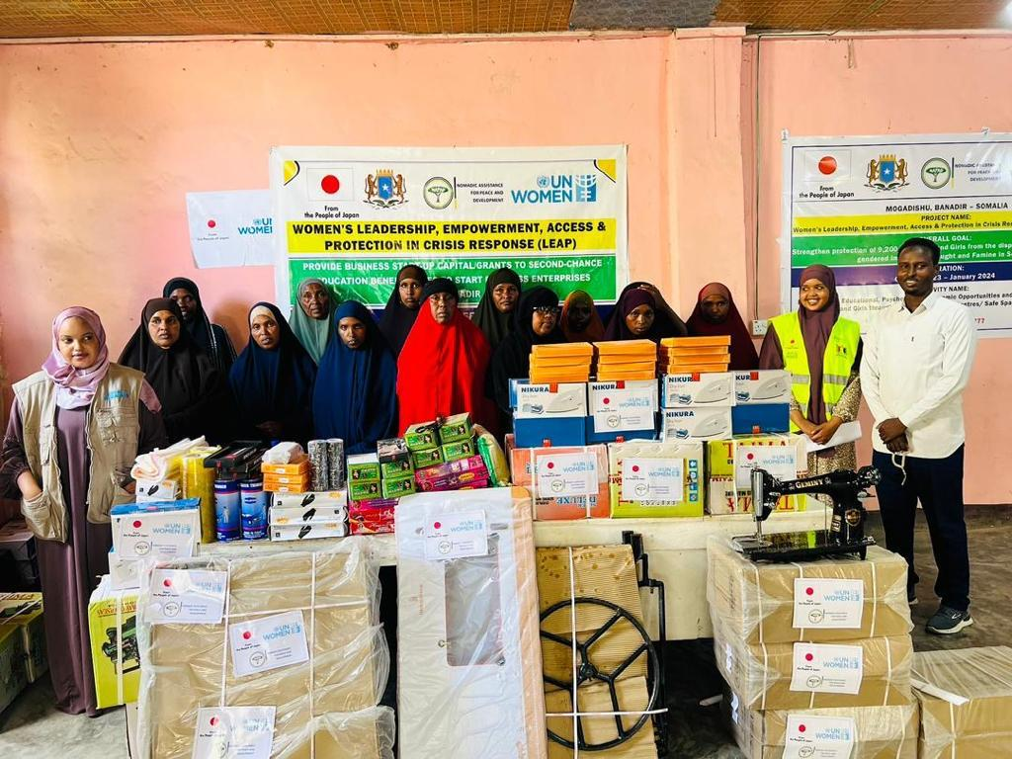
During the Kismayo FGD, one participant highlighted that girls who received tailoring support were subsequently employed by local cloth sewing factories, further increasing women's access to income and assets. Another participant emphasized that the project has significantly improved women's access to protection information and health messages. This includes enhancing women's understanding of protection services and various forms of gender-based violence (GBV), as well as supporting and standing in solidarity with survivors. The project facilitated the formation of committees comprised of both genders, dedicated to working towards achieving zero sexual exploitation and abuse (SEA) in the area. These committees engage in community awareness efforts and actively participate in the referral process, assisting victims of rape and other GBV incidents in accessing justice and social amenities such as medical support. Importantly, the committees provide these services without requiring any financial contributions from the victims. They guide them through the necessary processes, such as reporting cases to the police, assisting in the arrest of perpetrators if possible, or accompanying them to the hospital for treatment.
Figure 3: Women receiving start-up kits.

Relevance to the Needs of the target population
Finding 2: The project took a holistic approach by addressing violence, gender inequality, climate change, and economic empowerment, focusing on legal frameworks, psychosocial support, community engagement, and economic initiatives to uplift the lives of women and girls in targeted areas, resulting in highly relevant and effective interventions according to participants.
Overall, the project took a holistic and multi-faceted approach to address violence, gender inequality, climate change, and economic empowerment. By combining legal frameworks, psychosocial support, community engagement, and economic initiatives, the project aimed to create lasting change and uplift the lives of women and girls in the target areas. LEAP III recognized the importance of providing training on relevant legal frameworks and psychosocial counselling, understanding that these interventions are crucial for the protection and empowerment of women and girls, particularly in crisis-affected areas of Banadir, Baidoa, Garowe, and Kismayo.
According to the Key Informants, one of the key contributions of the project was its focus on promoting Gender Equality and Women's Empowerment (GEWE). In addition to legal and counselling aspects, the project recognized the need for a broader societal shift in attitudes and beliefs. It facilitated community conversations and dialogues led by influential leaders who advocated for a change in mindset towards gender equality and women's empowerment. By challenging harmful gender norms and fostering positive change within communities, the project aimed to create an environment where women and girls can thrive.
Recognizing the impact of climate change on vulnerable communities, the project also dedicated efforts to raise awareness and engage local communities in addressing this global challenge. Through innovative approaches, the project sought to empower communities to mitigate the effects of climate change and foster collaboration in tackling related issues. By integrating climate change adaptation and resilience-building measures, the project aimed to enhance the well-being and sustainability of the communities involved.
The FGD participants and the government officials confirmed that the project was the establishment and strengthening of referral pathways for survivors of violence. Recognizing that access to justice, support services, and protection are fundamental human rights, the project focused on ensuring that survivors had comprehensive and reliable avenues for seeking assistance. By strengthening these referral pathways, the project aimed to improve the overall response to violence against women and girls and promote their well-being and recovery. Economic empowerment and livelihood opportunities were also integral components of the project. Recognizing the importance of economic independence for women and girls, the project provided vocational skill-building Projects, startup capital for businesses, and support for strengthening savings and loan associations. These activities aimed to create sustainable economic opportunities, improve living standards, and promote the long-term empowerment and resilience of women and girls.
The training participants of the Legal Frameworks on Violence Against Women/Girls and the GBV highlighted that the interventions provided through the project were highly relevant and effective for both them and the community in the target locations.
Our community consists mainly of vulnerable individuals, minorities, and marginalized groups, who have historically faced gender-based violence (GBV). However, thanks to the training we received and our collective efforts as a team, we have been able to address and mitigate these challenges. The knowledge and skills we acquired through the project have empowered us to respond appropriately to instances of GBV within the camp. We now understand the proper channels to follow and the necessary steps to prevent such incidents from occurring. By working together and supporting each other, we have established a strong network that enables us to identify and address GBV cases promptly. As a result of our training, we have gained the confidence and understanding to intervene effectively in GBV situations. We have learned how to support survivors, provide them with the necessary resources, and guide them towards accessing appropriate services. This newfound knowledge has significantly contributed to reducing instances of GBV within our community. FGD Participant in Kismayo

Relevance of the project to the needs of women
Finding 3: The project demonstrated a strong commitment to addressing the needs of women and promoting gender equality and women's empowerment through various interventions, including training, counselling, provision of dignity kits, safe spaces, and support for economic opportunities, resulting in positive outcomes that may lead to transformative shifts in public perception and societal norms in the longer period.
According to the target beneficiaries, the project demonstrated a strong commitment to addressing the needs of women and promoting gender equality and women's empowerment. Through training, counselling, provision of dignity kits, creating safe spaces, and supporting economic opportunities, the project aimed to empower women and girls, foster their independence, and create an environment where they can thrive and contribute to their communities.
Firstly, the project conducted training sessions focused on relevant legal frameworks, engaging in dialogues with men and youth, and organizing environmental awareness campaigns. These initiatives played a vital role in raising awareness about women's rights, fostering accountability for gender-based violence, and empowering participants to become advocates for gender equality and women's empowerment. By equipping individuals with knowledge and encouraging dialogue, the project aimed to challenge societal norms and promote a more inclusive and equitable society.
Secondly, the project recognized the importance of providing psychosocial counselling and mentorship Projects. These interventions were designed to support Project participants in overcoming the effects of violence, fostering personal growth, and empowering individuals to take control of their lives. By addressing the emotional and psychological impacts of violence, the project aimed to promote healing and empowerment among survivors.
Another key aspect of the project was the provision of dignity kits for survivors of sexual and gender-based violence. According to the informants, these kits addressed the immediate needs of survivors, acknowledging the specific vulnerabilities faced by women and girls in crisis situations. By meeting their basic needs, the project sought to promote the well-being and support the recovery process of survivors, empowering them to move forward and rebuild their lives.
Additionally, according to the trainees of TVET, the project aimed to provide a comprehensive range of opportunities for women and girls, encompassing recreation, education, psychosocial support, and economic empowerment. This was achieved through the establishment of one-stop centres, GBV centres, and safe spaces. These spaces not only provided a supportive environment but also offered vocational skill-building Projects. By enhancing the skills, knowledge, and economic prospects of women and girls, the project sought to empower them to reach their full potential, gain independence, and make meaningful contributions to their communities.
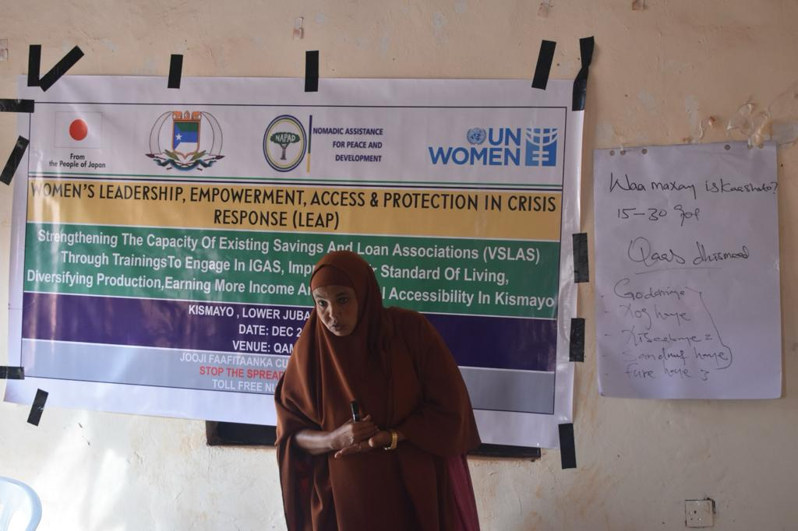
Furthermore, the project recognized the importance of financial independence and entrepreneurship. Through Village Savings and Loan Associations (VSLA) training, beneficiaries were empowered with the skills and knowledge to effectively manage their businesses. This intervention aimed to enhance economic prospects and promote self-sufficiency among women, further contributing to their empowerment and resilience.
Figure 4: VSLA Training in Kismayo
In Kismayo, community opinion leaders and youth the participants unanimously acknowledged the intervention's appropriateness to their needs for several compelling reasons. Firstly, the prevalence of FGM practices in the area was alarmingly high, and there was a notable absence of awareness initiatives in the target villages or community. However, according to the FGD participants in Kismayo, as a direct outcome of the intervention, the incidence of these harmful cultural practices has significantly decreased, reaching a reduction rate of 60%. This is only the perception of the participation, however there is no evidence for this. This indicates that the community has willingly embraced the abandonment of such practices, which have been known to impede the psychological and physical development of girls.
Secondly, the project adopted a community participatory approach, ensuring that both women and men were given equal opportunities to contribute to the project's design and implementation. Consequently, this inclusive approach fostered equal participation in service delivery and decision-making processes related to project activities. Moreover, it had a positive ripple effect on other social services and legal rights, such as access to justice. Women now possess a heightened awareness of the mechanisms available for reporting gender-based violence, empowering them to report incidents without fear.
Additionally, the project's impact extended beyond its primary objectives. It brought about a transformative shift in public perception towards women in Somali society. Women now experience improved treatment, respect, and a newfound mutual understanding between spouses, directly attributable to the project's influence.

Relevance of the Project Design
Finding 4: LEAP III project aligns with international commitments, regional priorities, and Somalia's National Development Plan (NDP) by addressing gender inequality, promoting resilience, and ensuring the protection and empowerment of women and girls affected by drought and famine in Somalia.
Overall, the project aligns with international commitments, regional priorities, and Somalia's NDP by addressing gender inequality, promoting resilience, and ensuring the protection and empowerment of women and girls affected by drought and famine in Somalia.
Globally, LEAP III is relevant to Sustainable Development Goals (SDGs). The project aligns with multiple SDGs, including Goal 1 (No Poverty), Goal 2 (Zero Hunger), Goal 5 (Gender Equality), Goal 10 (Reduced Inequalities), and Goal 16 (Peace, Justice, and Strong Institutions). It addresses poverty, food security, gender inequality, and social inclusion, which are key priorities outlined in the SDGs. Another key instrument that LEAP III is aligned with is the Convention on the Elimination of All Forms of Discrimination Against Women (CEDAW). The project aligns with CEDAW's objectives by focusing on strengthening the leadership, empowerment, and access of women and girls affected by drought and famine. It aims to promote gender equality, women's rights, and protection against discrimination.
Regionally, LEAP III is relevant to African Union (AU) Agenda 2063. The project contributes to AU's agenda by addressing the socio-economic challenges faced by women and girls in Somalia affected by drought and famine. It aligns with AU's goals of promoting gender equality, women's empowerment, and sustainable development in Africa.
LEAP III is also aligned to the Government of Japan’s commitment to promote Gender Equality and Women Empowerment in humanitarian crises. LEAP III project also contributes to the UN Women Somalia Strategic Note which supports Women's Leadership, Empowerment, Access & Protection in Crisis Response (LEAP) which is in line with on-going drought and famine responses aligned with Somalia National Development Plan 2020 to 20246 Pillar 3: Inclusive economic growth and Pillar 4: Improved social and human development, the Somalia Humanitarian response plan (HRP)7 , and drought response and famine prevention plan priorities that articulates Rapid Response Mechanism (RRM), protection and Gender Based Violence (GBV). Similarly, the project is contributing to UN Sustainable Development Cooperation Framework 2021-2025 (UNSDCF), which represent the commitment of the Federal Government of Somalia and the United Nations to partner in achieving peace, stability, and prosperity for all Somalis. The UNSDCF four overarching strategic priorities are: 1) Inclusive Politics and Reconciliation, 2) Security and Rule of Law, 3) Economic Development, and Social Development.
At national level, LEAP III is compatible with Gender Equality and Women's Empowerment: of the NDP 9 which prioritizes gender equality and women's empowerment. It aims to strengthen the leadership, access, and protection of women and girls affected by drought and famine, thereby contributing to the NDP's objectives. Besides, the project addresses the resilience-building aspect of Somalia's NDP, focusing on mitigating the impacts of drought and famine. By empowering women and girls to withstand and recover from these crises, it aligns with the NDP's goals of building resilience and reducing the vulnerability of affected communities.
Additionally, the project aligns with Somalia's NDP's objective of inclusive development by targeting women and girls who are disproportionately impacted by drought and famine. It aims to ensure the inclusion and active participation of marginalized groups, promoting their socio-economic well-being and protection.
The LEAP III project demonstrated a strong alignment with human rights principles as it ensured access to information and education about the harmful consequences of harmful practices including FGM while addressing gender-based discrimination. According to the Ministry for Women, the project recognized the pivotal role that women play as the backbone of society. By specifically targeting women and girls, the project aimed to address their unique needs and empower them to overcome the challenges they face.
The LEAP III project stands as a remarkable testament to its seamless alignment with the Federal Member States' concerted efforts in addressing critical issues pertaining to protection, gender-based violence (GBV), and social protection. By synergizing its objectives with the broader national response, LEAP III has emerged as a pivotal force in driving tangible positive change and making a lasting impact on the lives of individuals affected by these challenges.

Coherence
Finding 5: LEAP III project showed coherence with UN Women Strategic Note promoting gender equality, women's empowerment, and addressing the heightened vulnerabilities of women and girls in the context of the humanitarian.
LEAP III project aligns well with UN Women Somalia's strategic focus on promoting gender equality, women's empowerment, and addressing the heightened vulnerabilities of women and girls in the context of the humanitarian crisis in Somalia. The project seeks to enhance the resilience and well-being of women and girls in IDP settlements and host communities, which directly supports UN Women's strategic priorities in the country.
By addressing issues like sexual and gender-based violence, access to services, and women's economic empowerment, the LEAP III project is coherent with UN Women's mandate and the objectives outlined in its Somalia strategy. As the United Nations entity dedicated to gender equality and women's empowerment, UN Women brings unique expertise and a specialized focus on these issues compared to other UN entities.
UN Women's strong partnerships with civil society organizations, community leaders, and government stakeholders in Somalia allows it to effectively deliver gender-responsive humanitarian interventions. UN Women's technical knowledge and experience in areas like women's leadership, protection, and economic empowerment make it well-positioned to implement Projects like LEAP III that target the specific needs of women and girls. Additionally, UN Women's global mandate and country presence enables it to leverage resources, knowledge, and best practices from other contexts to strengthen its Project in Somalia.
As the United Nations entity dedicated to gender equality and women's empowerment, UN Women brings unique expertise and a specialized focus on these issues compared to other UN entities. The organization's strong partnerships with civil society organizations, community leaders, and government stakeholders in Somalia allows it to effectively deliver gender-responsive humanitarian interventions.
UN Women's technical knowledge and experience in areas like women's leadership, protection, and economic empowerment make it well-positioned to implement Projects like LEAP III that target the specific needs of women and girls. The organization's global mandate and country presence enables it to leverage resources, knowledge, and best practices from other contexts to strengthen its Project in Somalia.
This specialized expertise, extensive partnerships, and ability to draw on global experiences position UN Women as a comparative advantage in delivering the LEAP III project and addressing the multifaceted challenges faced by women and girls affected by the humanitarian crisis in Somalia.
Finding 6: LEAP III project effectively addressed the recovery needs of drought-affected women and girls by avoiding duplication of efforts, coordinating with relevant stakeholders, and creating synergies through collaboration, leading to efficient utilization of resources and more effective outcomes.
The LEAP III project added substantial value by effectively addressing the recovery needs of drought-affected women and girls. One key aspect of its success was the avoidance of duplication of efforts. The project coordinators and implementing partner (NAPAD) ensured that the interventions provided under LEAP III were complementary to existing initiatives and Projects. This approach prevented redundant activities and maximized the impact of resources, ultimately leading to more efficient and effective outcomes.
By collaborating and coordinating with relevant stakeholders, such as government agencies, non-governmental organizations, and community-based organizations, LEAP III sought to create synergies beyond the scope of the project. According to the government officials, this collaboration facilitated the integration of interventions and activities, leveraging the strengths and expertise of various actors to create a more holistic and comprehensive support system for the target beneficiaries. For example, the project collaborated with government-led initiatives focused on livelihood development, and psychosocial support for women and girls. For example, in the case of Puntland, Ministry of Women gave guidelines on those in need and areas the project to be implemented. This ensured effective utilization of resources to avoid duplication.
Furthermore, the project leveraged partnerships with local community organizations and women's groups to foster ownership and sustainability. By involving these stakeholders in the planning and implementation process, synergies were created, allowing for a more comprehensive and context-specific approach to addressing the recovery needs of drought-affected women and girls. The extent to which these synergies were created and sustained beyond the LEAP III project would depend on the commitment and continued collaboration of stakeholders. Establishing mechanisms for information sharing, coordination, and joint planning can help ensure that the positive outcomes and collaborations initiated under LEAP III are carried forward and integrated into future initiatives.

Effectiveness

Achievement of Indicators
Finding 7: LEAP III project achieved its target and successfully supported all the intended beneficiaries.
Assessment of the indicators indicate that the LEAP III project successfully achieved its overall goal of supporting women and girls affected by drought in recovering from the disproportionate and adverse gendered impacts of drought and famine in Somalia. The baseline value for the overall goals indicator was set at 0, indicating that initially, no women and girls had recovered from the impacts of drought through the project. The final target was set at 9,200, aiming to support that many individuals in their recovery process. By the end of the project, the actual absolute progress reached was 9,200, indicating that the project achieved its target and successfully supported all the intended beneficiaries. The relative achievement, calculated as a percentage of the set target, is 100%, indicating that the project fully accomplished its goal in terms of the number of women and girls recovered from the adverse impacts of drought. This demonstrates the effectiveness and success of the project in addressing the recovery needs of the targeted population.
The FGD participants confirmed that the project has made some progress in tackling gender-specific structural barriers rooted in prevailing social norms and attitudes by establishing platforms where community members can discuss such issues. For instance, in Kismayo, the committees established by the project actively engaged in meetings and formal conversations with the community, sensitizing them to deeply ingrained cultural barriers such as female genital mutilation (FGM), child marriage, forced marriage, and the denial of women's rights and legal entitlements. Through these efforts, the committees facilitated an environment that allowed women to gain access to their rights.
Moreover, the project has played a crucial role in enabling women to make choices to some extent that lead to happier lifestyles. Young girls, in particular, are now able to complete their studies instead of being forced into early marriages. The participants emphasized that women have gained the ability to voice their rights and fight for them, thanks to the project's provision of powerful information and economic support. Previously, some married women endured physical harm inflicted by their husbands due to the cultural belief that incorporating cultural values into their lives pleases God (as expressed in the Somali saying, "caada laga tagay caro alla ayeey ledahy"). However, through the project, they have come to understand that certain cultural practices are harmful and not favoured by God.
Several informants attested that the project's training services played a pivotal role in changing people's attitudes towards women and girls. Previously, women and girls were perceived as having only half the social value and human dignity of men, resulting in a power imbalance that favoured men. However, the project has challenged and shifted this perception, creating a more equitable understanding of gender roles and rights.
Table 8: Achievement of indicators
Level/Result | Indicator | Baseline (Point of Departure) | Set final target (at project end) | Actual absolute progress reached by project end | Relative achievement (in % of set target)
Overall Goal | Number of women and girls affected by drought recovered from disproportionate and adverse gendered impacts of drought and famine in Somalia. | 0 | 9,200 | 9200 | 100%
Outcome 1 | Number of women and girls affected by drought with knowledge & access to SGBV protection and appropriate referral pathways. | 0 | No target set | 7600 | 100%
Output 1.1: | # of women, youth, and girls completed training on legal frameworks on VAWG and GBV. | 0 | 200 | 200 | 100%
Output 1.1: | # of men meaningfully participated in efforts to bring about positive shifts in prevailing attitudes and social norms that condone VAWG and SGBV and climate change action | 0 | 800 | 800 | 100%
Output 1.1: | # of participants benefited from training on psychosocial counselling and engaged in facilitation of GBV eradicating efforts. | 0 | 300 | 300 | 100%
Output 1.1: | # of participants benefited from awareness-raising and environmental education campaigns | 0 | 700 | 700 | 100%
Output 1.2 | # of duty bearers trained on SGBV referral pathways and referral mechanisms | 0 | 100 | 100 | 100%
Output 1.2 | # of participants/ right-holder reached with referral pathways/messages through informal community meetings, radios, exist traditional platforms. | 0 | 5000 | 1,851,650 | People reached through billboards; community meeting/awareness are 6650 persons People reached through radio are 1,845,000
Output 1.2 | # of women of in reproductive age & SGBV survivors supported with dignity kits | 0 | 500 | 730 | 146%
Outcome 2 | Number of women and girls affected by drought with access to economic opportunities, built their resilience and empowered through access to multi-sectoral services. | 0 | No target set | 1600 | 100%
Output 2.1 | # of women & girls benefited from recreational, vocational skill education as a second chance education. | 0 | 440 | 440 | 100%
Output 2.1 | # of women and youth received start-up grant to augment their businesses. | 0 | 440 | 440 | 100%
Output 2.2 | # of VSLAs functional and engaging in IGA | 42 groups | 42 groups | 1030 (42 groups) | 100%
Output 2.2 | # of participants that received training on VSLAs operation and management | 42 groups | 42 groups | 1030 (42 groups) | 100%
Output 2.2 | # of participants that attended community engagement meeting | 0 | 130 | 130 | 100%

Regarding the number of target beneficiaries reached, the project has successfully reached a total of 10,850 individuals, with 70% being female and 30% being male. This indicates that the project has exceeded the overall target beneficiary count by about 18%, surpassing the initial goal of 9,200 beneficiaries. Furthermore, it is worth noting that an additional 1,845,000 people have been reached through referral pathway messages delivered via the radio Project. This demonstrates the project's extensive reach and impact in disseminating important information to a wider audience beyond the target beneficiaries.
Table 9: Total number of beneficiaries reached.
LEAP3 BENEFICIRIES TARGET & ACHIEVED
OUTCOME/ OUTPUT | TARGET | ACHIEVED
 | TARGET | Male | Female | Total | Male % | Female %
OUTCOME 1 | 7600 | 3179 | 6071 | 9250 | 34% | 66%
Output 1.1 | 2000 | 1139 | 861 | 2000 | 57% | 43%
Output 1.2 | 5600 | 2040 | 5440 | 7480 | 28% | 72%
OUTCOME 2 | 1600 | 29 | 1571 | 1600 | 2% | 98%
Output 2.1 | 440 | 0 | 440 | 440 | 0% | 100%
Output 2.2 | 1160 | 29 | 1131 | 1160 | 2% | 98%
TOTAL | 9200 | 3208 | 7642 | 10850 | 70% | 30%

The Likert Scale results as shown in table 4. reveal important insights regarding the impact of assistance, training, and activities on the well-being of participants. An overwhelming majority of respondents, representing 87%, either strongly agree or agree that these interventions had a positive effect on their well-being. This indicates that the majority of participants perceived tangible improvements in their personal lives as a direct result of the assistance and training they received.
Furthermore, the results indicate that there is a general consensus among participants regarding the project's capacity to address gender inequalities. A combined 70% of respondents either strongly agree or agree that the projects or activities they participated in contributed to enhancing society's ability to tackle gender disparities. However, it is worth noting that a significant portion, around 24%, remained neutral on this statement, suggesting some level of uncertainty or lack of a clear opinion. Additionally, a small proportion of participants, constituting 7%, expressed disagreement or strong disagreement, indicating that there are dissenting voices regarding the project's impact on addressing gender inequalities.
Regarding the protection of women and girls from sexual and gender-based violence (SGBV), structured interview demonstrates that a majority of respondents, accounting for 83%, either strongly agree or agree that the project has successfully provided adequate protection in the context of impending drought and famine. However, it is concerning that a notable proportion of participants, 12%, expressed varying levels of disagreement, with 10% strongly disagreeing. This suggests that there are valid concerns and dissatisfaction among a significant minority regarding the level of protection provided to vulnerable populations.
In summary, the findings indicate that the assistance, training, and activities have had a generally positive impact on the well-being of participants, as perceived by the majority. The respondents also acknowledged the contribution of the projects or activities in enhancing society's capacity to address gender inequalities, although a significant portion remained neutral on this aspect. While a majority agreed or strongly agreed that women and girls are adequately protected from SGBV as a result of the project, a notable minority expressed disagreement or strong disagreement, highlighting the need for further improvements in this area.
Table 10: Perception of FGD participants on the project
Perception Area | Strongly agree | Agree | Neutral | Disagree | Strongly disagree | Total
The assistance/training I received or the activity I participated improved my well-being | 42 | 45 | 2 | 4 | 3 | 96
The project or activity I participated improved the capacity of society to overcome gender inequalities | 33 | 37 | 19 | 2 | 5 | 96
Women and girls are adequately protected from sexual and gender-based violence (SGBV) in the context of impending drought and famine in Somalia as a result of the project | 47 | 36 | 1 | 2 | 10 | 96

As per table 11, When it comes to whether the project effectively implemented measures to prevent and respond to SGBV against women and girls during drought and famine in Somalia, majority of respondents (77%) either strongly agreed (64%) or agreed (13%) that the project had effectively implemented SGBV prevention and response measures. A smaller proportion (17%) were neutral, and only 2% strongly disagreed. This indicates a generally positive perception among the respondents that the project took adequate steps to address SGBV during the humanitarian crisis.
Regarding the project’s effectiveness in raising awareness among women and girls about their rights and available support services to address SGBV during drought and famine in Somalia, a significant proportion of respondents (72%) either strongly agreed (26%) or agreed (46%) that the project had raised awareness on SGBV-related rights and support services. However, 18% were neutral, and a small percentage (4% disagreed, 2% strongly disagreed) felt the project had not effectively raised such awareness. This suggests that while the project was perceived to have made notable efforts in this area, there is still room for improvement in ensuring widespread awareness among women and girls about SGBV support.
Table 11: Perception of respondents on prevention of SGBV and awareness raising.
Perception | Strongly agree | Agree | Neutral | Disagree | Strongly disagree | Total
The project has effectively implemented measures to prevent and respond to SGBV against women and girls during drought and famine in Somalia. | 64 | 13 | 17 | 0 | 2 | 96
The project has raised awareness among women and girls about their rights and available support services to address SGBV during drought and famine in Somalia. | 26 | 46 | 18 | 4 | 2 | 96

Finding 8: The vocational training component was conducted over a mere two-month period, which was reported to be considerably short for a Project aimed at equipping individuals with the necessary skills for employment and economic empowerment.
To address the recovery needs of women and girls affected by the humanitarian crises in Somalia, the LEAP III project aimed to break the cycle of vulnerability and provide them with the necessary support to rebuild their lives.
To improve the livelihoods of the target population, the project offered a multifaceted approach. It provided recreational activities and vocational skills training to the beneficiaries, equipping them with in-demand abilities. Additionally, the project distributed start-up grants to help augment their nascent business ventures. Village Savings and Loan Associations (VSLAs) were also trained on effective operation and management, empowering participants to sustainably manage their finances.
However, upon reviewing the evaluation findings, some areas for improvement emerged. The duration of the vocational skills training was reported to be inadequate, as it was conducted for a mere two-month period. This comparatively short timeframe may have been insufficient for participants to develop a strong foundation of knowledge and expertise in their chosen fields. A longer and more comprehensive technical and vocational education and training (TVET) Project could have better equipped the beneficiaries for employment and economic empowerment.
Furthermore, the beneficiaries indicated that the start-up kits distributed were not enough to establish a small-scale business and start anew. This suggests that the size and scope of the start-up grants may need to be reassessed to ensure they provide the necessary capital for the target population to meaningfully kickstart their own income-generating activities.

Enabling and Hindering Factors to Results
Finding 9: There is surge in GBV during Drought and famine in Somalia
The interviews with community members shed light on the severe gendered impacts of drought and famine on women and girls in Somalia. The findings reveal several key issues that contribute to their vulnerability and expose them to various forms of abuse and exploitation.
One significant concern is the extreme poverty and hunger faced by women and girls. Owing to the scarcity of food, they often go to sleep hungry, while men attempt to obtain sustenance from neighbours or relatives. However, cultural norms and expectations dictate that women and girls should remain at home and refrain from seeking assistance from others. This practice can have long-term consequences for their well-being, as it may adversely impact their prospects of marriage and subject them to social stigma.
Moreover, young girls are frequently forced to work instead of attending school, as their families rely on their income to sustain the household. In such employment situations, girls and women are susceptible to sexual abuses by their employers or members of the families they work for. They often lack knowledge of their rights and face challenges in reporting these incidents or claiming their rightful wages.
Financial constraints resulting from the drought further exacerbate the difficulties faced by women and girls. Limited access to resources leads to inadequate clothing and a lack of privacy due to poor sanitation facilities in camps. Women and girls may feel ashamed to use dilapidated toilets and resort to use nearby bushes, putting them at risk of sexual exploitation and abuse.
Disturbingly, young girls are sometimes married off at a young age to bring income to their families or sent to live with relatives due to food shortages. Being in unfamiliar environments exposes them to a heightened risk of gender-based violence (GBV), including forced sexual intercourse. Some girls resort to begging on the streets or sleeping there, increasing their vulnerability to sexual abuse and diseases. The dire circumstances resulting from the drought also contribute to an increase in drug and substance abuse among young girls and women. In their desperate attempts to cope with their situation, they may turn to drugs that cause them to lose consciousness. This leaves them vulnerable to sexual assault by men during nighttime.
These findings highlight the urgent need for comprehensive interventions to address the multifaceted challenges faced by women and girls during drought and famine. Efforts should focus on improving access to food, providing economic opportunities, enhancing education and skills training, strengthening legal protection, and raising awareness to prevent and respond to gender-based violence. By addressing these underlying factors and implementing targeted support, it is possible to promote the safety, well-being, and empowerment of women and girls in Somalia.
Finding 10: In the context of drought and famine, IDP communities in Somalia experience a distressing surge in sexual and gender-based violence (SGBV), which is exacerbated by a lack of knowledge, limited public awareness, insufficient capacity building, and scarcity of economic opportunities, intensifying the vulnerability of community members.
According to the Ministry of Women and Human Right Development, in the harsh realities of drought and famine, the plight of IDP communities becomes even more dire in regard to GBV. During these challenging times, a disheartening trend emerges: a surge in sexual and gender-based violence (SGBV) within these vulnerable populations. The causes behind this distressing escalation can be traced back to several underlying issues that further amplify the vulnerability of community members.
Firstly, within the IDP communities, a lack of knowledge prevails. Education is a scarce resource, with schools conspicuously absent from the IDP sites. This dearth of educational opportunities perpetuates a general unawareness and ignorance surrounding SGBV, its consequences, and preventive measures. The absence of this critical knowledge leaves community members ill-equipped to safeguard themselves and effectively address instances of SGBV.
Secondly, compounding the problem is the limited public awareness about SGBV. Comprehensive awareness Projects are absent, leaving many individuals uninformed about the various forms of SGBV, their inherent rights, and the support services available to them. In the absence of this vital information, community members often rely on their own interpretations and perceptions, leading to harmful behaviours and actions that perpetuate the cycle of violence.
Another significant challenge lies in the insufficient capacity building within the IDP groups. Access to training Projects and initiatives that could equip community members with the necessary skills and knowledge to prevent and respond to SGBV is severely lacking. The absence of these crucial interventions hampers the community's ability to recognize warning signs, intervene in potential cases, and provide support to survivors. The lack of capacity building perpetuates a cycle of helplessness and further deepens the vulnerability of the community.
Moreover, the scarcity of economic opportunities exacerbates the vulnerability of those residing in IDP sites. Limited job prospects within these communities breed feelings of helplessness and desperation, creating an environment ripe for SGBV to flourish. The absence of stable employment options disproportionately affects marginalized groups and minorities, leaving them even more susceptible to exploitation and violence.

Effectiveness in Partnerships
Findings 11: The project engaged all the key stakeholders including the government, which enhanced ownership.
The project was able to effectively collaborate with key stakeholders and partners, including relevant ministries at both Federal and State levels, civil society organization that implementing the project activities, and community leaders. The partnerships facilitated access to services to target communities and enhanced the implementation of project activities. Besides, the project management and monitoring and evaluation processes were generally satisfactory, with regular progress monitoring and reporting. However, there were some gaps in the M&E system, such as the lack of a comprehensive baseline assessment.
The implementation of the LEAP III project involved clear delineation of roles and responsibilities among key stakeholders. The government of Somalia, at both the Federal and State levels, actively participated in the project's implementation. They played a crucial role in overseeing the project, including the selection of beneficiaries and locations. Their guidance and involvement ensured that the project was aligned with the government's priorities and objectives, establishing a sense of ownership and collaboration.
UN Women, as a key partner, assumed the responsibility of monitoring the project's progress and providing technical support to NAPAD, the implementing partner. Throughout the project's life cycle, UN Women closely monitored the activities, ensuring their effective implementation. They also provided guidance and assistance to NAPAD, helping them navigate any challenges that arose during the implementation process. This support contributed to the successful execution of the project and the achievement of its intended outcomes.
NAPAD, as the implementing partner, took on the primary responsibility for executing the project activities in accordance with the agreed-upon workplan. They were accountable for the day-to-day implementation, ensuring that activities were carried out as planned. NAPAD maintained regular communication and provided updates to both UN Women and the government, keeping them informed about the progress and any significant developments. This transparent reporting mechanism facilitated effective coordination and collaboration among all stakeholders involved in the project.
By carefully assigning roles and responsibilities, engaging the government, providing technical support, and maintaining effective communication channels, the LEAP III project achieved a strong foundation for implementation success. The active involvement of the government, the monitoring support from UN Women, and the implementation efforts of NAPAD collectively contributed to the project's overall effectiveness and impact.

Efficiency

Fund Utilization
Finding 12: The fund was utilized efficiently to produce results.
Upon review, it is evident that the duration of the project may have been inadequate given the extensive range of activities that were planned. One aspect that stands out is the Technical and Vocational Education and Training (TVET) Project, which was conducted for a mere two-month period. This duration appears to be considerably short for a Project aimed at equipping individuals with the skills necessary for employment and economic empowerment. A longer and more comprehensive TVET Project would have allowed participants to delve deeper into their chosen fields and develop a stronger foundation of knowledge and expertise.
While the allocation of resources for the project may have been appropriate to some extent, there was a notable oversight in the emphasis placed on providing in-kind grants to women who graduated from the TVET Project. In the current competitive market, it is crucial to support these women with the necessary tools and resources to succeed. However, the amount given as in-kind grants may not have been sufficient to fully equip them for the challenges of market competition. It is essential to consider the costs and requirements of starting a business or pursuing employment within the specific industries targeted by the TVET Project. Adequate resources in the form of in-kind grants would have better positioned the graduates to establish themselves and thrive within their chosen sectors.
The implementation period of the LEAP III project has been a subject of concern raised by government officials. Specifically, they have expressed apprehension regarding the duration of the project and its actual commencement in October 2023, with a planned implementation period of six months, though the project was one year. However, there were no evidence reported on how the delays in implementation adversely affected the effectiveness and success of LEAP III project.

Financial Management
Finding 13: Project activities within the project have demonstrated a commendable level of budget utilization, effectively maximizing the resources allocated to them.
Upon careful review of the provided document, it becomes apparent that the majority of activities within the project have demonstrated a commendable level of budget utilization, effectively maximizing the resources allocated to them. It is noteworthy, however, that certain activities, namely Activity 3.1.4 (Monitoring and Quality assurance) and Activity 2.2.1 (Impact Assessment for VSLAs), have surpassed their initially assigned budgetary limits.
In a broader context, the Project as a whole has demonstrated a commendable level of financial prudence by utilizing 98% of the allocated funds for the support activities and fully exhausting the budgeted amount for the total project activities, attaining a utilization rate of 100%. This signifies a responsible and efficient approach to resource management.
Delving deeper into the expenditure distribution, it becomes apparent that 32% of the project budget has been allocated towards support costs, while the remaining 68% has been dedicated to Project activities. This allocation strategy demonstrates a concerted effort to strike a balance between maintaining the necessary infrastructure and resources to facilitate the smooth running of the project, while simultaneously prioritizing the implementation and execution of the core Project endeavours.
As the effective utilization of financial resources is of paramount importance in any project, the findings from this analysis underscore the significance of closely monitoring expenditures and ensuring that budgetary allocations align with the evolving needs and demands of the project. By adopting rigorous financial oversight measures, project managers can maintain adherence to budgetary constraints, mitigate the risk of cost overruns, and optimize the achievement of desired project outcomes.
Table 12: Project's expenditure
 | Activity Description | Total Budget USD | % | Expenditure | % | % To total project budget
Activity 1.2 | Support Costs
Activity 3.1.1 | SOM_D_5.1.3.10 - Audit & End Project Evaluation (2%) | $ 12,000 | 2% | $ 12,000.00 | 100% | 2%
Activity 3.1.2 | SOM_D_5.1.4.10 - Monitoring, Evaluation & Travel & Communication | $ 10,000.0 | 2% | $ 8,200.00 | 82% | 2%
Activity 3.1.3 | Activity 3.1.3 - Communication | $ 10,000.0 | 2% | $ 8,000.00 | 80% | 2%
Activity 3.1.4 | SOM_D_5.1.4.11 - Monitoring and Quality assurance (RO) | $ 8,000.0 | 1% | $ 8,273.00 | 103% | 1%
Activity 3..1. 5 | SOM_D_5.1.3.9 - National project Coordinator | $ 46,055.3 | 8% | $ 46,055.25 | 100% | 8%
Activity 3.1.6 | SOM_D_5.1.3.11 - Project Specialist-Gender & Humanitarian-(IUNV) | $ 48,901.1 | 8% | $ 48,901.11 | 100% | 8%
Activity 3.2.1 | SOM_D_5.1.2.9 - Operations Cost -CO | $ 14,297.6 | 2% | $ 14,297.00 | 100% | 2%
Activity 3.2.2 | SOM_D_5.1.3.12 - Project support Cost - 8% | $ 44,444.0 | 7% | $ 44,444.00 | 100% | 7%
Sub-total |  | $ 193,698.0 | 32% | $ 190,170.36 | 98% | 32%
Project Costs
Activity 2.2.1 | SOM_D_5.1.3.6 - Impact Assessment for VSLAs | $ 8,000.0 | 1% | $ 8,650.00 | 108% | 1%
Activity 1.1.1 | SOM_D_5.1.4.3- Training on legal frameworks governing VAWG and SGBV | $ 10,000.0 | 2% | $ 10,000.00 | 100% | 2%
Activity 1.1.2 | SOM_D_5.1.4.4 - Conduct community conversations/dialogues led by community opinion leaders on QUARTERLY bases for 800 men and youth to advocate for mindset shift towards the protection and promotion of Gender Equality and Women's Empowerment (GEWE) in Kis | $ 7,000 | 1% | $ 7,000.00 | 100% | 1%
Activity 1.1.3 | SOM_D_5.1.4.5 - Training on psychosocial counselling, peer influences | $ 13,160 | 2% | $ 13,160.00 | 100% | 2%
Activity 1.1.4 | SOM_D_5.1.4.6 - Awareness-raising and environmental education campaigns on climate change action | $ 7,840 | 1% | $ 7,840.00 | 100% | 1%
Activity 1.2.1 | SOM_D_5.1.4.7- Strengthen the referral pathways for duty bearers | $ 5,956 | 1% | $ 5,956.00 | 100% | 1%
Activity 1.2.2 | SOM_D_5.1.4.8 - Develop/disseminate referral pathways/messages for right-holder | $ 6,400 | 1% | $ 6,400.00 | 100% | 1%
Activity 1.2.3 | SOM_D_5.1.4.9 - Procurement of dignity kits | $ 6,000 | 1% | $ 6,000.00 | 100% | 1%
Activity 2.1.1 | SOM_D_5.1.2.6 - Provide recreational, educational, psychosocial, and economic opportunities | $ 142,600 | 24% | $ 142,600.00 | 100% | 24%
Activity 2.1.2 | SOM_D_5.1.2.7- Provision business start-up capital/grants | $ 132,000 | 22% | $ 132,000.00 | 100% | 22%
Activity 2.1.3 | SOM_D_5.1.2.8- Facilitate linkages of skills training graduates to Financial Institutions | $ 5,619 | 1% | $ 5,619.00 | 100% | 1%
Activity 2.2.2 | SOM_D_5.1.3.7 - Strengthening the capacity of existing Savings and Loan Associations (VSLAs) | $ 59,640 | 10% | $ 59,640.00 | 100% | 10%
Activity 2.2.3 | SOM_D_5.1.3.8 - Community engagement and stakeholder consultative meetings | $ 2,087 | 0% | $ 2,087.00 | 100% | 0%
Sub-total-Project Activities |  | $ 406,302 | 68% | $ 406,952.00 | 100% | 68%
Total Costs |  | $ 600,000 | 100% | $ 600,000 | 100%

Project Management and M&E process
Finding 14: The proactive monitoring approach employed by UN Women staff, including regular meetings and field visits, facilitated ongoing assessment of the project's effectiveness, allowed for improvements in implementation strategies, and contributed to the project's overall success.
The UN Women staff demonstrated a proactive approach in monitoring and evaluating the project by organizing regular bi-weekly meetings. These meetings served as a platform for sharing updates on the Project's progress, allowing for ongoing assessment of its effectiveness. By actively participating in these meetings, the staff contributed their expertise and insights, enriching the work plan shared by NAPAD and enhancing its quality and overall effectiveness.
In addition to the meetings, the UN Women staff conducted periodic field visits to gain firsthand knowledge of the project's implementation and assess its impact on the ground. These visits provided an invaluable opportunity to observe the project in action and gather valuable feedback. By carefully observing the project's activities and outcomes, the staff was able to identify areas for improvement and make informed decisions to ensure the project's success.
The feedback and observations provided by the UN Women staff during these field visits were utilized to refine and enhance the project's implementation strategies. The staff's keen observations and valuable insights played a vital role in identifying any challenges or gaps in the project's execution. By addressing these areas of improvement, the staff ensured that the project remained on track and aligned with its objectives, ultimately leading to successful outcomes.

Sustainability

Substantiality of the Results
Finding 15: The project's focus on establishing sustainable structures and mechanisms, along with capacity-building initiatives, demonstrated a strategic and analytical approach to ensuring the enduring benefits of the project, empowering communities, training local leaders, and fostering ongoing efforts, aiming to create a legacy of gender equality and women's empowerment that would extend far beyond its initial implementation.
The project's focus on establishing sustainable structures and mechanisms, along with capacity-building initiatives, demonstrated a strategic and analytical approach to ensuring the enduring benefits of the project. By empowering communities, training local leaders, and fostering ongoing efforts, the project aimed to create a legacy of gender equality and women's empowerment that would extend far beyond its initial implementation.
In recognition of the importance of long-term sustainability, the project took strategic measures to ensure that its benefits would extend beyond the project's completion. One such measure involved establishing sustainable structures and mechanisms that would continue to support the project's objectives even after its conclusion. By creating community structures and committees dedicated to advocating for gender equality and women's empowerment, the project aimed to foster ongoing efforts and sustained progress in these areas. These structures could serve as platforms for community engagement, dialogue, and collective action to address gender-based violence and promote gender equality. By empowering local communities to take ownership of these initiatives, the project aimed to create a lasting impact that would endure beyond the project timeline.
Furthermore, capacity-building initiatives were implemented to empower local stakeholders and ensure their continued involvement in addressing violence against women and girls. This included training local leaders and community members to effectively address and respond to gender-based violence. By equipping them with the necessary knowledge, skills, and tools, the project aimed to create a network of individuals who could champion the cause of gender equality in their communities. This capacity-building approach sought to create a ripple effect, as trained individuals would pass on their knowledge and skills to others, thereby expanding the reach and impact of the project.
These measures were not only instrumental in sustaining the project's impact but also in fostering local ownership and empowerment. By engaging and empowering local stakeholders, the project aimed to ensure that efforts to address gender-based violence and promote gender equality would continue long after external support had ended. This approach recognized the importance of building local capacity and fostering local leadership, as sustainable change can only be achieved when communities themselves are actively involved in driving progress.
Finding 16: The establishment of community-based monitoring mechanisms, along with partnerships with local civil society organizations, served as critical systems for accountability and oversight in the project.
In order to ensure accountability and secure the long-term benefits of the intervention for rights holders, the project implemented various systems and mechanisms. One key aspect was the establishment of community-based monitoring and evaluation mechanisms. NAPAD, in collaboration with stakeholders, set up toll-free hotlines (such as 1777) to provide a direct channel for beneficiaries to report concerns, provide feedback, and seek assistance. This approach allowed for real-time monitoring and feedback collection, enabling timely responses to any issues or challenges that arose during the project implementation. Additionally, suggestion boxes were made available to allow individuals to provide anonymous feedback, ensuring that their voices were heard and their suggestions considered.
To further strengthen oversight and accountability, NAPAD forged partnerships with local civil society organizations and networks with a focus on protection. These organizations played a vital role in ensuring the effectiveness and sustainability of the intervention, particularly in terms of referral mechanisms. As beneficiaries were referred to these organizations, they conducted independent evaluations to assess the impact of the intervention and its alignment with the rights holders' interests. This external evaluation provided an additional layer of accountability and verification, helping to ensure the project's effectiveness and protection of rights holders.
Finding 17: The project challenged prevalent attitudes and social norms condoning violence against women and girls (VAWG) and sexual and gender-based violence (SGBV)
The engagement of women, youth, and men to challenge prevalent attitudes and social norms condoning violence against women and girls (VAWG) and sexual and gender-based violence (SGBV), has the potential to bring about transformative changes in community perceptions. By empowering individuals with the knowledge and skills to challenge these harmful norms, there is a strong likelihood of reducing incidents of VAWG and fostering increased support for gender equality and women's empowerment.
Furthermore, by equipping them with essential skills and resources, they are better positioned to start their own businesses, improve their livelihoods, and gain greater independence. This output recognizes the importance of addressing not only the immediate psychological and emotional needs of women and girls but also their long-term economic well-being.
The VSLA assessment report presents several key findings regarding the Village Savings and Loans Association (VSLA) initiative in Kismayo and Baidoa. In Kismayo, out of the total 21 VSLA groups, 17 were operational, while 4 groups faced economic difficulties due to flooding and member relocations. On the other hand, all 21 VSLA groups in Baidoa were functional and located within the city. Some original group members had to be replaced due to various reasons such as death, relocation, and lack of commitment.
The needs and challenges expressed by the VSLA groups included a desire for enhanced financial literacy, improved teamwork and leadership skills, and a deeper understanding of market trends. Poor record keeping and documentation practices were also identified as challenges that needed to be addressed.
The report highlights several key lessons learned from the project. It emphasizes the importance of conducting initial and follow-up assessments to evaluate progress and identify areas for improvement. It also recognizes the challenges posed by security concerns and poor network connectivity, especially when reaching out to groups located outside the main towns. Location-specific challenges, such as economic difficulties, were acknowledged as important factors to consider for effective capacity building. Introducing the VSLA concept to new participants through training was found to be crucial, as was the need for enhanced financial literacy, teamwork, and leadership skills within the groups. Furthermore, the significance of accurate record keeping and documentation practices for tracking progress and accessing financial support was highlighted. Overall, the report concludes that capacity development initiatives for VSLA groups can contribute to long-term positive change and enhance the well-being of the communities involved.
Training of Village Savings and Loan Associations (VSLAs) in Kismayo (Jubaland) and Baidoa (Southwest) states fostered financial inclusion and economic empowerment by providing women with the means to save, access credit, and engage in income-generating activities. By enabling women to improve their financial resilience, the project contributes to their overall well-being and strengthens their ability to withstand the challenges posed by drought.
One particular area where the LEAP III project has demonstrated its transformative power is in the realm of recreational activities for women survivors. Through its carefully designed interventions, the project has succeeded in enhancing the trust and confidence of these women, thereby enabling them to embark on a journey of healing and empowerment.
The provision of recreational activities serves as a crucial avenue for women survivors to reclaim their agency and rebuild their lives. These activities create a safe and inclusive space where survivors can engage in various forms of self-expression, creativity, and social interaction. By partaking in such activities, women survivors not only find solace and respite from their traumatic experiences but also develop a renewed sense of belonging and self-worth.
The positive impact of the recreational activities organized under the LEAP III project extends far beyond mere leisure pursuits. These activities foster a supportive environment that encourages social cohesion, empathy, and understanding among participants. Through shared experiences, women survivors develop bonds of trust, forming a network of support that plays a pivotal role in their healing process.
Moreover, the recreational activities serve as a catalyst for empowerment, enabling women survivors to discover and nurture their talents and strengths. By engaging in creative endeavours, such as arts and crafts, performing arts, or sports, these women gain a renewed sense of purpose and accomplishment. This newfound confidence spills over into other aspects of their lives, empowering them to overcome challenges and pursue their aspirations with renewed vigour.
The timing of the project was particularly significant, given the cyclic nature of displacement caused by drought, flooding, and conflict. These recurring crises not only disrupt communities but also exacerbate the prevalence of gender-based violence (GBV). Women, in particular, become more vulnerable during these shocks, facing increased risks of abuse, exploitation, and marginalization.
By addressing the recovery needs of women and girls affected by these crises, LEAP III aimed to break the cycle of vulnerability and provide them with the necessary support to rebuild their lives. Through a comprehensive range of interventions, including vocational skills training, psychosocial support, and educational opportunities, the project sought to empower women and girls to overcome the adverse effects of displacement and regain agency over their lives.
Furthermore, by explicitly recognizing the link between these crises and the heightened risks of GBV, the project prioritized the safety and well-being of women and girls. By equipping them with livelihood skills, psychosocial support, and awareness of their rights, LEAP III aimed to mitigate the risks of GBV and strengthen their resilience in the face of future shocks.
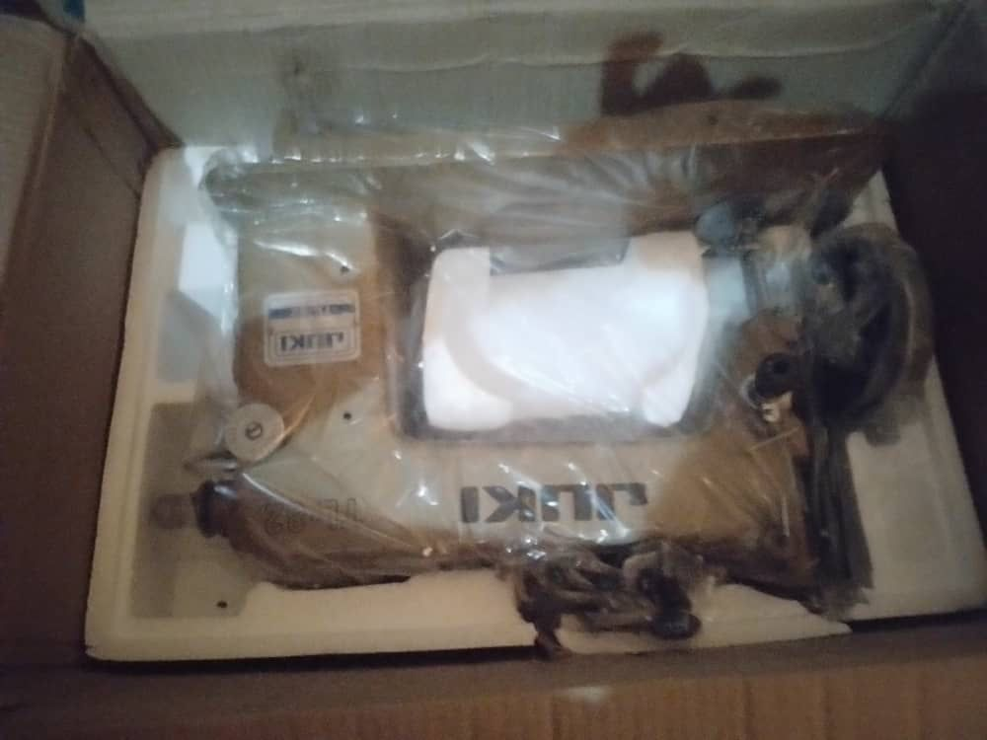
The integrated approach of addressing both the immediate needs and the underlying causes of vulnerability highlighted the project's commitment to human rights and gender equality. By recognizing the central role of women in society and addressing the complex challenges they face, LEAP III demonstrated a comprehensive and strategic response to the cyclic nature of displacement and its impact on gender dynamics.
Figure 5: Tailoring Machine not in use.
In the context of the project, there were 440 women who received training in different skills, namely tailoring, henna artistry, and cloth dyeing. However, upon closer examination, it becomes apparent that these women faced challenges in fully implementing their newly acquired skills due to certain limitations. Despite acquiring valuable knowledge and skills, the lack of necessary resources and equipment hindered their ability to fully utilize their training and engage in their respective trades effectively.
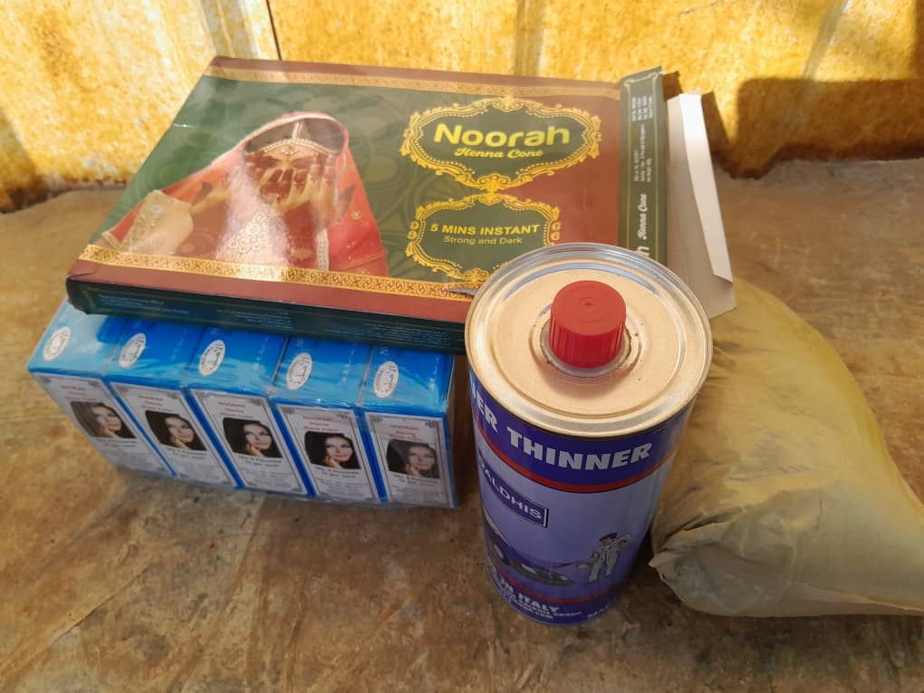
In the case of the women trained in tailoring, although they were provided with sewing machines, the machines remained unused. The reason behind this was the lack of funds to cover the expenses associated with installing the machines. Each machine required an installation cost of $10, which the project was unable to provide. As a result, the sewing machines were kept in the women's rooms, untouched since the day they were initially distributed. This situation is evident in the current photographs, which depict the machines still stored in the women's rooms.
Figure 6: The Henna items not in use.
Similarly, the women trained in henna artistry faced obstacles in running their businesses effectively. They did not have access to the full range of tools and equipment necessary for their trade. Instead, they were only given mirrors on the walls and packets of henna. However, these supplies were insufficient to meet their business needs adequately. Consequently, the women struggled to operate their henna artistry businesses to their full potential.
In the case of the group engaged in cloth dyeing, they also encountered difficulties due to incomplete resources. Specifically, they lacked a complete set of dyes required to actively engage in their businesses. The absence of certain colours of dyes limited their ability to dye clothes in a comprehensive range of shades. This deficiency hindered their capacity to offer a diverse selection of dyed clothing items.

Proposed Measures to Enhance Protection of Women and Girls
Finding 18: Women and girls in Somalia face significant challenges during drought and famine, which are further exacerbated by gender inequalities and vulnerabilities.
During the FGD, participants highlighted several significant challenges faced by women and girls in Somalia during drought and famine. These challenges shed light on the gendered vulnerabilities and hardships experienced by women in such circumstances. The challenges identified are summarised below underscore the systemic gender inequalities and vulnerabilities faced by women and girls in Somalia during drought and famine. They highlight the need for targeted interventions that address the economic, social, and legal barriers that perpetuate these challenges. Empowering women with financial support, reproductive health services, legal protections, and meaningful participation in decision-making processes can help mitigate these hardships and promote gender equality and women's rights in times of crisis.
- Lack of financial support for single mothers: Women who are divorced or abandoned by their partners often face the responsibility of caring for their children without any financial assistance. This places a significant burden on them, as they struggle to meet the basic needs of their families without receiving financial support from the absent fathers.

- Secret marriages and abandonment: Some women enter into secret marriages, only to be later abandoned by their partners. This situation makes it difficult for them to trace the men who impregnated them, leading to unwanted pregnancies. In their desperation, some women may resort to unsafe methods to terminate the pregnancies, putting their lives at risk.

- Family separation and disintegration: Divorces that occur during drought and famine can result in the separation of families. In these cases, husbands may take custody of the children, leaving women without support or means to maintain the family. The financial strain exacerbates the challenges faced by women, contributing to family disintegration and increased hardships.

- Exclusion and underrepresentation: Women and girls often face exclusion or limited representation in internally displaced persons (IDPs) committees. This marginalization stems from gender identity, as women are overlooked or given less voice and power in decision-making processes. This lack of inclusion denies women the opportunity to advocate for their needs and concerns, hindering their ability to access support and resources effectively.
Finding 19: implementing a comprehensive approach that includes increasing women's participation in SGBV training, improving access to information on SGBV, facilitating referral pathways, providing food vouchers and cash assistance, and offering renewable sources of energy for cooking can enhance the protection of women and girls from SGBV in the context of drought and famine, promoting their safety and well-being.
The participants in the discussion put forth several measures and actions that they believed should be taken to enhance the protection of women and girls from sexual and gender-based violence (SGBV) in the context of an impending drought and famine. These proposals are highlighted below, and these measures reflect a comprehensive approach to addressing the protection needs of women and girls in the context of impending drought and famine. They emphasize the importance of knowledge dissemination, coordination among stakeholders, provision of basic needs, and addressing the underlying challenges that contribute to the vulnerability of women and girls to SGBV. Implementing these actions can contribute to a safer and more resilient environment for women and girls in times of crisis.
- Increasing women's participation in training on SGBV and protection services: The informants emphasized the importance of empowering women through training on SGBV and making them aware of available protection services in the area. By enhancing women's knowledge and understanding of SGBV issues, they can better protect themselves and access the support they may need.

- Improving access to information on SGBV: The community members suggested utilizing radio Project and direct contact to improve access to information on SGBV. Additionally, constructing more community centres was proposed as a means to enhance community integration and serve as platforms for disseminating information on SGBV prevention, response, and available support services.

- Facilitating referral pathways: The participants highlighted the need for coordinated efforts among various stakeholders to establish effective referral pathways. This would ensure that survivors of SGBV can access appropriate services, including medical care, counselling, legal support, and psychosocial assistance. Coordinated efforts would enable a more holistic and streamlined response to cases of SGBV.

- Providing food vouchers and cash assistance: Participants recommended providing food vouchers and cash assistance to women and girls to improve their food security. By addressing the financial constraints and scarcity of resources during drought and famine, this support can help alleviate vulnerabilities and reduce the need for women and girls to engage in high-risk activities, such as searching for food or selling firewood.

- Provision of renewable sources of energy for cooking: The informants highlighted the importance of providing renewable sources of energy for cooking, such as clean cookstoves or alternative fuel sources. This measure aims to alleviate the burden on women who would otherwise have to venture into nearby bushes to collect firewood. By reducing their exposure to potential risks, such as rape or violence, the provision of renewable energy sources can enhance the safety and well-being of women and girls.

Gender Equality and Human Rights
Finding 20: Financial constraints, food scarcity, and limited employment opportunities contribute to the vulnerability of women and girls to sexual and gender-based violence (SGBV) during drought and famine in Somalia.
According to the community members in the target locations, several factors contribute to the vulnerability of women and girls to sexual and gender-based violence (SGBV) during drought and famine in Somalia. Financial constraints and food scarcity emerged as prominent factors in this regard. Due to the lack of financial resources and limited food availability at home, women and girls often resort to collecting firewood in the bush for sale. Engaging in this activity exposes them to significant risks, including the threat of rape. The community highlighted that women and girls cannot afford to purchase firewood or charcoal, leading them to search for these resources in nearby bushes where they are susceptible to various forms of violence such as rape, mutilation, murder, or kidnapping. Additionally, women who work as laundry washers face precarious situations during drought and famine. In their efforts to find employment and earn a living, they visit different households, including those occupied solely by men. Unfortunately, this exposes them to the risk of being raped.
"The project in provided us with crucial support, empowered us to create our own businesses and improve our financial well-being. Additionally, the project equipped us with valuable skills in tailoring and henna application, enabling us to generate income and enhance our financial independence. However, we need the project to continue and expand our business. "
Community Engagement & Stakeholder Consultative Meeting Participants in Baidoa

Moreover, young girls, due to their inability to acquire money and the lack of employment opportunities, are easily lured by men from the host community with promises of monetary assistance and food. This exploitation further exacerbates their vulnerability to SGBV.
The community's testimonies shed light on the complex dynamics that contribute to the heightened risk of SGBV faced by women and girls during times of drought and famine. The interplay of financial struggles, food scarcity, and limited employment opportunities creates an environment where women and girls are disproportionately exposed to violence and exploitation. Addressing these underlying factors and providing support in these critical areas is crucial in mitigating the vulnerability and protecting the rights and well-being of women and girls in such circumstances.
Finding 21: LEAP project in Somalia has made substantial progress in promoting gender equality, combating gender-based violence (GBV), and fostering positive shifts in community attitudes and behaviours.
Overall, the LEAP project has made significant strides in promoting gender equality, combating GBV, and fostering positive shifts in community attitudes and behaviours in Somalia. Through its comprehensive approach, the project has empowered individuals, raised awareness, and created sustainable change in the target areas.
The LEAP project has made remarkable progress in transforming community attitudes and behaviours concerning gender-based violence (GBV) and gender equality. Its multifaceted approach has included various activities that have effectively brought about a shift in mindset and increased awareness among individuals in Kismayo, Baidoa, Garowe, and Benadir.
The project's interventions targeted the root causes of gender inequality, as highlighted by all the participants. One notable aspect was the elimination of female genital mutilation/cutting (FGM/C) practices through various project activities. Trainings on FGM/C were conducted, targeting both circumcisers and mothers who were likely to subject their daughters to these harmful practices. Community meetings and sessions were also held to foster discussions on FGM/C, early and forced marriage, domestic violence, and other forms of sexual and gender-based violence (SGBV).
Ignorance emerged as a key underlying cause of gender inequality, and the project took steps to address this issue. The project supported young girls in accessing education by implementing mentorship Projects and providing hygiene kits that included sanitary pads. This approach aimed to enhance girls' access to education while reducing the likelihood of them missing classes during their menstrual periods.
Furthermore, the project actively engaged the entire community in discussions about FGM practices and their health implications. An important aspect of these discussions was the exploration of Islamic perspectives on FGM, as many community members lacked sufficient knowledge in this regard. Through the project, community members became aware that FGM has no basis in Islam. Consequently, many families have abandoned the practice of FGM, recognizing that it has nothing to do with preserving a girl's virginity. This shift in understanding and beliefs has contributed to the reduction of FGM prevalence within the community.
Training sessions on legal frameworks governing GBV and promoting gender equality have played a pivotal role in equipping community members with the necessary knowledge and understanding to address these issues. By providing individuals with a comprehensive understanding of the legal landscape, the project has empowered them to take action and advocate for change.
Community conversations led by influential opinion leaders have been instrumental in fostering dialogue and promoting gender equality. These regular engagements have served as platforms for open discussions, awareness-raising, and collaborative efforts. By leveraging the influence of opinion leaders, the project has been able to effectively challenge deep-rooted norms and promote positive change.
Psychosocial counselling and mentorship Projects have provided crucial support to individuals affected by GBV, enabling them to overcome the emotional and psychological impact of violence. Through these interventions, participants have gained the skills, knowledge, and attitudes necessary for healing, personal growth, and empowerment.
The project has also recognized the importance of addressing climate change and its impact on vulnerable communities. Awareness campaigns on climate change action have been conducted, disseminating key messages through community meetings and traditional media. By integrating climate change education into its initiatives, the project has raised awareness and empowered individuals to take collective action in mitigating the effects of climate change.
In addressing the needs of women and girls affected by drought and famine, the project has strengthened SGBV referral pathways, ensuring that survivors have access to essential services and support. Additionally, the provision of dignity kits has addressed the immediate needs of survivors, promoting their well-being and supporting their recovery process.
To enhance economic opportunities, the project has focused on vocational skill-building, providing business start-up capital, and facilitating linkages to financial institutions. By equipping women and girls with valuable skills, supporting their entrepreneurial endeavours, and promoting access to financial resources, the project has empowered them to improve their economic prospects and achieve sustainable income.
The project made concerted efforts to promote the inclusion of marginalized populations in its activities. The evaluation found that the project successfully engaged a total of 140 individuals from vulnerable groups, including women, youth, persons with disabilities, and religious or ethnic minorities.
Specifically, the project reached 59 participants in Benadir, 36 participants in Baidoa, 32 participants in Kismayo, and 13 participants in Garowe. By deliberately incorporating these marginalized groups into the project's interventions, the evaluation determined that the project was able to enhance the participation and representation of traditionally underserved populations.
Finding 22: Facilitating access to financial services, supporting girls in accessing markets and value chains, investing in education and skills, avoiding high-risk areas, and providing safety alarms can enhance the protection, resilience, and empowerment of women and girls in the face of impending drought and famine, addressing economic, educational, and safety aspects of their lives.
During the FGD, participants shared valuable suggestions on how women and girls could be protected from sexual and gender-based violence (SGBV) in the context of an impending drought and famine. The following recommendations were put forth. These suggestions underscore the importance of addressing the economic, educational, and safety aspects of women and girls' lives in the face of impending drought and famine. By implementing these recommendations, it is possible to enhance their resilience, promote their safety, and empower them to overcome the challenges posed by such crises.
- Facilitating access to financial services: Participants emphasized the importance of providing women and girls with access to financial services such as savings, Village Savings and Loan Association (VSLA) groups, and microcredit specifically tailored for their needs. By enabling them to invest in economic activities, build assets, manage risks, and recover from the impacts of drought and famine, financial services can enhance their economic resilience.

- Supporting girls in accessing markets and value chains: It was suggested that support be provided to girls in accessing markets and value chains, with a focus on providing training in market-oriented production. By equipping them with the necessary skills and knowledge, girls can recover fully from the effects of drought and famine and improve their economic resilience.

- Investing in education and skills: The participants stressed the importance of supporting girls' education and providing vocational and technical skills training. Enhancing the quality of education and skills development for girls can empower them to lead economically independent lives. Equipping women and girls with relevant skills not only promotes their safety but also enhances their overall well-being.

- Avoiding high-risk areas: To ensure the safety of women and girls, it was recommended that they should not be allowed to walk alone in high-risk places, such as venturing into the bush to collect firewood. This measure aims to minimize their exposure to potential dangers and reduce the risk of SGBV incidents.

- Providing safety alarms: Participants proposed the provision of safety alarms or whistle blowers to women and girls, particularly those living in internally displaced persons (IDP) camps. The alarms would serve as a means to alert others or seek help when they are in danger, particularly during incidents of rape that occur at night.

Lessons Learnt and Good Practices
The implementation of innovative approaches such as community conversations and dialogues, awareness-raising campaigns on climate change, holistic psychosocial and economic support, and strengthening VSLAs demonstrates a forward-thinking and analytical approach to address the challenges faced by women and girls in drought-affected areas. These approaches empower individuals, foster collective action, and promote sustainable change, ultimately contributing to the promotion of gender equality, women's empowerment, and resilience in the face of drought and famine.
- Conducting community conversations and dialogues: The innovative approach of conducting community conversations and dialogues led by community opinion leaders is a powerful method to promote mindset shifts towards gender equality and women's empowerment. This participatory approach creates a platform for open discussions and engagement among community members, fostering a sense of ownership and collective action. By involving the community in the dialogue, this approach encourages sustainable change that is rooted in the local context and addresses the specific needs and challenges faced by women and girls.

- Awareness-raising and environmental education campaigns on climate change: The implementation of innovative awareness-raising and environmental education campaigns on climate change action demonstrates a proactive approach to empower women, girls, youth, and men to address climate change issues. These campaigns utilize various creative and interactive methods such as tree planting and other engaging activities to encourage local communities to take action and become agents of change. By empowering individuals with knowledge and skills to address climate change impacts, this approach fosters a sense of environmental stewardship and promotes sustainable practices within the community.

- Support for psychosocial and economic opportunities: The implementation of psychosocial and economic support, including vocational activities, represents an innovative and holistic approach to addressing the multifaceted challenges faced by women and girls in drought-affected areas. This approach recognizes the importance of providing a safe and supportive space for women and girls to develop essential skills, access resources, and build resilience in the face of drought and famine. By combining recreational, educational, psychosocial, and economic support, this approach empowers women and girls to overcome barriers and improve their overall well-being.

- Strengthening VSLAs and promoting engagement in income-generating activities: The innovative approach of strengthening existing Village Savings and Loan Associations (VSLAs) and promoting their engagement in income-generating activities is a promising strategy to enhance financial inclusion and economic empowerment for women affected by drought. By providing training and support to VSLAs, women gain the necessary skills and resources to improve their standard of living, diversify their production, and gain financial accessibility. This approach not only empowers women economically but also promotes their long-term resilience by fostering self-reliance and economic independence.

- Community engagement and dialogue: The project recognized the pivotal role of community engagement and dialogue in promoting mindset shifts towards gender equality and women's empowerment. By facilitating community conversations and dialogues led by opinion leaders, the project creates spaces for open discussions, allowing community members to actively participate in addressing gender-based violence and promoting equality. This approach fosters a sense of ownership and commitment within the community, leading to sustainable change and empowerment.

- Multi-sectoral collaboration: The project embraced a multi-sectoral collaboration approach, engaging a diverse range of stakeholders such as duty bearers, community members, and financial institutions. By strengthening referral pathways and disseminating messages through community meetings and traditional platforms, the project establishes a supportive network for women and girls affected by drought and famine. Additionally, facilitating linkages to financial institutions enhances access to financial resources, contributing to the effectiveness and sustainability of the intervention. This collaborative effort creates a comprehensive response that addresses the multifaceted challenges faced by women and girls.

- Holistic economic empowerment: The project adopted a holistic approach to economic empowerment by providing comprehensive opportunities for vocational skill-building and income generation. By equipping women and girls with the necessary skills and resources, they gain access to sustainable economic activities. The project also leveraged Village Savings and Loan Associations (VSLAs) to enhance financial accessibility and income generation, enabling women to build resilience in the face of drought and famine. This comprehensive approach recognizes the importance of addressing economic barriers and promoting long-term sustainability.

- Comprehensive capacity building: The project emphasizes comprehensive capacity building through training Projects that cover various aspects, including legal frameworks, psychosocial counselling, peer influences, and mentorship. By equipping women, youth, and men with the necessary knowledge and skills, the project addresses the underlying causes of violence against women and girls. This comprehensive approach promotes sustainable change and empowerment by enabling individuals to challenge harmful norms, advocate for gender equality, and create a supportive environment within their communities.

Conclusions
- The LEAP III Project in Somalia proved to be highly relevant in addressing the pressing needs of women and girls who were severely affected by the devastating drought and famine. Aligned with the gender equality goals set by UN Women, the Project aimed to empower women by providing them with crucial protection, alternative livelihood opportunities, and the development of leadership skills. The LEAP III project in Somalia demonstrated strong relevance to the local context and the needs of the target population, particularly women. The project's design and interventions were well-aligned with the national and international priorities around gender equality and women's empowerment. This alignment is crucial given the disproportionate impact of the ongoing humanitarian crisis on women and girls in Somalia. By tailoring its approach to the specific challenges and vulnerabilities faced by the local communities, the project was able to effectively address their pressing needs.

- The Project's effectiveness in achieving its intended results was evident, following the logical framework and Theory of Change meticulously. It successfully reached and positively REACHED9,200 beneficiaries, making significant progress in areas such as women's economic empowerment, protection against violence and abuse, and the provision of support for alternative livelihoods. Furthermore, the project was highly effective in achieving all of its intended outcome indicators. This includes successfully increasing the number of women who received start-up kits and participated in Village Savings and Loan Association (VSLA) trainings. These tangible results indicated that the project's interventions were successful in directly addressing some of the key barriers and obstacles faced by the target beneficiaries, particularly in the areas of economic empowerment and access to financial services.

- The evaluation also noted the project's ability to build effective partnerships with a range of key stakeholders, including local authorities and civil society organizations. By fostering these collaborative relationships, the project was able to leverage the expertise and networks of local actors, further strengthening its reach and impact within the communities it served.

- While the LEAP III project demonstrated numerous strengths, the evaluation also found areas where improvements could be made to enhance the long-term sustainability of the project. One key concern raised was around the continued use and maintenance of the distributed assets, such as tailoring machines and henna items, beyond the project's lifetime. Ensuring the sustainability of these resources is crucial to safeguarding the project's achievements and enabling the target communities to continue benefiting from the provided support.

- Additionally, the evaluation found out that the project's monitoring and evaluation systems could be improved to better track outcomes and capture valuable lessons learned. Strengthening data collection, analysis, and reporting mechanisms would not only help the project track indicators, but also inform and enhance future Project efforts. This would contribute to a more evidence-based and adaptive approach to project implementation.

- The project made concerted efforts to promote the inclusion of marginalized populations in its activities. The evaluation found that the project successfully engaged a total of 140 individuals from vulnerable groups, including women, youth, persons with disabilities, and religious or ethnic minorities.

- Another area for improvement highlighted in the evaluation was the duration of the vocational training component. The evaluation noted that the vocational training was conducted over a mere two-month period, which was considered considerably short for a Project aimed at equipping individuals with the necessary skills for employment and economic empowerment. The brevity of the vocational training sessions was a concern, as it called into question the ability of the participants to fully develop the required competencies and technical skills to become viable candidates for employment or income-generating activities. Providing such a limited timeframe for vocational training may have constrained the project's ability to adequately prepare the beneficiaries for sustainable livelihoods and economic self-reliance.

- Lastly, another area for improvement identified in the evaluation was the adequacy of the start-up kits provided to the project beneficiaries. According to the feedback gathered from the beneficiaries themselves, the start-up kits distributed were not sufficient to enable them to establish a small-scale business and start anew. The beneficiaries reported that the contents of the start-up kits were limited and did not provide them with the necessary resources to kickstart their own income-generating activities. This was a significant concern, as the start-up kits were intended to serve as a foundational support mechanism to help the target population transition into sustainable livelihoods and economic self-reliance. Without access to a comprehensive set of tools, equipment, and initial capital, the beneficiaries faced significant challenges in translating the skills they had acquired through the project's training sessions into viable small businesses. The mismatch between the contents of the start-up kits and the actual needs of the beneficiaries was seen as a major obstacle to the project's goal of fostering economic empowerment.

In conclusion, the LEAP III Project in Somalia made substantial strides in addressing the critical needs of women and girls impacted by the daunting drought and famine. It succeeded in empowering women, promoting gender equality, and contributing significantly to their protection and overall well-being. The Project's unwavering commitment to sustainability, coupled with the identification of valuable lessons learned and good practices, further enhances its potential for future scaling up and replication in similar humanitarian settings.

Recommendations
The evaluation report presents the following recommendations that could help sustain the momentum gained by the project and may be considered for a future, similar initiative. These recommendations were developed in consultation with UN Women and government officials. Additionally, all key informants and focus group discussion (FGD) participants were asked to provide recommendations based on their participation in the project activities. In view of maximizing the evaluation findings’ utility, the following grid lists elements that can be used for UN Women’s official management response to the recommendations and related corporate follow-up:
Evaluation Title/year | LEAP 2 in Somalia /2023
Summary of evaluation | LEAP III -Project interventions were successful – the activities were implemented successfully and largely produced the expected results.
- Expand the geographic reach of the project:
  - The recommendation to expand the geographic reach of future Project acknowledges the importance of reaching more communities affected by drought and famine. By broadening the project's scope, it becomes possible to address the specific needs of women and girls in additional regions and provide a more comprehensive response to the gendered impacts of crises. This expansion can help ensure that vulnerable populations receive the necessary support and resources to overcome the challenges they face.
Key action | Timeframe | Responsible entity | Priority
Assess the gendered impact of the drought in Somalia and include more districts that do witness severe droughts. | Immediate continuation of existing LEAP 3 activities | UN Women Somalia, Funding Partners and IPs | High
- Revise the duration Technical and Vocational Education and Training (TVET) by:
  - Extending the Project duration to at least 6 months
  - Conducting a thorough assessment of resource requirements and providing adequate in-kind grants to support graduates
  - Offering ongoing business support and mentorship
Key action | Timeframe | Responsible entity | Priority
TVET programs need to provide employable skills and should run at least 6 months.  Conduct Market assessment of employable skills for women/girls in project areas | To be introduced as a feature of a new, further upgraded project design | UN Women Somalia and ESARO, IPs, local partners | High
- Strengthen existing stakeholder partnerships to foster a coordinated and holistic approach, leveraging diverse expertise and resources
  - Collaboration with a wide range of partners, including local organizations, government agencies, and community leaders, is critical for successful implementation and sustainability. Strengthening these partnerships fosters a coordinated and holistic approach to addressing gender equality and women's empowerment. By leveraging the expertise and resources of various stakeholders, future Project can benefit from diverse perspectives, local knowledge, and increased community buy-in, leading to more effective and sustainable outcomes.

Key action | Timeframe | Responsible entity | Priority
Facilitating knowledge sharing and joint problem-solving to leverage the diverse perspectives and strengths of the stakeholder group  Share LEAP project’s evaluation lessons learned, best practices, conclusions and recommendations with wider community to attract donors to mobilize more resources | After project close-out | UN Women Somalia and ESARO | High
- Diversify income-generating activities and support sustainable livelihoods, including access to financial resources and markets
  - While the project incorporates economic empowerment through the Village Savings and Loan Associations (VSLAs), future Project should focus on diversifying income-generating activities and supporting sustainable livelihoods. This includes exploring opportunities in sectors such as agriculture, entrepreneurship, and business skill-building. Facilitating access to financial resources and markets further enhances economic opportunities for women and girls, enabling them to become self-reliant and economically empowered.
Key action | Timeframe | Responsible entity | Priority
Supporting the development of small businesses and micro-enterprises through business development services, grants, or access to start-up capital  Connecting people to relevant markets, value chains, and market information to help them identify and access profitable income opportunities | Once this phase ends | UN Women Somalia and ESARO/HQ | High
- Integrate climate change action and resilience-building components to address the increasing impact of climate change
  - Considering the increasing impact of climate change, future Project should integrate climate change action and resilience-building components. This can involve providing training on climate change adaptation, supporting sustainable natural resource management practices, and promoting climate-smart agriculture techniques. By addressing climate change challenges, the project contributes to the long-term resilience and sustainability of communities, particularly those affected by drought and famine.
Key action | Timeframe | Responsible entity | Priority
Conducting a comprehensive climate risk and vulnerability assessment to understand the local impacts of climate change  Designing program activities and interventions that help communities adapt to climate change effects, such as introducing climate-smart agricultural practices, diversifying livelihood options, or improving early warning systems | Next phase of the project | UN Women | High
- Establish community-based support systems, such as women's organizations and community watch groups, to address and prevent SGBV
- Encourage the formation of women's organizations or community watch groups dedicated to addressing SGBV. These groups can act as support networks, providing guidance and assistance to survivors, and raising awareness about SGBV within the community. By fostering a sense of collective responsibility and support, community-based systems can effectively prevent and respond to SGBV incidents.

Key action | Timeframe | Responsible entity | Priority
Supporting the formation of self-help groups, or other community-based platforms where survivors can access peer support, information, and referrals to services  Providing training and resources to equip community members, especially women and girls, with knowledge and skills to identify, report, and respond to SGBV  Fostering linkages between community-based structures and formal service providers (e.g., law enforcement, social services, healthcare) to ensure comprehensive support for survivors | Incorporate in the next phase of the project | UN Women, IP, | High
- Improve access to justice and legal protection for survivors of SGBV, including strengthening legal frameworks and enhancing capacity in the legal and law enforcement sectors
- Establish mechanisms to ensure that survivors of SGBV have access to justice and legal protection. This includes strengthening the capacity of local law enforcement agencies to handle SGBV cases sensitively, providing legal aid services to survivors, and raising awareness about their rights and available legal remedies. Empowering survivors to seek justice not only holds perpetrators accountable but also sends a strong message against impunity.

Key action | Timeframe | Responsible entity | Priority
Providing training and capacity building for law enforcement, the judiciary, and other justice sector actors to improve their knowledge, skills, and sensitivity in handling SGBV cases | Incorporate in the next phase of the project | UN Women, IP, | High

Annexes

Documents Reviewed

Data Collection Instruments (questionnaires and interview guides)

Evaluation Matrix

List of People Interviewed

Evaluation ToR

Evaluator Profile
Muktar Abdi Hussein is an author, researcher, and Monitoring Evaluation, Learning and Accountability expert who has conducted several evaluations and assessments related to WPS, gender, education, agriculture, stabilization, early recovery and other humanitarian and development themes.

https://reliefweb.int/report/somalia/women-and-girls-somalia-face-critical-life-threating-drought-and-conflict-situations
https://reliefweb.int/report/somalia/women-and-girls-somalia-face-critical-life-threating-drought-and-conflict-situations
Project documents
https://jobs.undp.org/cj_view_job.cfm?cur_job_id=115043#:~:text=UNDP%20indicates%20that%20the%20majority,families%2C%20and%20evade%20sexual%20violence.
https://somalia.unfpa.org/sites/default/files/resource-pdf/situation_of_women_and_girls_-_drought_in_somalia.pdf
UN Women. (2019). Somalia: Gender Equality and Women's Empowerment in Humanitarian Action.
UNHCR. (2020). Somalia Regional Refugee and Migrant Response Plan.
UNFPA. (2019). Somalia: Gender-Based Violence Needs Analysis.
https://aho.org/emergencies/somalia-humanitarian-response-plan-2022-2025/
LEAP 1

