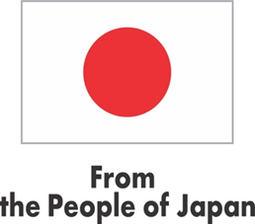
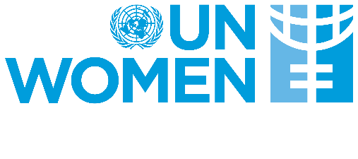

End of Project Evaluation

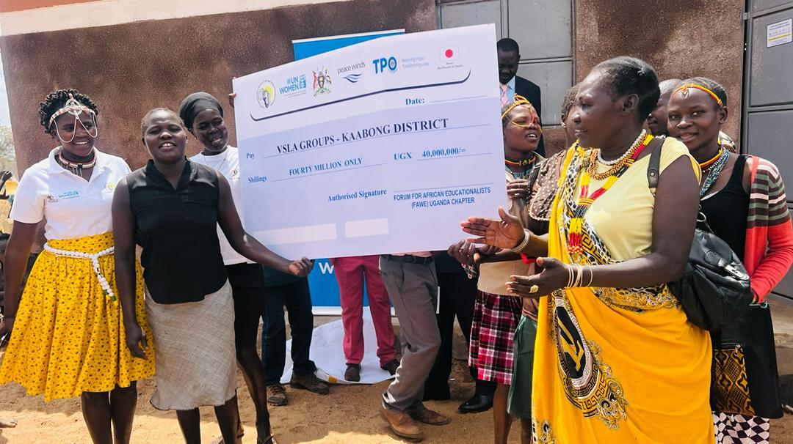
Promoting Leadership, Empowerment, Access and Protection of Women and Girls affected by Conflict, Severe Drought and Forced Displacement in Uganda under the Japan Supplementary Budget (LEAP JSB III)
Evaluation Manager
Allen Ankunda

Drake Rukundo
Independent Consultant

SEPTEMBER 2024

Project Profile
Title | Promoting Leadership, Empowerment, Access and Protection of Women and Girls affected by conflict, severe Drought and forced Displacement in Uganda under the Japan Supplementary Budget (LEAP JSB III)
Overall Goal | To strengthen emergency protection, leadership, access to services and empowerment of 3,250 (2750 Women and Girls and 500 Men and Boys) including persons with disabilities affected by interconnected crisis related to drought and displacement in Uganda
Outcomes | - Improved positive coping mechanisms for 1,750 vulnerable persons in refugees and host communities as well as drought-affected women and girls and 200 men and boys  - Strengthen gender-responsive emergency drought and displacement prevention, response and recovery interventions through the involvement of women leaders and key actors targeting 1,000 women and 300 men.
Duration | 12 Months (March 2023-March 2024)
Geographical Scope | Southwestern Uganda  Isingiro (Nakivale)  Kisoro (Nyakabande TC)  North Eastern Uganda  Moroto  Kaabong
Target Beneficiaries | Direct Beneficiaries  3,250 (2750 Women and Girls and 500 Men and Boys)  Indirect Beneficiaries  6,200 women, girls, men and boys including PWDs
Total Budget | USD 723,530
Source of Funding | Government of Japan Supplementary Budget
Implementing Agencies | UN Women Country Office
Other Partners | UN Agencies, International NGOs, Japan NGOs and Companies, CBOs, Academia, Private Sector, and women networks in project locations

List of Acronyms and Abbreviations

AMN Acute Malnutrition
CAOs Chief Administrative Officers
CDOs Community Development Officers
CSOs Civil Society Organisations
DAC Development Assistance Committees
DEQAS Decentralized Evaluation Quality Assurance System
DRC Democratic Republic of Congo
EMG Evaluation Management Group
ERG Evaluation Reference Group
FAWE Forum for African Women Educationalists
FGDs Focus Group Discussions
GBV Gender Based Violence
ICT Information and Communication Technology
IGAD Intergovernmental Authority on Development
IPC Integrated Food Security Phase Classification
LEAP Leadership, Access Empowerment and Protection
NEPIL Network of Public Interest Lawyers
NGOs Non-Governmental Organizations
ODK Open Data Kit
OECD Organization for Economic Cooperation and Development
PSEA Protection from Sexual Exploitation and Abuse
RAs Research Assistants
SGBV Sexual and Gender Based Violence
TC Transit Center
TPO Transcultural Psychosocial Organization
UN Women United Nations Entity for Gender Equality and the Empowerment of Women
UNDP United Nations Development Program
UNEG United Nations Evaluation Group
UNHCR United Nations High Commissioner for Refugees

Table of Contents

Project Profile ii
List of Acronyms and Abbreviations iii
List of Tables v
Executive Summary vi
1. BACKGROUND AND CONTEXT 1
1.1 Country Context 1
1.2 Project Description 2
1.3 Stakeholder Analysis 3
1.4 Evaluation Purpose Objectives and Scope 4
1.5 Uses and Users of the Evaluation 6
2. METHODOLOGY 8
2.1 Evaluability Assessment 8
2.2 Methodological Approach 8
2.3 Data Sources 10
2.4 Human Rights, Gender Equality and Disability Inclusion 12
2.5 Ethical Considerations 12
2.6 Study Limitations 13
3. EVALUATION FINDINGS 14
3.1 Relevance 14
3.2 Coherence 16
3.3 Effectiveness and Efficiency 18
3.4 Sustainability 34
3.5 Human Rights, Gender Equality and Disability Inclusion 35
4. CONCLUSION 41
5. LESSONS LEARNED 42
6. RECOMMENDATIONS 43
ANNEXES i
Annex 1: Evaluation Matrix i
Annex 2: Documents Reviewed iv
Annex 3: Lists of Agencies and Partners Contacted v
Annex 4: Data Collection Instruments xi
Annex 5: Terms of Reference xviii

List of Tables

Table 1: Stakeholder Categorization 3
Table 2: Sample of Beneficiaries that participated in Survey 9
Table 3: Number and Categories of Respondents 10
Table 4: Gender distribution (includes Refugees and Host Communities) 10
Table 5: Age and Marital Status 11
Table 6: Average Household size 11
Table 7: Main Assets and Income Sources of Beneficiaries 11
Table 8: Level of Participation in Project Interventions 12
Table 9: Delivery of Project Outputs 22
Table 10: Project Budget Allocation and Absorption 30
Table 11: Expenditure per Intervention by Implementing Partners 30
Table 12: Participation in Gender Training by beneficiaries Sampled 36
Table 13: Level of Appreciation of Gender Roles 37
Table 14: Impact of Gender Training on positive Gender norms 37
Table 15: Perception of Local authorities in supporting positive gender norms 37
Table 16: Respondent Beneficiaries Form of Disability 38

Executive Summary

This report presents the main findings, lessons learned, conclusions and recommendations of the final evaluation of the one-year project “Promoting Leadership, Empowerment, Access and Protection of Women and Girls affected by conflict, severe Drought and forced Displacement in Uganda” under the Japan Supplementary Budget (LEAP JSB III Project) which was implemented by UN Women in Karamoja drought affected districts of Kaabong and Moroto as well in Southwestern Uganda in the refugee hosting districts of Isingiro and Kisoro.

Project Background
In July 2022, escalating conflict in eastern Democratic Republic of Congo (DRC) led to an influx of refugees into Southwestern Uganda to a total of 39,585 (70% of which were women and girls). At the start of 2023, it was estimated that another 65,533 new refuges crossed into Uganda (UNHCR, 2023). Some of these women and girls suffered gender-based violence including rape. In addition, climate extremes coupled with land degradation has threatened livelihoods in Karamoja given its semi-arid nature and reliance on community lands and forests. In 2022, it was estimated that the Karamoja sub-region recorded 518,000 people facing food insecurity. With hunger posing a direct threat to life, there was heighted vulnerability especially for women, girls, children and Persons with Disabilities (PWDs) and susceptibility to abuse, violence and exploitation.

It is against this backdrop, that The United Nations Entity for Gender Equality and the Empowerment of Women (UN Women), with funding from the Government of Japan, implemented a one-year Leadership, Empowerment Access and Protection (LEAP JSB III) project. The project ran from March 2023 to February 2024.

Evaluation Purpose, Objectives and Scope.
In line with the program requirements and the UN Women evaluation policy, the end of project evaluation was conducted to assess the performance of the project, provide accountability and enhance learning. The purpose of this independent end term evaluation was to assess the project’s achievements against the set objectives, identify and document lessons learnt (including design issues, lessons and best practices that can be up-scaled or replicated), and assess how the program contributed to gender equality and economic empowerment for vulnerable refugees, host communities and drought affected women and girls living in Isingiro (Nakivale), Kisoro (Nyakabande TC), Moroto and Kaabong Districts in Uganda.

The objectives of the evaluation were to:
- Assess the relevance of LEAP III Japan Supplementary Budget (LEAP JSB III) intervention in addressing the needs of refugee and drought affected women and how gender equality principles were integrated in the project;
- Assess the effectiveness and efficiency of UN Women’s approach for achievement of results, as defined in the logical framework; and
- Identify lessons learned and provide actionable recommendations with respect to the strategy, and overall approach to UN Women’s programming in humanitarian settings.

The evaluation covered all the project activities implemented between March 2023 – February 2024 in Isingiro (Nakivale), Kisoro (Nyakabande TC), Moroto and Kaabong Districts in Uganda funded by the Government of Japan under the Japan Supplementary Budget (JSB).

Evaluation Methodology
The evaluation was conducted in accordance with UN Women evaluation policy, the Global Evaluation Reports Assessment and Analysis System (GERAAS evaluation report quality checklist), and adopted gender responsive methodology. The evaluation adopted a mixed-methods approach where a combination of qualitative and quantitative methods was used to ensure that there is a descriptive analysis of data – an explanation of the story behind the figures. The evaluation was informed by both qualitative and quantitative data obtained from desk review, consultative meetings and focus group discussions.
Evaluation Findings
Relevance
The project was designed to respond to emergency situations and was evaluated as highly relevant in its responsiveness to the identified needs of women, girls in refugee settlements and host communities in Southwestern Uganda and Karamoja Sub-region. It had been estimated that by 2022, 520,000 in Karamoja faced acute famine that led to deaths and threatened livelihoods as many desperate attempts to engage in activities to survive. Women and girls were disproportionately affected. In Southwestern Uganda, the escalation of conflict in Eastern Congo from July 2022, led to an influx of about 40,000 refugees (70%) of whom were women. Both these scenarios needed emergency responses, which the project provided.

Coherence
UN Women LEAP JSB III project was coherent to the national development framework on national disaster response under the Office of the Prime Minister (OPM). The interventions in Southwestern Uganda were also aligned to the national Comprehensive Refugee Response Plan (CRRP) and the Inter-Agency Uganda Country Refugee Response Plan (UCRRP) 2022-2025. All these are enshrined under Governance and Security, Human Capital Development, as well as Regional Development programmes in Uganda’s National Development Plan III (NDP III 2020-2025).

Effectiveness
Overall, although the project was only implemented over a period of one year, it was successful in meeting its goal and exceeded the coverage of 3,250 people (2750 Women and Girls and 500 Men and Boys) by strengthening emergency protection, leadership, access to services and empowerment. It was able to cushion people in Karamoja from the adverse effects of drought and helped strengthen livelihoods for refugees in Southwestern Uganda with various interventions as below.

- The project integrated provision of humanitarian assistance with provision of skills, services, and infrastructure including ICT services for refugees and drought affected women and women in host communities.
- Through the focus on climate smart agriculture over 700 women and 200 men participated in trainings to improve farming outcomes, food security and sales. This increased their self-reliance on food and enabled some to save and borrow from the Village Savings and loan associations (VSLAs) and engage in productive enterprises.
- Working with Network of Public Interest Lawyers (NETPIL) and Transcultural Psychosocial Organization (TPO), beneficiaries enhanced their access to emergency protection services including legal aid and psychosocial support for 750 refugee women and girls, within the Women Empowerment Centers in Uganda.
- The project included shelters within these centers, refurbished as safe spaces for SGBV survivors, which enabled women and girls to access protection services.
- With male involvement initiatives the project promoted positive gender norms in support of women's leadership and their protection from SGBV.

Efficiency
There was a delay in the disbursement of funds, leading to a four-month delay in the start of the project. This caused a rush in implementation of activities by the responsible partners. As a consequence, time left to complete the planned activities was inadequate.

Sustainability
The project was implemented in collaboration between partners and local government officials at district and sub-county levels. District and subcounty technical officers provided technical expertise in execution of project activities like establishment and training of village savings and loans association and delivery of agriculture trainings. This working partnership enhanced opportunities for the sustainability of project interventions as the district officers would be able to offer the follow up support to the groups after project closure. Sustainability of the refurbished safe spaces was however not clear and required a well elaborated exit and sustainability strategy.

Gender and Equity
In implementing the project interventions, the project considered both female and male participation in trainings that aimed at advancing financial literacy among beneficiaries as well as group dynamics. The dialogues on social norms targeted both female and male beneficiaries, who appreciated the contributions both women and men can make in strengthening household livelihoods. This became a critical step in contributing to a path towards future gender equitable outcomes. All implementing partners ensured that the training components as well as implemention of interventions like cash for work included both men and women as a means to complement each other on gender and equity.

Disability Inclusion
As part of the beneficiary selection criterion, partners obtained data from beneficiaries that recorded forms of disability. This was cognizant of the reality that PWDs are often excluded in humanitarian programming for emergency situations. As a consequence, the project was able to include PWDs who benefited from various interventions that were implemented.

Conclusions
Conclusion 1 (linked Finding 1): In terms of relevance, the project was designed as a humanitarian response, it focused more on aspects of longer-term resilience and tailored to the specific needs of beneficiaries.

Conclusion 2 (Linked to findings 3 and 7): The project was implemented by a consortium of credible implementing partners Oxfam and FAWE that had long standing competence and presence in both areas. This enabled the project to implement interventions (albeit in a short time) rallying on the reputation, networks, experience and mobilization capacity drawn from decades of working in similar conditions.

Conclusion 3 (Linked to finding 13) : The intervention went beyond a focus on emergency response to building long-term resilience for beneficiaries by building capacities of beneficiaries to fend for themselves even after the humanitarian response.

Conclusion 4 (Linked to finding 9) A delay in the disbursement of funds for the project occasioned a scenario where some interventions were not implemented fully as planned. Price changes over the period affected procurement of some items. Overall, the time left to complete some planned activities (especially agriculture related trainings and utilization of refurbished safe spaces to access services) was inadequate.

Conclusion 5 (linked to finding 13): For sustainability and exit strategy could have been included showing the hand-over of the project to district local governments (especially through the community development and agricultural officers) to better sustain the project.

Lessons Learned

Lesson 1 (linked to finding 1 and conclusion 1): The use of a consortium approach proved efficient. Each concentrated in implementing interventions where they had comparative advantage and expertise. This enhanced the delivery of the project as had been envisioned at design.

Lesson 2 (linked to finding 15): The project attempt to include aspects of male involvement in as much women and girls were the major targets. The trainings provided insights for men to appreciate the need for them to be accountable to their spouses. This laid a good foundation for males to be part of the broader fight against GBV.

Recommendations

Recommendation 1: During the Design stage, it is recommended that a needs assessment prior to the intervention be conducted with more active involvement of implementing partners and local leadership to enhance relevance and future sustainability.
Recommendation 2: As a one-year project it is recommended that there is a timely disbursement of funds to implementing partners. This would enable them time to implement activities and generate the desired impact
Recommendation 3: A consortium delivery model is highly recommended and worked well under this project and suited an emergency response scenario. In this project, each partner in this case had designated roles that they played (aligned to areas of expertise) that avoided duplication and overlaps and hence creating efficiency in delivery.
Recommendation 4: The GALs (Gender Action Learning System) Tool should be more emphasized in future similar project in an endevour to mainstreaming gender in local development and in similar settings.
Recommendation 5: Documentation and implementation of an exit strategy should commence at the design and start of implementation and should spell out the roles of key stakeholders and associated budget (for some aspects like psychosocial support, sustained training and maintenance of farmer field schools). Such an exit strategy could look at how the established safe spaces will be maintained at the end of the intervention to ensure that women and girls access and utilize the ICT services at the centers.

BACKGROUND AND CONTEXT

Country Context

Karamoja region remains the poorest in Uganda, at 65.7% poverty rate against the national average of 30.1%. Women and girls are disproportionally affected with high prevalence of malnutrition, interethnic conflict, poor health, and gender-based violence. The region continues to suffer from the impact of climate change resulting in drastic deterioration in the livelihoods of pastoralists due to lack of access to water and pasture. This has resulted in loss of crops, increased animal mortality and subsequent increased mortality rates and reduced nutrition outcomes, particularly affecting women, and children. According to the IGAD Regional Focus Report on the Food Crisis (2022), about 50 million people faced severe food insecurity in the East and Southern Africa region including Uganda. The food insecurity situation in this region is reported to have continued to deteriorate due to drought that has led to scarcity of water with heightened protection risks for vulnerable populations. In Uganda, the Karamoja sub-region is estimated to have recorded 518,000 people facing food insecurity in 2022 – a figure that rose from 360,000 in 2021. With this scenario, the incidence of acute malnutrition was expected to worsen with districts of Moroto and Kaabong as recorded in the Acute Malnutrition Analysis (IPC AMN Phase 4) report of April 2022. In addition, climate extremes coupled with land degradation has threatened livelihoods in Karamoja given its semi-arid nature and reliance on community lands and forests. With hunger, posing a direct threat to life, people are focused to make desperate attempts to engage in activities to feed themselves. In the process, there is heighted vulnerability especially for women, girls, children and PWDs and susceptibility to abuse, violence and exploitation.

Additionally, Uganda is one of the largest refugee-hosting nations globally with a total of 1,722,378 refugees and asylum seekers as of July 31 2024 with 79% being women and children. South Sudan and the Democratic Republic of Congo (DRC) account for the highest number of refugees in Uganda. In July 2022, escalating conflict in Eastern DRC led to an influx of refugees into South Western Uganda to a total of 39,585 (70% of which were women and girls). Later at the start of 2023, it was estimated that another 65,533 new refuges crossed into Uganda. Some of these women and girls have suffered, gender-based violence including rape.

It is against this backdrop, that The United Nations Entity for Gender Equality and the Empowerment of Women (UN Women), with funding from the Government of Japan implemented a one-year Leadership, Empowerment Access and Protection (LEAP JSB III) project. The project ran from March 2023 - February 2024. This project was designed to strengthen emergency protection, leadership, access to services and empowerment of 3,250 (2750 Women and Girls and 500 Men and Boys) including persons with disabilities affected by interconnected crisis related to drought and displacement in Uganda

Project Description

In February 2023, UN Women received funding from the Government of Japan to implement a one-year Leadership Empowerment Access and Protection (LEAP JSB III) project that aimed at Strengthening emergency protection, leadership, access to services and empowerment for 6,300 (5,300 women, girls and 1,000 men, and boys) including persons with disabilities) affected by interconnected crisis related to drought and displacement in Uganda.

The project targeted 3250 (2,750 women, girls, youth, and 500 men and boys including) and 100 key actors such as the district Local Government officials, local women organizations, para social workers, para legal, police and members of the judiciary. These were among the most marginalized groups, affected by interconnected crises related to drought and displacement including asylum seekers in Kisoro at Nyakabande Transit Center, new arrivals in Nakivale Refugee Settlement in Isingiro district, as well as drought affected women, girls, and youth in Moroto and Kaabong Districts. The project also targeted to support two women centers with ICT equipment to enable access to services for 500 women and girls; while 500 women and youth were to benefit from vocational skills, Climate Smart Agriculture and skills in agroforestry; and 750 women and girls were to be provided legal aid and psychosocial support services.

A total of 2 local women’s organizations were to be supported to reach out to 800 women and girls; 100 women and youth provided with literacy, numeracy skills and solar lanterns; and 500 men and boys engaged with training and mentorship in positive masculinities to promote gender equality and the empowerment of women and girls. Additionally, 200 women and girls were to access cash through participation in the cash for work opportunities to enable women access basic needs such as food. The project was also to establish and support 30 VSLA groups for women involved in agricultural and nonagricultural livelihoods to enable them access savings and credit to boost their business ventures.

This project Goal was to strengthen emergency protection, leadership, access to services and empowerment of 3,250 people (2750 Women and Girls and 500 Men and Boys), including persons with disabilities, affected by interconnected crisis related to drought and displacement in Uganda.

This Goal was to be achieved through the realization of the following outcomes and related outputs:

OUTCOME 1: Improved positive coping mechanisms for 1,750 vulnerable refugees, host communities and drought affected women and girls and 200 men and boys in Uganda.

Output 1.1: Increased access to integrated skills, services, and infrastructure including ICT services for 500 refugee and drought affected women and women in host communities in Uganda.
Output 1.2: Increased capacity and access to emergency social protection and climate friendly livelihood opportunities for 500 women and 200 men including youth and GBV survivors to mitigate the impacts of drought and displacement.
Output 1.3: Enhanced access to emergency protection services including legal aid and psychosocial support for 750 refugee women and girls, within the Women Empowerment Centers in Uganda.

OUTCOME 2: Strengthened gender-responsive emergency drought and displacement prevention, response, and recovery interventions through the involvement of women leaders and key actors targeting 1,000 women and 300 men.

Output 2.1: Skills to participate and lead in drought and displacement response enhanced for 1,000 refugees and host community members in Uganda.
Output 2.2: 300 men and boys and 100 key actors benefit from initiatives promoting positive gender norms in support of women's leadership and protection from SGBV.

The project was implemented as per the approved workplan from March 2023 – February 2024 with no changes made on the approved plan. According to the approved project document, the project did not have a stated theory of change.

Financial Information:

Overall, the project was budgeted at US $723,530. It was spent as follows:

Name of Implementing partner | Budget Allocation | Fund Spent | Absorption
OXFAM | 1,077,950,000 | 1,077,925,892 (reported) | 99.5%
FAWE | 980,025,002 | 949,635,150 (reported) | 96.8%
Total | 2,057,975,002 | 1,733,450,000 (Computed by evaluation) | 81.2%
Data source: Responsible Partner Quarterly reports

Stakeholder Analysis
The table below shows the stakeholders that were engaged during the evaluation:
Table 1: Stakeholder Categorization
Stakeholder | Categorization | Role played in the project
Office of the Prime Minister | Refugee Desk Officer, Settlement Commandant | Overall guidance and supervision during project implementation
District Local Government | CAO, District Chairperson, Community Development Officers, Probation Officer, District Production Officer, Sub County Chiefs | Provided technical guidance and expertise in project delivery. In particular, District CDO and Production Officers were resource persons in conducting technical trainings and providing support to established VSLA groups and Farmer Field Schools.
Responsible Partners and Sub grantees | Forum for African Women Educationist (FAWE) Uganda: (Sub grantees: Transcultural Psychosocial Organization (TPO) and Peace Winds Japan)  OXFAM (Sub grantees: National Association of Women’s Organizations in Uganda (NAWOU), Network of Public Interest Lawyers (NEPTIL) and African Women and Youth Action for Development (AWYAD). | Deliver on the various components of the project namely provision of legal aid, leadership, literacy and numeracy activities; Mental Health and Psychosocial Support, equipping of women’s empowerment centers with solar electricity, provide solar lanterns for women survivors and provide SGBV services and strengthening livelihood opportunities for women, girls, and youths including climate smart agriculture.
Donor | Government of Japan | Provide funding.
UN Women | Implementing Partner | Programme management and monitoring the performance of the project in accordance with the corporate requirements.

Evaluation Purpose Objectives and Scope

LEAP Japan Supplementary Budget (JSB) III came to an end in February 2024. An end of project evaluation was conducted to assess the performance of the project, provide accountability and enhance learning. Specifically, the purpose of this independent end term evaluation was to assess the project’s achievements against the set objectives, identify and document lessons learnt (including design issues, lessons and best practices that can be up-scaled or replicated), and assess how the project contributed to gender equality and economic empowerment for vulnerable refugees, host communities and drought affected women and girls living in Isingiro (Nakivale), Kisoro (Nyakabande TC), Moroto and Kaabong Districts in Uganda.

The objectives of the evaluation were the following:
- Assessing the relevance of LEAP III Japan Supplementary Budget (LEAP JSB III) intervention in addressing the needs of refugee and drought affected women and how gender equality principles were integrated in the project;
- Assessing the effectiveness and efficiency of UN Women’s approach for achievement of results, as defined in the logical framework; and
- Identifying lessons learned and provide actionable recommendations with respect to the strategy, and overall approach to UN Women’s programming in humanitarian settings.

The evaluation was guided by the following evaluation questions:

Evaluation Criteria | Indicators | Evaluation questions
Relevance  Extent to which the intervention objectives and design responded to beneficiaries, global country, partners/institutional needs, policies and priorities and continue to do so if circumstances were to change | - Appropriateness of project design | Was the project design appropriate to address the identified needs of beneficiaries?
 | - Choice of partners | Was the choice of partners most relevant to the situation of refugee women and marginalized groups in a project operational area?
 | - Relevance to the beneficiary context | Were the choice of interventions most relevant to the situation in the target thematic areas?
 | - Consonance with LEAP previous interventions | How well did the project design take into account learning from previous evaluation/reviews of LEAP?
 | - Contribution to partnership, systems and institutional systems strengthening | How relevant and effective were the project organizational structure and partnerships in achieving intended objectives and results?
Effectiveness and Efficiency  The extent to which the intervention achieved or is expected to achieve its objectives and its results, including any differential results across intended beneficiaries and partners. Efficiency on the other hand is in reference to the extent to which the project delivery in a cost-effective timely manner | - Level of achievement of project results as per the log frame | To what extent has UN Women achieved planned outputs and contributed to expected outcomes?
 | - Level of achievement on time and budget | Were the planned outputs achieved on time and on budget?
 | - The level of project contribution to strengthen of management systems and structures of UN Women and partners | To what extent did the UN Women management structures support efficiency for implementation and delivery of required results including risk and financial management?
 | - Robustness of the project’s envisioned Theory of Change | How was the envisaged Theory of Change a guide in the realization of the project implementation?
 | - Factors underpinning the realization of results or the lack thereof | What were the main project (I) enabling and (ii) hindering factors for achieving planned outcomes and what actions need to be taken to overcome any barriers that limit required progress?
 | - Assessment of the capacity of Implementing partners | Did the IPs have access to the necessary skills, knowledge and capacities needed to deliver the project?
Coherence | - Assessment of UN Women’s comparative advantage in implementing the project | What is UN Women’s comparative advantage in implementing this type of project compared to other UN entities?
Human Rights and Gender Equality Extent of project support and responsibility for Human Rights and Gender Equality | - The extent to which he project was implemented according to human rights and development effectiveness principles | Has the project been implemented according to human rights and development effectiveness principles: Participation/empowerment; Inclusion/non-discrimination; National accountability / transparency/ gender equality?
 |  | How did the project integrate gender equality principles in its design and implementation?
Lessons learnt, best practices and recommendations  are the key lessons and best practices that can be drawn from implementation of the project | - Lessons learned from the project implementation | What are the key lessons and best practices that can be drawn from implementation of the project?
 | - Recommendations from lessons learned for future similar projects | What recommendations can be put forward for future projects?

The evaluation applied the UN Evaluation Group (UNEG) evaluation criteria (relevance, effectiveness, efficiency and coherence), as well as an additional criterion on Human Rights and Gender Equality.

Evaluation Scope
The evaluation was conducted as an end of project evaluation for the one-year project and covered interventions implemented between March 2023 and February 2024 by the UN Women Uganda Country Office. This evaluation was undertaken in the north-eastern Uganda districts of Moroto and Kaabong Districts and Isingiro (Nakivale Refugee Settlement and Kisoro (Nyakabande Transit Center in Western Uganda. The evaluation assessed progress attained in implementation of the planned interventions and results achieved. Evaluation of the outcomes was challenging due to the significant delays experienced by the project that resulted into activities being implemented close towards the end of the project period. Evaluation focused on assessing the relevance, effectiveness, efficiency, coherence and alignment of the project with human right and gender equality principles. Achievement of impact being long term, the evaluation did not delve much into the impact of the project due to the short-term nature of the interventions considering that this was a one-year project.

The LEAP JSB III project was implemented by UN Women through two main responsible partners under the timeframes below:

Implementation Partner and sub-contracted partner | Timeframe
FAWE Uganda (working with Transcultural Psychosocial Organization (TPO) and Peace Winds Japan (PWJ) | 1st June 2023 – 28th February 2024
OXFAM Uganda | 1st October 2023 – 28th February 2024

Uses and Users of the Evaluation
In terms of utility, the following are the primary intended uses of this evaluation:
- Information on the program’s effectiveness will be used to inform decision making for the scale up of LEAP;
- Feedback, participation and accountability to affected communities;
- Accountability for the development effectiveness of the LEAP program to the donors and other stakeholders;
- Capacity development and mobilization of national stakeholders to advance gender equality and the empowerment of women. Evaluation will provide evidence on areas that need strengthening in the advancement of GEWE.

The primary intended users of this evaluation are:
- Relevant staff in target ministries, local government and targeted government institutions, and participating CSOs;
- Target beneficiary communities/groups;
- Members of community leadership structures;
- Relevant staff in participating UN agencies;
- Staff of implementing partners;
- Sector leads in the participating UN agencies and refugee response coordination;
- UN Agency technical working groups; and
- Other development partners in the humanitarian response space.

METHODOLOGY

Evaluability Assessment

The following aspects shaped the successful evaluability of the project:
- UN Women Uganda Country Office has put in place a systematic process that has ensured that evaluation was conducted in a timely and efficient manner and provided all needed documentation to support all processes,
- The Term of Reference became a point of reference for evaluation and ensured that all aspects of the evaluation criteria were followed;
- There was sufficient literature and readiness of stakeholders to meaningfully engage in the evaluation. UN Women Uganda Country office provided guidance, background information and contacts of various stakeholders that the evaluator engaged. This support included:
- Clear Terms of Reference that guided the Evaluation
- A list of key stakeholders and persons to meet;
- Documentation – including the Project Document, the progress reports as provided from various implementing partners;
- Cover letter and consent forms that supported data collection at all project locations;

While there wasn’t a baseline survey nor a mid-term review (being only a 1 year largely humanitarian response project, a mid-term review was not required), the project was guided by the approved project document that elaborated what was to be achieved per output area. Based on this, the evaluation utilized the project document and reports of responsible partners to support this end line evaluation.
Prior to the field visits the evaluator engaged staff of responsible partners who shared insights into the project and provided contacts to teams on the ground, both in Karamoja region and in Southwestern Uganda to support the evaluation.

Methodological Approach

The evaluation adopted a mixed method approach that combined both qualitative and quantitative methods for data collection and analysis.

Qualitative Methods: These included collecting and analysing secondary data notably: the project document, progress reports of responsible partners that shaped the inception report and data collection tools. During the inception phase a desktop review of secondary information about the project was done to provide insights into the project and complement data collected from the field. This ensured an evaluative and evidence-based case of the story behind the data. During the consultative phase, a sample of beneficiaries was interviewed on the various aspects of the project (see the beneficiary questionnaire attached in the annex 4). Key informant interviews were held with the aid of an interview guide for project staff, district local government officials as well as other actors who participated in the implementation of the project at various levels (see the key informant interview guide annex 4). There was also a Focus Group Discussion Guide for group meetings (at end of Annex 4). Qualitative data analysis of project progress reports from responsible partners; analysis of views from interview notes from various stakeholders; Focus Group Discussions (FGDs); Case studies of outstanding performance as well as record of observed data using thematic/content analysis. The purpose of the qualitative approach was analysing non-numerical data to understand concepts, opinions or experiences to get insights into how the project performed and reasons behind the performance.

Quantitative Methods: A beneficiary survey was conducted that collected data from all project areas on key questions around the evaluation to complement secondary data. Quantitative data analysis was done using statistical tools like MS-Excel and SPSS for descriptive statistics for mainly the beneficiary survey and triangulation of evaluation findings with reports from responsible partners FAWE and Oxfam.

The evaluation conducted a survey to draw responses from a sample of project beneficiaries. The evaluation used a combination of stratified and purposive sampling techniques to select a sample of beneficiaries as shown in table 3 below. The following considerations were made in the selection of the sample of beneficiaries:

- Owing to the fact that the project targeted mainly women and girls, the sample drew 76% women and 2% males.
- In particular, for Southwestern sampling took into consideration the 70:30 principle of the share of all assistance between refugees and host communities as indicated in the table below.

Table 3: Sample of Beneficiaries that participated in Survey
District | National |  |  | Refugee community |  |  | Overall
 | Female | Male | Total | Female | Male | Total | Total
Isingiro | 17 | 25 | 42 | 33 | 31 | 64 | 106
Kaabong | 82 | 19 | 101 |  |  |  | 101
Kisoro | 118 | 1 | 119 |  |  |  | 119
Moroto | 81 | 23 | 104 |  |  |  | 104
Total | 298 | 68 | 366 | 33 | 31 | 64 | 430

- With purposive considerations, beneficiaries were selected according to their role in implementation of the project. Overall, Focus Group Discussions (FGDs) were held with 67 respondents (52 female and 15 male).

Whereas the project did not have a stated Theory of Change at design stage, as part of the evaluation, a Theory of change was constructed to guide the contextualization of the project with reference to the project proposal and reports from responsible partners. The ToC helped to shape some of the questions around the assessment of project outputs and how that translated into intermediate (short term) and longer-term outcomes.

Gender Analysis was integral in this evaluation. The evaluation took caution to analyse the relationships between men and women as pertained the various project performance areas. In addition, the evaluation ensured gender data disaggregation; participation/empowerment; disability inclusion/non-discrimination and enhancement of the rights of women and girls as well as their economic empowerment and protection.

Data Sources

The evaluation was informed by secondary and primary data sources. Secondary data included review of key documents on the LEAP JSB III project; and primary data was obtained from the beneficiary survey and interviews with key stakeholders as shown below.
Table 4: Number and Categories of Respondents
Category of Respondents | No. of Respondents  (F- Female) and (M-Male)
Beneficiary Respondents | 331 (F) | 99 (M)
Focus Group Discussions | 52 (F) | 15 (M)
Implementing Partners and Sub-Grantee representatives | 8 (F) | 4 (M)
District Officials in all project districts | 2 (F) | 11 (M)
Others UN Agencies (UNHCR and WFP) | 1(F) | 1 (M)

The survey sample distribution leaned on the beneficiary coverage outlined in the project document – in selection of female and male respondents. This gave 332 women and 102 men as shown below
Table 5: Gender distribution (includes Refugees and Host Communities)
Region | District |  | Male | Female | Total
Southwestern Uganda | Isingiro | # | 59 | 50 | 109
Southwestern Uganda | Isingiro | % | 57.8 | 15.1 | 25.1
Southwestern Uganda | Kisoro | # | 1 | 118 | 119
Southwestern Uganda | Kisoro | % | 1.0 | 35.5 | 27.4
Karamoja | Kaabong | # | 19 | 83 | 102
Karamoja | Kaabong | % | 18.6 | 25.0 | 23.5
Karamoja | Moroto | # | 23 | 81 | 104
Karamoja | Moroto | % | 22.5 | 24.4 | 24.0
Overall Total (all) | Total | # | 102 | 332 | 434
Overall Total (all) | Total | % | 100 | 100 | 100

In terms of age distribution, 70.7% of respondents were above 18 years and below 35 years. Those above 35 years were 29.3% as shown below. Marital status was equally a key area of assessment (later critical in assessment of gender roles in subsequent sub-sections). 68.7% of the respondents were married or living together.
Table 6: Age and Marital Status
Characteristic | Southwestern Uganda |  |  |  | Karamoja |  |  |  | Total |  |  |  | Overall
 | Male |  | Female |  | Male |  | Female |  | Male |  | Female
 | # | % | # | % | # | % | # | % | # | % | # | % | # | %
Age group
18-35 years | 31 | 51.7 | 120 | 71.4 | 28 | 66.7 | 128 | 78 | 59 | 57.8 | 248 | 74.7 | 307 | 70.7
36 & above | 29 | 48.3 | 48 | 28.6 | 14 | 33.3 | 36 | 22 | 43 | 42.2 | 332 | 25.3 | 127 | 29.3
Marital Status
Single | 8 | 13.3 | 14 | 8.3 | 6 | 14.3 | 9 | 5.5 | 14 | 13.7 | 23 | 6.9 | 37 | 8.8
Married/living together | 48 | 80 | 102 | 60.7 | 35 | 83.3 | 113 | 68.9 | 83 | 81.4 | 215 | 64.8 | 298 | 68.7
Separated/Divorced | 3 | 5.0 | 34 | 20.2 |  |  | 23 | 14.0 | 3 | 2.9 | 57 | 17.2 | 60 | 13.8
Widowed | 1 | 1.7 | 18 | 10.7 | 1 | 2.4 | 19 | 11.6 | 2 | 2.0 | 37 | 11.1 | 39 | 9.0
Total | 60 | 100 | 168 | 100 | 42 | 100 | 164 | 100 | 102 | 100 | 332 | 100 | 434 | 100

In terms of understanding the average size of households (since this would determine the resource sharing and distribution at household level), it was noted from the survey that Karamoja area has slightly higher household size than in Southwestern Uganda (mainly because the nature of respondents in South-western Uganda included refugees who have small household sizes as opposed to households in host communities of South western Uganda).
Table 7: Average Household size
Region | Average HH Size (#) | No. of respondents (#)
Karamoja (Moroto Kaabong) | 6.7 | 206
Southwestern Uganda (Kisoro Isingiro) | 6.0 | 228
 | 6.3 | 434

Another aspect that the survey obtained information about was household assets and income sources. This would help to assess the appropriateness of the project interventions. As can be seen below, in both Karamoja and Southwestern Uganda, crop production provided the highest level of income and also assets. This meant that interventions of climate smart agriculture were relevant to the livelihoods context of beneficiaries. Similarly, cash for work interventions found that already, more than half of the beneficiaries (53.6%) were dependent on casual employment.

Table 8: Main Assets and Income Sources of Beneficiaries
Assets | Karamoja | Southwestern Uganda | Average
Keeping livestock | 9.3 | 17.5 | 13.6
Shopkeeping/Petty trade | 34.0 | 3.5 | 18
Cash and food assistance from Humanitarian agencies | 34.6 | 39 | 37
Casual employment | 58.0 | 49.6 | 53.6
Formal employment | 1.0 | 1.3 | 1.2
Small business or income-generating activities | 57.1 | 30.3 | 43
Crop production | 73.2 | 94.3 | 84.3
No income | 7.8 | 7.9 | 7.9

The table below shows the spread of the participation in various project interventions with most beneficiaries participating in Village Savings and Loans Association (VSLAs) and Leadership Training.
Table 9: Level of Participation in Project Interventions
Main activities engaged in | Isingiro |  | Kisoro |  | Kaabong |  | Moroto |  | Overall
Main activities engaged in | M | F | M | F | M | F | M | F | M | F
Village Savings and Loans (VSLA) | 78.9 | 88.9 | 100 | 98.3 | 57.9 | 98.8 | 94.7 | 100 | 77.9 | 97.8
Climate Smart Agriculture | 44.7 | 58.3 | 100 | 86.4 | 89.5 | 79.3 | 84.5 | 88.9 | 84.2 | 82
Computer Skills Training | 5.3 | 8.3 | 0.0 | 8.5 | 0.0 | 15.9 | 21.1 | 1.2 | 7.8 | 8.5
Leadership Training | 76.3 | 66.7 | 100 | 61 | 68.4 | 69.5 | 21.1 | 32.1 | 61.0 | 56.5

Human Rights, Gender Equality and Disability Inclusion

This project implemented interventions aimed at contributing to the achievement of gender equality and women’s empowerment around humanitarian action by promoting women leadership and participation, protection and safety, and enhancing livelihoods of targeted beneficiaries. The key principles for gender-responsive evaluation at UN Women that were a key focus of this evaluation included: National ownership and leadership; UN system coordination and coherence with regard to gender equality and the empowerment of women by looking out for aspects of:
- Fair power relations and empowerment;
- Participation and gender inclusivity;
- Independence and impartiality;
- Transparency;
- Quality and credibility;
- Intentionality and use of evaluation; and
- Ethics

The methodology was designed to ensure it captured aspects that related to efforts to uphold the rights and dignity of all stakeholders in general but of beneficiaries in particular. The evaluation later presents case studies from project beneficiaries to portray how gender equality principles were integrated in project implementation.

Ethical Considerations
The evaluation adhered to the 2020 United Nations Evaluation Group (UNEG) Ethical Guidelines. Accordingly, the evaluator took on the responsibility for safeguarding and ensuring ethics at all stages of the evaluation cycle. This included, but was not limited to: securing informed consent from respondents, protecting privacy, confidentiality and anonymity of participants, ensuring cultural sensitivity, respecting the autonomy of participants, ensuring fair recruitment of participants (including women and socially excluded groups) and ensuring that the evaluation results in no harm to participants or their communities. The following were additional aspects to ensure that the evaluation adheres to the ethical guidelines:
  - Integrity – data was collected with hindsight of the principles of truthfulness in communication; professionalism and impartiality in obtaining findings, analysis and reporting of results.
  - Accountability – the evaluation team was responsible for all actions taken in and out of the field in line with the evaluation terms of reference.
  - Respect for all persons with no discrimination and meaningful engagement and fair treatment of all stakeholders.
  - All members of the evaluation data collection team signed a declaration that indicated that zero tolerance to abuse and exploitation. Specifically, the declared included the below phrase:
UN Women Stands for zero tolerance for incidents of violence or abuse against women and children and other people in the communities covered by the evaluation. Members of the evaluation team must strictly adhere to safeguarding standards and abhor any misuse of power, status, or trusted position for any sexual or other exploitative purposes.

Evaluation Limitations

As only a one-year project, the LEAP JSB III project did not conduct a baseline survey nor a mid-term review, as this was not required. The evaluation had to rely on information that implementing partners had generated as well as analytical data by UN Women as was contained in their grant request to Government of Japan. This was supplemented by data from project reports submitted by the responsible partners. The evaluation utilized the approved results matrix which guided assessment of performance against set targets. Additionally, while the evaluation field mission visits took place without major restrictions, the lack of responsible partners on ground presented a few challenges in identification of some beneficiaries, since the end of the project evaluation was conducted fater the project closure and responsible partners had moved on from the project location. To address this, prior to the evaluation, the evaluation team secured contacts of district officials and volunteers who had supported the implementation of the project interventions and these provided the necessary support in mobilisation and identification of project beneficiaries.

EVALUATION FINDINGS

Relevance

    - Assessment of the appropriateness of project design to beneficiary needs

Finding 1: The project was designed to respond to emergency situations and was evaluated as highly relevant in its responsiveness to the identified needs of women and girls in refugee settlements and their host communities in Southwestern Uganda and Karamoja Sub-region. The project provided mental health and psychosocial services to refugees at Nyakabande Transit Center and Nakivale refugee settlement enabling 524 beneficiaries (497 Female, 27 Male) to adopt positive coping mechanisms while the livelihoods support including the startup grant provided through the village savings and loans groups enabled the beneficiaries to engage in livelihood interventions and be able to meet their basic needs. It had been estimated that by 2022, 520,000 people in Karamoja faced acute famine that led to deaths and threatened livelihoods as many made desperate attempts to engage in activities to survive. In Southwestern Uganda, the escalation of conflict in Eastern Congo from July 2022, led to an influx of about 40,000 refugees (70%) of who were women. Both these scenarios needed emergence responses, which the project provided. In Karamoja, LEAP JSB III project responded to needs of beneficiaries in drought-stricken areas. In Southwestern Uganda, the focus was on responding to an influx of refugees fleeing unrest in the neighboring DRC. Both these interventions were in line with Government relief efforts in Karamoja and the Comprehensive Refugee Response Planning Framework (CRRPF) respectively. However, it was noted that at design there wasn’t much involvement of responsible partners and local district leadership in the areas where interventions had been targeted.

    - Choice of Implementing Partners

Finding 2: The project was implemented under a consortium of credible partners, Oxfam and FAWE that had long standing competence and presence in the project areas. This enabled the project to implement interventions rallying on the reputation, networks, experience and mobilization capacity drawn from decades of working in similar conditions. Partners were able to leverage on their expertise and presence in the project locations to provide the needed support to the beneficiaries in a timely manner. For instance, the subgrantee Network of Public Interest Lawyers which provided legal aid indicated that they have included some of the cases that needed legal representation in courts into their database to be able to continue to provide legal services to the victims even beyond the project period.

    - Relevance and Choice of interventions to situation context

Finding 3: The choice of interventions was appropriate to address the needs of women and girls in refugee settlements and their host communities as well as in Karamoja in addressing the issues of gender equity. The project took a holistic and multi-faceted approach to address the multiple crises faced by refugee and drought affected women and girls aimed at creating a long-lasting impact. The evaluation noted the high relevance in regard to the choice of interventions:

- Provision of safe spaces: Women space in Kaabong was handed over to the district local government while the one of Nakivale is not yet due to on-going engagement between OPM, UNHCR, UN Women, Alight and FAWE Uganda on which partner will take on the activities planned for the women safe space and facilitate its sustainability.

- Training on rights protection as a means to empower women and girls by putting a spotlight on the rights to which they were entitled. The evaluation noted however, that the training sessions provided, were limited in scope and short in duration. For example, courses that had various schedules (nine in total for some – indicating various levels of rights protection) were compressed in just a few days of training instead of two weeks. As such the project could not ascertain changes in behavior of participants more so since tracer studies were not included at design stage.

- Male Involvement was included in the project with hindsight that men could be role models in protecting women rights and act as change agents in influencing other men. The dialogues and sessions on gender action learning systems (GALS) methodology shaped mindsets addressing gender-based violence. This is exemplified by the case study below.

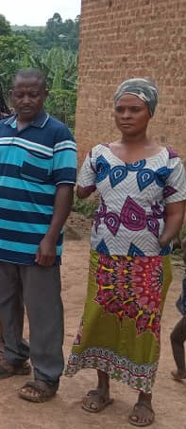
The couple besides (names withheld for confidentiality) were both project beneficiaries. The man (on left) cut off both the hands of his spouse (on the right) having caught her in an act of adultery, and was convicted and served to prison.

As part of reintegration, community authorities insisted that he returns to his wife.

With counselling as part of the project, the man is able to work and support his wife to expand her savings in the VSLA. This action has not only inspired the community but has lifted the stigma that the couple faced as a result of GBV.

This couple is a testament to overcoming adversity and leading a progress life regardless of consequences of a violent past.

- Grievance handling referral pathways to support victims of gender-based discrimination and violence. The project trained local leaders to set up mechanisms to handle grievances especially related to gender-based violence. Local leaders set up calendar days where they could receive and record complaints, which were followed-up by grievance handling committees. The documentation of case files however, was not done in a way systematic enough to trace case records from start to conclusion.

- Supporting VSLAs as a means of enhancing access to resources through saving and borrowing enabled women to obtain means to afford non-food items. The project aimed at strengthening already existing VSLAs through financial literacy and leadership trainings and provided a grant of UGX 6,000,000 for each group as a start-up for group-lending. This was linked to climate smart agricultural intervention to provide an avenue for beneficiaries to re-pay after the harvest season. The approach was that it would not be prudent to lend money to beneficiaries with no avenues to re-pay. This linkage made the VSLA and climate smart agriculture extremely relevant.

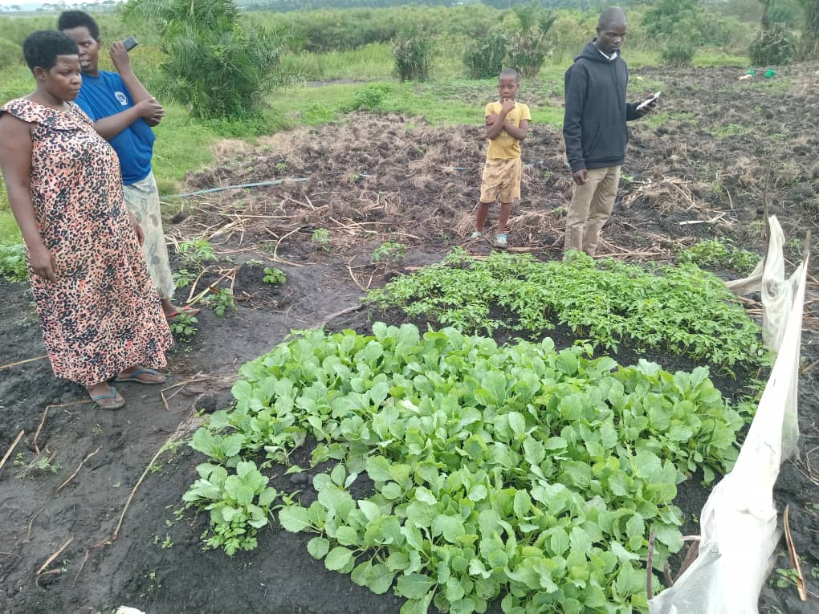
A VSLA group in Rushasha Sub- County, Kirunga Village used savings to hire land on which they grew various vegetables. All group members, every Friday, worked on this farm. A Sub- County agricultural extension service worker provided technical assistance on good agronomic practices as seen in photo on the left. CSA on the one hand provided food security and nutrition and incomes that beneficiaries used to save in the VSLAs.

    - Learning from previous LEAP evaluation/reviews

Finding 4: UN Women had successfully undertaken LEAP II project in West Nile and Mid-Western Uganda that focused on women empowerment within the COVID-19 emergency response. The design of the LEAP JSB III project adopted the same approach of entering into a MoUs with Implementing Partners very conversant with working in similar conditions. For instance, TPO-Uganda was a sub-contracted over both LEAP JSB II and LEAP JSB III to provide mental health and psychosocial support services. Working with responsible partners who were very conversant with working with refugees and host communities and in Karamoja enabled the project to succeed. This approach is in line with the strategy elaborated in the UN Women Strategic Note 2020-2025 that focuses on consolidating gains and proven/successful modular for efficiency in delivery.

    - Relevance of the Project Organizational Structure and Partnerships

Finding 5: The LEAP JSB III Project document and results framework provided a blueprint for how the project was structured and was to be implemented. The roles of the responsible partners and sub grantees were clearly stipulated and elaborated, based on areas of competency and presence in targeted locations. In terms of oversight, UN Women has sub offices in the project locations (Moroto and Mbarara) which enhanced its presence, strengthened coordination with key stakeholders including OPM in refugee settlements and with all district local governments. This presence strengthened management and delivery of the project as the suboffices actively provided oversight and monitoring of the project.

3.2 Coherence

Finding 6: UN Women leveraged on its mandate to advance the rights of women and girls through dedicated leadership trainings for women and girls, and supporting women rights organisations to deliver the project. UN Women premised on its clout and its vast expertise to advance gender empowerment and equality in emergency situations. It leveraged its mandate to advance the rights of women and girls through dedicated women leadership trainings, supporting local women rights organizations, use of credible partners (FAWE and Oxfam) to inspire women to rise up against gender-based violence, in ways that other UN agencies could not deliver. LEAP JSB III project adopted a holistic model that put consortium partners into a well-coordinated focus each with specific roles but roles that were complementary in delivery of results.

Finding 7: The project was coherent with national priorities and plans including the NDP III and refugee response plans. UN Women LEAP JSB III project was evaluated to having been highly coherent to the national development framework on national disaster response under the Office of the Prime Minister (OPM). The interventions in Southwestern Uganda were also aligned to the national Comprehensive Refugee Response Plan (CRRP) and the Inter-Agency Uganda Country Refugee Response Plan (UCRRP) 2022-2025. All these are enshrined under Governance and Security, Human Capital Development, as well as Regional Development programmes in Uganda’s National Development Plan III (NDP III 2020-2025).

3.3 Effectiveness and Efficiency

This section presents an evaluative response to aspects of the project in line with evaluation criteria for effectiveness and efficiency. The project was designed to achieve two outcomes and five output level results. The results of the project effectiveness are presented by project intervention. Overall, due to the short period of project implementation and the occasioned delays in project commencement the evaluation could not devolve into assessment of the impact of the project. Project implementation delayed for a period of between 4 to 6 months, however the evaluation found that largely the interventions were fully implemented.

3.3.1 Extent of achievement of planned outputs and expected outcomes

Finding 8: Overall, the project, achieved its target in regard to project reach and extended support to the targeted beneficiaries. Based on a review of the partner project reports the project was successful in meeting the target of 3,250 people (2,750 Women and Girls and 500 Men and Boys) with emergency protection, leadership, access to services and empowerment. The project generated the following outputs:

Under Output 1.1 Increased access to integrated skills, services, and infrastructure including ICT services for 500 refugee and drought affected women and women in host communities, the project managed to equip 2 women safe spaces in Kaabong district and Nakivale with Solar panels and ICT equipment. However, the project experienced delays in completing the safe spaces making it difficult to establish how many women and girls managed to access the services during the project period. The evaluation team noted that while safe shelters were in place their level of use was limited and to large extent awareness about them among beneficiaries remained low.
Under Output 1.2. the project aimed to achieve increased capacity and access to emergency social protection and climate friendly livelihood opportunities for 500 women and 200 men including youth and GBV survivors to mitigate the impacts of drought and displacement and access livelihoods opportunities. The evaluation found that:
750 women from 30 VSLA groups in Moroto, Kaabong, Isingiro, and Kisoro gained financial literacy skills. They can now save part of their earnings and access loans to boost their businesses. Additionally, a total of 165,000,000 UGX was extended to the groups as startup capital, which expanded their economic potential to invest, grow and enhance their savings. The support extended to groups was rated to be effective in equipping the group members to engage in enterprises that enabled them to meet their basic needs.
Under Output 1.3: Enhanced access to emergency protection services including legal aid and psychosocial support for 700 refugee women and girls, through the work done by NETPIL and TPO Uganda, the project supported women and girls to access justice by providing legal aid services in 211 cases and mental health and psychosocial support to 260 psychosocial beneficiaries. The evaluation further noted the following:
- Tackling GBV along with provision of psychosocial and refurbishment of empowerment centers offered safe spaces for GBV victims which provided the needed / targeted support especially for beneficiaries in the refugee settlements beyond the project period.
- Information obtained from focus group discussions and key informant interviews indicated that the project’s emphasis on male involvement was effective in raising awareness on positive gender norms with a notion that ‘supporting a woman builds a home and violating a woman destroys it’ as mentioned by one male respondent in Kaabong district.
- Most respondents both men and women noted that more resources could have been earmarked for the Cash for Work programme. The respondents noted that they found cash for work very beneficial in providing duo benefit of repairing community access road and income from payments to those who were able to participate. While the payment was noted as having been small, it made some difference in lives of beneficiaries.

Under Output 2.1. on increased capacity and access to emergency social protection and climate friendly livelihood opportunities for 500 women and 200 men including youth and GBV survivors to mitigate the impacts of drought and displacement and access livelihoods opportunities. The evaluation found that:

The project approach of working with District Local Governments technical officers especially the Natural Resource and Environment Officer, Agriculture (Production and Marketing) as well as Community Development Officers nested the project well in the district running interventions with communities in all the districts. Information obtained during key informant interviews indicated the readiness to carry on the work of farmer field schools and plot demonstrations even after the project closure. Additionally, 95 TOTs were trained in climate smart agriculture and through these TOTs the knowledge was cascaded down to the groups through the established demonstration sites at community level.
314 couples (188 Female, 126 Male) improved their knowledge and awareness on power in relations after their engagement dialogue sessions to improve family relations, sexual reproductive health rights, and referral pathways for cases of gender-based violence in Moroto, Kaabong, Isingiro and Kisoro. The analysis done by the evaluation under this out area from interviews with staff and focus group discussions with beneficiaries makes the following deduction:
- Beneficiaries were able to speak out about the challenges they faced related to gender-based violence noting that as the desperation increased as a result of the famine, some men to took to alcoholism, which exacerbated the violence. The project’s focus on male involvement helped in ensuring that men appreciated their roles as ‘leaders and not abusers’.

- In as much as time was limited to conduct comprehensive training on PSEA and SGBV, the sessions on gender using the Gender Action Learning System (GALS) Tool was very effective in providing insights on how districts and communities could mainstream gender into development practices in the future. It should be noted that TOTs were the ones trained in GALS with hope of cascading the sessions to the community level.

Case studies below provide perspectives of project beneficiaries on project performance:

CASE STUDY 1: FARMER FIELD SCHOOLS
The LEAP JSB III project extended training on Climate Smart Agricultural (CSA) practices. This was conducted using the farmer-field-school approach. The photo on the right shows beneficiaries at one of the farmer field schools who had planted onions (one of the short season vegetable) that was deemed suitable for drought-stricken areas in Kaabong.  In the photos below, the same approach was used in Southwestern Uganda – which received much more rains but require that beneficiaries understand modern agricultural practices. Supported by Oxfam beneficiaries (as the result of the knowledge they got were able to start their own kitchen gardens. This enabled them to boost their own food security (which also contributed to household nutrition) and some had a surplus for sale which supplemented their household incomes. | 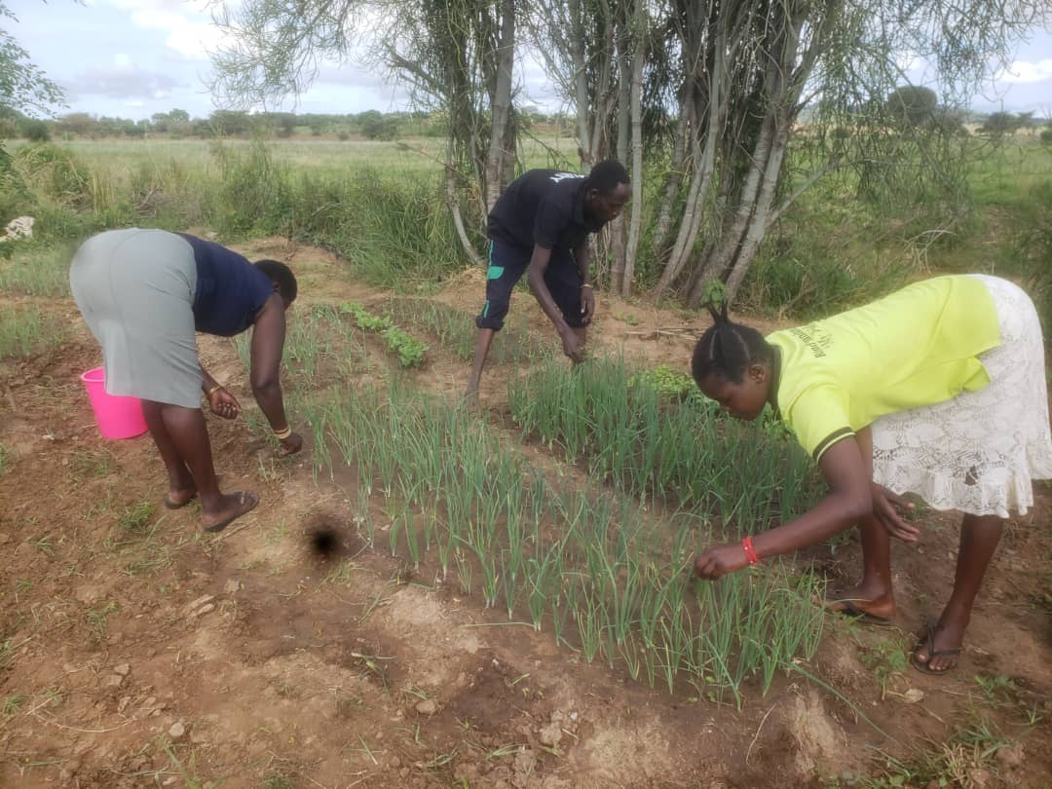
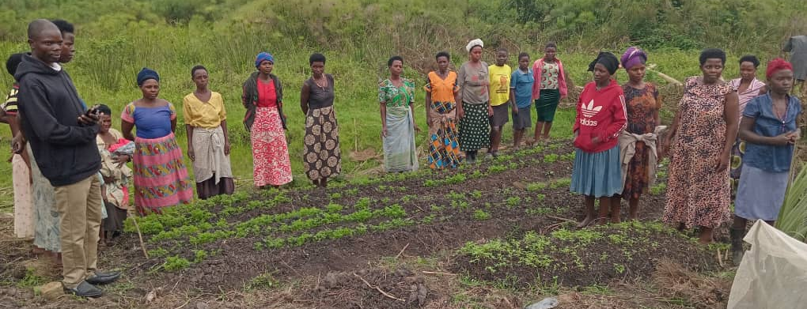

CASE STUDY 2 : VILLAGE SAVINGS AND LOAN ASSOCIATIONS

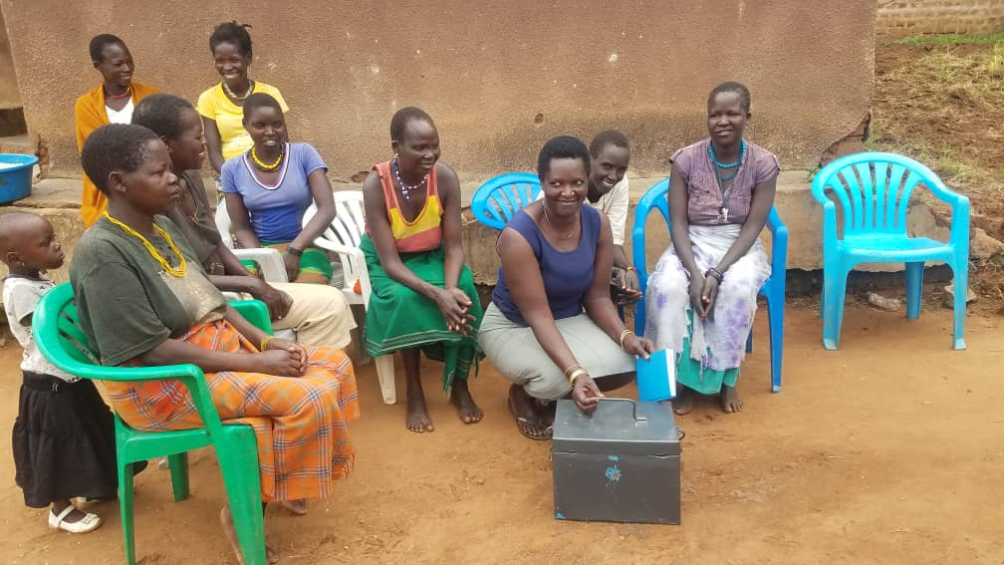
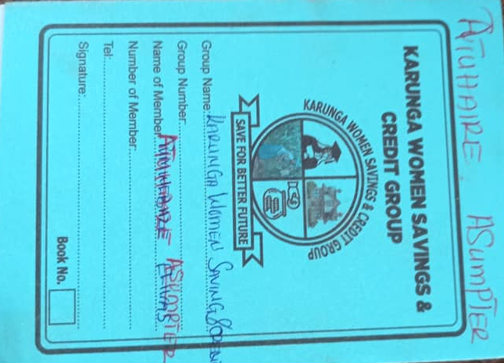
The project boosted VSLAs with a UGX 6,000,000 grant for each group which elevated their lending portfolio. As shown (on the left) each holds a saving and borrowing card with records of date for borrowing and loan repayment. Savings kits were also provided to the groups ensuring safe custody of the group records. One of the beneficiaries from the host community in Kisoro Atuhaire Asumpte, 42 years old and single mother of 4 children noted that: the project supported us to acquire knowledge in savings, bookkeeping and facilitated access to loans. The financial literacy skills helped me, and my group members set up businesses like grocery shops, among other income generating streams. I borrowed UGX. 150,000 which I used to expand my retail business. I continue to save to achieve my plans of going back to school to attain some vocational skills, expanding my business from retail to wholesale shop and starting goat rearing. I also plan to open a bank account.”

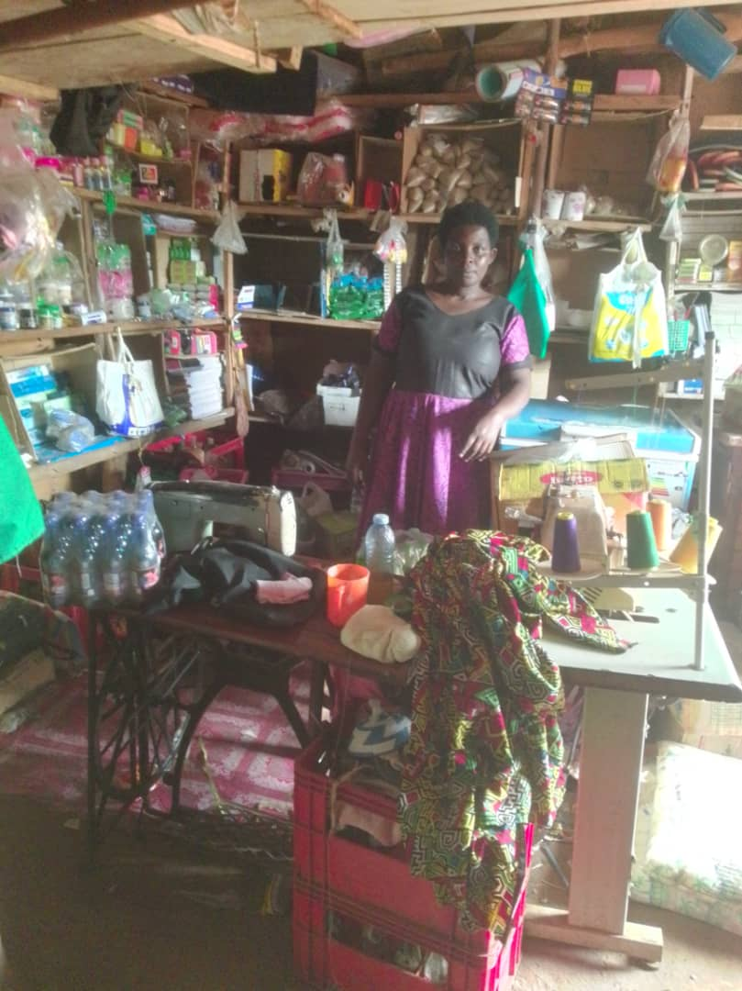
Above: Asumpter in her retail shop.

3.3.2 Level of achievement of project results as per the log frame
The table below presents the performance of the project against targets in the results framework.

Table 10: Delivery of Project Outputs and the Project Outcomes
Results | Indicators | Target (Uganda) | Achieved | Status
Goal: To Strengthen emergency protection, leadership, access to services and empowerment for 6,300 (5,300 women, girls and 1,000 men, and boys) including persons with disabilities) affected by interconnected crisis related to drought and displacement in Uganda (3250: 2750 W&G and 500 M&B) | Number of women and girls supported under the program to access services on emergency protection, leadership, and economic empowerment | 2,600 vulnerable women and girls | 3,191 women and girls were reached directly through various LEAP JSB III project interventions as shown in the various outcomes | FAWE and Oxfam supported women (with a focus on male involvement as well) in various interventions that strengthened emergency protection, leadership, access to services and empowerment. The evaluation noted that more could have been done on leadership trainings, and an exit/phase out phase made more elaborate for sustainability.
Outcome 1: Improved positive coping mechanisms for 3,300 (Uganda 1,750 and DRC 1,550) vulnerable refugees, host communities and drought affected’ women and girls and 200 men and boys in Uganda | Number of target refugee women who make an income of at least UGX 90,000 monthly or 3,000/- per day from their labour/services | 1500 | 1,300 direct beneficiaries (1,008 women and (292 men) were empowered with skills and knowledge on financial literacy, vocational skills. This further helped them to access financial services in their VSLAs that they used to expand their engagement in transformative agriculture and other non-agricultural income generation activities | The evaluation recorded testimonies (during focus group discussions) of the evidence that the provided start-up funds helped greatly to rejuvenate the VLSAs through enhancing saving portfolio of members thereby supplementing their income
Output 1.1: Increased access to integrated skills, services, and infrastructure including ICT services for 1,000 (Uganda 500 & DRC- 500) refugee and drought affected women and women in host communities in Uganda and DRC | Number of women and girls accessing integrated skills and services through women empowerment centers | 500 | 260 women at the time of the evaluation had been provided with psychosocial services in the safe spaces | At the time of the evaluation, the refurbished safe space in Nakivale was yet to be handed over as the project waited conclusion of engagements between OPM, UNHCR, UN Women, Alight and FAWE Uganda on sustainability of the center. The delay in completion of the safe spaces made it difficult to ascertain how targeted beneficiaries accessed the services during the project period.
Output 1.2: Increased capacity and access to emergency social protection and climate friendly livelihood opportunities for 1,000 women (Uganda 500; DRC 500) and 200 men (Uganda) including youth and GBV survivors to mitigate the impacts of drought and displacement and access livelihoods opportunities. | Number of women equipped with knowledge on financial literacy and vocational skills | 200 | 669 women received literacy and numeracy skills training over the course of the project – including financial literacy skills in their VSLAs | Responsible partner indicated that rather than train individuals the strategy was to train VSLA groups which enabled them to reach more people beyond the project target.
Output 1.3: Enhanced access to emergency protection services including legal aid and psychosocial support for 1,300 (700 Uganda; 550 DRC) refugee women and girls enhanced, within the Women Empowerment Centres and GBV shelters in Uganda and DRC | Number of women supported with psychosocial and legal aid services | 7500 | 260 (180 women in Kaabong and 80 women in Isingiro) Psychosocial support.  124 (91 female, 33 male) | The evaluation noted that more support for law enforcement was required. Mobile courts remained quite infrequent and readiness to present cases to them was critical so that the court sessions are responsive to the particular time of court hearing
Outcome 2: Strengthen gender-responsive emergency drought and displacement prevention, response, and recovery interventions through the involvement of women leaders and key actors targeting 2,000 women (Uganda 1,000 and DRC 1,000) and 800 men (Uganda 300 and DRC 500 | Percentage of targeted women and men serving on leadership structures within the refugee settlements and drought affected communities | 30% | Not achieved | Leadership training was not conducted due to limited time available for project implementation
 | Number of women and girls supported to access gender responsive protection including on PSEA and SGBV services through the local government, local women organizations, para social workers, Para legals, the police and judiciary | 500 | 1,512 community members being sensitized, and 38 male agents being strengthened 55 cases of GBV identified, managed, and referred for further management, Beneficiaries were able to report/place complaint (mostly related to SGBV which were being processed under the established grievance handling mechanism for GBV survivors - working with local leaders to resolve some issues that arose | Use of local leaders enhanced confidence among beneficiaries – through expedited resolution of some cases. However, training sessions were limited (due to time constraints) to a few sessions on mental health well-being, complaint feedback and awareness on prevention from exploitation and abuse
Output 2.1: Skills to participate and lead in drought and displacement responses enhanced for 1,000 refugees and host community members in Uganda. | Number of women’s organizations with increased capacities to participate in refuge settings and drought responses | 2 | Project sub granted to women rights organisation to implement some components of the project. | Capacity was built using the farmer field school approaches that were highly relevant to the drought-affected setting in Karamoja. Kitchen gardening and demonstration of short-season vegetable farms in south western Uganda were noted by beneficiaries as highly relevant
 | Number of women that have gained literacy and numeracy skills training with UN Women | 100 | 156 women received literacy and numeracy skills training over the course of the project – including financial literacy skills in their VSLAs | The evaluation was note able to deduce the level in increase in capacity since the training had just been concluded at the time of the project closure.
Output 2.2: 1,000 women (DRC) and 800 men and boys (Uganda 300 and DRC 500) and 300 key actors (Uganda 100 and DRC 200) benefit from initiatives promoting positive gender norms in support of women's leadership and protection from SGBV | No. of key actors in government and non-government sectors with skills on gender responsive social and protection programmes | 100 | 58 District officials participated in workshop sessions along with other targeted beneficiaries on training events that show-cased initiatives promoting positive gender norms in support of women's protection from SGBV | District leadership in Kaabong and Moroto as well Camp Commandants in Kisoro and Isingiro were very receptive of the project. Together with district leadership in Kisoro and Isingiro, they were at the time of the evaluation, looking at options to sustain gender responsive social and protection programmes – working with district CDOs
 | No. of community members (disaggregated by sex) reached with messages promoting positive gender norms | 300 men | 126 men (in Karamoja ) 67 men (in South Western Uganda), benefited from power and relationships and the importance of spouses planning together for resources This improved family relations, sexual reproductive health rights, and referral pathways for cases of gender-based violence | Negative cultural practices and attitudes remain a challenge in Karamoja. It was hence effective – a strategy for the project to approach this challenge with provision of friendly services to male victims of GBV to break the silence of majority that die in silence and trigger more violence against women and promote strategic partnerships in engaging men & boys in prevention & response to GBV

3.3.3 Level of achievement on time and budget

Finding 9: There was a delay in the disbursement of funds leading to a four months delay to the start of the project. However, IPs were able to complete the interventions by the project end as per the project proposal. The delay in funds disbursement caused a rush in implementation of activities as time was inadequate to effectively sequence the trainings. For instance, establishment of farmer field schools and related trainings that had been planned for a season-long period was conducted on average in 49 days (a month and half). This impacted the level of achievement of outcomes and impact of the CSA interventions. Delays in funds disbursement also affected the completion of the safe spaces to enable timely access to protection services.

The table below shows the budget that was allocated against what was spent based on responsible partner review reports.
Table 11: Project Budget Allocation and Absorption
Name of Implementing partner | Budget Allocation | Fund Spent | Absorption
OXFAM | 1,077,950,000 | 1,077,925,892 (reported) | 99.5%
FAWE | 980,025,002 | 949,635,150 (reported) | 96.8%
Total | 2,057,975,002 | 1,733,450,000 (Computed by evaluation) | 81.2%

The computations for the expenditure indicate that UGX 1,733,450,000 was spent against budget allocation of UGX 2,057,975,002 representing an 81.2% absorption rate. The details are provided below by the presentation of spending by activity for the respective responsible partners.

Table 12: Expenditure per Intervention by Implementing Partners
Project Stated Outcome and activities conducted | Amount Spent (US$) | Implementing Partner
Outcome 1: Improved positive coping mechanisms for 1,750 vulnerable refugees, host communities and drought affected’ women and girls
Supported women and youth with skills and knowledge on financial literacy, vocational skills and access to finance to engage in transformative non-agricultural income generation activities | $ 50,000 | FAWE
Supported extension of climate smart agricultural skills, tools and technologies focusing on skills training to drought and conflict affected women and youth including access to farmer led learning, farm inputs including new seed varieties for diversification | $ 80,000 | OXFAM
Trained women and male beneficiaries of social economic support in their households on Gender Action Learning systems (GALs) methodology | $20,000 | OXFAM
Trained women and youth on agroforestry, fabrication and marketing of fuel-efficient stoves | $ 50,000 | OXFAM
Support alternative sources of income through Cash for Work opportunities | $ 30,000 | OXFAM
Formatted and supported to Women’s VSLA groups for drought affected women | $ 10,000 | FAWE
Provision of psychosocial services for women, youth and girls (including psychological first aid including through telephonic counseling services | $ 30,000 | FAWE sub-grant to TPO
Provided legal aid services for women, youth and girls through mobile legal aid clinics, mobile courts, police follow ups, legal advice, legal representation and community policing | $40,000 | OXFAM
Put in place grievance handling mechanism for GBV survivors working with local leaders | $10,000 | OXFAM
Outcome 2: Strengthen gender-responsive emergency drought and displacement prevention, response, and recovery interventions through the involvement of women leaders and key actors targeting 1,000 women and 300 men
Provided support to local women organizations to build capacities of 900 women in leadership, climate change, DRR and gender equality | $30,000 | OXFAM
Provided literacy, numeracy and transformative leadership skills trainings for women | $18,500 | FAWE
Provide Solar lanterns to women learners and refugee leaders, as well as SGBV survivors | $ 20,000 | FAWE
Built capacity of representatives of district local government, local women organizations, para social workers and para legal, police and judiciary on gender responsive protection response on PSEA and SGBV awareness raising within communities | $30,000 | OXFAM
FAWE trained organizations with a focus on men and boys to implement the male engagement model for promoting positive gender norms in emergencies. This training reached 300 men and boys on male engagement to promote positive attitudes/ behaviors towards GEWE | $ 50,000 | FAWE
Overall Assessment | $468,500  (UGX 1,733,450,000)

3.3.4 Assessment of UN Women Support to Implementing Partners

UN Women leveraged on its sub offices in the project locations namely Moroto and Mbarara to coordinate with responsible partners in implementation, monitoring and reporting of the project. The presence of UN Women in the filed locations coupled with the long-standing track record of the responsible partners in working in these locations strengthened project delivery. UN women ensured that Oxfam and FAWE sustained a collaborative networking and information sharing the districts and OPM. Additionally, UN Women built capacity of partners in results-based reporting and monitoring, prevention of sexual exploitation and abuse, financial reporting, fraud and corruption which contributed to efficiency and effectiveness of partner project management.

3.3.5. Robustness of the project’s envisioned Theory of Change

Finding 10: The evaluation noted that there was a strong causal effect relationship between the interventions and the desired outcomes of the project. A Theory of Change is a presentation of an overview of pathways (a locus of points) that a project is designed to under-go from its design up to the attained of its goal or desired impact. LEAP JSB III project did not include the Theory of Change (TOC) in its design. However, for purposes of this evaluation, a ToC was reconstructed by the evaluation consultant as presented on the next page. The ToC was constructed based on the main aspects of the project outputs that were to be generated and how these are linked with the interventions that were implemented.

Theory of Change constructed at Evaluation

Interventions
Intermediate outcomes
Long-term Outcomes
Desired Impact

- Increased access to integrated skills, services, and infrastructure including ICT services for 500 refugee and drought affected women and women in host communities in Uganda.
- Increased capacity and access to emergency social protection and climate friendly livelihood opportunities for 500 women and 200 men including youth and GBV survivors to mitigate the impacts of drought and displacement

Strengthened gender-responsive emergency drought and displacement prevention, response, and recovery interventions through the involvement of women leaders and key actors
Economic empowerment through enhanced livelihoods for beneficiaries

Women and girls exhibiting leadership in emergence situations

Enhanced resilience and gender equality progress for populations in emergency situations

- Skills to participate and lead in drought and displacement response enhanced for 1,000 refugees and host community members in Uganda.
- 300 men and boys and 100 key actors benefit from initiatives promoting positive gender norms in support of women's leadership and protection from SGBV

Improved positive coping mechanisms for vulnerable refugees, host communities and drought affected’ women and girls

Assumptions/influencing factors
- Women and girls address their immediate needs and rights
- Targeted women and girls are responsive to interventions
- Partners and funders support interventions per MoUs and produce performance reports as per the terms

3.3.6. Factors underpinning the realization of results or the lack thereof

Finding 11: The strategic selection of partners and choice of interventions facilitated the achievement of results more so in a context where the project experienced delays in commencement. The following factors enabled the attainment of project results:
- Use of a consortium of partners (FAWE and Oxfam) who had a long-standing track-record in implementing similar projects in both regions;
- Working closely with District Local Governments, OPM and communities who now are able to sustain some of the interventions that the project left behind;
- The focus on easy-to-grow enterprises (like vegetable and fruits) which made it easy for households to embrace Climate Smart Agriculture practices.
- Working with already established VSLAs which made it easy to mobilize beneficiaries
- Inclusion of male involvement as a critical part of the interventions – which provided key in providing messages on PSEA and ending SGBV in the project areas.

The evaluation noted that delays in project commencement was the major hinderance to achievement of project outcomes. The project experienced a late start of the project interventions as result of late releases of funds to implementing partners. This resulted into inadequate time allocated to implementation of activities, implementation of activities in a rushed manner in order to complete the activities in a short period. For instance, training on farmer field schools that had been planned for a season-long training was conducted for 49 days (a month and half).

3.3.7. Assessment of the capacity of Implementing partners

Finding 12: Different components of the project were implemented by partners who had comparative advantage in the given area which enhanced efficiency in project delivery. The responsible partners, FAWE and Oxfam have decades of skills and expertise in working in humanitarian response. The responsible partners further worked with other subgrantees like TPO Uganda, who had well-known competence in provision of mental health psychosocial support services in both development and humanitarian settings, NEPTIL which has countrywide network of lawyers to provide legal aid services and Peace Winds Japan who had served communities in the same context, under previous LEAP JSB funded interventions in the past.

3.4 Sustainability

Finding 13: The intervention went beyond a focus on emergency response to building long-term resilience for beneficiaries. This resilience was enhanced by hands-on (practical training) reflective (learning from one’s self) and economic empowerment including support for Village Saving and Loans Associations. The evaluation deduced that the nature of need for Karamoja requires interventions that build resilience (as opposed to hand-outs). Focusing on financial literacy and strengthening livelihoods through climate smart agriculture in both Karamoja and Southwestern Uganda will go a long way in building the resilience of households that benefited from the interventions. This resilience was enhanced by building capacities of beneficiaries to fend for themselves even after the humanitarian response.

Findings 13: The project was implemented in collaboration between partners and local government officials at District and sub-county levels. This working partnership enhanced opportunities for the sustainability of project interventions, although this could have been well elaborated in a clearly spelt out exit and sustainability strategy (albeit with budget implications). It remains to be seen if the districts local governments will sustain the work that has been done as the result of the project’s implementation. The evaluation noted that working with the district agricultural officers and community development officers to sustain the farmer field schools and provide follow up supervision of the VSLA groups under the production and marketing grant of the district (or working with the office of the District Environment and Natural Resources on climate smart agriculture and energy saving technologies) were noted as credible approaches to enhance sustainability.

3.5 Human Rights, Gender Equality and Disability Inclusion
Under the theme of the UN Sustainable Development Goals of Leaving No one Behind, UN Women has emphasized the critical importance of ensuring that all projects uphold the aspects of Human Rights, Gender Equality and Disability Inclusion. This section looks at the extent to which these fundamental rights were regarded during implementation.

3.5.1 Upholding of Human Rights

Finding 14: By training paralegals who are based within the communities, the project ensured that community members have access to legal aid services which boosts access to justice as a human right. The project put in place a grievance handling mechanism and referral pathways for GBV victims (although it wasn’t yet fully operationalized) through establishment of safe spaces. The data from the field showed that legal aid services received through referral pathway/structures and service providers were mainly in Moroto and Isingiro as shown below.

Fig. 1 Provision of Legal aid Services as a result of the project

3.6.2 Gender Equality

Women economic empowerment and male involvement were highlights of the project’s endeavor to promote Gender Equality.
Finding 15: the project enhanced gender relationships between women and men through provision of trainings that benefitted both men and women in the communities. In particular, the community dialogue sessions on gender norms and practices, sessions on GALS strengthened and promoted positive gender values and strengthened household livelihoods. This became a critical step in contributing to a path towards future gender equitable outcomes. All implementing partners ensured that the training components as well as implementing of interventions like cash for work included both men and women as a means to complement each other on gender and equity.
Key informants in particular district leaders in the targeted project locations mentioned that the use of the Gender Action Leaning System GALs Tool (which due to time constraints was not fully implemented) provided broader insights on how districts and communities can mainstream gender into development practices. The GALs tool was used to demonstrate participatory processes and diagrammatic visualizations that explain how a household and its members can negotiate their needs and interests through innovative gender-equitable solutions based on livelihood planning and interventions.
Having embedded gender equality into the design of the project, during implementation, the project emphasised promotion of gender equality and equity through various training sessions that implementing partners conducted for beneficiaries. Over 95% of beneficiaries received trainings on the promotion of gender norms in all the project areas.
Table 13: Participation in Gender Training by beneficiaries Sampled
District |  | Yes | No | Don't know | Total
Isingiro | # | 107 | 1 | 1 | 109
Isingiro | % | 98 | 1 | 1 | 100
Kisoro | # | 119 | 0 | 0 | 119
Kisoro | % | 100 | 0 | 0 | 100
Kaabong | # | 98 | 3 | 1 | 102
Kaabong | % | 96 | 3 | 1 | 100
Moroto | # | 87 | 16 | 0 | 103
Moroto | % | 84 | 15 | 1 | 100
Toal | # | 411 (94%) | 20 (5%) | 3 (1%) | 431

To assess the impact that the training had made, 93% of the respondents (48% noting high and 45% moderately) appreciated that the training they had received had made them appreciate gender norms. The appreciation of this training was highest among beneficiaries in Kisoro and Moroto and least in Kaabong. It was not vivid why this was the case – but the evaluation from interviews noted that there wasn’t enough time that was provided for the training sessions in Kaabong as only one-day training was conducted.

Table 14: Level of Appreciation of Gender Roles
 |  | Gender roles Not yet well appreciated | Gender roles Fairly appreciated | Gender roles Well appreciated | Total
Isingiro | # | 11 | 75 | 23 | 109
Isingiro | % | 10% | 69% | 21% | 100%
Kisoro | # | 0 | 20 | 99 | 119
Kisoro | % | 0% | 17% | 83% | 100%
Kaabong | # | 3 | 42 | 57 | 102
Kaabong | % | 3% | 41% | 56% | 100%
Moroto | # | 19 | 57 | 28 | 104
Moroto | % | 18% | 55% | 27% | 100%
Total | # | (33) 8% | (194) 45% | (207) 4% | (434)

Finding 16: In as much as the project targeted women, male involvement provided critical insights into a holistic approach to women empowerment and contributed to spouses being accountable to each other. This laid a good foundation for males to be part of the broader fight against GBV. Results from the survey indicated that 42% of the respondents agreed that the project had contributed to change in attitudes towards promotion of positive gender norms while 53% noted that it was moderate. The highest response was in Kisoro where 87% agreed that there were positive changes in attitudes.

Table 15: Impact of Gender Training on positive Gender norms
District |  | High | Medium | Low | Total
Isingiro | # | 5 | 104 | 0 | 109
Isingiro | % | 5% | 95% | 0% | 100%
Kisoro | # | 103 | 16 | 0 | 119
Kisoro | % | 87% | 13% | 0% | 100%
Kaabong | # | 49 | 43 | 10 | 102
Kaabong | % | 48% | 42% | 10% | 100%
Moroto | # | 24 | 66 | 14 | 104
Moroto | % | 23% | 64% | 14% | 100%
Total | # | 181 (42% | 229 (53% | 24 (6%) | 434 (100%)

The engagement of local leaders in the promotion of positive gender norms is believed to have contributed positively to attainment of the changed attitudes amongst community members. Results of the survey indicated that 89% of the respondents agreed that sub-country, district and other local leaders were supportive of strategies promoted by the project that strengthened positive gender norms in the community. However, this was lowest in Kaabong.

Table 16: Perception of Local authorities in supporting positive gender norms
District | Yes | No | Don't know | Total
Isingiro | 95% | 0% | 5% | 100%
Kisoro | 100% | 0% | 0% | 100%
Kaabong | 76% | 8% | 17% | 100%
Moroto | 82% | 12% | 7% | 100%
Total | 89% | 5% | 7% | 100%

3.6.3 Disability Inclusion

Finding 17: Implementing partners allowed equal participation of everyone including persons with disabilities. As part of the beneficiary selection criterion, partners obtained data from beneficiaries that recorded forms of disability. This was cognizant of the reality that PWDs are often excluded in humanitarian programming for emergency situations. As a consequence, the project was able to include PWDs who benefited from various interventions that were implemented. The case study on the next page shows an illustration to this end.

Table 17: Respondent Beneficiaries Form of Disability
Forms of Disability | Overall
Forms of Disability | Persons with a form of disability | Percentage
Physical disability | 40 | 43%
Sight (Eyes) disability | 10 | 11%
Auditory (Hearing) disability | 9 | 10%
Mental disability | 35 | 37%
Total | 94 | 100%

From the data on beneficiaries collected by this evaluation, the level of disability was relatively high with an average of 25% indicating that they had a sort of disability as shown above. What was important to note is significant rate of persons with mental health issues contributing to 37% of all disability. This could point to the need to invest more in psychosocial support interventions especially among refugees in Southwestern Uganda.
3.6.4 Inclusion of Persons Living with HIV and AIDS

Finding 18: In as much as HIV/AIDS wasn’t a core intervention area, implementing partners ensured that People Living with AIDS – most of whom had faced stigma, exclusion and marginalization were included among project beneficiaries. FAWE in Karamoja included HIV/AIDS Champions (who had spoken out about their condition) to be part of the groups and speak at training events. Those that came out became an inspiration for the others to participate as shown in the case study below.

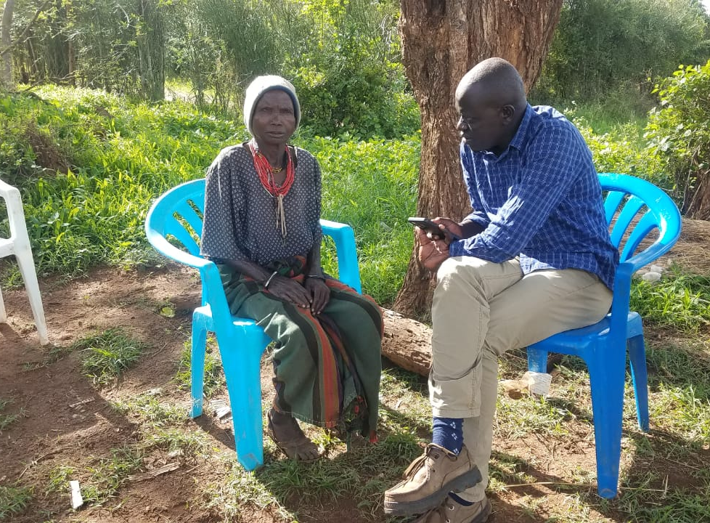
CASE STUDY 3: DISABILITY INCLUSION
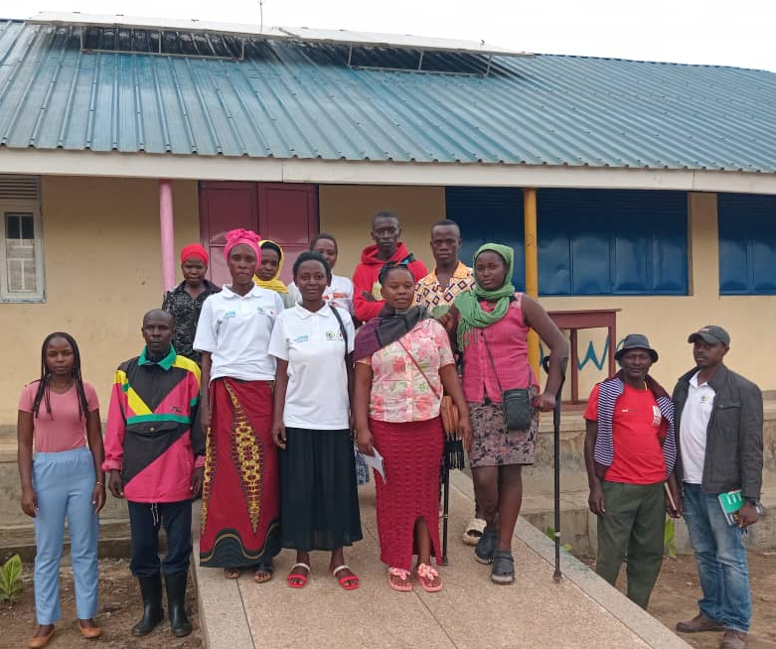  In Southwestern Uganda, the project included PWDs as (shown in the photo besides) and ensured they were enrolled in VSLAs. During the training in which they participated, they made reference (during focus group discussions on how training on positive living, self-expression and human rights helped them the fight against SGBV. In particular, the human rights training raised awareness among women with disabilities and how report and prevent gender based violence | 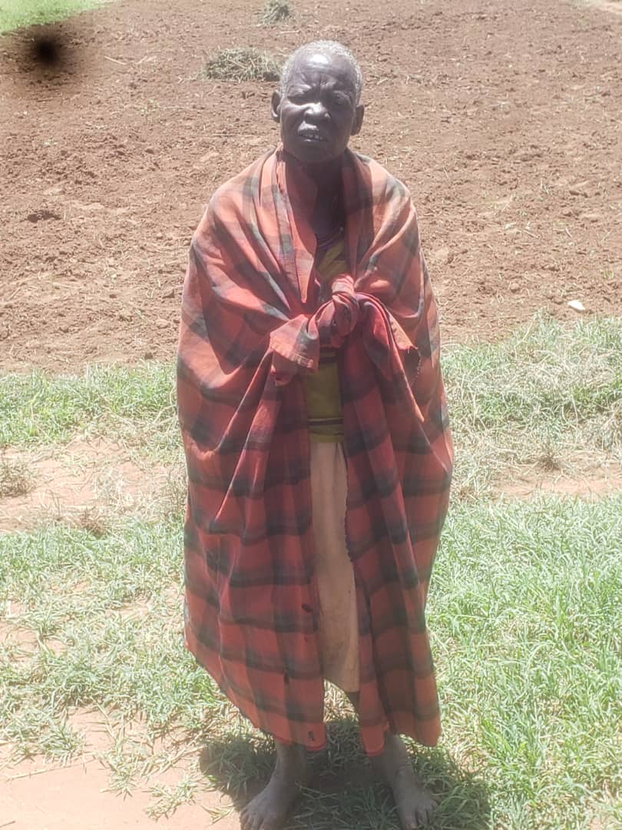  In Kaabong, the elderly lady in the photo (who is blind) with mental illhealth was provided psychosocial counselling and support. She was also enrolled into the VSLAs so that she can save and share in the group’s dividends. She noted that this has enabled her to buy both food and non-food items for her household.
One of the beneficiaries (besides on the left – being interviewed by a member of the evaluation team) in Kaabong was blind woman who was part of the project. The project with a purpose to include PWDs helped her to enroll as a member of the VSLA. Making her a beneficiary in the project has enabled her to save in the VSLA and access some low interest loans and be less dependent on others for her livelihood.

CASE STUDY 4: WOMAN LIVING HIV/AIDS TAKING THE LEAD IN MOBILIZING WOMEN IN MOROTO

One of the outstanding features of the LEAP JSB III project was the inclusion of Persons Living with HIV and AIDS. In Moroto, an exemplary case was for Madam Carolyne Achuka. She disclosed her HIV status as a result of the psychosocial support (through TPO and FAWE) and the associated counselling. Feeling free to express herself, Carolyne as seen below in the two photos (on the left with the focus group discussion and on the right at the farmer field demonstration site) has motivated other women to come out and obtain treatment. She is now the leader of the Village Saving and Loans Associations (VSLAs) in Katikekile Sub- County in Moroto.
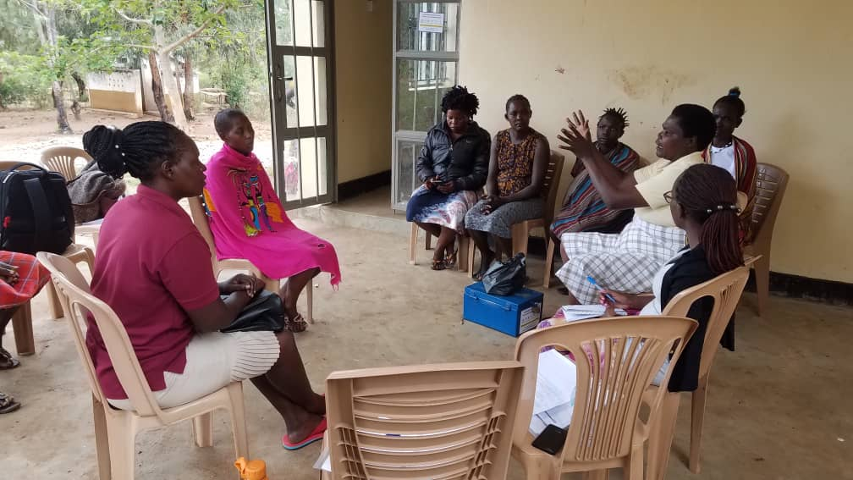 | 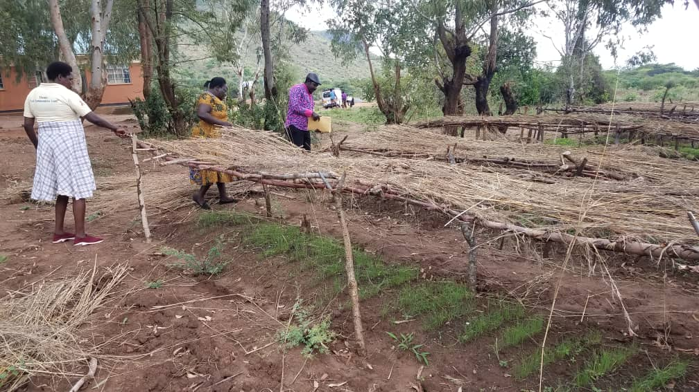

CONCLUSIONS

This section presents conclusions based on the findings from the various aspects of the evaluation.

Conclusion 1 (linked Finding 1): In terms of relevance, the project was designed as a humanitarian response, it focused more on aspects of longer-term resilience and tailored to the specific needs of beneficiaries.

Conclusion 2 (Linked to findings 3 and 7): The project was implemented by a consortium of credible implementing partners Oxfam and FAWE that had long standing competence and presence in both areas. This enabled the project to implement interventions (albeit in a short time) rallying on the reputation, networks, experience and mobilization capacity drawn from decades of working in similar conditions.

Conclusion 3 (Linked to finding 13): The intervention went beyond a focus on emergency response to building long-term resilience for beneficiaries by building capacities of beneficiaries to fend for themselves even after the humanitarian response.

Conclusion 4 (Linked to finding 9): The project implementation period was inadequate to result into the desired outcomes due the rushed manner in which activities were implemented. A delay in the disbursement of funds for the project occasioned a scenario where some interventions were not implemented fully as planned. Price changes over the period affected procurement of some items. Overall and the time left to complete some planned activities (especially training and other installations) was inadequate.

Conclusion 5 (linked to finding 13): The lack of a sustainability plan especially for the safe spaces limits the possibility of these spaces continuing to function beyond the project period. For sustainability an exit strategy should have been included in the design and implemented alongside the project to enhance ownership and enable the stakeholders to develop a plan on how to sustain the spaces. While the Kabong safe space was handed over to the district local government, the district did not have a substantive budget to maintain the space. In Nakivale the safe space had not be handing over was still hanging in balance at the time of the evaluation.

LESSONS LEARNED

This section presents the lessons learned as a result of the implementation of the project that could be a point of reference for future similar projects. These are linked to findings and conclusions.

Lesson 1 (linked to finding 1 and conclusion 1): The use of a consortium approach is effective and efficient for short term interventions as it enables each partner to focus on areas where they have comparative advantage. This enhances the delivery of the project as had been envisioned at design.

Lesson 2 (linked to finding 15): Integration of male engagement strategy in project interventions strengthens achievement of gender empowerment results. When men are included, they act as gender male champions and role models in the community. The gender trainings provided insights for men to appreciate the need them to be accountable their spouses which promoted positive relationships at household and community levels. This laid a good foundation for males to be part of the broader fight against GBV.

RECOMMENDATIONS

This chapter presents the recommendations made by the evaluation based on findings, conclusions and lessons learned in the previous sections. These recommendations are presented in the formats that show: the recommendation, to whom the recommendation is targeted as well as the level of priority and how earnestly (in terms of urgency, impact and low). While there wasn’t a workshop to validate these recommendations, they appraised by the evaluation reference group members during the review of the evaluation report.

Recommendation 1: During the Design stage, it is recommended that a needs assessment prior to the intervention be conducted with more active involvement of implementing partners and local leadership to enhance relevance and future sustainability.
How to do | Include LGs in the design and planning process
Responsible actor(s) | UN Women
What if it’s not done | Risk of selecting unsuitable project sites and inability to meet targets as planned
Urgency | Immediate
Impact | High
Difficulty | Low
 | Aligned to findings 1.
Recommendation 2: As a one-year project it is recommended that there is a timely disbursement of funds to implementing partners. This would enable them time to implement activities and generate the desired impact.
How to do | Expediting approvals within the UN Women system
How to do | Involve key stakeholders whose role is key at exit in the formulation and implementation of the sustainability plan  At the end of the project formally handover key aspects of the project to the local government
Responsible actor(s) | UN Women & Implementing Partners
What if it’s not done | Minimizes chances of continuity of interventions  There is possibility of causing harm to beneficiaries who may still be requiring services and support
Urgency | High
Impact | High
Difficulty | Low
 | Aligned to finding 9.
Recommendation 3: A consortium delivery model is highly recommended and worked well under this project and suited an emergency response scenario. In this project, each partner in this case had designated roles that they played (aligned to areas of expertise) that avoided duplication and overlaps and hence creating efficiency in delivery.
How to do | Map partners in the target areas based on expertise and comparative advantage during the design stage
Responsible actor(s) | UN Women and Implementing Partners
What if it’s not done | Duplication of efforts  Working with partners who don’t understand the context hence ineffective to deliver the project
Urgency | Medium
Impact | High
Difficulty | Low
 | Aligned to findings 1 and conclusion 1.
Recommendation 4: The GALs (Gender Action Learning System) Tool should be more emphasized in future similar project in an endeavor to mainstream gender in local development and in similar settings
How to do | Include the GAL methodology in the design of similar future projects
Responsible actor(s) | UN Women and Implementing Partners
What if it’s not done | Loss of opportunity for uptake of this innovation to ensure gender mainstreaming
Urgency | Medium
Impact | High
Difficulty | Low
 | Aligned to findings 15.
Recommendation 5: Documentation and implementation of an exit strategy should commence at the design and start of implementation and should spell out the roles of key stakeholders and associated budget (for some aspects like psychosocial support, sustained training and maintaining farmer field schools). Such an exit strategy could look at: offering scholarships (especially for vocational training like knitting/crochet; catering, hair dressing, bakery, solar and mechanical works, artisanry among others) with a focus on young mothers (since there is high secondary school drop-out rates among girls)
How to do | Include the exit strategy in the project design and budget to sustain project results
Responsible actor(s) | UN Women
What if it’s not done | Loss of current achievement and investments
Urgency | High
Impact | High
Difficulty | Low
 | Aligned to findings 13 and conclusion 5.

ANNEXES

Annex 1: Evaluation Matrix
Evaluation Criteria | Indicators | Evaluation questions | Data Sources | Data Collection Method/ Tools | Method of Data Analysis
Relevance  Extent to which the intervention objectives and design responded to beneficiaries, global country, partners/institutional needs, policies and priorities and continue to do so if circumstances were to change | - Appropriateness of project design | Was the project design appropriate to address the identified needs of beneficiaries? | - Literature/Desk review of project documents especially the Proposal of UN Women to Government of Japan | - Desk review  - Initial interviews with UN Women Team | Content analysis
 | - Choice of partners | Was the choice of partners most relevant to the situation of refugee women and marginalized groups in a project operational area? | - Literature/Desk review of project documents | - Desk review check list | Content analysis
 | - Relevance to the beneficiary context | Were the choice of interventions most relevant to the situation in the target thematic areas? | - Literature review of project documents  - In-depth interview with project staff, districts, Office of the Prime minister | - Desk review check list  - Key Informants interview guide | Content analysis  Narrative analysis
 | - Consonance with LEAP previous interventions | How well did the project design take into account learning from previous evaluation/reviews of LEAP? | - Literature/Desk review of project documents | - Desk review check list | Content analysis
 | - Contribution to partnership, systems and institutional systems strengthening | How relevant and effective were the project organizational structure and partnerships in achieving intended objectives and results? | - In-depth interview with project staff, implementing partners, districts | - Desk review check list  - Key Informants interview guide | Content analysis
Effectiveness and Efficiency  The extent to which the intervention achieved or is expected to achieve its objectives and its results, including any differential results across intended beneficiaries and partners. Efficiency on the other hand is in reference to the extent to which the project delivery in a cost-effective timely manner | - Level of achievement of project results as per the log frame | To what extent has UN Women achieved planned outputs and contributed to expected outcomes? | - Literature review  - In-depth interview with project staff, Project beneficiaries, implementing partners, district local government, Humanitarian actors, Office of the Prime minister  - Focus group discussions with project target groups | - Desk review check list  - Key Informants interview guide  - Focus Group Discussions guide  - Individual interview  questionnaire | Content analysis  Narrative analysis  Quantitative analysis
 | - Level of achievement on time and budget | Were the planned outputs achieved on time and on budget? |  |  | Content analysis  Narrative analysis  Quantitative analysis
 | - The level of project contribution to strengthen of management systems and structures of UN Women and partners | To what extent did the UN Women management structures support efficiency for implementation and delivery of required results including risk and financial management? |  |  | Content analysis  Narrative analysis  Quantitative analysis
 | - Robustness of the project’s envisioned Theory of Change | How was the envisaged Theory of Change a guide in the realization of the project implementation? | - Literature review  - In-depth interview with project staff, Project beneficiaries, implementing partners, district local government | - Desk review check list  - Key Informants interview guide  - Focus Group Discussions guide  - Individual interview  questionnaire | Content analysis  Narrative analysis  Quantitative analysis
 | - Factors underpinning the realization of results or the lack thereof | What were the main project (I) enabling and (ii) hindering factors for achieving planned outcomes and what actions need to be taken to overcome any barriers that limit required progress? |  |  | Content analysis  Narrative analysis  Quantitative analysis
 | - Assessment of the capacity of Implementing partners | Did the IPs have access to the necessary skills, knowledge and capacities needed to deliver the project? | Consultant’s assessment of IP performance | - Institutional/ functional analysis | Institutional analysis
Coherence | - Assessment of UN Women’s comparative advantage in implementing the project | What is UN Women’s comparative advantage in implementing this type of project compared to other UN entities? | Agency review assessment | - Review of documents from UN agencies | Institutional analysis
Human Rights and Gender Equality Extent of project support and responsibility for Human Rights and Gender Equality | - The extent to which he project was implemented according to human rights and development effectiveness principles | Has the project been implemented according to human rights and development effectiveness principles: Participation/empowerment; Inclusion/non-discrimination; National accountability / transparency/ gender equality? | Literature review  In-depth interview with project staff, Project beneficiaries, implementing partners, district local government, Office of the Prime minister  Focus group discussions with project target groups | - Desk review check list  - Key Informants interview guide  - Focus Group Discussions guide  - Individual interview questionnaire | Content analysis  Narrative analysis  Quantitative analysis
 |  | How did the project integrate gender equality principles in its design and implementation? |  |  | Content analysis  Narrative analysis  Quantitative analysis
Lessons learnt, best practices and recommendations  are the key lessons and best practices that can be drawn from implementation of the project | - Lessons learned from the project implementation | What are the key lessons and best practices that can be drawn from implementation of the project? | Interview with IPs and UN Women staff | Analysis of findings | Content analysis
 | - Recommendations from lessons learned for future similar projects | What recommendations can be put forward for future projects? | Interview with IPs and UN Women staff | Analysis of findings and lessons learned | Content analysis

Annex 2: Documents Reviewed
- Project Document
- Call for Proposals
- Proposal of UN Women to Government of Japan
- Budget and Results Framework
- Quarterly Progress Reports (1,2,3) by Implementing Partners
- Project completion Reports from FAWE
- Project completion Reports from Oxfam
- Final Narrative Reports by Implementing Partners to UN Women

Annex 3: Lists of Agencies and Partners Contacted

Kampala
M&E UN Women Uganda Country Office
UN Women Sub-Office Gulu
Head of Programs, Oxfam
Head of Programs, FAWE

Moroto
Focal Point, UN Women Moroto
UN Women Project Officer LEAP JSB III Project
Community Development Officer Katikekile, Sub County
Volunteer, FAWE Uganda
Focal Person OXFAM (Kaabong and Moroto)

Kaabong
Senior Gender Focal Point, Kaabong
FAWE Uganda Volunteer Oxfam Kaabong
Project Officer LEAP JSB III Project UN Women Kaabong

Mbarara
RDP, Office of the Prime Minister based in Mbarara

Kisoro
Community Development Officer Kisoro
Community Development Officer – Nyakakande Sub County
Office of the Prime Minister – Nayakanade Transit Center
Community Development Officer – Chahi Sub Country

Isingiro
Community Development Officer
Office of the Prime Minister, GBV Focal Point Person
Agriculture Officer, UN Women Focal Point Isingiro
Oxfam Focal Point Person
FAWE Uganda Volunteer
Program Coordinator Peace Wings Japan

ATTENDANCE – FOCUS GROUP DISCUSSION

District: KISORO Sub - County: NYAKABANDE
Date of Activity:23/4/2024
Activity description: Focused Group Discussion as part of the end of LEAP III JSP project Evaluation
No | Position | Organization | Sex  M/F | Disability status |  | Participant’s age (in years) tick
 |  |  |  | YES | NO | >5 | 5-17 | 18-49 | >50
1 | HOST FAMILY | GAHINGA GROUP | F |  | × |  |  | ×
2 | TREASURER | SHOZI GROUP | F |  | × |  |  | ×
3 | SECRETARY | KANYABUKUNGU GROUP | F |  | × |  |  | ×
4 | CHAIR PERSON | KANYABUKUNGU GROUP | F |  | × |  |  | ×
5 | TREASURER | GAHINGA GROUP | F |  | × |  |  | ×
6 | MEMBER | KANYABUKUNGU GROUP | M |  | × |  |  | ×
7 | MEMBER | KIBURARA GROUP | M |  | × |  |  | ×
8 | MEMBER | GAHINGA GROUP | M |  | × |  |  | ×
9 | SECRETARY | KIBURARA GROUP | F |  | × |  |  | ×
10 | CHAIR PERSON | SHOZI GROUP | F |  | × |  |  | ×
11 | TREASURER | SHOZI GROUP | F |  | × |  |  | ×
12 | TREASURER | KIBURARA GROUP | F |  | × |  |  | ×
13 | MEMBER | KIBURARA GROUP | F |  | × |  |  |  | ×

ATTENDANCE – FOCUS GROUP DISCUSSION

District: ISINGIRO Settlement: NAKIVALE-RUBONDO SUB BASE CAMP
Date of Activity: 25/6/2024
Activity description: Focused Group Discussion as part of the end of LEAP III JSP project Evaluation
No | Position | Organization | Sex  M/F | Disability status |  | Participant’s age (in years) tick
 |  |  |  | YES | NO | >5 | 5-17 | 18-49 | >50
1 | C/Person | TVUNGANE | F |  | × |  |  | ×
2 | Treasure | TVUNGANE | F |  | × |  |  | ×
3 | RWCII | LUZAMUNANE W/G | M |  | × |  |  |  | ×
4 | RWCII | LUZAMUNANE W/G | M |  | × |  |  |  | ×
5 | C/Person | LUZAMUNANE W/G | F |  | × |  |  | ×
6 | Member | TVUNGANE | M |  | × |  | ×
7 | Member | TVUNGANE | M |  | × |  | ×
8 | Member | TUMANI | F |  | × |  |  | ×
9 | RWCII | WAMAMATUNGANE | F | × |  |  |  | ×
10 | Member | WAMAMATUNGANE | F |  | × |  |  | ×
11 | C/Person | ABADAMUTWITEZEIMBE | F |  | × |  |  | ×

ATTENDANCE – FOCUS GROUP DISCUSSION

District: KISORO Sub - County: CHAHI
Date of Activity:23/4/2024
Activity: Focused Group Discussion as part of the end of LEAP JSP III Project Evaluation
No | Position | Organization | Sex  M/F | Disability status |  | Participant’s age (in years)
 |  |  |  | YES | NO | >5 | 5-17 | 18-49 | >50
1 | Member | BUHAYO GROUP | F | × |  |  |  | ×
2 | Treasurer | BUGAHE GROUP | F |  | × |  |  | ×
3 | Member | BUGAHE GROUP | F |  | × |  |  | ×
4 | Member | BUGAHE GROUP | F |  | × |  |  | ×
5 | Member | BUGAHE GROUP | F |  | × |  |  | ×
6 | Chair | BUHAYO GROUP | F |  | × |  |  | ×
7 | Member | BUHAYO GROUP | M |  | × |  |  | ×
8 | Member | BUHAYO GROUP | F |  | × |  |  | ×
9 | Member | BUHAYO GROUP | F |  | × |  |  | ×
10 | Member | BUHAYO GROUP | M |  | × |  |  | ×
11 | Member | BUHAYO GROUP | F |  | × |  |  | ×
12 | Member | BUHAYO GROUP | F |  | × |  |  | ×
13 | Member | BUHAYO GROUP | F |  | × |  |  | ×
14 | Secretary | BUGAHE GROUP | F |  | × |  |  | ×
15 | Member | BUHAYO GROUP | F |  | × |  |  | ×

ATTENDANCE – FOCUS GROUP DISCUSSION

District: Isingiro Sub - County: RUSHASHA
Date of Activity:26/4/2024
Activity description: Focused Group Discussion as part of the end of LEAP JSP III project Evaluation
No | Position | Organization | Sex  M/F | Disability status |  | Participant’s age (in years) tick
 |  |  |  | YES | NO | >5 | 5-17 | 18-49 | >50
1 | C/Person | KARUNGA WOMEN S/G | F |  | × |  |  | ×
2 | Treasurer | KARUNGA WOMEN S/G | F |  | × |  |  | ×
3 | Member | KARUNGA WOMEN S/G | F |  | × |  |  | ×
4 | Member | KARUNGA WOMEN S/G | F |  | × |  |  | ×
5 | Member | RWABARIMIRIZI GOATS RARING GROUP | F |  | × |  |  | ×
6 | Member | RWABARIMIRIZI GOATS RARING GROUP | F |  | × |  |  | ×
7 | Member | KARUNGA WOMEN GROUP | M |  | × |  |  | ×
8 | Member | KARUNGA WOMEN GROUP | F | × |  |  |  | ×
9 | Member | KARUNGA WOMEN GROUP | M |  | × |  |  | ×
10 | Member | KARUNGA WOMEN GROUP | M |  | ×

ATTENDANCE – FOCUS GROUP DISCUSSION - KARAMOJA

Moroto
No | Position | Organization | Sex  M/F | Disability status |  | Participant’s age (in years) tick
 |  |  |  | YES | NO | >5 | 5-17 | 18-49 | >50
1 | Chair | KATIKATHILE WOMEN’S GROUP | F |  | × |  |  | ×
2 | Treasurer | KATIKATHILE WOMEN’S GROUP | F |  | × |  |  | ×
3 | Secretary | KATIKATHILE WOMEN’S GROUP |  |  | × |  |  |  | ×
4 | Host | KATIKATHILE WOMEN’S GROUP | F |  | × |  |  |  | ×
5 | Vice Chair | KATIKATHILE WOMEN’S GROUP | F |  | × |  |  | ×
6 | Member | KATIKATHILE WOMEN’S GROUP | F |  | × |  | ×
7 | Member | KATIKATHILE WOMEN’S GROUP | F |  | × |  | ×
8 | Member | KATIKATHILE WOMEN’S GROUP | F |  | × |  |  | ×
9 | Local Leader | KITIKATHILE SUB-COUNTY | M |  | × |  |  | ×

Kaabong
No | Position | Organization | Sex  M/F | Disability status |  | Participant’s age (in years) tick
 |  |  |  | YES | NO | >5 | 5-17 | 18-49 | >50
1 | Chair | LOBONGIA VSLA WOMEN GROUP | F |  | × |  |  | ×
2 | Treasurer | LOBONGIA VSLA WOMEN GROUP | F |  | × |  |  | ×
3 | Vice Chair | LOBONGIA VSLA WOMEN GROUP | F |  | × |  |  | ×
4 | Host Family | LOBONGIA VSLA WOMEN GROUP | M |  | × |  |  | ×
5 | Secretary | LOBONGIA VSLA WOMEN GROUP | M | ×
6 | Member | LOBONGIA VSLA WOMEN GROUP | F |  | × |  |  | × | ×
7 | Member | LOBONGIA VSLA WOMEN GROUP | F |  | × |  |  | ×
8 | Member | LOBONGIA VSLA WOMEN GROUP | F |  | × |  |  | ×
9 | Member | LOBONGIA VSLA WOMEN GROUP | F | × |  |  |  |  | ×

Annex 4: Data Collection Instruments

KEY INFORMANT INTERVIEW GUIDE

INTRODUCTION

In line with UN Women evaluation policy, the project Promoting the Leadership, Empowerment, Access, and Protection (LEAP JSB III) of Women & Girls affected by conflict, severe drought and forced displacement in Uganda requires a final in-depth evaluation when nearing conclusion to focusing assessing the impact of the project against the goals and document key lessons for possible replication and upscaling

The evaluation is focused on accountability, on learning and on utility (usefulness). The work of the evaluation is intended to be of specific value to the Projects in the planning for their next phases, as well as of specific value in formulating the ongoing regional approach (if that is seen as valuable by stakeholders).

It is important to the quality of our work that you are able to speak freely to us. Our evaluation approach (and UN Women policy) ensures that the comments you make to us remain confidential. I will be making notes, but my notes will not be available to anyone outside the evaluation team. As importantly, in any oral and written reporting we do for the evaluation any information or commentary you make to us that is used in the report will be anonymous. There will be nothing in the report to identify individuals.

Do you consent to participate in this interview
Yes ………………….( If yes continue)
No ………………….( If no discontinue)

Interviewee name, organization, position
Interviewer name (s)
Date, time, method of interview

INTRODUCTORY COMMENTS – INTERVIEWEE
Question | Response Notes
To what extent does the RP framework align with your perspectives of future priorities and indicated directions?
To what extent are the objectives of the project aligned with:
- Your priorities?
- National and regional priorities?
- SDGs?
How well does the project respond to your needs and priorities as a donor?
- How well does the project respond to the real needs of the country/ region?
Is the project conducive to the development of agency partnerships at the bilateral and multi-lateral level?
- between agencies within the same country?
- with other national and international partners?
- Internationally?
. Do you consider the project successful?
- To what degree were the project outcomes and objectives achieved?
- What were the facilitating and hindering factors in achieving results?
- Are there areas where UN Women is working that are more appropriate to other UN Agencies or international organizations?
To what extent have specific measures been taken to address the needs and priorities of human rights, gender and vulnerable groups?
To what extent are the projects effective in strengthening and promoting cross-border cooperation and collaboration with regional
entities?
Were your resources and inputs converted to outputs and outcomes in a timely and cost-effective manner?
- Did they spend their budgets? Did they try and use tools and systems that encourage cost-effective use of resources? Were there decreases in costs as a result of systems and processes?
- What modalities of training delivery were used – do they focus on use of national trainers and provide specific examples of a focus on cost effectiveness? Are national researchers being used in place of international resources?
- Were resources (financial, time, people, expertise) allocated strategically to achieve human rights and/or address gender and vulnerable group related needs?
- What are the consequences of office costs (project support costs and the full cost recovery policy) on the efficiency and cost-effectiveness of the projects?
- Do they undertake risk analysis, regularly update this analysis, and make specific plans for mitigating identified risks?
- Does the project have results frameworks, including well-defined indicators? Were results frameworks used in a defined and resourced monitoring system? Do results frameworks inform reporting? Planning
To what extent did the projects contribute to counterpart implementation of relevant international Conventions and other instruments?
- How did the projects contribute to legislative or policy change?
- Anything specifically in reference to G/HR/VG?
- Normative: accession to relevant international Conventions and other instruments and implementation in national legislation and regulations;
- Agency: evidence of use and enduring impact on work of government agencies or services, including borders, investigations, prosecution, judicial, etc.;
- Beneficiary: evidence of enduring change in relation to target groups, including in relations to cross-cutting themes of human rights, gender, vulnerability and disability and the overarching principle of leaving no one behind
To what extent can long-term sustainable results be expected for all stakeholders from current project implementation?
- To what extent has the anticipated impact been reached by the project? Are there changes in legislation; policy; staffing; budget and MoUs / agreements that can be seen as indicators of sustainable results?
What lessons can be learned from the implementation of the projects in order to improve performance, results and effectiveness in the future?
- What has been learned in the course of the project implementation? What elements could be strengthened? What opportunities were missed?
- What are the lessons learned for future project implementation?

BENEFICIARY SURVEY QUESTIONNAIRE
DATE ……

Consultancy Services to Conducting an end of Project Evaluation for Promoting the Leadership, Empowerment, Access, and Protection (LEAP JSB III) of women and girls affected by conflict, severe drought, and forced displacement in Uganda

Greetings,

My name is …………………………………………. I am part of the team from UN Women, that has been contracted to Conducting an end of Project Evaluation for Promoting the Leadership, Empowerment, Access, and Protection (LEAP JSB III of women and girls affected by conflict, severe drought, and forced displacement in Kisoro, Isingiro, Moroto and Kaabong Districts of Uganda.

The study seeks to assess the relevance of LEAP III Japan Supplementary Budget (LEAP III JSB) intervention in addressing the needs of refugee and drought affected women and how gender equality principles were integrated in the project; to assess the effectiveness and efficiency of UN Women’s approach for achievement of results, as defined in the logical framework; to identify lessons learned and provide actionable recommendations with respect to the strategy, and overall approach to UN Women’s programming in humanitarian settings.

The information you give us will help to assess the outcome and impact of the project on target beneficiaries (young people) in this area. Also, the results from this survey will be used to improve and enhance future project intervention. All the information you will give shall be kept strictly confidential and used for research purpose only. Thank you very much in advance for your assistance.
Do you accept to be part of this interview? 1.Yes 2. No (if no discontinue)

- BACKGROUND INFORMATION
District
Settlement
Zone
Cluster
Nationality status | - Refugee  - National
If refugee in above, what is your country of birth? | - Democratic Republic of Congo  - Rwanda  - South Sudan  - Burundi  - Somalia  - Kenya  - Other………

1. HOUSEHOLD DEMOGRAPHICS
1.1 | Total member in the household:  Female  Male
1.2 | What is the main job providing main source of income to the household: |  | ………….…
1.3 | Have you participated in the LEAP JSB III project activities? | 1. Yes  2. No
1.4 | Which activities did you participate in? | - Village Savings and Loans (VSLA)  - Climate Smart Agriculture  - Computer Skills Training  - Leadership Training  - other
1.5 | Which Organization implemented those activities? | - NETPIL  - NAWOU  - AWYAD  - TPO  - Peace Winds  - FAWE  - Oxfam  - Other ….

2. ACCESS TO INTEGRATED SKILLS, SERVICES, AND INFRASTRUCTURE
 | Have you had access to safe spaces and the services offered?  Note that is question is for Kaabong and Nakivale only | 1. Yes  2. No
 | How did you get information about the safe spaces? | - Friend  - Myself  - Word of Mouth  - Other.
 | What kind of information and services did you get at the safe spaces? | - Referral,  - Prevention from exploitation and abuse,  - ICT services,  - Emergency shelter,  - Emergency medical aid.  - None
 | How many times have you been at the safe space? | - Once  - Twice  - Thrice  - Many times,  - Never
 | Have been trained on preventing exploitation and abuse? | 1. Yes  2. No
 | What was the training about?
 | Have you been able to put in action the training that you got? | 1. Yes  2. No

3.CAPACITY AND ACCESS TO EMERGENCY SOCIAL PROTECTION AND CLIMATE FRIENDLY LIVELIHOOD OPPORTUNITIES

 | As part of the project what skills training have you attained in order to engage in income generating activities for you household? | 1.Finacial Literacy  2. Vocational skills  3. Climate smart agricultural skills,  4. Agricultural Tools  5. Agricultural Technologies  6. Agroforestry  7.Fabrication  8.Marketing of fuel-efficient stoves  9. Access to finance  10.Income Generating Activities.  11. Formation of VSLAs.  12. Alternative sources of income
Please offer a response to the following; How have been the following been beneficial to you?
Climate Smart Agriculture technologies ………………………………………………………………………
ICT training …………………………………………………………………………….
Cash for work ……………………………………………………………….
VSLA …………………….
Safe Spaces……………….
In what other ways could this support have been provided better? …………………………………………………………………………………………..

4. ACCESS TO EMERGENCY PROTECTION SERVICES
 | Did you receive any psychosocial services as part of the project? 1.Yes 2. No
 | What kind of psychosocial services did you receive from the project? | 1. Psychological first aid  2. Psycho-social education  3. Cognitive Behavioral Therapy  4.Therapy  5. Counselling
 | Did you receive any legal aid services as part of the project? 1.Yes 2. No
 | What kind of legal aid services did you receive from the project? | 1. Mobile legal aid clinics.  2. Mobile courts.  3. Police follow ups.  4.Legal advice.  5.Legal representation & community policing.  6. Access to Rights.  7. Conflict resolution  8. Community protection
 | Were the services helpful to you that your received? 1.Yes 2. No
 | If yes above, please give examples:

5. SKILLS TO PARTICIPATE AND LEAD IN DROUGHT AND DISPLACEMENT RESPONSES

 | Are you part of any local organization? 1.Yes 2. No
 | What is the composition of the group? 1. Women Only 2. Men Only 3. Both Men and Women
 | Did you access any training support from the project? 1.Yes 2. No
 | How do you feel about the overall skill improvement after the training? | No improvement —1  Little improvement—2  Some improvement—3  high improvement—4
 | What did you encounter any problems during the training as an organization? Yes—1, No—2
 | What kind of problems did you face in participating in the training? | - Lessons is difficult to understand  - High technique manual  - Short-term training  - Lack of practice  - Limited skill  - Not confident  - Limited support  - Lack of credit  - Lack of capital  - Not confident  - Other…………………………………………
 | Are you applying the skills gained from your training? Yes—1, No—2 |  | If no skip to sec. 6
 | What skill are you practicing for your local organization?
 | If not applying, why?

- PROMOTING POSITIVE GENDER NORMS

 | Did you participate in promoting positive gender norms in your community? |  | Yes—1 |  | No--2 | Don’t know--99
Do you think that gender roles and awareness of these roles are now better appreciated as a result of the project interventions
  - Gender roles Not yet well appreciated
  - Gender roles Fairly appreciated
  - Gender roles Well appreciated
 | What do you think about the attitude of local community toward promoting positive gender norms?
 | Provide more opportunity ¨ | Recognize youth group ¨ |  | Aware of youth issues ¨
 | Aware of gender ¨ | Value youth groups ¨ |  | Others ¨ …………………….
 | Did the local authority help to disseminate/support the activities of promoting positive gender norms in your community?
 | Yes—1 | No—2 |  | Don’t know—99
What is your suggestion on how better such a project can empower women and girls?
…………………………………………………………………………………………………………………………………………

FOCUS GROUP DISCUSSION GUIDE

These questions were asked in a group format for two separate groups of males (6) and women beneficiaries (6) selected purposively from various interventions in the deference project areas. These are guiding questions but the facilitator could allow ideas and interceptions by participants to occur during the meeting:

    - Explain the process through which you participated in this project

    - To what extent did the interventions that were made meet your needs/expectations?

    - How beneficiary were the following interventions:
- Climate Smart Agriculture technologies
- ICT training
- Cash for work
- VSLA
- Safe Spaces
- Leadership training
- Others

    - As the project was implemented what in your perception
Worked well (and why?) ………………………
Did not work well (and why?) …………….

    - How has the project enhanced the empowerment of women and girls in such a vulnerable and humanitarian context?

    - This project has come to an end. Do you suggest options on how it can be carried forward so that it continues to impact this community?

Annex 5: Terms of Reference

End of Project Evaluation

Promoting Leadership, Empowerment, Access and Protection (LEAP JSB III) of Women and Girls affected by Conflict, Severe Drought and Forced Displacement in Uganda

UN Women Organizational Context

The United Nations Entity for Gender Equality and the Empowerment of Women (UN Women), grounded in the vision of equality enshrined in the Charter of the United Nations, works for the elimination of discrimination against women and girls; the empowerment of women; and the achievement of equality between women and men as partners and beneficiaries of development, human rights, humanitarian action and peace and security. UN Women provides support to Member States’ efforts and priorities in meeting their gender equality goals and for building effective partnerships with civil society and other relevant actors.

In February 2023, UN Women received funding from the Government of Japan to implement a one-year Leadership Empowerment Access and Protection (LEAP JSB III) project that aimed at Strengthening emergency protection, leadership, access to services and empowerment for 6,300 (5,300 women, girls and 1,000 men, and boys) including persons with disabilities) affected by interconnected crisis related to drought and displacement in Uganda.

The project targeted 3250 (2,750 women, girls, youth, and 500 men and boys including) and 100 key actors such as the district Local Government officials, local women organizations, para social workers, para legal, police and members of the judiciary. These were among the most marginalized groups, affected by interconnected crises related to drought and displacement including asylum seekers in Kisoro transit center, new arrivals in Nakivale Settlement in Isingiro district, as well as drought affected women, girls, and youth in Moroto and Kaabong Districts. The project also targeted to support two women centers with ICT equipment to enable access to services for 500 women and girls; while 500 women and youth were to benefit from vocational skills Climate Smart Agriculture and skills in agroforestry; and 750 women and girls were to be provided legal aid and psychosocial support services. A total of 2 local women’s organizations were to be supported to reach out to 800 women and girls; 100 women and youth provided with literacy, numeracy skills and solar lanterns; and 500 men and boys engaged with training and mentorship in positive masculinities to promote gender equality and the empowerment of women and girls. Additionally, 200 women and girls were to access cash through participation in the cash for work opportunities to enable women access basic needs such as food. The project was also to establish and support 30 VSLA groups for women involved in agricultural and nonagricultural livelihoods to enable them access savings and credit to boost their business ventures.

II. Project Overview / Results

The project aimed at achieving the following:

Project Goal: To Strengthen emergency protection, leadership, access to services and empowerment for 3250: 2750 Women and girls and 500 men and boys including persons with disabilities affected by interconnected crisis related to drought and displacement in Uganda.

OUTCOME 1: Improved positive coping mechanisms for 1,750 vulnerable refugees, host communities and drought affected’ women and girls and 200 men and boys in Uganda.
Output 1.1: Increased access to integrated skills, services, and infrastructure including ICT services for 500 refugee and drought affected women and women in host communities in Uganda.
Output 1.2: Increased capacity and access to emergency social protection and climate friendly livelihood opportunities for 500 women and 200 men including youth and GBV survivors to mitigate the impacts of drought and displacement.
Output 1.3: Enhanced access to emergency protection services including legal aid and psychosocial support for 750 refugee women and girls, within the Women Empowerment Centers in Uganda.

OUTCOME 2: Strengthen gender-responsive emergency drought and displacement prevention, response, and recovery interventions through the involvement of women leaders and key actors targeting 1,000 women and 300 men.
Output 2.1: Skills to participate and lead in drought and displacement response enhanced for 1,000 refugees and host community members in Uganda.
Output 2.2: 300 men and boys and 100 key actors benefit from initiatives promoting positive gender norms in support of women's leadership and protection from SGBV.

III. Purpose of the Evaluation
The UN Women Evaluation Policy is the main guiding document that sets forth the principles and organizational framework for evaluation planning, conduct and follow-up in UN Women. These principles are aligned with the United Nations Evaluation Group (UNEG) Norms and Standards for Evaluation in the UN System. The key principles for gender-responsive evaluation at UN Women are: 1) National ownership and leadership; 2) UN system coordination and coherence with regard to gender equality and the empowerment of women; 3) Innovation; 4) Fair power relations and empowerment; 5) Participation and inclusion; 6) Independence and impartiality; 7) Transparency; 8) Quality and credibility; 9) Intentionality and use of evaluation; and 10) Ethics.

The one-year project funded by the Government of Japan whose implementation commenced in March 2023 will come to an end in February 2024. In line with the project requirements and the UN Women evaluation policy, an end of Projected evaluation is to be conducted to assess the performance of the Project, provide accountability and enhance learning. The purpose of this independent end term evaluation is to assess the project’s achievements against the set objectives, identify and document lessons learnt (including design issues, lessons and best practices that can be up-scaled or replicated), and assess how the project contributed to gender equality and economic empowerment for vulnerable refugees, host communities and drought affected’ women and girls living in Isingiro (Nakivale), Kisoro (Nyakabande TC), Moroto and Kaabong Districts in Uganda.

It is a priority for UN Women that this end line project evaluation was to be gender-responsive and actively support the achievement of gender equality and women’s empowerment, with emphasis on UN Women key areas central to supporting women and girls’ empowerment in humanitarian action: Leadership and participation, Protection and safety, and Economic well-being.

The primary intended users of this evaluation are:
- Relevant staff in target ministries, local government and targeted government institutions, and participating CSOs
- Target beneficiary communities/groups
- Members of community leadership structures
- Relevant staff in participating UN-agencies.
- Staff of implementing partners
- Sector leads in the participating UN-agencies and refugee response coordination.
- UN Agencies technical working groups
- Development partners
Primary intended uses of this evaluation are:
- Information on the project’s effectiveness was be used to inform decision making for the scale up of LEAP JSB III;
- Feedback, participation and accountability to affected communities;
- Accountability for the development effectiveness of the LEAP JSB III project to the donors and other stakeholders;
- Capacity development and mobilization of national stakeholders to advance gender equality and the empowerment of women. Evaluation was to provide evidence on areas that need strengthening in the advancement of GEWE.
II. Evaluation criteria and key questions
The objectives of the evaluation are to:
- Assess the relevance of LEAP III Japan Supplementary Budget (LEAP III JSB) intervention in addressing the needs of refugee and drought affected women and how gender equality principles were integrated in the project.
- Assess the effectiveness and efficiency of UN Women’s approach for achievement of results, as defined in the logical framework.
- Identify lessons learned and provide actionable recommendations with respect to the strategy, and overall approach to UN Women’s programming in humanitarian settings.
The evaluation will apply four UN Evaluation Group (UNEG) evaluation criteria (relevance, effectiveness, efficiency and coherence), as well as standards based on Human Rights and Gender Equality.

The evaluation sought to answer the following key evaluation questions and sub-questions:
Criterion | Questions
Relevance | Was the Project design appropriate to address the identified needs of beneficiaries?
Relevance | Was the choice of partners most relevant to the situation of refugee women and marginalized groups in the project operational areas?
Relevance | Were the choice of interventions most relevant to the situation in the target thematic areas?
Relevance | How well did the Project design take into account learning from previous evaluations / reviews of LEAP JSB III?
Effectiveness & Efficiency | To what extent has UN Women achieved planned outputs and contributed to expected outcomes? Were the planned outputs achieved on time and on budget?
Effectiveness & Efficiency | To what extent did the UN Women management structure support efficiency for implementation and delivery of required results (including Risk and Financial Management)?
Effectiveness & Efficiency | What were the main project enabling and hindering factors to achieving planned outcomes and what actions need to be taken to overcome any barriers that limit required progress?
Effectiveness & Efficiency | Did the IPs have access to the necessary skills, knowledge and capacities needed to deliver the project?
Coherence | What is UN Women’s comparative advantage in implementing this type of project compared with other UN entities?
Human Rights and Gender Equality | Has the project been implemented according to human rights and development effectiveness principles: Participation/empowerment; Inclusion/non-discrimination; National accountability / transparency/ gender equality
Human Rights and Gender Equality | How did the project integrate gender equality principles in its design and implementation?

Scope of the evaluation

Whereas this project was implemented in both Uganda and the Democratic Republic of Congo, this end-of-project evaluation was to cover only project activities implemented in Uganda from March 2023 – February 2024. The evaluation was to also cover project beneficiaries in Isingiro (Nakivale), Kisoro (Nyakabande TC), Moroto, and Kaabong Districts in Uganda.
The evaluation team is expected to undertake a rapid evaluability assessment in the Inception. This should include the following:
- An assessment of the relevance, appropriateness and coherence of the implicit or explicit theory of change, strengthening or reconstructing it where necessary through a stakeholder workshop;
- An assessment of the quality of performance indicators in the project, and the accessibility and adequacy of relevant documents and secondary data;
- A review of the conduciveness of the context for the evaluation;
- Ensuring familiarity with accountability and management structures for the evaluation.

IV. Evaluation Approach and methodology
The evaluation will be an external, independent and participatory exercise, which should be completed within a timeframe of 30 days spread over a period of 3 months beginning on 1st March 2024. The final evaluation report will document and analyze the distinct achievements of each programmatic pillar, while also assessing the ways in which efforts contributed to national implementation and project-level work influenced country advocacy and policy.

The evaluation shall provide evidence-based information that is credible, reliable and useful and will be based on gender and human rights principles, as defined in the UN Women Evaluation Policy and adhere to the United Nations norms and standards for evaluation.

The evaluation methodology will employ mixed methods and an innovative approach for capturing results, while ensuring that the views of the most excluded groups of women are represented in the evaluation. An initial desk review and brief discussions with key stakeholders will support the refinement and finalization of the methodology and analytical framework. An important component of this evaluation will be the assessment of performance against the results framework to assess whether the project remained on track to achieve expected outcomes.

The evaluation is expected to follow a collaborative and participatory approach ensuring close engagement with Project beneficiaries, implementing partners, district local government leadership, Humanitarian actors, Office of the Prime minister and other key stakeholders as informed by the stakeholder mapping process. The analysis of the application of human rights and gender equality principles in LEAP JSB III interventions will be an integral part of the evaluation. Integration of human rights and gender equality issues into the evaluation requires adherence to three main principles – inclusion, participation, and fair power relations.
The main recommended phases of the evaluation methodology were:

Inception Phase:
- Conduct a rapid evaluability assessment.
- Conduct an initial desk review of available documents, gather and analyze project data, conceptualize the evaluation approach and develop an evaluation matrix, consult internally on the approach, develop data collection tools, stakeholder mapping, sampling strategy, engage reference group.
- Conduct inception interviews with key stakeholders to refine the evaluation scope and methodology.
- Draft an Inception Report that will be reviewed by the Evaluation Reference Group.
- Refine the evaluation methodology/question matrix based on Evaluation Reference Group’s feedback and integrate proposed changes (as appropriate) into the final evaluation report.

Data collection Phase
- Collect survey data from beneficiaries and key stakeholders as informed by the stakeholder analysis.
- Conduct in-depth interviews with national UN Women staff, partner organizations, donor representatives, and others as necessary.
- Deliver PowerPoint presentation of preliminary field key findings.

Analysis and Report Writing Phase:
- Review and analyze all available data including staff, partner and stakeholder survey(s) and interpret findings.
- Prepare first draft of the evaluation report and submit to Evaluation Reference Group for comments and possible endorsement.
- Revise report based on the feedback from Evaluation Management Group and debriefing session (as appropriate).
- Compile final report. The report should not be longer than 40 pages in the following format:
- Title and opening pages
- Executive summary
- Background and purpose of the evaluation
- Project/object of evaluation description and context
- Evaluation objectives and scope
- Evaluation methodology and limitations
- Findings, Conclusions, Recommendations, Lessons learned
- Annexes (Terms of reference, documents reviewed, list of interviews conducted)

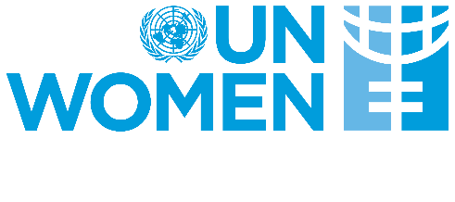

https://reliefweb.int/report/uganda/unhcr-uganda-factsheet-june-2023
Integrated Food Security Phase Classification (IPC) 2022 Report
IGAD Regional Focus Report on Food Crisis, July 2022
www.independent.co.ug/karamoja-food-crisis-worsens/
IPC stands for Integrated Food Security Phase Classification
District local government, local women organizations, para social workers and para legal, police and judiciary
Ibid 24
District local government, local women organizations, para social workers and para legal, police and judiciary

