
Mid-Term Evaluation Brief

Dare to Care Regional Programme



August 2026



Background

This Mid-term evaluation (MTE) serves both accountability and learning purposes. It assesses the overall performance of the Dare to Care (DTC) regional programme of UN Women’s Regional Office for the Arab States (ROAS) and its achievement towards planned results and analyses the programme to determine effective strategies and areas requiring course correction. It assesses the DTC based on its relevance, effectiveness, efficiency, coherence, sustainability, and integration of gender and human rights principles, providing actionable recommendations for the remaining implementation period.

The MTE covers the implementation period of DTC from its commencement in October 2023 up until the end of the data collection period of the MTE in March 2026. The main focus of the MTE is on the three principal DTC implementation countries (Egypt, Jordan and Morocco) as well as on the regional components of the programme, with a smaller focus on the DTC interventions in Tunisia.

DTC programme in brief

The DTC programme is guided by a Theory of Change (ToC) that is grounded in a socio-ecological model for social norms change, i.e. of seeking to achieve mutually reinforcing change at multiple levels simultaneously.

DTC’s total budget is approximately USD 9 million, supported by three key donors: the Swedish International Development Cooperation Agency (Sida) contributing USD 7,176,750; German International Development Cooperation (Gesellschaft für internationale Zusammenarbeit – GIZ) contributing USD 1,465,662; and the Basque Agency for Development Cooperation (Agencia Vasca de Cooperacion para el Desarrollo - AVC) contributing USD 436,000.

DTC is implementing a socioecological model of change consisting of several components:

- a youth-led regional campaign, also implemented nationally, aiming to increase men’s and boys’ participation in caregiving and household responsibilities;
- locally implemented community-level programmes (one each in Egypt, Jordan, and Morocco) aiming at improving attitudes towards gender equality with respect to men's involvement in care work; women’s participation in the labour market; women’s participation in public decision making; and delegitimising intimate partner violence (IPV);
- work with the private sector to implement Women's Empowerment Principles (WEP) and encourage male allyship for gender equality;
- working with youth-serving state institutions in order to contribute to transforming patriarchal masculinities and social norms, with a focus on increased participation of men and boys in care work and increasing and women’s participation in paid employment;
- working with religious institutions to transform patriarchal masculinities and promote women’s economic empowerment;
- regional engagements with the Arab Women's Organisation (AWO) to develop and promote a regional road map on the care economy and establish a regional network of universities and research institutions;
- working with national women’s machineries, women’s CSOs and other key stakeholders catalyse legal/policy reforms for more equal and meaningful involvement of men/boys in care work responsibilities, with a focus on paternity leave and its uptake by men, including by working through a regional Male Decisionmakers Network, and
- dissemination and uptake of DTC’s knowledge products to advance the transformation of patriarchal masculinities and social norms.

MTE methodology
The MTE is a non-experimental, theory- based evaluation and has been guided by the following principles:
- Gender responsive,
- Utilisation-focused,
- Participatory and inclusive,
- Culturally sensitive and applying a do no-harm approach,
- Contribute to learning and decision-making.

The evaluation team reconstructed parts of the original programme ToC, and used this as the main reference document to evaluate the programme's intervention logic by testing the validity of the programme's underlying assumptions and pathways of change.

It is based on six Organisation for Economic Co-operation and Development (OECD) Development Assistance Committee (DAC) evaluation criteria and a dedicated criteria on gender and human rights:
• Relevance,
• Effectiveness,
• Efficiency,
• Coherence,
• Sustainability, and
• Gender and human rights dimensions.

A total of 21 evaluation questions were developed for these criteria. It does not include the criteria of Impact as this is a mid-term evaluation.

The MTE adheres to the United Nations Evaluation Group (UNEG) Norms and Standards for Evaluation, the UNEG Code of Conduct for Evaluations in the UN System, UNEG ethical guidelines, emerging UNEG Ethical Principles for Harnessing AI and UN Women Evaluation Guidelines including Evaluation Policy, GERAAS evaluation report quality checklist, and the UN Women’s “How To Manage Gender-Responsive Evaluation” handbook.

Findings

Relevance: The ToC of the programme remains valid and relevant and has been validated in its intervention logic in those areas where evidence of the programme’s impact was available. Stakeholders across the board saw DTC as highly relevant and aligning with key national and regional policies and priorities, and also contributing to the development of these. Although the thematic focus of DTC is not necessarily one which is prioritised by local women’s organisations, they were supportive of it. Stakeholders saw UN Women as being uniquely positioned in carrying out the programme.

Effectiveness: While some of the programme’s components have already shown themselves to be effective (such as community, youth and private sector engagement; advocacy on legal and policy frameworks), other components are either not yet at a stage where their effectiveness can be assessed (e.g. work on religious norms) or implementation has been delayed due to circumstances beyond the control of the programme, especially the engagement with youth-serving institutions in Egypt and Morocco. While resistance to the programme’s gender transformative aims was anticipated, this has been less than expected and the programme has had positive unintended consequences. Peer-to-peer and in-person programming, flexibility in localising messages, as well as direct engagement through motivated and competent implementing partners have contributed to the successes so far.

Efficiency: Both at the regional and country levels, DTC has a lean and efficient management structure. The programme has been designed and implemented as a regional rather than as a multi-country programme. The country and regional levels work symbiotically, and this can be further enhanced as new findings and knowledge products become available. DTC has deployed financial, human and regional resources in a broadly efficient and timely manner, though at times it has been constrained by approval bottlenecks. The programme has a robust and sophisticated MEL system that allows for adaptive management.

Coherence: DTC has a high level of coherence and synergy with other GEWE interventions nationally and regionally, addresses areas of programming not covered by others, and has actively helped shape policy and programming alignment. It aligns with, and contributes to, national, regional and UN frameworks and policies, and has leveraged existing strategic partnerships and forged new ones.

Sustainability: Whilst it is too early in the implementation process to firmly establish the degree of sustainability of the various components of the programme, in particular the effected legal and policy changes will, as laws, likely endure at least for the medium-term given their status, while government policies will likely be in effect for at least the respective current electoral period, while other components, including the community-level intervention, show a high degree of promise in this respect. Local implementing partners showed a high degree of interest in continuing to use skills, capacities, and approaches developed or learned under DTC. The greatest risks to sustainability come from announced budget cuts, which will need to be carefully managed, and regional political dynamics. Knowledge generated through DTC has actively informed national, regional and global policy debates.

Gender and Human Rights: In its design and implementation, DTC has sought to effect transformative change and approach gender both relationally and intersectionally, even if not all components are strictly gender transformative. The programme has integrated a strong LNOB perspective with respect to disabilities and ethno-religious minorities in some of its components, especially under Outcome 1.

Lessons learned

Lesson 1: Designing and implementing a multi-level, socioecological approach

- Multilevel socioecological approaches require a dedicated run-up period to establish evidence, partnerships and institutional foundations.
- Regional models that are locally adapted can generate economies of scale while enabling learning and change across multiple levels.
- A clearly defined thematic entry point can help operationalise complex socioecological approaches across multiple spheres of influence.
- Working across multiple levels and actors requires realistic sequencing and timelines, particularly where progress depends on external institutions and decision-making processes.

Lesson 2: Implementation modalities

- DTC’s provision of flexibility to implementing partners to adapt regional approaches to local contexts has contributed to its success, but requires maintaining intervention fidelity.
- Localised implementation showed the importance and utility of in-person engagements.
- Direct, rather than mediated, engagement with implementing partners proved successful.
- Engagement with state institutions remains essential, but counterparts need the mandate, political will, and internal processes that are amenable to the intended ways of collaboration and aimed-for timelines.

Lesson 3: Enhanced, impact-oriented Monitoring Evaluation and Learning (MEL)

- DTC’s enhanced, more outcome-oriented MEL allows for greater and faster adaptive programme management and better understanding of impacts.
- More and faster MEL data requires dedicated and trained staff and resources, as well as robust data analysis structures and processes for it to be useful, rather than a hindrance.
- While more impact-focused indicators allow for a better understanding, there are limitations to how much they can measure in terms of longer-term change. However, more elaborate tracking would raise issues of costs versus benefits.

Conclusions

Conclusion 1: Promising programme foundations position DTC to consolidate and deepen results despite a more constrained resource environment.

Conclusion 2: The full value of DTC's socio-ecological model depends on the extent to which its diverse programme strands reinforce one another.

Conclusion 3: There are promising opportunities for mutually reinforcing linkages between DTC and WEE programming, provided these are pursued strategically and without diluting DTC's broader gender-transformative norms and behaviour change objectives.

Conclusion 4: DTC's achievements and convening abilities has create a good foundation for mobilising new and diversified sources of support, including from less traditional sources.

Conclusion 5: While DTC's culturally adapted, care-focused approach has successfully advanced gender-transformative change, sustaining these gains will require continued attention to potential backlash and a more systematic integration of disability inclusion across programme implementation.

Recommendations

Recommendation 1: UN Women should consolidate, safeguard and capitalise on achieved gains during the remaining implementation period, while recalibrating targets and activities that have proven more challenging to achieve within the reduced budget envelope.

Recommendation 2: Strengthen coordination, learning and knowledge sharing across various DTC work streams and across local, national and regional levels, so that approaches, evidence, achievements and knowledge products are systematically exchanged and used to reinforce programme coherence, implementation and results.

Recommendation 3: Map and evaluate the degree to which aspects of DTC could be meaningfully and synergistically linked up with existing or planned WEE and livelihoods programming.

Recommendation 4: Assess how DTC's demonstrated results, accumulated momentum and networks of partners can be strategically leveraged to mobilise additional resources and diversify future sources of support.

Recommendation 5: Maintain and, if needed, enhance support to implementing staff on how to sustain momentum towards achieving gender-transformative goals and aspirations while building the capacity of implementing partners at all levels to identify and counter potential backlash. Particular attention should also be given to continuing to strengthen the application of Leave No One Behind principles, including more deliberate and comprehensive disability inclusion across programme implementation, monitoring and learning processes.

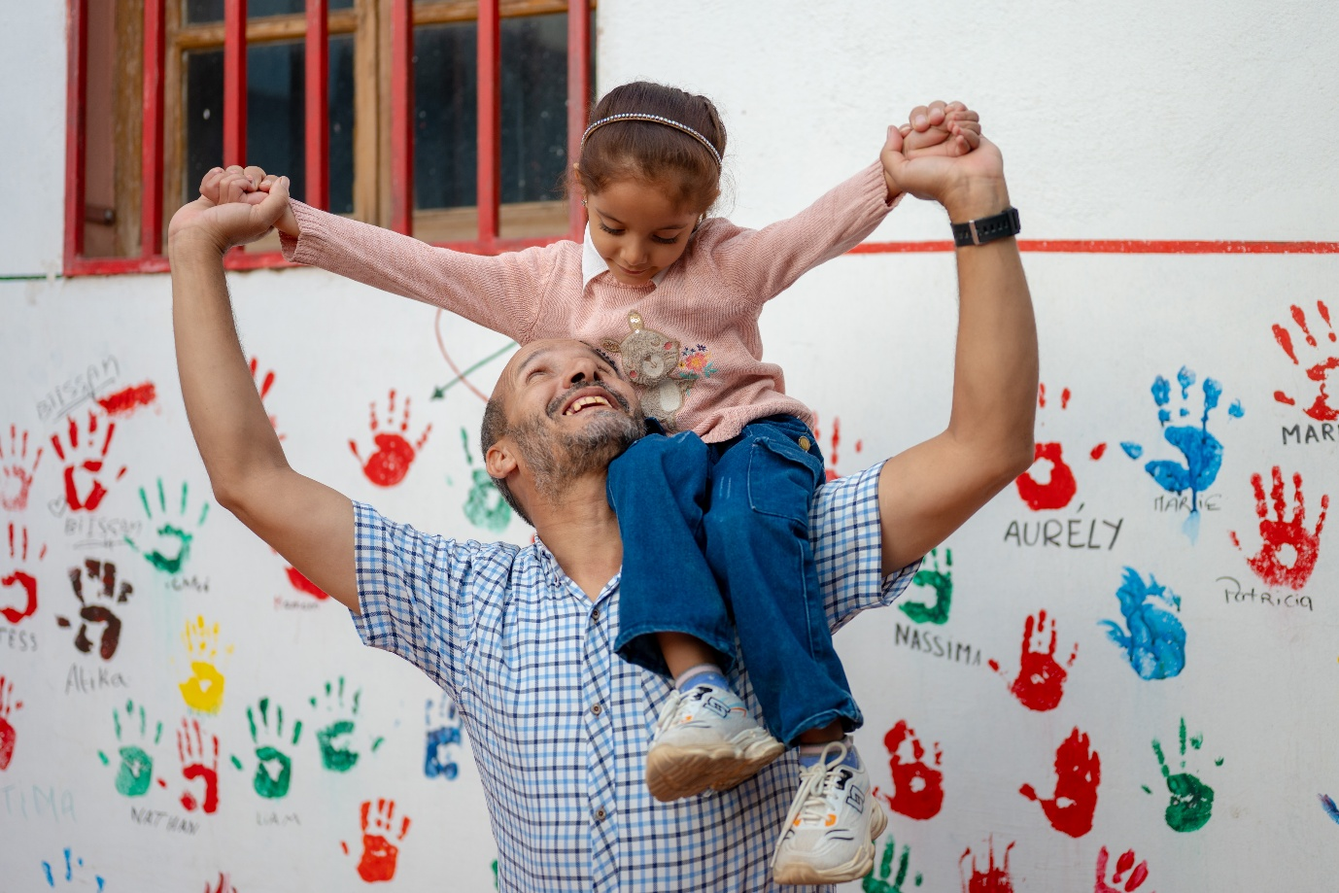 Photo: UN Women

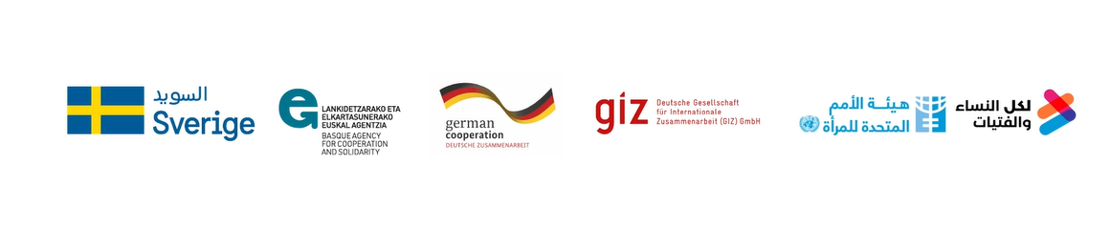


The socio-ecological approach to social norms change recognizes that discriminatory norms are sustained through interacting individual, interpersonal, community, institutional and structural factors, and therefore require mutually reinforcing interventions across multiple levels. See Cislaghi, B., Manji, K. and Heise, L. (2018). Social norms and gender-related harmful practices: Theory in support of better practice. Learning Group on Social Norms and Gender-related Harmful Practices, London School of Hygiene & Tropical Medicine.

