
Dare To Care Mid Term Evaluation - Annexes

Henri Myrttinen and Tarek Jalleb

August 2026



TABLE OF CONTENTS
Contents
Table of contents 2
Annex 1 – Terms of Reference 4
Annex 2 – Methodology in Detail 5
1. Guiding principles 5
1.1. Key Principles 5
1.2. Ethical considerations 5
1.3. Use of AI 6
2.Data collection tools 6
3. FGD Sampling Strategy 7
Annex 3 – Evaluation Matrix 9
Annex 4 – Stakeholder analysis and final list of interviewees/FGDs/survey participants 14
Annex 5 – Data Collection Tools 16
5.1. Interview guidance 16
5.2. FGD Guide: Community Members (Men and Women) 20
5.3. Online Survey Guide 23
Annex 6 – Results of online Survey of DTC Stakeholders (Indicative Findings) 25
Annex 7 – Key documentation for review and analysis 30
Annex 8 – DTC Results to date (end March 2026) 36

Annex 1 – Terms of Reference

https://gate.unwomen.org/Evaluation/Details?evaluationId=11908

Annex 2 – Methodology in Detail
- Guiding principles

  - 1.1 Key Principles

The following principles guided the mid-term evaluation (MTE) of DTC:
- Gender responsive
- Utilisation-focused
- Participatory and inclusive
- Culturally sensitive and applying a no-harm approach
- Contribute to learning and decision-making

This was a theory-based evaluation that adhered to the United Nations Evaluation Group (UNEG) Norms and Standards for Evaluation, the UNEG Code of Conduct for Evaluations in the UN System, UN Women Evaluation Guidelines including Evaluation Policy, GERAAS evaluation report quality checklist, and the UN Women’s “How To Manage Gender-Responsive Evaluation” handbook. The evaluation integrated disability inclusion throughout its design, data collection and reporting, in line with the UN Disability Inclusion Strategy and its Entity Accountability Framework.

  - 1.2 Ethical considerations

All data collection followed informed consent procedures, with particular attention to confidentiality and anonymity. Cultural sensitivity protocols were established for each country context, and all interviews were conducted in Arabic where preferred.

Due to a possible reluctance by respondents to sign forms, verbal consent was sought instead. Participants were told about the study rationale and its methodology, and asked whether they would be willing to participate in the study. The participant was explicitly asked whether s/he wanted to participate in the study. It was made clear to them that they were free to decide whether or not to be a participant, and that they could stop the interview and opt out of the study at any time. If the evaluation team noticed signs of discomfort or distress during the interview, they again asked whether the interviewee wanted to stop the data collection process. Research participants were given the contact details of the UN Women CO in case they wanted to discuss any aspect of their participation in the MTE, or if they wished to withdraw consent.

Any research on sensitive issues such as gender carries risks to both the research participant and researcher. Possible risks included, and were not limited to:

- Personal distress and discomfort (including re-traumatisation/secondary traumatisation)
- Embarrassment, shame or stigma
- Social or political repercussions
- Violence and discrimination from third parties

Throughout the research design and implementation, the evaluation team took all necessary steps to minimise and prevent any of the above impacts, both to evaluation participants and the evaluation team. Even though the evaluation team did not explicitly plan to interview GBV survivors, as a matter of precaution, WHO protocols and guidelines on engaging with GBV survivors were followed throughout. The wellbeing and safety of research participants and data collectors superseded any data collection objectives. The evaluation team therefore carefully looked for signs that respondents were reluctant to be interviewed (even if they agreed) about certain issues, or that there was a potential risk of re-traumatisation of the interviewee or secondary traumatisation. The evaluation team aimed to minimize the risks for the participants by not asking them about any traumatic events. If, however, respondents began to talk about direct instances of harm, they were free to do so. If any line of inquiry led to distress for the research participant, the interviewer refrained from asking any further questions, and ended the interview if necessary. Interviewers had contact details of nearby service providers at hand if the respondents requested these, and were shared in an appropriate “do no harm” manner, especially if the need related to GBV cases.

  - 1.3 Use of AI

Use of artificial intelligence (AI) in this midterm evaluation was strictly aligned with emerging UNEG Ethical Principles for Harnessing AI, particularly on privacy, data protection, transparency and human oversight. Any use of AI during primary data collection and analysis involving sensitive information on gender norms, masculinities and caregiving was limited to functions that protect participants’ confidentiality, such as secure storage, anonymisation or deidentification, and did not replace human judgement in interpreting findings. By contrast, restricted use of AI tools was tolerated for low-risk tasks such as searching and synthesising publicly available literature, organising notes or drafting initial summaries, provided this was agreed in advance with the commissioning partners, clearly documented, and subject to human review to avoid bias, errors or undue disclosure of confidential material.

  - 2.Data collection tools

The evaluation was implemented between December 2025 and April 2026. The methodology used for the MTE was based on the following:

- Document and literature review of key programmatic and policy documents, programme-level documents and reports, knowledge products, and MEL data; as well as of key state-of-the-art literature on gender norms (including masculinities) in the MENA region and on gender transformative change, respective national level laws and policies relevant to care work and parental leave, as well as central UN Women policy documents on transforming patriarchal masculinities (see Annex 7 for a list of these).
- Simplified Most Significant Change (MSC)-based semi-structured interviews. All interviews were treated confidentially and conducted in English or in Arabic in person or using virtual communication tools such as Microsoft Teams or Zoom. Interviewees included DTC implementing staff and other relevant UN Women personnel, donor representatives (Sida, GIZ and AVCD), project implementing partners, target groups and select experts (see Annex 4 for a list of interviewees and Annex 5 for guiding questions).
- Focus Group Discussions (FGDs) were carried out with youth advocates and members of the participating communities in Egypt, Jordan, and Morocco (see Annex 5 for guiding questions).
- Online surveys were conducted with key networks, namely with youth advisory group members, the network of male decision-makers, and private sector stakeholders (see Annex 5 for survey questions)

Following discussions with key UN Women ROAS staff involved with DTC, the evaluation team did not engage with the regional university network at this point, as it had yet to commence work. Similarly, the evaluation team did not reach out to religious leaders directly, as it was too early in the process of their engagement, so instead the implementing partner Adyan Foundation was interviewed.

An online validation workshop was held with key stakeholders in April 2026 to present preliminary findings, check the accuracy and fairness of interpretations, and gather feedback before finalising the evaluation report.

  - 3. FGD Sampling Strategy
The study used a stratified purposive quota approach to select participants for each 7-8 person focus group. Eligible adults were first listed and randomly ordered, selection then aimed to fill flexible quotas on marital and parental status, age, education, spouse’s employment, and disability so that each analytically important subgroup was present while reflecting that most adults in the settings were married and many have children. Quotas were expressed as approximate percentages to guide field teams rather than rigid proportions, consistent with qualitative quota sampling practice.​ Sampling quotas and criteria were informed by data from the project’s midline assessment. These quotas were deliberately flexible and context-specific, designed to reflect both the available evidence and the specific characteristics of each local setting. In practice, the aimed-for quotas were not always met, but the high degree of coherence in the findings give us confidence in the overall validity of the data.

Marital and parental status
- Marital status: Around 70% married, 30% single/separated/divorced/widowed. This deliberately over-represents married participants because marriage is central to family roles, gender norms, and decision-making in the study contexts, while still ensuring that never-married and previously married adults are heard.​
- Children: Approximately 60% with children and 40% without. This balance prioritizes parents who are assumed to be more engaged with care, schooling, and household provisioning yet preserves enough adults without children to explore how norms differ for them.​
Age structure
- Age bands: About 25% aged 18–29, 30% aged 30–44, 30% aged 45–59, and 15% aged 60+. This spreads participants across early adulthood, mid-life, and older age, allowing comparison of generational perspectives while keeping numbers in each band high enough for meaningful discussion.​ With a relative over representation of the 30–44 and 45–59 age groups because these are the core years when people usually carry the main household and caregiving responsibilities and make most family and economic decisions.
Education
- Education level: Roughly 15% low education, 60% medium, and 25% high. This reflects that medium levels of schooling are common in many study areas, while ensuring that both less-educated participants, who may face greater constraints, and highly educated participants, who may experience and interpret norms differently are included.​

Spouse’s employment and disability
- Spouse’s employment: Among partnered participants, the evaluation team requested for roughly equal representation of respondents with a working spouse and those with a non-working spouse. This balance (and its variation across groups) captures differences in economic arrangements and dependence, which is important for understanding bargaining power and attitudes toward women’s and men’s work
- Disability: Based on demographocs, we aimned for around 15% of participants with a disability. I

Annex 3 – Evaluation Matrix
Criteria | Central question (as per OECD/DAC) | Sub-Questions | Indicator data | Data Collection method | Data source | Assumptions
Relevance | Is the intervention doing the right things? | How relevant, fit for purpose, and evidence-informed are the programme intervention logic, Theory of Change (ToC), and the respective assumptions and risks, for bringing about gender transformative changes in behaviours and challenge social norms at the local, national and regional level?  How well are the program objectives aligned with national policies, international frameworks, and the priorities of local women’s organizations?  What is the comparative advantage of UN Women in leading this programme? Is UN Women's value addition well understood and recognized among regional and national stakeholders? | Alignment with key strategies and policies; strength and relevance of ToC and project logic; relevance of chosen intervention methodologies | KIIs, document review | Interviews: DTC implementing staff; UN Women global, regional, national leadership; other UN entities DTC has engaged with; donors; national government/ women’s machinery representatives; implementing partners.  Document review: programme documentation; UN Women and regional and national government policy documents, UNSDCF, MEL data; research data; secondary literature | Data and interviewees are available; interviewees are willing to engage openly
Effective-ness | Is the intervention achieving its objectives? | To what extent have the different components of the programme been effective in promoting positive behaviours and/or challenging social norms that underpin gender inequality?  What were the positive/negative unintended effects, if any?  What factors have supported or hindered implementation progress? What innovations and good practices have emerged?  Does the programme have effective monitoring, evaluation and learning systems to track progress and support adaptive management at the national and regional level? | Degree to which different project activities contribute to intended change at various levels; to what degree can these be attributed to DTC activities | KIIs, FGDs, survey, MEL data | KIIs: DTC staff, donors, national government counterparts, implementing partners; FGDs: target group populations; Survey: private sector partners; Document review: programme documentation, MEL data | Data and interviewees are available; interviewees are willing to engage openly
Efficiency | How well are resources being used? | Is the programme management structure fit for purpose with regional and country level institutional arrangements to deliver results in a cost-effective and timely manner?  Is the regional arrangement successfully leveraging the combined effects of the multi-country programme approach?  Have financial, human and other resources been optimally deployed during the concerned implementation period? | Evidence that the available resources are being used in a way that maximises their utility, and that structures and processes ameliorate implementation | KIIs, document review | KIIs: DTC staff, implementing partners, donors and national government counterparts; Document review: budget/spending data, HR data; coordination meeting minutes | Data and interviewees are available; interviewees are willing to engage openly
Coherence | How well does the intervention fit? | To what extent is the programme coherent with other gender equality interventions at country and regional levels, ensuring complementarity and avoiding duplication?  How well does the programme align with national development frameworks, donor priorities, country-level UNSDCF and UN Women's broader programming in nationally/the region?  Have strategic partnerships been effectively developed and utilized to contribute toward programme results? | Evidence of various parts of the programme cohering and supporting each other at different levels | KIIs, FGDs survey document review | KIIs: DTC staff, implementing partners, donors and national government counterparts; FGDs: target groups; Survey: private sector partners;  Document review: Programme documentation, ToC, UNSDCFs, UN Women and national government strategic documents, MEL data | Data and interviewees are available; interviewees are willing to engage openly
Sustain-ability | Will the benefits last? | What early indications exist that outcomes will be sustained through requisite policy and regulatory frameworks, capacities, partnerships, systems, and structures being established?  How well has the capacity of local stakeholders been enhanced to allow them to take future ownership and sustain results?  What risks or barriers exist that could undermine the sustainability of programme outcomes, and how are these being mitigated? How has the knowledge generated from the program contributed to wider policy dialogues or replication regionally or in other contexts? | Changes in structures, attitudes, practices, legal and policy frameworks attributable to the programme that are likely to continue beyond its implementation period | KIIs, FGDs, online survey, MEL data, project documentation | KIIs: DTC staff, implementing partners, donors and national government counterparts; FGDs: target groups ; Survey: private sector partners;  Document review: programme documentation, MEL data, legal frameworks and national/regional strategies DTC has influenced/contributed to | Data and interviewees are available; interviewees are willing to engage openly
Gender responsiveness and human rights | Has the programme fully integrated GEWE, human rights and LNOB principles in its design, implementation and MEL? | How has the programme addressed underlying causes of gender inequality and to what extent has it established foundations for transforming negative behaviours and challenging negative social norms?  To what extent was a human rights-based, gender transformative, and disabilities-inclusive approaches incorporated in programme design and early implementation?  To what extent does the programme incorporate the principle of Leave No One Behind (LNOB) with special focus on marginalized groups (incl. ethnic and religious minorities, persons living with disabilities, forcibly displaced, etc.)? | Evidence that key gender equality and human rights principles have been taken into account and integrated at in the programme’s design, implementation and MEL | KIIs, FGDs, programme documentation, online survey | KIIs: DTC staff, implementing partners, donors and national government counterparts; FGDs: target groups; Survey: private sector partners;  Document review: programme documentation, ToC, MEL data | Data and interviewees are available; interviewees are willing to engage openly

Annex 4 – Stakeholder analysis and final list of interviewees/FGDs/survey participants

Category of interviewee | Who | What (their  role in the  intervention) | Why (gains from  involvement in  the evaluation) | How (data collection method) | When  (at what  stage) | Priority
UN Women DTC staff (ROAS and Egypt, Jordan, Morocco and Tunisia COs) | ROAS:  1. Regional Programme Manager;  2.MEL specialist/consultant  3.Masculinities and Social Norms consultant;  4. Youth Mobilization and Communications specialist;  5. Gender and religion lead;  6. Senior Consultant; Private Sector Specialist;  7. LNOB and Knowledge Management consultant  Country Offices: 1.Egypt CO  2.Jordan CO, 3.Morocco CO, 4.Tunisia CO.  5.Palestine CO,  6.Lebanon CO. | Implementers | Essential insights from implementation | KIIs | Early/  during main data collection period | High
Other UN Women/UN agency staff | UN Women Headquarters: Global Advisor on Macroeconomics and Care; Care Economy Policy Specialist; Policy Advisor on Social norms  UN Women ROAS: Regional Lead on Results and Evidence; Regional Communications Specialist; Head of Regional Programme Management Support Unit  ILO ROAS: Regional Senior Gender Advisor and Non-Discrimination  UN ESCWA: Social Affairs Officer | Potential audiences for lessons learned and take-up of methods developed by DTC, with a focus on care economy and social norms; co-chairs of the regional UN Working Group on Care | Assessing degree of sharing and take-up of lessons learned and innovation | KIIs | During main data collection period | High-Medium
Donor representatives | Sida; GIZ; AVC | Funders | Essential insights from implementation | KIIs | Early/  during main data collection period | High
Implementing partners | Regional: AWO; Egypt: Gozour Foundation; Youth Leaders Foundation,  Community Hub Jordan: Athar, CCN, RHAS; Morocco: ATEC, Project SOAR | Implementers | Essential insights from implementation | KIIs, online survey (for networks) | During main data collection period | High
National government Jordan and Morocco | Jordan (National Council For Family Affairs) Morocco (Ministry of Solidarity, Social Inclusion, and the Family) | Co-implementers and audiences for policy messaging | Insights on uptake, messaging; views on implementation | KIIs | During main data collection period | High-Medium
Target groups | Target Groups: Egypt, Jordan, Morocco (youth mobilisation, community model) | Target audience of DTC | Essential insights from implementation (impacts, effectiveness and sustainability) | FGDs, survey | During main data collection period | High
Youth Advisory Group | Whole network | Part of implementation | Essential insights from implementation | KIIs /survey | During main data collection period | High
Network of male decision-makers for GEWE | Whole network | Part of implementation | Essential insights from implementation | Survey | During main data collection period | High
Network of private sector stakeholders | Whole network | Part of implementation | Essential insights from implementation | Survey | During main data collection period | High
Others | Adyan Foundation,  Emakunde | Variously involved with DTC to date | Additional insights into other aspects of the programme | KIIs | During main data collection period | Medium

Annex 5 – Data Collection Tools
  - 5.1. Interview guidance

INTERVIEW GUIDANCE- Please note that this is the most comprehensive version of the KII guide and this was adapted to the respective interviewee’s degree of engagement with DTC

Dear Madam/Sir,

My name is __________________ and I have been commissioned by UN Women to conduct a Mid-Term evaluation of the Dare to Care Programme. We aim to assess its strengths and challenges, with a view to further improving the programme. For this purpose, we are interviewing nominated internal and external stakeholders. We have selected you due to your engagement with the programme and are very grateful for your taking the time to talk to us. The interview should be approximately one hour.

All our interviews are confidential and anonymous, and no quotes will be directly attributed to you unless you explicitly wish for us to do so. Your personal data such as your phone number, email address or other shall not be distributed and only collected for internal purposes exclusively for this evaluation, such as remaining in touch with you for the duration of the data collection and analysis period. We comply with the General Data Protection Regulation 2016/679 is a regulation in EU law on data protection and privacy. Furthermore, you are free to end this interview and withdraw your consent at any point. In order to do so, please do so in written form for our archives.

Do you have any questions for me at this point? If not, then if it is alright with you, we can start with the interview.

Introduction:

☑ Check that interviewee has given verbal consent

(Note to interviewers: These questions are indicative, please use your own judgment to ask follow-up questions on any issues which may come up during the interviews that you think are of particular interest. Not all questions will be relevant to all stakeholders.)

Introduction: Thank you for agreeing to this interview, your insights are immensely valuable to our evaluation. We appreciate all of your answers but also please do let us know if you want to skip a question or if you would rather not answer – that is completely acceptable.

ROLE AND MOST SIGNIFICANT CHANGE

1.Can you describe your role with regards to the DTC programme and/or how you engage with DTC?

2. From your point of view, what has been the most significant change that has taken place as a result of the implementation of DTC?

RELEVANCE

3. How relevant, fit for purpose, and evidence-informed are the programme intervention logic, Theory of Change (ToC), and the respective assumptions and risks, for bringing about gender transformative changes in behaviours and challenge social norms at the local, national and regional level?

4. How well are the program objectives aligned with national policies, international frameworks, and the priorities of local women’s organizations?

5. What is the comparative advantage of UN Women in leading this programme? Is UN Women's value addition well understood and recognized among regional and national stakeholders?

EFFECTIVENESS

- To what extent have the different components of the programme been effective in promoting positive behaviours and/or challenging social norms that underpin gender inequality?
- What were the positive/negative unintended effects, if any?
- What factors have supported or hindered implementation progress? What innovations and good practices have emerged?
- Does the programme have effective monitoring, evaluation and learning systems to track progress and support adaptive management at the national and regional level?

EFFICIENCY
- Is the programme management structure fit for purpose with regional and country level institutional arrangements to deliver results in a cost-effective and timely manner?
- Is the regional arrangement successfully leveraging the combined effects of the multi-country programme approach?
- Have financial, human and other resources been optimally deployed during the concerned implementation period?

COHERENCE
- To what extent is the programme coherent with other gender equality interventions at country and regional levels, ensuring complementarity and avoiding duplication?
- How well does the programme align with national development frameworks, donor priorities, country-level United Nations Sustainable Development Cooperation Frameworks (UNSDCF) and UN Women's broader programming nationally/in the region?
- Have strategic partnerships been effectively developed and utilized to contribute toward programme results?

SUSTAINABILITY
- What early indications exist that outcomes will be sustained through requisite policy and regulatory frameworks, capacities, partnerships, systems, and structures being established?
- How well has the capacity of local stakeholders been enhanced to allow them to take future ownership and sustain results?
- What risks or barriers exist that could undermine the sustainability of program outcomes, and how are these being mitigated?
- How has the knowledge generated from the program contributed to wider policy dialogues or replication regionally or in other contexts?

GENDER AND HUMAN RIGHTS
- How has the programme addressed underlying causes of gender inequality and to what extent has it established foundations for transforming negative behaviours and challenging negative social norms?
- To what extent was a human rights-based, gender transformative, and disabilities-inclusive approaches incorporated in programme design and early implementation?
- To what extent does the programme incorporate the principle of Leave No One Behind (LNOB) with a special focus on marginalized groups (incl. ethnic and religious minorities, persons living with disabilities, forcibly displaced, etc.)?

ENDING
Thank you very much for sharing your experiences and for being so generous with your time. Is there anything else that you would like to add or any questions that you have for me?

5.2. FGD Guide: Community Members (Men and Women)

Dear Madams/Sirs,

My name is __________________ and I have been commissioned by UN Women to conduct a Mid-Term evaluation of the Dare to Care Programme. We aim to assess its strengths and challenges, with a view to further improving the programme. For this purpose, we are conducting focus group discussions with people engaged with the programme and are very grateful for your taking the time to talk to us. The discussion should be approximately one hour.

All focus group discussions are confidential and anonymous, and no quotes will be directly attributed to you unless you explicitly wish for us to do so. Your personal data will not be collected. We comply with the General Data Protection Regulation 2016/679 is a regulation in EU law on data protection and privacy. Furthermore, you are free to end this focus group discussion and withdraw your consent at any point during the discussion.

Do you have any questions for me at this point? If not, then if it is alright with you, we can start with the discussion.

Introduction:

☑ Check that participants have given verbal consent

(Note to interviewers: These questions are indicative, please use your own judgment to ask follow-up questions on any issues which may come up during the focus group discussion that you think are of particular interest.)

INTRODUCTION:
- Your context and needs (Relevance)
  - In your daily life, what are the main things that affect family well-being?
  - What things make it hard for women and girls here to have the same opportunities as men and boys (for example in work, money, decision‑making, time, safety)?
  - Thinking about your own situation: what are your main needs and priorities to improve your and your family’s sense of well-being (for example earning an income, sharing care at home, feeling safe, being heard in decisions)?

Probe: Are these needs different for young women/men, married/unmarried, refugees, rural/urban, people with disabilities?
- How well do the activities you joined in this project (for example sessions, trainings, campaigns, youth clubs, dialogues, care‑related support) match your real needs and the way things work in your family and community?

- Are there any changes that you noticed in your/your family’s well-being since joining the project?

- What feels most relevant? What feels less useful or unrealistic?

Probe: Can you give some examples of what you have learned and applied in everyday life?

2. Changes you see (Effectiveness / Impact)
- Since you started participating, have you noticed any changes in:

a) How you think about women’s and men’s roles at home and at work?

b) How people around you (family, friends, neighbours) talk about women working, earning, or men sharing care?

c) How much time you or others spend on unpaid care (cooking, cleaning, childcare, elder care)?

- Did the project help you change anything practical in your life?

Probe: Starting or improving work or a business; Talking with your partner/family about sharing housework or childcare; Feeling more confident to speak up or make decisions; Feeling safer in public spaces, transport, or workplaces.

- Have you seen any changes in how men and boys behave—for example helping more at home, supporting women’s work, or speaking differently about women?

Probe: Positive changes? Any resistance or backlash?

- Did you share what you learned (for example about gender equality, care, or rights) with others?

Probe: With whom (family, peers, online), and what was their reaction?

3. How the activities work for you (Efficiency / Quality)
- Which project activities have been most useful or meaningful for you, and why?

Probe: Group discussions, trainings, youth actions, media/social media, community events, care‑related support, work with religious or community leaders.

- Which activities did you find less useful, hard to attend, or not suitable for your situation?

Probe: Timing, place, childcare, transport costs, language, mixed vs single‑sex groups, sensitivity of topics.
- Do you feel you had a real chance to speak, share your views, and help shape activities, or were you mostly just receiving information?

Probe: Examples of when your feedback changed something.

4. Inclusion, barriers and risks (LNOB / Sustainability)
- Who do you think is benefiting most from the project, and who is not reached or finds it hard to join (for example the poorest women, rural women, refugees, certain ethnic/religious groups, persons with disabilities, adolescent girls/boys)?

- Have you or others faced any problems because of your participation (for example criticism from family or community, conflict at home, problems at work)?

Probe: How did you handle this? Did the project help you manage these risks?

- What makes it easier for people here to continue the changes (for example sharing care, supporting women’s work, youth activism) after the project ends?

Probe: Support from family, community leaders, organisations, local authorities, groups you belong to.
- What makes it difficult to keep these changes going in the future?

5. Learning and suggestions
- From your experience, what is one thing the project is doing very well that should definitely continue or be expanded?

- What is one thing you would change to make the project better for people like you (for example topics, approach, who is involved, timing, support provided)?

- If you could give one piece of advice to the project team to better support women’s and men’s lives in this community, what would it be?

ENDING
Thank you very much for sharing your experiences.

5.3. Online Survey Guide

(PLEASE NOTE THAT THESE WERE TRANSLATED INTO SIMPLIFIED ARABIC)

Part A: General information

A.1. Country
a. Jordan
b. Egypt
c. Morocco
d. Tunisia
e. Lebanon
f. Palestine
g. Other _______

A.2. Sex
a. Male
b. Female
c. Other / prefer not to say

A.3. Age _____________

A.4. Role
a. Youth Advocacy Group
b. Male leaders’ network
c. Private sector

Part B: Relevance and design

For each statement, please say how much you agree.

B.1. The Dare to Care programme addresses the most important issues related to men’s caregiving and gender norms in my context.
1 Strongly disagree 2 Disagree 3 Neither 4 Agree 5 Strongly agree 0 Don’t know

B.2. Programme activities are appropriate for the cultural and social norms in my community.
1 Strongly disagree 2 Disagree 3 Neither 4 Agree 5 Strongly agree 0 Don’t know

B.3. The programme responds to issues that are important to me in my work/community
1 Strongly disagree 2 Disagree 3 Neither 4 Agree 5 Strongly agree 0 Don’t know

B.4. Messages and materials about men and caregiving are communicated in a way that is understandable and acceptable for my community.
1 Strongly disagree 2 Disagree 3 Neither 4 Agree 5 Strongly agree 0 Don’t know
B.5. Messages and materials about women in the workforce are communicated in a way that is understandable and acceptable for my community.
1 Strongly disagree 2 Disagree 3 Neither 4 Agree 5 Strongly agree 0 Don’t know

Part C: Effectiveness and early change

C.1. Because of the programme, it is more acceptable for men and boys to share caregiving and domestic work.
1 Strongly disagree 2 Disagree 3 Neither 4 Agree 5 Strongly agree 0 Don’t know

C.2. Because of the programme, it is more acceptable for women to work outside of the household.
1 Strongly disagree 2 Disagree 3 Neither 4 Agree 5 Strongly agree 0 Don’t know

C.3. The messages used by DTC resonate with the people I engage with for positive change
1 Strongly disagree 2 Disagree 3 Neither 4 Agree 5 Strongly agree 0 Don’t know

Part D: Resistance and sustainability

D.1. Sometimes when I talk about gender equality, I face resistance from my peers
1 Strongly disagree 2 Disagree 3 Neither 4 Agree 5 Strongly agree 0 Don’t know

D.2. I believe that I will continue using the skills/knowledge I have learned so far through DTC
1 Strongly disagree 2 Disagree 3 Neither 4 Agree 5 Strongly agree 0 Don’t know

D.3. I believe that some of the changes promoted by the programme (for example attitudes to men’s caregiving) are likely to continue in the future.
1 Strongly disagree 2 Disagree 3 Neither 4 Agree 5 Strongly agree 88 DK

Part E: Open questions (Effectiveness)

F.1. What is the most important change you have seen (if any) related to men’s caregiving or women’s economic empowerment?
[Open text]

F.2. What should be improved in the programme to better fit your context?
[Open text]

Annex 6 – Results of online Survey of DTC Stakeholders (Indicative Findings)

- Purpose and scope
As foreseen in the inception phase, an online survey was used to generate comparable quantitative and narrative data on awareness, perceived social expectations and satisfaction with DTC interventions among programme participants and key stakeholders across the four countries. The survey was designed to complement qualitative data and monitoring information, rather than to provide statistically representative findings.

- Methodology
The survey was administered online to DTC-engaged stakeholders drawn from three main groups: the Youth Advisory Group, the network of male decision-makers and the network of private-sector stakeholders, with outreach across Jordan, Morocco, Egypt, Palestine and Tunisia. The survey remained open for approximately three weeks, with reminder messages sent once. In practice, 35 complete responses were received. Given this small number and potential response bias, all findings are treated as indicative only and are used for triangulation. The detailed survey results are presented below.

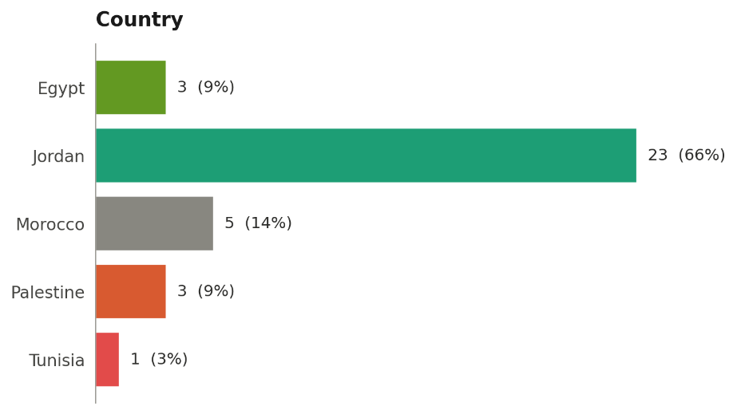
- Profile of respondents (n = 35)
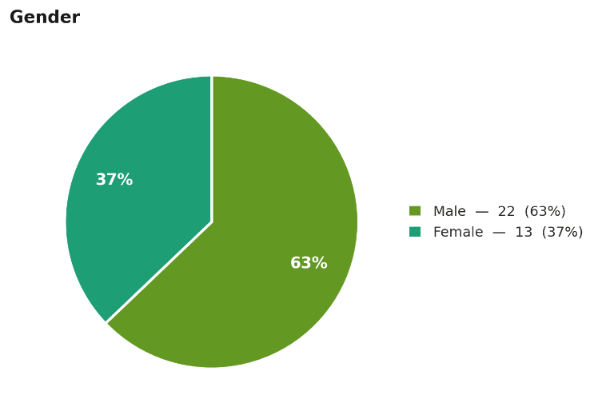
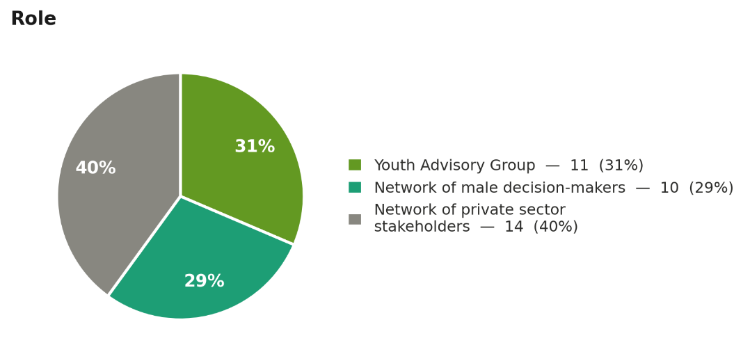
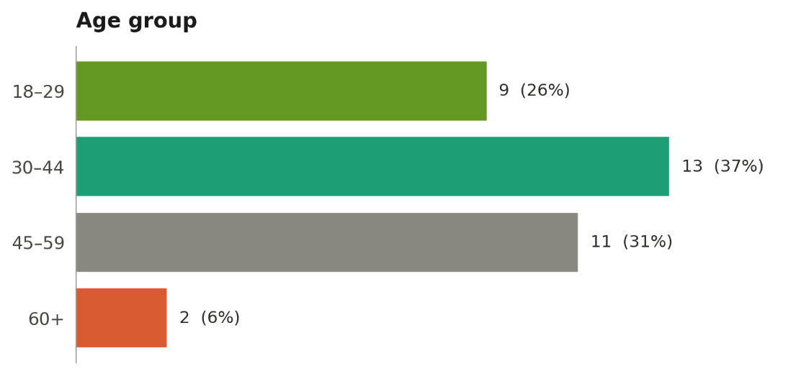

- Key indicative findings

Survey Questions:

- Perceived relevance: 33 of 35 respondents (94 %) agreed or strongly agreed that DTC addresses the most important issues related to men’s caregiving and gender norms in their context.
- Cultural appropriateness: 33 of 35 (94 %) agreed or strongly agreed that programme activities are appropriate for the cultural and social norms in their community.
- Alignment with respondents’ priorities: 32 of 35 (91%) agreed or strongly agreed that the programme responds to issues that are important in their work or community.
- Communication and resonance: 30 of 35 (86 %) agreed or strongly agreed that messages on men’s caregiving are understandable and acceptable, and 33 of 35 (94 %) reported the same for messages about women in the workforce. Furthermore, all respondents agreed or strongly agreed that DTC messages resonate with the people they engage for positive change.
- Perceived norm shifts: 27 of 35 (77 %) agreed or strongly agreed that it is now more acceptable for men and boys to share caregiving and domestic work, and 25 of 35 (71 %) that it is more acceptable for women to work outside the household.
- Experience of resistance: 23 of 35 (66%) agreed or strongly agreed that they face resistance from peers when they talk about gender equality.
- Sustainability: 32 of 35 (91 %) agreed or strongly agreed that they will continue using the skills and knowledge gained through DTC, and 34 of 35 (97 %) believed that some of the changes promoted by the programme are likely to continue in future.

Open ended questions:

Open ended responses (n=35) to questions on ”most important change” and “what should be improved” were reviewed and grouped into broad themes. Answers were provided in Arabic and English, and analysis focused on recurring ideas rather than detailed coding.

Q12. What is the most important change you have seen related to men’s caregiving or women’s economic empowerment?

According to respondents, the most frequently reported change is a move toward shared caregiving, with men, especially younger men and fathers, more openly participating in household tasks, childcare and family decision-making, and feeling less shame or stigma about doing so. Respondents noted that this practical shift is already visible in daily life and in some cases has turned men advocates for shared care within their own social circles.

A second, closely linked change is greater acceptance of women’s economic participation, including education, paid work and involvement in financial decisions. Respondents described not only a reduction in women’s physical burden of unpaid care, but also increased psychological and social empowerment, as partners engage more seriously with women’s ideas, ambitions and leadership. Several respondents underlined that sustaining this shift will require continued legal and policy support alongside community level efforts.

Q13. What should be improved in the programme to better fit your context?

Respondents suggested that DTC should be more closely tailored to specific local realities, with activities and examples adapted to different governorates, communities and workplace contexts rather than treating each country as homogeneous. They called for more intensive and longer￼term engagement, including additional in￼person sessions, work in informal male spaces such as cafés, and expanded outreach to new families, adolescents and younger generations.

Respondent form the private sector reported on the need for stronger content and practical tools on women’s economic empowerment, such as links to jobs, skills training, childcare support and workplace policies, as well as more region￼specific guidance and case studies for private￼sector actors, especially SMEs. Respondents also recommended engaging a wider range of stakeholders, including community and religious leaders, decision￼makers and middle management, to sustain change.
Results of online Survey of DTC Stakeholders
Response distribution by question
 | Strongly agree |  | Agree |  | Neither |  | Disagree |  | Strongly disagree |  | Don't know

Question | Response distribution
Q1 The Dare to Care programme addresses the most important issues related to men’s caregiving and gender norms in my context.
  54% | 40%
Q2 Programme activities are appropriate for the cultural and social norms in my community.
  37% | 57%
Q3 The programme responds to issues that are important to me in my work/community.
  46% | 46%
Q4 Messages and materials about men and caregiving are communicated in a way that is understandable and acceptable for my community.
  29% | 57% | 11%
Q5 Messages and materials about women in the workforce are communicated in a way that is understandable and acceptable for my community.
  34% | 60%
Q6 Because of the programme, it is more acceptable for men and boys to share caregiving and domestic work.
  20% | 57% | 17%
Q7 Because of the programme, it is more acceptable for women to work outside of the household.
  20% | 51% | 20%
Q8 The messages used by DTC resonate with the people I engage with for positive change.
  31% | 69%
Q9 Sometimes when I talk about gender equality, I face resistance from my peers.
  11% | 54% | 17% | 17%
Q10 I believe that I will continue using the skills/knowledge I have learned so far through DTC.
  57% | 34%
Q11 I believe that some of the changes promoted by the programme are likely to continue in the future.
  51% | 46%

n=35 · percentages may not sum to 100 due to rounding
- Limitations and use of data
With only 35 self-selected respondents, the survey does not provide a representative picture of all DTC stakeholders or countries. Findings are therefore used as illustrative perceptions that help triangulate interview and document-based evidence on relevance, cultural fit, emerging norm change and perceived sustainability and are not interpreted as stand-alone statistical evidence.

Annex 7 – Key documentation for review and analysis

List of programme documents reviewed
  - CCN_Proposal Updated (1).pdf
  - 05. Proposal – Athar.pdf
  - 09. RBCA (1).pdf
  - CCN Progress report – Feb – Mar.pdf
  - rev Narrative report AWO Feb–April 2024 – signed RM.pdf
  - Athar – Capacity Assessment.pdf
  - RBCA - CCN (2).pdf
  - CCN Progress Report (Apr 2025 – Jun 2025) (1).pdf
  - Narrative Report May–July 2024 – signed RM.pdf
  - CCN Progress Report (Jul 2025 – Sep 2025) Final (1).pdf
  - Narrative Report Aug–Sep 2024 – signed RM.pdf
  - 300524 Final IR Eval – EIF V4_DWS (1).docx
  - CCN Progress Report Oct 2025.pdf
  - Final Narrative Report Oct 2024–Feb 2025 – signed.pdf
  - Narrative Report March–April 2025 revised – signed RM.pdf
  - Advocacy and Its Role in Social Change agenda.pdf
  - Adyan_Foundation–_Capacity Risk Assessment.pdf
  - Agenda – National Strategic Group Meeting for the Dare to Care Project (1).pdf
  - Analysis of Financial Performance of the DTC Regional Programme So Far - Second Regional Coordination Committee Meeting of the DTC Regional Programme.pptx
  - ANNEX I – Survey on participation in caregiving and household responsibilities.pdf
  - ANNEX I-Baseline Survey Dare to Care.pdf
  - ANNEX II – Time Use Diary Dare to Care.pdf
  - Aswan workshop notes.docx
  - Athar – RBCA.pdf
  - Athar – UN WOMEN PA.pdf
  - Baseline Survey Report – inputs RM_NM_V2.pdf
  - Baseline_Report_Community_Model_EGY.pdf
  - Baseline_Report_Community_Model_JOR_UPD.pdf
  - Baseline_Report_Youth_Model_MOR_UPD.pdf
  - Basque (English) – Annexes of Agreement for DTC programme – 10 Oct 2023.pdf
  - Brief Report- Beirut Workshop.docx
  - CCN.Campaign_Talks_Dare_to_Care_Schools (Boys).pdf
  - CCN.Campaign_Talks_Dare_to_Care_Schools(Girls).pdf
  - CCN.Campaign_Talks_Dare_to_Care_Universities..pdf
  - Community_Model_Baseline_Guidance_Note.docx
  - DAREtoCARE Manual – clean.pdf
  - Donor Agreement for Dare to Care regional programme – 12 Sept 2023_SIDA.pdf
  - Donor visit Agenda of Field Visit to Russeifa – DTC regional programme.pdf
  - Draft 3 Interactive activity toolkit Nov (1).docx
  - DRAFT MOM- Second Meeting of the Regional Coordination Committee-- NS- April 2025.docx
  - DTC Monitoring and Evaluation Strategy.docx
  - Farm activity – Q4 (1).docx
  - FGDs Report – Dare to Care (1).pdf
  - Final draft_UN Women– December 2024.pdf
  - Final Minutes of First Regional Coordination Committee Meeting – DTC programme.docx
  - First Progress Report of DTC regional programme – final submitted to donors.docx
  - Gozour PARTNER AGREEMENT 006142EGY.pdf
  - Gozour Risk Based Capacity Assessment.pdf
  - Hand in Hand Campaign Annual Progress Report for 2025: Social Media Engagement, Qualitative Insights on Comments, and Action-Oriented Platform
  - Interactive Theater Scripts.docx
  - Interactive Theatre Pre & Post (1).docx
  - List of Participants – Network Members.docx
  - Male Decisions Makers Manual – in progress.docx
  - Midline assessment report: Community Model Implementation in Jordan, January 2026
  - Midline assessment report: Community Model Implementation in Morocco, February 2026
  - NCW Risk Based Assessment.pdf
  - Partner Agreement UN Women Jordan and Core Consultants Network 2025 .pdf
  - Partner Agreement UN Women Jordan and National Council for Family Affairs 2025 .pdf
  - Four Stages of Engaging Community Groups Plan 2025 (Jordan).pdf
  - Project Management Framework Dare to Care 1.4.xlsx
  - PO_40091331_0 (The Community Hub Contract).pdf
  - Presentation by UNW (Rodrigo) – Workshop on Nurseries – 24 April.pptx
  - Programme Partner Monitoring Reporting Template_Annex O – Athar Feb 20.pdf
  - Progress Report (Annex 6 – English)– GFD signed MA.pdf
  - Project Proposal AWO – revised after RPAC.pdf
  - PSEA Dare to Care Training_Apr2025.pdf
  - Q1. UN Women Narrative Report_Athar_DTC (2) (1).pdf
  - Q2 UN Women Narrative Report_Athar_DTC (2).pdf
  - Q3 2025_Narrative report_Signed (2).pdf
  - Q3 UN Women Narrative Report_Athar_DTC_signed (1).pdf
  - RE_ No-cost extension until 30 June 2026.eml
  - Results_Private_Sector_Indicator.xslx
  - Revised ProDoc – Dare to Care regional programme – UN Women – 24 June 2025.docx
  - RHAS – RBCA (2).pdf
  - Risk-Based Assessment of AWO Oct 2024.pdf
  - Second Progress Report of DTC regional programme – final submitted to donors.docx
  - Signed NCE Donor Agreement Amendment for DTC programme – signed by all.pdf
  - Signed_ NCE Amendment till April 2025 GIZ – UN Women – signed by all.pdf
  - Summary_Community_Model_V3.pdf
  - T.01.a. Satandatd_Survey – Youth-Led_Movement_upd.docx
  - T.01.a. Satandatd_Survey_Communities_UPD.docx
  - T.01.b. Satandatd_Survey-Diary-Communities_upd.docx
  - T.01.b. Satandatd_Survey-Diary-Youth_Led_Movement_upd.docx
  - Terms of Reference – CBO CoP_final.docx
  - The Community Hub Technical Proposal Rapid Gender Assessment for Central Administration-UN Women - TCH.docx
  - TOR_elective_course.pdf
  - ToR_Interactive_activity_toolkit.pdf
  - TOR_Short_Videos.pdf
  - Transforming patriarchal masculinities_Learning from practice_Lessons from UN Women DRILS initiative (Dialogue, Reflection, Insight, Learning & Sharing).docx
  - UN Women (2024) Interim Financial Donor Report for Period ended 31 December 2023 – AVC
  - UN Women (2024) Interim Financial Donor Report for Period ended 31 December 2023 - Sida
  - UN Women (2025) ‘Dare to Care’: A groundbreaking regional programme to transform patriarchal masculinities and social norms and advance women’s economic empowerment in the Middle East and North Africa - Second Progress Report, January 2024-2025
  - UN Women (2025) Gender Equality in the Private Sector: A Toolkit For Male Allies in the Arab States
  - UN Women (2026) Consolidated Multi Year Budget Plan - DTC programme 2025
  - UN Women and NCW Partnership Concept Note, Budget & Workplan.pdf
  - UNWOMEN_Capacity Assessment_AWO_Final August 2024.pdf
  - v.2 Advocacy and Its Role in Social Change.CCN.UNWOMEN.pdf
  - v.2 Final – MoM – National Group Strategic Meeting -.pdf
  - WEPs trainings report.pdf
  - YLF final package.pdf
  - YLF Signed Risk Assessment.pdf
100.Youth_led_Guidance.docx

Secondary literature
      - Asouilem, Souad (2025) The Manosphere in Arabic - Mapping Subcultures, Narratives,and Impacts across Arabic-Speaking Online Spaces
      - Gibbs, Andrew, Laura Washington, Smanga Mkhwanazi, Esnat Chirwa, Sivuyile Khaula, Nwabisa Jama Shai, Samantha Willan, Neha Batura, Rochelle Burgess, Nangipha Mnandi, Nonhlonipho Simelane, Rachel Jewkes, and Jenevieve Mannell (2025) Stepping Stones and Creating Futures Plus: A pilot randomised controlled trial of a co-developed intervention with young South Africans. PLOS Glob Public Health 5(4)
      - GIZ (2024) Social Protection for Women in the MENA region
      - Guskey et al. (2002). Gauge impact with five levels of data.
      - Heise LL. Violence against women: an integrated, ecological framework. Violence Against Women. 1998 Jun;4(3):262-90. https://pubmed.ncbi.nlm.nih.gov/12296014/
      - Hennani, S., Bhatnagar, I., and Gupta, T. (2025). Masculinities in Morocco and Jordan: Embodying traditions with new aspirations.
      - Itad (2021) Final Evaluation of UN Women’s ‘Men and Women for Gender Equality’ Programme
      - Jordanian National Commission for Women. (2020). National Strategy for Women in Jordan 2020–2025.
      - Jordanian National Commission for Women. (2023). National Strategy for Women in Jordan: Action Plan 2023–2025.
      - Maroc Diplomatique (2026) Vision Royale 2026, un Maroc où les femmes façonnent l’avenir
      - Mastonshoeva, Subhiya, Henri Myrttinen, Esnat Chirwa, Shahribonu Shonasimova, Parvina Gulyamova, Nwabisa Shai, Rachel Jewkes (2020). Evaluation of Zindagii Shoista (Living with Dignity), an intervention to prevent violence against women in Tajikistan: impact after 30 months
      - Ministère de la Femme, de la Famille et de l'Enfance (2017) Note de Présentation de la "Stratégie nationale pour l'autonomisation économique et sociale des femmes et des filles rural, 2017-2020"
      - Ministry of Planning and Economic Development (MPED). (2023). The national agenda for sustainable development: Egypt’s updated Vision 2030.
      - National Council for Women (NCW). (2017). National Strategy for the Empowerment of Egyptian Women 2030.
      - OECD (2024) Invest in Care Economy, Empower Women, Build Resilient Lives
      - OECD/DAC (2024) L’autonomisation économique des femmes au Maroc
      - ONU Maroc (2023) Cadre de Coopération pour le Développement Durable pour la période 2023-2027
      - Ricks, Jacob I. and Amy H. Liu (2018). Process-Tracing Research Designs: A Practical Guide
      - UN (2023) Arab Republic Of Egypt United Nations Sustainable Development Cooperation Framework 2023-2027
      - UN (n.d.) UN Disability Inclusion Strategy
      - UN HRC (2018) Review of promising practices and lessons learned, existing strategies and United Nations and other initiatives to engage men and boys in promoting and achieving gender equality, in the context of eliminating violence against women
      - UN Jordan (n.d.) United Nations’ Cooperation Framework in Jordan 2023-27
      - UN Women (2015) How To Manage Gender-Responsive Evaluation – Handbook
      - UN Women (2021) Global Evaluation Report Assessment And Analysis System (GERAAS)
      - UN Women (2021) UN Women Strategic Plan 2022-2025
      - UN Women (2021) Working with Men and Boys for Gender Equality: State of Play and Future Directions, Policy Brief No 23
      - UN Women (2022) Transforming patriarchal masculinities - Learning from practice. Lessons from UN Women DRILS initiative (Dialogue, Reflection, Insight, Learning & Sharing)
      - UN Women (2024) Transforming patriarchal masculinities: Learning from practice: Lessons from UN Women DRILS initiative (Dialogue, Reflection, Insight, Learning & Sharing), New York: UN Women
      - UN Women (2025) UN Women Strategic Plan 2026-2029
      - UN Women (2026) Ideologies, Institutions and Power: Addressing Discriminatory Social Norms – Guidance Note
      - UN Women Egypt Country Office Strategic Note under the Government of Egypt/UN Sustainable Development Cooperation Framework 2023-2027
      - UN Women Jordan Country Office (2023) Country Office Strategic Note 2023-2027
      - UN Women Morocco Country Office (2023) Country Office Strategic Note 2023-2027
      - UN Women Regional Office for the Arab States Strategic Note 2022 to 2025, pp. 17-18
      - UN Women Regional Office for the Arab States, Arab States Strategic Note Narrative, 2026 – 2029
      - UN Women Tunisia Country Office (2022) UN Women Strategic Note 2022-2025
      - World Bank (2024) MENA Regional Gender Action Plan 2025-2030
      - World Economic Forum (2022) Global Gender Gap Report 2022.

Annex 8 – DTC Results to date (end March 2026)

Level | Indicator | Target | Current Status/Achievement | Completion Level | Notes
OUTCOME 1: Societies across the MENA region demonstrate increased involvement of men and boys in caregiving and household responsibilities
Outcome | 1.1: Reduction of gender gap in time spent on unpaid care and domestic work | -60 minutes from Baseline:  Average: 4h:30m  (4h:46m in Egypt, 4h:22m in Jordan, 4h:22m in Morocco) | Achievement at midpoint:  Jordan: -25.2m (42% of target)  Morocco: -72.6 (122% of target) | Progress: On Track- | End-line to be collected in 2026, Egypt midline time use data not available
Outcome | 1.2: Extent to which youth-led movement contributes to gender equality and women's economic empowerment | Qualitative assessment | On track, although not measured yet | In progress – data not available yet | Data collection planned for Q4 2026, Q1& Q2 2027
OUTPUT 1.1: Youth-led social movement contributes to increased caregiving by men and boys
Output | 1.1.1: Number of people impacted by youth campaign actions | 1 million | 2024:  1,277 people in Tunisia (offline)  2025:  Online (Regional):  2.5 million people actively engaged (1.5M Women / 1M Men) — Likes/Reactions: 2,492,000; Shares: 5,500; Comments: 2,500  Offline: Jordan: 1,485; Morocco: 2,933; Egypt: 11,168 | Progress: Achieved | Targets include online and in person
Output | 1.1.2: People impacted by organizational changes (private sector, CSOs) | 50,000 | 2024:  150 private sector representatives from WEPs  2025:  194,059 (57,805 women and 136,254 men) | Progress: Target achieved and exceeded | Includes private sector employees covered by WEPs signatories and CSO policy changes. Detailed disaggregation is available.
Output | 1.1.3: Increased % of online audiences believing in equal caregiving | +20% from baseline | Baseline: 48.1%  (Egypt: 48.25%, Jordan: 43.01%, Morocco: 53.04%) | In progress – data not available yet | End-line to be collected in Q4 2026/Q1 2027
OUTPUT 1.2: Targeted communities show progress in social norms change
Output | 1.2.1: Increase in populations with improved gender equality attitudes | EGY: +18.91%  JOR: +16.09%  MOR: +18.37%  (+25% from BL) | Baseline: 71.15%  Jordan:64.4% (71.4%f, 59.3%m), Egypt: 75.64% (81.88%f, 69.21%m),  Morocco: 73.4% (80.7%f, 66.4%m)  Achievement at midpoint:  Egypt: 16.01% (+10.46%f, +21.7%m) (85% of target)  Jordan: +16.87% (+15.17f, +18.09m) (105% of target)  Morocco: +11.01% (+9.11%f, +12.98%m) (60% of target) | Progress: On Track | End-line collection in 2026
Output | 1.2.2: Increase in populations believing males should participate in caregiving | EGY: +14.58%  JOR: +11.60%  MOR: +18.43%  (+30% from BL) | Baseline: 49.57%  Jordan: 38.7% (45.0%f, 34.2%m), Egypt: 48.6% (49.5%f, 47.7%m), Morocco: 61.4% (67.3%f, 55.8%m)  Achievement at midpoint:  Egypt: +36.41% (35.88%f, 36.97%m) (250% of target)  Jordan: +3.97% (-4.78%f, +10.2%m) (34% of target)  Morocco: +19.6% (+16.03%f, +22.96%m)  (106% of target) | Progress: On Track | End-line collection in 2026
Output | 1.2.3: Decrease in males believing they'll be judged negatively | EGY: -10.46%  JOR: −9.42%  MOR: −4.92%  (−20% from BL) | Baseline: 41.33%  Egypt: 52.3%, Jordan: 47.1%, Morocco: 24.6%  Achievement at midpoint:  Target: Egypt: -25.6% (138% of target)  Jordan: -8.87% (94% of target)  Morocco: -14.36% (292% of target) | Progress: On Track | End-line collection in 2026

Level | Indicator | Target | Current Status/Achievement | Completion Level | Notes
OUTCOME 2: Key institutions effectively transform patriarchal masculinities and social norms-with a focus on advancing caregiving and household responsibilities of men and boys and the economic empowerment of women and girls
Outcome | 2.1a: Percentage of young male beneficiaries who increase time on unpaid care | +30% from baseline | 2025  Not measured but in progress | In progress – data not available yet. | Baseline surveys pending due to delays in implementation. Will be implemented in Q2 2026.
Outcome | 2.1b: Number of young male beneficiaries who increase time on unpaid care | Estimated 50,000 | 2025  Not measured but in progress | In progress – data not available yet
Outcome | 2.2a: Increased percentage of young women willing to enter paid labor market | +20% from baseline | 2025  Not measured but in progress | In progress – data not available yet | Baseline surveys pending due to delays in implementation. Will be implemented in Q2 2026
Outcome | 2.2b: Number of young women willing to enter paid labor market | Estimated 50,000 | 2025  Not measured but in progress | In progress – data not available yet
OUTPUT 2.1: Youth-serving institutions contribute to transform patriarchal masculinities and social norms, with a focus on caregiving of men and boys and women’s participation in paid employment
Output | 2.1.1: Youth-serving institutions with improved gender audit scores | 3 institutions (1 per country) | Foundation activities implemented | In progress – data not available yet | Measurement at end of intervention (2026)
Output | 2.1.2: Increased % of staff with improved capacity | +25% of targeted staff (43 in Tunisia) | 2024:  59% achievement in Tunisia (44/75 staff)  2025:  Will be reported in the annual report. Data needs to be calculated and validated. | In progress – data not available yet for Egypt, Jordan and Morocco. Exceeded in Tunisia
OUTPUT 2.2: Religious institutions contribute to transform patriarchal masculinities and promote women’s economic empowerment
Output | 2.2.1: Extent religious actors promote caregiving and women's economic empowerment | Qualitative indicator | 2024: ToR completed for partnerships  2025: Regional partner has been selected (Adyan Foundation) and set of Activities are to be implemented during January – December 2026 (RO) | In progress – data not available yet | Measurement in 2026

Level | Indicator | Target | Current Status/Achievement | Completion Level | Notes
OUTCOME 3: More men and boys are able to take their share in caregiving and household responsibilities with more enabling laws and policies that promote their caregiving and household responsibilities, and paternity leave
Outcome | 3.1: Number of men who can benefit from changed normative frameworks | 40,547,285 men | 2024: 5,844,715 men (Tunisia)  2025:  No change | In progress | 14.4% of target achieved
Outcome | 3.2: Number of laws reformed/enacted for equal paternity leave | 3 laws (1 per country) | 2024: 1 law in Tunisia  2025:  Jordan:  Draft of the Childcare policy, expected to be endorsed in 2026 | In progress | 33% of target achieved
Outcome | 3.3: Number of national policies reformed | 3 policies (1 per country) | No policies reformed yet  2025:  Jordan:  1 – but still not endorsed | In progress | Policy development ongoing
OUTPUT 3.1: A sustainable regional network of universities and research institutions, and regional programme’s knowledge products, advance the transformation of patriarchal masculinities and social norms through data and evidence using an intersectional approach to Leave No One Behind
Output | 3.1.1: Regional network of 18+ MENA academic institutions established | Yes | Regional mapping completed and network’s TOR and regional two-year action plan developed and validated with universities. | In progress
Output | 3.1.2: Number of people reached by evidence and knowledge products | 10 million | Not measured yet | In progress – data not available yet
Output | 3.1.3: Demonstrable use of evidence by stakeholders | Yes, in each country (Qualitative) | Not measured yet | In progress – data not available yet | Measurement Q3, Q4 2026
OUTPUT 3.2: National women’s machineries, women’s CSOs and other key stakeholders catalyse legal and policy reforms in favour of more equal and meaningful involvement of men and boys in caregiving and household responsibilities, with a focus on paternity leave and its uptake by men
Output | 3.2.1: Actions by key decision makers for policy/legal reforms | 9 actions (3 per country) | 2024:  9 actions achieved  2025:  Jordan:  Draft of the Childcare policy, expected to be endorsed in 2026  Morocco:  1 (Process of the development of an integrated care national strategy initiated by the Women’s Machinery with the support of UN Women) | Progress: Target Achieved and expected to become even higher | 2024:  Tunisia (2), Jordan (2), Morocco (3), Egypt (1), Regional (1)  2025:  Jordan (1)  Morocco (1)

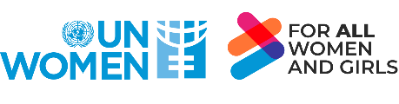
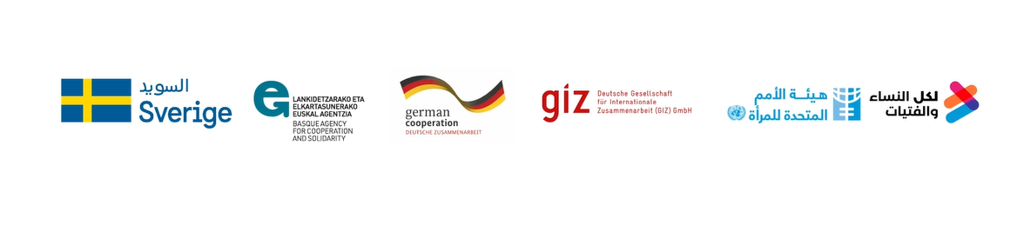

WHO (2005) Researching violence against women: a practical guide for researchers and activists, https://www.who.int/publications/i/item/9241546476
The simplified MSC technique is a form of participatory monitoring and evaluation, with programme/project stakeholders involved both in deciding the sorts of change to be recorded and in analysing the data. The approach is simplified in the sense that the original MSC approach involves multiple rounds of soliciting and analysing project implementers’ and target groups’ views of what the most significant change was at regular intervals throughout the lifecycle of a project, whereas in this case was only one round of interviews. Nonetheless, even in its simplified application, the method contributed to the evaluation because it focused on implementers’ and target groups’ views on impact and outcomes that could be used to help assess the performance of the programme/project as a whole.
Carolyn Louise Barnett, Gender Role Attitudes, Perceived Norms, and the "Double Burden’’ in Morocco (Washington, DC: World Bank, 2024), https://doi.org/10.1596/1813-9450-10694.

