ANNEX F
How CGF Changes lives
… of a woman:
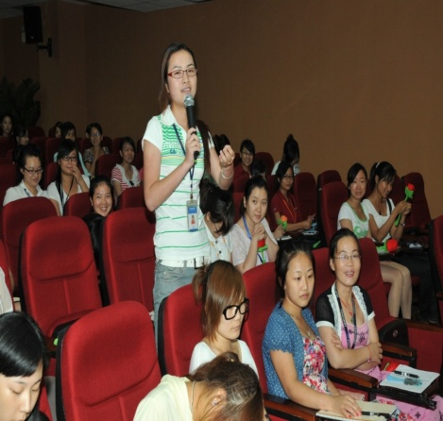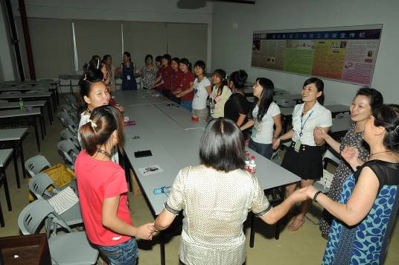
Since the past couple of years considerable media spotlight has been on Foxconn, a Taiwanese manufacturing company that supplies parts for Apple computers operating in Shenzhen, Guangdong province, China, for the high number of workers who took their lives. This year, 20-year old Tian Yi from Hubei Province became the 13th worker who decided to suicide. Tian Yi moved to Shenzhen to seek work from her village when she was 18. She performed the same monotonous, single action job 2888 times every day. Although the physical facilities at the plant are of good standards, the company has a zero tolerance policy on any type of human interaction. Tian Yi often felt very lonely and did not have anyone to talk to when she experienced difficulties or felt frustrated. One day she found herself with only 5 yuan left in her purse. She asked her supervisor for her salary card. She was ping-ponged from one office to the next until she had only 1 yuan left. She went back to her room feeling very angry. Many small incidents that had frustrated her began to weigh ever more heavily than ever all together. Suddenly she felt that her life was utterly meaningless and no longer worth living. Tian Yi climbed up her dormintory stairs and jumped from the high rise building.
Luckily she jumped only from the 4th floor. While critically injured, Tian Yi’s life was eventually saved so that she could live on to tell her story. Upon hearing Tian Yi’s sad tale, a group of women professors at Huazhong University in Wuhan, Hubei province, decided to take action. Prof. Liu had been a grantee of the China Gender Facility previously and had a good experience working with UNIFEM and local partners. She persuaded her psychologist colleague Prof. Chen to work with her on a new initiative to help prevent more women migrant workers from falling victims to the tragic circumstances that led Tian Yi to her suicide attempt. They responded to the 5th CGF call for proposals and succeeded in receiving a grant.
First they conducted research on mental health status of women and men workers, including symptoms of psychological issues manifested and stressors. The research evidence was clear on the poorer psychological well being of the women workers. The team from Huazhong University subsequently persuaded Foxconn to agree to let them conduct regular training sessions with the women after their working hours. Through participatory methods the women workers were able to talk openly about the issues and challenges they often faced and shared experiences and coping skills with each other. All the while expert guidance was on hand and tips on coping with transitions from village to urban life were interspersed throughout the sessions. These sessions have been little oases of comfort for the women. Not only do they learn about themselves and realize that they are not at fault, they now know that they are not alone. Many of the interactive exercises are designed to improve their self esteem and supportive relationship with each other. They have formed mutual-care support groups with 20-30 members per group. As one woman said, she now knows that she matters; that has a voice that is beautiful and clear; and that she has friends who love to listen to her.
As a part of the CGF project results, the Huazhong Team expects to be making policy recommendations to the company and the government on protecting the women workers’ psychological well-being as they continue to contribute to China’s economic development. The team has already managed to turn around Foxconn’s attitude towards their intervention and is now warmly welcome by the company.

… and of a man:

A Confession of A Male Convert
I started my university studies in 1977. Although my professional interest is in public health, I had to study all forms of medicine from communicable diseases to obstetrics and gynecology. As a product of the medical science-based education, my way of thinking was firmly entrenched in that paradigm. I became aware of the need for alternative perspectives in addressing public health issues only when I began working in the area of HIV/AIDS, through which I participated in different types of training both as a listener and a speaker. As a part of my involvement in one of the HIV/AIDS programs supported by an international organization, I worked closely with Ms. Wang and colleagues at the Zhiyang Prefecture Women’s Federation. I was hugely impressed by the dedication and tireless work of this group of women. So when we found out about the opportunity offered by UN Women through the China Gender Facility, we decided to collaborate on a shared interest. We were successful in our grant application for a study on gender differences in rural medical and health services, followed by gender sensitization advocacy.
Through this work it became increasingly clear for me that gender issues are usually undetected. I am convinced that a gender-based analysis is a must for public health if we are serious about improving the situation in China. Throughout my career as a teacher, researcher, and advisor to government and international organizations, I have been to many conferences, seminars and trainings. However, it is this China Gender Facility Project that has given me a real understanding of what a difference a gender perspective can make. As a bonus, the project also familiarized us with a results-based approach to project/program management, with the ongoing capacity building support to CGF grantees provided by UN Women China. Both Ms. Wang and I found that very helpful and believe that it will help other organizations with their management know-how.

Note:
Dr. Zhang is a Professor at a top-ranked medical school in China. He met Ms. Wang through his work as a DfID-appointed expert in an HIV/AIDS program. He now volunteers for the ACWF in Zhiyang, regularly driving his personal car to make the hundreds of miles’ journeys to the counties to help train other government bureaus across several technical sectors at the Prefecture in Results-Based-Management - with gender equality built in as a part of the contents.

