SAFE CITIES EVALUATION ANNEX

ANNEX 1: EVALUATION MATRIX

Evaluation questions | Sub Questions |  | Evidence to be collected | Sources of verification | Data collection methods | Outcome
Relevance
What has been the progress made towards achievement of the expected outcomes of program interventions and expected results? What are the results achieved? | What were the activities linked to each outcome/result? How well was that link established? (Channel of impact)  What is the degree of achievement of the planned activities, outputs and outcomes?  What were the reasons for the gaps in results’ achievement? |  | Evidence of progress towards activities and their results  Views of stakeholders including implementing partners and beneficiaries on the perceived results of the activities  Documentation of views on public safety and GBV in intervention areas  Practices and daily life decisions on mobility, work, public engagement and agency as made by local women and girls | Project documents including progress reports, process documentation and evaluation reports  Local implementing partners and volunteers  National and international stakeholders  Beneficiaries and non-beneficiaries | Desk reviews  Semi-structured interviews with local implementing partners, national and international stakeholders  Interviews with locals and household survey  On-site visits | Data collection methods were successful in answering questions and showed channel of impact and challenges to realizing sustainable and diffused outcomes
Does the program have effective monitoring mechanisms in place to measure progress towards results? | What are the programme’s monitoring mechanisms?  How well do these mechanisms capture progress and link to results? |  | Information on the program’s monitoring mechanisms  Evidence on relevance and effectiveness of those monitoring mechanisms | Project documents including progress reports, process documentation and evaluation reports  UN Women staff  Monitoring architecture of the programme including database etc. | Desk reviews  Semi-structured interviews with UN Women staff  Evidence traceable on site  Program documentation | There are clear gaps in the mode of monitoring whereby reports and monitoring mechanisms focus on the mechanics of the program and do not sufficiently address context and strategic outcomes
Efficiency
Were resources (financial, human, technical support, etc.) allocated via a strategic and efficient design? | What were the features of the technical support provided by the HQ through the global advisory role, seed support and the cross- regional exchanges? How effective was that support?  What resources were allocated to the intervention. Were these adequate? |  | Evidence on the features of the technical support provided by the HQ through the global advisory role, seed support and the cross- regional exchanges  Views from UN Women staff on this support | Project documents  UN Women CO staff  UN Women HQ staff  Experts involved in intervention.  National stakeholders | Reports  E-mail questions and zoom interviews | The information on financial efficiency relies on self-reporting by implementers and on the tacit approval of donors who have accepted submitted budgets. The evaluation research could not access audits or access data to make a judgment. The finding is inferred from available documents
Have the outputs been delivered in a timely manner? | What was the timeline of each of the program’s outputs? On what basis was it determined?  Did implementation match projected time-lines?  What were the reasons behind the outputs that were not delivered in a timely manner? as well as success factors that contributed towards the delivery of outputs. |  | Outputs’ timeline  Views from UN Women staff  Coverage of dissemination events | Project documents  UN Women CO staff | Semi-structured interviews with UN Women CO staff  Program documents and reports | Reviewed documents and interviewed stakeholders showed timely implementation The dynamic and focused role of UNwomen in ensuring timely implementation was appreciated by stakeholders.
Impact – including likelihood of/pathways to impact
How have program interventions affected local communities? What are the still evident traces of impact that are discoverable through research? |  | What are the interventions that can be evaluated according to impact?  Do local stakeholders and communities retain opinions or perspectives on interventions?  What are the programme components that can be scaled up? What were the lessons learnt? | Evidence on the program’s impact  Views on program’s impact from implementing partners, beneficiaries, national and international stakeholders/contribution analysis | Project documents  Monitoring data  Implementing partners and volunteers  National and international stakeholders  Beneficiaries | Contribution analysis of semi-structured interviews with local implementing partners, national and international stakeholders, beneficiaries  Focus group discussions (FGDs) with beneficiaries  Site visits  Household survey | The effects on local communities vary as those who are direct beneficiaries of or participants in SC programs and activities manifested changes in norms, attitudes, and practices. The impact was less evident in wider communities and the contrast between intervention and control areas was quite small.
To what extent was gender equality and women’s empowerment advanced amongst local communities and can these changes be associated with the interventions? (GEWE issues targeted: agency, voice, body and work as aspects of gender and women's empowerment) |  | What gender equality and women’s empowerment concepts are included in the design and implementation of the interventions?  How were the activities implemented linked to those concepts?  What was the effect of those activities on gender equality and women empowerment taking into account the changing context? If identifiable  What are the changes in views on gender and women’s empowerment that can be traced through the end-line as compared to base-line? | Evidence on incorporation of gender equality and women empowerment in the program  View of implementing partners, national and international stakeholders, UN Women CO staff  Views of local communities | Project documents  Implementing partners and volunteers  National and international stakeholders  Households in intervention and control areas | Semi-structured interviews with local implementing partners, national and international stakeholders  Focus group discussions (FGDs) with beneficiaries  Household survey | Gender equality and women’s empowerment advanced amongst local beneficiaries and participants but not in local communities. These detected changes are associated with the interventions
What were the unintended effects, if any, of the intervention? |  | Did the program cover outputs/target beneficiaries not included in its original design? Are they identifiable?  Have some interventions not materialized? Have they had a different effect on policy than that intended?  If identifiable, how did the program result in those unintended effects and in what way? | Evidence on unintended effects of the program  Views of implementing partners, national and international stakeholders, beneficiaries, non-beneficiaries and UN Women CO staff on the unintended effects.  Views of local communities | Project documents  Implementing partners  National and international stakeholders  Beneficiaries  Non-beneficiaries  UN Women CO staff  households | Semi-structured interviews with local implementing partners, national and international stakeholders, beneficiaries, non-beneficiaries, UN Women CO staff  Focus group discussions (FGDs) with beneficiaries  Site visits  Household survey | There were some unintended effects of the intervention which mostly concerned building human capacity amongst local participants and NGO workers.
Sustainability (likelihood of) |  |  |  | · | ·
Will program beneficiaries be able to reproduce innovative and relevant post intervention activities (after funding is withdrawn)?  To what extent was the capacity of partners developed in order to ensure sustainability of efforts and benefits?  How are the next phases of Safe Cities in Egypt informed by past experiences in intervention and non-intervention areas? | How are the project results going to be sustained after the project ends? Will they be replicated in new phase?  ·What mechanisms are in place (if any) to ensure that stakeholders live up to their commitments post project completion?  ·To what extent are programme partners, key stakeholders and beneficiaries able to implement the resources/support from this programme into their own work?  ·What is the level of ownership of the programme towards partners and beneficiaries?  ·To what extent has the programme engaged and strengthened capacities of local NGOs? |  | Stakeholders’ views on general outcome sustainability  · Potential evidence of beneficiaries moving on and building on the support from the programme.  · Evidence of realistic post-programme sustainability planning including resource commitment | Project-related documents concerning next phase  UN Women staff  Implementing partners  National and international stakeholders  Beneficiaries | Semi- structured interviews with UN women, implementing partners, and the donor.  Focus group discussions (FGDs) with beneficiaries  Site visits | Sustainable impact is possible and is detected in self-reported changes in gender norms that favor women’s empowerment and capabilities. The local NGO’s workers have been able to continue using SC tools and approaches. But these sustainable outcomes are challenged by contextual developments that have endangered women’s security. However, national level legal and administrative reforms and services have instilled a right to gender justice.  This research cannot make a statement on future phases due to variability of findings
To what extent are policy and regulatory frameworks in place that will support the continuation of program outcomes? | What kinds of policy and regulatory changes have taken place because of the programme?  How sustainable are UN Women-supported results and strategies as a contribution to national development? |  | Stakeholders views on the appropriateness of policy and institutional level mechanisms established to ensure sustainability of policymaking interventions.  Stakeholders views on the general outcome sustainability  Evidence of realistic post-programme sustainability planning based around partner capacity | Desk review of policy and regulatory frameworks, existing capacity building assessments (pre/post assessments), partner audits, and financial and progress reports  Semi-structured interviews with partners | Policy and regulatory framework mapping and contribution analysis  Document review  -Semi- structured interviews with UN women, implementing partners, and the Donor. | Frameworks are in place and there is a strong political will and appetite for further reforms
Gender equality and human rights
To what extent was a human rights-based approach, gender equality principles and LNOB incorporated in the design and implementation of the program? | Was a human rights and gender equality-based approach incorporated at the centre of the programme ToC?/ Were considerations of equity, access, power, voice and dignity incorporated in programming and services? Did it focus on the most vulnerable women and girls such as women with disabilities, women from ethnic and religious minorities?  Did this approach then translate into the design and implementation of the individual project components of the programme?  Did the programme result in challenging the existing gender structural norms and relations leading to a more transformative change- what were success and challenging factors.? |  | Evidence from ToC and other planning documents of a human rights and gender equality-based approach  Stakeholders’ views (within and outside of UN Women) of the programme’s adherence to UN Women’s principles and goals | Project-related documents  Implementing partners  National and international stakeholders | Document review  Semi- structured interviews with UN women, implementing partners, and other stakeholders  Household survey | The program was based on strong gendered principles that sought to realize justice according to a clear theory of change.  The principle of leave no one behind was compromised by lack of attention to issues of representation at the community level and by an unclear approach to disability

ANNEX 2: STAKEHOLDER LIST AND INTERVIEWS

UN Agencies | National Partners | Donors | Implementing Partners | Local CSOs | Beneficiaries
UN Women HQ | National Council for Women (NCW) | USAID | CARE Egypt (main) | El Shehab (Ezbet El Haggannah) | Women, children, youth, men
UN Habitat | Ministry of Social Solidarity (MoSS) | EU | Aspire | Hawaa Al Mostaqbal (Imbaba) | Community leaders – rural women leaders
UNODC | Public Prosecutor’s Office | Spain | Imprint | Youth Association for the Women Support and Environment Improvement (Mansheyyet Nasser) | CSOs staff and national entities’ staff
 | Ministry of Justice (MoJ) | Netherlands | Takween
 | Giza Governorate |  | Safe Kids
 | Cairo University |  | Al Hayat
 |  |  | Freedom Foundation
 |  |  | HarassMap

S.No | Affiliation | Position | Date of interview
1 | Safe Organization | CEO and founder | 11 January
2 | Cairo University Anti-Harassment Unit | Professor of English Literature and adjunct professor at the faculty of political science and economics | 11 January
3 | NCW Complaints Office | Amal: Manager of the Complaints Office since 2018. Salma: Social worker in Complaints Office since 2015 | 12 January
4 | UN Women | Assistant on the programme since 2011 and officer in 2015, 2016 | 13 January
5 | CARE Egypt | Sandra Azmy: Women's Rights programme director and previous Safe Cities project manager. Khadija El Taher: Gender consultant and previous Safe Cities field supervisor 2012-end | 13 January
6 | Takween | CEO of Takween Integrated Community Development | 14 January
7 | NCW | Previous director of UNW Egypt office and current President of the NCW | 17 January
8 | Aspire | Co-founder of Aspire Training Solutions | 2 February
9 | ENACTUS | Head and founder of ENACTUS Egypt | 19 January
10 | Spanish Cooperation | Ventura: head of the office. Monica: programme manager (was not involved in the implementation) | 19 January
11 | Imprint | Currently regional manager of an international training company "Engineeius"/GBV consultant and used to be founder of Imprint | 19 January
12 | El Hayat | Now deputy head of the board of trustees and was the CEO during Safe Cities | 20 January
13 | UN Habitat | Programme Officer at UN Habitat | 17 January
14 | USAID | Nardeen:Project management specialist in the democracy and governance office. Amira: Senior women's empowerment specialist | 20 January
15 | Hired by CARE | Art consultant (specializes in art therapy, interactive theatre and psychodrama with Egyptian and refugees) | 20 January
16 | MoSS (UN Women consultant) | Consultant for the development of the shelters | 21 January
17 | UN Women HQ | EVAW Policy Specialist | 21 January
18 | Ex- UN Women | Current gender policy officer in the Dutch Embassy in Egypt and used to be project manager of Safe Cities 2010-2015 | 27 January
19 | UN Women | Deputy Country Representative of UN Women, Egypt | 28 January
20 | UN Women | Programme analyst of the programme, working on the programme since 2015 | 2 February
21 | UN Women | Was communication and media assistant and currently is communication and advocacy analyst | 1 February
22 | MoSS | Coordinator of MoSS shelters since 2018 and has been involved in different capacities with the shelters since 2016 | 27 January
23 | Giza Governorate (previosuly) and currently Damietta governorate | Deputy Giza Governor for the service of the community and environment (previously) | 14 February
24 | Freedom Foundation | Radwa: Was responsible of the monitoring and evaluation of the project and she is a trainer and assistant training manager  Kamal: Was supervisor for one of the 3 areas and is a trainer and counselor in the foundation. Medhat: Was responsible for access and rehabilitation and is the outreach director . Nanis: Project manager and is a doctor and manager of training unit | 17 February
25 | HarassMap | Cofounder of harassmap was the director of Harassmap at the time Safe Cities | 31 January
26 | HarassMap | Volunteer at HarassMap, | 2 February
27 | UN Women consultant | Currently freelance consultant in women economic empowerment (still working on Safe Cities in Damietta) and used to be consultant of economic empowerment for Safe Cities Cairo | 4 February
28 | UNODC | Criminal justice programme officer | 4 February
29 | Consultant UN Women (Complaints Office) | Currently senior national consultant for governance and digital transformation /coordinator at the Egyptian German Center for Migration (related to Ministry of Migration and GIZ). Used to be a the consultant of the NCW complaints office | 7 February
30 | Etijah | Was project manager and now head of programmes | 3 March

ANNEX 3: LIST OF DOCUMENTS FROM DESK RESEARCH

 | Publisher | Year | Document Title
1 | USAID | 2018 | MIDTERM PERFORMANCE EVALUATION  ‘Safe Cities’ Ending Violence Against Women (EVAW): Final Report
2 | USAID | 2013 | Grant Contract (USAID - UNWOMEN)
3 | USAID | 2013 | UNWomen-USAID prodoc
4 | USAID | 2017 | UN WOMEN-USAID prodoc 2
5 | USAID | 2015 | UNWOMEN - USAID EVAW Cost Extension 2015
6 | UNWOMEN | 2015 | UN Women - USAID Annual Progress Report Oct. 2014 - Sept. 2015
7 | UNWOMEN | 2014 | UN Women - USAID Annual Progress Report Oct. 2013 - Sept. 2014
8 | UN Women | 2016 | UN Women - USAID Annual Progress Report Oct. 2015 - Sept. 2016
9 | UNWOMEN | 2019 | EVAW Annual Report USAID. October 18 - September 19
10 | UNWOMEN | 2018 | EVAW Annual Report USAID. October 17 - September 18
11 | UNWOMEN | 2017 | EVAW Annual Report USAID - Oct 16 to Sept 17
12 | UNWOMEN | 2016 | VAW Campaign Report
13 | UNODC | 2011 | Safe Cities free of violence for women and girls - joint program document
14 | UNDOC | 2013 | Elements of a Strategy to Improve the Criminal Justice Response to Violence against Women: Report on the National Workshop on Violence against Women, Cairo, Egypt
15 | the UN Joint Programme on Essential Services for Women and Girls Subject  to Violence | n.d. | Module 1 - Overview and Introduction: Essential Services Package for Women and Girls Subject to Violence Core Elements and Quality Guidelines
16 | UNHABITAT | 2021 | Meshwary: A study about women’s experience in Greater Cairo’s public transportation system
17 | UNWOMEN/Takween | 2013 | Safe Cities free of violence against women and girls - Urban development component: Preliminary Report
18 | UNWOMEN/Takween | 2014 | Safe Cities free of violence against women and girls - Urban development component: Manshiyyit NAsser Final Report
19 | UNWOMEN/Takween | 2014 | Safe Cities free of violence against women and girls - Urban development component: Imbaba Final Report
20 | UNWOMEN/Takween | 2014 | Safe Cities free of violence against women and girls - Urban development component: `Izbit Al-Haggana Final Report
21 | Spanish Agency for International  Development Cooperation (AECID) | 2019 | THE MASAR PROGRAMME IN EGYPT: GOOD PRACTICES OF THE SPANISH COOPERATION IN PROMOTING GENDER EQUALITY IN THE PROCESS OF DEMOCRATIC TRANSITION IN EGYPT
22 | NCW | 2015 | جدول فعاليات مكتب الشكاوى
23 | NCW (Ombudsperson office) | 2015 | تقرير عن تنفيذ أنشطة مشروع المدن الآمنة فى الفترة من مايو2013 حتى أبريل 2015
24 | NCW | 2020 | تقرير مشروع مدن أمنه
25 | NCW | 2014 | أحصائية مشروع مدن آمنة للوحدة القانونية لسنة 2014
26 | NCW | 2015 | تقرير مكتب الشكاوى بالمجلس القومى للمرأة عن تنفيذ أنشطة مشروع المدن الآمنة خلال الفترة من فبراير – أبريل 2015
27 | NCW | 2015 | (الاستراتيجية الوطنيــــــــة لمكافحــــــــــة العـنــــــــــف ضـــــــد المــــــرأة 2015 –2020)
28 | NCW | 2017 | National Strategy for the Empowerment of Egyptian Women 2030: Vision and Pillars)
29 | CARE Egypt | 2018 | توثيق تجربة سائقى التوك توك بمنشأة ناصر_ النسخة الأخيرة
30 | IDS Bulletin | 2020 | Maha El-Said - Accountability with Teeth- IDS Bulletin
31 | Aspire Experiential Business Solutions |  | FINAL REPORT SAFE CITIES EGYPT – 2011- 2012
32 | Aspire Experiential Business Solutions | 2013 | Safe Cities Graduation Report
33 | SRC | 2016 | Safe Cities Free of Violence against Women and Girls - Second Qualitative Study
34 | SRC | 2011 | Safe cities free of violence against women and girls - Report on scoping and baseline studies, Cairo project
35 | CARE Egypt | 2012 | SAFE CITIES FREE OF VIOLENCE AGAINST WOMEN AND GIRLS PROJECT - Community Assessment: Participatory Qualitative Research Final Report
36 | Freedom Foundation | 2015 | من يناير حتى يوليو 2015  (تقرير عن مدن أمنة من يناير حتى يوليو 2015)
37 | Freedom Foundation | 2015 | تقرير قطاع التدريب عن مشروع المدن الآمنة
38 | Freedom Foundation | 2015 | Safe Cities Free From Violence against Women and Girls Partners Quarterly Report)
39 | Freedom Foundation | 2015 | Numbers of Beneficiaries served in the Safe Cities Project
40 | Youth Association-MN | 2015 | تقرير مشروع مدن آمنة خالية من العنف الموجه ضد النساء و الفتيات عن عام 2015
41 | Youth Association-MN | 2014 | تقرير شهر نوفمبر 2014
42 | Youth Association-MN | 2015 | تقرير شهر أغسطس 2015
43 | Youth Association-MN | 2017 | التقرير السنوي - مدن آمنة 2017
44 | Youth Association-MN | 2015 | التقرير الربع سنوي في الفترة من يوليو حتى سبتمبر 2015
45 | Youth Association-MN | 2016 | التقرير الربع سنوي في الفترة من يوليو حتى سبتمبر 2016
46 | Youth Association-MN | 2016 | التقرير الربع سنوي في الفترة من يناير حتى مارس 2016
47 | Youth Association-MN | 2015 | التقرير الربع سنوي في الفترة من يناير حتى مارس 2015
48 | Youth Association-MN | 2014 | التقرير الربع سنوي في الفترة من اكتوبر حتى ديسمبر 2014
49 | Youth Association-MN | 2015 | التقرير الربع سنوي في الفترة من ابريل 2015 حتى يونيو 2015  (تقرير مشروع مدن آمنة خالية من العنف الموجه ضد النساء و الفتيات)
50 | Youth Association-MN | 2018 | التقرير الربع سنوى مدن امنة فى الفترة من يناير الى مارس 2018  (تقرير مشروع مدن آمنة خالية من العنف الموجه ضد النساء و الفتيات)
51 | Youth Association-MN | n.d. | مقترح دمج الأسر- مشروع مدن آمنة
52 | Youth Association-MN | 2018 | تقرير ميثاق التحالف  (تقرير ميثاق جمعيات تحالف مدن آمنة بمنشأة ناصر)
53 | Youth Association-MN | 2015 | تقرير معسكر الجندر اغسطس 2015 - مدن آمنة
54 | Youth Association-MN | 2018 | تقرير خطة الاستمرارية - مدن آمنة 2018
55 | Youth Association-MN | 2018 | تقرير تدريب تعبئة الموارد فبراير 2018
56 | Youth Association-MN | 2017 | تقرير تدريب الجندر يوليو 2017  (تدريب مفاهيم النوع الاجتماعي بمنشأة ناصر)
57 | Youth Association-MN | 2017 | تقرير احتفالية 16 يوم - 2017- مدن آمنة  (تقرير احتفالية مدن آمنة 16 يوم مناهضة العنف ضد المرأة)
58 | Youth Association-MN | n.d. | المطلوب عن سائقي التكتوك لتوثيق التجربة- منشأة ناصر
59 | SRC | n.d. | الهجانة  (مدن آمنة من العنف ضد المرأة: جداول المسح الأولى لمنطقة الهجانة)
60 | Al Shehab- El Hagganah | 2014 | report (10-11-12)2014  (تقرير ربع سنوى مقدم من مؤسسة الشهاب بعزبة الهجانة)
61 | Al Shehab- El Hagganah | 2014 | report (7-8-9)2014  (تقرير ربع سنوى مقدم من مؤسسة الشهاب بعزبة الهجانة)
62 | Al Shehab- El Hagganah | 2015 | report (1-2-3)2015  (تقرير فني)
63 | Al Shehab- El Hagganah | 2014 | report (1-2-3)2014  (تقرير فني)
64 | Al Shehab- El Hagganah | 2015 | july_august_september_2015  (تقرير مشروع مدن آمنه خالية من العنف ضد المرأة والفتاة عن الفترة من يوليو 2015 إلى ستمبر 2015)
65 | Al Shehab- El Hagganah | 2015 | April_May_June_2015  (تقرير مشروع مدن آمنه خالية من العنف ضد المرأة والفتاة)
66 | Al Shehab- El Hagganah | 2017 | 10-11-12-2017  (تقرير مشروع مدن آمنه خالية من العنف ضد المرأة والفتاة)
6 | Al Shehab- El Hagganah | 2016 | 10-11-12-2016  (تقرير مشروع مدن آمنه خالية من العنف ضد المرأة والفتاة)
67 | Al Shehab- El Hagganah | 2015 | 10_11_12_2015  (تقرير مشروع مدن آمنه خالية من العنف ضد المرأة والفتاة)
68 | Al Shehab- El Hagganah | 2017 | 7-8-9-2017  (تقرير مشروع مدن آمنه خالية من العنف ضد المرأة والفتاة)
69 | Al Shehab- El Hagganah | 2016 | 7-8-9-2016  (تقرير مشروع مدن آمنه خالية من العنف ضد المرأة والفتاة)
70 | Al Shehab- El Hagganah | 2017 | 4-5-6-2017  (تقرير مشروع مدن آمنه خالية من العنف ضد المرأة والفتاة)
71 | Al Shehab- El Hagganah | 2016 | 4-5-6-2016  (تقرير مشروع مدن آمنه خالية من العنف ضد المرأة والفتاة)
72 | Al Shehab- El Hagganah | 2014 | 4-5-6 2014  (تقرير مشروع مدن آمنه خالية من العنف ضد المرأة والفتاة)
73 | Al Shehab- El Hagganah | 2017 | 1-2-3-2017  (تقرير مشروع مدن آمنه خالية من العنف ضد المرأة والفتاة)
74 | Al Shehab- El Hagganah | 2016 | 1-2-3-2016  (تقرير مشروع مدن آمنه خالية من العنف ضد المرأة والفتاة)
75 | Hawaa Al Mostakbal- Imbaba | 2015 | تقرير ربع سنوى من الفترة يناير الى مارس 2015
76 | Hawaa Al Mostakbal- Imbaba | 2017 | تقرير الربع سنوي من شهر اكتوبر الي شهر ديسمبر
78 | Hawaa Al Mostakbal- Imbaba | 2015 | الربع سنوي من 1 اكتوبر وحتي 31ديسمبر 2015 (1)
79 | Hawaa Al Mostakbal- Imbaba | 2017 | التقرير الربع سنوي من شهر ابريل الي يونيو 2017 (1) (1)
80 | Hawaa Al Mostakbal- Imbaba | 2016 | التقرير الربع سنوي من 1يوليو 2016 وحتي 30 ستمبر 2016
81 | Hawaa Al Mostakbal- Imbaba | 2016 | التقرير الربع سنوي من 1 يناير 2016 وحتي 31 مارس 2016
82 | Hawaa Al Mostakbal- Imbaba | 2016 | التقرير الربع سنوي من 1 ابريل 2016 وحتي 30يونيو 2016
83 | Hawaa Al Mostakbal- Imbaba | 2016 | التقرير الربع سنوي في الفترة من 1 يوليو 2016 وحتي 30 ستمبر 2016 (3)
84 | Hawaa Al Mostakbal- Imbaba | 2014 | التقرير الربع سنوى من اكتوبر الى ديسمبر 2014
85 | Hawaa Al Mostakbal- Imbaba | 2015 | التقرير الربع سنوى من ابريل الى يونيو2015
86 | Hawaa Al Mostakbal- Imbaba | 2017 | 2017تقرير الربع سنوي من شهر يناير الي شهر مارس.doc (2) (1)
87 | Imprint | 2015 | الدليل التدريبي لتدريب المتطوعين على قضايا النوع الإجتماعي والتحرش الجنسي - مؤسسة بصمة الجديدة 2015
88 | Shoroke H. Zedan | 2016 | Safe Cities_Process documentation March 16  (Title: SAFE CITIES FREE OF VIOLENCE FOR WOMEN AND GIRLS IN PUBLIC SPACES  PROCESS DOCUMENTATION)
89 | Tadamun | 2020 | Manshiet Nasser - Tadamun. http://www.tadamun.co/?post_type=city&p=11354&lang=en&lang=en#.YLU9aKGxU2w
90 | Tadamun | 2017 | Izbit Al-Haggāna - Tadamun. http://www.tadamun.co/?post_type=city&p=5469&amp;lang=en&lang=en#.YLU9bKGxU2x
91 | Tadamun | 2017 | Imbaba - Tadamun. http://www.tadamun.co/?post_type=city&p=8873&amp;lang=en&lang=en#fn10

ANNEX 4: FRAMING THE FINDINGS: COMMUNITY AND NGO PROFILES

- Community Profiles

The community and NGO profiles offer a contextual framing for the evaluation findings. They relay the ‘who’ and ‘where’ of Safe Cities interventions. Having a visual (see photos) historical and descriptive understanding of intervention communities enables a nuanced engagement with the challenges and achievements of interventions and helps to frame the participants’ views on safety and security within the local setting. These profiles were compiled from project documents, desk research, field visits and qualitative interviews/focus groups.
The selection of the intervention sites was based on the baseline study. The four main criteria were:
- The site area comprises three adjacent sectors representing different socio-economic status scale gradients.
- The site area includes a common area of economic and social activity.
- The site area doesn’t include area of extreme poverty.
- The site area is not included in the planned demolition and/or move as per Cairo 2050 plan.³²
Accordingly, the three selected areas for intervention were Imbaba, Mansheyyet Nasser, and Ezbet El Haggannah. Specific intervention sites within each area were identified through UN-Habitat’s safety audit of each neighborhood. The available information describing each of the intervention sites was scarce, hence the compiled profiles relied mainly on Safe Cities Urban Development Component preliminary and final reports³³ and on Tadamun’s Cairo neighborhood profiles. The available information was not standardized across the three sites. Researchers also conducted fieldwork in the 3 intervention areas to update and enrich available secondary data on each site.

- Imbaba:
An area of 8.28 km² with a population of around two million persons. It is divided in two administrative sections containing 18 zones, 11 in the first division and 7 in the second. Imbaba is acknowledged as a middle and lower-middle-income area (not poor) that mainly consisting of narrow alleyways that may measure a meter in width in some parts. This proximity between opposite buildings violates the privacy of homes.³⁴ Future Eve (Hawa’ el Mostaqbil, in Arabic) the main implementing NGO for Safe Cities in Imbaba cites this proximity and density as one of the main reasons for the tensions and frustrations of citizens in the area. The neighborhood’s varied housing configurations reflect the diversity of its inhabitants themselves in terms of origin, social and educational and economic profiles. The area is well endowed with sound basic infrastructure. But most of these utilities are in poor condition as there is no proper maintenance of roads, street lighting, and other public utilities as confirmed by a study conducted by the local NGO.

The site selected for SC intervention was the governmental Housing Blocks including Tag Al‐Diwal Housing Blocks, Tag Al‐Diwal Inner St., and Mugahid Nada St. The specific site was described in the UN-Habitat’s Safety Audit report: “…. the outer unsafe areas, where the crime rates are much higher, especially drug dealing and sexual harassment, and the sense of ownership of the public spaces is in its minimum level”. The selected zone has a physical public space amenable to upgrade which was an important factor that contributed to choosing the area.
Interviewed residents talked of improvements in the area in in terms of infrastructure, aesthetics, and safety which have taken place over the past decade. Pavements have been restored in parts of the area, solid waste disposal has been regular and open dumpsters are periodically cleared. Several buildings have been renovated, in addition to the establishment of the women friendly space: one of the main urban upgraded contributions of Safe Cities in Imbaba. The area is now safer thanks to the instalment of streetlights and cameras. Police are visible and stationed in areas that had historically been dangerous for women such as the space outside the Bahethat El-Badeya girls’ school. The improvements in utilities, services and in policing are not linked to safe Cities work but may have been a result of interest and raised awareness of local elites and civil society.

These changes effected significant reduction in street harassment and enabled women and girls to feel safe enough to move around both inside Imbaba and to commute to other parts of Cairo including at nighttime. However, problems of drug dealing, and youth unemployment persist and were reported by the residents as considerable burdens that put residents at risk.

- Mansheyyet Nasser:
A densely populated urban area (7.93 km² in area with 1.25 million inhabitants) that is located on Al-Muqattam hill and has been at risk of landslides. It is a far from homogenous neighborhood that is divided into 8 Sheyakhas (administrative zones). The starkest division in the area is between the garbage collectors’ area (surrounding Fr. Semaan’s Monastery; a historical cave church landmark that is both a tourist attraction and a place for religious pilgrimage) and Ezbet Bekhit, a tribal Muslim community whose members derive from several Upper Egyptian tribes and families.

The Garbage collectors’ side of the area is mostly Coptic with some Muslim “Wahiya” families still residing there. This area is well served by charities and associations working with the garbage collectors. The area has over 102 development associations and foundations catering to the needs of local families and working with garbage collectors to improve their economic situation and protecting their industry and right to work. There are far fewer organizations active in Ezbet Bekhit. Both the garbage collector’s area and Ezbet Bekhit are home to workers in informal industries and both are production hubs for artisanal craft and activities yet both different in nature³⁵. The dichotomy of the two sites illustrates the overall nature of Mansheyyet Nasser as an internally divided and mostly informal lower income neighborhood with limited access to functioning infrastructure and utilities.³⁶

Mobility is very difficult due to the narrowness of the streets. The local community have reported restricted ability for women and girls at nighttime due to safety concerns. There is also an ongoing threat of demolition and/or relocation by the government. Several demolitions have already taken place (contradicting the 4th site selection criterion).

The intervention site was the governmental housing blocks surrounded by El-Herafeyeen Housing, Suzanne Mubarak Housing, and Al‐Gabal. The specific site was described in the UN-Habitat’s Safety Audit report: “The connections between El‐Duwaika area; the highest area in Mansheyyet Nasser and the public blocks of El-Herafeyeen; are the most unlit and dangerous areas in Mansheyyet Nasser, as recognized by the participants. The linkages between the area and the adjacent Suzan Mubarak public housing project are considered the most unsafe, dark and deserted areas, where most of violence and crimes take place, even for males.” Responses from the community have indicated that no significant changes happened over the past 10 years other than the relocation of the Dwei’a residents after the landslide that killed many and destroyed homes. The proliferation of drugs in the area and the widespread use of substances by youth were reported as a major threat to security and to women’s safe mobility. Drug use and drug dealing has significantly increased in the last 10 years according to residents.

- Ezbet El Haggannah³⁷
In the first half of 20th century, this was a desert area used to house the army’s camel corps. The Corpsmen of the camel reserve largely descended from Upper Egypt and Sudan; they were eventually allowed to build settlements for themselves in the area which explains the name Ezbet El Haggannah. Many decades later, during the building boom of the late 1970s and the urban expansion that became Nasr City (and which borders Ezbet El Haggannah,) the area catered to the housing needs of construction workers. The area remained a magnet for workers as it offers cheap housing close to the vibrant markets of Cairo.³⁸ In the 1980’s and later it also became a site popular amongst Sudanese refugees looking for affordable rentals that are near their places of work. Al-Shehab NGO, one of the area’s prominent development organizations, estimated that here were around 4,500 Sudanese families living in Haggannah as of 2009³⁹. Ezbet El Haggannah is a sub-district of East Nasr City district. It is 3 km² in area and is home to a population of around one million.

Local NGOs identified two sub-areas as being the most precarious and infrastructurally impoverished: El-Daght El-’aaly (The High Voltage Area) and El-Ghagar (The ‘Gypsy’ area). El-Daght El-’aaly is in essence an uninhabitable zone, where high voltage electrical wires run through the area. Over the years, many people have been electrocuted and houses burned down because of their exposure to these wires, more so during rain. Recently the area has been demolished. El-Ghagar is a socially excluded part of Ezbet El Haggannah as its residents are perceived to be descendants of Egypt’s dwindling Gypsy population⁴⁰. This perception exposes inhabitants of El-Ghagar to forms of social exclusion and marginality. The area has few schools (three schools but no high schools) and has degraded infrastructure but good transport links thanks to the Arba’a we Noss (four and a half) bridge that easily connects the area to Cairo.
The specific intervention site was the school Zone: Salah Eldin school surrounded by Al-Madaris St., Khulafa’ Al-Rashidin St., and a vacant military land. The site is described by the UN-Habitat’s Safety Audit report as: “… the most dangerous area with the highest crime rates and violence incidents due to its own physical structure that encourage crimes, with many deserted and dark areas, in addition to other physical settings… The community members also recognized the schools’ area, surrounded by the same military land, as a dangerous area, where they have to accompany their children while going and returning from their schools even in the daylight.”

Several changes took place over the last decade as reported by some of the local community including the installation of streetlights and cameras in main streets and at the main bus stop. The bus stop was moved out of El Haggannah and relocated to its entrance under the bridge that is considered more controlled and induced feelings of safety among the community, in addition to the presence of a police force at the stop. Such changes have reduced street harassment for local inhabitants, yet outsiders might still face it. A police station was established in El Haggannah and started operation in January 2021. The station was built in the empty military-owned land close to the intervention site, next to Salah El-din school. Many reported that mobility has increased for women and girls because of police presence and street lighting. Safety for women is compromised however by the prevalence of drugs distributed in el-Daght el-Aly.

The areas selected for interventions are small parts of bigger areas and ones that were chosen because their women and girls are more vulnerable. However, the boundaries of these spaces within communities are fictitious and the borders are subjective.

NGO profiles

The NGOs were selected by CARE Egypt. They are dissimilar in many ways. Eve of the Future is a well-established community development NGO run according to the norms of social work. El-Shehab is a younger organization that has a recognized body of work in contentious areas such as sex work and HIV AIDS. The Youth Association for Women Support and Environment Improvement is even younger as it was initially created to undertake Safe Cities work. The organizations have different approaches, legacies, modes of work and levels of community presence. NGOs were selected based on a process, but available documents did not avail evaluation team to clear criteria for NGO selection. However, two of the NGOs selected are renowned for their work and are well known as community-based service providers.

 | Hawaa Al Mostaqbal (Imbaba) | Al Shehab (Ezbet El Haggannah) | The Youth Association for Women Support and Environment Improvement
Date of establishment/registration | Early 1990s/1998 | 2001/2003 | 2004
Staff # | 12 including 6 volunteers. | 60 staff with access to 100 volunteers | 5 staff with access to 60 volunteers.
Scope | Focus on women, children, and education. | Women, health, and infrastructure. | Women, youth, environment, heritage, children.
Geographical Outreach | Operates allover Egypt with offices in Sohag, Qena, Assiut, Damietta and Alexandria. | Offices within Cairo in El Marg, Ain Shams and El Haggannah, outside Cairo in Alexandria. Operates in other governorates with partner NGOs. | Operates in other governorates with partner NGOs.
Other Notes | Has an experience with gender projects but didn’t work on SH before Safe Cities, mostly handle government projects, strong ties with the community and the municipality. Part of the EVAW program. | Focuses on domestic workers, water and sanitation, vulnerable groups to HIV/AIDS. They offer services such as: psychological support, testing lab and vocational training, children’s activities. Strong ties with the community. Sustainability vision through social enterprise. Part of EVAW. | Works on GBV and intrahousehold relationships after Safe Cities. Has projects in peace building, heritage, and crafts. UNESCO club member. Trusted among the community. Partner in Ministry of Manpower Youth Network. Not part of EVAW because of the NGO dilemma discussed in the findings. It is not the official contracted NGO.

Pictures
- Intervention areas
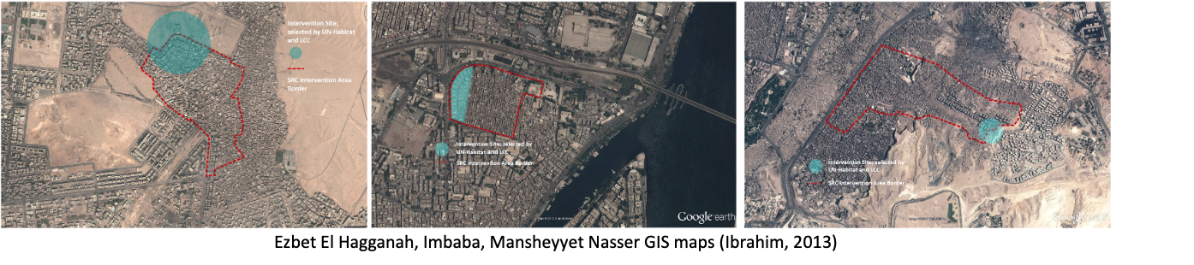
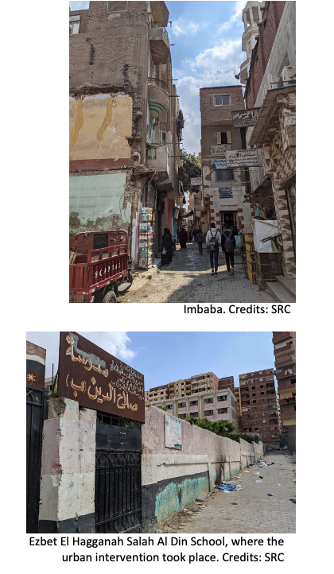

- Programme Interventions

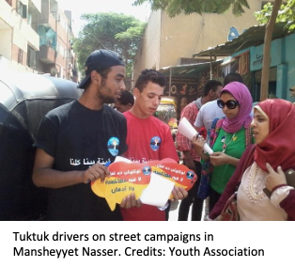

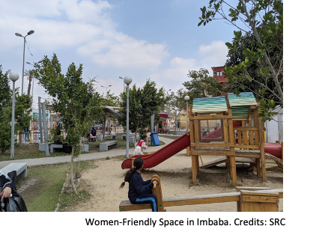
ANNEX 5: DATA ON EFFECTIVENESS
Table 8.5.1: Knowledge of the NGOs participating in the project and their activities, ever-married respondents* 2021
 | Al-Haggannah |  |  |  | Mansheyat Nasser |  |  |  | Embaba
Have you heard of the NGO (….)? | 90 |  | 13.53% |  | 10 |  | 4.295 |  | 36 |  | 18.46%
N | 665 |  |  |  | 587 |  |  |  | 470
Have any of the following taken place? | Have you heard of (mention the activity)? |  | Did you participate? |  | Have you heard of (mention the activity)? |  | Did you participate? |  | Have you heard of (mention the activity)? |  | Did you participate?
Interactive theatre | 46 | 6.92 | 17 | 36.96 | 5 | 0.85 | 2 | 40.00 | 22 | 4.68 | 5 | 22.73
Sport activities | 22 | 3.31 | 0 | 0.00 | 1 | 0.17 | 1 | 100.00 | 14 | 2.98 | 5 | 35.71
Activities for volunteers | 16 | 2.41 | 3 | 18.75 | 1 | 0.17 | 1 | 100.00 | 12 | 2.55 | 4 | 33.33
Activities for tuk-tuk drivers | 8 | 1.20 | 2 | 25.00 | 2 | 0.34 | 1 | 50.00 | 26 | 5.53 | 12 | 46.15
Awareness sessions | 28 | 4.21 | 16 | 57.14 | 9 | 1.54 | 5 | 55.56 | 30 | 6.38 | 14 | 46.67
Art Therapy | 11 | 1.65 | 4 | 36.36 | 1 | 0.17 | 1 | 100.00 | 9 | 1.91 | 4 | 44.44
Door knocking campaigns | 16 | 2.41 | 7 | 43.75 | 1 | 0.17 | 1 | 100.00 | 20 | 4.26 | 10 | 50.00
Safe sessions in schools | 23 | 3.46 | 3 | 13.04 | 3 | 0.51 | 1 | 33.33 | 38 | 8.09 | 10 | 26.32
Safe spaces for women and girls | 11 | 1.65 | 1 | 9.09 | 1 | 0.17 | 0 | 0.00 | 51 | 10.85 | 11 | 21.57
Activities at the renovated ball court | 99 | 14.89 | 1 | 1.01 | 47 | 8.02 | 2 | 4.26 | 11 | 2.34 | 4 | 36.36
N |  | 665 |  |  |  | 587 |  |  |  | 470

Which of the activities you participated in have you benefited more?
Interactive theatre | 14 |  | 82.35 |  | 1 |  | 50.00 |  | 5 |  | 100.0
Sport activities |  |  |  |  | 0 |  | 0.00 |  | 3 |  | 60.00
Activities for volunteers | 1 |  | 33.33 |  | 1 |  | 100.00 |  | 3 |  | 75.00
Activities for tuk-tuk drivers | 2 |  | 100.00 |  | 0 |  | 0.00 |  | 7 |  | 58.33
Awareness sessions | 15 |  | 93.75 |  | 4 |  | 80.00 |  | 14 |  | 100.0
Art Therapy | 1 |  | 25.00 |  | 1 |  | 100.00 |  | 4 |  | 100.0
Door knocking campaigns | 4 |  | 57.14 |  | 1 |  | 100.00 |  | 7 |  | 70.00
Safe sessions in schools | 1 |  | 33.33 |  | 1 |  | 100.00 |  | 9 |  | 90.00
Safe spaces for women and girls | 1 |  | 100.00 |  |  |  |  |  | 9 |  | 81.82
Activities at the renovated ball court | 0 |  | 0.00 |  | 1 |  | 50.00 |  | 2 |  | 50.00
Can you tell me to what extent has your participation influenced your personality?
I knew my rights | 6 |  | 23.08 |  | 0 |  | 0.00 |  | 0 |  | 0.00
Learn how to defend oneself in the event of harassment or violence | 9 |  | 34.62 |  | 1 |  | 11.11 |  | 2 |  | 14.29
Dump internal energy especially when angry | 0 |  | 0.00 |  | 0 |  | 0.00 |  | 0 |  | 0.00
Exchange of Views/Expression | 2 |  | 7.69 |  | 1 |  | 11.11 |  | 1 |  | 7.14
Gain new information, for example, on (harassment/addiction) | 8 |  | 30.77 |  | 4 |  | 44.44 |  | 9 |  | 64.29
Creating good social relationships with others | 0 |  | 0.00 |  | 0 |  | 0.00 |  | 1 |  | 7.14
My personality became better/ changed, I am not a harasser/ I became better when I got away from home | 0 |  | 0.00 |  | 2 |  | 22.22 |  | 0 |  | 0.00
No Effect | 1 |  | 3.85 |  | 1 |  | 11.11 |  | 1 |  | 7.14
N |  | 26 |  |  |  | 9 |  |  |  | 14
How did your participation influence how you treat others?
I knew my rights | 6 |  | 23.08 |  | 0 |  | 0.00 |  | 1 |  | 7.14
Learn how to defend oneself in the event of harassment or violence | 14 |  | 53.85 |  | 2 |  | 22.22 |  | 5 |  | 35.71
No Effect | 0 |  | 0.00 |  | 3 |  | 33.33 |  | 1 |  | 7.14
Good social relationships with others | 3 |  | 11.54 |  | 4 |  | 44.44 |  | 2 |  | 14.29
Exchange of Views/Expression | 2 |  | 7.69 |  | 0 |  | 0.00 |  | 1 |  | 7.14
I now know what to do if someone was harassed/ addiction | 1 |  | 3.85 |  | 0 |  | 0.00 |  | 3 |  | 21.43
My personality is getting stronger. | 0 |  | 0.00 |  | 0 |  | 0.00 |  | 1 |  | 7.14
How did your participation influence your opinion regarding harassment?
The girl must talk and not be shy | 1 |  | 3.85 |  | 1 |  | 11.11 |  | 3 |  | 21.43
Increasing Awareness/ Knowing How to Protect myself | 24 |  | 92.31 |  | 3 |  | 33.33 |  | 9 |  | 64.29
No Effect | 1 |  | 3.85 |  | 4 |  | 44.44 |  | 1 |  | 7.14
The harasser is a sick person/harasser harms society/ that harassment can be a word | 0 |  | 0.00 |  | 1 |  | 11.11 |  | 0 |  | 0.00
The harasser must be punished/reported | 0 |  | 0.00 |  | 0 |  | 0.00 |  | 1 |  | 7.14
How did your participation influence your advice to young males and females?
Know Her Rights | 6 |  | 23.08 |  | 0 |  | 0.00 |  | 7 |  | 50.00
Learn how to defend oneself in the event of harassment or violence | 7 |  | 26.92 |  | 1 |  | 11.11 |  | 2 |  | 14.29
No Effect | 1 |  | 3.85 |  | 1 |  | 11.11 |  | 1 |  | 7.14
Be careful to attend these activities to take advantage of them/ go to the stadium | 8 |  | 30.77 |  | 6 |  | 66.67 |  | 3 |  | 21.43
Young people should treat girls like their sisters/ improve youth behavior | 2 |  | 7.69 |  | 1 |  | 11.11 |  | 1 |  | 7.14
Girls Must Commit to Modest Clothing | 2 |  | 7.69 |  | 0 |  | 0.00 |  | 0 |  | 0.00
Would you recommend these activities to others? | 24 |  | 92.31 |  | 9 |  | 100.00 |  | 13 |  | 92.86
Have you benefited financially/socially/ or in any way from your participation?
Yes, financially | 5 |  | 19.23 |  | 0 |  | 0.00 |  | 0 |  | 0.00
Yes, socially | 26 |  | 100.00 |  | 9 |  | 100.00 |  | 13 |  | 92.86
Yes, benefited | 0 |  | 0.00 |  | 0 |  | 0.00 |  | 6 |  | 42.86
No | 0 |  | 0.00 |  | 0 |  | 0.00 |  | 1 |  | 7.14
Have you participated in any other activities with the NGO? | 2 |  | 7.69 |  | 0 |  | 0.00 |  | 1 |  | 7.14
Like what?
Literacy | 1 |  | 50.00 |  | 0 |  | 0.00 |  | 0 |  | 0.00
Soap industry training courses | 1 |  | 50.00 |  | 0 |  | 0.00 |  | 1 |  | 100.00
Have you heard about the safe spaces for girls and women/ the renovated sports field in your neighborhood? | 19 |  | 2.86 |  | 15 |  | 2.56 |  | 51 |  | 10.85
Have you visited/used these places or know someone who did? | 0 |  | 0.00 |  | 8 |  | 53.33 |  | 20 |  | 39.22
What do you think of it?
OK, but it should be without fees | 0 |  | 0.00 |  | 0 |  | 0.00 |  | 7 |  | 35.00
Small area | 0 |  | 0.00 |  | 0 |  | 0.00 |  | 2 |  | 10.00
Dedicated to children more than women | 0 |  | 0.00 |  | 0 |  | 0.00 |  | 5 |  | 25.00
Beautiful / spacious / clean place | 0 |  | 0.00 |  | 7 |  | 87.50 |  | 6 |  | 30.00
Don’t know | 0 |  | 0.00 |  | 1 |  | 12.50 |  | 0 |  | 0.00
How did this place influence females of the neighborhood?
Increase the sense of safety among women (because there is a place designated for women only | 0 |  | 0.00 |  | 3 |  | 37.50 |  | 13 |  | 65.00
There remains in it a place where they can spend their children | 0 |  | 0.00 |  | 1 |  | 12.50 |  | 3 |  | 15.00
There is no impact because the place is reserved for more children / youth to play soccer | 0 |  | 0.00 |  | 4 |  | 50.00 |  | 4 |  | 20.00

Table 8.5.2: Knowledge of the NGOs participating in the project and their activities, never-married respondents* 2021

 | Al-Haggannah |  |  |  |  | Mansheyat Nasser |  |  |  |  |  | Embaba
E401: Have you heard of the NGO (….)? | 19 |  | 10.05 |  | 10 |  |  | 4.29 |  |  | 36 |  |  | 18.48
N | 189 |  |  |  |  | 233 |  |  |  |  |  | 195
E402: Have any of the following taken place? | Have you heard of (mention the activity)? |  | Did you participate? |  |  | Have you heard of (mention the activity)? |  |  | Did you participate? |  |  | Have you heard of (mention the activity)? |  |  | Did you participate?
Interactive theater | 9 | 4.76 | 1 | 11.1 | 0 |  |  |  |  |  | 10 |  | 5.13 | 3 |  | 30.00
Sport activities | 9 | 4.76 | 0 | 0.0 | 0 |  |  |  |  |  | 4 |  | 2.05 | 1 |  | 25.00
Activities for volunteers | 3 | 1.59 | 1 | 33.33 | 0 |  |  |  |  |  | 4 |  | 2.05 | 1 |  | 25.00
Activities for tuk-tuk drivers | 1 | 0.53 | 0 | 0.0 | 0 |  |  |  |  |  | 10 |  | 5.13 | 6 |  | 60.00
Awareness sessions | 5 | 2.65 | 1 | 20.00 | 3 |  | 1.29 | 1 |  | 100.0 | 15 |  | 7.69 | 7 |  | 46.67
Art Therapy | 2 | 1.06 | 0 | 0.0 | 0 |  |  |  |  |  | 3 |  | 1.54 | 3 |  | 100.0
Door knocking campaigns | 1 | 0.53 | 0 | 0.0 | 1 |  | 0.43 | 1 |  | 100.0 | 10 |  | 5.13 | 5 |  | 50.00
Safe sessions in schools | 14 | 7.41 | 1 | 7.14 | 1 |  | 0.43 | 1 |  | 100.0 | 20 |  | 10.26 | 5 |  | 25.00
Safe spaces for women and girls | 0 | 0.0 | 0 | 0.0 | 0 |  |  |  |  |  | 17 |  | 8.72 | 4 |  | 23.53
Activities at the renovated ball court | 19 | 10.05 | 0 | 0.0 | 21 |  | 9.05 | 0 |  | 0.0 | 3 |  | 1.54 | 0 |  | 0.0
N |  | 189 |  |  |  |  | 233 |  |  |  |  |  | 195
Which of the activities you participated in have you benefited more?
Interactive theater |  | 1 | 5.88 |  |  |  | 0 | 0.00 |  |  |  |  | 2 | 40.00
Sport activities |  |  |  |  |  |  | 0 | 0.00 |  |  |  |  | 0 | 0.00
Activities for volunteers |  | 1 | 33.33 |  |  |  | 0 | 0.00 |  |  |  |  | 0 | 0.00
Activities for tuk-tuk drivers |  | 0 | 0.00 |  |  |  | 0 | 0.00 |  |  |  |  | 3 | 25.00
Awareness sessions |  | 1 | 6.25 |  |  |  | 1 | 20.00 |  |  |  |  | 6 | 42.86
Art Therapy |  | 0 | 0.00 |  |  |  | 0 | 0.00 |  |  |  |  | 3 | 75.00
Door knocking campaigns |  | 0 | 0.00 |  |  |  | 0 | 0.00 |  |  |  |  | 5 | 50.00
Safe sessions in schools |  | 1 | 33.33 |  |  |  | 0 | 0.00 |  |  |  |  | 4 | 40.00
Safe spaces for women and girls |  | 0 | 0.00 |  |  |  |  |  |  |  |  |  | 3 | 27.27
Activities at the renovated ball court |  | 0 | 0.0 |  |  |  | 0 | 0.0 |  |  |  |  | 0 | 0.0
Can you tell me to what extent has your participation influenced your personality?
I know my rights |  | 0 | 0.0 |  |  |  | 0 | 0.0 |  |  |  |  | 1 | 10.0
Knowing how to defend oneself in case of harassment or violence |  | 2 | 66.67 |  |  |  | 0 | 0.0 |  |  |  |  | 5 | 50.0
Draining your inner energy, especially when angry |  | 0 | 0.0 |  |  |  | 0 | 0.0 |  |  |  |  | 0 | 0.0
Exchange of opinions / expression of opinion |  | 0 | 0.0 |  |  |  | 0 | 0.0 |  |  |  |  | 1 | 10.0
Gaining new information, for example about (harassment / abuse / addiction) |  | 0 | 0.0 |  |  |  | 0 | 0.0 |  |  |  |  | 1 | 10.0
Create good social relationships with others |  | 1 | 33.33 |  |  |  | 0 | 0.0 |  |  |  |  | 1 | 10.0
My personality has gotten better / I have changed I never bake a harasser |  | 0 | 0.0 |  |  |  | 1 | 100.0 |  |  |  |  | 1 | 10.0
No effect |  | 0 | 0.0 |  |  |  | 0 | 0.0 |  |  |  |  | 0 | 0
N |  | 3 |  |  |  |  | 1 |  |  |  |  |  | 10
How did your participation influence how you treat others?
I knew my rights |  | 2 | 66.67 |  |  |  | 0 | 0.0 |  |  |  |  | 3 | 30.0
Knowing how to defend oneself in case of harassment or violence |  | 0 | 0.0 |  |  |  | 0 | 0.0 |  |  |  |  | 4 | 40.0
No effect |  | 0 | 0.0 |  |  |  | 0 | 0.0 |  |  |  |  | 1 | 10.0
Create good social relationships with others |  | 0 | 0.0 |  |  |  | 1 | 100.0 |  |  |  |  | 1 | 10.0
Exchange of opinions / expression of opinion |  | 0 | 0.0 |  |  |  | 0 | 0.0 |  |  |  |  | 1 | 10.0
I still know what I recommend to people what to do if someone experiences harassment / addiction |  | 1 | 33.33 |  |  |  | 0 | 0.0 |  |  |  |  | 0 | 0.0
E406: How did your participation influence your opinion regarding harassment?
Girl must speak and don’t be shy |  | 0 |  |  |  |  | 0 |  |  |  |  |  | 1 | 10.0
Increased awareness / knowledge of how I can protect myself |  | 3 | 100.0 |  |  |  | 0 |  |  |  |  |  | 7 | 70.0
The harasser is a sick person / The harasser is harmful to society / The harassment can be word |  | 0 |  |  |  |  | 1 | 100.0 |  |  |  |  | 0 | 0.0
The harasser must be punished / reported |  | 0 |  |  |  |  | 0 |  |  |  |  |  | 2 | 20.0
How did your participation influence your advice to young males and females?
know her rights |  | 1 | 33.33 |  |  |  | 0 | 0.0 |  |  |  |  | 0
Knowing how to defend oneself in case of harassment or violence |  | 2 | 66.67 |  |  |  | 0 | 0.0 |  |  |  |  | 2 | 20.0
Make sure to attend these activities to take advantage of them / go to the stadium instead |  | 0 | 0.0 |  |  |  | 0 | 0.0 |  |  |  |  | 7 | 70.0
Young people are supposed to treat girls as their sisters / improve youth behavior |  | 0 | 0.0 |  |  |  | 1 | 100.0 |  |  |  |  | 1 | 10.0
Girls should be dressed modestly |  | 0 | 0.0 |  |  |  | 0 | 0.0 |  |  |  |  | 0
Would you recommend these activities to others? |  | 3 | 100.0 |  |  |  | 1 | 100.0 |  |  |  |  | 8 | 80.00
Have you benefited financially/socially/ or in any way from your participation?
Yes, financially |  | 3 | 100.0 |  |  |  | 1 | 100.0 |  |  |  |  | 10 | 100.0
Yes, socially |  | 3 | 100.0 |  |  |  | 1 | 100.0 |  |  |  |  | 10 | 100.0
Yes, benefited |  | 0 | 0.0 |  |  |  | 0 | 0.0 |  |  |  |  | 2 | 20.0
No |  | 0 | 0.0 |  |  |  | 0 | 0.0 |  |  |  |  | 1 | 10.0
Have you participated in any other activities with the NGO? |  | 0 |  |  |  |  | 0 |  |  |  |  |  | 0
Have you heard about the safe spaces for girls and women/ the renovated sports field in your neighborhood? |  | 2 | 1.06 |  |  |  | 9 | 3.86 |  |  |  |  | 18 | 9.23
Have you visited/used these places or know someone who did? |  | 0 | 0.0 |  |  |  | 2 | 22.22 |  |  |  |  | 7 | 24.14
What do you think of it?
OK, but it should be without entry fees |  | 0 |  |  |  |  | 0 |  |  |  |  |  | 3
Small area |  | 0 |  |  |  |  | 0 |  |  |  |  |  | 4
It is intended for children more than women |  | 0 |  |  |  |  | 0 |  |  |  |  |  | 1
Beautiful / spacious / clean place |  | 0 |  |  |  |  | 4 |  |  |  |  |  | 7
Do not know |  | 0 |  |  |  |  | 0 |  |  |  |  |  | 0
How did this place influence females of the neighborhood?
Increase the sense of safety among women (because there is a place designated for women only |  |  |  |  |  |  | 1 |  |  |  |  |  | 4
There remains in it a place where they can spend their children |  |  |  |  |  |  | 0 |  |  |  |  |  | 1
There is no impact because the place is reserved for more children / youth to play soccer |  |  |  |  |  |  | 1 |  |  |  |  |  | 0.

Table 8.5.3: Knowledge of the NGOs participating in the project and their activities, male respondents* 2021
 | Al-Haggannah |  |  |  | Mansheyat Nasser |  |  |  |  |  | Embaba
Have you heard of the NGO (….)? |  | 37 | 11.82 |  |  | 16 |  | 5.05 |  |  |  | 28 | 11.29
N | 313 |  |  |  | 317 |  |  |  |  |  | 248
Have any of the following taken place? | Have you heard of (mention the activity)? |  | Did you participate? |  | Have you heard of (mention the activity)? |  | Did you participate? |  |  |  | Have you heard of (mention the activity)? |  | Did you participate?
Interactive theater | 9 | 2.88 | 0 |  | 1 | 0.32 |  | 1 | 100.0 |  | 13 | 5.24 | 2 | 15.38
Sport activities | 24 | 7.67 | 3 | 12.50 | 6 | 1.89 |  | 2 | 33.33 |  | 6 | 2.42 | 1 | 16.67
Activities for volunteers | 4 | 1.28 | 0 |  | 2 | 0.63 |  | 2 | 100.0 |  | 8 | 3.23 | 1 | 12.50
Activities for tuk-tuk drivers | 6 | 1.92 | 2 | 33.33 | 1 | 0.32 |  | 0 |  |  | 10 | 4.03 | 1 | 10.00
Awareness sessions | 3 | 0.96 | 1 | 33.33 | 3 | 0.95 |  | 2 | 66.67 |  | 16 | 6.45 | 4 | 25.00
Art Therapy | 3 | 0.96 | 0 |  | 0 |  |  |  |  |  | 3 | 1.21 | 1 | 33.33
Door knocking campaigns | 1 | 0.32 | 0 |  | 1 | 0.32 |  | 1 | 100.0 |  | 11 | 4.44 | 2 | 18.18
Safe sessions in schools | 14 | 4.47 | 0 |  | 1 | 0.32 |  | 1 | 100.0 |  | 13 | 5.24 | 3 | 23.08
Safe spaces for women and girls | 5 | 1.60 | 0 |  | 1 | 0.32 |  | 0 |  |  | 24 | 9.68 | 1 | 4.17
Activities at the renovated ball court | 89 | 28.43 | 1 | 1.12 | 65 | 20.50 |  | 8 | 12.31 |  | 9 | 3.63 | 2 | 22.22
N |  | 313 |  |  |  | 317 |  |  |  |  |  | 248
Which of the activities you participated in have you benefited more?
Interactive theater |  | 0 | 0.00 |  |  | 1 |  | 5.88 |  |  |  | 2 | 11.11
Sport activities |  | 3 | 50.00 |  |  | 2 |  | 11.76 |  |  |  | 1 | 5.56
Activities for volunteers |  | 0 | 0.00 |  |  | 2 |  | 11.76 |  |  |  | 1 | 5.56
Activities for tuk-tuk drivers |  | 2 | 33.33 |  |  | 0 |  | 0.00 |  |  |  | 1 | 5.56
Awareness sessions |  | 1 | 16.67 |  |  | 2 |  | 11.76 |  |  |  | 4 | 22.22
Art Therapy |  | 0 | 0.00 |  |  | 0 |  | 0.00 |  |  |  | 1 | 5.56
Door knocking campaigns |  | 0 | 0.00 |  |  | 1 |  | 5.88 |  |  |  | 2 | 11.11
Safe sessions in schools |  | 0 | 0.00 |  |  | 1 |  | 5.88 |  |  |  | 3 | 16.67
Safe spaces for women and girls |  | 0 | 0.00 |  |  | 0 |  | 0.00 |  |  |  | 1 | 5.56
Activities at the renovated ball court |  | 0 | 0.00 |  |  | 8 |  | 47.06 |  |  |  | 2 | 11.11
Can you tell me to what extent has your participation influenced your personality?
I know my rights |  | 1 | 20.00 |  |  | 0 |  | 0.00 |  |  |  | 0 | 0.00
Knowing how to defend oneself in case of harassment or violence |  | 1 | 20.00 |  |  | 0 |  | 0.00 |  |  |  | 1 | 20.00
Draining your inner energy, especially when angry |  | 1 | 20.00 |  |  | 0 |  | 0.00 |  |  |  | 0 | 0.00
Exchange of opinions / expression of opinion |  | 0 | 0.00 |  |  | 0 |  | 0.00 |  |  |  | 2 | 40.00
Gaining new information, for example about (harassment / abuse / addiction) |  | 0 | 0.00 |  |  | 1 |  | 10.00 |  |  |  | 1 | 20.00
Create good social relationships with others |  | 0 | 0.00 |  |  | 1 |  | 10.00 |  |  |  | 0 | 0.00
My personality got better / I changed what I did for a harasser |  | 2 | 40.00 |  |  | 3 |  | 30.00 |  |  |  | 1 | 20.00
No effect |  | 0 | 0.00 |  |  | 5 |  | 50.00 |  |  |  | 0 | 0.00
N
How did your participation influence how you treat others?
Knowing how to defend oneself in case of harassment or violence |  | 0 | 0.00 |  |  | 0 |  | 0.00 |  |  |  | 2 | 40.00
No effect |  | 0 | 0.00 |  |  | 6 |  | 60.00 |  |  |  | 0 | 0.00
Create good social relationships with others |  | 5 | 100.00 |  |  | 4 |  | 40.00 |  |  |  | 0 | 0.00
Exchange of opinions / expression of opinion |  | 0 | 0.00 |  |  | 0 |  | 0.00 |  |  |  | 2 | 40.00
I still know what I recommend to people what to do if someone experiences harassment / addiction |  | 0 | 0.00 |  |  | 0 |  | 0.00 |  |  |  | 1 | 20.00
How did your participation influence your opinion regarding harassment?
One must speak and not be shy |  | 0 | 0.00 |  |  | 0 |  | 0.00 |  |  |  | 1 | 20.00
Increased awareness / knowledge of how I can protect myself |  | 5 | 100.00 |  |  | 1 |  | 10.00 |  |  |  | 4 | 80.00
No effect |  | 0 | 0.00 |  |  | 8 |  | 80.00 |  |  |  | 0 | 0.00
The harasser is a sick person / The harasser is harmful to society / The harassment can be word
The harasser must be punished / reported |  | 0 | 0.00 |  |  | 1 |  | 10.00 |  |  |  | 0 | 0.00
How did your participation influence your advice to young males and females?
Know her rights |  | 1 | 20.00 |  |  | 0 |  | 0.00 |  |  |  | 1 | 20.00
Knowing how to defend oneself in case of harassment or violence |  | 0 | 0.00 |  |  | 0 |  | 0.00 |  |  |  | 2 | 40.00
No effect |  | 0 | 0.00 |  |  | 5 |  | 50.00 |  |  |  | 0 | 0.00
Make sure to attend these activities to take advantage of them / go to the stadium instead |  | 3 | 60.00 |  |  | 5 |  | 50.00 |  |  |  | 2 | 40.00
Young people are supposed to treat girls as their sisters / improve youth behavior |  | 1 | 20.00 |  |  | 0 |  | 0.00 |  |  |  | 0 | 0.00
Would you recommend these activities to others? |  | 5 | 100.0 |  |  | 10 |  | 100.0 |  |  |  | 5 | 100.0
Have you benefited financially/socially/ or in any way from your participation?
Yes, financially |  | 0 | 0.00 |  |  | 0 |  | 0.00 |  |  |  | 0 | 0.00
Yes, socially |  | 0 | 0.00 |  |  | 0 |  | 0.00 |  |  |  | 0 | 0.00
Yes, benefited |  | 5 | 100.0 |  |  | 5 |  | 50.00 |  |  |  | 5 | 100.0
No |  | 0 | 0.0 |  |  | 3 |  | 30.00 |  |  |  | 0 | 0.0
Have you heard about the safe spaces for girls and women/ the renovated sports field in your neighborhood? |  | 20 | 6.39 |  |  | 27 |  | 8.52 |  |  |  | 28 | 11.29
Have you visited/used these places or know someone who did? |  | 1 | 5.00 |  |  | 0 |  | 0.0 |  |  |  | 3 | 10.71
What do you think of it?
OK, but it should be without fees |  | 1 |  |  |  | 0 |  |  |  |  |  | 0
Beautiful / spacious / clean place |  | 0 |  |  |  | 5 |  |  |  |  |  | 3
How did this place influence females of the neighborhood?
Increase the sense of safety among women (because there is a place designated for women by Guy |  | 1 |  |  |  | 2 |  |  |  |  |  | 2
There is no impact because the place is reserved for more children / youth to play soccer |  | 0 |  |  |  | 3 |  |  |  |  |  | 0

Table 8.5.4: Knowledge of the NGOs participating in the project and their activities, Estimated ever-married * 2021

 | Al-Haggannah | Mansheyat Nasser | Embaba
E401: Have you heard of the NGO (….)? | 302 | 30 | 125
E402A: Have you heard of (mention the activity)?
Interactive theater | 154 | 15 | 76
Sport activities | 74 | 3 | 49
Activities for volunteers | 54 | 3 | 42
Activities for tuk-tuk drivers | 27 | 6 | 90
Awareness sessions | 94 | 27 | 104
Art Therapy | 37 | 3 | 31
Door knocking campaigns | 54 | 3 | 69
Safe sessions in schools | 77 | 9 | 132
Safe spaces for women and girls | 37 | 3 | 177
Activities at the renovated ball court | 332 | 141 | 38
E402B: 402B. Did you participate?
Interactive theater | 57 | 6 | 17
Sport activities | 0 | 3 | 17
Activities for volunteers | 10 | 3 | 14
Activities for tuk-tuk drivers | 7 | 3 | 42
Awareness sessions | 54 | 15 | 49
Art Therapy | 13 | 3 | 14
Door knocking campaigns | 24 | 3 | 35
Safe sessions in schools | 10 | 3 | 35
Safe spaces for women and girls | 3 | 0 | 38
Activities at the renovated ball court | 3 | 6 | 14
E403: Which of the activities you participated in have you benefited more?
Interactive theater | 47 | 3 | 17
Sport activities | 0 | 0 | 10
Activities for volunteers | 3 | 3 | 10
Activities for tuk-tuk drivers | 7 | 0 | 24
Awareness sessions | 50 | 12 | 49
Art Therapy | 3 | 3 | 14
Door knocking campaigns | 13 | 3 | 24
Safe sessions in schools | 3 | 3 | 31
Safe spaces for women and girls | 3 | 0 | 31
Activities at the renovated ball court | 0 | 3 | 7
E404: Can you tell me to what extent has your participation influenced your personality?
01 I knew my rights | 20 | 0 | 0
02 Knowing how to defend myself in case of harassment or violence | 30 | 3 | 7
03 Discharging the energy, especially when angry | 0 | 0 | 0
04 Exchange of opinions/ expression of opinion | 7 | 3 | 3
05 Gaining new information, for example about (harassment / abuse / addiction) | 27 | 12 | 31
06 Create good social relationships with others | 0 | 0 | 3
07 My personality got improved / I changed I am no longer a harasser / I felt better when I distant myself | 0 | 6 | 0
08 No influence | 3 | 3 | 3
E405: How did your participation influence how you treat others?
01 I knew my rights | 20 | 0 | 3
02 Knowing how to defend myself in case of harassment or violence | 47 | 6 | 17
03 No influence | 0 | 9 | 3
04 Create good social relationships with others | 10 | 12 | 7
05 Exchange of opinions/ expression of opinion | 7 | 0 | 3
06 I became able to advise people when they experience harassment / addiction | 3 | 0 | 10
07 My personality became stronger | 0 | 0 | 3
E406: How did your participation influence your opinion regarding harassment?
01 That women must speak and don’t get embarrassed | 3 | 3 | 10
02 Increased awareness / knowledge of how I can protect myself | 81 | 9 | 31
03 No influence | 3 | 12 | 3
04 The harasser is a sick person / The harasser is harmful to society / Harassment can be verbal | 0 | 3 | 0
05 The harasser must be punished / reported | 0 | 0 | 3
E407: How did your participation influence your advice to young males and females?
01 To know her rights | 20 | 0 | 24
02 Knowing how to defend oneself in case of harassment or violence | 24 | 3 | 7
03 No influence | 3 | 3 | 3
04 Make sure to attend these activities to benefit from them / go to playground instead | 27 | 18 | 10
05 Young people are supposed to treat girls as their sisters / improve youth behavior | 7 | 3 | 3
06 Girls should be dressed modestly | 7 | 0 | 0
E408: Would you recommend these activities to others? | 81 | 27 | 45
E409: Have you benefited financially/socially/ or in any way from your participation?
Yes, financially | 17 | 0 | 0
Yes, socially | 87 | 27 | 45
Yes, benefited | 0 | 0 | 21
No | 0 | 0 | 3
E410: Have you participated in any other activities with the NGO? | 7 | 0 | 3
E411: Like what?
01 Literacy | 3 | 0 | 0
02 Training courses to teach soap making | 3 | 0 | 3
E412: Have you heard about the safe spaces for girls and women/ the renovated sports field in your neighborhood? | 64 | 45 | 177
E413: Have you visited/used these places or know someone who did? | 0 | 24 | 69
E414: What do you think of it?
01 It’s good but it should be without entry fees | 0 | 0 | 24
02 small area | 0 | 0 | 7
03 is designed for children more than women | 0 | 0 | 17
04 beautiful / spacious / clean place | 0 | 21 | 21
98 do not know | 0 | 3 | 0
E415: How did this place influence females of the neighborhood?
01 Increase the sense of safety among women (because there is a place designated for women | 0 | 9 | 45
02 There is a place where they can entertain their children | 0 | 3 | 10
03 There is no impact because the place is more likely to be designed for children / youth to play soccer | 0 | 12 | 14

ANNEX 6: DATA ON INTERNET USAGE
H215:
ياتري عندكم وصلة إنترنت في البيت؟ * shikha Crosstabulation
 |  |  | shikha |  |  |  |  |  | Total
 |  |  | عزبة الهجانة | السلام | منشية ناصر | الأباجية | امبابة | بولاق الدكرور | Total
H215:  ياتري عندكم وصلة إنترنت في البيت؟ | نعم | Count | 350 | 377 | 213 | 259 | 271 | 212 | 1682
H215:  ياتري عندكم وصلة إنترنت في البيت؟ | نعم | % within shikha | 52.2% | 70.9% | 35.6% | 62.4% | 55.3% | 41.5% | 52.3%
H215:  ياتري عندكم وصلة إنترنت في البيت؟ | لا | Count | 320 | 155 | 386 | 156 | 219 | 299 | 1535
H215:  ياتري عندكم وصلة إنترنت في البيت؟ | لا | % within shikha | 47.8% | 29.1% | 64.4% | 37.6% | 44.7% | 58.5% | 47.7%
Total |  | Count | 670 | 532 | 599 | 415 | 490 | 511 | 3217
 |  | % within shikha | 100.0% | 100.0% | 100.0% | 100.0% | 100.0% | 100.0% | 100.0%

H216:
ياتري بتستخدموا الإنترنت؟ * shikha Crosstabulation
 |  |  | shikha |  |  |  |  |  | Total
 |  |  | عزبة الهجانة | السلام | منشية ناصر | الأباجية | امبابة | بولاق الدكرور | Total
H216:  ياتري بتستخدموا الإنترنت؟ | نعم | Count | 593 | 481 | 409 | 371 | 344 | 428 | 2626
H216:  ياتري بتستخدموا الإنترنت؟ | نعم | % within shikha | 88.5% | 90.4% | 68.3% | 89.4% | 70.2% | 83.8% | 81.6%
H216:  ياتري بتستخدموا الإنترنت؟ | لا | Count | 77 | 51 | 190 | 44 | 146 | 83 | 591
H216:  ياتري بتستخدموا الإنترنت؟ | لا | % within shikha | 11.5% | 9.6% | 31.7% | 10.6% | 29.8% | 16.2% | 18.4%
Total |  | Count | 670 | 532 | 599 | 415 | 490 | 511 | 3217
 |  | % within shikha | 100.0% | 100.0% | 100.0% | 100.0% | 100.0% | 100.0% | 100.0%

H217:
الإنترنت ده موجود داخل المنزل ولا خارج المنزل؟ * shikha Crosstabulation
 |  |  | shikha |  |  |  |  |  | Total
 |  |  | عزبة الهجانة | السلام | منشية ناصر | الأباجية | امبابة | بولاق الدكرور | Total
H217:  الإنترنت ده موجود داخل المنزل ولا خارج المنزل؟ | داخل المنزل | Count | 239 | 192 | 221 | 164 | 217 | 186 | 1219
H217:  الإنترنت ده موجود داخل المنزل ولا خارج المنزل؟ | داخل المنزل | % within shikha | 40.3% | 39.9% | 54.0% | 44.2% | 63.1% | 43.5% | 46.4%
H217:  الإنترنت ده موجود داخل المنزل ولا خارج المنزل؟ | خارج المنزل | Count | 29 | 5 | 19 | 2 | 5 | 13 | 73
H217:  الإنترنت ده موجود داخل المنزل ولا خارج المنزل؟ | خارج المنزل | % within shikha | 4.9% | 1.0% | 4.6% | 0.5% | 1.5% | 3.0% | 2.8%
H217:  الإنترنت ده موجود داخل المنزل ولا خارج المنزل؟ | الأثنين | Count | 325 | 284 | 169 | 205 | 122 | 229 | 1334
H217:  الإنترنت ده موجود داخل المنزل ولا خارج المنزل؟ | الأثنين | % within shikha | 54.8% | 59.0% | 41.3% | 55.3% | 35.5% | 53.5% | 50.8%
Total |  | Count | 593 | 481 | 409 | 371 | 344 | 428 | 2626
 |  | % within shikha | 100.0% | 100.0% | 100.0% | 100.0% | 100.0% | 100.0% | 100.0%

H219:
ياتري كل الأسرة بتستخدم الإنترنت ولا فين ناس معينة بس هي اللي بتستخدمه؟ * shikha Crosstabulation
 |  |  | shikha |  |  |  |  |  | Total
 |  |  | عزبة الهجانة | السلام | منشية ناصر | الأباجية | امبابة | بولاق الدكرور | Total
H219:  ياتري كل الأسرة بتستخدم الإنترنت ولا فين ناس معينة بس هي اللي بتستخدمه؟ | كل الأسرة | Count | 387 | 262 | 238 | 213 | 206 | 218 | 1524
 | كل الأسرة | % within shikha | 65.3% | 54.5% | 58.2% | 57.4% | 59.9% | 50.9% | 58.0%
 | ناس معينة بس | Count | 206 | 219 | 171 | 158 | 138 | 210 | 1102
 | ناس معينة بس | % within shikha | 34.7% | 45.5% | 41.8% | 42.6% | 40.1% | 49.1% | 42.0%
Total |  | Count | 593 | 481 | 409 | 371 | 344 | 428 | 2626
 |  | % within shikha | 100.0% | 100.0% | 100.0% | 100.0% | 100.0% | 100.0% | 100.0%
ANNEX 7: DATA ON FEELING OF SAFETY
Al Haggannah & Al Salam | Ever married | Never married | Male
Area safe | 58.55 | 71.39 | 75.71
Feel safe to:
Leave one of your family at home alone* | 42.43 | 33.39 | 16.53
Stay at home alone at night | 40.05 | 60.51
Open windows while sleeping | 73.76 | 83.35 | 54.4
Open windows while you are not at home | 71.16 | 70.63 | 38.22
Leave something in front of your house/Stairwell | 38.1 | 27.04 | 39.65
Work inside neighborhood | 50.66 | 54.25
Go and come to do errands/work | 31.84 | 50.66
Go out shopping/Leisure activity in public space* | 64.92 | 78.5
Go out at night alone if it isn’t late | 51.97 | 58.75
Work till late time | 30.79 | 23.56
Allow wife/mother/sister go alone for errands/neighbors |  |  | 9.02
Allow wife/mother/sister go alone for shopping/leisure act.* |  |  | 33.91
Allow young daughter/sister to go school alone* | 18.6 | 6.91 | 14.3
Allow young son/brother to go school alone* | 23.59 | 34.74 | 16.89
Allow young daughter/sister to go to neighbors alone* | 20.15 | 13.71 | -1.62
Allow young son/brother to go to neighbors alone* | 25.39 | 28.7 | 15.52

Mansheyat Nasser & Al-Ebageyah | Ever married | Never married | Male
Area safe | 18.92 | 13.94 | -22.06
Feel safe to:
Leave one of your family at home alone* | 21.98 | 13.08 | 13.57
Stay at home alone at night | 17.61 | 19.21
Open windows while sleeping | 13.31 | 9.11 | 0.77
Open windows while you are not at home | 3.26 | 0.86 | 8.72
Leave something in front of your house/Stairwell | 6.29 | 2.36 | 3.83
Work inside neighborhood | 9.20 | 1.09
Go and come to do errands/work | 11.81 | 2.15
Go out shopping/Leisure activity in public space* | 29.17 | 37.24
Go out at night alone if it isn’t late | 9.07 | 1.89
Work till late time | -1.75 | 39.38
Allow wife/mother/sister go alone for errands/neighbors |  |  | -2.10
Allow wife/mother/sister go alone for shopping/leisure act.* |  |  | -2.99
Allow young daughter/sister to go school alone* | 13.15 | 2.86 | 6.71
Allow young son/brother to go school alone* | 18.49 | 12.81 | 9.61
Allow young daughter/sister to go to neighbors alone* | 15.13 | 20.06 | 19.36
Allow young son/brother to go to neighbors alone* | 19.92 | 16.61 | 7.30

Embaba & Boulak Al-Dakrour | Ever married | Never married | Male
Area safe | 29.74 | 34.72 | 41.88
Feel safe to:
Leave one of your family at home alone* | 12.43 | 17.66 | 15.17
Stay at home alone at night | 8.34 | 24.34
Open windows while sleeping | -15.16 | -4.41 | -7.81
Open windows while you are not at home | -12.44 | -7.12 | -11.12
Leave something in front of your house/Stairwell | -17.81 | -12.06 | 0.14
Work inside neighborhood | 4.54 | 8.32
Go and come to do errands/work | 2.84 | 24.90
Go out shopping/Leisure activity in public space* | -49.15 | 13.97
Go out at night alone if it isn’t late | -20.94 | 17.29
Work till late time | 11.89 | 9.56
Allow wife/mother/sister go alone for errands/neighbors |  |  | 9.65
Allow wife/mother/sister go alone for shopping/leisure act.* |  |  | -31.32
Allow young daughter/sister to go school alone* | 9.08 | 3.56 | 0.53
Allow young son/brother to go school alone* | 12.34 | 7.41 | 0.43
Allow young daughter/sister to go to neighbors alone* | 9.33 | 11.80 | 5.85
Allow young son/brother to go to neighbors alone* | 16.28 | 1.96 | 1.27

ANNEX 8: SPEAK UP BILLBOARD
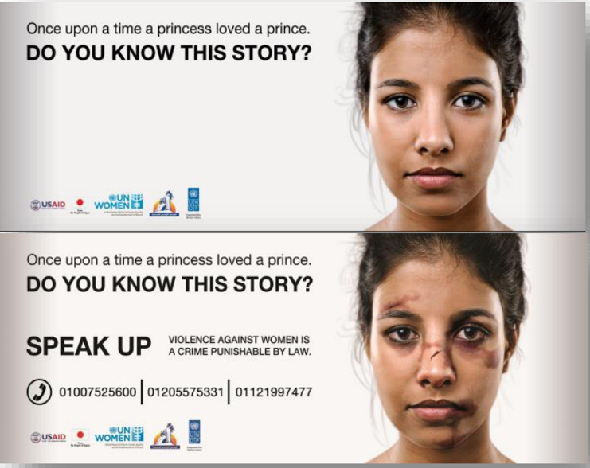

“Speak Up” billboards on main roads. First picture was seen in the morning, second was seen at night. Original billboard was in Arabic.
ANNEX 9: DATA ON REASONS FOR HARASSMENT
Al Haggannah & Al Salam | Ever married | Never married | Male
Reasons for harassment
Lack of religion awareness | -5.98 | 0.07
Lack of morals and manners | -3.13 | 2.67
Effect of what they watch on satellites | 38.72 | 31.94
Difficulty of getting married | 32.75 | 28.87
Men/Youth misunderstand manhood | 9.27 | 0.29
The person who do this is drug addict | 4.03 | 11.85
Spread of unemployment | 4.91 | 14.27
Way of dressing | 15.7 | 18.44
Way of walking | 18.43 | 11.93
How to prevent/decrease harassment
Increase religion awareness | -2.48 | -5.55 | -6.48
Morals and manners | -1.12 | -0.96 | -0.44
Women/Girls shouldn’t go out alone | 12.74 | 5.99 | 6.43
Women/Girls should wear decent clothes | 17.33 | 24.65 | 28.17
Women/Girls should watch way of walking/Talking | 18.32 | 23.14 | 6.84
Offer jobs for youth | 11.42 | 16.12 | 8.37

Mansheyat Nasser & Al-Ebageyah | Ever married | Never married | Male
Reasons for harassment
Lack of religion awareness | 1.41 | 2.21
Lack of morals and manners | 1.56 | 1.42
Effect of what they watch on satellites | 2.18 | 5.67
Difficulty of getting married | -0.63 | 8.92
Men/Youth misunderstand manhood | -3.33 | 2.33
The person who do this is drug addict | 5.56 | 2.52
Spread of unemployment | 1.03 | -3.00
Way of dressing | -0.84 | -23.56
Way of walking | -2.26 | -24.45
Prevent/decrease harassment
Increase religion awareness | 3.36 | 5.15 | -0.18
Morals and manners | 0.94 | 2.28 | 1.14
Women/Girls shouldn’t go out alone | 4.54 | -11.09 | -4.63
Women/Girls should wear decent clothes | -0.48 | -16.97 | -0.08
Women/Girls should watch way of walking/Talking | -2.35 | -15.92 | -1.07
Offers jobs for youth | -0.24 | 5.93 | 0.32

Embaba & Boulak Al-Dakrour | Ever married | Never married | Male
Reasons for harassment
Lack of religion awareness | -6.31 | -8.00
Lack of morals and manners | -0.01 | -2.34
Effect of what they watch on satellites | -32.02 | -29.66
Difficulty of getting married | -24.68 | -23.35
Men/Youth misunderstand manhood | -16.46 | -1.53
The person who do this is drug addict | -23.29 | -21.07 | --
Spread of unemployment | -39.46 | -35.53 | --
Way of dressing | 3.22 | 9.31 | --
Way of walking | 7.67 | 11.26 | --
Prevent/decrease harassment
Increase religion awareness | -2.36 | -5.32 | --
Morals and manners | 0.25 | -1.65 | --
Women/Girls shouldn’t go out alone | -0.46 | -3.49 | --
Women/Girls should wear decent clothes | -0.98 | 13.00 | --
Women/Girls should watch way of walking/Talking | 2.23 | 10.02 | --
Offers jobs for youth | -24.26 | -25.05 | --

ANNEX 10: DATA ON SAFETY RELATED PROBLEMS
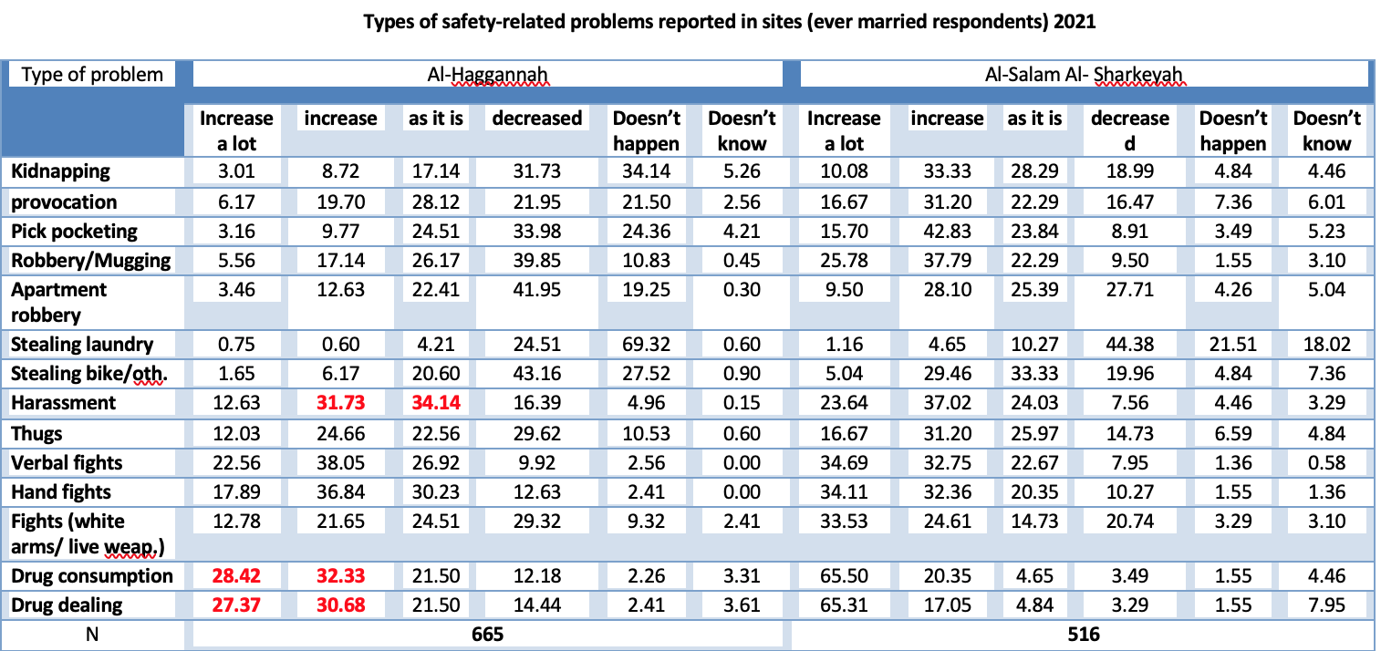
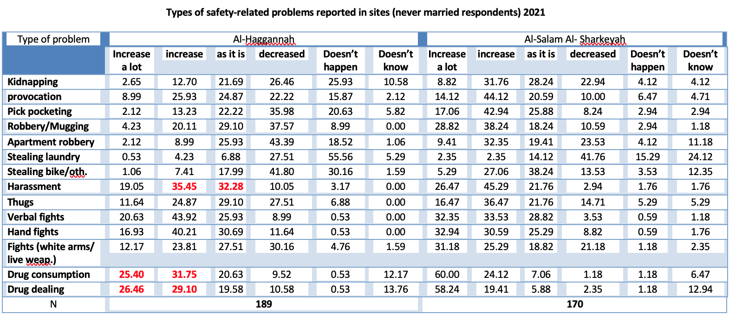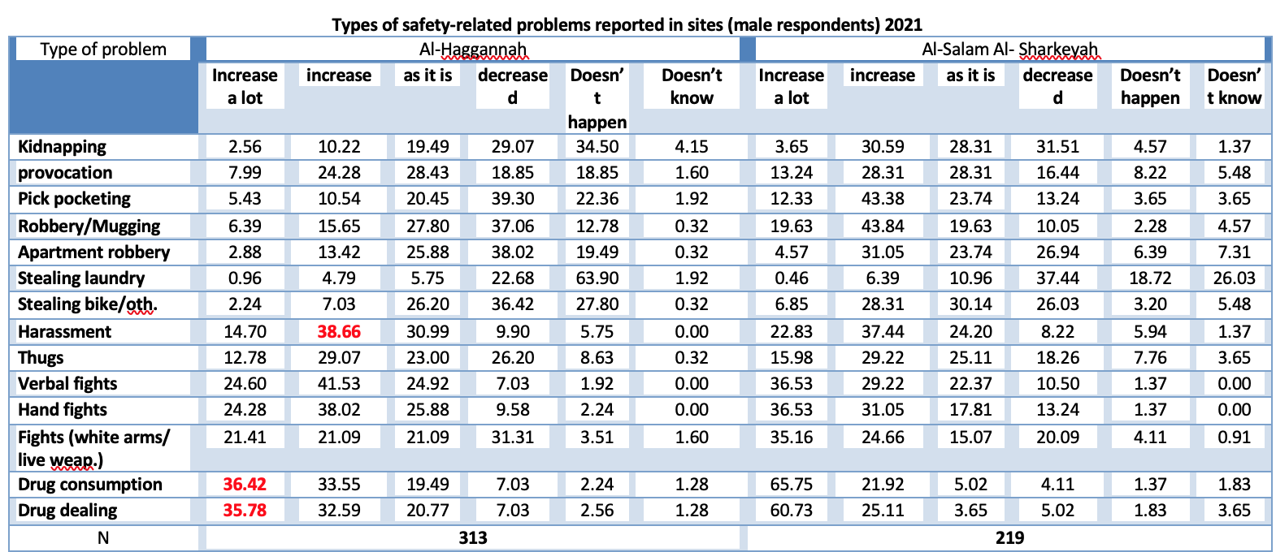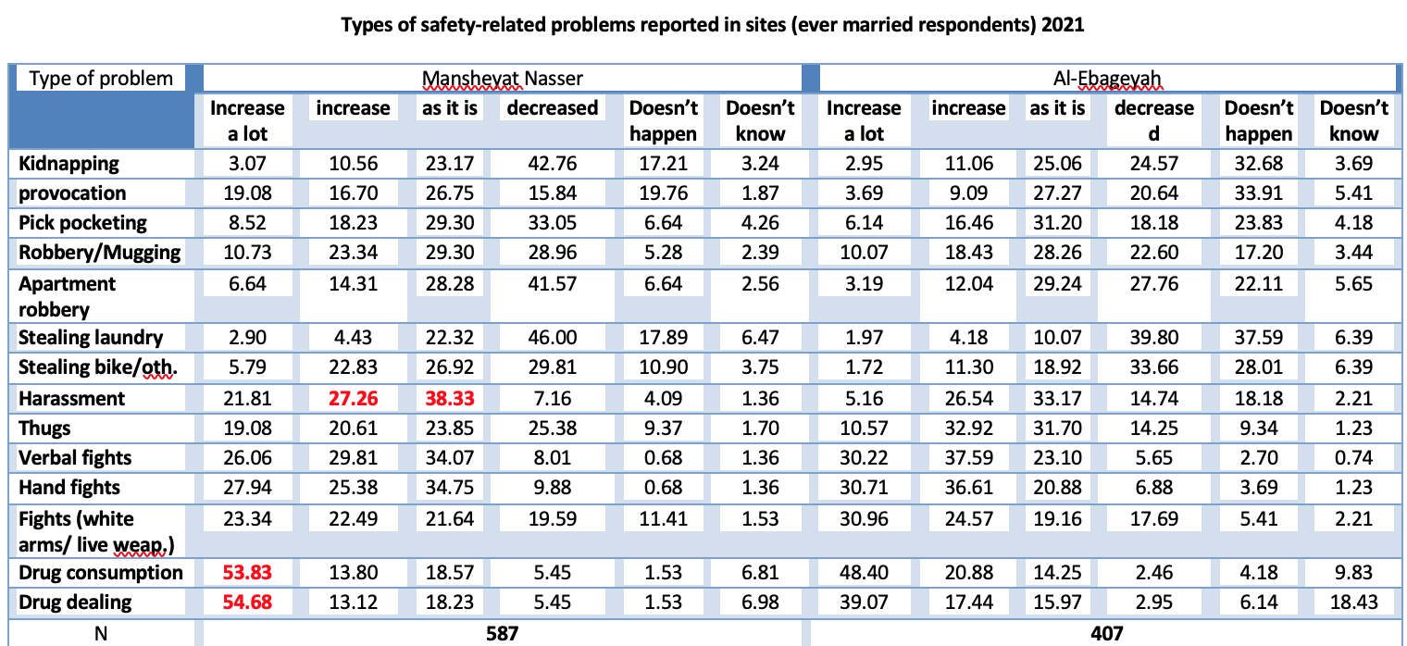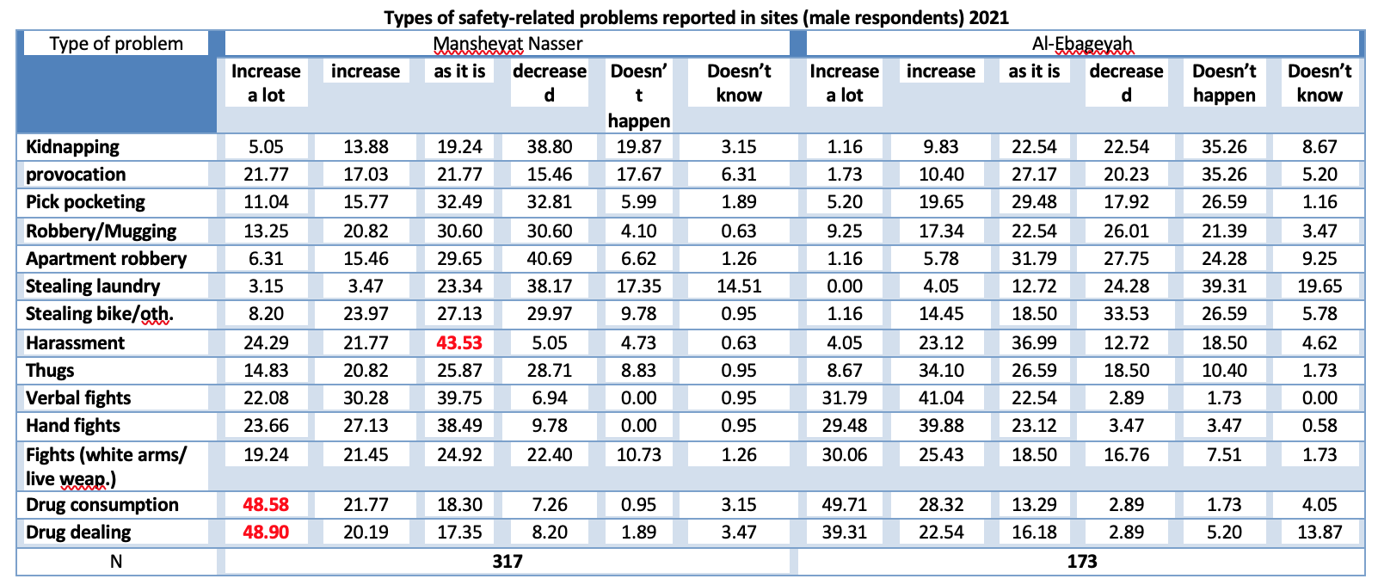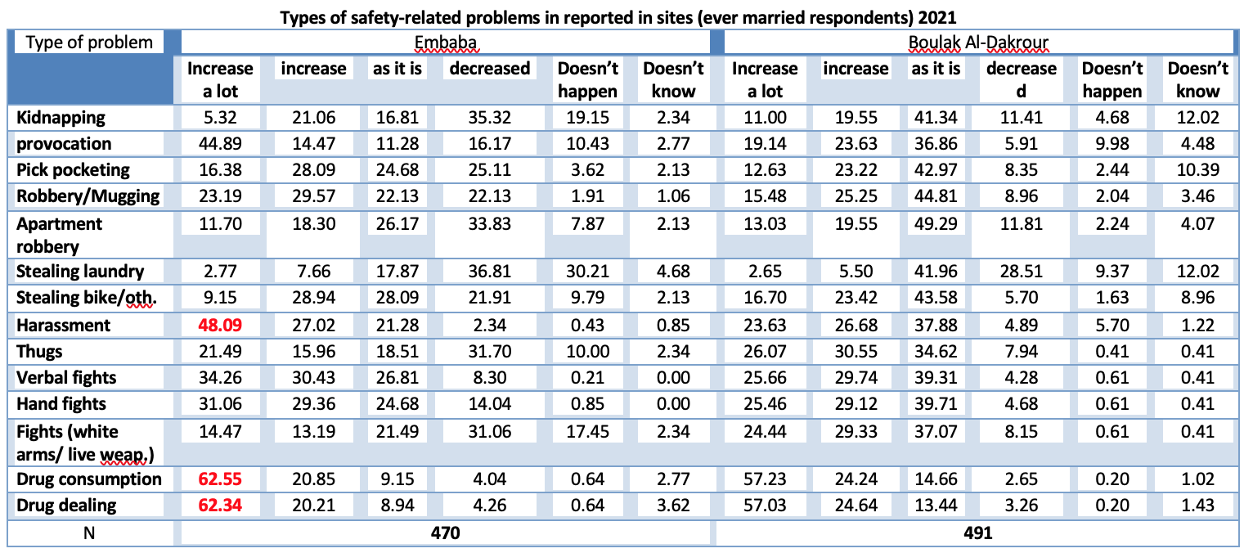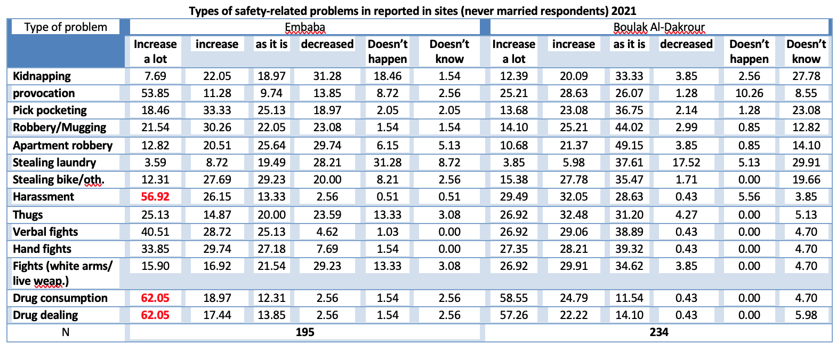

ANNEX 11: DATA ON COVID’S INFLUENCE

ANNEX 12: ETHICAL REVIEW

The Evaluation team was comprised of independent experts in their respective fields with no conflicts of interest that would impair their activities or findings. The team complied with ethical codes of social research and committed to highest possible standards of subject protection. The team for example ensured that sensitive information could not be traced to its source so that the relevant individuals are protected from reprisals. To guarantee comprehensive ethical compliance the evaluation was subject to multiple levels of oversight listed as follows:

- National Oversight: The field and survey activities took place under the auspices and oversight of CAPMAS. The National Council for Women was also fully informed and engaged with the research.
- UN Women Oversight: UN Women procedures were followed. This included presentation of an inception report with all intended research steps and all proposed research tools presented for approval. Evaluation quality assurance was maintained following UN Women GERAAS quality assurance matrix and United Nations Evaluation Group (UNEG) standards and was available for review by two committees composed by UN Women so as to provide third party guidance and oversight and ensure that the research is in line with ethical and best practices. The UN Women Regional Evaluation Specialist (RES) advised on how to improve all research tools and plans. Reference to relevant UNEG and UN Women ethical norms standards and WHO ethical guidance- was made throughout all research and analysis steps.
- AUC Oversight: The research was conducted by an academic research center that is subject to the stringent ethical standards of the University. The American University in Cairo mandates an Internal Review Board (IRB) procedure for ALL research undertaken by a member of the university body. The IRB is an anonymized peer review process that follows the standards and guidelines of academic ethical guidelines. All research activities were conducted after IRB approval of all research tools and activities.

- Project Ethical Provisions:

  - Informed consent was obtained for all data collection activities.
  - All researchers and enumerators received ethical training from PIs
  - All interviews and households were provided with contact information of a designated third party in case they have questions or complaints
  - All data is kept on a password protected drive and only SRC research team members have access to field data
  - All data is anonymized and files that identify data files to names are password protected and accessible only to PI’s
  - All data files will be destroyed after 3 years of evaluation completion.
  - All data files are stored on a Google drive and no copies are kept on any devices or sent over email for purposes of security and confidentiality of data
  - Data analysis complies with a “do no harm” principle and ensures that all quotes and opinions are protected and anonymous unless interviewees have explicitly given their permission to be quoted.
  - In including individuals or groups in the evaluation, evaluators ensured:
    - Right to Self-Determination. Prospective participants were treated as autonomous agents and given the time and information to decide whether they wish to participate or not and to be able to make an independent decision without any pressure or fear of penalty for not participating.
    - Fair Representation was assured as participants have been fairly selected in relation to the aims of the evaluation, not simply because of their availability, or because it was relatively easy to secure their participation. Care was taken to ensure that relatively powerless, “hidden”, or otherwise excluded groups were represented.

