UN Women
Evaluation of the Strengthening Resilience of Women and Girls affected by conflicts, violent extremism and climate change
in the Lake Chad Region (LCB) programme
Report

Submitted by

Keiko Tamura
Augustus Emerogu
William Fobasso

List of Acronyms
CBIs | Cash-Based interventions
CSOs | Civil Society Organizations
COVID-19 | Corona Virus Disease – 2019
DRR | Disaster Risk Reduction
Empowerment Hub | Multipurpose centres that enable women and girls to convene in a safe space to access livelihood, protection, and empowerment services.
GBV | Gender Based Violence
Gender Sensitive Market | Markets that are designed through gender perspectives to ensure marginalized women and girls at risk have access to women friendly spaces and to ensure the equity of the economic, social, and environmental activities of the market are accessible to all and ensures that all actors can take part in productive activities in a safe environment.
LCB | Lake Chad Basin
LEAP | Women’s Leadership, Empowerment, Access and Protection
LGA | Local Government Area
MINPROFF | Ministry of Women's Empowerment and Family of Cameroon
MOWA | Ministry of Women's Affairs of Nigeria
UNDP | United Nations Development Programme
UNEP | United Nations Environmental Programme
WOs | Women’s organizations
WRD | Women’s Resilience to Disasters

Table of Contents
1. Executive Summary 4
2. Background and purpose of the evaluation 7
3. Programme description and context 8
4. Evaluation objectives and scope 9
5. Evaluation methodology and limitations 10
Desk Review 11
Self-Assessments using UN Women tools 11
Targeted Consultations 11
Focus Group Discussion 12
Limitations 12
6. Findings 12
6.1. Relevance 12
6.2. Effectiveness 16
6.3. Efficiency 19
6.4. Sustainability 20
6.5. Gender equality and human rights 22
7. Conclusions 23
8. Lessons learned and good practices 24
9. Recommendations 25

Annex 1. Women’s Resilience Index Survey Results 29
Annex 2. Women’s Organisations Leadership Self-Assessment Results 38
Annex 3. List of documents requested for desk review and its availability for the evaluation 70
Annex 4. List of informants for individual interviews 71
Annex 5. Evaluation Matrix 73
Annex 6. Data collection tools 79
Annex 7. Evaluation Terms of Reference (TORs) 87

1. Executive Summary
Background
Under the Women's Resilience to Disasters (WRD) framework and Women’s Leadership, Empowerment, Access and Protection (LEAP) program, a global project ‘Strengthening Resilience of Women and Girls affected by conflicts, violent extremism, and climate change’ was implemented from April 2020 for 24 months, covering Nigeria and Cameroon in the Lake Chad Basin Region (LCB), complemented by a West Africa regional component and a global knowledge management, normative and coordination component.

The LCB project aimed to provide a comprehensive package for women’s and girls’ resilience, which focused on increasing the gender-responsiveness of prevention, preparedness, and the humanitarian/crisis response systems and plans, addressing gender gaps, inequalities, and discrimination.

The project had two objectives: (i) Crisis affected women and girls are prepared to withstand crises, recover from them, and increase their resilience to future crises, and (ii) Prevention, preparedness and recovery systems, plans and tools are gender-responsive and inclusive through enhancing women’s leadership and decision making.

Findings
The evaluation team found the LCB project has brought tangible changes to the beneficiaries, communities, implementing partners and relevant government agencies in both countries, which are likely to last after the project closure. Progress has been made towards both objectives. Women reached by the intervention are demonstrating improved resilience to crisis: there are GBV services available for the victims and people at risk, there have been changes in women’s confidence to talk about GBV, there is improvement in income stability, and male and female leaders are engaged in a dialogue aiming to change community perceptions on women.

Local agencies were identified to provide training and improve services in GBV, and livelihood opportunities in agricultural and small businesses. Business kits have been used to start small businesses successfully. The livelihoods component of the programme achieved between 65 and 80% success, which is a great achievement given the pre-existing vulnerability of the beneficiaries selected. Survey respondents also reported full controls over their own incomes. In a limited number of cases, women cashed out their kits to meet daily needs, suggesting these highly vulnerable beneficiaries were unable to take the risks associated with starting a business and resorted to a short-term benefit from the assets provided.

Significant progress has been made at empowering women leaders to influence policy and encouraging improved gender responsiveness in both work areas. Women led organisations are increasingly engaged in local and regional dialogues, advocating for improved and equitable services for women, particularly those surviving or at risk of GBV.

The two assessments, expanded beyond cash for work into possible cash-based interventions (CBIs), confirmed a selection of CBI’s are being used successfully, even in the complex environments of Northern Cameroon and North-East Nigeria. While the project used cash to pay school fees in Nigeria, and cash for work for 30 women in Cameroon, the project did not record any progress with advocacy to increase opportunities for women to earn short-term wages through cash for work.

An early investment in building the relationship between government stakeholders and the decision to engage with multiple government agencies (including the police), rather than just the ministry responsible for women, proved invaluable. UN Women can learn how capacity mapping of partners led to both effective programming and a shared understanding of training/capacity building needs. The twin track of resourcing local implementing partners and building capacity of government actors delivered results and increased the probability of sustainability. Field support, particularly joint field visits with national counterparts, combined with remote dialogue, built a common understanding of the project and allowed effective risk management and adaptability from the management structure.

Maximising local capacity and augmenting it with learning opportunities to share emerging best practice, helped to accelerate capacity building. The provision of opportunities for participation of women’s leaders in local, national, regional, and global activities provided a successful learning-by-doing process.

A high-level multi-stakeholder regional workshop with over 200 participants agreed on advocacy messages for increased women’s voice and visibility in the humanitarian response. Subsequent improved networking generated peer support in line with the project design. A subsequent global lessons-learned workshop consolidated south-south networks and introduced the WRD Knowledge Hub. Participants evaluated them both as useful and appropriate.

While COVID-19 caused a large disruption over the project cycle, the teams effectively adjusted and adapted to public health requirements, minimising risk to staff and maximising staff and partners ability to continue to work. Flexible management and open information flow within the project, especially the provision of close routine support from global, regional, and country office teams, contributed to effective implementation and rapid resolution of problems despite the COVID-19 challenges. This innovation/approach should be continued and not lost as movement frees-up.

In a similar way, the implementing partners’ prior experience of working in the field and their respective security systems allowed them to schedule and/or reschedule field activities to meet changing security challenges, reach communities when security allowed and successfully deliver project activities and outputs.

An under-developed monitoring and evaluation system was one weakness of the project. Eligibility criteria were not clearly defined, baseline situation of beneficiaries was not captured in detail, leading to challenges attributing change to project interventions.

The multi-year commitment from the Government of Japan, has allowed foundations to be established and then a deeper partnership to be developed, leading to a shared sense of ownership of the project goals, approach and problem solving, as well as leading to government commitments to sustain the resulting action.

However, all women engaged in the evaluation acknowledged that it is a small start, more resources, especially longer-term resources are needed to continue the progress made.

The funding situation across the Lake Chad Basin remains critical. Increased government investment and broadening the donor base will be required to ensure these innovations reach the large number of extremely vulnerable women living in the project areas.

Recommendations
The evaluation suggests some modifications of future projects to best learn from the LCB project:

Project design phase
- Ensure the development of a Theory of Change that reflects the goals of UN Women WRD using well-defined impact indicators.
- Within this design phase, consider extending targeted assistance across the range of needs. These could include support for the most vulnerable, sole-trader training and kits, small and medium sized women led business development loans, village savings and loans groups, revolving funds, loans for livelihoods, engagements with banks and microfinance agencies etc.
- Future project design should be more confident to advocate for and pilot a spectrum of CBI options to reach the most vulnerable families, starting with social protection payments, and access to cash for work.
- Aligning approaches with emerging global best practice while ensuring ongoing engagement with protection and cash working groups, could allow projects to demonstrate the flexibility of “cash plus” interventions to lift highly vulnerable women into a position of increased resilience.
- Better definition of the purpose and expected benefits of any cash or in-kind interventions should aim to achieve equitable outcomes (rather than equitable inputs) for women in differing situations.
- The purpose and implementation of capacity building (CB) should be further developed, using the new UN Women leadership tool, to baseline the needs of partner agencies, and ensure the provision of resources in a consistent way and with a medium-term strategy, to make sustainable progress. This should include considering partnerships with relevant CSO capacity building and resource development specialists in any project location.
- UN Women could define a risk position, challenging/encouraging projects to better demonstrate the impact of adopting emerging technologies, supporting vulnerable families and communities to adopt greener activities that contribute to a long-term local and global environmental benefit.

Project Implementation
- Continue to engage with men to develop a shared sense of purpose in the community.
- Ensure local partners have sufficient security training, systems, and resources to keep staff safe.
- Use social and traditional media to deliver social behavioural change communication programs within projects, systematically expanding learning from projects beyond direct beneficiaries and project field staff, to a wider audience.

Monitoring and Evaluation (M&E)
- Ensure the construction of a robust M&E framework and adequately resource for M&E activities.
- Invest in a suite of online baseline assessment tools and cascade training to bring implementing partners and host governments together.
- Ensure regional and country offices have capacity to train implementation partners (IP) in the use of the tools, data collection and analysis.
- Periodically assess resilience score of beneficiaries to identify individuals who may need additional supports to reach the desired resilience.

2. Background and purpose of the evaluation
The Women’s Resilience to Disasters (WRD) Programme aims to render the lives and livelihoods of women and girls resilient to disasters, including climate related disasters and health pandemics, in order to contribute to sustainable, secure, and thriving communities. The Programme will deliver a comprehensive but flexible package, to secure gender-responsive disaster risk reduction and resilience decision making and action that can be tailored to unique regional and country circumstances.

The WRD programme recognises the importance of country driven and locally owned action focused on local priorities, but supported by regional and global elements, which create an enabling environment for women’s agency, leadership, coordination, knowledge exchange, and advocacy. Key principles of the Programme are localisation, local ownership and flexibility.

Through its work in the region since 2014, UN Women had identified that significant gaps existed in the humanitarian and DRR initiatives, these included:
- increased needs for protection against GBV of various forms, including early marriage and sexual exploitation,
- a lack of livelihood opportunities, which could be promoted as a critical lifesaving need for women,
- a lack of coordinated support for a women’s role in conflict management and prevention of violent extremism,
- a broad need to strengthen gender-responsive programming in the humanitarian response, and
- a need to upgrade or build infrastructure that provided a safe place for women to meet and work.

Under the WRD framework and Women’s Leadership, Empowerment, Access and Protection (LEAP) program, the global project ‘Strengthening Resilience of Women and Girls affected by conflicts, violent extremism and climate change’ has been implemented since April 2020, covering Nigeria and Cameroon in the Lake Chad Basin Region (LCB), complemented by a West Africa regional component and a global knowledge management, normative and coordination component, aimed at generating catalytic action and producing practical lessons-learned and best practice for upscaling and widespread adoption. The LCB project aimed to demonstrate this comprehensive approach in the conflict affected areas of North-East Nigeria and Northern Cameroon.

This final evaluation was undertaken after the completion of programme implementation, as a mandatory activity, as articulated in the project document and as in agreed with the Government of Japan (the donor for the project). The key users and target audience of the evaluation include the Government of Japan, relevant ministries of the national and local governments in Nigeria and Cameroon, regional organizations, CSOs and women-led organisations. The evaluation report will be posted on the Global Accountability and Tracking of Evaluation Use (GATE System).

3. Programme description and context
Areas in the Lake Chad Basin (LCB) region, particularly Northern Cameroon and North-East Nigeria have experienced unprecedented impacts from the multiple ongoing crises, including the effects of climate change, violent attacks, and alleged human rights abuses by Boko Haram (BH), that has resulted in widespread hunger, malnutrition, loss of livelihoods, destruction of property and the disruption of government institutions including medical and education facilities. More than 2.5 million people have been uprooted in the region, with women and girls being disproportionately affected by the crisis which magnified the already existing gender inequalities.

In this context, the project had three objectives:
Objective 1: Women and girls are prepared to withstand crises, recover from the impact of crises, and increase their resilience to future crises,
Objective 2: Women affected by crisis, lead, and participate in decision making and social cohesion and are protected from GBV with increased support of men and boys in their respective local communities, and
Objective 3: Prevention, preparedness and recovery systems, plans and tools are gender-responsive through women’s leadership and their enhanced influence in decision-making.

To achieve these objectives the project logic was designed with two outcomes:
Outcome 1: Crisis affected women and girls are prepared to withstand crises, recover from them, and increase their resilience to future crises. The activities at the country level provided immediate, life-saving, and essential services as well as capacity building to affected populations (in particular, women and girls affected by, or at risk of conflict and climate change). The project resourced women’s training and access to livelihood and other economic opportunities, access to cash for work initiatives, economic diversification, and micro-business development skills, responding to women’s immediate and mid- to long-term needs, to make them and their communities more resilient.
Outcome 2: Prevention, preparedness and recovery systems, plans and tools are gender-responsive and inclusive through enhancing women’s leadership and decision making. This focused on UN Women’s programmatic approach of promoting leadership development and building the capacity of women’s leaders to engage in and influence national and international decision-making forums on disaster risk reduction (DRR), humanitarian and crisis response at the local, national, and global level. UN Women engaged in a dialogue to strengthen the resilience of crisis-prone and crises-affected women and girls, including refugees, IDPs and host families at the community, government, regional and global level.

The project focussed on two highly volatile regions:

In the northern Cameroon, in Kolofata town and Kerawa village, UN Women established gender-responsive services, to ensure that women and girls led, participated in, and were empowered by the humanitarian response, recovery and resilience building efforts. UN Women supported the construction and equipping of a Women's Empowerment Centre in Kolofata and the construction of a Gender Sensitive Market in Kerawa. The Women's Empowerment Centre was designed to offer prevention and response activities against sexual and gender-based violence, and functional literacy training, by promoting "second chance education" for women who had missed schooling. The Gender Sensitive Market allowed women to safely carry out economic activities through the day, by offering gendered toilets and sleeping spaces for babies and children.

In Yobe State in North-East Nigeria, UN Women, as requested by the Ministry of Women’s affairs, resourced the rehabilitation of a women's empowerment hub in Damaturu city and constructed a storage facility for women in Gashua town. These locations were chosen as they are not only affected by the conflict, but are also in the poorest areas, with limited public services. The hub intended to provide women with access to resources, support, basic services, and social networks as well as opportunities to be referred to additional services. Social activities included training on income generation, women's rights and GBV. The storage facility provides a safe and accessible women-friendly space to marginalized women and girls offering training in improved rice processing, and a dedicated space to operate their business.

4. Evaluation objectives and scope

Objectives
The evaluation had nine objectives:
- At the outcome level, analyse whether women’s resilience to crises has been achieved and if the strategies and approach have been effective.
- Examine programme results in relation to the intended outcomes and outputs and identify the strengths and weaknesses in programme design, implementation, and monitoring.
- Assess how the regional and global components of the project contributed to UN Women’s global learning and partnership enhancement.
- Examine critical factors that enable and/or hinder effective achievement of intended results and provide recommendations on how to address and/or leverage these critical factors, including key considerations around risk mitigation/management by UN Women and implementing partners and programmatic adaptation in a rapidly changing context.
- Draw good practices and key lessons on the role/contribution of partnerships in the achievement of planned outputs and outcomes.
- Document lessons learned and best practices and provide recommendations to inform future work on women’s resilience building.
- Assess the potential for sustainability of the on-going work in programme countries.
- Contribute to UN Women’s global efforts on evidence building on cash-based interventions.
- Assess if COVID-19 mitigation measures and adjustments were carried out in a timely-manner and compile recommendations for future programming/on-going initiatives.

Scope
The scope included the project design, implementation, management, lessons learned, replicability and recommendations for current and future programmes/initiatives. The evaluation covered the relevance, effectiveness, efficiency, and sustainability of the project and explored how the project had addressed gender equity, inclusion, and human rights. The evaluation questions were developed by the evaluation team in coordination with UN Women.

Thematic areas: As described in the project logical framework, thematic areas included resilience, GBV, protection and women’s leadership. In addition, the project supported livelihoods and piloted cash-based intervention as an approach to build resilience and to support UN Women’s contribution to global cash-based interventions (CBI programming) evidence building. The success, challenges and limitations of this pilot activity were discussed as a part of the evaluation.

Involvements of stakeholders/key informants: Given the multiple levels of project implementation (global, regional, country and field levels), a wide range of stakeholders and key informants were identified for inclusion in the evaluation:
- Community level beneficiaries in both Cameroon and Nigeria
- UN Women project teams at country, regional and global project management level
- Government counterparts (line ministries and local administrations)
- Implementing partners
- Women’s organizations
- Humanitarian agencies/cluster coordinators (UN and NGOs who are working on resilience, GBV and Protection, women’s leadership, and cash-based intervention)
- Regional partners

5. Evaluation methodology and limitations
The Evaluation team was led by one Evaluation Team Leader (International Consultant), supported by two National consultants, one leading in Cameroon, one in Nigeria. Each National consultant mobilized a small team of evaluators to assist in field data collection.

The Evaluation Team Leader was responsible for overall implementation, task distribution, and supervision of the entire evaluation process, while the national Evaluation Team members collected and analysed data in each country. The Evaluation Team Leader was responsible for global and regional levels of data collection and analysis, coordination with UN Women, analysis of initial findings from the countries and preparing the final report and presentation to the Reference Group.

The evaluation process was conducted in accordance with gender and human rights principles and followed both the UN Women Evaluation Guidelines and UN Evaluation Group (UNEG) norms, standards, and ethical guidelines. A Reference Group provided oversight and were consulted at agreed points in the evaluation, for review, comments, and guidance, and provided advisory services to the overall evaluation process. The DRR and resilience team in Geneva managed the day-to-day aspects of the Evaluation process in collaboration with the Evaluation Office.

The evaluation was as transparent and participatory as possible within the conflict and COVID-19 affected context. It followed a mixed-methods approach, primarily qualitative, aligning with the final matrix of evaluation questions (as agreed with the Reference Group). Within the field context, a level of homogeneity allowed small samples of resident, IDP, GBV survivors, and partners of beneficiaries to represent the broader general population.
The evaluation process attempted to maximize participatory approaches, while adhering to global best practice and following National COVID-19 guidelines in each country throughout the field data collection.
The research methodology followed the agreed data collection process, namely:

Desk Review
The evaluation team were provided with the core project and context related documents from UN Women teams at the global, regional, and national level (Annex 3). A systematic review of the provided documents assisted in identifying areas for focus to the questionnaires that were prepared for the subsequent consultation phase.

Self-Assessments using UN Women tools
UN Women has recently (since the start of the LCB project) developed two tools to support women and women’s organisations self-assess both their capacity and environment. The evaluation team applied an abridged version of the self-assessment exercise for the women’s organizations, providing them an opportunity to reflect on the current (post-project) status of their organisation and environment. A similar approach was adapted for focus group discussion participants, with a short questionnaire of ten questions circulated, targeting the individual aspects of women’s roles in decision making around finance, financial stability, and safety (areas considered too sensitive to ask people to discuss openly during group exercises). Results from both tools were uploaded onto the KOBO application, allowing cross-analysis and visualisation.

Targeted Consultations
Following a training day, where each of the data collection tools was reviewed with the national consultants, the evaluation team interviewed a wide range of stakeholders from the multiple levels of project implementation (global, regional, and country levels) as agreed with the Project Manager and Country teams (Annex 3).

Focus Group Discussion
The consultant team in each country undertook focus group discussions with small groups of beneficiaries from key program initiatives (business training and kit recipients, users of the women’s centres, women’s groups and women focussed organisations (Cameroon April 2022, Nigeria June and July 2022)). Focus group discussions (FGDs) with both men and women in field communities discussed how the project supported the community to prepare for and prevent GBV, support referrals and provided legal aid for any survivor of GBV, the effectiveness of the psychosocial group activities, and whether the activities and facilities were accessible to all people at risk/in need and any open comments they wanted to make.

In line with research ethics, all adult participants signed consent forms that they agreed to their data being used to compile this report.

Limitations
The teams followed careful COVID-19 protocols during field visits, which guided how individual interviews could be held and reduced the number of people participating in each group activity and the number of FGDs that could be completed. Within this context, individual interviews were successfully completed with each target group. One project document, the zero evaluation of livelihoods in Cameroon, allowed cautious extrapolation of data collected to represent the broader population in lieu of a statistically representative survey.

Contextual Factors: As identified in the inception report, the Cameroon field deployment successfully managed the risks of insecurity and the fasting month to successfully complete the interviews as planned. Delays in mobilization by the Nigeria team led to the field work not overlapping with the Ramadan festival.

A sizable number of documents requested (itemized in red in annex 3) were not made available to the team, leading to the assumption they were not developed by the project team, the relevant government department, or the local implementing partners within the project.

It had been agreed that the regional and global interviews would follow the field data collection and analysis from each country to verify their findings. The delay and quality of data and inputs provided by the evaluation team in Nigeria resulted in a delay to the whole evaluation, and imposed challenges in the quality of data comparison. At the time allocated for regional and global interviews, several key stakeholders were unable to participate in interviews /did not response to interview requests, thus their input is missing from the evaluation.

6. Findings

6.1. Relevance
The appropriateness of the program approaches to address the problems and achieve the planned results

The LCB project design, strategies and approaches were considered appropriate to meet the needs and priorities of women and girls in the crises-prone North-East Nigeria and Northern Cameroon by all the stakeholders interviewed. The composition of activities successfully contributed to addressing needs in both the short-term crisis response and the building of resilience for future crises, across the spectrum of the humanitarian-development-peace nexus. The project has demonstrated that the activities are effective to reach the targeted vulnerable group of women in each location.

The focus on both acute needs and on long term resilience, to promote peaceful and robust communities, was considered appropriate by the UN Women staff, host governments, implementing partners and beneficiaries in the field.

Stakeholders interviewed in both countries confirmed the project approaches were fully aligned with National (and regional) Strategies and provided a good learning environment for future scaling-up. The Theory of Change (ToC) logic was robust, most of the training, awareness raising, and livelihood inputs were delivered effectively, contributing to the outputs and outcome 1 and 2. The quantified outcome 1 indicator was achieved, despite of some delay on the construction of the empowerment hub in Damaturu and the market in Kerawa. The quantitative empowerment of women (outcome 2) target was also achieved.

The project resourced mapping of agencies and pre-existing GBV services in both Nigeria and Cameroon, allowing local partners to be identified. Understanding the range of GBV services available at community level informed areas for training and capacity building, following a pragmatic course that covered methodologies, mitigation, and prevention of GBV response and the need to create a leadership response system that girls and women at risk from GBV could leverage. In addition, the strengthening of reporting mechanisms to document implementation was considered appropriate.

The evaluation found progress on enhancing women’s leadership and their ability to engage in decision making, the women’s empowerment component of the log-frame/ ToC was considered appropriate by government and implementing partners. The ex-post application of the UN Women’s new tools suggests that the approaches were successful (see annex 1 and 2).

There has been demonstrated enhanced leadership, especially in advocacy by women participating in the project. Women’s Organisations (WO) and the governments appreciated UN Women’s investment in local organisations. However, as reported by several UN Women staff, capacities and organizational experiences of targeted WO vary significantly, the LCB project might have overlooked organizational capacity building of local and small WOs, in areas including resource mobilisation, monitoring and evaluation. The consulted WO requested more support for their organizational development, to form quality partnerships in the field, rather than acting just as implementing partners.

The linkage between planned cash for work and intended outcomes remained unclear. The evaluation did not find any evidence of the project advocacy achieving an expansion of cash for work opportunities for women. The cash for work assessments commissioned in both countries expanded to cover the whole of the CBI landscape in each country. Divergent views on the value and importance of Cash for Work between project design and implementation, and the preference for unrestricted cash transfers voiced by women in the project areas, may have contributed to a reluctance to promote the benefit of increasing sources of incomes from Cash for Work for women as described in the project plan.

The key weakness in the implemented approach was the lack of a robust M&E system in the programme design, making it difficult to trace deliverables and to measure the project impacts in a timely manner. There was insufficient capture and analysis of beneficiary data (age, educational level, ethnic and religious minorities, disability etc.) to clearly attribute whether the project was reaching those most at need, and whether they encountered barriers, or made progress leading to success. COVID-19 was also presented as a reason the project teams were not able to conduct M&E activities such as collecting baseline data.

The extent to which the project responded to the needs and priorities of the target beneficiaries

Project reports describe improved access to social protection services by impoverished and at-risk women, good participation in GBV awareness raising, and that trainings for GBV exceeded the project targets. GBV survivors expressed their gratitude as they finally felt that they have a way forward out of their world of violence. Beneficiaries also report successful uptake of the livelihood support offered and women’s organisations strengthening activities made progress during the project lifetime.

Although delayed, the construction deliverables were successfully completed. In Kerawa village in Cameroon, despite delays in construction, the community reported appreciation on the early completion of a drilled borehole at the market. The provision of dependable water at the market was identified as a key improvement to their lives.

Targeted women’s organisations (WOs) reported their increased engagement in the local disaster risk reduction (DRR), climate change and humanitarian fora, actively participating in regular meetings and playing decision-making roles. In Cameroon, 100% of the surveyed WO also report that the stakeholders recognised the capacities of and roles which women can play in DRR and the humanitarian forum. However, they did not feel they were playing leadership role. In Cameroon, all (100%) of WOs reported support for project implementation. However, 60% felt they do not have enough support for policy making. They felt that there are still lots of barriers for WO leadership in disaster and climate resilience and humanitarian fora, naming limited funding for WO to attend meetings and events, that they don’t feel safe or comfortable in male-dominated forums, or that they were not being invited to participate.

There was widespread feedback that the project met the real needs of the beneficiaries but the number of women in need of services far exceeded the scope of the project. To achieve the desired outcome at the scale, more resources and modifications to the approach would be needed, particularly to access women living at a distance from the centres of project activity.

The relevance of the training and capacity building initiatives in the given environments

UN Women had previous experience of working in the two work areas of the project and an understanding of the context. This was further developed by the mapping of actors described above. At the local level, the contents of the training and capacity building initiatives have had success sensitizing women on GBV, on their rights, and on the availability of GBV services. There was widespread acknowledgment of the complaints mechanisms.

Interviews with institutional partners, other United Nations agencies, regional clusters, community leaders, and beneficiaries, confirmed that the contents of training and capacity building initiatives were relevant for beneficiaries and were assimilated by the participants. Participants self-reported that the trainings were appropriate.

Most significantly, 91% (Cameroon) and 78% (Nigeria) of the interviewed women stated their intentions to report GBV cases to relevant authorities if they encountered such cases. While there is no baseline to demonstrate attributions by the project, the women’s willingness to report these cases will likely remain unchanged, at least for short-term.

In addition, the LCB project successfully targeted men and boys for awareness raising and demonstrated a certain level of change among the men and boys reached. One man commented that he had not realized women could contribute to the family income. The consulted women also emphasized the importance of continuous male engagements on GBV issues and women empowerment.

However, many WOs reported that there remains strong resistance against women empowerment from traditional leaders, faith-based organisations who perpetuate traditional gender norms. In some cases, WOs engaged wives of powerful community men, and addressed this issue indirectly, which seemed to have worked well. Several WOs commented on the importance played by media, which could further reduce or enhance traditional gender norms. They proposed media campaigns, particularly through radio and social media to spread more transformative gender norms.

The ability of the cash-based intervention to mitigate possible risk to women beneficiaries
The project demonstrated different results in different countries. In Nigeria, the project chose to provide a cash grant for women to pay their daughters’ school fees instead of cash for work, without explaining the intended mitigation benefits. In Cameroon the assessment identified several agencies using cash for work for road improvement and market clean-ups. The project team consulted UN agencies on the safe approach, and the project successfully demonstrated safe deliver of cash for work for 30 women to prepare land for construction. Women participants reported appreciation for the opportunity to earn some money, and men interviewed were positive that their wives had been able to better contribute to their family’s needs.

The evaluation consequently concludes that the project successfully demonstrated how to mitigate risks to women during cash based interventions.

The appropriateness of the business kits/training opportunities to the target group and local environments
The projects decision to appoint experienced local service providers to run the women’s business training component, is considered a key decision that led to a high success rate of the businesses resourced by the project. In Cameroon, beneficiaries chose from a list of options, either small business income generating activities or livestock rearing. In Nigeria, it appears some beneficiaries were appointed to a training/input package. The evaluation found across the two countries, a 65-80% success rate reported by community leaders, which is a high rate for small business start-up.

In Nigeria, solar powered irrigation systems and solar powered food dryers contributed to their food security and reducing their time-poverty. Some beneficiaries reported a lack of markets or seasonal factors hindering their success.

There were cases reported where women given livelihood support packages, failed to use the provided resources to start a business, deciding instead to sell the assets supplied. This suggests that there was a sub-set of the beneficiaries chosen whose situation was too acute for them to be able to take the risks associated with starting a business, choosing instead to addressing their urgent needs by cashing out of the assets provided. Reports from Cameroon mentioned that some of the selected beneficiary women also had a low level of literacy or numeracy, making running a business challenging. This aligns with a request from women requesting educational opportunities (could be formal or literacy and numeracy classes) as a precursor before launching into business.

The options for very small businesses were limited and traditional, women were not provided gender transformative options. Climate resilience technology was introduced, but it was limited to the agricultural sector.

The project design or implementation teams appear to have not used the UN Women global network to identify any climate resilient socio-economic opportunities in disadvantaged communities (e.g. energy solutions by solar or biogas, access to water, transportation, reproductive health related products), some of which have demonstrated triple benefits of financial gains, increased access to service, and reduction of risk faced by women, while still being appropriate for women in even extremely volatile environments such as Nigeria and Cameroon

6.2. Effectiveness
The extent to which expected outcomes were achieved and UN Women’s contribution to them

Within the very difficult situation that evolved during project implementation- an increased level of conflict and COVID-19, the project successfully completed most of its activities and made measurable progress towards the project outputs and outcomes.

While there was no baseline survey, the short questionnaires from the UN Women self-assessment tools indicate that women beneficiaries interviewed are currently demonstrating an increased level of resilience. It is reported that women in Cameroon demonstrated stronger resilience than Nigeria, measured by (a) positive change in income stability, (b) having enough food for the year and (c) having an improved diet. However, the lack of baseline data has inhibited the quantification of improvements at the country level. The evaluation could not confirm if this resilience variance was a pre-existing condition, or impact of different levels of success by the project.

A significant percentage of women in Cameroon (83%) and Nigeria (77%) said that they could decide how their personal income could be spent, while 15% in Cameroon and 20% in Nigeria believed they could decide partially with their partner. Their involvement and decision-making ability for household income, showed a lower but still significant level of self-determination, women believe that they could decide fully (Cameroon 60%, Nigeria 48%) and partially (Cameroon 60%, Nigeria 32%).

Most women leaders reported that they had personally had an influence on the development of national disaster and climate resilience building legislation, policies, standards, strategies, and plans. Further most women “agreed “or “strongly agreed” that their organisations had influenced the gender responsiveness of plans, 80% of respondents felt that national policy now “represented women’s needs” and 80% felt their “organisation now represented the prevention and preparedness needs of women effectively”, but this level fell to 40% at the recovery activity level. Women expressed confidence that their voices were being heard but were less positive about decision making in climate funding.

The evaluation survey showed that although 80% agreed that stakeholders recognised the contribution women could make and felt women’s organisations could access resources to participate in the dialogue about disasters and climate resilience and that 80% of respondents felt they had a decision-making role to take, only 20% felt they “had a leadership role” in the dialogue at the local level. Opinions were divided on their role at the national level, with 60% saying they had “no role” and 40% feeling they had “been active at the national level, and they had influenced the development of policy through their participation in national dialogue”.

The global and regional component intended to disseminate in both directions, good practices, and initiatives between LCB and other countries, and at the global level through promoting available resources and tools for local partners. These components were amongst the most affected activities due to COVID-19. In-person engagements through country visits were not possible for most of the project lifespan. Over time, management adapted the contents and durations of the planned regional and global events, successfully completing both information exchange workshops in a hybrid meeting format, with participants gathering in each country and a larger number of participants joining remotely.

The 3-day Regional high-level Forum, organised in September 2021, engaged nearly 200 women and men in both face-to-face and online participation. Government participation from Cameroon, Chad, and Nigeria, was combined with their respective NGO Partners, together with representatives from Women’s Organisations in Burkina Faso and Mali. The workshop invited senior participation from the African Union (AU), ECOWAS, ECCAS, and the UN, together with most of the humanitarian donors. Discussing broad themes including advancing gender equality, social inclusion, women and girl leadership, disaster risk reduction, and resilience building, together with regional stability and the Boko Haram insurgency. Recommendations included advocating for increased women’s participation in DDR, DRR and the revitalisation of women’s networks at regional and global levels; a concerted effort to identify appropriate ways of improving the status of women and girls, and increased funding in a sustained and dependable manner, including special allocations for women led CSO’s. As a final recommendation, the forum encouraged increased training and awareness raising, for institutional and state actors, donors and female led CSO’s together with investment to find concrete and sustainable solutions.

The second event, the regional training and South-South knowledge exchange meeting held in December 2021 attracted participants from beyond the LCB region, including Burkina Faso, Mauritania, Jordan, Colombia, and Japan. The participants expressed their great desire of continuation of such training events and requested more women to be invited in the future. Although a limited sample size, the participants highly ranked thematic learning. Cross-country learning and a session on CBIs were highly appreciated. Not unexpectedly, given the online circumstance, there was less success with networking and coordination. The global component also offered the opportunity for WOs to organise themselves into a co-working platform, which resulted in successful presentation of the LCB region at various global platforms.

As a part of the global component, UN Women’s knowledge hub, called the ‘Women’s Resilience to Disaster Knowledge Hub’, was introduced, and a dedicated page on West and Central Africa was developed, hosting knowledge sharing information from the LCB project. While it is still early stage of development, UN Women is planning to measure the knowledge hub outreach level as a part of global initiatives. Currently, only limited knowledge products have been posted on the West and Central Africa pages. As a recent publication has reported, substantial efforts and commitments of resources are needed to ensure knowledge products will be outreached and used by the country level programming staff.

Key challenges encountered during the project implementation and adaptation strategies put in place by UN Women and Partners
The project was implemented in an area plagued by violent extremism, armed conflict, and extreme weather conditions, exacerbated by extreme poverty and the prevailing socio-religious context, which combined have contributed to the erosion of women's rights.

The two key challenges encountered during project implementation were the escalation of the security risk in both work areas and the global COVID-19 pandemic. Both inhibited the implementation of the project by reducing the frequency of face-to-face work by all stakeholders.

Specifically, with relation to COVID-19, both countries experienced delays as each country first managed lock-down then recovered the resulting delays to field activities. Beneficiaries described the care and precautions adopted by the project implementation team, the provision of hand-sanitizer, the use of PPE and that activities took care to ensure social distancing becoming standard operating procedure. Once these processes were in-place, and whenever the government allowed activities to resume, the project team continued to deliver the program interventions to the satisfaction of both direct beneficiaries and government agencies, maintaining both activity outputs and cash disbursement according to plan as reported in the second steering committee meeting.

Following the COVID-19 outbreak, the project adopted a mixed modality for training and mentoring. Budgets were adjusted to give resources to field teams to travel to reach internet connectivity, successfully allowing some mentoring and on-line training to be delivered by both UN Women country office, regional and global technical support teams. On-line training was also possible. Project management frequently described the monthly on-line meeting as a significant positive change in project management, allowing decision making and follow-up to be more responsive to the changing needs of the project.

Regarding the deteriorating security situation, the IPs previous experience of managing their teams safely continued. Through their own internal systems and networking to local security information, they continued to schedule team movements and project activities when the security situation and security advisory services confirmed it was safe. This has proved sufficient to deliver the project activities and outputs, keeping their staff, partners and beneficiaries safe.

6.3. Efficiency
The extent to which the management structure supported program implementation

It was reported that a considerable time to build coordination between the relevant government stakeholders and local partners at the start of the project, successfully built a shared vision and purpose. During the evaluation FGD in Nigeria and Cameroon, the project beneficiaries and community leaders reported that the project management structure (including local project management committees) together with joint monitoring by UN Women team, local government and implementing partners, ensured the quality of the interventions and the strategies for reaching the beneficiaries.

The project management structure at global regional and country level was designed to allow information flow through the project- global experience into the project and lessons learned out. Flexibility from the UN Women project management team in Geneva, and the encouragement to adopt a monthly technical working group for each country, ensured that the project could be delivered. Time taken to discuss progress, solve problems , and agree on subsequent month’s plans, facilitated a clear shared picture of how the project would be successfully delivered by the diverse stakeholders and eventuated in activity completion and on-time budget disbursement, despite the unexpected delays due to COVID-19 and deteriorating security situation. The increased use of remote support, the resourcing of, and willingness for field teams to move to good internet connectivity and participate in this forum provided the de-facto oversight and monitoring of the project, leading to successful delivery of all activities and disbursement of project budget within the 2-year timeframe.

Delays in commencing construction, could have had a knock-on impact of delayed provision of community services. The pragmatic decision to start most activities in other locations/facilities, helped the teams to continue to make progress toward achieving service outputs. By the end of the project, the construction and infrastructure components were successfully completed.

The country offices report the active involvement of the Project Manager in Geneva to intervene and resolve a problem with one of the project partners and the benefit from the technical meetings combined with two project board meetings as a successful approach to facilitates issue resolution

The first meeting in June 2021 reported delays in construction to band gave sign off to the decision that the service provision and training activities should commence in other locations until construction was completed. Other decisions, to add travel budgets to field teams to facilitate access to internet and better manage communication, facilitated the project to get back on track. One delay that couldn’t be addressed was the late procurement and delivery of some agricultural and fish farming inputs, delivered late, leading to missing the planting season.

6.4. Sustainability
The extent to which benefits from the program will continue after the program concludes

The evaluation concludes that the impacts from the program are likely to continue for a considerable time.

Commitments from the host governments and implementing partners for post-project activities funded in 2022, described both a sense of ownership and commitment to the approaches of the project, suggesting a more sustainable outcome than a humanitarian response that focussed only on short-term life-saving programming.

While the two ministries, MINPROFF and MOWA considered the project activities in line with their strategic plans, they acknowledged that the project has allowed them to provide more services than possible with their routine budgets. Both ministries reported their intention to continue the activities tested in the project, that they have already started cascading the trainings through their organisations. At the same time, they have committed to finding resources to manage the infrastructure constructed.

While not underestimating the challenges for maintaining the services without funding by this project, the evaluation further identified innovations and progress for women surviving or at risk of GBV beyond the project plan, including:

- The establishment of “Gender desks” and dedicated officers in police branches (Nigeria/Cameroon)
- Self-funding of cascade training by both MOWA and Police (Nigeria)
- 5-year farmland access guaranteed by the Government in Nigeria), better recognition of allowing female access to land (Cameroon)
- New representations of women counsellors (Nigeria)
- 14 farmer associations and 7 Village Savings and Loans associations remain functioning (Nigeria)

Both local women’s organisations reported an increase in the openness of conversations around GBV with women, community leaders, and government staff, which was allowing an increased impact of advocacy, and ongoing progress in the dialogue about the inappropriateness and illegality of GBV. The police also reported that the project approach had triggered significant changes in their way of working, evidenced by the establishment of a gender desk and gender officers initially in Damaturu, and subsequently increasing to other offices. One local partner ALVF has increased the reach of GBV services through extension staff to more remote locations, staff have received training and understand the procedures to be followed in the event of a reported GBV case, as well as the complaint mechanisms. The system suggests the responsibility between the NGO and the government and is likely to continue.

The evaluation expects that with time there will be a reduction in the intensity of services offered. While services will continue to be provided, both by implementing partners who delivered case management before the project, without further donor funding, the intensity of activities, especially new livelihood investment and construction are likely to decline. This was echoed by one of the GBV officers expressed concerns that “only NGOs have the resources to continue the livelihoods support to families in need”. Both local partners pre-existed the project and are expected to continue in the future mobilising resources to continue their activities for women with or without follow-on funding from UN Women and have had success in finding resources for social protection programming, which has a high likelihood of continuing.
Results from a rapid self-assessment of five Women’s organisations in Cameroon showed that they were vulnerable to drops in funding. Most felt most unsure about their organizations funding situation. Only 40% of WO interviewed confirmed that their organisations have access to multi-year funding.
At the local level, women are very optimistic about the sustainability of their individual income generating activities (IGA). In all the group discussions, it emerges that, despite the few women unable to take up their IGA opportunities, for the most part, the IGA projects are proving successful, and they continue to provide financial support to beneficiaries. Interviewed recipients of the livelihood trainings reported they felt confident to continue with the activities they had been trained in.

Knowledge products have been in the process of finalization and translation, not yet fully available globally. To ensure maximum impact, further dissemination will be required. Meanwhile, through the production of a series of surveys and assessments, the LCB project greatly contributed to knowledge sharing and learning of practitioners, especially in-depth information on resilience building through the gender lenses.

Where and how capacity building has been successful in the varied project partners

The project targeted a particularly challenging environment in conservative communities living with conflict and impacted by violent extremism. Within this context, the project has demonstrated significant impact as captured by applying the Women’s leadership survey, which recorded women’s feeling of agreement or strong agreement that they could safely involve themselves in public meetings and that their voices would be heard. The survey showed that women felt that there were still significant barriers to their participation, but that resources were increasingly available for them to actively address the issues.
The consulted stakeholders widely acknowledged that the LCB project enhanced their knowledge and skills. However, there was no systematic way to prove or measure these enhanced capacities, or the effectiveness of partnerships. No partner capacity assessment was conducted prior to implementation, the training agenda was set without assessing existing knowledge/capacities, instead being informed by previous project experiences and interactions with WOs. While local authorities and women’s organisations widely acknowledged the contribution brought by the LCB project, for better effectiveness, future programmes should embed both a capacity assessment cycle for the beneficiaries, WOs, and the governmental partners and a structured capacity building plan/partnership enhancement plan or strategy that could be resourced in line with the identified gaps and needs for which various tools are now available.

6.5. Gender equality and human rights
How the project design and implementation addressed human rights and gender considerations

The phased nature of the project was intended to identify women survivors and women at risk of GBV and then provide them with PSS and other services in a safe environment. Local partners have provided services in pre-existing facilities in a safe and responsible manner. The project has demonstrated the engagements of men, community and police leadership who are now willing to discuss gender issues more openly.

The project offered income generating opportunities for marginalised women, who are now confident that their businesses will succeed. Further the majority reported their full control over their own incomes.

In Nigeria, the project also succeeded in winning a land access for vulnerable women, who can farm and benefit from their leased land up to 5 years, a major breakthrough in a pastoral economy.

In both countries, the project invested in the construction of safe-places for women to meet but their late delivery means the ability of these facilities to mitigate the risk of human rights abuses remains untested.

However, the main obstacles to human rights observed during the implementation of the project continues to be threats from the husbands of GBV survivors, and community threats suffered by some women survivors of GBV who were helped by the project. The scale of this continued problem was not quantified by the project, but the evaluation reported that people felt empowered to report GBV, which is a positive outcome from the project. On a less positive side, only one example was found of a GBV perpetrator being taken to court and sentenced (and the sentence was light, 18 months in jail), suggesting the need for continuing advocacy for addressing legal recourse for GBV survivors, which may be assisted by the Gender desks established in the local police stations.

How the project design and implementation addressed the needs of people living with disabilities

The project described ambition to targeting of the most vulnerable women. The evaluation could not find any evidence of specific selection criteria being discussed, applied or a transparent scoring system being used to select beneficiaries. The project accepted that implementing partners, with their considerable experience of working in the two field sites, would be able to ensure that the most vulnerable women were reached. It was seen that IP’s generated lists of beneficiaries, but there is no evidence of a specific strategy to reach people with disabilities, rank vulnerability, or ensure inclusion of minority groups within the project documentation. Given that UN Women commit to an inclusive approach, future projects should ensure an appropriate percentage/targeting of beneficiaries with disabilities, and ensure IPs are resourced to provide supportive/inclusive environments through community engagement and building peer networks between people with and without disabilities to complement their skills and experiences. While widows and women with disabilities are reported at higher risk of GBV, no data was available to confirm their relative percentages among the beneficiaries.

The lack of a sex, age, and disability disaggregated data (SADDD) reporting system, makes it difficult to measure inclusion in the project. Inclusion of people living with disabilities appears to have been ad hoc, examples of activities where people living with disabilities were included and not included were described in beneficiary interviews. In Nigeria, one beneficiary commented that community leaders were informed of where people with disabilities lived and could have assisted the project team to reach out to them, but this was not reported as a project strategy.

7. Conclusions
Despites highly challenging environments imposed by insecurity and COVID-19, the evaluation team found the LCB project has brought tangible changes to the beneficiaries and communities which are likely to last after the project closure. Progress is reported across the Theory of Change, in both Cameroon and Nigeria.

The Women’s organisations (WOs) engaged by the evaluation surveys, describe an improvement in their ability to engage and successful outcomes for advocacy on behalf of women in general and vulnerable, at risk of GBV women particularly, despite starting from a low level.

The results of the surveys show that although the project has delivered on its outputs, and that significant progress has been made for women directly involved in the project, there remains a frequent comment from women in both field locations that too many women have unmet needs and still need more support.

For many women in both work areas, there remains a lack of authority for them to freely leave their houses, a lack of voice in public fora, a lack of economic opportunity, and only limited control over economic decisions in households. The project can be summarised as having made a good start, but expansion and acceleration is now needed to take the initiatives to scale.

While awareness raising on GBV, as well as sensitization of services exceeded their numerical targets, case management of GBV survivors achieved the target in Cameroon, but not in Nigeria. Ways to ensure removal of cultural and logistical obstacles for women to access services should be further developed. Successes from other projects, such as creative use of Cash Based Initiatives and paying GBV survivors for their transport costs on arrival at point of service could improve the reach of any subsequent project.

Improvements in livelihoods are also a success. Considering the vulnerability of the chosen beneficiaries, that 65-80% of the business have been successful is a major achievement. However, as the project also focused on nutrition interventions, the low level of impact on income stability, food security and diet in Nigeria, despite high levels of beneficiary satisfaction and business success, warrants further investigation.

The LCB project was implemented while UN Women has been formalising its WRD programme, developing various new tools and guidelines, thus the LCB project may not have fully benefitted from the corporate tools and progress in conceptualization, particularly in measuring impacts and evidence generation.

As stated above, the project management and coordination went relatively smoothly despite an insufficient investment in setting up a system for monitoring and evaluation. While the consulted stakeholder confirmed positive outcomes of the project, it would be further beneficial to set up a rigorous system for evidence generation from the beginning, particularly, periodically assessing resilience score of individual beneficiaries and identify low-achieving groups who may needs additional supports to reach the desired resilience.

8. Lessons learned and good practices
Partnership
- Investing time and energy to bring all the relevant stakeholders from government into the project, rather than a single department, encouraging each agency to contribute from its own technical expertise, sharing both the resources and responsibilities for the project
- Joint assessments, implementation, and monitoring by UN Women, inviting partnership from the government provides opportunities to build trust and cooperation between the Government, National and local Women’s led organisations/NGO’s
- Technical leadership from experienced NGO’s is more effective when combined with State agency endorsement, and agreeing how to capacity build /invest in local partners/WOs
- The multiple levels of intervention, from community to inter-state agency, provides a forum for dialogue and building a shared vision beyond the project implementation staff.
- Involving both men and women in meetings and discussions, provides an opportunity to explore gender perceptions and advocate for change at all levels
- Wider accessibility of PSS, including couple counselling to reduce tensions between intimate partners, particularly when women are taking up new roles and voices

Flexibility in management
- Establishing rapid cycle information flow (e.g., monthly meetings including partner, project, and government staff) allows problems to be raised and addressed, if combined with Baselining, M and E systems and IPTT tools, project management can focus on solving problems in good time, improving the efficiency of project delivery
- Adapting to travel bans and lockdowns with activity and budget adjustments, reallocating international travel budget lines to ensure local partners can travel to reliable internet connections to report and more successfully use internet-based conferencing has supported the success of the project.
- UN Women staff in Nigeria commented on the importance of the project having a multi-year strategy. A significant amount of time was needed in each country to build the shared sense of ownership for both the project outcomes and the active participation of all relevant stakeholders. The engagement strategy in both countries achieved multiple government stakeholder participation. The UN Women country team described the need for multiple meetings and a timeline of almost six months to agree the planning for the project.

9. Recommendations
Programme Design
Develop a Theory of Change that better reflects the goals of UN Women WRD programme, focusing on impact
Revise the current WRD Theory of Change (ToC) to adopt indicators from the Women’s resilience index and the leadership and organisation tools, making it a corporate standard practice to best capture programme outcomes, contributing to UN Women’s global WRD ToC.
Use capacity and vulnerability assessments to better predict an appropriate support package needed to make a sustained change to vulnerability and deliver equitable rights-based outcomes, rather than equality of inputs (see below).

Match cash-based intervention with the desired outcome(s)
UN Women have an opportunity to further diversify the benefits of different CBIs in the context of resilience building and emerging best practices in GBV. Having a suite of different interventions including predictable social protection funding for the most vulnerable, small business grants, or loans through groups and development loans for successful business expansion, and accepting cash for work provides a short-term benefit and empowers women. Inequitable vulnerabilities, such as health may require different support for each case to achieve equitable outcomes. Learning from recent publications on lessons learned and the use of transport reimbursement, to allow women from greater distances to arrive at service centers, be reimbursed for their travel, and enter the health and protection service system in an equitable way.

This may require expanding partnerships and asset sharing across projects, to ensure investment in training and sensitization of relevant local capacity, but could allow projects to successfully support the most extremely vulnerable individuals and groups including:
- Families experiencing problems with substance abuse
- Families with members with disabilities: consider topping up allowance/input values to cover transportation, medical, NFI needs to ensure equitable outcomes, not input.
- Young mothers: Set up peer support groups, encourage their return to formal education or second chance education, followed by higher level of vocational training.
- Families (women and children) on the move
- Families with children at risk of moving to the street: linking to specialized agencies where available or resourcing the development of the capacity at local level where needed
- GBV survivors living far from services

Extend the breadth of financial assistance to small business development
Building a network of beneficiaries who can contribute into village savings and loans or revolving fund that resources livelihood packages on a pay-back approach, could perpetuate a slow expansion of beneficiaries, during and after a project. Continuing to support entrepreneurs, encouraging the scale up of women business groups and associations to build business models that provide employment opportunities that could include more women and deliver results at scale.

Undertake a mapping of pre-existing micro-finance service providers (in a similar way to the GBV Service providers) could identify potential partners (local banks, cooperatives or and microfinance institutions) who could be encouraged to maximise opportunities for women of all abilities and situations in a sustainable way.

Structured Capacity Building
The purpose and approach of capacity building (CB) should be unpacked and reflected upon. While the WO leadership tool is an excellent tool to inform organizational milestones, it will not show the appropriate path for CB of WO. Consider supporting a specialised centre or form a partnership with agencies that are specialised in CSOs capacity building.

For instance, many WO interviewed commented on lack of access to funding, or skills in resource mobilization and hopes this could be part of future projects, Preparing them to be qualified to find more sustainable funding. UN Women have an opportunity to pioneer capacity building of local partners towards sustainability (as opposed to risk transfer). Acknowledging this will take time, in the short-term, continuing flexibility in project management could allow a dialogue with WO to develop a local CB strategy for WRD programs that could work in an organic way across the continuum of baseline assessments, M and E frameworks, and negotiation of a sustainable resourcing strategy to learn what works.

Develop mutual support networks
Consider building a pool of peer networks/counsellors for GBV between women and men who have experienced partner violence who can mediate between couples.

Invest in emerging technologies to solve emerging problems
A future generation of livelihoods or income generating activities (IGA) could experiment with the piloting, evaluation and adoption of technologies that mitigate local environmental issues and climate change, including improved livelihood opportunities. Moving towards IGA that improve the environment, biogas production from animal waste, safe-drinking water, drying, freezing, or cooking, or interventions that manifest low-carbon communities (adoption of solar panels, electric vehicles etc). Within this context, cash for work infrastructure opportunities may focus on disaster risk reduction and climate change mitigation, producing better long-term outcomes, especially in urban communities and open doors to additional related funding streams. UN Women could consider working more closely with UNEP, UNDP and other institutions who are working on innovative energy solutions and livelihoods.

Programme implementation
Continue to develop shared sense of purpose with men in the community
Build on the early successes in the LCB project to expand the engagement of men, targeting religious leaders, traditional leaders, and role models, emphasising the healthy benefits from gender empowerment.

Invest in the safety and mutual support for implementing partners
UN Women heavily depended on local partners to deliver activities in the field especially in these high-risk contexts, presenting a high level of risk transfer. Partner concerns over their team’s security should be addressed through ensuring capacity for security assessments, training, security equipment, staff insurance, and appropriate visibility for staff, etc. It should be budgeted adequately to demonstrate an appropriate level of duty of care.

Do no harm with CBI
A thorough understanding of the opportunities for CBI to assist women in situations of vulnerability, requires a strong understanding of the cultural context, including the perceptions of men in the relationship. The project and secondary evidence show that men can be amenable to targeted interventions for their partner/spouse, when the context is understood and socialisation sufficient. Clear communication on eligibility and benefit packages has repeatedly been shown to reduce to insignificant possible risks. Involving local women in discussions on the various modalities, (cash in hand, e-cash, mobile money, vouchers at the point of service etc.) can further enhance women’s empowerment and should all always be part of a design process.

Encourage quality-building partnerships
Build on the successful GBV mapping and training for enhanced service provision for other areas of women’s resilience programming. Encourage partnerships to agree to experiment and prototype interventions for proof-of-concept investments, initially funding from flexible donor grants before subsequent transition of successful approaches to more risk averse state-owned services who can invest in sustainable scale-up.

Use appropriate communication channels to amplify messages
Advances in tele-connectivity and increases in the number of people using phones for information gathering (from both formal and social media) provides an opportunity for a more explicit use of social behavioural change communication campaigns using multiple-media sources to magnify the dialogue is now possible without huge investments and could be included in any future project.

Programme monitoring, evaluation, and learning
Invest in developing an online baseline assessment tool for all WRD programmes
Develop, on a simple to use platform (e.g., KOBO), a suite of tools to allow baseline and change measurement over any project duration. Provide libraries of sample questions and invest in cascade training for regional and country programme staff to be able to train host governments and implementing partners in baseline data collection and periodically assessing resilience score of individual beneficiaries and identify low-achieving groups who may needs additional supports to reach the desired resilience.

Set-up a proper M & E system for tracking and evaluating.
Build on the on-line tools (above) to describe how UN Women and its partners can measure the impact of capacity building investments. Conducting capacity assessment for Women’s Organisations, potentially mapping other capacity building initiatives by other partners to UN Women indicators to show how synergy through cooperation with other initiatives contributes to improved outcomes.

Annex 1. Women’s Resilience Index Survey Results

Women's resilience index (Cameroon)
Sample Size (35)
What is your current marital status?
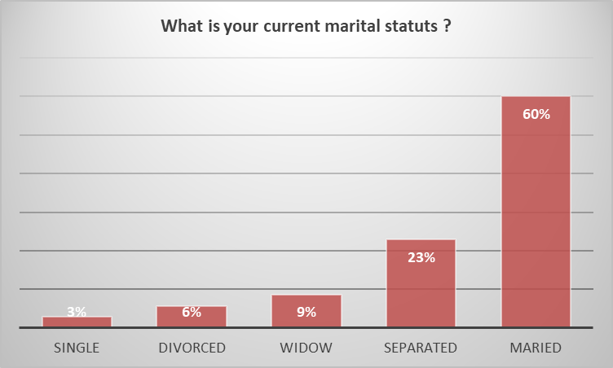
In the project area, we realize that more than 60% of women survivors of GBV are married, and 23% are separated. It is important to clarify that most marriages in the community are religious marriages. Virtually none of these women have a civil marriage certificate. The separated women are mostly women whose husbands left the locality during the crisis or even joined unconventional armed groups.

Relationship with the head of household in the family
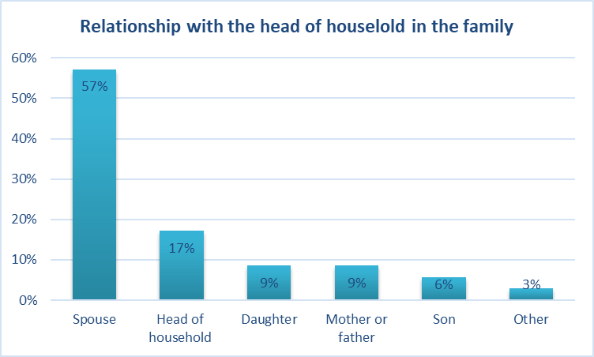
17% of women in the community are heads of families, most of these women lost their husbands during the crisis linked to terrorist groups.

Is there enough food in the household to feed everyone adequately throughout the year ?

63% of female survivors believe they have enough food to feed their family for the year. Although we cannot confirm to what extent this increased after the project intervention, it clearly indicates increased resilience among beneficiaries. The project's empowerment interventions would therefore be effective.

Has your diet improved over the last 2 years ?
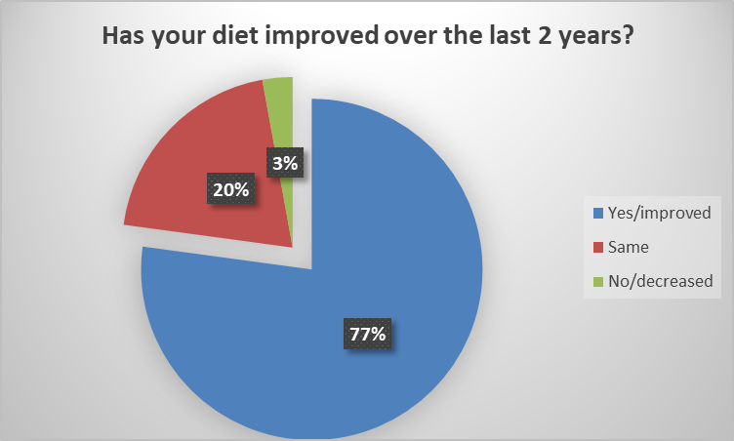
77% of women survivors believe that their food income has increased during the two years of project intervention. We are therefore entitled to believe that the project interventions have contributed to an improvement in the living conditions of the beneficiaries, although the project is implemented simultaneously with the CERF humanitarian project piloted by UN-Women.

Does your personal income remain stable throughout the year ?
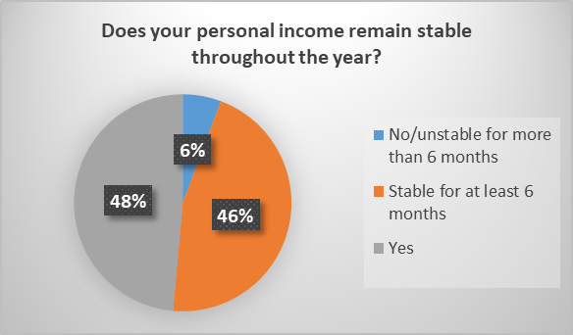
48% of beneficiaries believe that their personal income has increased, and 46% believe that income has remained stable during the previous 6 months. From this observation, given that there was no baseline assessment of the beneficiaries' income, we are not able to confirm any influence of the project on the personal income of the beneficiaries.

From whom can you take a loan if you need ?
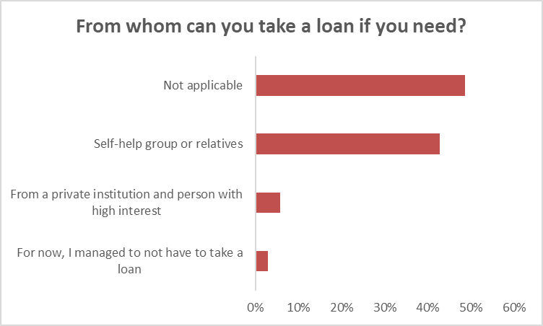
49% of survivors believe that they do not borrow money and 43% believe that they have recourse to private help when needed, from family or friends. This observation is understandable given the prevailing social context. Extreme poverty is widespread in these localities.

Do you decide how your personal income is spent ?
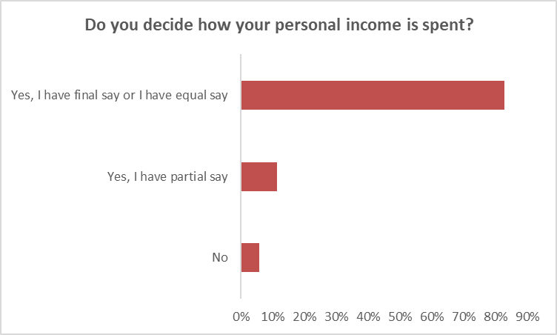
83% of GBV survivors believe that they have the last word or at least their opinion counts as much as that of their partner. This observation gives an idea of the level of emancipation of women in the community. It is important to specify that their personal income is mostly reused in the context of family well-being (having food, access to health care, school fees). We are not able to confirm a contribution of the project to this figure, although, thanks to the project, several women have embarked on a process of empowerment and are therefore in the process of increasing their income. Nevertheless, this observation reflects a high rate of reduction in “Resource Denial” in the community.

Do you decide how the household income is spent ?
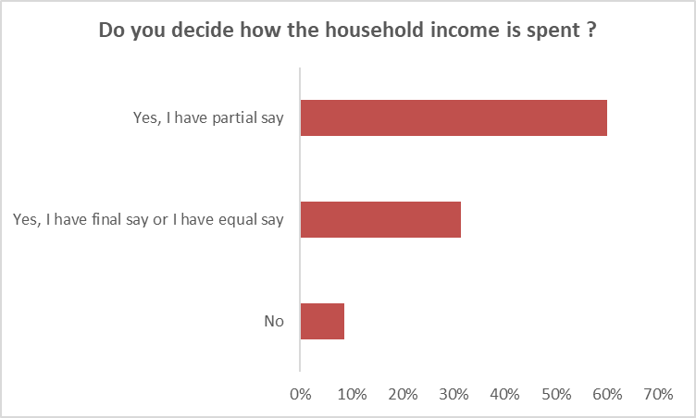
60% of GBV survivors believe they have a partial say in family income. This income comes from a contribution between their personal income and the income of the head of the family. 31% believe they have the last say on family income; by cross-referencing the data, these women are actually the heads of families themselves.

The analysis of the last two graphs reveals that in this community, women nevertheless have a say in family management. This is understandable because they are the ones who most often take care of the day-to-day tasks.

Do you feel safe to go outside of the village whenever you want?
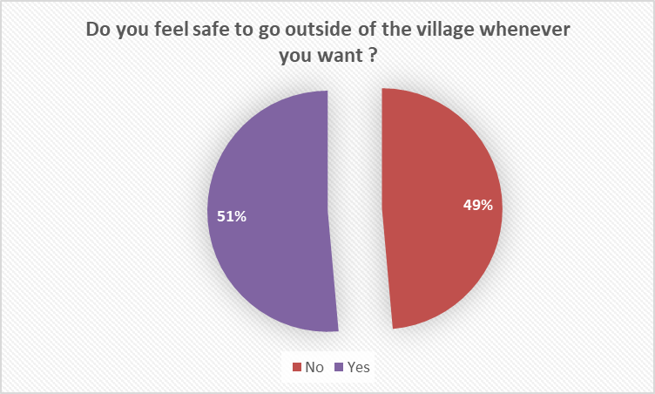
Opinions are practically shared with equal values with regard to outings outside the village. Indeed, although violent extremism continues to rage sporadically in the community, there has been a clear lull compared to previous years. This translates to nearly 51% of survivors feeling they feel safe leaving the village. It should be mentioned that these outings only occur at well-defined time intervals, in order to ensure their safety.

Would you report cases of gender based violence to the police/village leaders/ authority / CWCC?
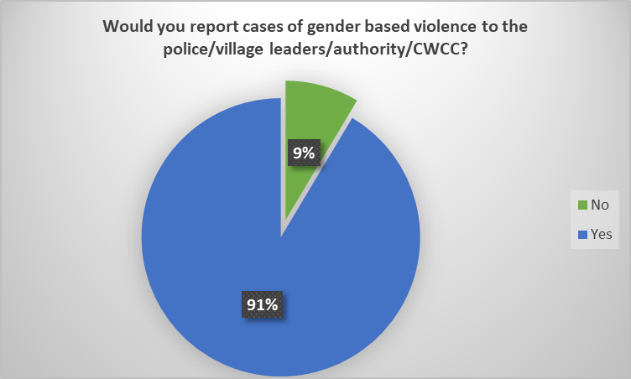
Nearly 91% of GBV survivors say they would report GBV. Although we cannot confirm to what extent this increased after the project intervention, this clearly indicates the lasting effects among the beneficiaries, it is reasonable to believe that the training addressed to them was relevant and achieved its objectives. Most of the stakeholders interviewed appreciate the GBV training, which confirms this high figure.

Women's resilience index (Nigeria)

Respondent Size (60)
What is your current marital status?

68% of surveyed women are married, and 15% are separated. It is important to clarify that most marriages in the community are religious marriages.

Relationship with the head of household in the family

Over 30% of the respondents are mother of the heads of households, indicating probably the older women took part in the survey. 20% of women in the community are heads of families.

Is there enough food in the household to feed everyone adequately throughout the year?

Only 15% of female survivors believe they have enough food to feed their family for the year.

Has your diet improved over the last 2 years ?

Only 28% of women survivors believe that their food security has increased during the two years of project intervention. 38% reported remaining the same and 34% in fact believe it has not improved or even decreased.

Does your personal income remain stable throughout the year ?

20% of beneficiaries believe that their personal income has stable throughout the year and 32% believe at least it has been stable for 6 months. Nearly a half of respondents reported that their incomes have been unstable for more than 6 months.

From whom can you take a loan if you need ?

Do you decide how your personal income is spent ?

77% of respondents believe that they have the last word or at least their opinion counts as much as that of their partner.

Do you decide how the household income is spent?

48% of respondents believe they have a final or equal say in family income. This trend was exactly the same among women who themselves are heads of the households.

Do you feel safe to go outside of the village whenever you want?

70% of survivors feeling they feel safe leaving the village while 30% don’t feel safe.

Would you report cases of gender based violence to the police/village leaders/ authority / CWCC?

Nearly 80% of the respondents say they would report GBV.

Annex 2. Women’s Organisations Leadership Self-Assessment Results

Note: Five WOs interviewed in Cameroon. In Nigeria, the field team did not target WO leadership, instead, individual women responded the survey which are sum up in two separate reports. As their experiences within the leadership roles vary, the findings from Nigeria may not fully represent the views/experiences of WOs senior levels.

NARRATIVE SELF ASSESSMENT QUESTIONNAIRE of Women’s Organisations
(Nigeria part 1 - Bade and Jakusko)
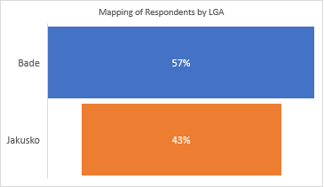
The figure above shows the disaggregation of respondents by LGA. Bade recorded 57% and Jakusko 43% of respondents respectively.

The figure above shows respondents response on the building platforms participated in. Respondents recorded 35% and 20% in Bade and Jakusko respectively in working groups, Local climate change commissions/committees recorded 20% and 13% in Bade and Jakusko respectively, while Local DRR committees/councils/platforms recorded 8% and 53% respectively in Bade and Jakusko LGA.

The figure above shows that 90% and 100% of respondents in Bade and Jakusko respectively participated in a needs assessment to inform recovery planning or a risk assessment to inform development planning. During the needs assessment, 97% and 60% of respondents in Bade and Jakusko reported that there were several women on the team, while 0% and 33% of respondents in Bade and Jakusko respectively reported that they were no women on the team.

THE FOLLOWING STATEMENTS ARE ABOUT ACCESS AND SAFETY ISSUES FOR WOMEN WHEN ENGAGING IN DISASTER AND CLIMATE RESILIENCE BUILDING, HUMANITARIAN COORDINATION/DECISION-MAKING PLATFORMS. PLEASE INDICATE THE EXTENT TO WHICH YOU AGREE OR DISAGREE.

The figure above shows that respondents 55% and 67% in Bade and Jakusko agree that women can actively participate and engage in relevant meetings, while 45% and 33% in Bade and Jakusko LGA respectively strongly agree that women can actively participate and engage in relevant meetings.

The figure above shows that 58% and 77% of respondents in Bade and Jakusko LGA strongly agree that it is safe for women to participate in relevant activities; while 43% and 23% of respondents in Bade and Jakusko LGA agree that it is safe for women to participate in relevant activities.

From the figure above, 65% and 53% of respondents in Bade and Jakusko LGA strongly agree that Key forums/meetings are conducted in local languages; while 35% and 47% of respondents in Bade and Jakusko LGA agree that Key forums/meetings are conducted in local languages.

From the figure above, 53% and 73% of respondents in Bade and Jakusko LGA strongly agree that Physical barriers to attending relevant meetings are actively addressed (e.g., transportation, internet, location); while 48% and 27% of respondents in Bade and Jakusko LGA agree that Physical barriers to attending relevant meetings are actively addressed (e.g., transportation, internet, location).

LEADERSHIP AND DECISION MAKING

The figure above shows approximately the percentage of leadership team that is comprised of women. 15% and 0% of respondents in Bade and Jakusko reported between 25 49%, while; 25% and 67% of respondents in Bade and Jakusko LGA reported between 50 to 74%, while; 60% and 33% of respondents in Bade and Jakusko respectively reported between 75 to 100% respectively.

The figure above shows that 75% and 93% of respondents in Bade and Jakusko LGA have a leadership role in disaster and climate resilience building, humanitarian forums/meetings, while; 25% and 3% of respondents in Bade and Jakusko LGA do not have a leadership role in disaster and climate resilience building, humanitarian forums/meetings.

THE FOLLOWING STATEMENTS ARE ABOUT HOW DISASTER AND CLIMATE RESILIENCE BUILDING, HUMANITARIAN SECTOR SUPPORT AND RECOGNISE THE CAPACITIES THAT WOMEN BRING TO DISASTER AND CLIMATE RESILIENCE PROGRAMMING. PLEASE INDICATE THE EXTENT TO WHICH YOU AGREE OR DISAGREE WITH THE FOLLOWING:

The figure above shows that 55% and 53% of respondents in Bade and Jakusko LGA agree that Stakeholders recognize the capacities women bring to disaster and climate resilience building and humanitarian activities, likewise, 45% and 43% of respondents in Bade and Jakusko LGA agree that Stakeholders recognize the capacities women bring to disaster and climate resilience building and humanitarian activities.

From the figure above, 70% and 57% of respondents in Bade and Jakusko LGA agree to have a clear decision-making role in disaster and climate resilience building and humanitarian forums; while 30% and 40% of respondents in Bade and Jakusko LGA strongly agree to have a clear decision-making role in disaster and climate resilience building and humanitarian forums.

The figure above shows that 45% and 33% of respondents in Bade and Jakusko LGA agree that there is targeted support to increase women’s capacity to engage in disaster and climate resilience building and humanitarian; while 55% and 67% of respondents in Bade and Jakusko LGA strongly agree that there is targeted support to increase women’s capacity to engage in disaster and climate resilience building and humanitarian.

The figure above shows that 55% and 45% of respondents in Bade and Jakusko LGA agree that there is targeted support for women to engage in disaster and climate resilience building and humanitarian actions in decision making; while 33% and 67% of respondents in Bade and Jakusko LGA strongly agree that there targeted support for women to engage in disaster and climate resilience building and humanitarian actions in decision making.

From the figure above, 60% and 30% of respondents in Bade and Jakusko LGA agree that there is targeted support for women to engage in disaster and climate resilience building and humanitarian actions in policy making; while 40% and 67% of respondents in Bade and Jakusko LGA strongly agree that there is targeted support for women to engage in disaster and climate resilience building and humanitarian actions in policy making.

From the figure above, 50% and 70% of respondents in Bade and Jakusko LGA agree that there is targeted support for women to engage in disaster and climate resilience building and humanitarian actions in planning; while 50% and 27% of respondents in Bade and Jakusko LGA strongly agree that there is targeted support for women to engage in disaster and climate resilience building and humanitarian actions in planning.

The figure above shows that 50% and 23% of respondents in Bade and Jakusko LGA agree that there is targeted support for women to engage in disaster and climate resilience building and humanitarian actions in programming; while 48% and 77% of respondents in Bade and Jakusko LGA strongly agree that there is targeted support for women to engage in disaster and climate resilience building and humanitarian actions in programming.

The figure above shows that 60% and 30% of respondents in Bade and Jakusko LGA agree that there is targeted support for women to engage in disaster and climate resilience building and humanitarian actions in monitoring and evaluation; while that 33% and 70% of respondents in Bade and Jakusko LGA strongly agree that there is targeted support for women to engage in disaster and climate resilience building and humanitarian actions in monitoring and evaluation.

From the figure above, 58% and 23% of respondents in Bade and Jakusko LGA reported no barriers to women’s leadership in disaster and climate resilience building and humanitarian; while 8% and 7% of respondents in Bade and Jakusko LGA reported lots of barriers to women’s leadership in disaster and climate resilience building and humanitarian; while 35% and 60% of respondents in Bade and Jakusko LGA reported that there are some barriers to women’s leadership in disaster and climate resilience building and humanitarian.

The figure above shows the main barriers to women’s leadership in disaster and climate resilience building and humanitarian in Bade and Jakusko LGA respectively.

The figure above shows that 80% and 63% of respondents in Bade and Jakusko LGA reported that they have influence in disaster and climate resilience building and humanitarian actions in local setting; while 15% and 23% of respondents in Bade and Jakusko LGA reported that they have influence in disaster and climate resilience building and humanitarian actions in sub-national setting; 5% and 13% of respondents in Bade and Jakusko LGA reported that they have influence in disaster and climate resilience building and humanitarian actions in national setting.

INFLUENCE AND ADVOCACY

The figure above shows that 58% and 10% of respondents in Bade and Jakusko LGA agree that they have influenced the development of national disaster and climate resilience building legislation, policies, standards, strategies and plans; while 43% and 90% of respondents in Bade and Jakusko LGA strongly agree that they have influenced the development of national disaster and climate resilience building legislation, policies, standards, strategies and plans.

The figure above shows that 65% and 40% of respondents in Bade and Jakusko LGA agree and believe disaster and climate resilience building policies and frameworks reflect the priorities and needs of women; while 35% and 60% of respondents in Bade and Jakusko LGA strongly agree and believe disaster and climate resilience building policies and frameworks reflect the priorities and needs of women.

The figure above shows that 70% and 17% of respondents in Bade and Jakusko agree that there organization influences prevention and preparedness activities to be gender responsive (i.e. consider the needs of all genders); while 28% and 83% of respondents in Bade and Jakusko strongly agree that there organization influences prevention and preparedness activities to be gender responsive (i.e. consider the needs of all genders).

The figure above shows that 65% and 57% of respondents in Bade and Jakusko LGA agree that there organization influences recovery activities ensuring they are gender responsive, i.e.. Consider the needs of all genders; while 35% and 43% of respondents in Bade and Jakusko LGA strongly agree that there organization influences recovery activities ensuring they are gender responsive, i.e.. Consider the needs of all genders.

CAPACITY

The figure above shows responses of respondents as to who defines the capacity needs in there organization. 38% and 3% of respondents in Bade and Jakusko LGA mentioned Our own organization; 20% and 13% of respondents in Bade and Jakusko LGA mentioned A combination of both; 43% and 83% of respondents in Bade and Jakusko LGA mentioned Partner organizations (international or national). 98% and 97% of respondents mentioned that who defines the capacity of there needs in their organizations is appropriate.

FUNDING

The figure above shows 48% and 50% respondents in Bade and Jakusko agree that their organization receives direct access to multi-year funding for disaster and climate resilience and humanitarian programming, while 53% and 50% respondents in Bade and Jakusko strongly agree that their organization receives direct access to multi-year funding for disaster and climate resilience and humanitarian programming.

The figure above shows 55% and 13% respondents in Bade and Jakusko agree that their organization is involved in decisions about budgets in relation to disaster and climate resilience and humanitarian programming, while 43% and 87% respondents in Bade and Jakusko strongly agree that their organization is involved in decisions about budgets in relation to disaster and climate resilience and humanitarian programming and 3% and 0% respondents in Bade and Jakusko disagree that their organization is involved in decisions about budgets in relation to disaster and climate resilience and humanitarian programming.

The figure above shows 63% and 38% respondents in Bade and Jakusko agree that Partners share project budgets and financial reports with them; while 83% and 17% respondents in Bade and Jakusko strongly agree that Partners share project budgets and financial reports with them.

NARRATIVE SELF ASSESSMENT QUESTIONNAIRE of Women’s Organisations
(Nigeria part 2 : Damaturu and Gashua)
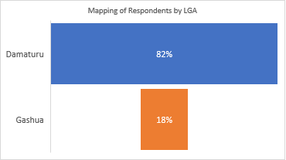
The figure above shows the disaggregation of respondents by LGA. Damaturu recorded 82% and Gashua 18% of respondents respectively.

The figure above shows respondents response on the building platforms participated in. Respondents recorded 45% and 30% in Damaturu and Gashua in Local DRR committees/councils/platforms respectively; Working Groups recorded 43% and 10% in Damaturu and Gashua respectively; Local climate change commissions/committees recorded 23% and 0% in Damaturu and Gashua respectively, while cluster groups recorded 23% and 40% respectively in Damaturu and Gashua LGA.

The figure above shows that 62% and 100% of respondents in Damaturu and Gashua respectively participated in a needs assessment to inform recovery planning or a risk assessment to inform development planning. During the needs assessment, 90% and 100% of respondents in Damaturu and Gashua reported that there were several women on the team, while 0% and 0% of respondents in Bade and Jakusko respectively reported that they were no women on the team.

THE FOLLOWING STATEMENTS ARE ABOUT ACCESS AND SAFETY ISSUES FOR WOMEN WHEN ENGAGING IN DISASTER AND CLIMATE RESILIENCE BUILDING, HUMANITARIAN COORDINATION/DECISION-MAKING PLATFORMS. PLEASE INDICATE THE EXTENT TO WHICH YOU AGREE OR DISAGREE.

The figure above shows that respondents 51% and 90% in Damaturu and Gashua strongly agree that women can actively participate and engage in relevant meetings, while 49% and 10% in Damaturu and Gashua respectively agree that women can actively participate and engage in relevant meetings.

The figure above shows that 57% and 80% of respondents in Damaturu and Gashua LGA strongly agree that it is safe for women to participate in relevant activities; while 43% and 20% of respondents in Damaturu and Gashua LGA agree that it is safe for women to participate in relevant activities.

From the figure above, 47% and 90% of respondents in Damaturu and Gashua LGA strongly agree that Key forums/meetings are conducted in local languages; while 47% and 10% of respondents in Damaturu and Gashua LGA agree that Key forums/meetings are conducted in local languages; only 6% of respondents in Damaturu disagree that Key forums/meetings are conducted in local languages.

From the figure above, 36% and 80% of respondents in Damaturu and Gashua LGA strongly agree that Physical barriers to attending relevant meetings are actively addressed (e.g., transportation, internet, location); 45% and 20% of respondents in Damaturu and Gashua LGA agree that Physical barriers to attending relevant meetings are actively addressed (e.g., transportation, internet, location); 17% and 0% of respondents in Damaturu and Gashua LGA disagree that Physical barriers to attending relevant meetings are actively addressed (e.g., transportation, internet, location).

LEADERSHIP AND DECISION MAKING

The figure above shows approximately the percentage of leadership team that is comprised of women. 13% and 10% of respondents in Damaturu and Gashua LGA reported between 25-49%, while; 40% and 50% of respondents in Damaturu and Gashua LGA reported between 50 to 74%, while; 26% and 40% of respondents in Damaturu and Gashua LGA respectively reported between 75 to 100% respectively.

The figure above shows that 90% and 34% of respondents in Damaturu and Gashua LGA have a leadership role in disaster and climate resilience building, humanitarian forums/meetings, while; 10% and 57% of respondents in Damaturu and Gashua LGA do not have a leadership role in disaster and climate resilience building, humanitarian forums/meetings; only 9% of respondents in Gashua reported I don’t know.

THE FOLLOWING STATEMENTS ARE ABOUT HOW DISASTER AND CLIMATE RESILIENCE BUILDING, HUMANITARIAN SECTOR SUPPORT AND RECOGNISE THE CAPACITIES THAT WOMEN BRING TO DISASTER AND CLIMATE RESILIENCE PROGRAMMING. PLEASE INDICATE THE EXTENT TO WHICH YOU AGREE OR DISAGREE WITH THE FOLLOWING:

The figure above shows that 40% and 10% of respondents in Damaturu and Gashua LGA agree that Stakeholders recognize the capacities women bring to disaster and climate resilience building and humanitarian activities, likewise, 34% and 90% of respondents in Damaturu and Gashua LGA strongly agree that Stakeholders recognize the capacities women bring to disaster and climate resilience building and humanitarian activities.

From the figure above, 38% and 20% of respondents in Damaturu and Gashua LGA agree to have a clear decision-making role in disaster and climate resilience building and humanitarian forums; while 26% and 80% of respondents in Damaturu and Gashua LGA strongly agree to have a clear decision-making role in disaster and climate resilience building and humanitarian forums; only 21% of respondents in Damaturu LGA disagree to have a clear decision-making role in disaster and climate resilience building and humanitarian forums.

The figure above shows that 55% and 103% of respondents in Damaturu and Gashua LGA agree that there is targeted support to increase women’s capacity to engage in disaster and climate resilience building and humanitarian; 32% and 0% of respondents in Damaturu and Gashua LGA strongly agree that there is targeted support to increase women’s capacity to engage in disaster and climate resilience building and humanitarian; only 9% of respondents in Damaturu LGA disagree that there is targeted support to increase women’s capacity to engage in disaster and climate resilience building and humanitarian; 4% of respondents in Damaturu LGA don’t know that there is targeted support to increase women’s capacity to engage in disaster and climate resilience building and humanitarian.

The figure above shows that 55% and 20% of respondents in Damaturu and Gashua LGA agree that there is targeted support for women to engage in disaster and climate resilience building and humanitarian actions in decision making; 0% and 80% of respondents in Damaturu and Gashua LGA strongly disagree that there targeted support for women to engage in disaster and climate resilience building and humanitarian actions in decision making; 32% and 0% of respondents in Damaturu and Gashua LGA strongly agree that there targeted support for women to engage in disaster and climate resilience building and humanitarian actions in decision making.

From the figure above, 55% and 10% of respondents in Damaturu and Gashua LGA agree that there is targeted support for women to engage in disaster and climate resilience building and humanitarian actions in policy making; 28% and 90% of respondents in Damaturu and Gashua LGA strongly agree that there is targeted support for women to engage in disaster and climate resilience building and humanitarian actions in policy making.

From the figure above, 49% and 20% of respondents in Bade and Jakusko LGA agree that there is targeted support for women to engage in disaster and climate resilience building and humanitarian actions in planning; while 50% and 27% of respondents in Bade and Jakusko LGA strongly agree that there is targeted support for women to engage in disaster and climate resilience building and humanitarian actions in planning.

The figure above shows that 53% and 10% of respondents in Damaturu and Gashua LGA agree that there is targeted support for women to engage in disaster and climate resilience building and humanitarian actions in programming; 30% and 90% of respondents in Damaturu and Gashua LGA strongly agree that there is targeted support for women to engage in disaster and climate resilience building and humanitarian actions in programming; 11% and 0% of respondents in Damaturu and Gashua LGA strongly agree that there is targeted support for women to engage in disaster and climate resilience building and humanitarian actions in programming;

From the figure above, 4% and 10% of respondents in Damaturu and Gashua LGA reported no barriers to women’s leadership in disaster and climate resilience building and humanitarian; while 28% and 20% of respondents in Damaturu and Gashua LGA reported lots of barriers to women’s leadership in disaster and climate resilience building and humanitarian; while 68% and 70% of respondents in Damaturu and Gashua LGA reported that there are some barriers to women’s leadership in disaster and climate resilience building and humanitarian.

The figure above shows the main barriers to women’s leadership in disaster and climate resilience building and humanitarian in Damaturu and Gashua LGA respectively.

The figure above shows that 72% and 20% of respondents in Damaturu and Gashua LGA reported that they have influence in disaster and climate resilience building and humanitarian actions in local setting; while 17% and 60% of respondents in Damaturu and Gashua LGA reported that they have influence in disaster and climate resilience building and humanitarian actions in sub-national setting; 11% and 20% of respondents in Damaturu and Gashua LGA reported that they have influence in disaster and climate resilience building and humanitarian actions in national setting.

The figure above shows that 45% and 20% of respondents in Damaturu and Gashua LGA agree that they have influenced the development of national disaster and climate resilience building legislation, policies, standards, strategies and plans; 34% and 80% of respondents in Damaturu and Gashua LGA strongly agree that they have influenced the development of national disaster and climate resilience building legislation, policies, standards, strategies and plans; 13% and 0% of respondents in Damaturu and Gashua LGA disagree that they have influenced the development of national disaster and climate resilience building legislation, policies, standards, strategies and plans.

The figure above shows that 53% and 30% of respondents in Damaturu and Gashua LGA agree and believe disaster and climate resilience building policies and frameworks reflect the priorities and needs of women; 40% and 70% of respondents in Damaturu and Gashua LGA strongly agree and believe disaster and climate resilience building policies and frameworks reflect the priorities and needs of women; 4% and 0% of respondents in Damaturu and Gashua LGA disagree and believe disaster and climate resilience building policies and frameworks reflect the priorities and needs of women.

The figure above shows that 49% and 20% of respondents in Damaturu and Gashua LGA agree that there organization influences prevention and preparedness activities to be gender responsive (i.e. consider the needs of all genders); 45% and 80% of respondents in Damaturu and Gashua LGA strongly agree that there organization influences prevention and preparedness activities to be gender responsive (i.e. consider the needs of all genders); 4% and 0% of respondents in Damaturu and Gashua LGA disagree that there organization influences prevention and preparedness activities to be gender responsive (i.e. consider the needs of all genders).

The figure above shows that 49% and 40% of respondents in Damaturu and Gashua LGA agree that there organization influences recovery activities ensuring they are gender responsive, i.e. Consider the needs of all genders; 47% and 60% of respondents in Damaturu and Gashua LGA strongly agree that there organization influences recovery activities ensuring they are gender responsive, i.e. Consider the needs of all genders; 2% and 0% of respondents in Damaturu and Gashua LGA disagree that there organization influences recovery activities ensuring they are gender responsive, i.e. Consider the needs of all genders.

CAPACITY

The figure above shows responses of respondents as to who defines the capacity needs in there organization. 36% and 10% of respondents in Damaturu and Gashua LGA mentioned Our own organization; 38% and 10% of respondents in Damaturu and Gashua LGA mentioned A combination of both; 26% and 50% of respondents in Damaturu and Gashua LGA mentioned Partner organizations (international or national). 91% and 100% of respondents in Damaturu and Gashua mentioned that who defines the capacity of their needs in their organizations is appropriate.

FUNDING

The figure above shoes that 34% and 90% of respondents in Damaturu and Gashua LGA strongly agree their organization receives direct access to multi-year funding for disaster and climate resilience and humanitarian programming; 23% and 10% of respondents in Damaturu and Gashua LGA agree their organization receives direct access to multi-year funding for disaster and climate resilience and humanitarian programming; 19% and 0% of respondents in Damaturu and Gashua LGA don’t know their organization receives direct access to multi-year funding for disaster and climate resilience and humanitarian programming.

The figure above shoes that 34% and 90% of respondents in Damaturu and Gashua LGA strongly agree their organization is involved in decisions about budgets in relation to disaster and climate resilience and humanitarian programming; 32% and 10% of respondents in Damaturu and Gashua LGA agree their organization is involved in decisions about budgets in relation to disaster and climate resilience and humanitarian programming; 13% and 0% of respondents in Damaturu and Gashua LGA don’t know their organization is involved in decisions about budgets in relation to disaster and climate resilience and humanitarian programming; 15% and 0% of respondents in Damaturu and Gashua LGA disagree their organization is involved in decisions about budgets in relation to disaster and climate resilience and humanitarian programming.

The figure above shoes that 30% and 40% of respondents in Damaturu and Gashua LGA agree their organization is involved in decisions about budgets in relation to disaster and climate resilience and humanitarian programming; 28% and 60% of respondents in Damaturu and Gashua LGA strongly agree organization is involved in decisions about budgets in relation to disaster and climate resilience and humanitarian programming; 11% and 0% of respondents in Damaturu and Gashua LGA don’t know their organization is involved in decisions about budgets in relation to disaster and climate resilience and humanitarian programming; 1% and 0% of respondents in Damaturu and Gashua LGA disagree that their organization is involved in decisions about budgets in relation to disaster and climate resilience and humanitarian programming and 11% and 0% of respondents in Damaturu and Gashua LGA strongly disagree that their organization is involved in decisions about budgets in relation to disaster and climate resilience and humanitarian programming;

NARRATIVE SELF ASSESSMENT QUESTIONNAIRE of Women’s Organisations (Cameroon)
PARTICIPATION
Q1. 20% of the respondents participated in local DRR committees/councils/platforms and 40% participated in either cluster group meeting or sub-working group meeting. 40% reported having meetings with ALVF and 20% just noted meeting.

Q2 and Q3. 80% participated in a needs assessment to inform recovery planning or a risk assessment to inform development planning and 100% of respondents confirmed that there were several women in the team during the needs assessment.
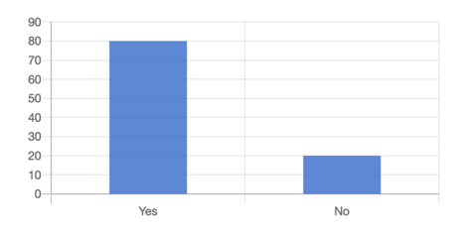
Q4. All respondents reported that women can actively participate and engage in relevant meetings (strongly agree – 60%, agree – 40%).
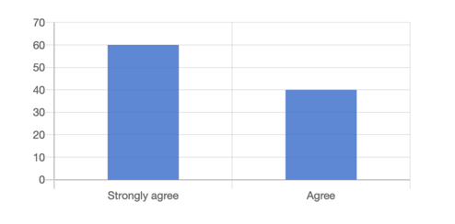

Q5. All respondents reported that it is safe for women to participate in relevant activities (strongly agree – 60%, agree – 40%).
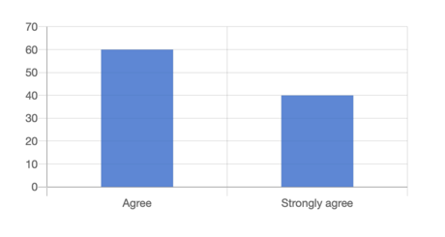
Q6. All respondents confirmed that key forum and meeting are conducted in local languages (strongly agree – 20%, agree – 80%).
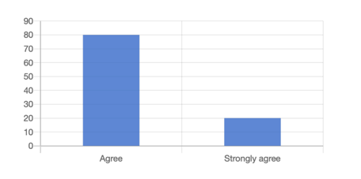
Q7. All respondents agreed that physical barriers to attending relevant meetings are actively addressed such as transportation, internet, location (strongly agree – 20%, agree – 80%).
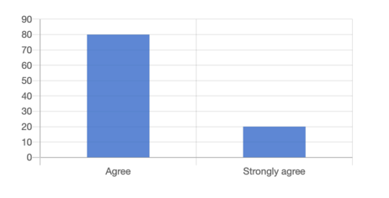
LEADERSHIP AND DECISION MAKING
Q8. The respondents confirmed high representation of women at the leadership level within their organisations. 40% reported that 75-100% of women representation and 60% reported between 50-74% of women representation.
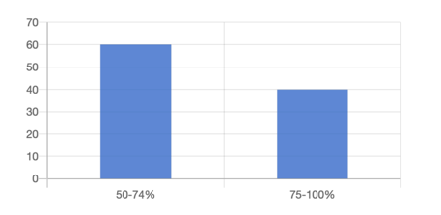
Q9. Only 10% of the respondents reported that they have a leadership role in disaster and climate resilience building, humanitarian forums/meetings. The rest (90%) did not consider themselves having leadership roles.
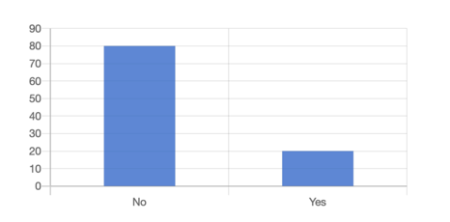
Q10. 80% of the respondents agreed that stakeholders recognise the capacities women bring to disaster and climate resilience building and humanitarian activities. While 40% of them strongly agreed, 20% believed that stakeholders do not recognize the capacities of women.
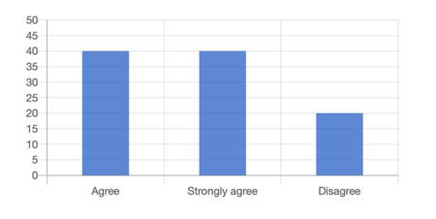
Q11. The respondents widely believed to have a clear decision-making role in disaster and climate resilience building and humanitarian forums (80%). Only 20% did not confirm their decision-making role.
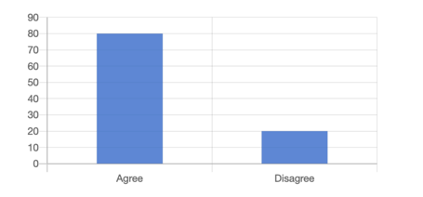

SUPPORTS FOR WOMEN’S ORGANISATIONS
Q12. The majority of the respondents agreed that there is targeted support to increase women’s capacity to engage in disaster and climate resilience building and humanitarian (strongly agree – 40%, agree – 40%), with 20% disagreed.
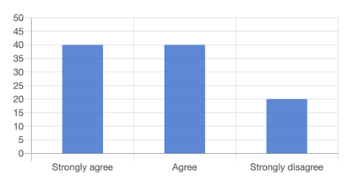

Q13. 80% of the respondents reported that there is targeted support for women to engage in decision making on disaster and climate resilience building and humanitarian actions (strongly agree – 40%, agree – 40%), with no response from one organisation.
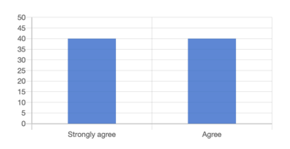

Q14. 60% of the respondent reported that there is no target supports for women to engage in policy making on disaster and climate resilience building and humanitarian actions. Only 40% acknowledged such support.
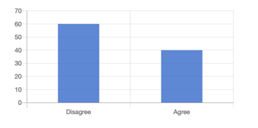

Q15. 60% of the respondent reported that there is no target supports for women to engage in planning on disaster and climate resilience building and humanitarian actions. Only 40% acknowledged such support.
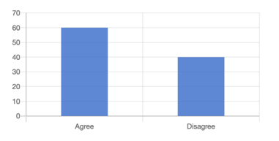

Q16. All respondents reported that there is targeted support for women to engage in programming on disaster and climate resilience building and humanitarian actions.
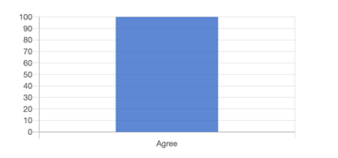
Q17. The majority of the respondents reported that there is targeted support for women to engage in monitoring and evaluation (strongly agree – 40%, agree – 20%), while 20% did not acknowledge such a support.

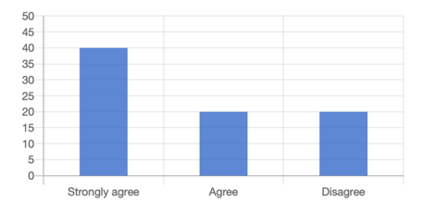

Q18. 80% of the respondents reported lots of barriers to women’s leadership in disaster and climate resilience building and humanitarian while 20% reported that there are some barriers to women’s leadership in disaster and climate resilience building and humanitarian.

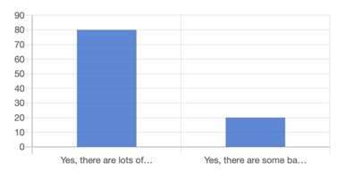

Q19. On their perceived barriers, 60% reported that no funding available for women’s organisation to attend meetings and events. 40% reported that women feel uncomfortable in male-dominated forums/meetings. 20% reported don’t feel safe physically or culturally in forums/meetings, not invited to forums/meeting and women not supported by authorities respectively.

INFLUENCE AND ADVOCACY
Q20. The majority of the respondents considered that they have influenced in disaster and climate resilience building and humanitarian actions, primarily at the local level, then at the sub-national level. Fewer organisations considered they have influenced at the national level.

1st choice | 2nd choice | 3rd choice
Local level (80%) | Sub-national level (100%) | National level (80%)
National level (20%) |  | Local level (20%)

Q21. More than a half of the respondents (strongly disagree – 20%, disagree – 40%) felt that they have not influenced the development of national disaster and climate resilience building legislation, policies, standards, strategies and plans; while 40% felt that they have influenced.
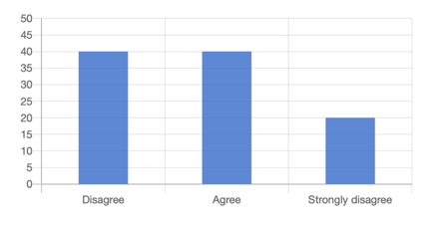

Q22. 80% believed that disaster and climate resilience building policies and frameworks reflect the priorities and needs of women (strongly agree – 20%, agree – 60%) while 20% did not believe disaster and climate resilience building policies and frameworks reflect the priorities and needs of women.
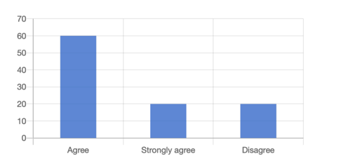
Q23. The majority of the respondents (80%) reported that their organisations have influenced prevention and preparedness activities to be gender responsive (i.e., consider the needs of all genders).
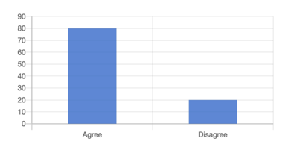
Q24. In comparison with the above response (Q23), fewer respondents (60%) felt that their organisations have influenced recovery activities to be gender responsive (i.e., consider the needs of all genders). Nearly a half of the respondents felt that their organisations have not influenced recovery activities to be gender responsive.
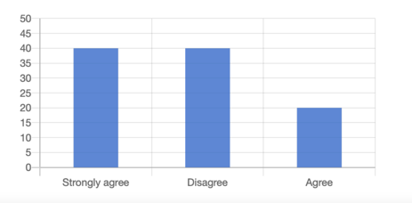

CAPACITY OF WOMEN’S ORGANISATIONS
Q25. 80% reported that their own organisations defined the capacity needs of their organisations. 20% reported their partner organisations (international or national) defined the capacity needs.
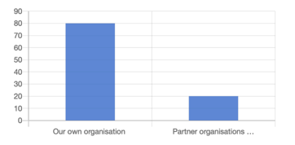

Q26. One organisation was positive about their partner organisation to conduct their capacity assessment. Meanwhile, the responses about conducting own capacity assessment were split, 50% considered it was not appropriate and another 50% consider it was appropriate.

FUNDING
Q27. 40% of the respondents reported their direct access to multi-year funding. The majority of the respondents confirmed that their organisations don’t have direct access to multi-year funding for disaster and climate resilience and humanitarian programming.
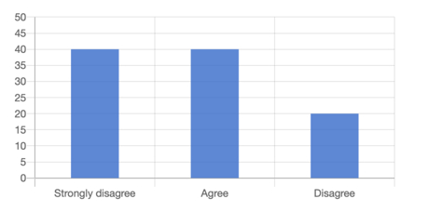

Q28. Only 20% of the respondents reported that their organization is involved in decisions about budgets in relation to disaster and climate resilience and humanitarian programming. Significantly higher percentage of the respondents felt that they are excluded from the budgeting process (strongly disagree – 60%, disagree – 20%).
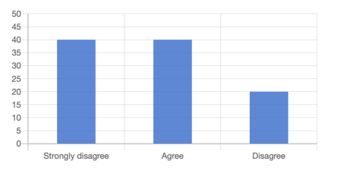

Q29. 40% of the respondents reported that partners share project budgets and financial reports with them. While 20% of the respondents disagreed, 40% reported they do not know.
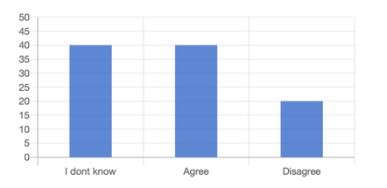

Annex 3. List of documents requested for desk review and its availability for the evaluation
(red, not provided)
National Strategies (Laws, Policies, action plans, reviews of action plans etc)
- Cameroons National Development Strategy
- Women’s empowerment/Gender
- Disaster Risk Reduction
- Gender Based Violence reduction
UN Women previous project final reports and recommendations
Pre-design documents,
- End of (previous) UN Women project reports and recommendations
- Regional/National Needs Assessment
LCB Project Documents
- Program logic
- Budget

UN Women project documents
- Periodical reports (UN Women)
- Periodical reports (Implementing partners)
- Capacity/gap assessment of women’s organization conducted prior to training
Overall training plan
- Training guidelines and session plans
Training Evaluation
Evidence of skill/knowledge improvement (pre/post-test, KAP survey, etc.
- Selection criteria of the beneficiaries per activities
- Market assessment/Business opportunity reports
- Press releases, case-studies, web-site articles
- Local, regional, or global workshop report
LCB Project Partner documentation
- Pre-selection assessment/governance/financial capacity assessment
- Partner checklists
- Partner capacity building plans
UN Women LCB Management tools
- Senior Management Team participation list, agenda’s, minutes, action points
- Management issues logs
- Finance reports /BVA’s
- Project Monitoring and evaluation (MEAL) plan and tools
- Gender markers and periodic reports
- Output/ Indicator Performance tracking tools (eg. IPPT)
AAP/Safeguarding Policy and SOP’s
- AAP issue log, investigation reports, action plans, and updates
- Country/Region Security reports
- COVID-19 preparedness documentation/SOP’s/Policies
- COVID-19 updates/internal reports
UN Women Global WRD program related tools and documents
UN Women SoP on cash-based intervention and GBV survivor referral pathway/SOP
Protection Cluster/GBV/Cash Working group meeting agenda and minutes
Cluster or Working group national SoP on cash-based intervention
National dialogue/policy (GBV, Gender, Cash, etc.) meeting minutes
Regional coordination body (LCB Commission, AU, etc.) guidelines/policy documents
Regional annual plans and reports
Information on Partner organizations, Strategies, Policies, pre-selection assessment
- Facility management guideline/ GBV referral system guidance
Individual SADD Project beneficiary database
- Project beneficiary lists by activity and location

Annex 4. List of informants for individual interviews
Stakeholders interviewed (Global/Regional)
No. | Stakeholders | Manager/Occupation | Organization
1 | UN-Women | LCB Programme Manager | UN-Women

Stakeholders interviewed (Cameroon)
No. | Stakeholders | Manager/Occupation | Organization
1 | UN-Women | CO Cameroon | UN-Women
2 | Local project implementation partner | President ALVF-EN | ALVF-EN
3 | Local project implementation partner | Livelihood Assistant | ALVF-EN
4 | Local project implementation partner | Project coordinator assistant | ALVF-EN
5 | Institutional partners | Regional Delegate of MINPROFF, Far North | MINPROFF
6 | Institutional partners | Departmental Delegate of MINPROFF, Far North | MINPROFF
7 | Institutional partners | Kolofata District Delegate | MINPROFF
8 | Regional partners | National Social Cohesion Expert, UNDP, Far North | UNDP
9 | Regional partners | UNFPA Expert, Far North | UNFPA
10 | Clusters | Project Coordinator | CARE International
11 | Clusters | Expert at PLAN International | PLAN International
12 | Community leaders | Lamido of Kolofata | Locality of KOLOFATA
13 | Community leaders | UEC Pastor of Gance, Kolofata | Locality of KOLOFATA
14 | Community leaders | Kolofata District Hospital | Locality of KOLOFATA
15 | Community leaders | President of the GIC Amida de Gance, Kolofata | Locality of KOLOFATA
16 | Community leaders | President of the "Mediators" association of Kolofata | Locality of KOLOFATA
17 | Community leaders | Kerawa UEEC Pastor | Locality of KERAWA
18 | Community leaders | Lamido of Kerawa | Locality of KERAWA
19 | Community leaders | Imam of Kerawa | Locality of KERAWA
20 | Community leaders | Head of Kerawa Integrated Health Center | Locality of KERAWA
21 | Community leaders | President of the "Dynamic Women" association of Kerawa | Locality of KERAWA
22 | Community leaders | President of the "MOURABA" association of Kerawa | Locality of KERAWA

Stakeholders interviewed (Nigeria)
No. | Stakeholders | Manager/Occupation | Organization
 | UN Women | Deputy Country Representative | UN Women
 | Local project implementation partner | Director of CCDRN
 | Local project implementation partner | Sasakawa Africa, Technical Coordinator, Business Development
 | Local project implementation partner | Ministry of Women Affairs, Dir of Planining, Research Statistics | Damaturu
 | Local project implementation partner | Ministry of Women Affairs, ,Dir of Finance | Damaturu
 | Local project implementation partner | Ministry of Women Affairs, GBV officer | Damaturu
 | Local project implementation partner | Dir of Humanitarian | Damaturu
 |  | Ministry of Women Affairs, ,Dir of Women | Damaturu
 | Institutional partners | Nigerian Police/SPRO Yobe State | Damaturu
 |  | International Federation of Women Lawyers (FIDA), Chairperson | Damaturu
 |  | Ministry of Agriculture/Senior Superintendent officer | Gashua
 |  | Ministry of Budget and Economic Planning/Chief Planning Officer
 |  | Bade, LGA Women Head in Agriculture, Bade LGA | Bade
 |  | ADP Chairman | Bade
 |  | LGA Desk Officer (Community Development Officer) | Bade

Organization | Email | Point of Contact | Telephone | Address
Child protection and Women Empowerment Initiative - CPWEI | gambomaryamhassan@gmail.com | Maryam Hassan Gambo | 8037257282 | No. B1 kamala Plaza Besides Model/College of Agric G.R.A Damaturu
Gender and constitutional reform network | falmatamaina7@gmail.com |  | 8106652239 |  | Gujba Road Damaturu
Forum for promotion of gender equity and moral values | fatimahamshi@gmail.com | Fatimah Ahmad Amshi | 8036229173 | Opposite yobechildrens academy along gashua road Damaturu yone state
Women and Youth Empowerment Initiative | hibrahim@woyeinngo@gmail.com | Hajiya Husna Ibrahim | 8036848750 | Abba Ibrahim Quarters, behind Danburga filling station, by Gujba Road, Damaturu, Yobe State
FIDA NIGERIA YOBE | altinei@yahoo.com | ALTINE IBRAHIM | 8033867158 | HIGH COURT 3 YOBE STATE
IYALI COMMUNITY DEVELOPMENT ASSOCIATION | iyalicda@gmail.com | HauwaBubaGwary | 2.35E+12 | Plot N0.18, Ali Marami Potiskum/Gashua bypass road, Damaturu Yobe State.
Rural Empowerment Acceleration Programme REAP | maryvaugustine@gmail.com | Mary Vassumu Augustine | 8036301758 | Dougerie Yola.
Centre for women and Adolescent empowerment yola | hauwajjr@gmail.com | HauwaHamisuHamajoda | 7060563359 | Galadima Quarters yola Town
Alheri Peace Building and | Hajjaganabukar3@gmail.com | HajjaganaBukar | 7061264569 | No B38 Don Etebet Housing Estate Damaturu Yobe State.
Female Emancipation League | fatsumadada@gmail.com | Dr. Fatsuma Dada Mohammed | 8036254610 | F56 Alimarami Housing Estate, off Gashua Road, Damaturu
Female Role Model Initiative ( FROMI) | halimaamshi@yahoo.com | Halimatu Waziri Laminu | 8036269076 | No.165 LGA Shopping Complex Bukar Abba Ibrahim Way, Maiduguri Road Damaturu
Women Led CSOs Network Yobe State | womenledcsos.yobestate@gmail.com | Maryam Aje | 8080250052 | Behind Danburga Filling Station Abba Ibrahim Gujba Road Damaturu
African Youths for Peace Development and Empowerment Foundation | info@afrydev.org | Maryam Aje | 8067658135 | No 22 opposite Yobe state printing press Maiduguri Road Damaturu

Annex 5. Evaluation Matrix
Relevance / PERTINENCE
1 | Evaluation Question | Sub-Questions | Methodologies and required documents/resource
1.1 | Were the programmatic approaches and strategies appropriate to address the problem and to achieve planned results?  Les approches et stratégies programmatiques étaient-elles appropriées pour résoudre le problème et obtenir les résultats prévus ? | - Does ToC make a sense to achieve intended results?  - Are approaches/strategies in lines with the global trends, UNW, SDGs, national action plans?  - Anything significant aspects missed or overlooked?  - How interrelating between country components, global/regional components (Knowledge management/evidence-collection) are contributing to country level?  - Y ‘a-t-il une adéquation entre la chaine de résultats du projet et les problèmes identifiés ?  - Les stratégies d’intervention du projet ont-elles été de nature à apporter des solutions ? | Desk Review  - Prodoc, periodical reports, event reports  - Government strategies, action plans and policies (women empowerment, GBV reduction, DRR)  - UN Women WRD programme, related documents and tools  Key Informant Interviews (KII)  - Gov officials  - Cluster Coordinators or relevant
1.2 | To which extend did the project respond to the needs and the priorities of the target beneficiaries?  Dans quelle mesure le projet a-t-il répondu aux besoins et les priorités des bénéficiaires cibles ? | - Identified needs and priorities in the need assessment are addressed?  (access to service, social protection, economic opportunity, skills/leadership were there?)  - Anything significant needs/priorities missed or overlooked? | Desk Review  - a needs assessment  - Any reports indicating women/WO’s involvements in selection of the interventions  Key Informant Interviews  - Local authorities  - WO representatives  Focus Group Discussion  - Local community members  Analyse des rapports de suivi du projet  - enquête quantitative et qualitative auprès des bénéficiaires sur base des indicateurs majeurs du projet (Entre autres comparaison baseline vs Endline)
1.3 | Contents of the training and capacity building initiatives are relevant to the target audience and appropriate level?  Le contenu des initiatives de formation et de renforcement des capacités est-il pertinent pour le public cible et au niveau approprié ? | - A capacity assessment of the beneficiaries conducted to inform training/CB component?  - Is there a structured plan in training/CB component?  - Satisfaction level of the participants?  - Es ce que les éléments de contenus utilisés pour les renforcement de capacité répondent effectivement aux besoins des différents publics cibles ?  - Es ce que la forme dans laquelle ce contenu est délivrée est appropriée | Desk Review  - A capacity assessment of the beneficiaries  - Training/CB plan  - Training evaluation reports  - Knowledge/skill tools (participants evaluation/pre-post test/KAP conducted?)  Key Informant Interviews  - UNW team  - Implementing partners  - WO representatives  - Government officials  Focus Group Discussion  - Beneficiary  - Questionner les différents bénéficiaires sur leur appréciation des contenus et de la forme dans laquelle ce contenu est livré
1.5 | Business kits/opportunities options offered are relevant to the target groups and to the given environments?  Les idées d'affaires/d'opportunités offertes sont-elles pertinentes pour les groupes cibles dans l’environnement donné? | - A capacity assessment of the beneficiaries and market/business opportunity conducted  - Selection of business options are relevant?  - How was the beneficiary selection decided and selection criteria was relevant?  - Did it contribute to diversifying income sources?  - Existe une analyse du marché et une analyse coût bénéfice préalable au choix des idées d’entreprise par les bénéficiaires ?  - Les idées/projets d’investissement prennent ils en compte la condition des bénéficiaires ?  - Comment l’environnement (socio – économique et anthropologique) accueille-t-il les initiatives entrepreneuriales des bénéficiaires | Desk Review  - A capacity assessment of the beneficiaries  - An assessment of market/business opportunity  - Selection criteria  - End of project reports  - Case studies  Key Informant Interviews  - Implementing partners  - WO  - Government officials  Beneficiary Quick Survey  Focus Group Discussion  - Beneficiary  - Local community members  Apprécier les idées d’affaires/d’opportunités proposés au regards des capacités des populations cibles ainsi que de l’environnement dans lequel elles se trouve :  - Consultation éventuelle des business plans  - Analyse de l’étude de marché (si existant)  - Discussions avec les bénéficiaires et personnes ressources  - Analyse des cas
1.6 | Cash-Based intervention are designed according to the country contexts and did not pose any threats to the targeted women?  Les interventions monétaires sont conçues en fonction des contextes nationaux et n'ont posé aucune menace pour les femmes ciblées ? | - Compliant with CBI protocols/SoP/cluster guidelines/MEB?  - How was CBI modality decided?  - Did it contribute to diversifying income sources?  - any concerns about risks of giving money to women  - Comment se sont effectués les opérations de cash transfert eu égard au contexte local ?  - Les bénéficiaires se sont-ils senti menacés et exposés à un moment donné dans le processus ? Quelle a été la nature de ces menaces ? Comment cela a été géré par le projet ?  - Quels ont été les défis relevés dans le cadre de ces opérations ? | Desk Review  - National or cluster CBI protocols or SoP  - UNW’s CBI SoP  - Issues logs or monitoring reports  Key Informant Interviews  - Implementing partners  - Government officials  - Cluster coordinators or equivalent  Beneficiary Quick Survey  Focus Group Discussion  - Beneficiary  Reconstituer le processus des transferts de fonds et identifiés les problèmes éventuels survenus à travers :  - La consultation des rapports de suivi  - L’entretien avec les personnes ressources y compris l’équipe projet  - Enquête auprès des bénéficiaires suivant un procédé garantissant leur sécurité

Effectiveness / EFFICACITE
2 | Evaluation Question | Sub-Questions | Methodologies and required documents/resource
2.1 | To what extent were the expected outcomes achieved and how did UN Women contribute towards these?.  Dans quelle mesure les résultats attendus ont-ils été atteints et comment ONU Femmes y a-t-elle contribué ? | - Based on outputs achieved by the project, the expected outcomes are happening in Nigeria/Cameroon?  - If the expected outcomes are not happening, why?  - Quel est la proportion d’atteinte des résultats ?  - Qu’es ce qui justifie ce niveau d’&atteinte de résultats ?  - Quel a été la valeur ajoutée d’UNWOMEN ?  - Quelles leçons à tirer ? | -Sur base des rapports de suivi et notamment le tableau de suivi des indicateurs, faire une analyse comparative entre les indicateurs des résultats prévus et ce qui est effectivement réalisé  -Discussion avec les personnes ressources du projet et les bénéficiaires et autres parties prenantes pour identifier les leçons apprises
2.2 | What are the key challenges encountered during the project implementation including the impact of COVID-19? What were the adaptation strategies put in place by UNW and partners to ensure effective implementation of the project?  Quels sont les principaux défis rencontrés lors de la mise en œuvre du projet y compris l'impact de la COVID-19 ?  Quelles ont été les stratégies d'adaptation mis en place par ONU Femmes et les partenaires pour s’assurer de la mise en œuvre efficace du projet? | - How were the key challenges mitigated?  - The key challenges encountered could have been identified earlier.  - Decreased income/mobility of women limited the impact of the project?  Quels défis pour les stratégies du projet ?  Quels défis pour les publics cibles et bénéficiaires ?  Comment le Covid _ 19 a influencé la mise en œuvre du projet ?  Quelles ont été les approches d’adaptation prise par le projet ? pour quelle efficacité ? | Desk review  - Periodical reports, amendment requests  - Seuciryt reports, issue logs  Key Informant Interviews  - UNW team  - Implementing partners  - WO  - Government officials  - Exploitation des rapports de suivi  - Discussion avec diverses parties prenantes y compris les bénéficiaires  - Analyse des stratégies du projet sous période Covid_19

Efficiency / EFFICIENCE
3 | Evaluation Question | Sub-Questions | Methodologies and required documents/resource
3.1 | To what extent does the management structure of the project support efficiency for programme implementation?  Dans quelle mesure la structure de gestion du projet appuie-t-elle l'efficacité de la mise en œuvre du programme ? Le processus était-il suffisamment inclusif du point de vue du LNOB ? | - What are the project management structure/system (board meetings, management set-up, tools, finance tracker, output tracker, etc.) in place?  - Which monitoring mechanism (especially feedback mechanism) is in place (frequency, tools)?  - Communication and coordination was perceived as smooth by the stakeholders?  Quel a été l’appui apporté l’unité de gestion du projet ? quel a été la contribution de cet appui aux résultats du projet ? Qu’es ce qui peut être identifié comme les manquements de cet appui ? Jusqu’ou les personnes marginalisées ont-elles été impliquées dans le projet ? | Desk Review  - Prodoc – management structure  - Board meeting minutes  - Finance reports  - Monitoring tools/reports, issues trackers  Key Informant Interviews  - UNW team  - Implementing Parners  - Government officials  Analyse de la fonctionnalité, des mécanismes de gestion et de la fluidité de la communication (temporalité – efficacité – précision – pertinence – fréquence) – analyse des supports et relais de communication – mis en relief des facteurs explicatifs  - Analyse des approches d’inclusion du projet

Sustainability / DURABILITE
4 | Evaluation Question | Sub-Questions | Methodologies and required documents/resource
4.1 | What is the likelihood that the benefits from the programme will be maintained for a reasonably long period of time when the program ceases?  Quelle est la probabilité que les avantages du programme soient maintenus pendant une période raisonnablement longue lorsque le programme cesse ? | - Increased social protection could be maintained?  - Increased skill/knowledge could be maintained?  - Diversified income source could continue?  - Access to service through infrastructure build through the project?  - Networks/CoP created could be maintained?  Quels déterminants de la durabilité du programme ? quel a été le niveau d’appropriation des acquis du projet ? | Key Informant Interviews  - UNW team  - WO  - Government officials  Beneficiary Quick survey  Focus Group Discussion  - Beneficiary  - Local community members  Identification et Analyse des déterminants de durabilité des acquis du projet
4.2 | Have capacities of implementing partners and other actors developed? In which area and how?  Les capacités des partenaires de mise en œuvre et des autres acteurs ont-elles été développées ? Dans quel domaine et comment ? | At the women group level, the five areas prioritized by UN Women (Transformative leadership, safe and meaningful participation, collective influencing, and advocacy, enabling partnerships, capacity development and leadership, funding) had been addressed?  Improved knowledge and skills are measured? (Potentially conduct UNW leadership tool assessment jointly with WO), particularly on GBV?  Dans quelle mesure le projet a-t-il soutenu les acteurs sur le terrain ? quelle en a été la valeur ajoutée ? | Desk Review  - Capacity Development plan  - Knowledge products development and dissemination plan  - Knowledge/skill tools (participants evaluation/pre-post test/KAP conducted?)  - UN Women Leadership Development Tool  Key Informant Interviews  - UNW team  - WO  - Government officials  - Cluster coordinators or equivalent  Analyse des activités de renforcements des capacités des parties prenantes et notamment appréciation de la dimension durable des livrables de ces activités

Gender Quality and Human Rights / EGALITE DES GENRES ET DES DROITS HUMAINS
5 | Evaluation Question | Sub-Questions | Methodologies and required documents/resource
5.1 | To what extent have gender and human rights considerations been integrated into the project design and implementation?  Dans quelle mesure les considérations de genre et de droits humains ont-elles été intégrées dans la conception et la mise en œuvre du projet ? | - Identified gender and human rights issues are incorporated into the project design?  - (e.g., gender dimension assessment, rights awareness sessions, access to service/opportunities, etc.)  - Any markers used to inform the project design?  - Any reported cases of gender right violation, human right violation?  Appréciation des marqueurs genre du projet – Quel a été le niveau de prise en compte du genre dans la conception et la mise en œuvre du projet ? Quelles sont été les stratégies déployées prenant en compte cette approche ? quels ont été les résultats obtenus? | Desk Review  - Assessment reports  - Gender markers so similar  - Issue logs, monitoring reports, security reports  Key Informant Interviews  - UNW team  - Implementing partners  - WO  Analyse du processus de conception du projet et du caractère « Gender Mainstream » - Analyse des marqueurs genre du projet

Annex 6. Data collection tools

Focus Group Discussion (FGD) Guide
(With wider community participation, including women and men)
- For other men in the community: How has the project supported your community to:
  - Prepare and prevent GBV
  - Access referrals for any survivor of GBV
  - Group activities that provide Psychosocial support
  - Legal aid for survivors
  - Have the services provided been accessible to all the people at risk or in need?

- For women in the groups: How has the project supported your community to
  - Prepare and prevent GBV
  - Access referrals for any survivor of GBV
  - Group activities that provide Psychosocial support
  - Legal aid for survivors
  - Have the services provided been accessible to all the people at risk or in need?
- Did the project address the needs of women and communities?
- Is there anything critical but the project didn’t address?
- How appropriate was the business development component of the project?
- How many of the businesses are succeeding? (Number or percentage)
- How are community people using the women Centre/markets?
  - How busy is it?
  - What services does it offer?
  - How often do you go?
- Are there any concerns that achievements through the project may not continue in your areas in the following areas or likely to continue?
- Increased social protection
- Increased skill/knowledge of women and men, and leadership of women
- Diversified income source
- Access to service through infrastructure

Community Leaders Questionnaire (CLQ)
Relevance To what extent was the projects suited to the priorities, interests of the beneficiaries, and policies of local and national authorities, donors, and other partners.
Key evaluation Questions
Q1. To which extend did the project respond to the needs and the priorities of the target beneficiaries?
Local representatives
- Did the project address the needs of women and communities?
- Is there anything critical but the project didn’t address?

Q2. Contents of the training and capacity building initiatives are relevant to the target audience and appropriate level?
Individual women and men who participated in project trainings

- How satisfied are you with the training?
- Do you think they were at the right level for you and your colleagues?
- What has changed for you after the trainings?
- How has the material been used in your daily or work-related life?

Q3. Business kits/opportunities options offered are relevant to the target groups and to the given environments?
Local representatives
- Who did UN women consult with about business development before the project started?
- How appropriate was the business development component of the project?
- How many of the businesses are succeeding? (Number or percentage)

Individual women who participated in business opportunities
- How appropriate was the business development component of the project for you?
- Are your businesses succeeding? (Number or percentage)

Effectiveness: Is the intervention achieving its objectives? The extent to which the intervention achieved, or is expected to achieve, its objectives and its results, including any differential results across groups.
Q1. To what extent were the expected outcomes achieved and how did UN Women contribute towards these?
Individual women who participated in the project
- What does the women’s Centre /market rehabilitation mean to you?
  - How busy is it? What services does it offer?
  - How often do you go?

Q2. What are the key challenges encountered during the project implementation including the impact of COVID-19? What were the adaptation strategies put in place by UNW and partners to ensure effective implementation of the project?
- What were the key challenges your community faced with the outbreak of COVID-19?
- What impact did COVID have on the UNW project activities?
- Outside of COVID-19, what challenges did the UNW project face?
- How were they managed?
- Were the mitigation measures successful
- What challenges couldn’t be overcome and impacted on the project?
- What could you do differently next time?
Women Group Questionnaire (WGQ)
Relevance To what extent was the projects suited to the priorities, interests of the beneficiaries, and policies of local and national authorities, donors, and other partners.
1. Were the programmatic approaches and strategies appropriate to address the problem and to achieve planned results?
- Did the project address the needs of women and communities?
- Is there anything critical but the project didn’t address?

2. Contents of the training and capacity building initiatives are relevant to the target audience and appropriate level?
- Were you consulted on the contents/approach of the training and capacity building activities before they were presented?
- Were the contents/approach of the training are relevant or useful for your organisation? Or yourself?
- How satisfied are you with the training?
- Anything to improve?
3. Business kits/opportunities options offered are relevant to the target groups and to the given environments?
- How were you involved in deciding what business support (kits/opportunities) the project provided?
- How were you involved in developing selection criteria?
- How appropriate was the business development component of the project, give the business environment, situation of women/men and education levels? ?
- How do you rate success of the business supports and why?

4. Cash-Based intervention are designed according to the country contexts and did not pose any threats to the targeted women?
- How were you consulted in the design phase?
- Did anyone express any concerns around security for women receiving the cash-based interventions?
Effectiveness: Is the intervention achieving its objectives? The extent to which the intervention achieved, or is expected to achieve, its objectives and its results, including any differential results across groups.
1. To what extent were the expected outcomes achieved and how did UN Women contribute towards these?.

- Can you tell us how the UNW project has increased women’s voice and leadership in disaster preparedness and response?
  - Can you share examples of where your membership has been able to participate in meetings and challenge norms or inequalities?
- Can you describe any examples of where your membership has reported feeling unsafe to raise issues of gender in disaster and climate resilience meetings?
- Can you give an example of where the UNW project has helped you reduce the risks to women being vocal – ensuring their safe participation?

4. What are the key challenges encountered during the project implementation including the impact of COVID-19? What were the adaptation strategies put in place by UNW and partners to ensure effective implementation of the project?
- What were the major challenges during the project implementation?
- How did COVID-19 affect the implementation of the UNW project?
- What were the adaptation strategies you adopted to protect your team and partners?
- Was there any assistance UNW gave you to accommodate those challenges?
- Did anyone else help?
  - In what way

Efficiency: How well are resources being used? The extent to which the intervention delivers, or is likely to deliver, results in an economic and timely way.
1. To what extent does the management structure of the project support efficiency for program implementation?
- How did UN Women teams engage with you over the past few years?
- What was your role in project implementation and monitoring the project?
  - What meetings did you attend?
  - Were you copied on any minutes?
  - Did you receive any reports? If yes, which ones?
- Has there been a mechanism where you can raise any concerns of share any ideas?
  - What was it and?
  - How well did it work?
- What was best about the way they worked?
- Where were their inefficiencies? How did they impact on the project implementation?
Sustainability: Will the benefits last? The extent to which the net benefits of the intervention continue or are likely to continue. Includes an examination of the financial, economic, social, environmental, and institutional capacities of the systems needed to sustain net benefits over time
1. What is the likelihood that the benefits from the program will be maintained for a reasonably long period of time when the program ceases?

- Are there any concerns that achievements through the project may not continue in your areas in the following areas or likely to continue?
  - Increased social protection
  - Increased skill/knowledge of women and men, and leadership of women
  - Diversified income source
  - Access to service through infrastructure

2. Have capacities of implementing partners and other actors developed? In which area and how? (let’s make a combined Q on training, etc and make a reference to outcome 2) ---- most question we included under training and CB.

- How as the UNW Capacity development process helped you to be more effective
- What partnerships have you been able to establish during the project
- What activities do you undertake yourself (your organization) to support the sustained development of women’s participation in disaster and climate resilience?

Gender Equality and Human Rights
1. To what extent have gender and human rights considerations been integrated into the project design and implementation?
- Has the project addressed gender and human rights issues present in your community?
- Have there been any human rights issues you encountered during the project implementation

2. To what extent, needs and priorities of persons with disabilities been integrated into the project design and implementation? as the process inclusive enough from the LNOB perspective?
- How did the project manage the insecurity and challenge of reaching women in areas not under government control?
- What risks did your team face and what was the strategy to reach them?
- Were there areas which despite your best intentions, women remained out of reach to your team?
- Reflecting on the real challenges you faced, which vulnerable groups do you feel were least well supported?
- What could be done differently next time to improve their inclusion?

Government Stakeholders Questionnaire (GSQ)
Relevance To what extent was the projects suited to the priorities, interests of the beneficiaries, and policies of local and national authorities, donors, and other partners.
Key evaluation Questions
1. Were the programmatic approaches and strategies appropriate to address the problem and to achieve planned results?

- Did the UNW project align its activities with your development agenda?
- How would you evaluate the effectiveness of the interventions? Which were the best, which less so and why?
- What was the level of consultation by UNW during the design phase of the project?

2. Were the Contents of the training and capacity building initiatives relevant to the target audience and appropriate level?
- How satisfied are you with the training?
- Are there significant improvements in knowledge, attitudes, skills and capacities among the WO?
- Which areas, both individual and organisation levels, what are remaining capacity gaps among the WO? How best it could be enhanced for the WO to be self-driven and self-managed?
3. Business kits/opportunities options offered are relevant to the target groups and to the given environments?
- How were you involved in discussions about developing women’s business kits & opportunities?
- How appropriate was the business development component of the project?
- How does this match the government priorities? (move this under relevance)

4. Cash-Based intervention are designed according to the country contexts and did not pose any threats to the targeted women?
- Did UNW consult with you before starting the cash grant program?
- What problems were encountered if any?
- What could be done to improve it next time?

Effectiveness: Is the intervention achieving its objectives? The extent to which the intervention achieved, or is expected to achieve, its objectives and its results, including any differential results across groups.
1. To what extent were the expected outcomes achieved and how did UN Women contribute towards these?
- Do you think outcome 1 achieved? Any evidence? Do you think outcome 2 achieved? Any evidence?
- Do you think the project has successfully reached women at risk?
- Has the construction or rehabilitation of a center successfully become a focus for women to access information on social protection, training in livelihood services or income opportunities?
- What indicator is there that women leaders have become more empowered and able to influence relevant systems, engage in planning and use tools they received during training

2. What are the key challenges encountered during the project implementation including the impact of COVID-19? What were the adaptation strategies put in place by UNW and partners to ensure effective implementation of the project?
- What were the key challenges you faced implementing the UNW directly attributable to COVID-19?
- What was the overall impact of COVID-19 on the delivery of the UNW project?

Efficiency: How well are resources being used? The extent to which the intervention delivers, or is likely to deliver, results in an economic and timely way.
1. To what extent does the management structure of the project support efficiency for program implementation?
- What was your role in project implementation and monitoring the project?
  - Which project documents were shared with you?
  - What meetings did you attend?
  - Were you copied on any minutes?
  - Did you receive any reports? If yes, which ones?
- Can you give examples of how they worked well with you?
- Are there examples where the efficiency was less than ideal?

Sustainability: Will the benefits last? The extent to which the net benefits of the intervention continue or are likely to continue. Includes an examination of the financial, economic, social, environmental, and institutional capacities of the systems needed to sustain net benefits over time
1. What is the likelihood that the benefits from the program will be maintained for a reasonably long period of time when the program ceases?
1. Are there any concerns that achievements through the project may not continue in your areas in the following areas or likely to continue?
- Increased social protection
- Increased skill/knowledge of women and men, and leadership of women
- Diversified income source
- Access to service through infrastructure

2. Have capacities of implementing partners and other actors developed? In which area and how?
- Which areas of the Gov staff knowledge, attitudes, skills, and capacities among the gov staff on gender equality improved? Provide examples?
- What changes have you seen in your agencies ability to challenge gender norms and inequality during the UNW project?
- What internal barriers do you think the project has been able to help you overcome?
- How far would you say you have been able to take a transformative leadership role
- Which areas, both individual and organisation levels, what are remaining capacity gaps among the Gov on gender equality?
- Have you seen any significant improvements in knowledge, attitudes, skills and capacities among the WO? Can you describe them?

Project Team Questionnaire (PTQ)
Relevance To what extent was the projects suited to the priorities, interests of the beneficiaries, and policies of local and national authorities, donors, and other partners.
1. Contents of the training and capacity building initiatives are relevant to the target audience and appropriate level?
- How did you determine the training agenda?
2. Business kits/opportunities options offered are relevant to the target groups and to the given environments?
- How did you decide the options of business kits?
- What was the selection process for beneficiaries to receive the kits or trainings?

3. Cash-Based intervention are designed according to the country contexts and did not pose any threats to the targeted women?
- How were the cash-based interventions designed in each country?
  - How Were there any conversations on the value, conditions or frequency of grants was decided?
  - Did you follow CBI protocols/SoP/cluster guidelines/MEB in the country?
  - Any previous experiences of UN Women or other agencies on CBI were reflected in the design? If so, how?
- Were there any concerns about risks of giving money to women?
  - If yes, how were the risks managed/mitigated

Effectiveness: Is the intervention achieving its objectives? The extent to which the intervention achieved, or is expected to achieve, its objectives and its results, including any differential results across groups.
1. To what extent were the expected outcomes achieved and how did UN Women contribute towards these?.
- Can you show any evidence that the project has contributed to a successful increase in resilience to future natural disasters or helped recover from past ones?
  - Are there any examples from Cameroon you can share?
  - And from Nigeria?

2. What are the key challenges encountered during the project implementation including the impact of COVID-19? What were the adaptation strategies put in place by UNW and partners to ensure effective implementation of the project?
- What are major challenges during the project implementation?
- How did you mitigate?
- Are similar concerned/situations happened earlier?
- Overall, how would you describe the impact of COVID-19 on the success of the project

Efficiency; How well are resources being used? The extent to which the intervention delivers, or is likely to deliver, results in an economic and timely way.
1. To what extent does the management structure of the project support efficiency for programme implementation?
- To what extent did the management structure of the project support efficiency for programme implementation?
- Could you list up the project management structure/system (board meetings, management set-up, tools, finance tracker, output tracker, etc.)?
- What problems were encountered, how did the team guarantee efficiency, provide evidence?

Sustainability: Will the benefits last? The extent to which the net benefits of the intervention continue or are likely to continue. Includes an examination of the financial, economic, social, environmental, and institutional capacities of the systems needed to sustain net benefits over time
1. What is the likelihood that the benefits from the program will be maintained for a reasonably long period of time when the program ceases?
- Explain the system in place to ensure sustainability of the components of the project?
  - Increased social protection
  - Capacity building of WO
  - Increased income
  - Increased access to service offered at the constructed buildings

2. Have capacities of implementing partners and other actors developed? In which area and how? (let’s make a combined Q on training, etc. and make a reference to outcome 2) ---- most question we included under training and Capacity Building.
- How have you seen the leadership of Women led organizations develop during the project
- Which women’s organization is successfully advocating and influencing other organizations in their work area?
  - Who are the engaged with?
  - Which meetings, networks, decision making fora and coordination mechanisms do they participate in?
- Which women’s organizations have engaged in advocacy and at which level (community, local national or regional) Can you give examples?
- Can you give any examples of which of your partner women’s organizations have developed targeted activities to support women’s capacity and climate resilience on their own during the program?

Gender Equality and Human Rights
1. To what extent have gender and human rights considerations been integrated into the project design and implementation?
- Could you provide concrete examples showing how the project included gender considerations? (e.g., gender dimension assessment, rights awareness sessions, access to service/opportunities, etc.)
- What gender markers have been used
- Have there been any human rights issues you encountered during the project implementation

2. To what extent, needs and priorities of persons with disabilities been integrated into the project design and implementation? as the process inclusive enough from the LNOB perspective?
- Could you provide concrete examples of how the project included people living with disability into the program
- What was the strategy to reach under areas controlled by Boko Haram/non-government-controlled areas/controlled by armed groups?
- How successful was it?
- Which groups do you feel you were still unable to reach?

Annex 7. Evaluation Terms of Reference (TORs)



Evaluation Team Leader (International Consultant)
Final evaluation of the Strengthening Women’s Resilience
in Lake Chad Basin (LCB) programme

Location: Home-Based
Type of Contract: SSA Consultancy
Languages Required: English
Expected Duration of the Assignment: 25 working days
Starting Date: 1 April 2022
Expected Duration of Assignment: 1 April – 30 August 2022

Project Title
Strengthening Women’s Resilience in Lake Chad Basin (LCB) programme

B. Project Description
Grounded in the vision of equality enshrined in the Charter of the United Nations, UN Women works for the elimination of the discrimination against women and girls; the empowerment of women; and the achievement of equality between women and men as partners and beneficiaries of development, human rights, humanitarian action, peace and security and disaster risk reduction.

Through its focus on prevention and resilience building, UN Women ensures that new and existing disaster risks are mitigated by putting women at the center of disaster risk reduction, by giving them a voice, empowering them as disaster risk reduction leaders and actors, and by building their resilience. Evidence proves that majority of victims and those affected by disasters are women. Due to the gendered dimensions of disaster risk, women and girls face greater vulnerability and exposure to disasters, yet women remain largely ignored and their capacities, unleveraged in conventional disaster risk reduction processes.

UN Women promotes gender-responsive disaster risk reduction and resilience building through technical and policy support, provision of gender expertise to disaster risk reduction mechanisms and processes, and by implementing global programmes and projects for gender-responsive disaster risk reduction and resilience building, including Global Programme on Women’s Disaster Resilience to Disasters (WRD). The programme proposes a comprehensive package for women’s resilience to disasters that focuses on rendering prevention, preparedness, and response systems, plans and tools gender-responsive and provides targeted actions enabling women and girls to withstand natural hazards, recover fully from disasters and increase their resilience to future natural hazards. The initiative influences policy change for gender-responsive disaster prevention, preparedness and recovery, enhances accountability, generates catalytic action, and produces practical lessons learned and best practices for upscaling and replication.

Under the WRD framework and UN Women’s Leadership Empowerment Access and Protection (LEAP) program, a global project ‘Promoting women’s resilience’ has been implemented in the Lake Chad Basin Region (LCB) since April 2020, covering Nigeria and Cameroon, complemented by a West Africa regional component and a global knowledge management, normative and coordination component. The LCB programme aims to provide a comprehensive package for women’s and girls’ resilience that focuses on rendering prevention, preparedness, and humanitarian/crisis response systems/plans gender-responsive addressing gender gaps, inequalities, and discrimination.

Under Outcome 1, activities at the country level provided immediate life-saving and essential services as well as capacity building to affected population, in particular women and girls affected by or at risk of conflict and climate change in implementing countries. This initiative promotes women’s access to livelihood and economic opportunities, access to cash for work initiatives, economic diversification and micro-business development skills through responding to women’s immediate and mid/long-term needs and while making them and their communities more resilient. Through the development and/or rehabilitation of infrastructure, women, and girls from host, IDPs and refugee communities will be able to access; training centers, empowerment hubs with comprehensive service packages, food processing facilities and/or market spaces for livelihood opportunities, economic empowerment, and resilience. As majority of the population depends on agriculture, this project integrated training and other programmatic interventions on Climate Smart Agriculture (CSA) and improved food/nutrition security. Based on the UN Women’s Global Leadership Empowerment Access and Protection (LEAP) methodology, livelihood services were paired with a GBV component and a key focus was placed on prevention, as addressing GBV is a precondition for women and girls’ meaningful and safe participation in economic activities, skills development, and access to services. For GBV survivors, UN Women focuses on referrals for individual cases, psycho-social support through group activities, legal aid and GBV prevention through addressing gender norms in the community.

Under Outcome 2, UN Women’s programmatic approach aimed to promote the leadership, and capacity of women’s leaders to engage in and influence national and international decision-making forums on disaster risk reduction (DRR), humanitarian and crisis response. UN Women ensured continued technical support to Civil Society Organizations (CSOs) and other partners and in particular, women-led organizations to develop and review gender-responsive DRR and humanitarian policies and plans, thereby increasing coherence among different policy and normative frameworks and commitment to gender mainstreaming across the HDP nexus.

The project logical framework, targets and intended outcome/output indicators
Outcome 1: Crisis affected women and girls are prepared to withstand crises, recover from these and increase their resilience to future crisis
Outcome indicator 1: No of women at risk who have used spaces where GBV protection, livelihood services and income opportunities are provided (Target: 2710)
Indicator 2: Percentage of women and girls reporting new sources of income and livelihood opportunities and improved GBV protection services (Target: 80%)
Output 1.1: Marginalized and impoverished women at risk have access to social protection, livelihood services and income opportunities. | Activity 1.1.1  Indicator: No of women at risk receiving trainings and reporting on increased capacities and skills as a result of UN Women supported training.  Target: 690 (345 each for Cameroon and Nigeria for 2 years)  Activity 1.1.2  Indicator: No of women that have access to business kits in support of their micro-entrepreneurship activities  Target: 600* (300 each for Cameroon and Nigeria for 2 years)*including same individuals as activity 1.1.1  Activity 1.1.3  Indicator: No of national and/or local authorities reached through strategic dialogue sessions in the targeted areas Target: 100 (50 each for Cameroon and Nigeria for 2 years)  Activity 1.1.4  Indicator: Storage facility in place with the support of UN Women (Target: Yes)  Indicator: No of women who benefited from the safe and women friendly space and services (Target: 510)  Activity 1.1.5  Indicator: Rehabilitated empowerment hub in place and accessible to crisis affected women and girls (Target: Yes) Indicator: No of women benefited from services provided in the empowerment hub (Target: 1000)  Activity 1.1.6  Indicator: Gender sensitive market facilities in place Baseline (Target: Yes)  Indicator: No of women who reported having benefited from the safe market facilities and accessible women friendly space as a result of UN Women's support (Target: 510)  Indicator: Percentage of women vendors that have expressed satisfaction with the services/ infrastructure provided through the safe market (Target: 80%)
Output 1.2 Crisis affected women and girls increasingly access cash for work opportunities. | Activity 1.2.1  Indicator: No of inventory developed (Target: 2)  Indicator: No of women and women's organizations that contributed to the development of inventory  Activity 1.2.2  Indicator: No of stakeholders reached through dialogue on gender considerations of cash for work initiatives in the affected communities (Target: 200 (100 each for Cameroon and Nigeria for 2 years))  Indicator: No of stakeholders committed to gender-responsive cash for work initiatives (Target:5)  Activity 1.2.3  Indicator: No of women participating in focus group discussions (Target:70 (35 each for Cameroon and Nigeria for 2 years))  Indicator: No of set of recommendations emerging from the focus group discussions with women and women's local organisations (Target:2)  Activity 1.2.4  Indicator: No of crisis affected women with access to information on cash for work opportunities  Target:90 (45 each for Cameroon and Nigeria for 2 years)
Output 1.3: Women have access to GBV and protection services through comprehensive service packages. | Activity 1.3.1  Indicator: No of community members reached through the discussions (Target: 720 (360 each for Cameroon and Nigeria for 2 years))  Indicator: No of new community initiatives on ending GBV with UN Women's interventions (Target: 2)  Indicator: Number of ethnic groups reached through the discussion (Cameroon)  Activity 1.3.2  Indicator: No of women and girls who benefited from referral and psycho-social support (PSS), legal services for GBV survivors, especially through Empowerment Hubs  Target: 320 (160 each for Cameroon and Nigeria for 2 years)  Activity 1.3.3  Indicator: No of women, men, girls and boys who have increased access to information and knowledge on GBV related issues (Target: 310 (155 each for Cameroon and Nigeria for 2 years))  Indicator: Percentage of women, men boys and girls who report increased knowledge on the root cause of GBV (Cameroon) Target: 80%  Activity 1.3.4  Indicator: Percentage of protection actors service providers, and national institutions reporting increased skills, knowledge and capacities to implement gender-responsive GBV policies and systems.  Target: 80%  Activity 1.3.5  Indicator: Women's Empowerment Center in place with the support of UN Women (Target: Yes)  Indicator: No of women used this building (Target: 1000)  Indicator: Percentage of women and girls reporting increased knowledge on prevention and response to GBV and enhanced livelihood skills as a result of services they benefited from at the Centre (Target: 80%)
Outcome 2: Prevention, preparedness and recovery systems, plans and tools are gender-responsive and inclusive through enhancing women’s leadership, and decision-making, and building the capacity of women’s leaders and key stakeholders

Outcome indicator 1: Percentage of women leaders reported empowered and equipped to influence relevant systems, plans and tools to be gender-responsive and inclusive (Target: 80%)
Indicator 2: No of humanitarian policies, plans, or tools that have been amended to incorporate gender-responsive elements. (Target:4 (2 per country))
Indicator 3: Percentage of women organizations reporting increased knowledge to influence gender-responsive prevention, preparedness and recovery systems and plans (Cameroon) (Target: 80%)
Output 2.1 Women develop skills and capacities to engage and influence decision-making processes and policy frameworks across the Humanitarian Development Nexus. | Activity 2.1.1  Indicator: No of women leaders that have received trainings for both Cameroon and Nigeria (Target: 96 women (48 each for Cameroon and Nigeria for 2 years))  Indicator: Percentage of women leaders reporting increased knowledge on gender-responsive humanitarian response, DRR and livelihood and GBV assistance in both Cameroon and Nigeria as a result of trainings (Target:80%)  Activity 2.1.2  Indicator: No of mapping developed out of women's organizations existing in the country  Target: 2 (1 each for Cameroon and Nigeria for 2 years)  Activity 2.1.3  Indicator: No. of humanitarian policies or response plans reviewed through technical support to women leaders, government officials and CSOs on gender-related elements, considerations and priorities  Target: 4 (1 per country, region and global)  Activities 2.1.4  Indicator: Percentage of women's organizations' representatives that attended the training and attest to increased knowledge  Target: 80%(international level)  Indicator: No. of women who have conducted step down session with their peers on gender-responsive resilience building. (Nigeria)
Output 2.2 Knowledge, including recommendations and best practices, as well as expertise for gender-responsive resilience building is available, accessible and widely disseminated. | Activity 2.2.1  Indicator: No of trainers that emerge from the global event on gender transformative DRR and humanitarian response tools and methodologies  Target: 16  Activity 2.2.2  Indicator: No of decision makers that adopt commitments to gender transformative DRR and HA/CR policies and strategies as result of the high level fora

The programme implementation period is for two years (April 2020 – March 2022) with a total budget of USD 2,392,344.50. UN Women is therefore looking for the services of an independent international consultant to carry out the final evaluation of the LCB programme lead the evaluation team assigned to conduct the final evaluation of the LCB project. The team will consist of one international (team leader) and two national consultants (Nigeria and Cameroon).

C. Purpose of the Evaluation
The evaluation will assess improvements in project participating countries by reviewing the programme design, implementation arrangements and achieved results and outcomes. It will assess progress of the programme against stated outputs and outcomes, as well as identify valuable lessons and recommendations to further expand on and scale-up the work on gender-responsive humanitarian action and disaster risk reduction.

The evaluation will be an independent evaluation and conducted by a team of external consultants. The evaluation is being undertaken towards the completion of programme implementation. The final evaluation is a mandatory activity articulated in the project document and the agreement signed with the Government of Japan, a donor for the project. The evaluation report will be posted on the Global Accountability and Tracking of Evaluation Use (GATE System). The key users and target audience of the evaluation include the Government of Japan, relevant ministries of the national and local governments in Nigeria and Cameroon, regional organisations, CSOs and women-led organisations.

D. Objectives
The main objectives of the Evaluation are as follows:
- Analyse programme outcomes and assess effectiveness of the approach and strategies used by the programme to increase women’s resilience to crises.
- Examine programme results in relation to the intended outcomes and outputs and identify the strengths and weaknesses in programme design and implementation.
- Assess how the regional and global components of the project contributed to UN Women’s global learning and partnership enhancement.
- Examine critical factors that enable and/or hinder effective achievement of intended results, and provide recommendations on how to address and/or leverage these critical factors.
- Draw good practices and key lessons on the role/contribution of partnerships in the achievement of planned outputs and outcomes.
- Document lessons learned and best practices and provide recommendations to inform future work on women’s resilience building.
- Assess potential for sustainability of the on-going work in programme countries.

Key evaluation questions
Relevance
- Were the programmatic approaches and strategies appropriate to address the problem and to achieve planned results?
- To which extend did the project respond to the needs and the priorities of the target beneficiaries?
- Contents of the training and capacity building initiatives are relevant to the target audience and appropriate level?
- Business kits/opportunities options offered are relevant to the target groups and to the given environments?
- Cash-Based intervention are designed according to the country contexts and did not pose any threats to the targeted women?

Effectiveness
- To what extent were the expected outcomes achieved and how did UN Women contribute towards these?
- What are the key challenges encountered during the project implementation including the impact of COVID-19? What were the adaptation strategies put in place by UNW and partners to ensure effective implementation of the project?

Efficiency
- To what extent does the management structure of the project support efficiency for programme implementation?

Sustainability
- What is the likelihood that the benefits from the programme will be maintained for a reasonably long period of time when the program ceases?
- Have capacities of implementing partners and other actors developed? In which area and how?

Gender Equality and Human Rights
- To what extent have gender and human rights considerations been integrated into the project design and implementation?
- Was the process inclusive enough from the LNOB perspective?

E. Scopes
Project implementation: The scope will include the project design, implementation and management, lessons learned, replicability and recommendations for current and future programmes and initiatives.

Involvements of stakeholders/Key informants: Given the natures of multiple levels project implementation (global, regional and country levels), the wide range of stakeholders and key informants shall be included during the evaluation process.
- Beneficiaries
- UN Women project teams
- Government counterparts (line ministries and local administrations)
- Implementing partners (Nigeria and Cameroon)
- Womens organisations
- Humanitarian agencies/cluster coordinators (UN and NGOs who are working on resilience, GBV and Protection, women leadership and cash based intervention)
- Regional partners (AU, LBAC, ARC, etc)

Timeframe: The Evaluation will cover the programme implementation from April 2020 – March 2022.

Geographic scope: The Evaluation will assess global, regional and country-level (Nigeria and Cameroon) programme components.

F. Evaluation design (process and methods)
The evaluation will adhere to the principles established in Evaluation Policy and guidelines of UN Women, and UNEG Norms and Standards and Ethical Code of Conduct. These should include but not limited to: independence, impartiality, transparency, ethics, partnerships, credibility and utility.

a. Methods
The Evaluation will be a transparent and participatory process and will use a mixed-methods approach, primarily qualitative, that aligns with the final matrix of questions (to be completed by the Evaluation team in consultation with the Reference Group). However, it will also include quantitative data collection/analysis as feasible. The evaluation will be based on gender and human rights principles, as defined in the UN Women Evaluation Policy, and adhere to the United Nations norms and standards for evaluation in the UN System.
Under the circumstances of the COVID-19, the evaluation process will maximize participatory approach in a strictly COVID-19 safety observed manner. Technical proposal must be explicit on measures taken to secure safety of the beneficiaries and the evaluation team. The financial proposal is encouraged to indicate necessary equipment and costs (hand sanitizers, masks, etc) during data collection activities.
Other tools of qualitative data collection (such as ‘Most Significant Change’) could be considered, the consultant is expected to propose some participatory evaluation tools/methodologies.
Sample size and selection criteria shall be included in the technical proposal.
The following data sources may be utilized, with data triangulated to ensure validity and reliability:
- Desk review of documents
- Review of the existing data
- Data collection with beneficiaries
- Key informant interview and/or focus group discussions with the stakeholders (in country)
- Key informant interview and/or focus group discussions with the stakeholders (regional/global levels)

b. Evaluation process to be carried out by the Evaluation Team (respective tasks to be inserted into a table)
Inception Phase:
- Kick off meeting with the Evaluation Reference Group to clarify evaluation scopes, timeframe, deliverables.
- Conduct an initial desk review of available documents.
- Review existing baseline data to determine the scale and types of data collection activities with the beneficiaries.
- Conduct interviews (via Microsoft teams or phone, etc) with key internal and external stakeholders to refine the Evaluation scope and develop the evaluation methodology.
- Draft an Inception Report to be reviewed by the Evaluation Reference Group.
- Refine the Evaluation question matrix based on feedback and integrate proposed changes (as appropriate) into the final inception report.
- Draft data collection tools and verified by the Evaluation Reference Group.

Data Collection Phase:
- in-depth review of key documents. Conduct a quantitative survey with the beneficiaries and women organisatons as feasible and in consultation with the Reference Group.
- Conduct interviews with key stake holders, including women’s organisations particularly at country level but also with global and regional actors and stakeholders and partners.
- Conduct follow-up, interviews with UN Women staff, partner organizations, and others as necessary.

Analysis and Report Writing Phase:
- Review and analysis of all available data.
- Prepare first draft of the final Evaluation report.
- Receive feedback from Reference Group on draft report and revise (as appropriate).
- Submit final report and share main findings/recommendations through a final Evaluation meeting with the Evaluation Reference Group.
- Report back findings to the country stakeholders (Nigeria/Cameroon) and the regional partners

The final report will be uploaded to the website of UN Women, Global Accountability and Tracking of
Evaluation Use (GATE System).

Proposed Format of Final Evaluation Report
Final evaluation report:
- Executive Summary (maximum five pages)
- Background and purpose of the evaluation
- Programme/object of evaluation description and context
- Evaluation objectives and scope
- Evaluation methodology and limitations
- Findings
- Conclusions
- Lessons learned and good practices
- Recommendations
- Annexes (including interview list, without identifying names; data collection instruments; key documents consulted; Terms of Reference)

G. Evaluation Management
The Evaluation team will be led by one Evaluation Team Leader (International Consultant), supported by two national Evaluation Team members (National individual consultants one each in Cameroon and Nigeria).
The Evaluation Team Leader is responsible for overall implementation, task distribution and supervision of the entire evaluation process while the national Evaluation Team members are principally responsible for data collection in each country. The national Evaluation Team members will plan, coordinate and supervise works of numerators (as needed) and be responsible for country level data collection, data verification, clean-up and initial data analysis. In accordance with the Evaluation Team Leader, the national Evaluation Team members may conduct key informant interviews and provide full transcripts of the interviews to the Evaluation Team Leader for its analysis. The Evaluation Team Leader is responsible for global and regional level of data collection and its analysis, coordination with UN Women, analysis of initial findings from the countries, preparing the final report and its presentation.

The Evaluation team will be supervised by the DRR and resilience team at UN Women Geneva (GVA) and the entire process will be conducted in accordance with UN Women Evaluation guidelines and UN Evaluation Group (UNEG) norms, standards, and ethical guidelines. There will be an oversight body established: the Reference Group to be consulted at agreed-upon points for review, comments, and guidance and provide advisory services to the overall evaluation process. The DRR and resilience team at GVA will manage the day-to-day aspects of the Evaluation process in collaboration with Evaluation Office.

At the end of the Evaluation, the DRR and resilience team will draft the management response, in consultation with the Reference Groups, and support dissemination of the Evaluation report, findings and recommendations.

Distribution of Roles
 | Team Leader | National Team Members
Overall process supervision | x
Writing an inception report | x
Train enumerators and test tools (as needed) |  | x
Data collection (country) |  | x
Data analysis (country) |  | x
Key informant interviews (country) | x | x
Initial findings (country) |  | x
Data collection (region) | x
Data analysis (region) | x
Data collection (global) | x
Data analysis (global) | x
Final report draft | x
Feedback |  | x
Presentation | x

I. Timeframe
- Desk review and inception report: 5 working days
- Training and guidance of the national teams: 1 working day
- Key informant interview (regional/global): 7 working days
- Data analysis and prepare the evaluation report draft: 7 working days
- Present, incorporate feedback and develop the final report: 5 working days

J. Qualifications

Competencies
Core Values
Integrity
Professionalism
Respect for Diversity

Core Competencies
Awareness and Sensitivity Regarding Gender Issues
Accountability
Creative Problem Solving
Effective Communication
Inclusive Collaboration
Required Skills and Experience
Education
- Master degree in development, human rights, gender, political science or any other relevant fields is required.

Experience
- At least 10 years of experience in gender programming, monitoring and/or evaluation in the UN and/or international development are required. Familiarities with UN Women and its programme evaluation is an asset.
- Experience in gender-responsive evaluation is required.
- Recent experience with result-based management evaluation methodologies is desirable.
- Knowledge on cash based intervention for protection outcomes, particularly for GBV survivors is an asset.
- Recent research/evaluation experiences under COVID-19 restriction is an asset, especially clear methodologies/plans on how to work/collaborate with local researchers.

Language
- Fluency in written and spoken English is required.
- Knowledge of French and/or Japanese is an asset.

Schedule of Payments
The payment for this consultancy will be made based on satisfactory completion of services and days worked. The fees will be determined based on the TOR, the resume of the selected candidate and the official salary scale for UN consultancies.

UN Women, “The Cambodia Women's Resilience Index”, 2020. https://www.empowerforclimate.org/en/resources/t/h/e/the-cambodia-womens-resilience-index UN Women, “Toolkit for assessing women's leadership in disaster and climate resilience”, 2022. https://wrd.unwomen.org/practice/listing-toolbox/toolkit-assessing-womens-leadership-disaster-and-climate-resilience
https://gate.unwomen.org/ GATE System is an on-line based Information Management System, which facilitates UNWOMEN's effort to strategically plan and effectively use evaluations for accountability, management for results, and knowledge management.
UN Women, “The Cambodia Women's Resilience Index”, 2020. https://www.empowerforclimate.org/en/resources/t/h/e/the-cambodia-womens-resilience-index UN Women, “Toolkit for assessing women's leadership in disaster and climate resilience”, 2022. https://wrd.unwomen.org/practice/listing-toolbox/toolkit-assessing-womens-leadership-disaster-and-climate-resilience
https://www.kobotoolbox.org
Applying from UN Women’s cooperate tool on measuring women’ resilience, reports from each country to be found in annex 1 and 2
Africa Regional Platform on DRR in Nairobi, November 2021​, CSW 66th on DRR, March 2022​, Global Platform on DRR, May 2022
In both countries, the response coordination mechanism advocated for CBI and the study described the widespread adoption within the regional humanitarian response plan. Multiple agencies were reported using different CBI modalities, including cash for work to achieve different outcomes for different target groups.
The evaluation team were not presented with a specific Monitoring and Evaluation plan for the project, nor resources for M&E activities at the beginning of the project (baseline data, post-distribution monitoring, eligibility criteria), indicator performance tracking tables (IPTT) were not developed at the country office level, and capacity and needs assessment of target women groups was not conducted.
Through Women Organisation Leadership survey, 5WOs interviewed in Cameroon. In Nigeria, the field team did not target WO leadership, instead, individual women responded the survey. As their experiences within the leadership roles vary, the findings from Nigeria may not fully represent the views/experiences of WOs senior levels in Nigeria.
Only 20% of WOs in Cameroon believed that WOs are playing leadership roles while these percentages are very high among individuals in Nigeria (average 73%).
Applying from UN Women’s cooperate tool on measuring women’ resilience, reports from each country to be found in annex 1 and 2.
88% of positive income stability, 63% reported having enough food throughout year and 77% having improved diet in Cameroon, opposed to 52% of positive income stability, 15% having enough food and 28% having improved diet in Nigeria.
Africa Regional Platform on DRR in Nairobi, November 2021​, CSW 66th on DRR, March 2022​, Global Platform on DRR, May 2022
UN Women, UNFPA, UNDRR, Beyond Vulnerability to Gender Quality and Women’s Empowerment and Leadership in disaster risk reduction (2021)
In Nigeria, 100 % of individuals in 3 locations and 57% of individuals in 1 location reported having access to such funding
The assessment reports on CBIs identified a prevalence of other forms of CBI being used widely in the work areas by multiple actors and identified barriers to women’s participation in cash for work activities including an unchallenged cultural belief that women should limit their time outside of their homes.
J. Friedman, Care International (2019) Cash & Voucher Assistance and Gender-Based Violence Compendium
https://jhumanitarianaction.springeropen.com/articles/10.1186/s41018-017-0021-4
A. Gorter, C. Grainger (2021), A ‘stocktake’ of CVA for Health Outcomes in the MENA Region Moving from Evidence to Practice
https://gate.unwomen.org/ GATE System is an on-line based Information Management System, which facilitates UNWOMEN's effort to strategically plan and effectively use evaluations for accountability, management for results, and knowledge management.

