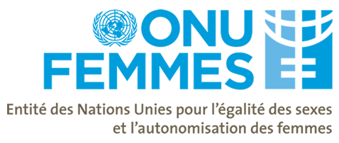

UN WOMEN COTE D’IVOIRE
MONITORING, EVALUATION AND RESEARCH PLAN 2015-2016
Activity | Partners and stakeholders | Planned Dates (Month and year of start and end) | Budget
Activity | Partners and stakeholders | Planned Dates (Month and year of start and end) | Source | Amount (USD)
MONITORING
Quartely monitoring field missions (of various project including H4+, Muskoka, PBF, UBRAF,PBF) | UNWomen | janv/16 | N-Core | 7,000
Annual country office report (2014-2015) early 2016 based on the findings of the regular monitoring of 2014-2015 SN | UN Women | Janv/16 | Staff contribution | -
RESEARCH
Impact of local committees on the fight of VAW: lessons and challenges | NGO, MoH, | July 16 | N-core | 20 000
Elaboration of gender statistics in partnership with the National institute of statistic. | Elaboration of data base in gender, VAW and GEWE | Janv/16 |  | 30 000
Mapping of Donors supporting GEWE and PND implementation and in CIV | Ministry in charge of gender | janv/16 | core | 2,000

Evaluation Plan 2016
Evaluation Name | Mandatory?  (Yes) | UNDAF Outcome/ UN Women SP Goal, Outcome | Country/ MCO/ RO AWP Output |  | Office in charge | Region/ country | Joint activity  (Yes indicate partners) | Key Stakeholders | Planned Dates  (start-end) | Budget (US$) / Sources of Funding |  | Status (pending/ initiated/ ongoing/ completed) | Remarks
Evaluations managed by the UN Women office
Evaluation of Strategic note 2014-2015 | No | UNW SP |  | CIV | CIV CO | WCARO | UNHCR  MSFFE | Administration (bin-hounien and Toulepleu)  Cooperatives | January 2016 |  | N-core | Planned | 30 000
Evaluations in which the office participates
Final review and evaluation of Projet d'appui aux initiatives communautaires des femmes en faveur de la réconciliation et de la paix en Côte d'Ivoire | No | UNW SP Goal  1 and 4 | CIV |  | CIV CO | WCARO/CIV | UNFPA  UNDP | Government  Donors | TBD/2016 | PBF |  | Planned | 5000
Evaluation of the H4+ initiative and MUSKOKA | No | UNW SP Goal 3 | CIV |  | CIV CO | WCARO/CIV | UNDP  UNFPA  UNICEF  WHO  UNAIDS | Government  Donors | TBD/2016 | France  Sweden |  | planned | 5000

Please fill out a separate row for each evaluation

